**Ve270 Introduction to Logic Design Homework 2**

**Assigned: May 24, 2018**

**Due: May 31, 2018, 2:00pm.**

**The homework should be submitted in hard copies.**

1. Prove DeMorgan’s Law. (5 points)
2. Problem 2.26. (10 points)



1. Problem 2.28. (5 points)



1. Problem 2.30. (5 points)



1. Problem 2.40 (5 points)





1. Problem 2.48 (c) (5 points)



1. Problem 2.51 (5 points)

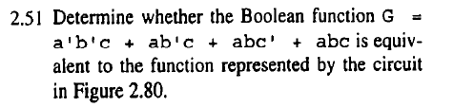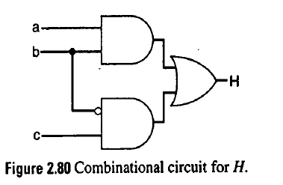

1. Problem 2.55 (10 points)



1. Problem 6.3 (10 points)



1. Problem 6.5, using both algebraic methods and K-map. (10 points)



1. Problem 6.8. (10 points)



1. Problem 6.11 (a) (10 points)



1. Problem 6.14 (10 points)

