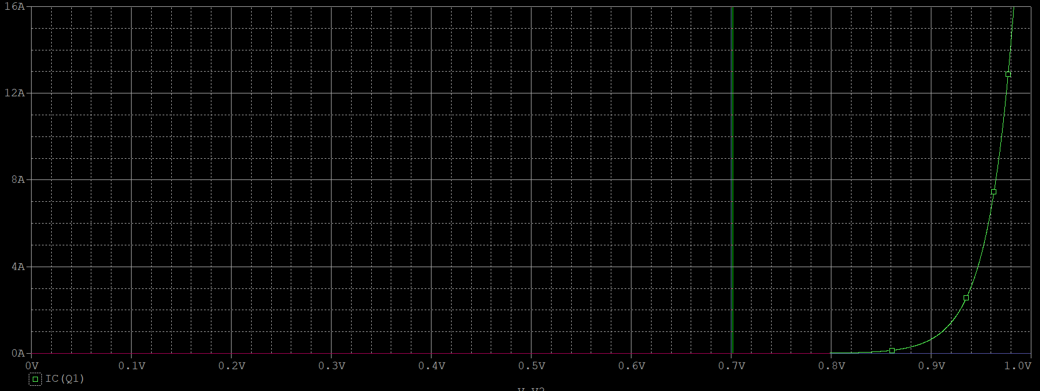**2.(b)**

**The slope at 0.7V is about 0.0115, which is a bit smaller than the calculated value 0.013.**

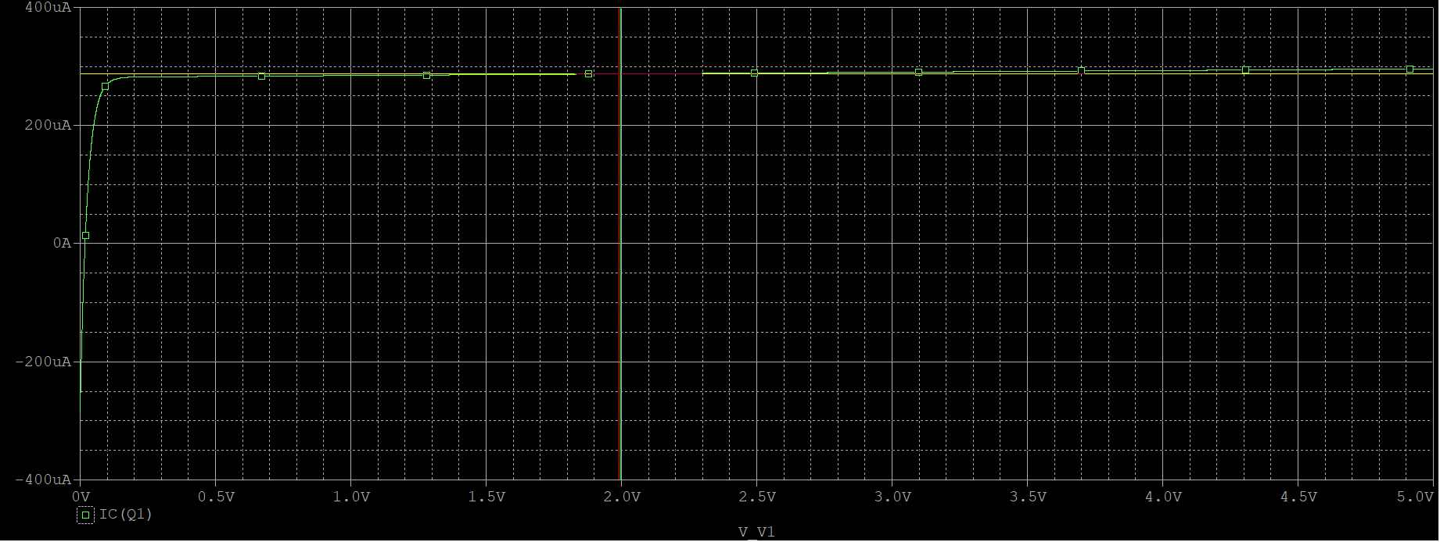**2.(c)**

**The slope at 2V is about 430695, which is also smaller than my calculated answer**