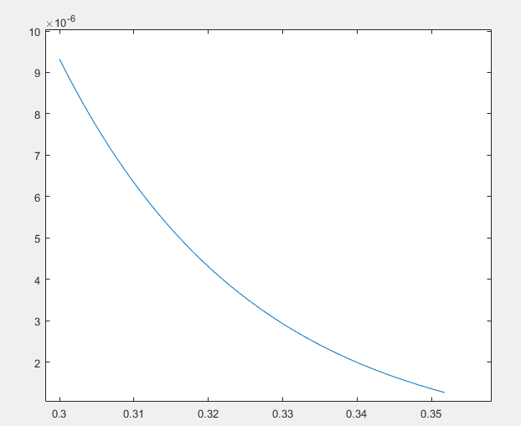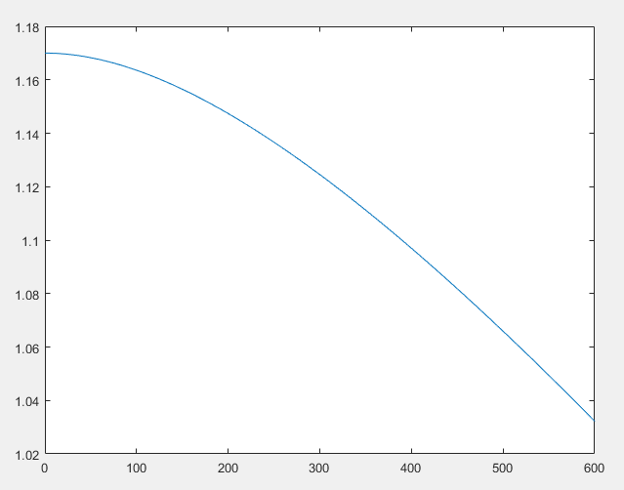**Problem 1**

T=1.170-(4.73e-4*(300^2))/(636+300)=1.1245

**Problem 5 (a)**

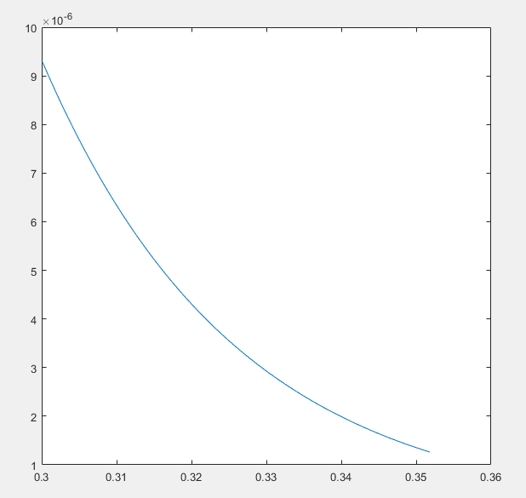

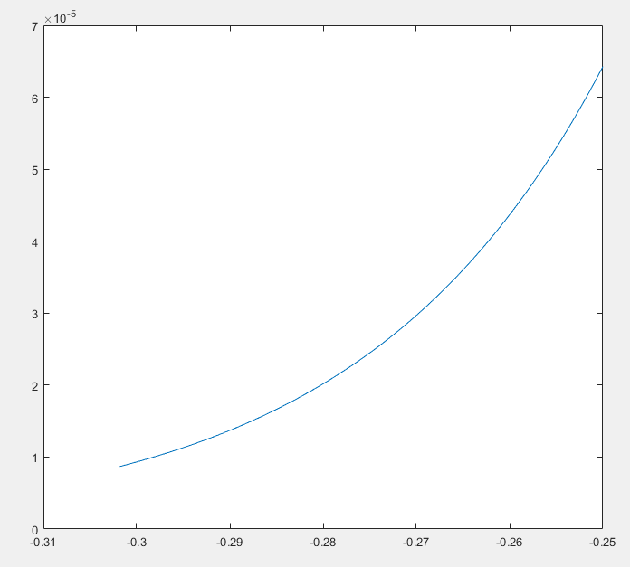**Problem 5 (b)**