**Problem (2)**

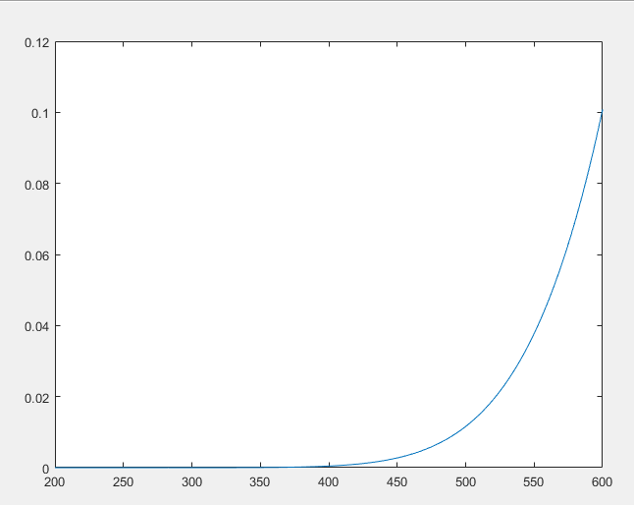

**Problem 9（c）**

The black line represents for the intrinsic level, red line represents for the

Fermi Level, blue and green lines represent for the quasi-Fermi level for

holes and electrons respectively.

