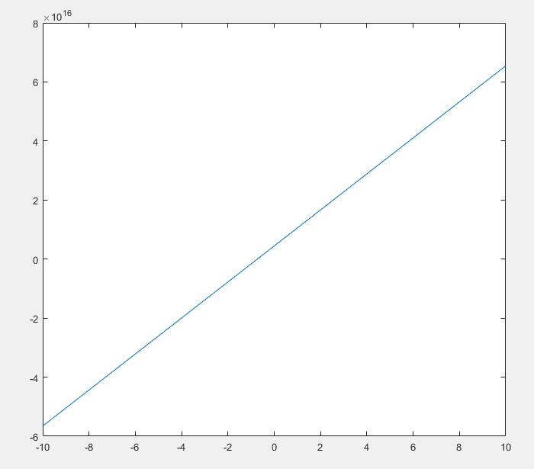**11（c）**

The intercept is equal to -Vbi and the intercept won’t change with Nd.

The slope decreases as Nd increases but it won’t change with Vbi