**（2）**

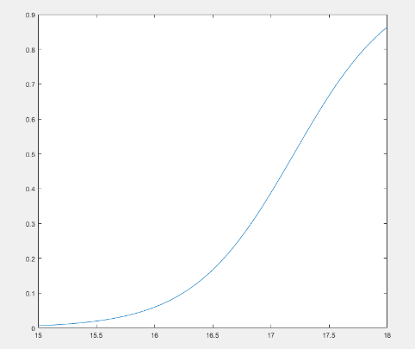

**(5)**

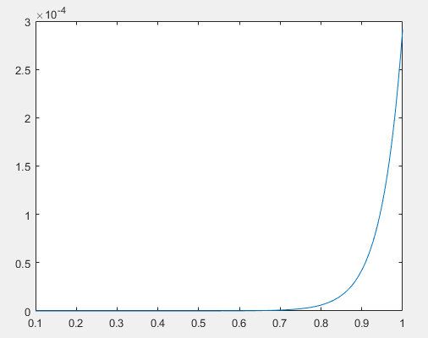

**For ideal diode, the turn on voltage is about 0.6V, which is smaller than that in my plot. In addition, for diode, the current increase more rapidly than that in my plot, the slope for ideal diode is about infinity, but the current can’t reach 0.001A when voltage is lower than 1V, so my slope is much smaller.**

**(9)**

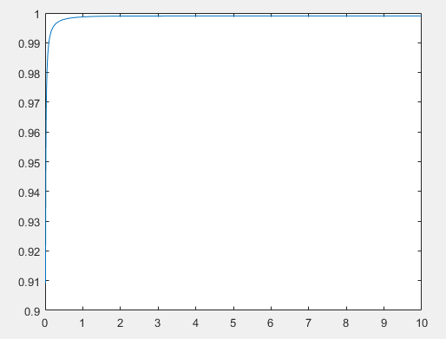 **The efficiency increases with emitter width and it increases most rapidly when the width is very small, then it approaches to 1. The same thing happens to current gain as well**