# **I called this place ‘America’s worst place to live.’ Then I went there.**

# By [Christopher Ingraham](https://thewhyaxis.substack.com/)

# September 3, 2015

I drove up to the Red Lake County, Minn., courthouse not knowing exactly what to expect. This was, after all, the seat of the county that I had just a few days ago proclaimed, in a story, the "[absolute worst place to live in America.](http://www.washingtonpost.com/news/wonkblog/wp/2015/08/17/every-county-in-america-ranked-by-natural-beauty/?itid=lk_inline_manual_2)" [Residents had been outraged](http://www.washingtonpost.com/news/wonkblog/wp/2015/08/19/thick-coats-thin-skins-why-minnesotans-were-outraged-by-a-recent-washington-post-report/?itid=lk_inline_manual_2). A county commissioner told the state's largest newspaper [I could kiss his butt](http://www.startribune.com/washington-post-reporter-says-minnesota-is-ugly-minnesotans-politely-beg-to-differ/322350791/). Would I be arrested? Beat? Flogged with a [hotdish](https://en.wikipedia.org/wiki/Hotdish)?

But what greeted me instead last weekwas pure spectacle. A drum line from nearby [Lafayette High School](http://www.redlakefalls.k12.mn.us/lafayette_high_school.htm) performed a routine on the courthouse steps. Officials and county residents, beaming and full of civic pride, lined up to shake my hand and welcome me to their home. And a gaggle of local press was there, cameras rolling, to cover it all.

As a reporter, I'm used to folks disagreeing with me, especially when covering contentious topics like guns, gay marriage and drug policy. But until I wrote about [the U.S. Department of Agriculture's natural amenities index](http://www.washingtonpost.com/news/wonkblog/wp/2015/08/17/every-county-in-america-ranked-by-natural-beauty/?itid=lk_inline_manual_6) -- which rates and ranks counties on measures of scenery and climate -- I had never been disagreed with so much.

And so politely.

Minnesota, you see, ended up looking less-than-great in the USDA's ranking. And the state's Red Lake County, five hours northwest of Minneapolis in the flat fertile basin of the Red River valley, came in dead-last in the nation. The summers are hot, the winters are cold, and there aren't any actual lakes in the county -- all of which contribute to a low score by the USDA's criteria.

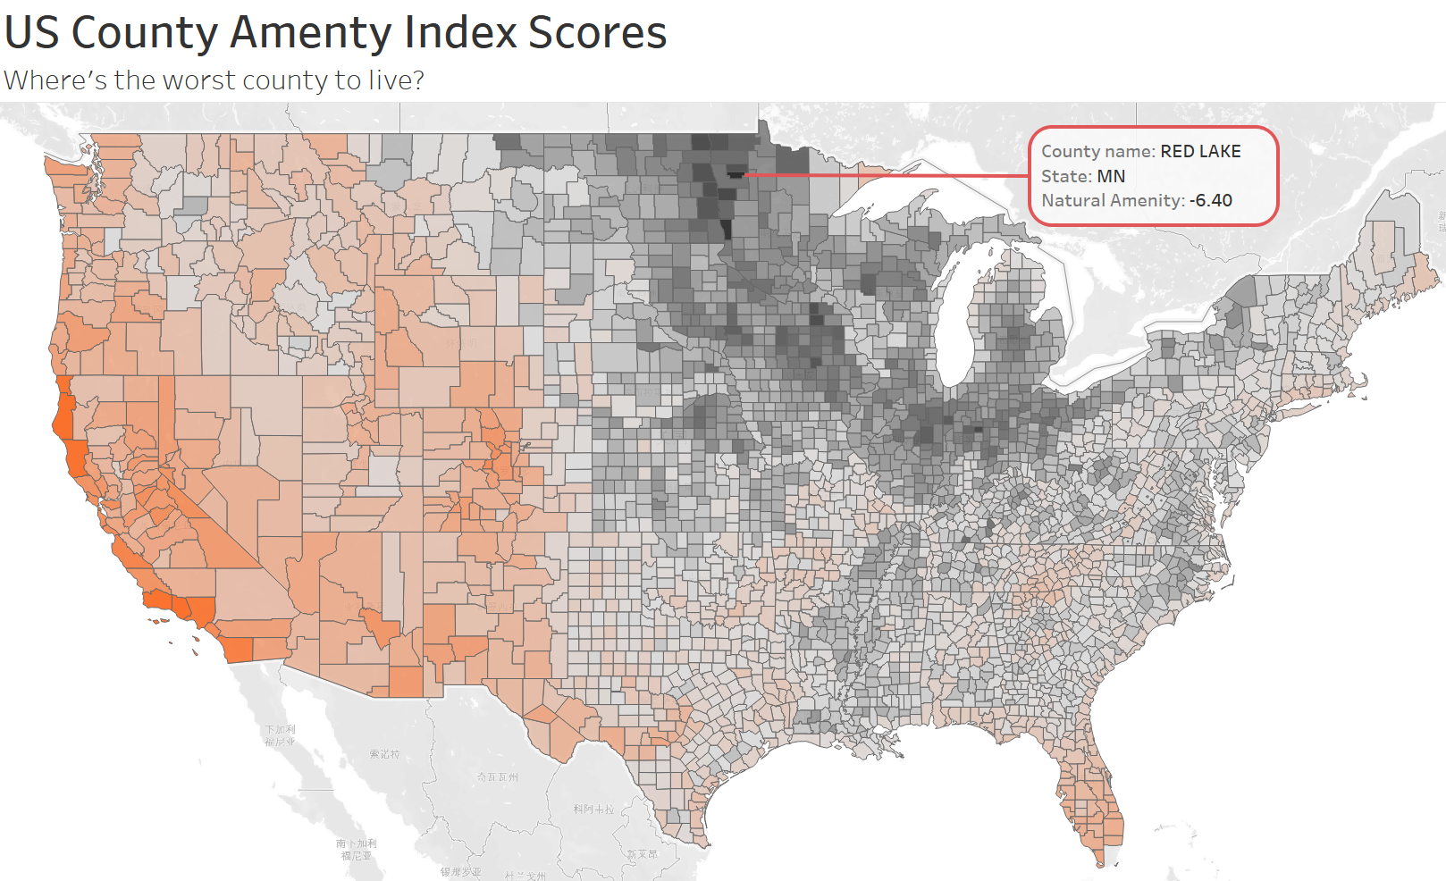

Could it really be that bad? I had to find out. At the invite of local businessman Jason Brumwell (The Post paid), I took a trip up there last week to see the truth behind the numbers. I wanted to find out what life in America's worst county was *really* like.

Some county residents were hurt and even angered by their last-place ranking. But not Brumwell. He's a relentlessly positive guy who keeps a beat-up copy of "The 2,548 Best Things Anybody Ever Said" in the back of his beat-up Buick LaCrosse.

Where others saw a slight, Brumwell saw an opportunity. With his father and two of his siblings, he operates Voyageur's View Camping & Tubing on Red Lake River. "My family gets to spend our days listening to people from all over the United States and the world tell us how beautiful our area is," he says.

Brumwell welcomed the [media](http://www.grandforksherald.com/news/region/3821943-red-lake-insulted-being-named-ugliest-county-us) [attention](http://www.wday.com/news/minnesota/3822985-community-defends-red-lake-after-article-says-its-ugliest-county-country) the county's last-place ranking [brought](http://bringmethenews.com/2015/08/17/rude-a-minnesota-county-is-called-the-nations-ugliest/), and encouraged other businesses to do the same. My original story hadn't quite framed it this way, but some locals took it to mean that we called their county *ugly.* So, soon after my article went up, restaurants and bars began offering specials on "ugly burgers" and "ugly wings." Officials in Red Lake Falls, the county's largest town, with a population of 1,410, floated the idea of renaming next year's [Summerfest](http://redlakefalls.com/index.php/rlf-latest-news/24-summerfest-2015) the "Uglyfest."

When I arrived at the county courthouse, Red Lake Falls mayor Kevin Harmoning, who also runs a modular home manufacturer in town, took me inside for some initial introductions. The biggest headache in a town like Red Lake Falls? "Making ends meet," he says, referring to keeping the town running, the bills paid and the lights on.

During the recession, they had actually been forced to turn some of the street lights off to keep everything else running, city administrator Kathleen Schmitz said. But all in all, the downturn's effects hadn't been as harsh here as elsewhere. Many of the farms outside of town that form the economic backbone of the county weren't affected much at all. "People still needed to eat," Schmitz said.

From the courthouse, Brumwell piled a group of us into a bright red roofless tour bus and took us to a dairy farm outside of town owned by brothers Carl and Joe Schindler. They milk about 120 cows 12 at a time the old-fashioned way, with a simple pump system installed in their dairy barn.

The visit was a shot of pure country. A newborn calf suckled my thumb as the brothers told me about life on the farm. The earthy smells of a dairy operation -- manure and hay and sawdust and dirt -- hung thick in the air. It sure didn't *seem* like the worst place in America -- or one particularly lacking in natural amenities, or natural beauty, either.

In the course of my visit, I learned how crucial farming is to the local economy. The wheat harvest had just wrapped up, leaving fields of golden stubble behind, but fourth-generation farmer Alex Yaggie, 27, showed me the cockpit of one of his 40-foot combines and let me drive it around an empty lot as much as I dared.

Agriculture directly or indirectly supports a lot of economic activity in the county. And the small-town narrative we're all used to hearing -- of boom and decline, of good jobs leaving for overseas and Main Streets hollowed out by relentlessly low prices -- doesn't really seem to apply here. Harmoning's manufacturing plant was a hum of activity the day I visited, with home components in varying stages of construction moving along the quarter mile-long rail line that cranks out a completed house, ready for shipping, once every 10 hours.

The economic opportunity is a big reason many people stay, and some others who left eventually make their way back here. County resident Justin Carriere came back to the area after an eight-year stint as an investment banker in New York City. He's an avid fisherman and makes a lightly-breaded fried walleye that will knock your socks off. Having grown up in the area and then experienced the frantic chaos of the financial crisis first-hand, he started hankering for home. He moved back and took a job at a bank in town.

"You just know that there was an easier way to go about things," he told me at a meet-and-greet later in the day with county residents at [TNJ's Bar & Grill](http://www.tnjsbarandgrill.com/) in Red Lake Falls. His commute now is a whole lot shorter and less hectic. And it's easier to talk to people. "You can strike up a conversation with just about anyone you meet," he said.

The folks at TNJ's were certainly eager to talk to an out-of-town reporter, and tell him what made their community so special. Al Buse, for instance, is Red Lake Falls' oldest resident at 101 -- "like everyone's grandpa," Jason Brumwell told me. He still lives alone, and every morning he loads his tools in the back of his bright yellow golf cart and makes his way through town, fixing things that need fixing.

Al helped himself to my fries as I chatted him up over a dinner of "ugly burger" (double-decker burger and fried egg on toasted wheat). He told me about his stint with the Marines during World War II, and how he had watched the Enola Gay take off on its fateful flight to Hiroshima. I asked him what his secret to long life was. He said it was the wrong question. "I would recommend that you don't live past 80," he said. "This 100 business is the worst."

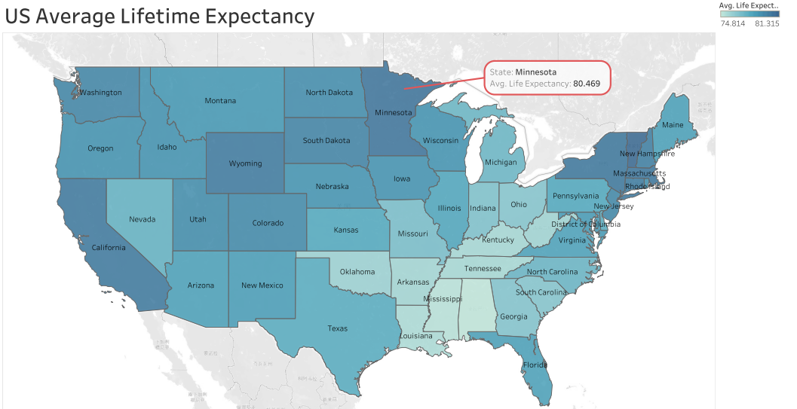

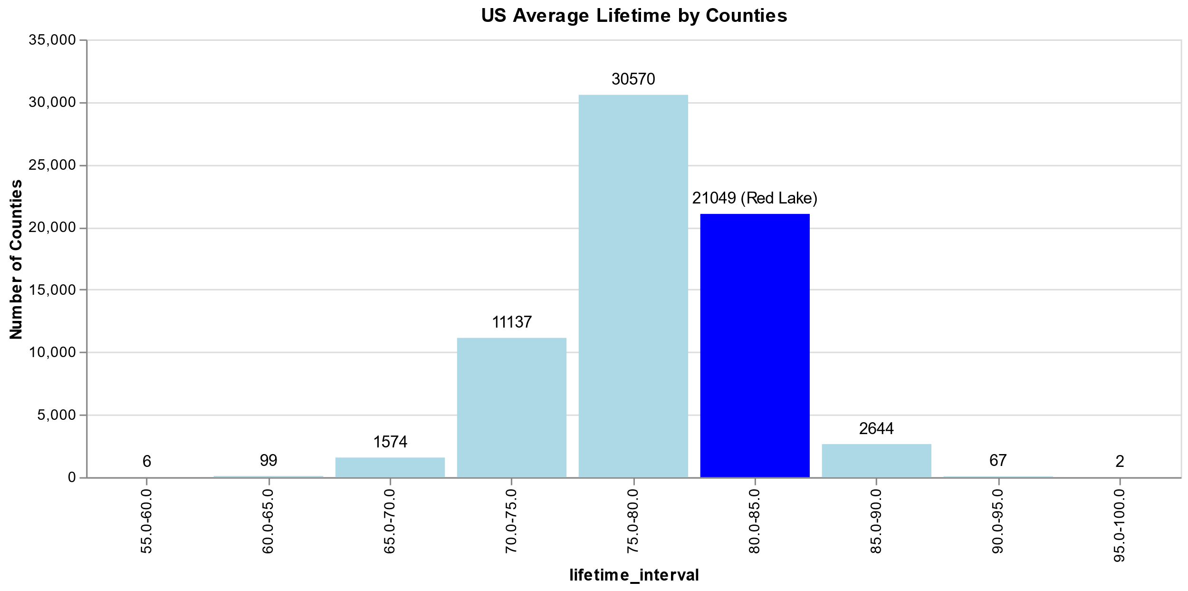

For dessert, TNJ's served a cake built as a map of the county by baking prodigy Matt Weiss, a student at a local high school. It was, by far, the finest work of cake-based cartography I have ever seen. I don't expect to encounter its equal even if I live as long as Al Buse.

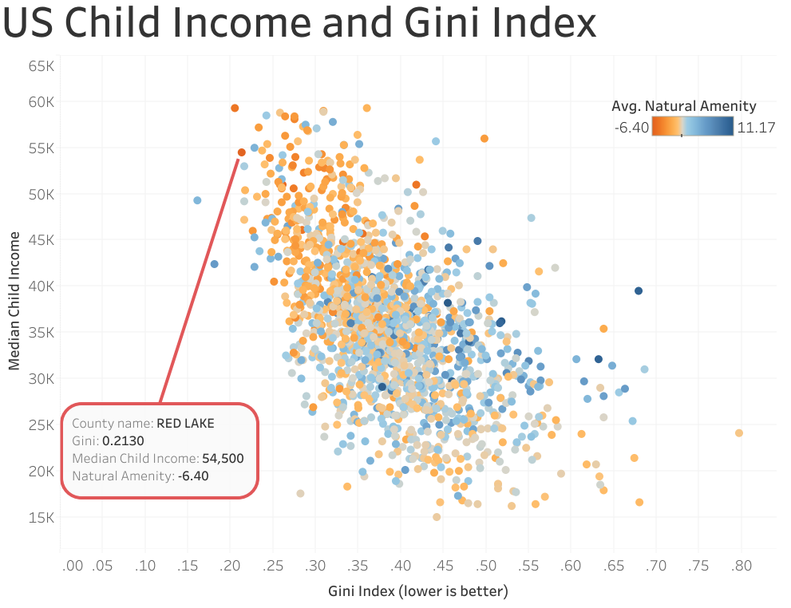

Education is big in the county. Despite a population of only 4,000, the county supports two elementary schools and two high schools. Each of the high schools graduates roughly two dozen students each year, and even the county's poor have a remarkably good shot of becoming middle class later in life, according to a [2013 study](http://www.nytimes.com/2013/07/22/business/in-climbing-income-ladder-location-matters.html?pagewanted=all) by Harvard's Equality of Opportunity Project.

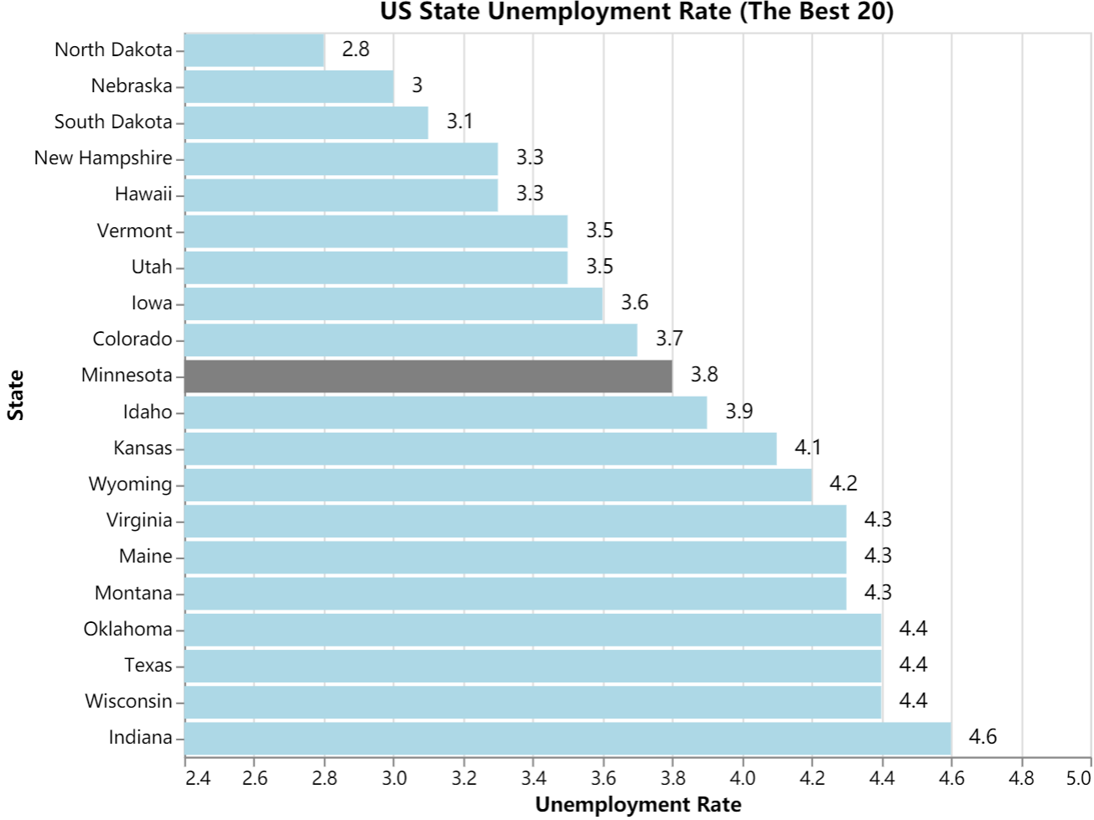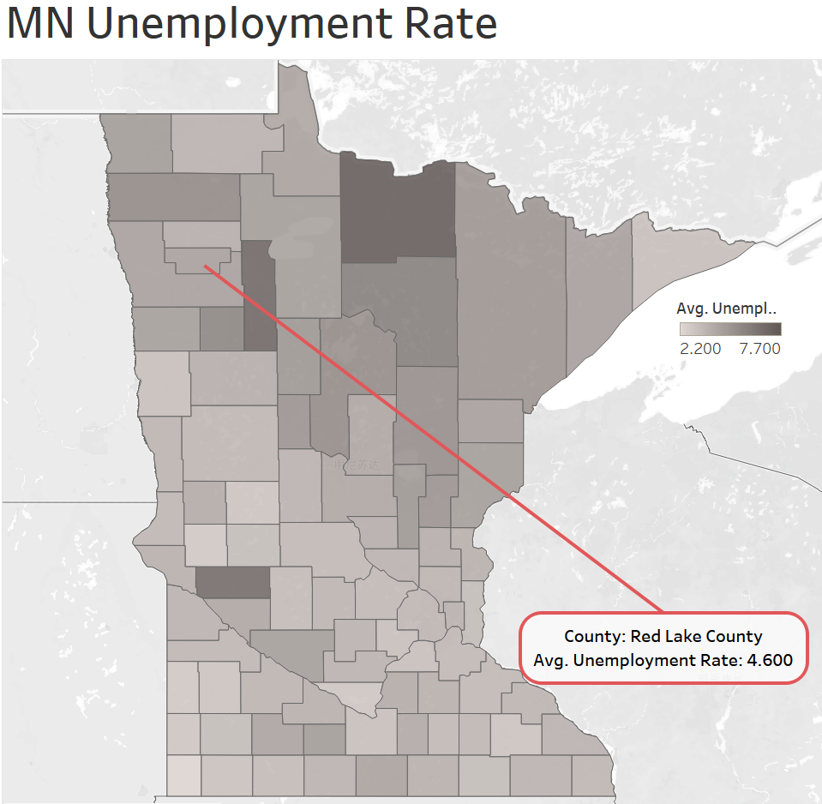

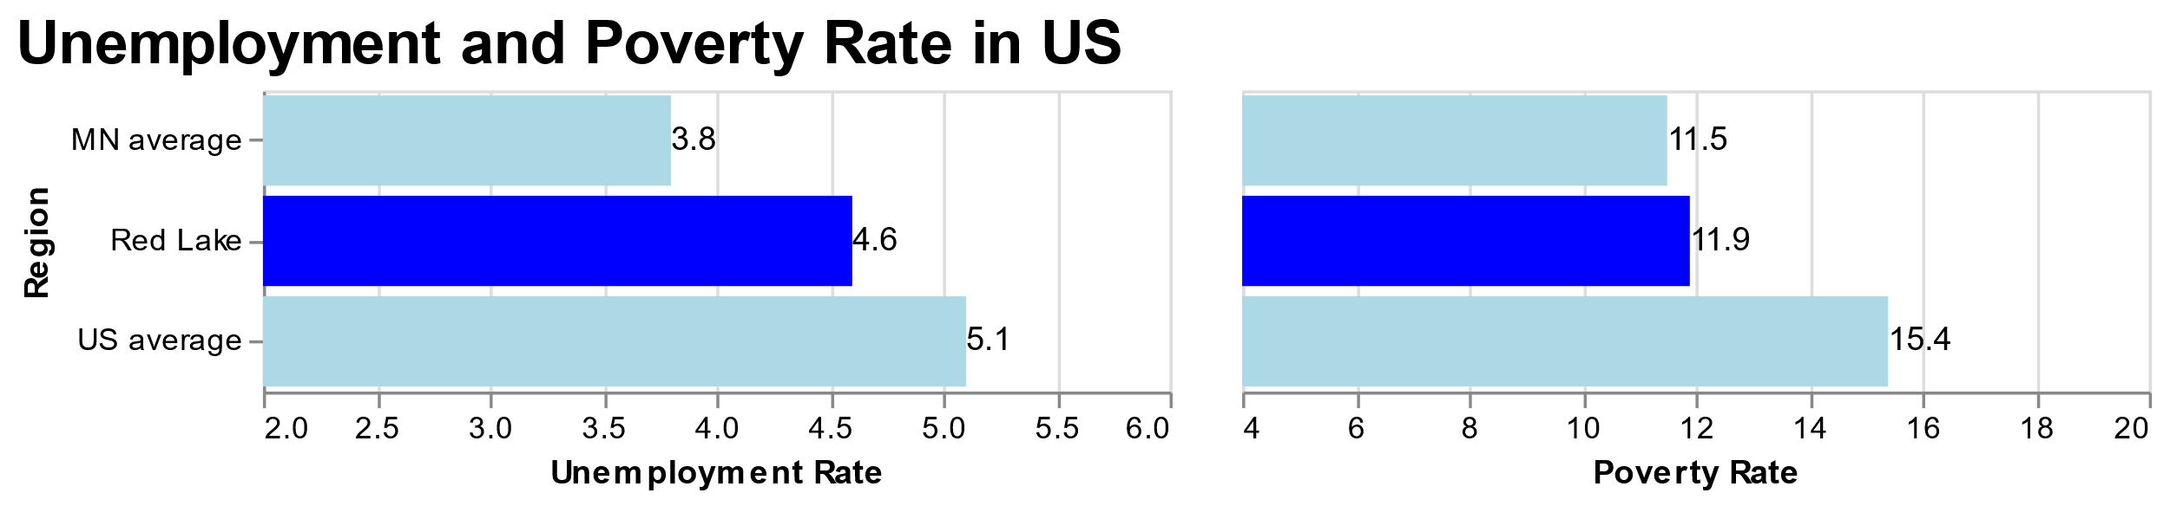

In fact, by most economic metrics, the county looks pretty good. The unadjusted employment rate in July was [4.6 percent](http://data.bls.gov/map/MapToolServlet), well below [the national average](http://data.bls.gov/timeseries/LNU04000000). The median household income is [$48,000](http://quickfacts.census.gov/qfd/states/27/27125.html), while the median home value is about $89,000, according to the U.S. Census. The poverty rate is [11.9 percent](http://quickfacts.census.gov/qfd/states/27/27125.html), below the U.S. average of [15.4 percent](http://quickfacts.census.gov/qfd/states/00000.html). One reason I suspect the outcry against my article was so strong is that Minnesotans aren't used to being ranked low on anything.

I spent the night at the Chateau Motel & Liquor Store, which is a brilliant business idea that absolutely needs to come east. The accommodations were nice, but what I found most striking is how friendly everyone I'd met had been. They were fiercely proud of their community in a way I'd never seen before -- not even during my childhood in small-town upstate New York. "We don't welcome people like this when they come to D.C.," I kept saying to people, dumbfounded.

The next day, Burwellplanned a whirlwind tour of the county on a bus with a sign that read "Welcome To America's Worst Tour." We saw the county's largest asparagus farm and sampled some amazing pickled asparagus with cayenne pepper.

When we stopped for lunch -- fried cheese curds and a "Minnesota burger" -- at TJ's Tavern in the town of Oklee (pop. 429), U.S. Rep. Collin Peterson (D-Minn.) swung by and sang an ode to ugliness on the bar's main stage. A savvy politician, Peterson "just happened" to have a handful of guitar picks in his pocket.

Peterson's a Democratic representative in a largely Republican district. But most folks I talked to didn't give much thought to politics, or think too highly of politicians, at least at the national level. Residents aren't particularly ideological. The county voted for Bill Clinton in 1992 and 1996, George W. Bush in 2000 and 2004, Barack Obama in 2008, and Mitt Romney, narrowly, in 2012.

Gun culture is strong in the region. With some consternation, given my recent article, I learned that Chuck Simpson, the county commissioner interviewed by the Minneapolis Star-Tribune, would be giving me a tour of the Plummer Area Sportsman Club's [shooting range](http://www.plummerareasportsmanclub.org/). But Chuck was gracious about it, and we made amends as he told me about how residents banded together to raise funds and build the shooting range when there was a need for it. (I didn't actually do any shooting.)

It's a point of pride in the county that when residents need to get something done, they often simply do it themselves. Residents raised the funds to build Red Lake Falls' [municipal swimming pool](https://www.facebook.com/RedLakeFallsPublicSwimmingPool) on their own, dollar-by-dollar. When the nearby town of Brooks needed a [community center](http://www.brooksmn.com/communitycenter.html), businesses donated funds and residents volunteered time to build it by hand.

Over and over, the folks I spoke with told me it was that sense of community that kept them here, and that contributed to that enormous outpouring of civic pride in response to my original article. "There's lots of freedom here," Jason Brumwell said. "But everybody's still watching out for each other."

The people were amazing. "Minnesota Nice," as it's called, is a verifiable phenomenon. But even going beyond the civic pride that was so thick you could season a fried walleye with it, there was the landscape.

The high point of the tour for me was a kayak trip down Red Lake River, which meanders through the county before meeting with Clearwater River in Red Lake Falls and eventually emptying into the Red River along the Minnesota-North Dakota border.

The river was a ribbon of tranquility slicing through the green-gold late August landscape. Broad and flat, but with just enough elevation drop to keep things interesting for this novice kayaker, the river carried a group of us smoothly through the pylons of a defunct railroad trestle and downstream toward sandy bluffs that rose 50 or so feet above the banks.

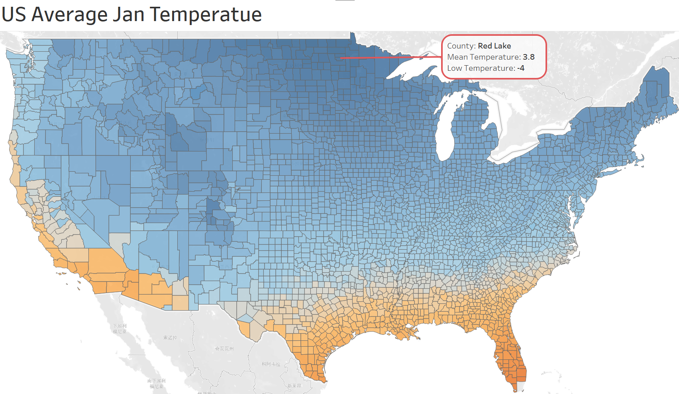

Locals fish the river for bass and walleye in the summer. When it freezes in the winter ([average low temperature](http://www.weather.com/weather/monthly/l/56750:4:US) in January: -4 degrees), they make the best of it by skiing and skating across its surface. I began to understand what schoolteacher Bobbi Aakhus had said to me at the meet-and-greet at T&J's. "There's so much to do here," she said. "You just have to really dig into it."

Before visiting, I wouldn't have believed her. I was worried that 36 hours would be too long a visit, that we'd run out of things to say or do and end up sitting in silence, staring at corn. But I left feeling like I'd barely scratched the surface of all there is to see and know about the county and the people who call it home.

I kept looking for signs of discord or trouble, cracks in the facade of Minnesota Nice. But I couldn't find any. The places I visited, from the bars to the barns to the warehouses, even *smelled* wholesome -- like wood and grain and prairie air.

There's perhaps something amiss in a ranking that places Red Lake County at the absolute bottom of the nation when it comes to scenery and climate. As I noted in my original story, the USDA's index places a lot of emphasis on mild weather and a little less on true scenic beauty, which of course is harder to quantify. But there's no doubt that the Red Lake County region is flat-out gorgeous. In a phone interview, Minnesota Sen. Amy Klobuchar called it a "stark beauty," and I think she's right. And you can see that beauty everywhere, from the open farm country to the craggy bluffs and hills of the river valley.

When people and places halfway across the country are just a mouse-click away on your computer, it's easy to assume that the we live in a nation made small and manageable by technology. But traveling to a place like Red Lake County, hours away from any major metro area, is a reminder that in much of the country, the rhythms of daily life are, still, markedly different than the coastal city grind of long commutes and high-octane jobs.

For some of us, it takes a place as small as Red Lake County to drive home just how big this country really is.