# Tableau Lab Answer Sheet – Independent Activity Part 1

Use this answer sheet to answer the questions with the **red squares ⬜** from the Tableau Lab (see lab handout for the entire set of instructions). You can include partial screenshots of displays/visualizations if the entire display is too big. We just want to know that you were able to generate the answer/transformation.

**Question 6: Which movies were about dragons?**

Crouching Tiger, Hidden Dragon. Dragonfly. Dragonheart. Dragonslaver. Dungeons & Dragon 2: The Element Might. Dungeons & Dragon. George and the Dragon. How to Train Your Dragon. Kiss of the Dragon. Pete’s Dragon. Red Dragon. The Mummy: Tomb of the Dragon Emperor. Three Kingdoms: Resurrection of the Dragon.

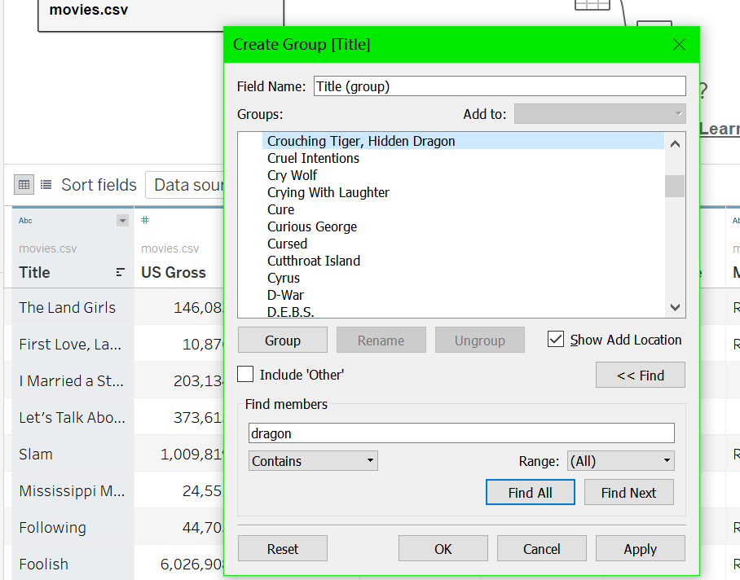

**Question 9: Are there directors who have never directed a profitable movie? Who are they?**

I create a worksheet by setting columns to be the max revenue, and rows to be the director. Then I applied filtering on negative max revenue. Finally, I get all directors, whose max revenue is less than 0.

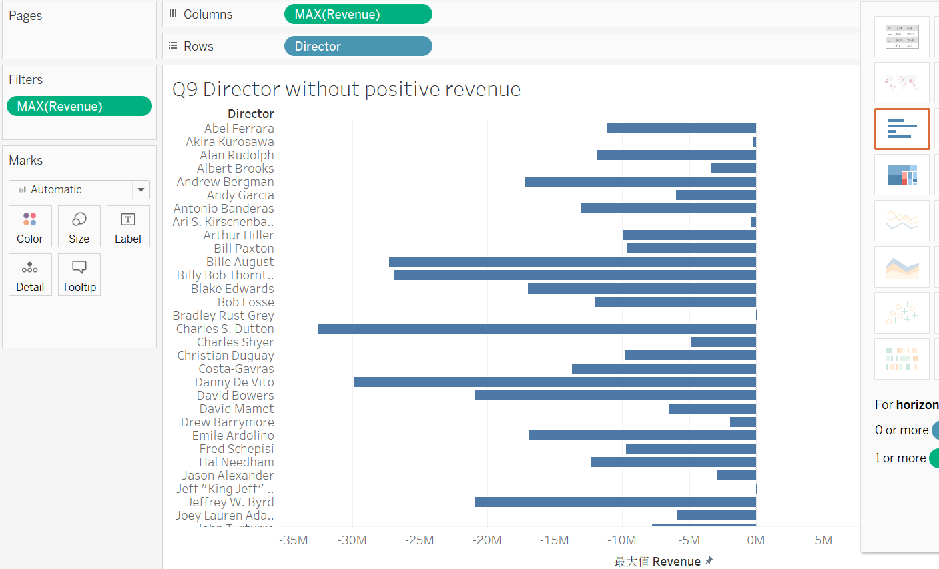

**Question 11: Which director has directed the most profitable Comedy movie?**

I drew horizontal bars. Its rows’ label is max revenue and column’s label is director and movie title.

After filtering movies with revenue larger than 400M, I got Brad Bird.

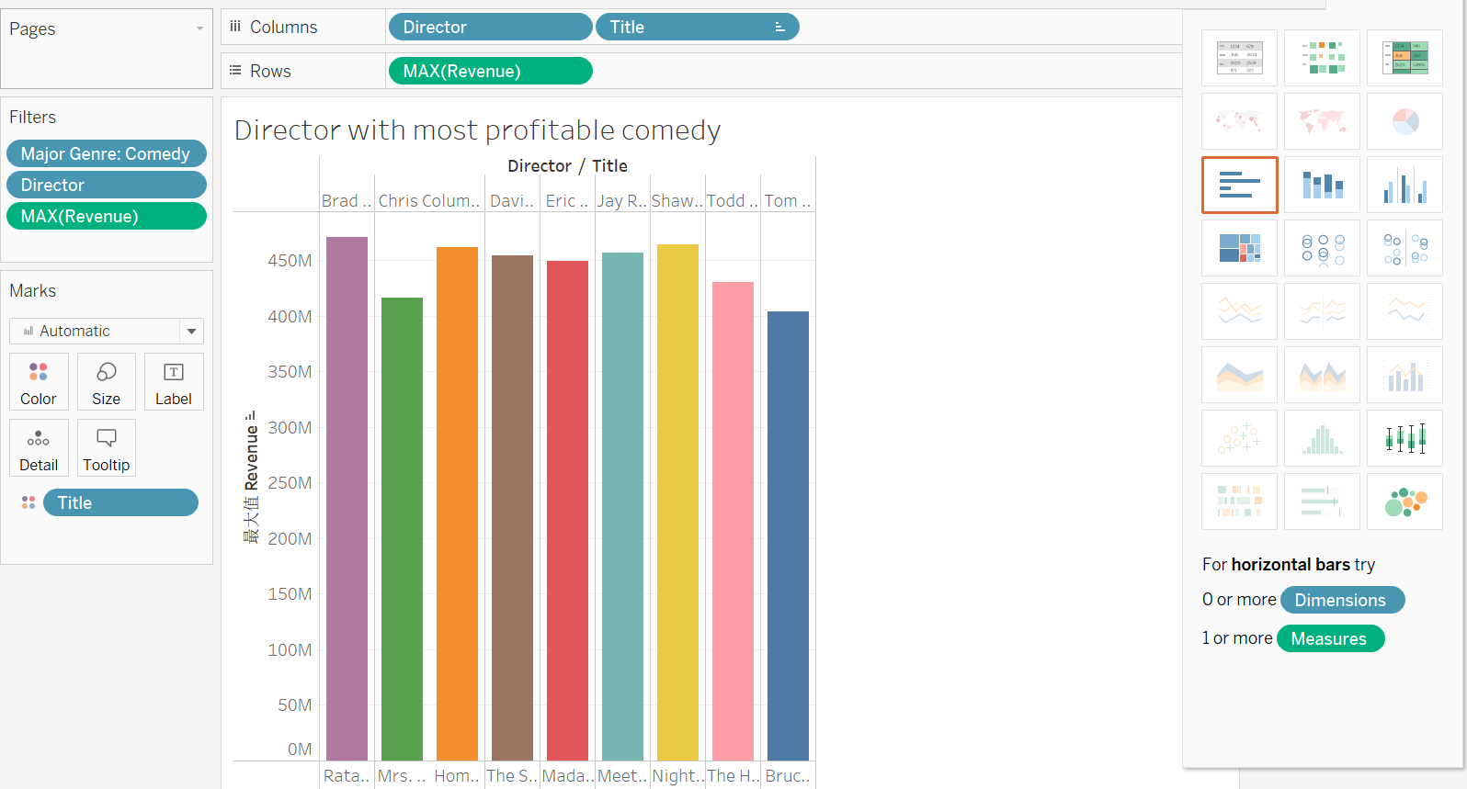

**Question 12: (bonus question): Do movies that contain the word “star” have higher average revenue than movies with “dragon” in the title?**

I create two groups with keyword “star” and “dragon” in a new field called “title keyword”. Then I the two groups’ average revenue. It turns that “star” do have higher average revenue

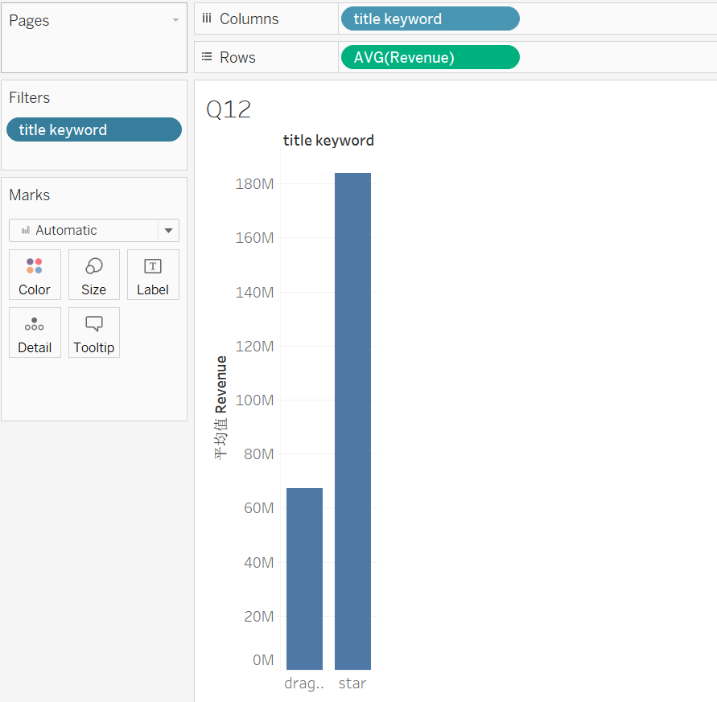

**Question 15: Is it better to invest in action movies or comedies? Which director would you invest in?**

I created bar chart. The sheet’s row label was average revenue, and column label was major genre. I excluded other major genre to make it more clear.

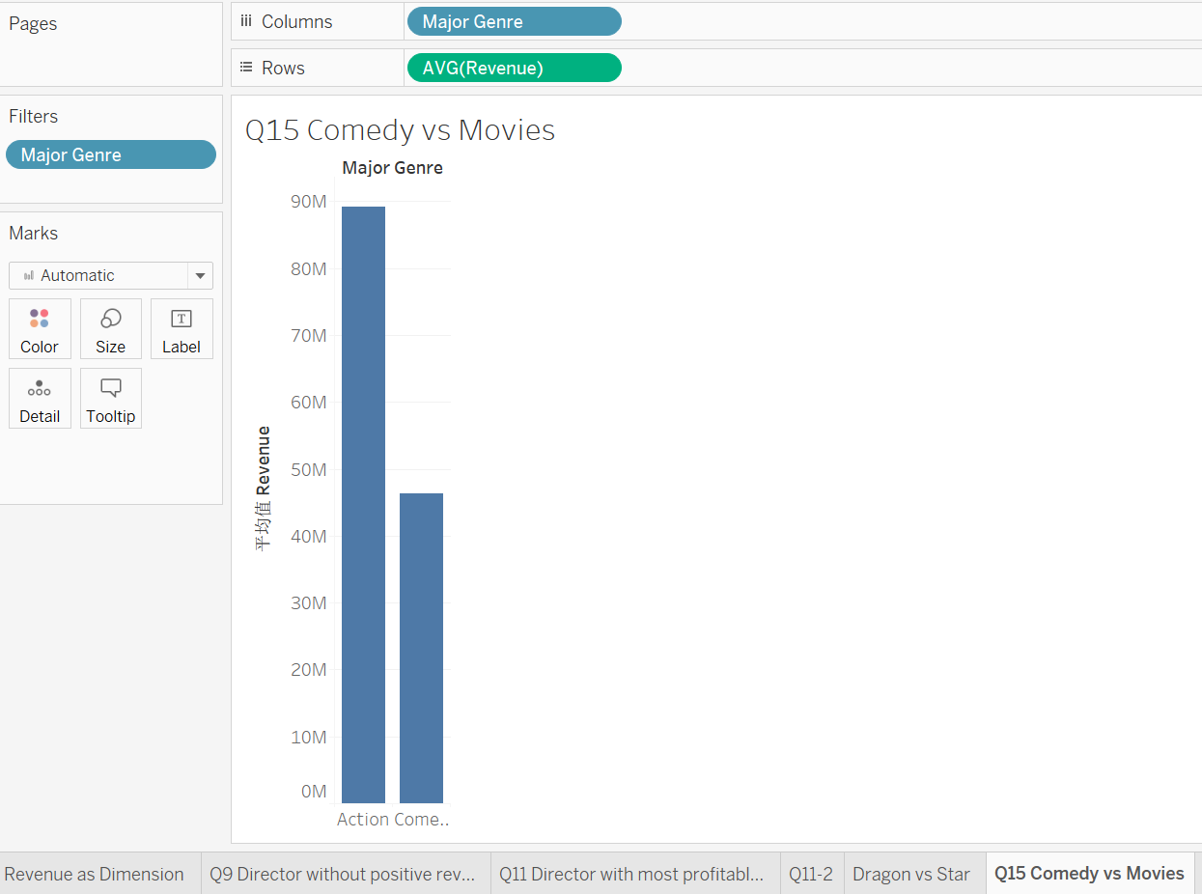

From the sheet, we could see action genre had a higher average revenue than comedy, hence it’s a better choice for me.

For the director I like to invest in. I create another sheet with bar chart. The row label is average revenue and column label is director. I also filter major genre in action or comedy.

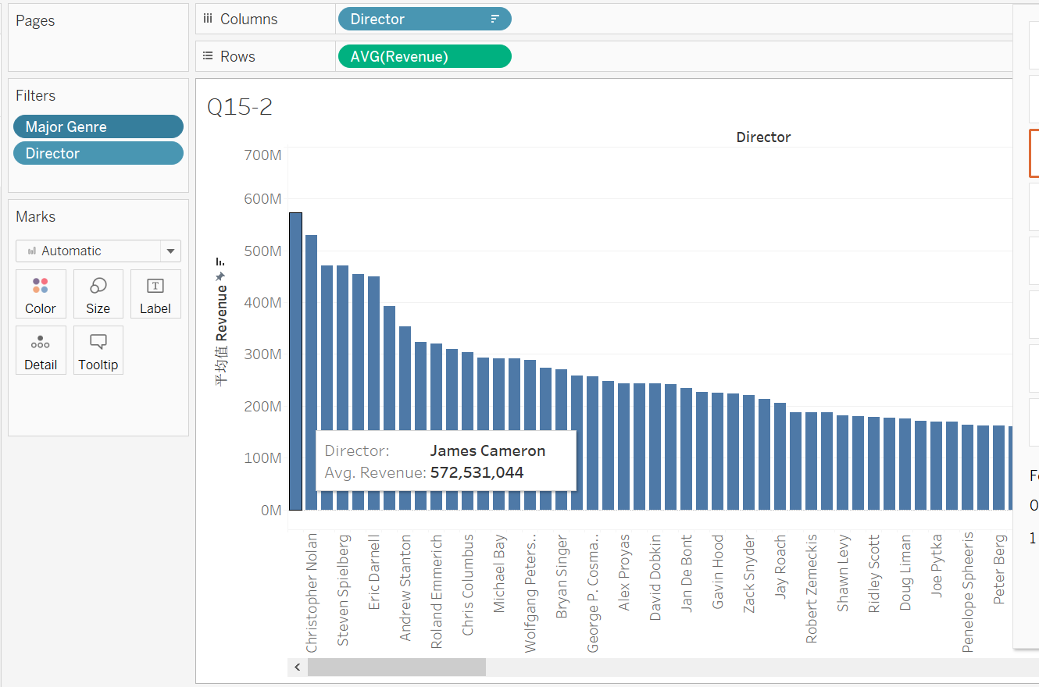

According to the visualization, I’d invest in James Cameron because he has highest average revenue.

**Question 16: What’s the relationship between IMDB ratings and revenue? Are highly-rated movies more profitable?**

To figure it out, I created a worksheet, who column label is IMDB Rating as dimension, and row label is average revenue. I set bot label as dimension and then drew a Gannt view based on the data. To avoid bias, I also set filter condition that the revenue count must be larger than 5.

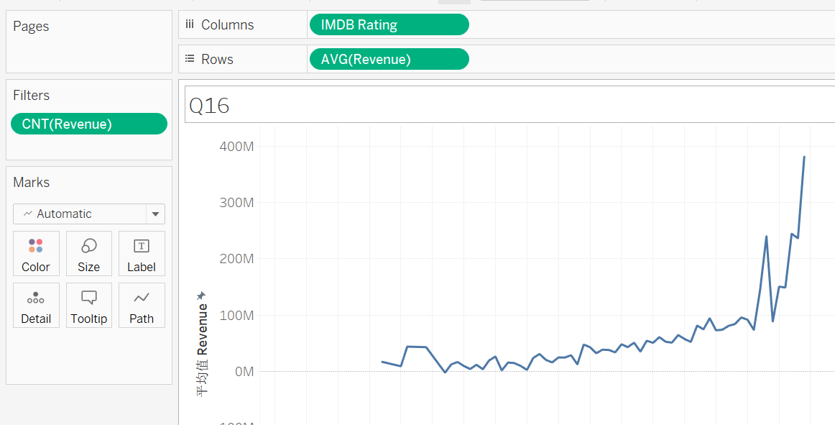

According to the visualization, we can see that there is a positive correlation between IMDB ratings and revenue. Hence, highly-rated movies generally can lead to a higher revenue.

**Question 18: Who would you invest in?**

I created a horizontal bar worksheet with setting the row label to be average revenue and columns to be director. To avoid bias, I also excluded directors whose movie number is less than 5. After sorting based the average revenue, I got James Cameron with highest average revenue. I would like to invest in his movie.

