# DESIGN SPECIFICATION

Eddy Ekofo - x00119959

Graham Lalor - x00122026

Philip Cheape - x00123757

Juris Cicelimovs - x00116645

# WEBSITE STORY BOARD

These are the patterns in which we will base the design of our website. The reason why this was chose is due to its simplicity and clarity to present the contents which will be displayed in our website.

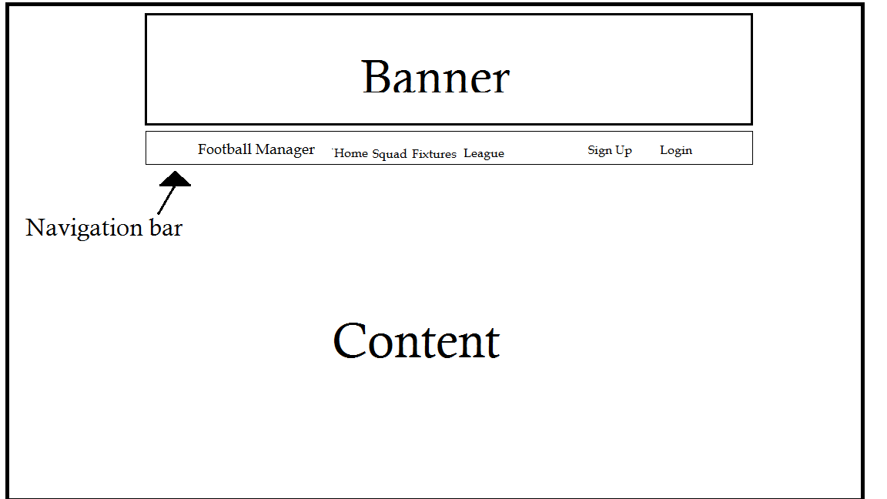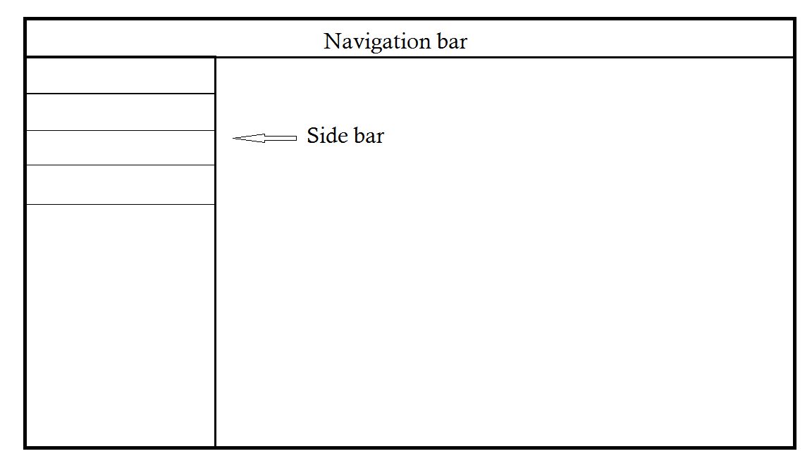

# WEBSITE SCREENSHOTS

Home Page

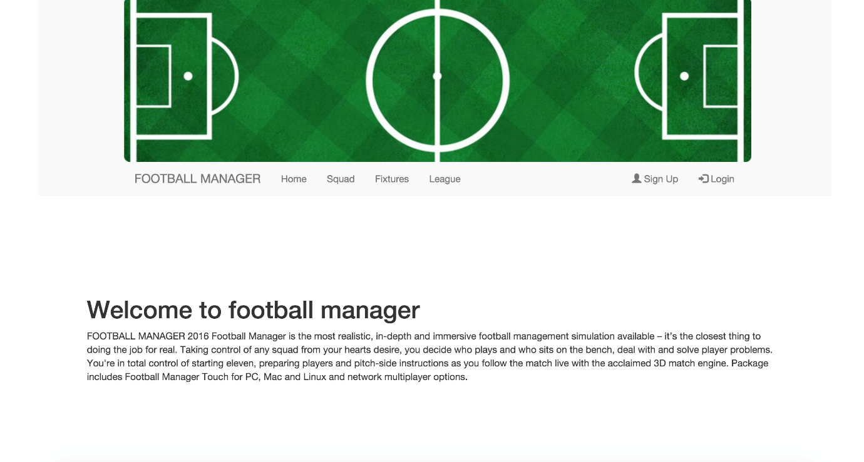

Login Page

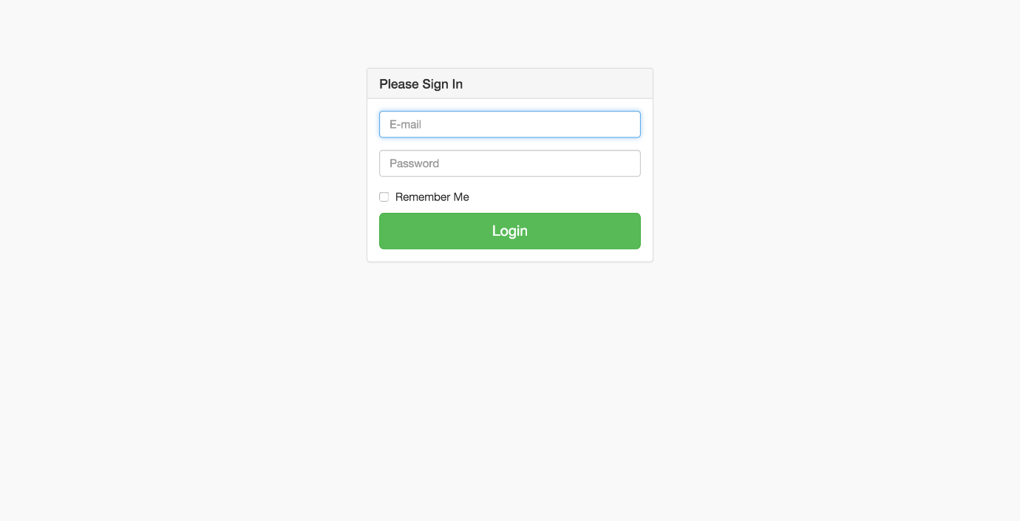

Register Page

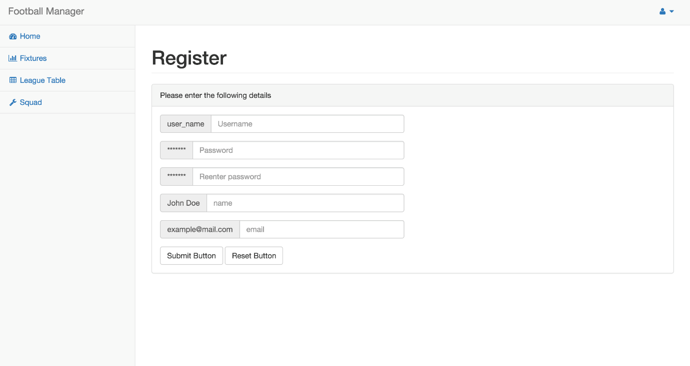

Fixtures Page

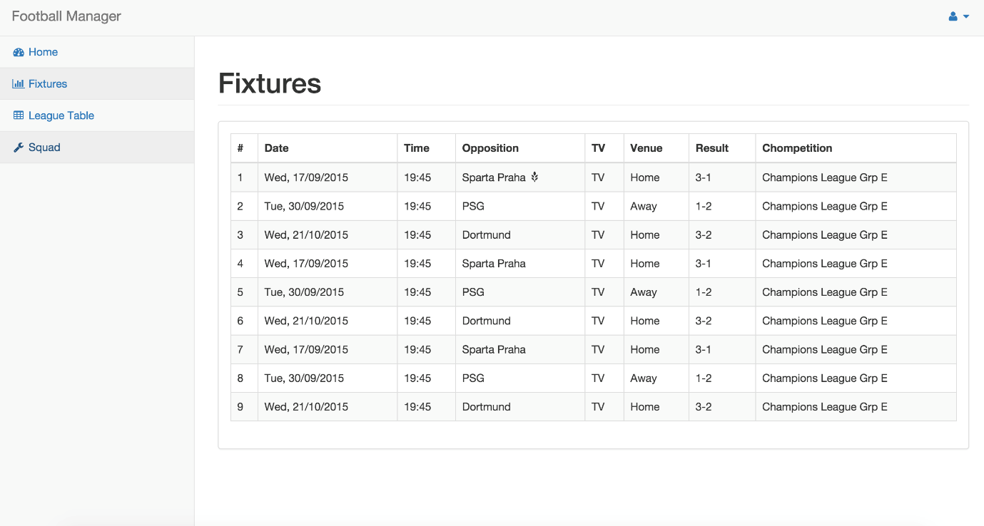

Squad Page

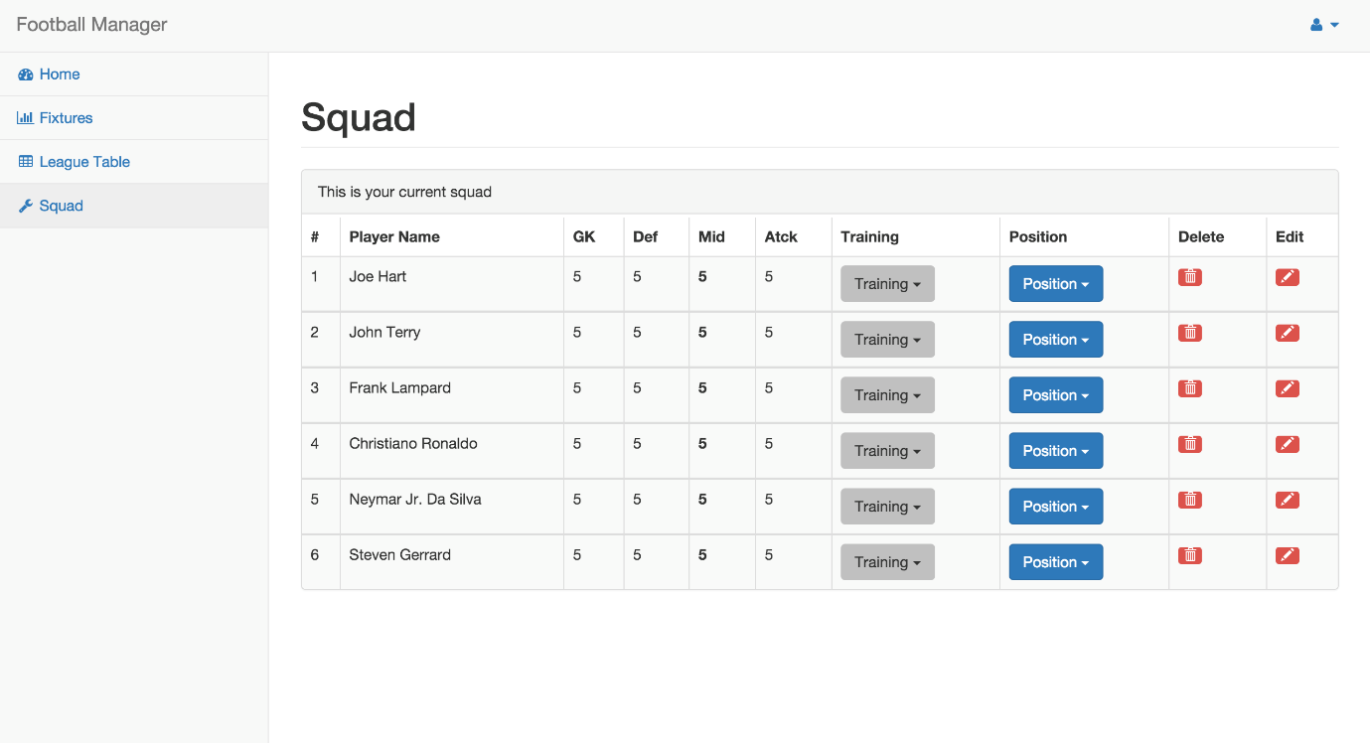

League Table

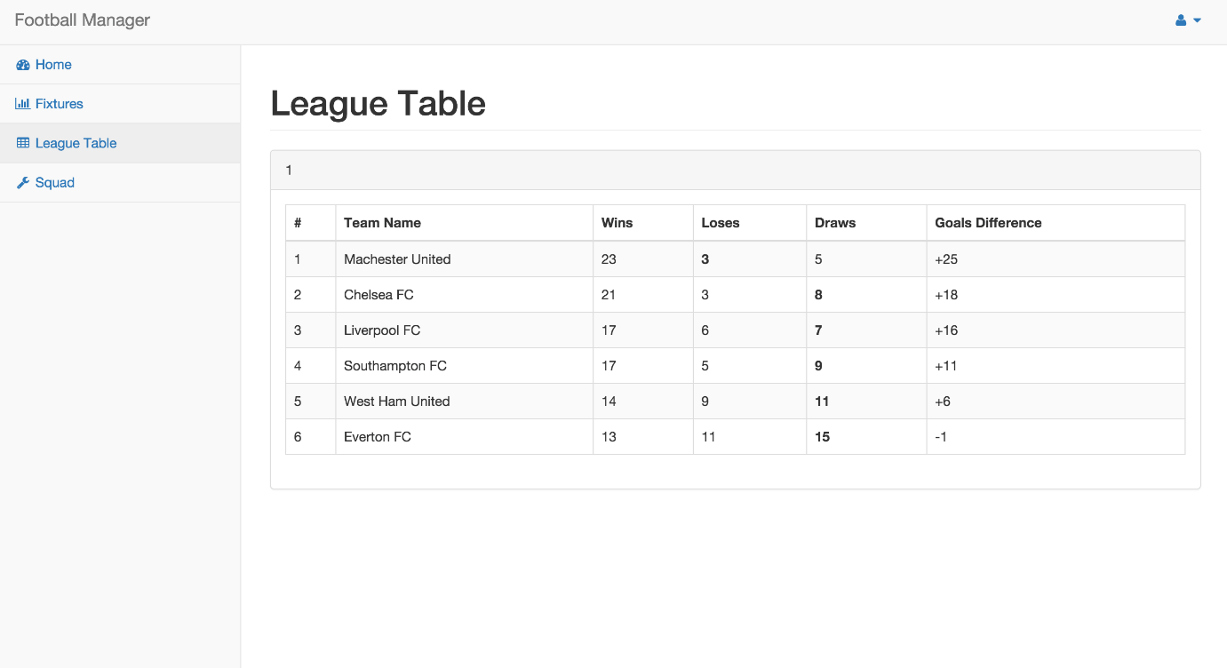

# USER MANUAL TABLE OF CONTENTS

1. Registering and login
2. Managing your team
3. Assembling a team
4. Playing a match
5. How the league works
6. The administrators special privileges

# ERD DIAGRAM’s

Basic system: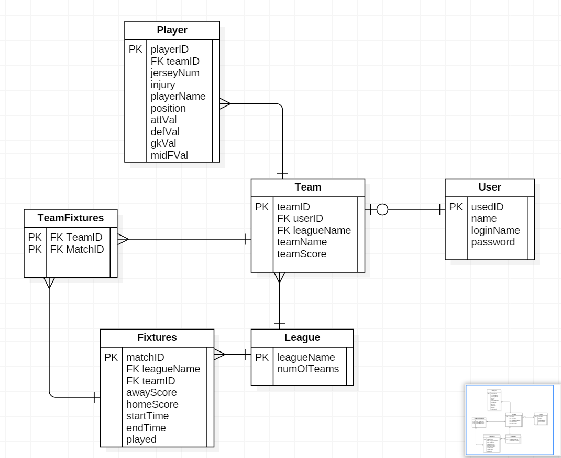

Advanced system:

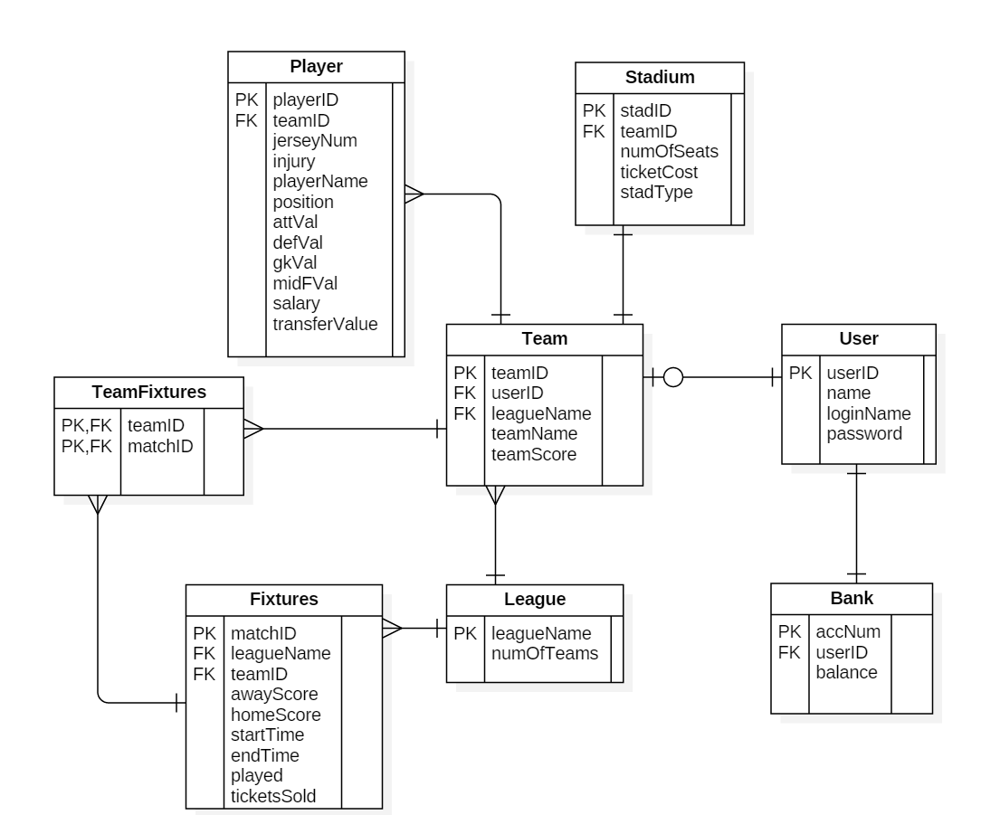

# Test Case Matrix

|  |  |  |  |  |  |
| --- | --- | --- | --- | --- | --- |
| **Test Case Matrix** | | | | | |
| **Test Case No** | **Test Case Name** | **Input** | **Expected Outcome** | **Actual Outcome** | **Result (Pass/Fail)** |
| 1 | Register user | Phill : name [phill.cheape@gmail.com](mailto:phill.cheape@gmail.com):email  Pcheape: username, password:Password  password: confirm password.  Team1:Team name | Account created |  |  |
| 2 | Register user password not confirmed | Phill : name [phill.cheape@gmail.com](mailto:phill.cheape@gmail.com):email  Pcheape: username, password:Password  pass: confirm password.  Team1:Team name | Passwords do not match |  |  |
| 3 | User name Taken | Phill : name [phill.cheape@gmail.com](mailto:phill.cheape@gmail.com):email  Pcheape: username, password:Password  password: confirm password.  Team1:Team name | User name taken error |  |  |
| 4 | Field left blank | : name [phill.cheape@gmail.com](mailto:phill.cheape@gmail.com):email  Pcheape: username, password:Password  password: confirm password.  Team1:Team name | Unable to submit. |  |  |
| 5 | Email incorrect format | Phill : name [phill.cheapegmail.com](mailto:phill.cheape@gmail.com):email  Pcheape: username, password:Password  password: confirm password.  Team1:Team name | Incorrect email error |  |  |
|  | Login | Pcheape:username  password:Password | Login |  |  |
|  | Login incorrect password | Pcheape:username  pass:Password | Incorrect username/password |  |  |
|  | Login incorrect username | Pche:username  password:Password | Incorrect username/password |  |  |
|  | Manage team | Setup 11 players + 3 subs submit . | Team submitted |  |  |
|  | Manage team | Setup 10 players + 3 subs submit . | Incorrect Team please choose 11 players |  |  |
|  | Admin edit user | Pnill | Username changed |  |  |
|  | Team edit | Team2:Team name | Team name changed |  |  |
|  | Admin edit user existing name | pcheape | User already exists |  |  |
|  | Play match win | Win | +3 points on legaue and assoicated stats |  |  |
|  |  |  |  |  |  |
|  | Play match lose | Lose | +0points on legauetable and assoicated stats |  |  |
|  | Play match draw | draw | +1 points on legauetable and assoicated stats |  |  |
|  | TrainPlayer fail | Gk | No change on stat |  |  |
|  | TrainPlayer Pass | Gk | +1 to goalKeeping stat |  |  |
|  | Player injured | (these are random so will have to keep playing and trainning player till he is injured ) | Player injured. |  |  |
|  | Injured player in team | Setup 10 + players plus injured player | Incorrect Team please choose 11 players |  |  |



# PSUEDO CODE

|  |  |
| --- | --- |
|  | |
| **Pseudo Code** | CalculateMatch() |
|  |  |
|  | **Inputs:** |
|  | **Name: Type** |
|  | teamaScore Int |
|  | teambScore Int |
|  |  |
|  |  |
|  |  |
|  | **Outputs:** |
|  | **Name: Type** |
|  | **WinnerScore int** |
|  | LoserScore int |
|  |  |
|  |  |
|  |  |
|  | **Constants** |
|  | **Name: Type** |
|  |  |
|  |  |
|  |  |
|  | **Other** |
|  | **Name: Type** |
|  | **randTeamscoreA (1-100) int** |
|  | **randTeamscoreB (1-100) int** |
|  | **randDrawScore(0-3) int** |
|  | **loserScore(0-10) int** |
|  | **totalTeamScoreA** |
|  | **totalTeamScoreB** |
|  |  |
|  |  |
| **Algorithm** | **Begin** |
|  | generate randTeamScoreA(1-100) |
|  | generate randTeamScoreB(1-100) |
|  | (teamaScore + randTeamScoreA)/10 = totalTeamScoreA |
|  | (teamBScore + randTeamScoreB)/10 = totalTeamScoreB |
|  | begin if |
|  | totalTeamScoreA = totalTeamScoreB |
|  | then randDrawScore = winnerGoalScore |
|  | winnerGoalScore = loserGoalScore |
|  | end if |
|  | begin if |
| \\calculate winners score | teamAscore > teambBScore |
|  | then TeamteamAScore - teamBScore = WinnerScore |
| \\calculate losers score | goalKeeperScore= get winning teams goalkeeper attribute add random 1-10 |
|  | attackScore = get loser teams attak and random 1-10 |
|  | end if |
|  | begin if |
| rounded up | goalKeeperScore - attackScore > 0 |
|  | then LoserScore = (goalKepperScore-attackScore)/2 |
|  | end if |
|  | calculateResults(getFixtureID(),teamAScore int, teamBScore int) \\team A will always be the home team |
|  | **End** |

|  |  |
| --- | --- |
| **Pseudo Code** | addTrainVal() |
|  |  |
|  | **Inputs:** |
|  | **Name: Type** |
|  | trainingVal int |
|  | playerID int |
|  | positionString |
|  |  |
|  |  |
|  | **Outputs:** |
|  | **Name: Type** |
|  |  |
|  |  |
|  |  |
|  |  |
|  |  |
|  | **Constants** |
|  | **Name: Type** |
|  | MAX_VAL int |
|  |  |
|  |  |
|  | **Other** |
|  | **Name: Type** |
|  | overByMaxVal int |
|  | playerVal int |
|  |  |
|  |  |
|  |  |
|  |  |
|  |  |
|  |  |
| **Algorithm** | **Begin** |
|  | playerVal = getPlayerPositionVal(playerID int, positon String) |
|  | begin if |
|  | playerVal + trainVal <= MAX_VAL |
|  | then playerVal = playerVal + trainVal |
|  | else |
|  | begin if |
|  | playerVal + trainVal > MAX_VAL |
|  | then overByMaxVal = (playerVal + trainVal) - maxVal |
|  | end if |
|  | playerVal = (playerVal + trainVal) - overByVal |
|  | end if |
|  | setPlayerStatistic(playerID int, position String, playerVal int) |
|  | **End** |

|  |  |  |
| --- | --- | --- |
| **Pseudo Code** | calculateResults() |  |
|  |  |  |
|  | **Inputs:** |  |
|  | **Name: Type** |  |
|  | homeScore int | awayTeamID int |
|  | awayScore int |  |
|  | fixtureID int |  |
|  | teamA |  |
|  | homeTeamID int |  |
|  | **Outputs:** |  |
|  | **Name: Type** |  |
|  |  |  |
|  |  |  |
|  | **Constants** |  |
|  | **Name: Type** |  |
|  | WIN_POINTS int |  |
|  | DRAW_POINTS int |  |
|  |  |  |
|  | **Other** |  |
|  | **Name: Type** |  |
|  | teamAGoals int |  |
|  | winingTeam char |  |
|  | teamBGoals int |  |
|  | teamAPoints int |  |
|  | teamBPoints int |  |
|  |  |  |
| **Algorithm** | **Begin** |  |
|  | teamAGoals = homeScore |  |
|  | TeamBGoals = awayScore |  |
|  | begin if |  |
|  | homeScore > awayScore |  |
|  | then |  |
|  | winningTeam = A | \\home team always is team A |
|  | teamAPoints = WIN_POINTS |  |
|  | teamBPoints = 0 |  |
|  | else if |  |
|  | homeScore == awayScore |  |
|  | teamAPoints = DRAW_POINTS |  |
|  | teamBPoints = DRAW_POINTS |  |
|  | else |  |
|  | then |  |
|  | winningTeam = B |  |
|  | teamBPoints = WIN_POINTS |  |
|  | teamAPoints = 0 |  |
|  | end if |  |
|  | END |  |
|  |  |  |

|  |  |
| --- | --- |
| **Pseudo Code** | getTrained() |
|  |  |
|  | **Inputs:** |
|  | **Name: Type** |
|  | position String |
|  | playerId int |
|  |  |
|  |  |
|  |  |
|  | **Outputs:** |
|  | **Name: Type** |
|  | Trained boolean |
|  |  |
|  |  |
|  |  |
|  |  |
|  | **Constants** |
|  | **Name: Type** |
|  | injuryHealth int |
|  | maxPlayerStat int |
|  |  |
|  | **Other** |
|  | **Name: Type** |
|  | randomTrainVal (1-5) |
|  | randomHealthLose(1-4) |
|  | health int |
|  |  |
|  |  |
|  |  |
|  |  |
|  |  |
| **Algorithm** | **Begin** |
|  | generate randomTrainVal(1-5) |
|  | Begin if |
|  | playerMaxed(playerID) == true |
|  | then handle maxedPlayerException and retrun false |
|  | else if |
|  | randomTrainVal <=2 |
|  | then return false |
|  | else if |
|  | randomTrainVal = 3 or randomTrainVal = 4 |
|  | then generate randomHealthLose(1-4) - 1 |
|  | addTrainVal(randomTrainVal int, playerID int, position String) |
|  | health = getPlayerHealth(playerID int - randomHealthLose |
|  | getInjured(heath int, playerId int) |
|  | return true |
|  | else |
|  | then generate randomHealthLose(3-4) |
|  | addTrainVal(randomTrainVal int, playerID int, position String) |
|  | health = getPlayerHealth(playerID int - randomHealthLose |
|  | getInjured(heath int, playerId int) |
|  | end if |
|  | **End** |

|  |  |  |
| --- | --- | --- |
| **Pseudo Code** | manageTeam() |  |
|  |  |  |
|  | **Inputs:** |  |
|  | **Name: Type** |  |
|  | newTeamName String |  |
|  | newPlayerPosition String |  |
|  | newPlayerID int |  |
|  | oldPlayerID int |  |
|  | oldPlayerPosition String |  |
|  | **Outputs:** |  |
|  | **Name: Type** |  |
|  | successful boolean |  |
|  |  |  |
|  | **Constants** |  |
|  | **Name: Type** |  |
|  | MAX_PLAYERS int |  |
|  | MAX_ON_FIELD int |  |
|  | MAX_SUBS int |  |
|  |  |  |
|  | **Other** |  |
|  | **Name: Type** |  |
|  |  |  |
|  |  |  |
| **Algorithm** | **Begin** |  |
|  | pass newTeamName to database |  |
|  | set oldPlayerID as newPlayerID |  |
|  | set oldPlayerPosition as newPlayerPosition |  |
|  | begin if |  |
|  | teamSize > MAX_PLAYERS |  |
|  | then return false |  |
|  | else if |  |
|  | numberSubs > MAX_SUBS |  |
|  | then return false |  |
|  | else if |  |
|  | numberOnField > MAX_ON_FIELD |  |
|  | then return false |  |
|  | else |  |
|  | commit changes |  |
|  | return true |  |
|  | end if |  |
|  | **End** |  |