Letshu Phinees Abel

Note: I did not include cases where users enter bad data as it would be exhaustive but it works fine

Invalid case

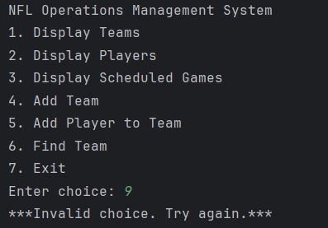

Display teams

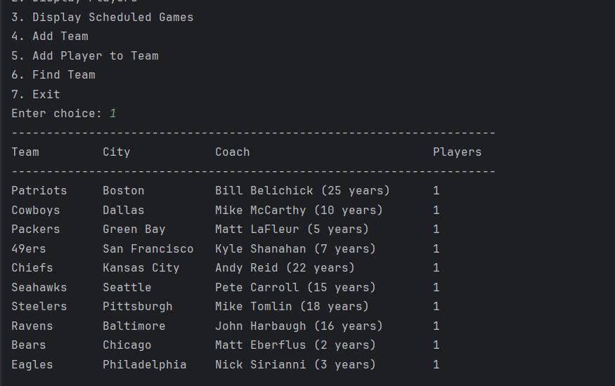

Display Players

Display schedule Games

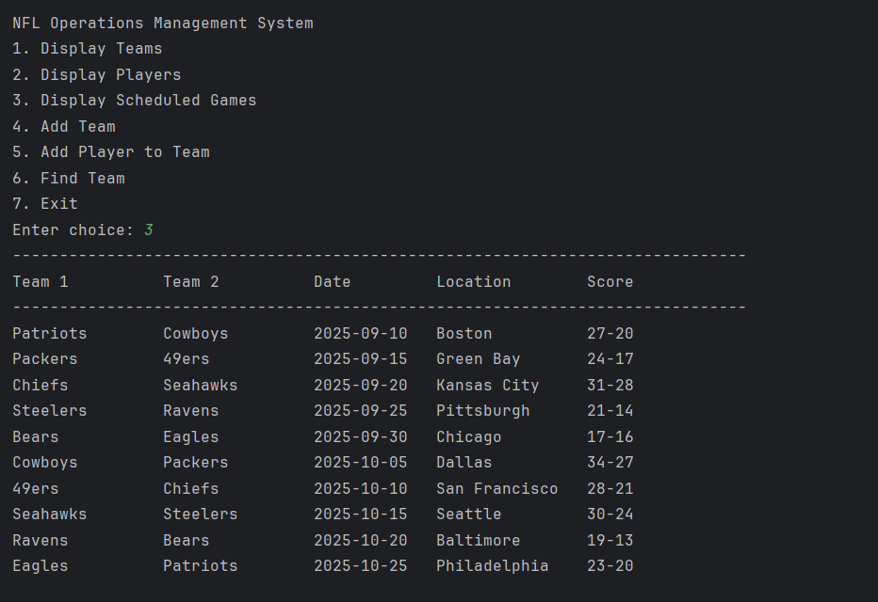

Adding Team

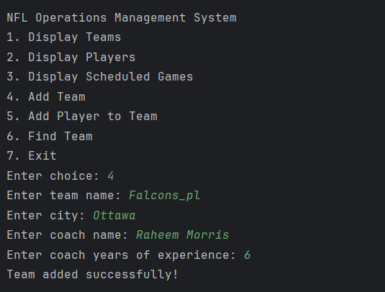

Add player

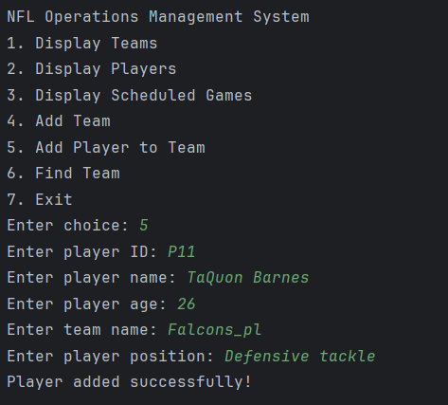

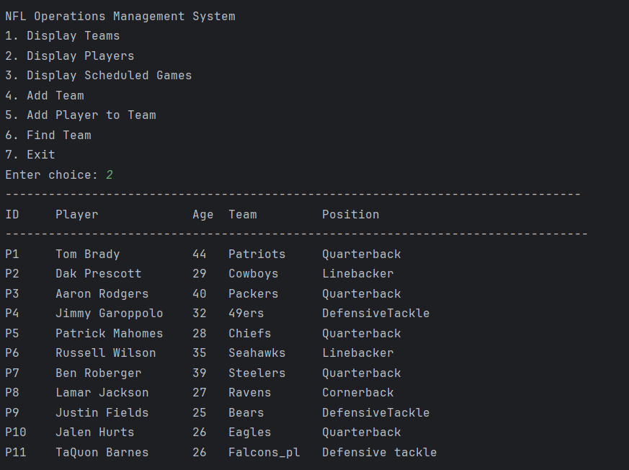

Finding the Team

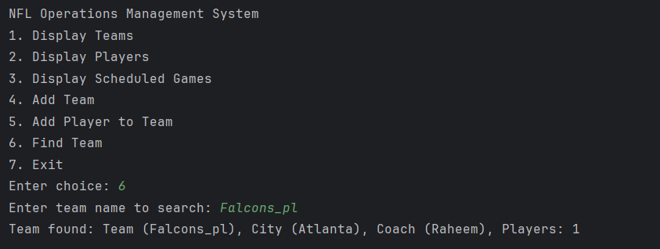

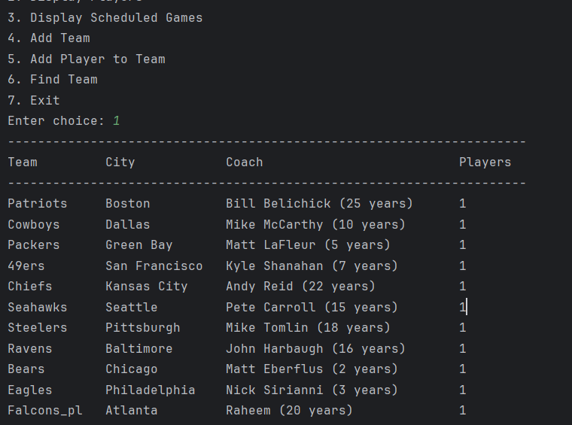

Exiting

