**Bug 1:**

If the player of the game happens to win on all the dice moves, he is only awarded once i.e. the player is only winning once at most.

The rolled dice values were not unique. The logic to get unique dice was changed so the list retains unique value by checking if the value is already present in the list.

**Bug 2:**

The code has a condition to quit the game but that never gets executed. The player has to play all the turns and is never allowed to quit the game.

Resolution:  
Player is given a change every time they initiate the game to quit so they don’t lose a lot.

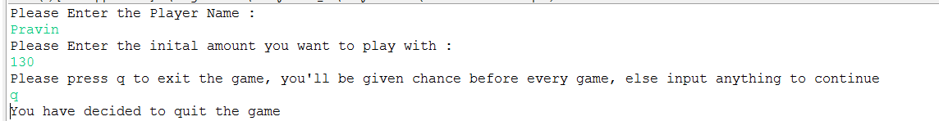

**Bug 4:**

Initial Player Name and balance are always the same.



Resolution:

Use Scanner API’s to get the input from the console. The logic Remains the same but by using the Scanner API’s player name and initial amount was changed.

Please Enter the Player Name :

Pravin

Please Enter the inital amount you want to play with :

150

Please press q to exit the game, you'll be given chance before every game, else input anything to continue

n

Start Game 0:

Pravin starts with balance 150, limit 0

Turn 1: Pravin bet 5 on ANCHOR

Rolled DIAMOND, HEART, CROWN

Pravin lost, balance now 145

**Bug:** Player Cannot reach the limit value

The Limit is not checked correctly. Modifying the condition in below code by adding equals take the limit to 0 for the player.

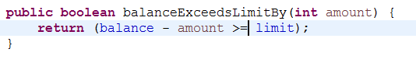

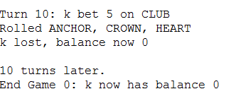

**Bug 0:** Game does not pay out at correct level. When player wins on 1 match, balance does not increase.

Initial bet value is reduced from the player and on the very first go.

