**Advance javascript For Front-end Introduction**

**And Code Quality**

**Q.1) Write a program to Show an alert**

**Ans)**

**<script>**

**function myFunction () {**

**alert("How are you?");**

**}**

**</script>**

**Q.2) What will be the result for these expressions?**

**1. 5 > 4**

**2. "apple" > "pineapple"**

**3. "2" > "12"**

**4. undefined == null**

**5. undefined === null**

**6. null == "\n0\n"**

**7. null === +"\n0\n"**

**Ans)**

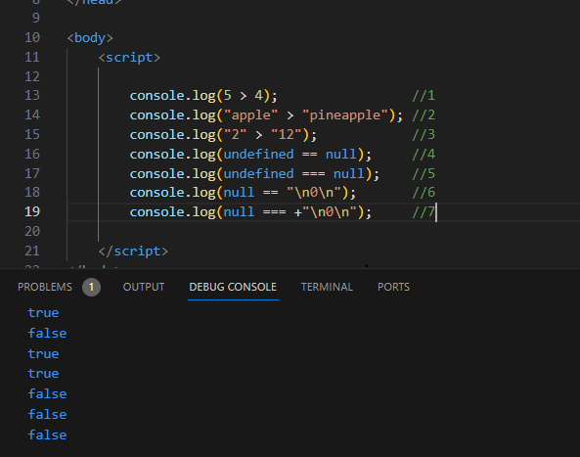

**Q.3) Will alert be shown?**

**if ("0") { alert( 'Hello'); }**

**Ans)**

=> Yes ,alert will be shown.

**Q.4) What is the code below going to output? alert( null || 2 || undefined );**

**Ans)**

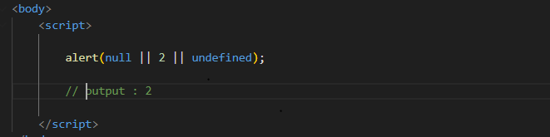

**Q.5) The following function returns true if the parameter age is greater than 18. Otherwise it asks for a confirmation and returns its result:**

**function checkAge(age)**

**{**

**else { }**

**}**

**if (age> 18)**

**{ return true; }**

**// ...return confirm (‘did parents allow you?');**

**Ans)**

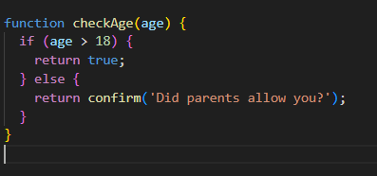

=>If the age is greater than 18, it returns true.

=>If the age is 18 or less, it prompts the user with a confirmation dialog asking whether their parents allowed them. If the user confirms, it returns true, otherwise, it returns false.

**Q.6) Replace Function Expressions with arrow functions in the code below:**

**Function**

**ask(question, yes, no)**

**{ if (confirm(question))yes(); else no();**

**}**

**ask("Do you agree?", function()**

**{ alert("You agreed."); },**

**function()**

**{ alert("You canceled the execution."); } }**

**Ans)**

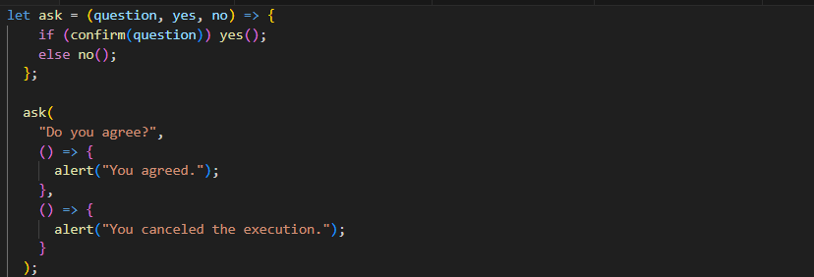

**Data type and Object**

**Q.7) Write the code, one line for each action:**

**a) Create an empty object user.**

**b) Add the property name with the value John.**

**c) Add the property surname with the value Smith.**

**d) Change the value of the name to Pete.**

**e) Remove the property name from the object.**

**Ans:-**

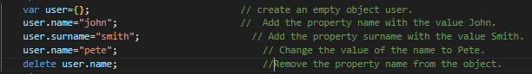

**Q.8)** **Map to names**

**let john = { name: "John", age: 25 };**

**let pete = { name: "Pete", age: 30 };**

**let mary = { name: "Mary", age: 28 };**

**let users = [ john, pete, mary ];**

**let names = /* ... your code */ alert( names ); // John, Pete, Mary**

**Ans)**

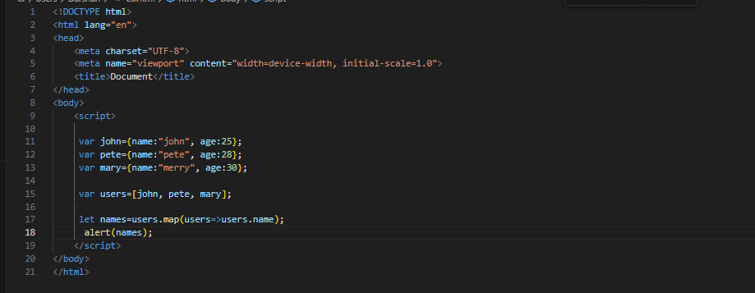

Q.9) **Map to objects**

**let john = { name: "John", surname: "Smith", id: 1 };**

**let pete = { name: "Pete", surname: "Hunt", id: 2 };**

**let mary = { name: "Mary", surname: "Key", id: 3 };**

**let users = [ john, pete, mary ];**

**let usersMapped = /* ... your code ... */ /* usersMapped = [ { fullName: "John Smith", id: 1 }, { fullName: "Pete Hunt", id: 2 }, { fullName: "Mary Key", id: 3 } ] */ alert( usersMapped[0].id ) // 1 alert( usersMapped[0].fullName ) // John Smith**

**Ans)**

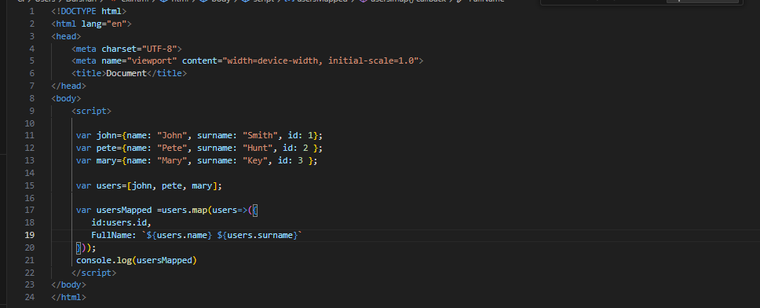

**Q.10)** **Sum the properties There is a salaries object with arbitrary number of salaries. Write the function sumSalaries(salaries) that returns the sum of all salaries using Object.values and the for..of loop.If salaries is empty, then the result must be 0.**

**let salaries = { "John": 100, "Pete": 300, "Mary": 250 };**

**alert( sumSalaries(salaries) ); // 650**

**Ans)**

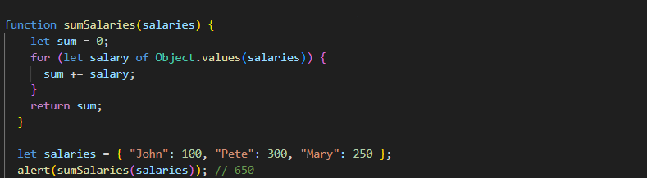

**Q.11)** **Destructuring assignment We have an object: Write the Destructuring assignment that reads:**

**a) Name property into the variable name.**

**b) Year’s property into the variable age.**

**c) isAdmin property into the variable isAdmin (false, if no such property)**

**d) let user = { name: "John", years: 30};**

**Ans)**

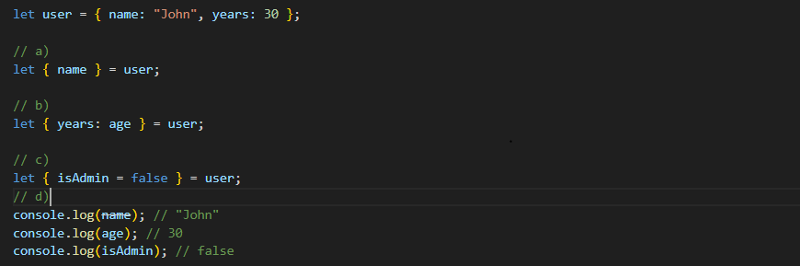

**Q.12)** **Turn the object into JSON and back Turn the user into JSON and then read it back into another variable.**

**user = { name: "John Smith", age: 35};**

**Ans)**

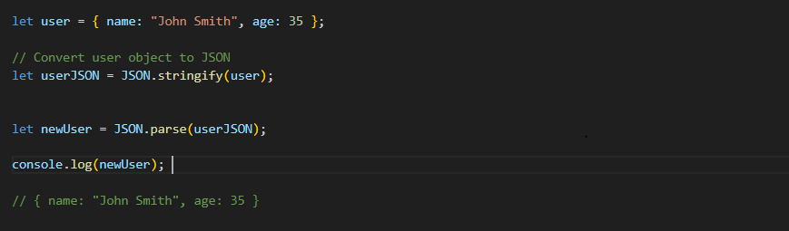

**Document, Event and Controls**

**Q.13)** **Create a program to hide/show the password.**

**Ans)**

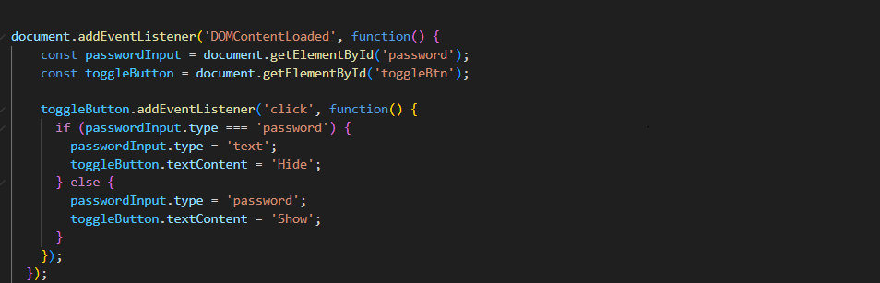

**Q.14)** **Create a program that will select all the classes and loop over and whenever i click the button the alert should show**

**Ans)**

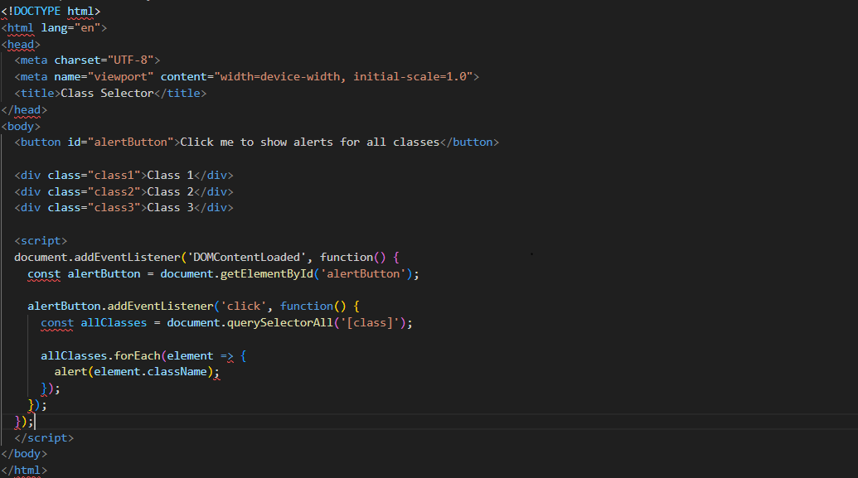

**Q.15)** **Create a responsive header using proper JavaScript**

**Ans)**

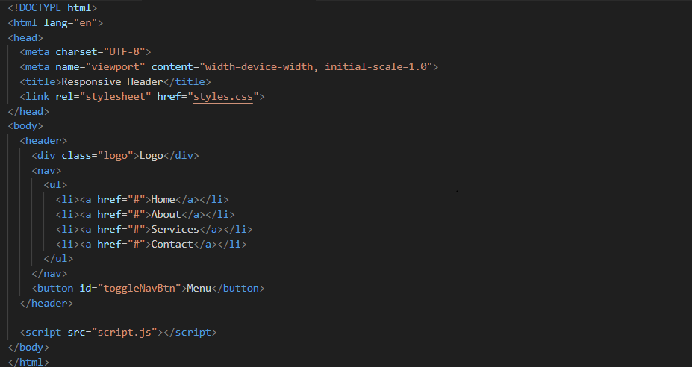

Styles.css:

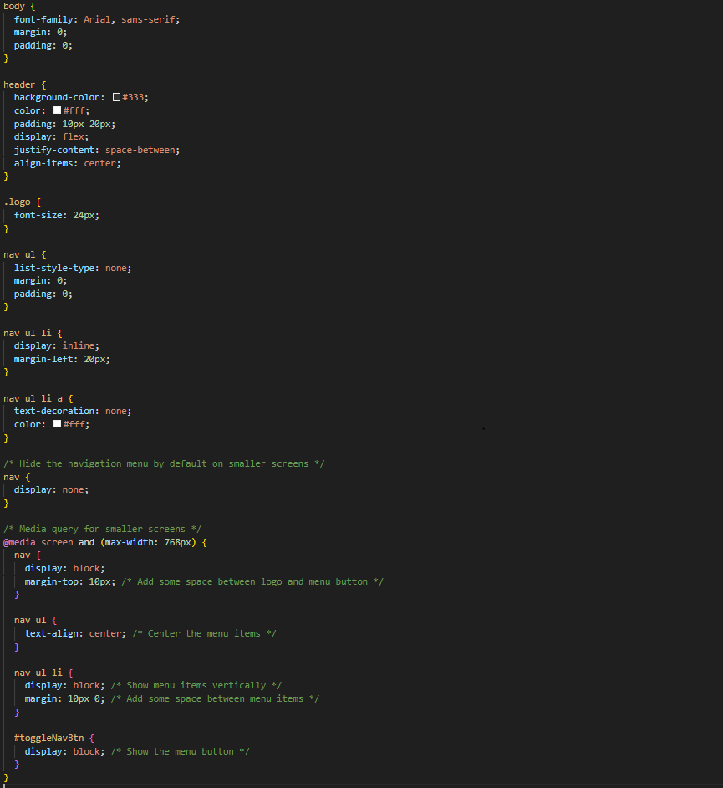

Script.js:

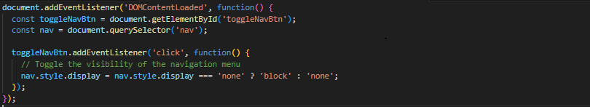

**Q.16) Create a form and validate using JavaScript**

**Ans:-**

**HTML:**

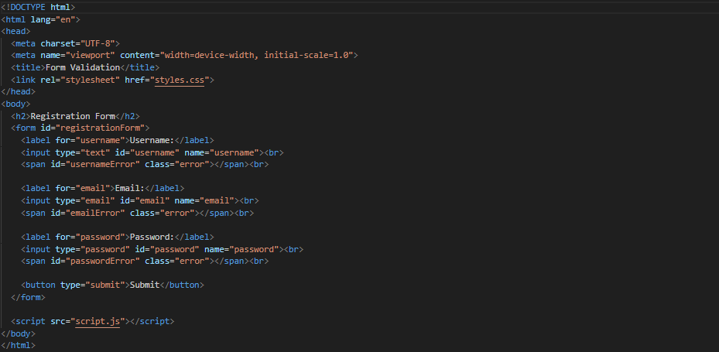

**Script.js**

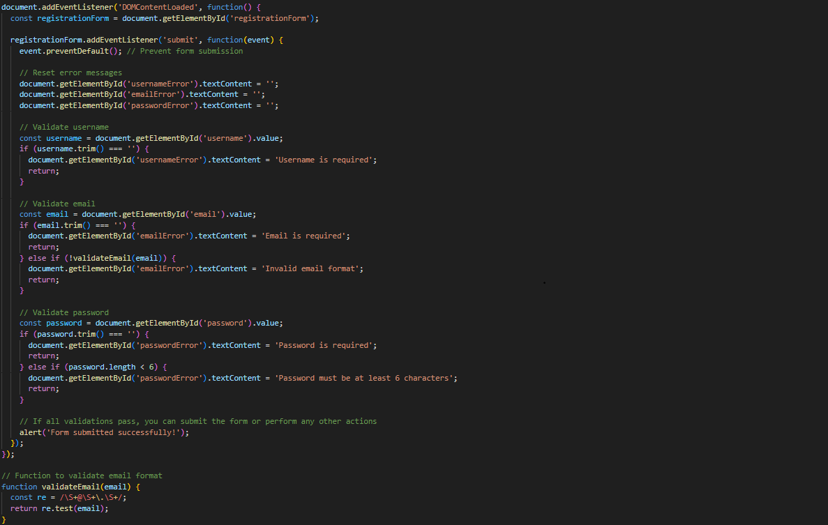

**Q.17) Create a modal box using css and Js with three buttons**

**Ans)**

**HTML:**

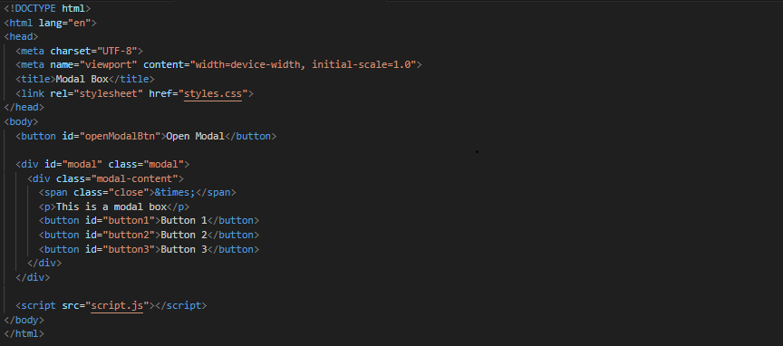

CSS:

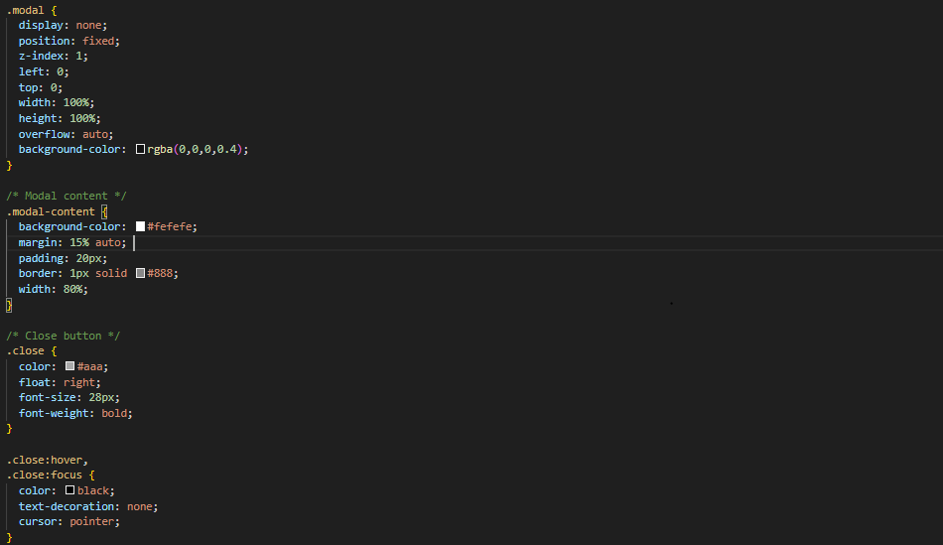

JS:

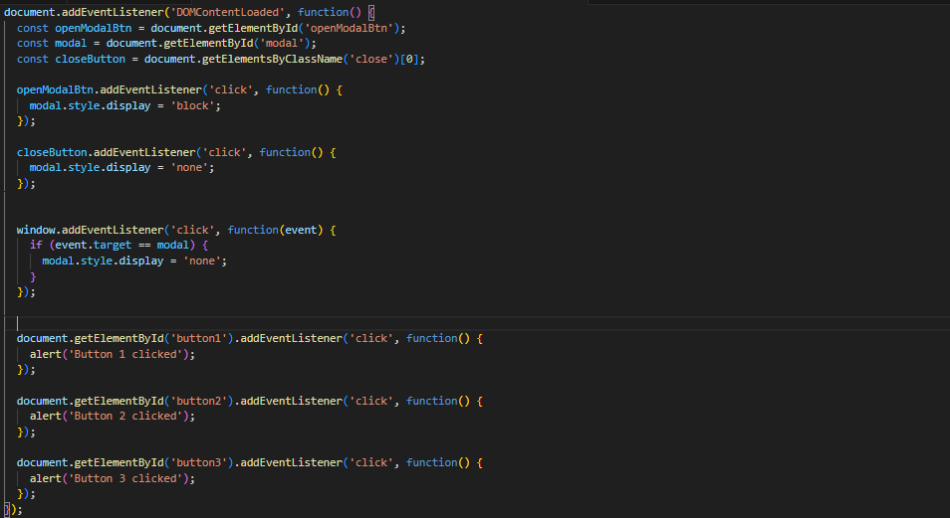

**Q.18) Use external js library to show slider**

**Ans)**

**HTML:**

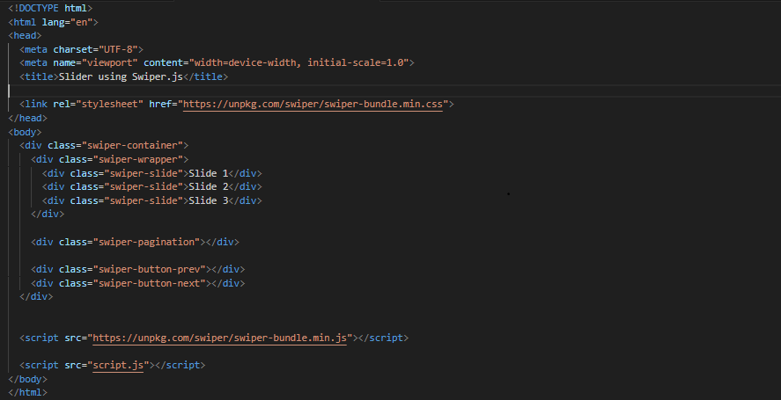

**JS:**

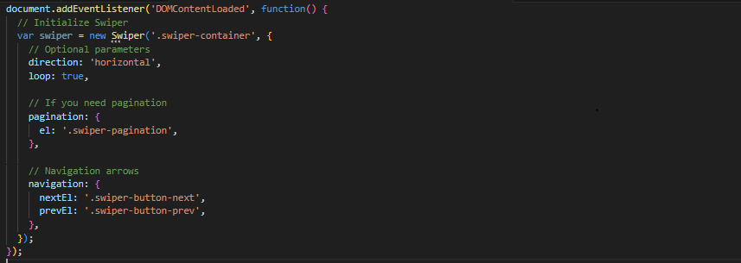

**Q.19)** **Prevent the browser when i click the form submit button**

**Ans)**

**HTML:**

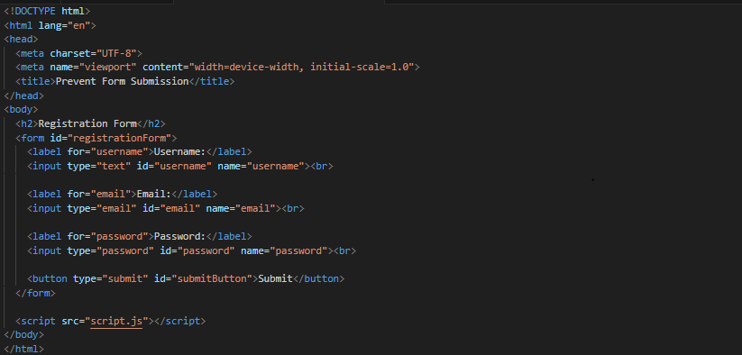

**JS:**

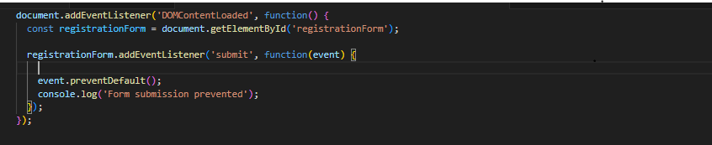

**New Request**

**Q.20)** **What is JSON**

**Ans)**

=>JSON is a JavaScript Object Notation.

=>JSON is often used for transmitting data between a server and a web application as it is a text-based format, making it ideal for data interchange.

=>JSON data is represented as key-value pairs and supports arrays and nested objects.

**=>Example**

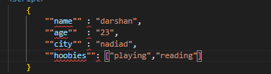

**Q.21) What is promises**

**Ans)**

=>Promises are a feature in JavaScript used for asynchronous programming.

=>They represent the eventual completion or failure of an asynchronous operation and its resulting value.

=>Promises provide a cleaner and more maintainable way to handle asynchronous operations compared to traditional callback functions.

**Q.22) Write a program of promises and handle that promises also**

**Ans)**

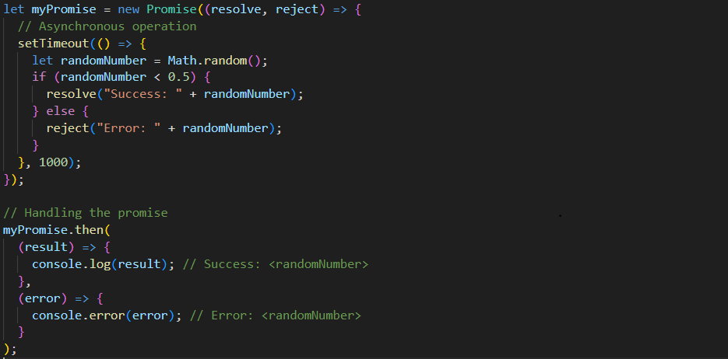

**Q.23) Use fetch method for calling an api** [**https://fakestoreapi.com/products**](https://fakestoreapi.com/products)

**Ans)**

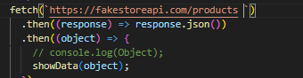

**Q.24) Display all the product from the api in your HTML page**

**Ans)**

**HTML:**

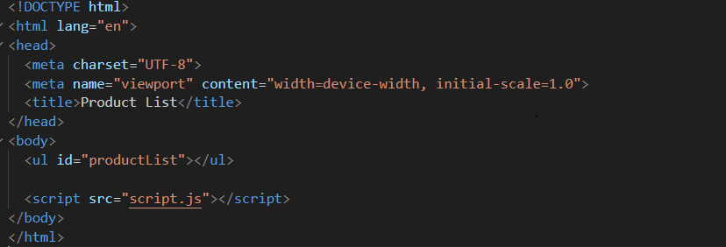

**JS:**

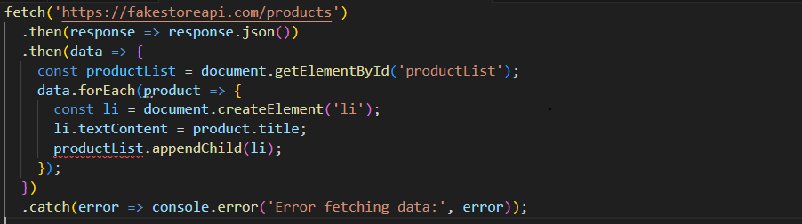

**JavaScript Essentials**

**Q.24) Calculate subtotal price of quantity in JavaScript?**

**Ans)**

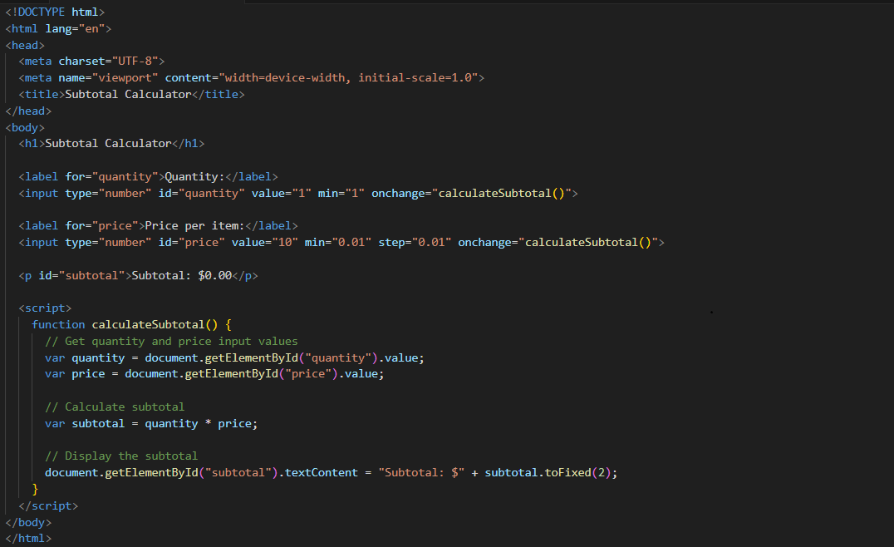

**Q.25) What is JavaScript Output method?**

**Ans)**

=>JavaScript provides several methods for outputting data to the user, depending on the context and environment.

=>Example

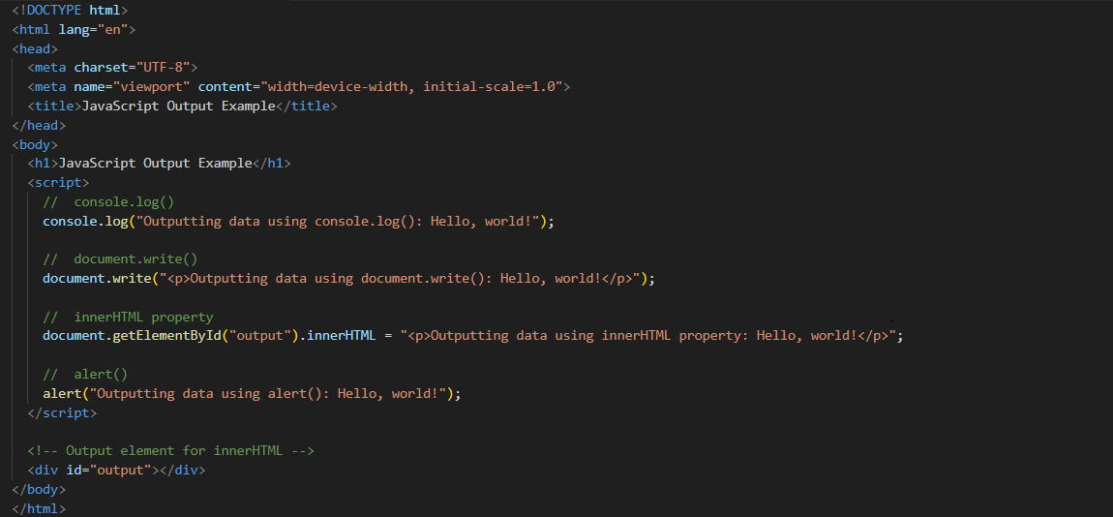

**Q.26) How to used JavaScript Output method?**

**Ans:-**

**=>Example**

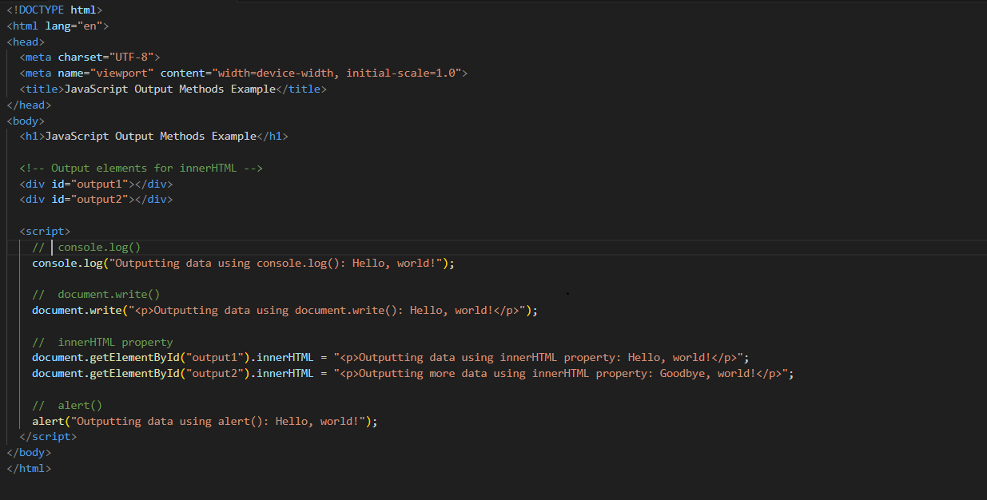

**Q.27) How to used JavaScript Events to do all examples?**

**Ans)**

**=>Example**

