# **ASSIGNMENT(HTML)-1**

**(Q-1) Are the html tags and the elements are same things?**

**Ans)** Html tags and the elements are not the same things. HTML tags holds the Html element and the Html elements are hold the contain.

Ex-<p>enter the name</p>

-Here <p></p> is the Html tags and the hole content is Html element.

**(Q-2) what are tags and attributes in Html?**

**Ans )** Html tags holds the element and Html attribute adjust the behaviour and display of the Html element.

Ex-Here the img src tag is known as a attribute.it is shown by arrow.

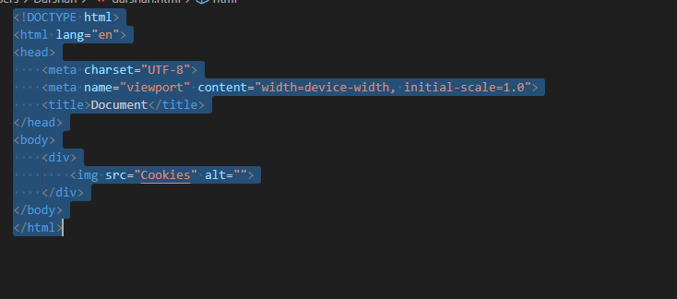

**(Q-3) What are void element in Html? With example.**

**Ans)** Those tag have start tag but not have end tag it is called void element. Ex-Here the img tag closing oint is not available.shown <img> 

**(Q-4) What are html entities? With example.**

**Ans)** A piece of text (“string”) that begins with an ampersand (&) and ends with a semicolon (;).

EX-Result-I, entity name: &iexcl; number code: &#160;

**(Q-5) What are the different types of list in HTML? With example.**

**Ans)** There are the three types of list;

(1) order list (OL)

(2) Under list (UL)

(3) Discription list (DL)

Ex-the following picture indicate the code .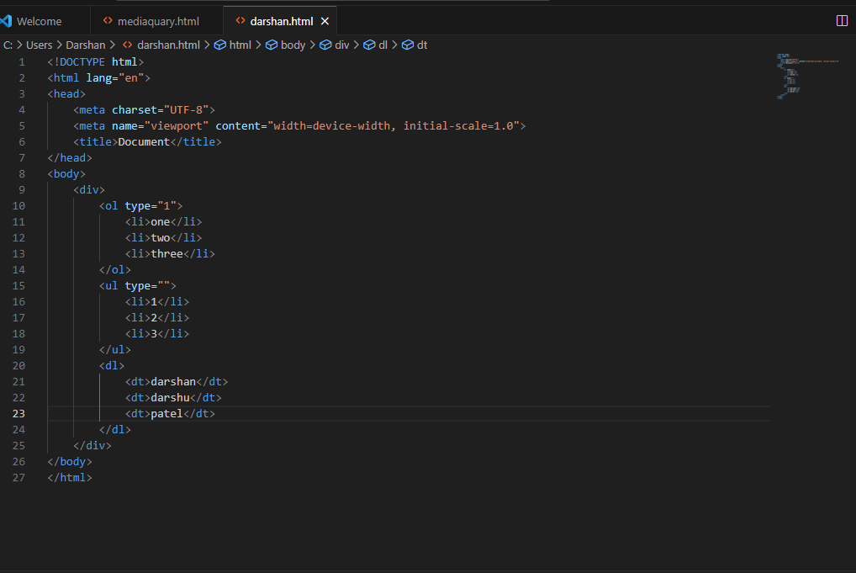

-And the output is shown below.

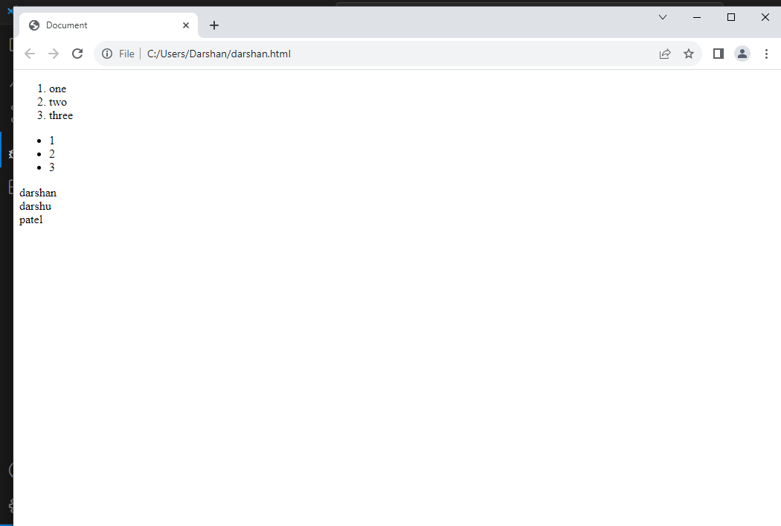

**(Q-6) What is the ‘class’ attribute in HTML? With example.**

**Ans)** A class attribute can be used by the multiple HTML elements.

The class attribute specifying one or more class name for an element.

Ex-here in the picture “ONE” is known as a class and its covers the one or more id like a (two 1,two2,,,etc)

-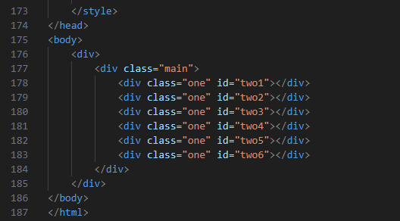

**(Q-7) What is the difference between the ‘id’ attribute and the ‘class’ attribute of HTML elements? With example.**

**Ans)** Class name is covers one or more HTML elements , while the id name is covers only one element within the page.

Ex-In the following picture (one) is indicate the class it is covers one or more HTML element like, two 1 ,two 2,two3,two4,two5,two6.

And the( two) is indicate the id its is shown in the below picture the id name covers only one element within the page.



**(Q-8) What are the various formatting tags in HTML?**

**Ans)** There are following formatting tags are shown below;

(1) Bold text <b>

(2) Strong text<strong>

(3) Italic text<i>

(4) Smaller text<small>

(5) Strike text<strike>

(6) Subscript text<subscript>

(7) Superscript text <superscript>

Ex-Below pictures are shown the code and it is effect. There are a formatting tags. 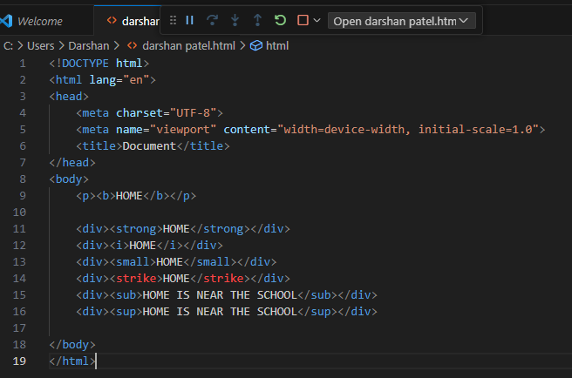

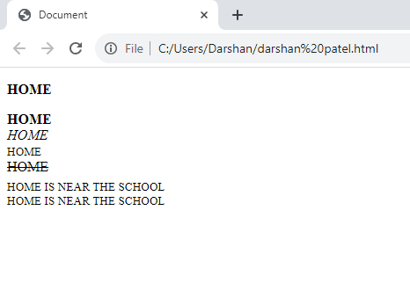

**(Q-9)How is cell padding different from cell spacing? With example.**

**Ans)** Cell padding to give space inner side of the cell. And cell spacing to give space outer side of the cell.

Ex-Below picture is shown the cell padding.

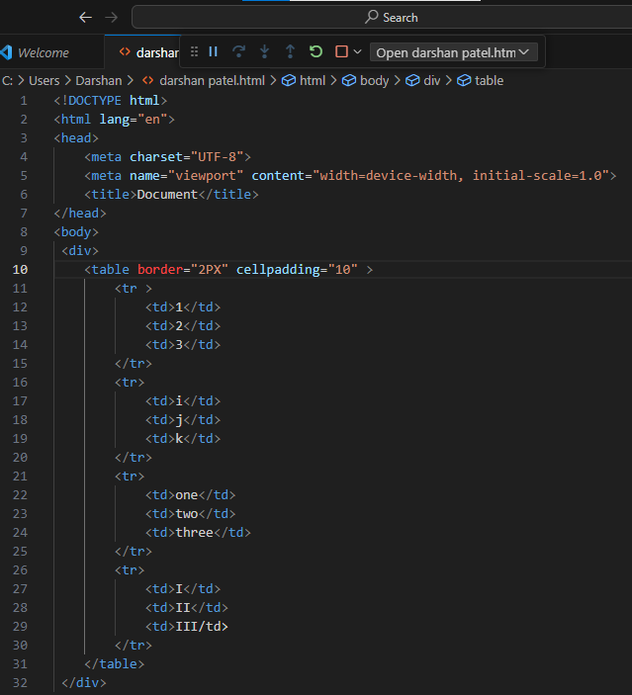

-And cell padding output shown below picture. The arrow indicate the cell padding is covers the inside space of cell.

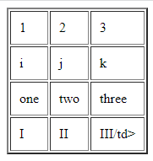

-Below the picture shown the properties of cell spacing.

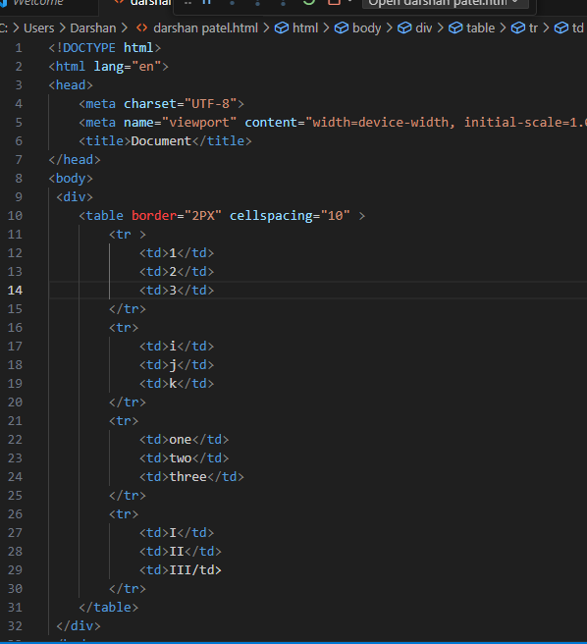

-And the cell spacing output shown below. And in the picture arrow indicate the cell spacing is giving to us outer side space of the cell.

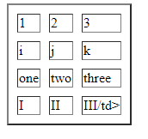

**(Q-10) How can we club two or more raw or columns into a single raw or column in HTML table? With example.**

**Ans)** We club two or more columns or raw applying the “**colspan**” or “**rawspan**” in the table.

Ex-below picture indicate the code of colspan it is suggest how to club the two or more column.

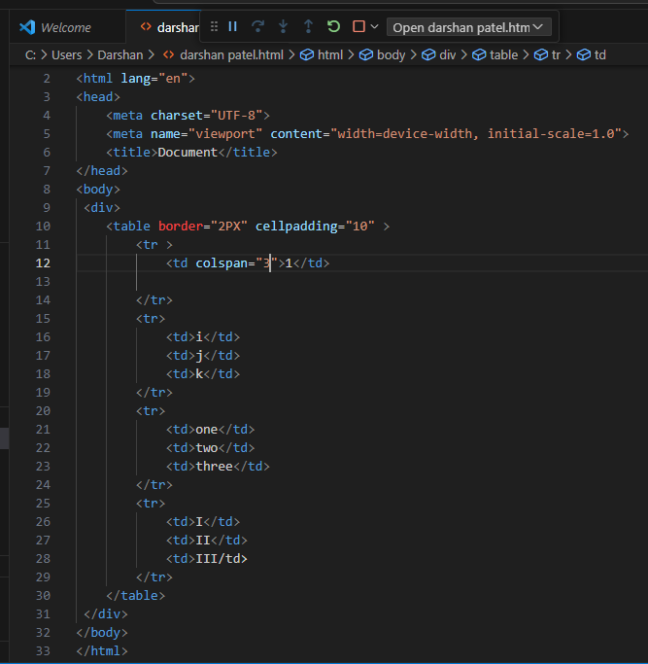

-In this picture the arrow indicate the property of the colspan.

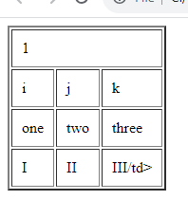

--Below picture indicate the code of rowspan it is suggest how to club the two or more column.

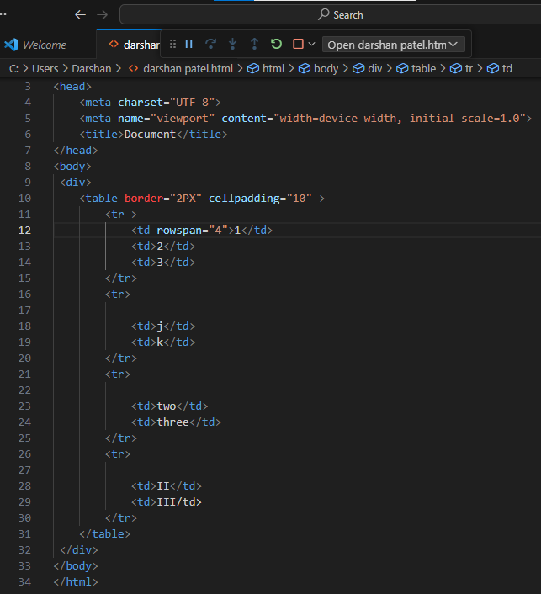

--In this picture the arrow indicate the property of the rawspan.

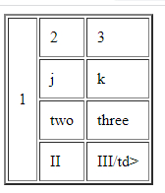

**(Q-11) What is difference between block-level element and an inline element?**

**Ans)** Those elements covers the 100% of the space of screen it is called “ Block element”.

-Those elements covers the required space of screen it is called “Inline element”.

EX-Block element (<div>, <p> ,<br>..etc)

Ex-Inline element ( <a> , <span> )

**(Q-12) How to create Hyperlink in HTML? With example.**

**Ans)** For creating the hyperlink we use the anchor tag.

Anchor tag is specially used for the users to allow “jump” from one section to another section on the same page.

Ex-The following picture is shown the tag which is use for the create hyperlink and this tag is indicate by the arrow.

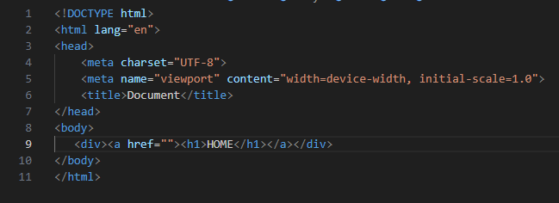

-And the shown below picture is indicate the hyperlink in HTML is created. It is recognize by the underline of the text and text color is purple when the link is actively. It is indicate by the arrow.

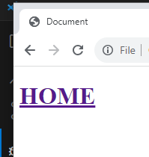

**(Q-13) What is the use of an iframe tag? With example.**

**Ans)** The most common use of iframe tag is to load content from another site within the page.

-Iframe best used to embed specific content one web page-like a form, document -within a different page.

Ex-Shown below picture is giving a code of iframe tag use,

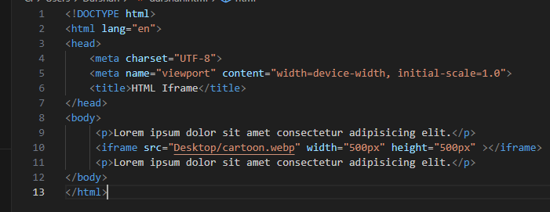

-And second picture is show the ouput it is suggest the benifits of iframe tag in HTML.

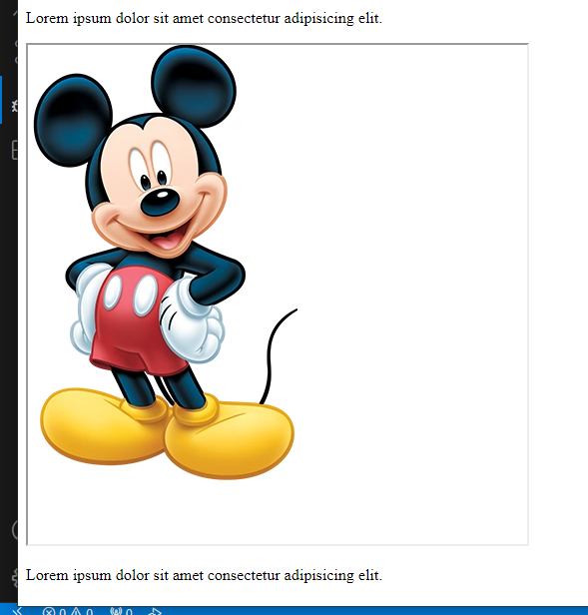

**(Q-14) What is the use of the span tag? Explain with example?**

**Ans)** when we required a some important words in to the whole paragraph , then we use a span tag. It is very useful for the show the some content is different for the whole text.

Ex- Below picture is show the code of the span tag.

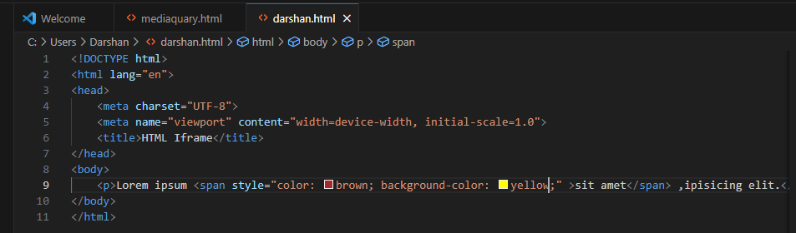

-And this following picture is indicate how to span tag is differentiate the word into the line. And the differentiate word is indicate by the arrow.

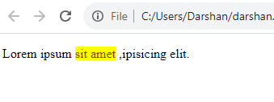

**(Q-15) How to insert a picture into a back ground image of a web page?**

**Ans)** The most common and easy way to insert a background image is using by the back ground image attribute inside the body tag.

Ex-This below picture is show the code of the insert the back ground image. 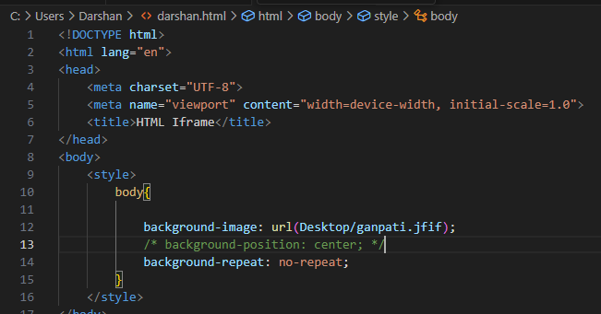

-And the second below pitcure is show the ouput of the back ground image.This back grond image indicate by arrow.

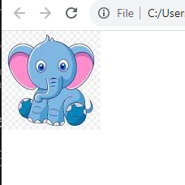

**(Q-16) How are active links different from normal link?**

**Ans)** An active link could refer to a hyperlimk that is currently functional and clickable.

-when we clicked on the link directs them to another web page.

-They are often highlighted through the underlining, color changes and other visual cause to indicate that they are clickable.

-**Normal link:** A normal link might refer to a hyperlink that is not currently clickable.

-It could indicate a link that is present in the content but does not lead to a valid destination.

-A normal link is not provide any interactivity or lead user to another page when clicked.

**(Q-17) What are the different tags to separate section of text?**

**Ans)** There following tags are used for the separate section of text.

1. <br>

2. <p>

3. <hr>

4. <blockquote>

5.<h>

-This tags are one way to separate section of text.

**(Q-18) What is SVG?**

**Ans)** SVG: Scalable vector graphic.

-The SVG file format is a popular tool for displaying two-dimensional graphics, charts, and illustration on website.

-The SVG images do not lose their quality when zoomed or resized.

-The can be created and edited with an text editor.

-SVG allows three type of graphic objects:

1.Vector graphics shapes

2.image

3.text.

-SVG is also good for accessibility and SEO.

-

**(Q-19) What is difference between HTML and XHTML?**

**Ans) HTML**

**-**HTML is an SGML based language. This is defines standard for generalizing the markup languages for documents.

-SGML (Stands for Standard Generalized Markup Languages)

-HTML is not case sensitive language.

-HTML empty elements do not require a closing tag at the end, not even a “/” symbol to signify the end of the tag.

**XHTML**

**-**XHTML is an XML based language, which means it manipulates and processes data using XML technologies.

-XTML is a case sensitive language.

-XHTML empty elements must have always be closed; there must be a “/” symbol at the end of the empty element.

- All XHTML elements and attributes must be in lowercase.

**(Q-20) What are logical and physical tags in HTML**

**Ans) Logical tag:**

-Logical tags are used in HTML to display the text according to the logical styles.

Ex- <del> this contains deleted content. </del>

**Physical tag:**

**-**Physical tags are used in HTML provide the physical strength to the text.

Ex- <b> I am darshu- This bold text</b>.

**(Q-21)TASK.**

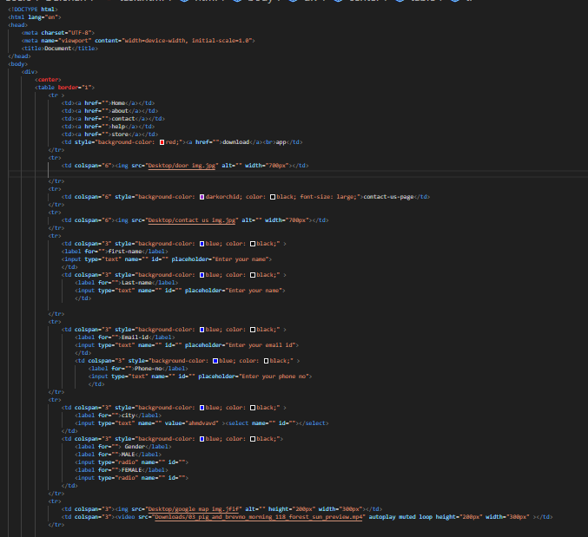

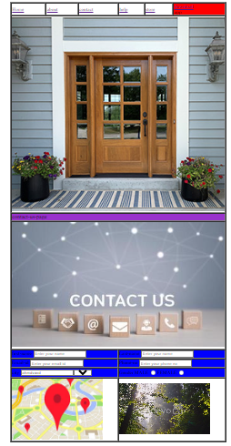

**Modual-1(HTML)**

**(Que) Do search for web site, http, URL ,etc given topics in lecture.**

**Ans)** **Web-site**:

-A web site is a collection of a files accessed through a web address, covering a particular theme or subject, and managed by a particular person or organization.

Ex-www.amazon.com is a web site.

**HTTP (Hypertext Transfer Protocol):**

**-**HTTP is a method for encoding and transporting information between a clinet and a web server.

-HTTP is the primary protocol for transmission of information across the internet.

**URL (Uniform Resource Locator):**

**-**URL is nothing more than the address of a given unique resource on the web.

-The URL path is the starting of information that comes after the top level domain name.

**(Que) Do search for domain, hosting, SEO etc.**

**Ans)** A domain is a group of connected windows computers that share user account information and a security policy.

* A domain controller manages the user account information for all domain members.

**Hosting:**

* When a hosting provider allocates space on a web server for a web site to store its files, they are hosting a website.

**SEO:**

-SEO full form is Search Engine Optimization.

- SEO is circular because it makes your web site more visible.