**­­­­­­­**

**Industry Internship report**

***Submitted in***

***partial fulfillment of requirement for the award of degree of***

**Bachelor of Technology**

**in**

**Electrical Engineering**

***by***

**Mr. Nikhil**

**Mr. Ketan Sharma**

***Industry / Organization Guide***

**Dr. Swapnil Khubalkar**

***at***

**Center of Excellence**

**Smart City & Intelligent Transportation**

***Institute Guide (from College)***

**Mrs. Prajakta Vaidya**

Asst. Professor



**Department of Electrical Engineering**

G H Raisoni College of Engineering, Nagpur

(An Autonomous Institute affiliated to Rashtrasant Tukadoji Maharaj Nagpur University, Nagpur)

Accredited by NAAC with “A++” Grade

Ranked 163th by NIRF, in the Engineering Category for India Ranking 2022,

**June 2023**

**Industry Internship report**

***Submitted in***

***partial fulfillment of requirement for the award of degree of***

**Bachelor of Technology**

**in**

**Electrical Engineering**

***by***

**Mr. Nikhil**

**Mr. Ketan Sharma**

***Industry / Organization Guide***

**Dr. Swapnil Khubalkar**

***at***

**Center of Excellence**

**Smart City & Intelligent Transportation**

***Institute Guide (from College)***

**Mrs. Prajakta Vaidya**

Asst. Professor



**Department of Electrical Engineering**

G H Raisoni College of Engineering, Nagpur

(An Autonomous Institute affiliated to Rashtrasant Tukadoji Maharaj Nagpur University, Nagpur)

Accredited by NAAC with “A++” Grade

Ranked 163th by NIRF, in the Engineering Category for India Ranking 2022,

**June 2023**

**Declaration**

We, hereby declare that the Industry Internship report submitted herein has been carried out by me/us in **Center of Excellence-Smart City & Intelligent Transportation** towards partial fulfillment of requirement for the award of Degree of **Bachelor of Technology** in **G H Raisoni College of Engineering, Nagpur**.The work is original and has not been submitted earlier as a whole or in part for the award of any degree / diploma at this or any other Institution / University.

We also hereby assign to G H Raisoni College of Engineering, Nagpur all rights under copyright that may exist in and to the above work and any revised or expanded derivatives works based on the work as mentioned. Other work copied from references, manuals etc. are disclaimed.

|  |  |  |  |
| --- | --- | --- | --- |
| **Name of student** | **Mobile No** | **Mail ID**  **(Other than Raisoni.net)** | **Signature** |
| Nikhil | 7488152219 | nikhilpd.99@gmail.com |  |
| Ketan Sharma | 6006024574 | ketansharma9114@gmail.com |  |

**Place Nagpur**

**Date**

**Certificate**

The Industry Internship Report entitled as “**IoT-Enabled BMS for Enhanced EV Performance”** carried out under our supervision in **Center of Excellence-Smart City & Intelligent Transportation** by **Mr. Nikhil, Mr. Ketan Sharma** for the award of Degree of Bachelor of Technology in Electrical Engineering. The work submitted is comprehensive, complete and fit for evaluation.

|  |  |
| --- | --- |
| **Dr. Swapnil Khubalkar**  **Industry / Organization Guide**  Assistant Professor  Department of Electrical Engineering  COE (Smart City)  G H R C E, Nagpur | **Mrs. Prajkata Vaidya**  **Instiute Guide**  Assistant Professor  Department of Electrical Engineering  G H R C E, Nagpur |

**Prof. Pankaj Ramtekkar** **Dr. Prema Daigavane**

**III Coordinator, Electrical Engineering Head**

Assistant Professor Department of Electrical Engineering

Department of Electrical Engineering G H R C E, Nagpur

G H R C E, Nagpur

|  |  |
| --- | --- |
| **Mr. Gurpal Singh**  **Dean III Cell**  G H R C E, Nagpur | **Dr. Sachin Untawale**  **Director**  G H R C E, Nagpur |









**ACKNOWLEDGEMENT**

We would like to convey our sincere gratitude and appreciation for the invaluable internship opportunity at the **Centre of Excellence in Smart City** and

**Intelligent Transportation**, Electrical Engineering Department, G H Raisoni College of

Engineering, Nagpur. It has been an enriching and transformative experience that has

greatly contributed to my personal and professional growth.

We are particularly grateful for the patience, encouragement, and mentorship provided by

**Dr. Swapnil Khubalkar**. He played a crucial role in guiding us, sharing knowledge, and

helping me navigate through challenges. We truly appreciate his dedication and the trust

he placed in us to contribute effectively to the organization.

We would also like to express our gratitude to our college guide **Prof.** **Prajakta Vaidya** for her support, collaboration, and willingness to share his expertise. Lastly, we would like to extend our appreciation to the entire Centre of Excellence, Electrical Department for fostering a culture of growth, innovation, and excellence. The values upheld by the

organization, such as integrity, teamwork, and commitment to delivering exceptional

results, have left a lasting impression on me.

Once again, thank you for the remarkable opportunity to be a part of the Centre of

Excellence, Electrical Department. We are truly honored to have been associated with

such an esteemed organization.

**ABSTRACT**

The study recommends using IoT techniques to monitor the performance of electric vehicle batteries, which is a major concern for battery manufacturers because the battery’s energy capacity decreases over time, resulting in reduced vehicle performance. The monitoring system is responsible for collecting data from various sensors installed in electric vehicles, such as voltage sensors, voltage sensors, and current sensors. This data is then sent to the system interface component, which runs the system and provides useful insight into the battery’s performance. Based on the test results, the IoT-based battery monitoring system can determine the performance of the battery, which leads to more movement. This early detection mechanism can help prevent potential damage and reduce treatment costs. Research shows the potential of IoT technology to improve the performance and safety of electric vehicles through real-time monitoring and early detection of battery-related problems.

**I**

**LIST OF FIGURES**

|  |  |  |
| --- | --- | --- |
| **Sr. No.** | **Caption** | **Page No.** |
|  |  |  |
| 1. | BMS Setup | 1 |
| 2. | BMS unit mounted on power train | 4 |
| 3. | Model Flowchart | 15 |
| 4. | Experimental Setup | 16 |
| 5. | Project Model Actuation | 17 |
| 6. | Code ss-1 | 18 |
| 7. | Code ss-2 | 19 |
| 8. | Code ss-3 | 19 |
| 9. | Code ss-4 | 20 |
| 10. | TP-4056 Battery Module | 21 |
| 11. | Battery Module Actuation | 22 |
| 12. | Node-MCU ESP-8266 | 23 |
| 13. | LiPo Battery | 24 |
| 14. | Serial Monitor Output | 26 |
| 15. | Battery Voltage Visualisation | 27 |
| 16. | Battery SOC Visualisation | 27 |
| 17. | V-SOC Correlation | 28 |
| 18. | Battery SOC Estimation | 28 |

II

**LIST OF TABLES**

|  |  |  |
| --- | --- | --- |
| **Sr. No.** | **Caption** | **Pg. No.** |
|  |  |  |
| 1. | Components | 21 |
| 2. | Battery Specifications | 24 |

III

**INDEX**

|  |  |  |
| --- | --- | --- |
| **Sr no.** | **Chapters** | **Pg No.** |
|  |  |  |
| 1. | Introduction | 1-4 |
| 2. | Literature Review | 5-14 |
| 3. | Modeling | 15-16 |
| 4. | Implementation | 17-20 |
| 5. | Components | 21-24 |
| 6. | Results and Observations | 25-28 |
| 7. | Conclusion | 29-31 |
| 8. | References | 32-33 |

**IV**

**CHAPTER 1**

**INTRODUCTION**

**INTRODUCTION**

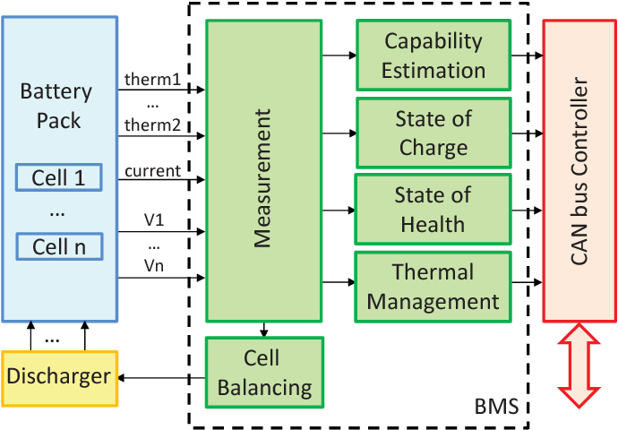Electric vehicles (EVs) are gradually taking the center-stage as gasoline prices soar, and an initiative to shift to green energy. As a result, manufacturers are looking for alternative energy sources to power the automobiles. Electric cars also provide a significant advantage in this regard, thereby reducing dependency on gasoline derived fuel and reducing carbon footprint. Battery capacity and composition limit the range of travel for EVs, which is one of the significant factors hindering their use. Hence, a robust battery monitoring system that alerts the operator about the battery status is critical for EVs’ safety. Previous battery monitoring systems could simply identify the status of the battery and warn the driver via the vehicle’s battery indicator. However, as notification system design advances, Internet of Things (IoT) technology is increasingly being used to notify manufacturers and users about battery status, forming a robust and efficient system that can be considered part of the manufacturer’s upkeep support routine. Over-the-air communication utilising frequency waves is referred to as wireless communication, and it encompasses all strategies and forms of connecting and communicating between two or more devices using wireless communication technologies and devices using a wireless signal. Previous study has identified ZigBee, GPRS, Android, WIFI, and Bluetooth as common wireless battery monitoring technologies. Furthermore, satellites are used by the Global Positioning System (GPS) to provide location and time data to GPS.

Fig.1.1 BMS setup

receivers all over the world. ZigBee/GPRS technology was previously utilised to monitor and manage an EV battery, but it has constraints such as baud rates and signal noise. In the era of the Internet of Things (IoT), where devices are interconnected and data flows seamlessly, the integration of IoT technologies into battery management systems (BMS) has emerged as a game-changer. An IoT-based

1

BMS brings forth a new paradigm in battery monitoring, control, and maintenance, revolutionizing how batteries are managed in various applications. This article delves into the unique aspects and advantages of an IoT-based battery management system, exploring its potential to optimize battery performance and propel the efficient use of energy storage.

The advent of the Internet of Things (IoT) has brought about a revolutionary transformation in the way we interact with and manage devices. One area where IoT has made significant advancements is in battery management systems (BMS). An IoT-based BMS harnesses the power of connectivity and data analytics to optimize battery performance, improve operational efficiency, and extend battery life. This introduction provides an overview of IoT-based battery management systems, highlighting their key features and advantages.

Battery management systems play a crucial role in monitoring and controlling the performance of batteries. Traditional BMS focuses on basic functions like voltage monitoring, temperature control, and state-of-charge estimation. However, as the complexity and demands of modern applications increase, there is a growing need for more advanced and intelligent battery management solutions.

The integration of IoT into BMS offers a paradigm shift in battery management. IoT-based BMS leverages interconnected devices, sensors, and cloud computing to enable real-time monitoring, data analytics, and remote control capabilities. This connectivity allows for seamless communication between batteries, sensors, and management systems, facilitating efficient and proactive battery management.

One of the key advantages of IoT-based BMS is real-time monitoring. By continuously collecting data on battery parameters such as voltage, current, temperature, and state of charge, IoT-based BMS provides real-time insights into battery health and performance. This enables early detection of anomalies, allowing for prompt actions and minimizing the risk of battery failures or degradation.

2

Data analytics is another critical aspect of IoT-based BMS. By leveraging advanced algorithms and machine learning techniques, the vast amounts of battery data collected can be analyzed to extract valuable insights. These insights can inform decision-making processes, optimize battery usage, and improve overall system efficiency.

Predictive maintenance is a powerful feature offered by IoT-based BMS. By analyzing historical and real-time data, the system can predict battery degradation and performance trends. This allows for proactive maintenance scheduling, reducing the risk of unexpected battery failures and optimizing maintenance costs.

Remote control and optimization capabilities are also inherent in IoT-based BMS. With connectivity at its core, IoT-based BMS enables remote access and control of battery parameters. This facilitates remote diagnostics, optimization of charging and discharging profiles, and efficient energy management.

The benefits of IoT-based BMS extend to various applications, including electric vehicles, renewable energy systems, and industrial equipment. In electric vehicles, IoT-based BMS can enhance range estimation, optimize charging infrastructure, and ensure safe operation. In renewable energy systems, it enables optimal energy storage and integration with the grid. In industrial equipment, IoT-based BMS enables proactive maintenance scheduling, energy optimization, and reduced downtime.

While IoT-based BMS offers immense potential, challenges such as data security, interoperability, and standardization need to be addressed. Furthermore, as IoT technologies continue to evolve, further advancements in battery management systems are expected, contributing to a more sustainable and connected future.

In conclusion, IoT-based battery management systems are transforming the way batteries are monitored, controlled, and maintained. With real-time monitoring, data analytics, and remote control capabilities, IoT-based BMS optimizes battery performance, enhances operational efficiency, and extends battery lifespan. As the IoT ecosystem evolves and the demand for smarter energy management solutions grows, IoT-based BMS will play a pivotal role in enabling a more sustainable and efficient energy landscape.

3

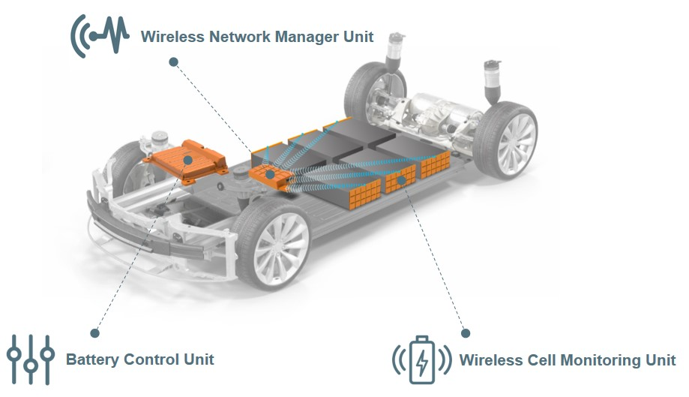The drawback of conventional battery monitoring system was the inability to track real time data . Consequently , the introduction of wireless technology remote monitoring of battery systems was essential. PLC based BMS is a different battery monitoring system that uses wireless communication that is designed for industries such as uninterruptible power supply (UPS), which is important to ensure power continuity for household and business customers during power supply . The ESP8266-based battery health monitoring system is designed for UPS and sends alarm signals to the SCADA module when the battery is in critical condition, the temperature is too high, or an anomaly is detected. This system can monitor the battery’s status, including voltage, current, and temperature, and detect low battery cells. The use of wireless communication is suggested for UPS battery monitoring. Previous studies have explored the use of ZigBee and GPRS communication and point-to-point wireless topology in electric cars. However, these methods have limitations such as low baud data rates, unstable networks, and range issues. It was concluded that robust battery management systems are crucial for electric cars to balance the charge and extend the battery life. Currently, there is no automatic control system to enhance battery performance, making the adoption of IoT technology in conjunction with a monitoring system critical for enhancing preventative maintenance, ensuring better battery quality, and overall safety.

Fig.1.2 BMS unit mounted on power train

4

**CHAPTER 2**

**LITERATUTE REVIEW**

**LITERATUTE REVIEW**

**Betala, Rachna, and Hari Kumar Naidu. ”A Review to Innovative a Green Electric Vehicle for Future.” In 2022 10th International Conference on Emerging Trends in Engineering and Technology-Signal and Information Processing (ICETET-SIP-22), pp. 01-06. IEEE, 2022.**

Electrical vehicle run by Renewable Energy sources is the future of transportation The review undertaken for the Green Electricity Generation revealed the various methods is the energy Generation from the movement of the plant using piezoelectric effect, Triboelectric Nano Generator, Artificial leaves, organic solar cell, Plant Microbial cell, and Glucose Biofuel Cell. This review paper has given an innovative idea to future Researchers to explore the possibility of using Electricity from Plants for charging an electric vehicle.

**Mohit Chaudhari, S.W. Khubalkar, Off-grid Hybrid Online Solar Power Conditioning Unit For Domestic Purposes, IEEE International Conference On Computing, Power And Communication Technologies GUCON 2019.**

The aim of the designed power conditioning unit is to eliminate the need of separate offline inverter, MPPT charge controller and online UPS for sensitive loads. Another feature of the designed system is to isolate critical load from noncritical load in order to improve the backup power with minimal battery banks. It includes grid charger, online inverter and MPPT charge controller all together in a compact size. It includes grid charger which allows wide range of input voltage fluctuations. The MPPT charge controller used is a PWM controlled DC-DC converter which extracts maximum possible power coming from sun. The system is controlled with DSPic controller which ensures remarkably quick operation and is economical to use in case of cost consideration.

5

**J.Mane, M.V.Aware, S.W.Khubalkar, MulticarrierMulti-Modulation Techniques in Multilevel Neutral Point Clamped Inverter Setup for Advanced Power Electronics and Drives Lab, The International Journal of Electrical Engineering & Education, April 2020**

A laboratory setup is developed to experimentally reinforce the student’s understanding of multilevel neutral point clamped inverter operated with various multicarrier and modulation reference signals. Sixteen combinations of carrier and reference signals out of many more possible are studied in this setup. The lab module is project-based and is designed to perform experiments for the ‘advanced power electronics and drives’ course at the undergraduate level. The hardware implementation details of the multilevel inverter are given in detail for reference to the teachers, students and researchers. Flexible hardware able to be driven by an analogue pulse-generation circuit is explained here or by an external digital programmable device is developed. With the help of dSPACE, complex reference signals are produced for performance analysis.

**Padwad, Dipali, and Hari Kumar Naidu. ”A Review of Electrical Boat Vehicle Solar Generation for Energy Sustainability and Development.” In 2022 10th International Conference on Emerging Trends in Engineering and Technology-Signal and Information Processing (ICETET-SIP-22), pp. 1-6. IEEE, 2022**

Growing concerns about air pollution effects on health, and weather change with an explosive hike in fuel prices in recent decades, we have to think about the use of another alternative like low carbon technology option means renewable energy. The increased demand for energy and the finite recourses of fossil fuel is shifting toward solar energy which is available abundant in nature and free of charge, ecological, and maintains environmental sustainability. This paper looks into and reviews the floating photovoltaic solar power plants installed worldwide and gives input to researchers to accept Floating Solar Power Plants technology to deal with the Energy Crises issue.

6

**M.Patil, K.Vadirajacharya, S.W. Khubalkar, Design of fractional order controllers using constrained optimization and reference tracking method, International Journal of Power Electronics and Drive Systems, Vol11, No1, March 2020.**

In recent times, fractional order controllers are gaining more interest. There are several fractional order controllers are available in literature. Still, tuning of these controllers is one of the main issues which the control community is facing. In this paper, online tuning of five dierent fractional order controllers is discussed viz. tilted proportional-integral-derivative (T-PID) controller, fractional order proportional-integral (FO-PI) controller, fractional order proportional-derivative (FO-PD) controller, fractional order proportional-integral-derivative (FO-PID) controller. A reference tracking method is proposed for tuning of fractional order controllers. First order with dead time (FOWDT) system is used to check feasibility of the control strategy.

**M.Patil, K. Vadirajacharya, and S.W. Khubalkar,”Design and tuning of digital fractional-order PID controller for permanent magnet DC motor.” IETE Journal of Research (2021): 1-11**

One of the central problems in control theory is related to the design of controllers for the improvement of system performance. The aim of this paper is to design an efficient digital fractional-order proportional-integral-derivative (FO-PID) controller for the speed control of buck converter fed permanent magnet DC (PMDC) motor. Speed control is achieved by a pulse width modulated control. The FO-PID controller parameters (gain and order) are obtained by using the ant colony optimization (ACO) technique. The effectiveness of the proposed control scheme is simulated and verified using MATLAB/Simulink results. The performance comparison shows that the speed control of buck converter fed PMDC motor is improved with proposed FO-PID controller than that of integer-order PID controller.

7

**Lanjewar, S.W. Khubalkar, and A.S. Junghare, “Comparative Analysis**

**of Two Loop Integerand Fractional Order PID Controller for Inverted**

**Pendulum,” ICSEDPS 2018, GHRCE, Nagpur, June 2018**

In this paper, a novel prototype laboratory is presented for engineering education, in which experiments are based on the fractional calculus. The prototypes of analog and digital fractional-order proportional-integral-derivative (PID) controllers are built in the laboratory. These fractional-order PID controllers are applied to linear and nonlinear plants to demonstrate the effectiveness of fractional-order calculus in real time. These experiments are designed, developed, and implemented on the analog and digital platforms. These controllers are integrated to control the DC motor, brushless DC motor, and magnetic levitation modules through hardware-in-loop as well as stand-alone systems. The analog type of fractional-order PID implementation is carried out by using passive components (i.e. resistances and capacitances) with an operational amplifier. This paper describes how the experiments on fractional calculus can be tailored for graduate, undergraduate students’ education and extended for research in this emerging area.

**Khandait, Rohit, Vasant Kumar, Vivek Bhurse, Vivek Tiwari, and Swapnil Khubalkar. ”Quadcopter Control using Different Controllers.” In 2022 International Conference on Intelligent Controller and Computing for Smart Power (ICICCSP), pp. 1-6. IEEE, 2022.**

This paper discusses implementation of the PD, PID, Fuzzy-PID controllers on quadcopter. Quadcopter have variety of applications in real. Generally, quadcopter are unstable system. To avoid any form of damage to the quadcopter, a quadcopter mathematical model should be built first, and then various control strategies can be employed. MATLAB/Simulink is used for modelling and control of the quadcopter. The primary goal of the study is to obtain intended result from that of intended input. Finally, simulation outcomes were compared on the basis of settling time, overshoots and undershoots to see which controller is the most effective for the quadcopter. The effectiveness of the best controller is verified through MATLAB/Simulink.

8

**Raut, Sonu, Prema Daigavane, and M. B. Shaikh. ”Test Bench of Automotive Component of an Electric Vehicle for Electrical Parameter Measurement.” In Innovations in Electrical and Electronic Engineering: Proceedings of ICEEE 2020, pp. 479-488. Springer Singapore, 2021.**

In this paper, a novel and economical test bench of automotive component of an electric vehicle (EV) has been developed to measure the electrical parameters. This test bench provides the flexible testing and monitoring system to ensure the quality and traceability on the production line. This paper briefly describes the hardware and software implementation of the test bench. The automotive component is subjected to different electrical parameters tests such as low voltage short circuit test, high voltage insulation test and low voltage connection test. The tests parameters are displayed on supervisory control and data acquisition (SCADA) and human–machine interface (HMI) screen.

**Baghmare, Kundan, and P. M. Daigavane. ”Supercapacitor based Controller for electric vehicle to Grid Power.” In 2021 Second International Conference on Electronics and Sustainable Communication Systems (ICESC), pp. 1-8. IEEE, 2021.**

The goal of this work is to introduce a novel machine learning based battery degradation control strategy to avert the rapid capacity loss of battery packs bearing in mind of vehicle performance. The proposed closed-loop control strategy is developed by evaluating different regression models using generated dataset, based on work related to data-driven power management strategy and controlling battery current limit values. From the comparison, it is observed that Gaussian process regression shows better precision over other regression models. The simulation outputs prove the ability of the proposed strategy to extend the electric vehicle battery life by 2.03% over 200,000km. This work can be extended by using deep learning based models and more charge and discharge profiles.

9

**Ramtekkar, Pankaj, Harikumar Naidu, and Suraj Dudhe. ”An Innovative Safe Electrical Vehicle using Fuzzy Logic based Voice Control Device.” In 2022 10th International Conference on Emerging Trends in Engineering and Technology-Signal and Information Processing (ICETET-SIP22), pp. 01-04. IEEE, 2022.**

A fuzzy logic based Voice controlling devices like Alexa, Google Home, Seri etc application methods are introduced in this paper to drive the Electric vehicle. The innovative application of this voice control technology is useful for Leg and arm physically Challenged people due to disability and also to the Elderly who are not able to drive the vehicle due to age related diseases since their arm and leg becomes physically unfit. The prototype Electric Vehicle was developed as per the scheme proposed in this paper and was tested which gave satisfactory operational result with the voice control.

**Sushrut Deshmukh, S.W. Khubalkar, Designing of Control Strategy for High Voltage Battery Isolation in an Electric Vehicles, IEEE International Conference on Convergence in Technology, I2CT, Pune, 29-31 March 2019.**

In recent year there are numerous developments ongoing in Electric Vehicle industries. Because of increasing fuel prices and pollution, there are many factors to be considered in a performance of an electric vehicles. One among them is safety factor. In an electric vehicle high voltage batteries were used for the motor operation. So there must be a proper isolation between its high voltage battery terminals and also battery pack with respective to chassis of the vehicle. So in order to overcome this issue a control technique is proposed in this paper for the isolation measurement of battery terminals. It monitors proper isolation check at initial stage that is before starting the vehicle and also during the continuous working. This control strategy ensures the proper stability and allows decoupling the system avoiding that the disturbances affect the battery terminal isolation and operation of on-board charger.

10

**IoT based Lithium-Ion Battery Monitoring System in Electric Vehicle V. G, Aruna N, Janadharani S, Varshini N D Engineering 2023 Third International Conference on Artificial Intelligence and Smart Energy (ICAIS) 2023**

A system to monitor and examine the parameters such as temperature, voltage, current, charge and discharge cycle of Lithium-ion battery is developed. Frequent monitoring and a way to manage the battery temperature is necessary to improve battery performance in electric vehicles. The performance characteristics of the batteries, being the vehicle’s primary power source determines the lifecycle, safety and mileage of an electric vehicle. The system consists of a microcontroller-based circuit, with solid state components for handling sensors, data communication module which is based on IOT protocol. The battery monitoring and management system is constructed with a liquid cooling system in which a coolant tube is inserted between battery cells to cool them when they are overheated. The system is installed in electric vehicles and by measuring above parameters it will help the users to optimally utilize battery and identify problems before any failure. Here the information of abnormality is sent to the user mobile phone through the IoT.

**Qing Xie, Siyu Yue and Massoud pedram, ”Adaptive Thermal Management for portable system Batteries by Forced Convection Cooling”, Design Automation Test in Europe Conference Exhibition, pp. 978- 981, 2013.**

This paper presents an efficient temperature dependent hot carrier injection reliability simulation flow which is scalable. The flow makes use of some efficient techniques at different design hierarchical levels to enable full chip simulation with a fast run time and high enough accuracy. While the transistor-level HCI effect is modeled based on the conventional reaction–diffusion (R–D) framework, the gate-level characterization method combines HSpice simulation and piecewise linear curve fitting to model the impact of HCI effect over the time. Also, as one of the ways to improve the speed of the simulation, only the NMOS transistors, which suffer much more from the HCI effect, are considered in the modeling.

11

The proposed method reduces the simulation time without losing much of accuracy. Also, due to the considerable impact of the temperature on the reliability, at all levels of the proposed simulation flow, the impact of the temperature on the impact of the HCI phenomena is modeled. The simulations performed on some benchmarks reveal that the proposed circuit-level HCI modeling is able to reduce the runtime of calculating the threshold voltage and mobility drifts of the gates significantly without sacrificing accuracy unacceptably. Also, the circuit-level simulations indicate an about 19% increase in the average of the HCI-induced delay degradation of the benchmarks when the temperature rises from 20 °C to 100 °C.

**Siddhesh Adavade, Rohit Shirudkar, Abhishek Jamnare, Nikhil Shirsath and Nikhil Abraham, ”Lithium -ion Battery Chemistries Battery cooling system”, International Research Journal of Engineering and Technology, vol. 8, no. 2, pp. 402-406, 2021.**

Lithium-ion battery pack technology is the current trend in the automotive industry. For this study, we compared the different materials and systems available, according to the working conditions of automobiles in India, where aspects like operating temperatures, fuel efficiency, cost-effectiveness, charging capabilities and ease of maintenance were the prime factors taken into consideration. The study has been divided into two parts i.e. battery chemistries, thermal management systems. The principle commitment of this work lies in the similar investigation of these frameworks, to choose a particular setup for the utilization of small commercial vehicles like farm haulers, pickup trucks and ATV's. This study shall help anyone interested in using Lithium-ion technology for their projects and wants to understand different chemistries and ways to manage their temperature which affect the selection procedure depending upon the application of the user

12

**Aniket Rameshwar Gade, The New Battery Management System in Electric Vehicle, International Journal of Engineering Research Technology, vol. 10, no. 7, pp. 402-405, 2021**

In electric vehicles, batteries are the primary source of power. The battery we use in electric vehicles are not that efficient and requires charging after few miles. So here is the idea of New battery management system. This study presents a comprehensive overview of this relatively revolutionary and gratifying solution for battery difficulties in electric vehicles, as well as an in-depth investigation of it. In this new battery management system, we divide the battery in two half. One half is for charging and the other half is for discharging. For charging, we use renewable energy sources such as solar panels, regenerative braking, regenerative suspension, and so on. While one half is charging, the other half is discharging simultaneously. When the other half is discharged completely, we use the charged portion of the battery, and a discharged portion is kept for charging.

**R. Cecchini, G. Pelosi IEEE Antennas Propag. Mag., 34 (1992), pp. 30-37**

In this paper, the recent progress on sinuous antennas is detailed, focusing the attention on the antenna geometry, dielectric structure, and miniaturization techniques. In the first part, we introduce the basic principles of the frequency-independent antenna, in particular the self-complementary and log-periodic geometries, as well as the antenna geometries, all characterized in terms of angles. The operating principles, main advantages, system design considerations, limits, and challenges of conventional sinuous antennas are illustrated. Second, we describe some technical solutions aimed to ensure the optimal trade-off between antenna size and radiation behavior. To this aim, some special modification of the antenna geometry based on the meandering as well as on the loading with dielectric structures are presented. Moreover, the cavity backing technique is explained in detail as a method to achieve unidirectional radiation. Third, we present a new class of supershaped sinuous antenna based on a suitable merge of the 2D superformula and the sinuous curve.

13

**FirouzY. et al. Block-oriented system identification for nonlinear modeling of all-solid-state Li-ion battery technology J. Energy Storage (2020)**

The high energy density characteristic of the all-solid-state battery technology makes it one of the promising competitors of current liquid electrolyte-based lithium-ion batteries. However, due to the low ionic conductivity of solid materials and existing issues in active material-solid electrolyte interfaces, all-solid-state batteries show strong nonlinear behavior when the amplitude of input current is relatively high. In this paper, we have developed a methodology based on block-oriented nonlinear systems that can detect, quantize, and model the battery behavior, accurately. For this purpose, two solid-state coin cells, which have different ionic conductivity at the cathode interface are manufactured and excited with multisine input current. The Best Linear Approximation (BLA) method has been used to separate linear frequency response function (FRF) from nonlinear distortion. Then, a Hammerstein-Wiener system has been developed and parametrized to model the nonlinear distortions caused by ionic conductivity variation of the solid electrolyte at the cathode layer. Furthermore, the developed model has been utilized to detect possible faults in the electrode-electrolyte interface based on the nonlinearity level of the measured voltage.

14

**CHAPTER 3**

**MODELING**

**MODELING**

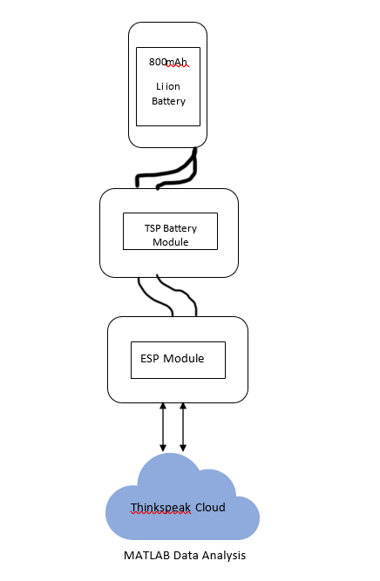It is widely recognized that the battery is the most critical component of any device since it powers the entire system. Therefore, monitoring the battery voltage level is essential as incorrect charging or discharging can lead to battery damage or system failure. Most electronic devices have a Battery Management System (BMS) that monitors all battery characteristics, including voltage, current, temperature, and automatic shutdown systems. This ensures the safety and proper functioning of lithium-ion or lithium-polymer batteries. Previously, BMS only monitored the battery status and warned the user via the battery indicator. However, with the emergence of the Internet of Things, users can now be remotely notified of any issues with the battery. An IoT-based charging control system is now available for all types of electric cars. Once the charging process is confirmed, the vehicle will adjust its charging parameters based on various factors such as battery condition, power limits, and desired travel times. These parameters are then sent to the backend, which manages the distribution of charging stations and generates optimal charging profiles based on the guidelines provided by manufacturers. The vehicle can then choose a charging profile and communicate it to the charging station. The EV charge controller

Fig 3.1 Model Flowchart

15

sets the minimum and maximum values of the current that can be supplied. During the charging process, Power Electronics provides information about its status such as measured current, voltage, and insulation conditions. After the pre-charge phase, the vehicle establishes a connection between the electronics and the battery, and the actual energy transfer takes place. The communication control continuously transmits necessary values to the electronics and provides feedback on the current state of the vehicle until the battery is fully charged or until the user or backend stops the charging process.

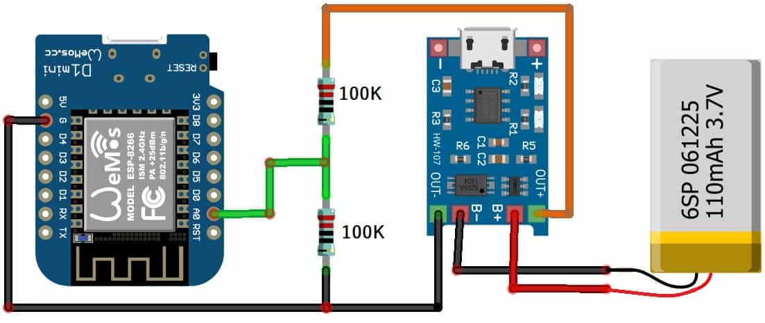

Fig 3.2 Experimental setup

16

**CHAPTER 4**

**IMPLEMENTATION**

**IMPLEMENTATION**

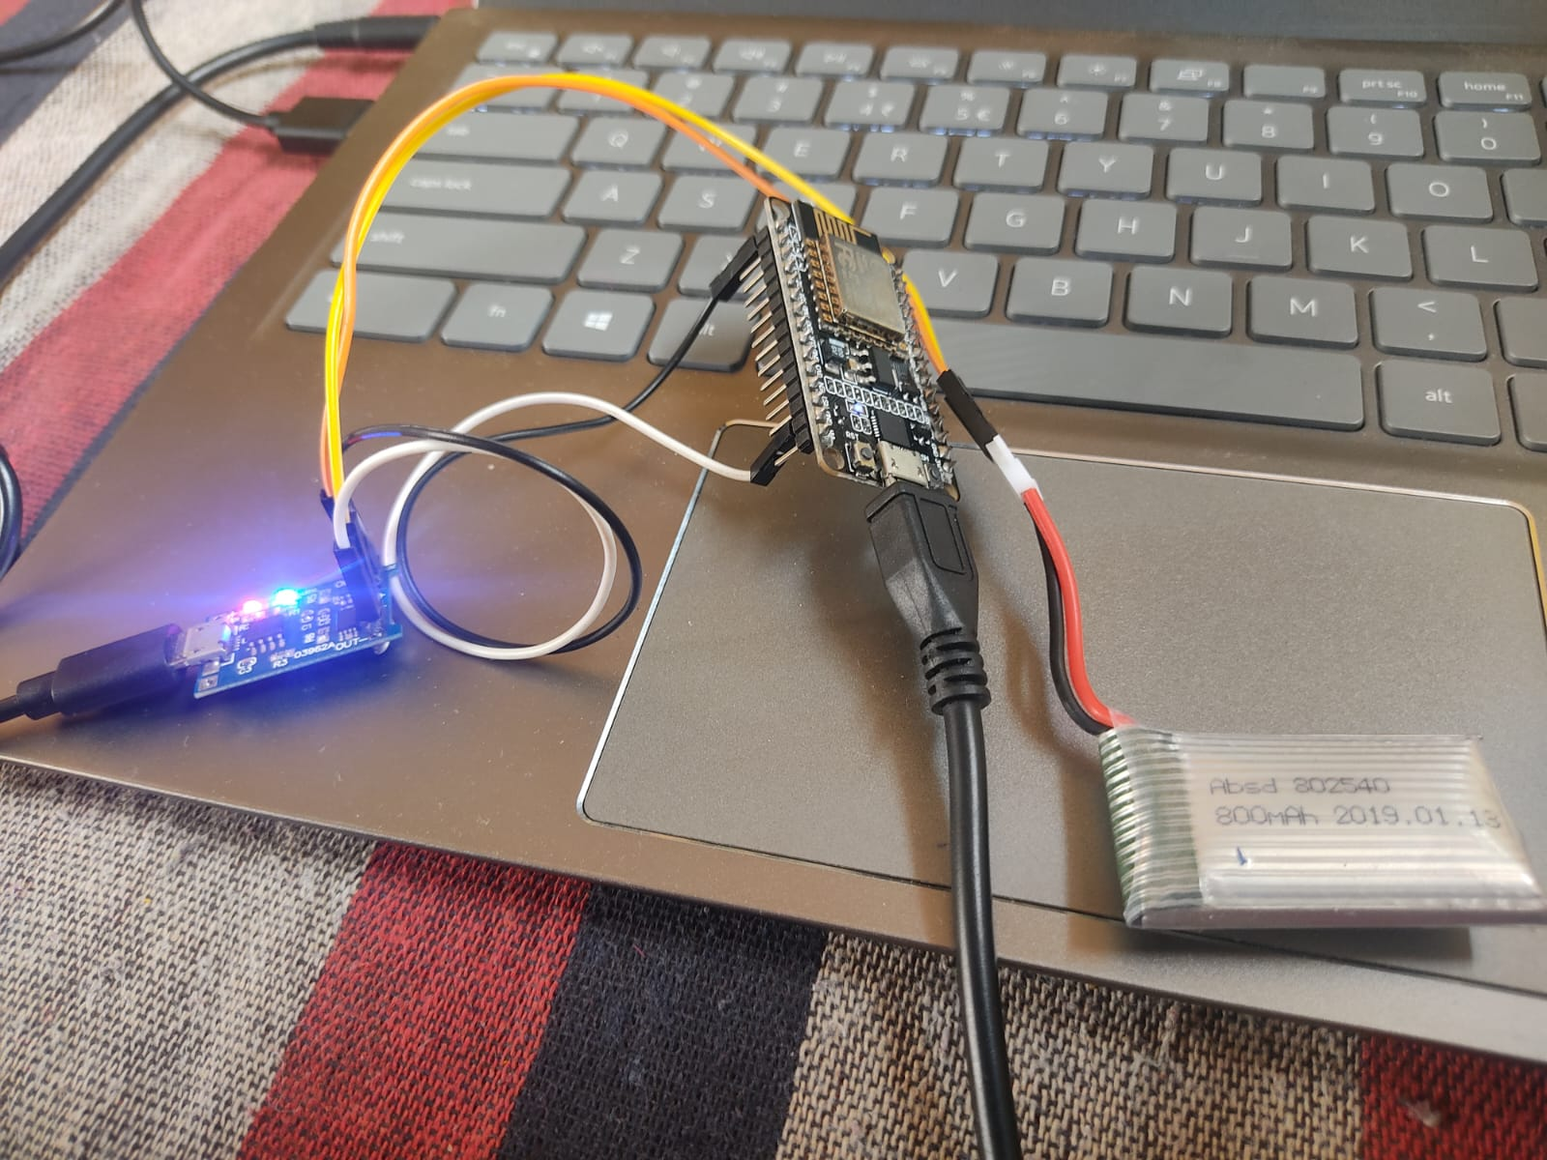We have developed a reliable battery monitoring system using IoT and ESP8266, which enables monitoring of the battery’s charging/discharging status, as well as its voltage and percentage. The system utilizes the Wemos D1 Mini equipped with an ESP8266 chip to transmit the battery status information to the ThingSpeak cloud platform. The battery voltage and percentage are displayed on ThingSpeak during both charging and discharging. Statistical analysis of the voltage and state of charge (SoC) is conducted, and the results are graphically presented over a range of time periods. Additionally, the correlation between these two parameters is examined to provide further insights. The TP4056 module is a linear charger designed for charging lithium-ion batteries, including batteries made up of individual cells. It supports both constant current and constant voltage charging modes, giving users the flexibility to choose the most suitable mode. The module provides a charging current of up to 1 amp, making it a powerful charging option. Some of the key features and specifications of the TP4056 module include over-protection, the ability to control or adjust output charge current through a resistor, a generic Micro USB female connector, a battery charging LED indicator, an LED charge indicator for fully charged batteries, automatic disconnection of the battery from the charging circuit when fully charged, fast charging capability, the ability to charge any size of 3.7V Li-ion cell, and internal battery temperature measurement to prevent charging when the

Fig 4.1 Project Model Actuation

17

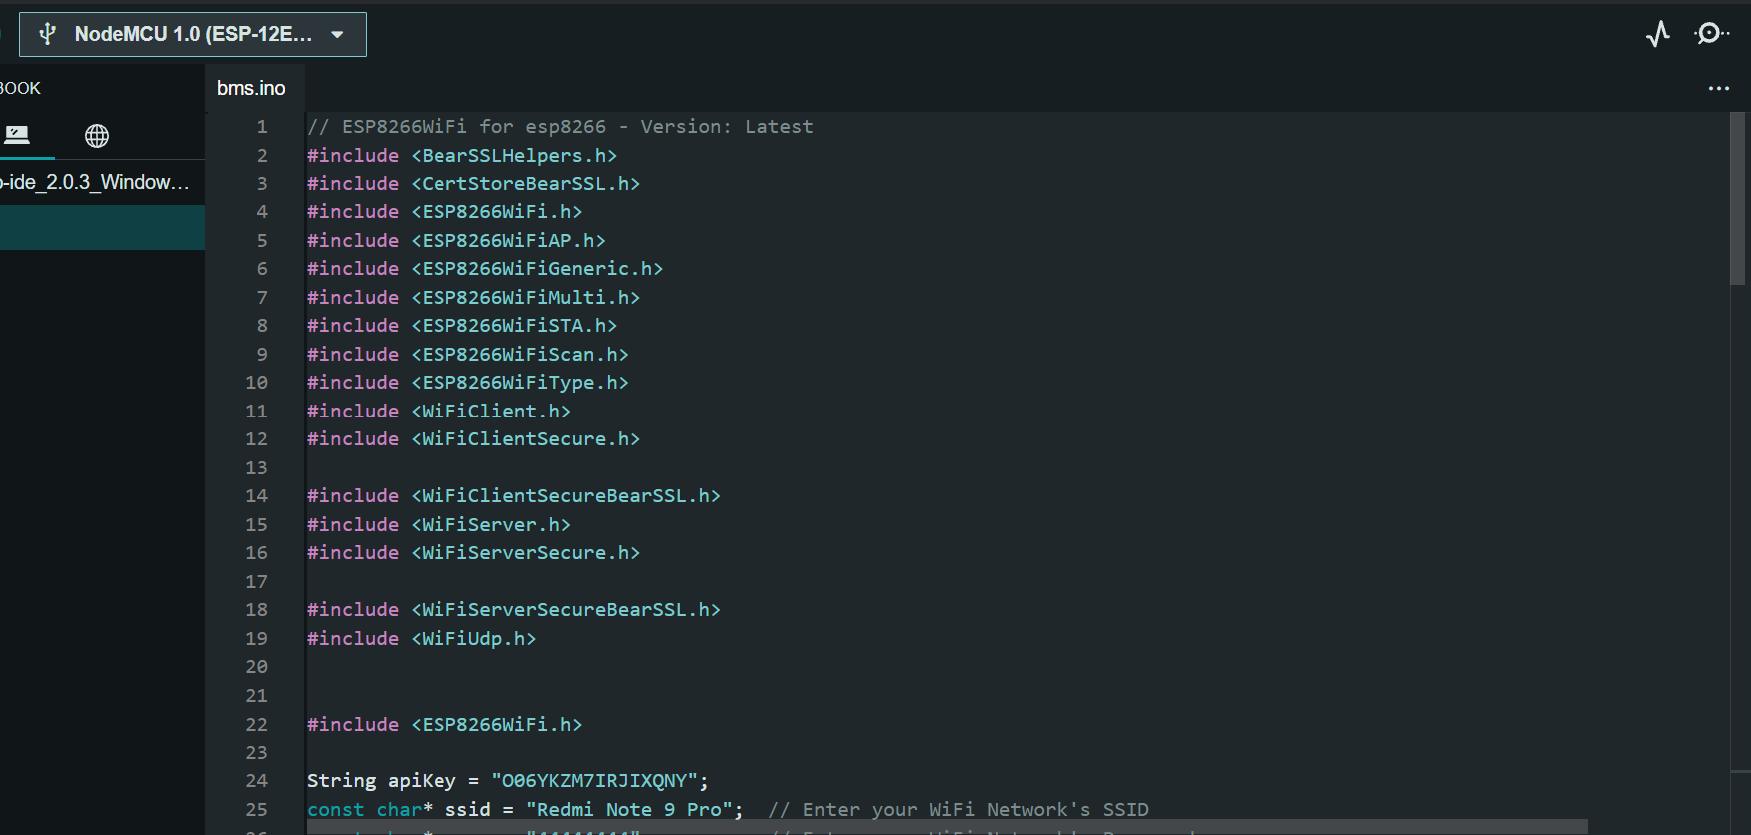battery temperature exceeds the normal range. The TP4056 module is a cheap and reliable option for charging Li-ion batteries, and it can be connected to any USB port using a USB cable, making it a versatile option for a wide range of applications. The NodeMCU ESP8266 is a multipurpose microcontroller with amazing capabilities and characteristics. It has a Tensilica 32-bit RISC CPU Xtensa LX106 that runs at 3.3V and accepts input voltages ranging from 7 to 12V. It features 16 DIO and 1 ADC, as well as 1 UART, 1 SPI, and 1 I2C. It also has 4 MB of flash memory and 64 KB of SRAM, both of which operate at an 80 MHz clock speed. It also features a USB-TTL-based CP2102, making it Plug and Play compatible. The NodeMCU ESP8266 has a PCB antenna and is tiny enough to integrate into any IoT project.

Fig. 4.2 Code SS-1

18

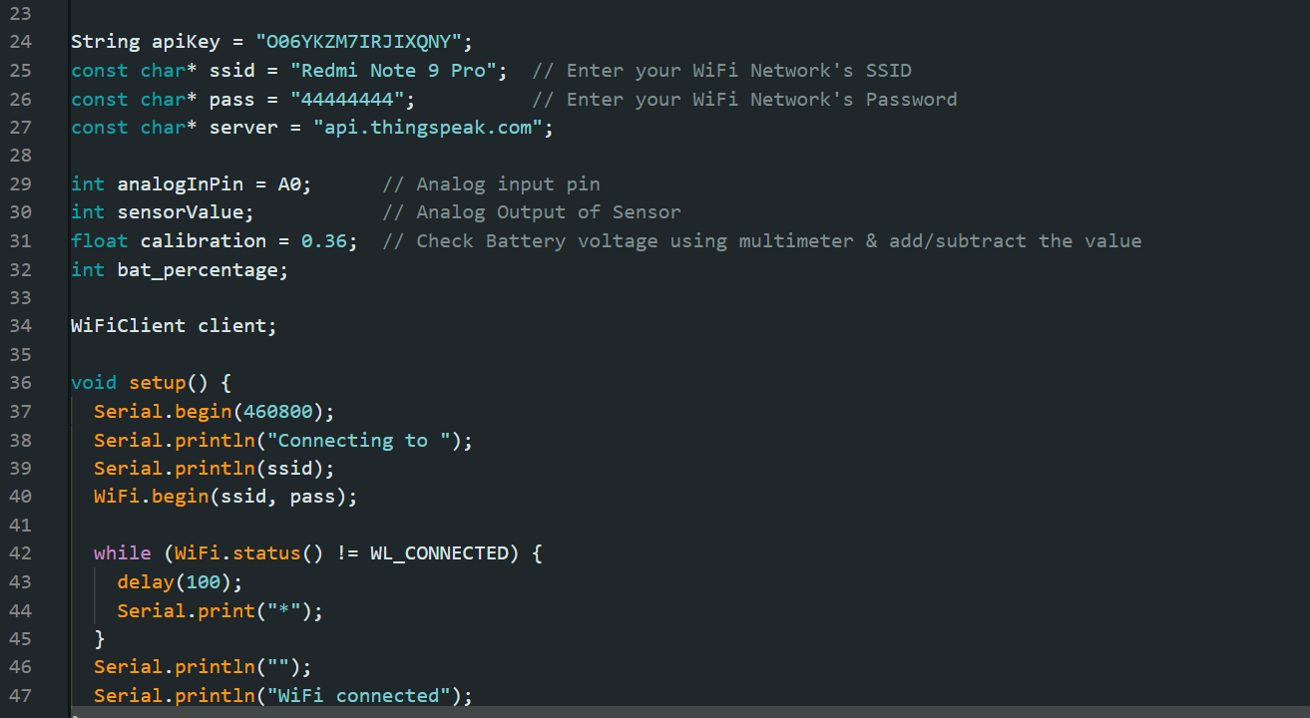

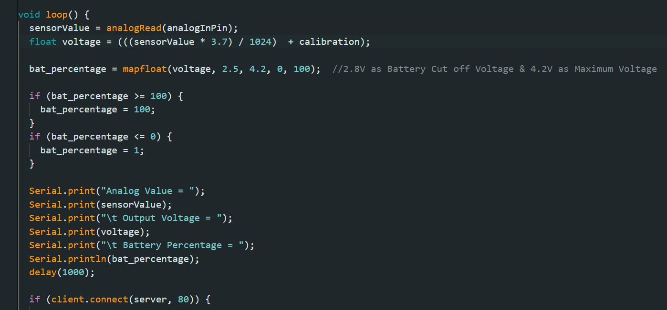 Fig 4.3 Code SS-2

Fig 4.4 Code SS-3

19



Fig 4.5 Code SS-4

20

**CHAPTER 5**

**COMPONENTS**

**COMPONENTS**

|  |  |  |
| --- | --- | --- |
| Sr no.  1. | Components  NodeMCU ESP8266 or Wemos D1 Mini Board | Quantity  1 |
| 2. | TP4056 Battery Charging Module | 1 |
| 3. | Resistor 100K | 2 |
| 4. | Micro-USB Cable | 2 |
| 5. | 3.7V Li-ion Battery | 1 |

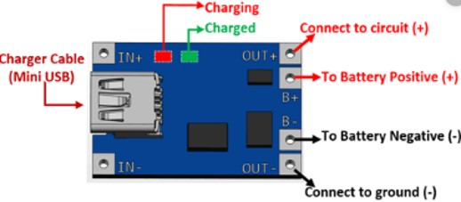

Fig 6.1 TP-4056 Battery Module

21

**TP4056 module** is a linear charger for lithium-ion batteries. Most importantly, it supports constant current and constant voltage modes of charging operations. Users can select both modes. This module offers a maximum of 1-ampere charging current.

**TP4056 Module Features & Technical Specs:**

* Over Current Protection
* Output charging current can be controlled or adjusted from a single resistor
* General Micro USB Female Connector
* Battery Charging Indication LED
* Battery full Charged Indication LED
* 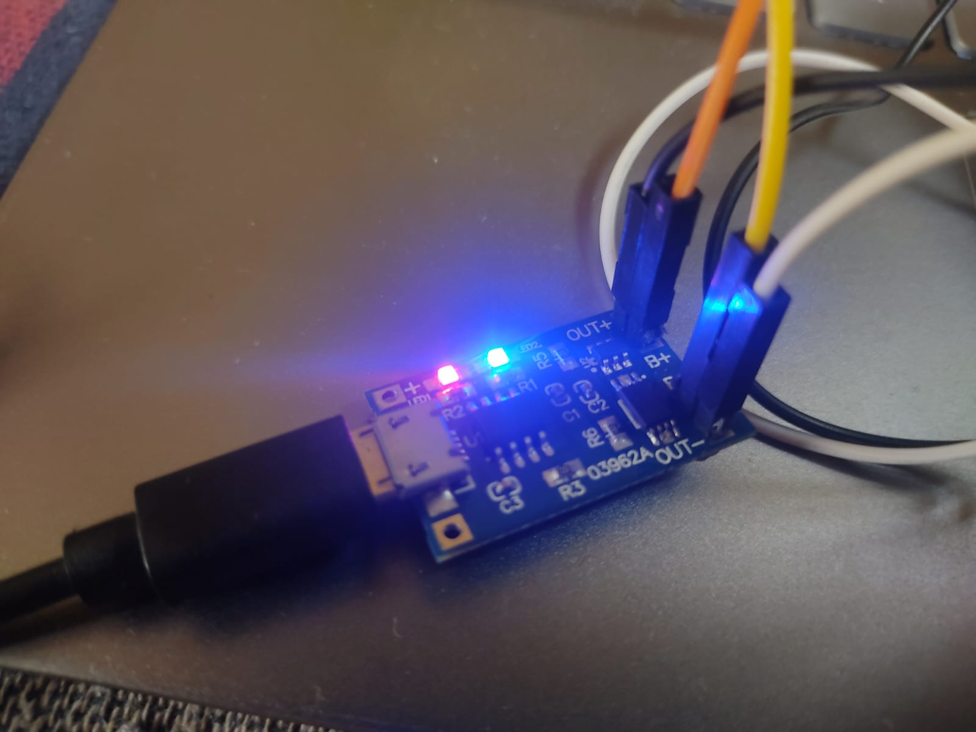Battery auto cutoff from the charging circuit when fully charged

Fig 6.2 Battery Module Actuation

* Soft Start Charging
* It can charge any size of 3.7V Li-ion cell
* Low cost and reliable Li-ion battery charger
* Battery temperature measurement inside (Disconnect charging when temperature of the battery goes high than normal)

22

**NodeMCU ESP8266 Specifications & Features:**

* Microcontroller: Tensilica 32-bit RISC CPU Xtensa LX106
* Operating Voltage: 3.3V
* Input Voltage: 7-12V
* Digital I/O Pins (DIO): 16
* Analog Input Pins (ADC): 1
* UARTs: 1
* SPIs: 1
* I2Cs: 1
* Flash Memory: 4 MB
* SRAM: 64 KB
* Clock Speed: 80 MHz
* USB-TTL based on CP2102 is included onboard, Enabling Plug n Play
* PCB Antenna
* 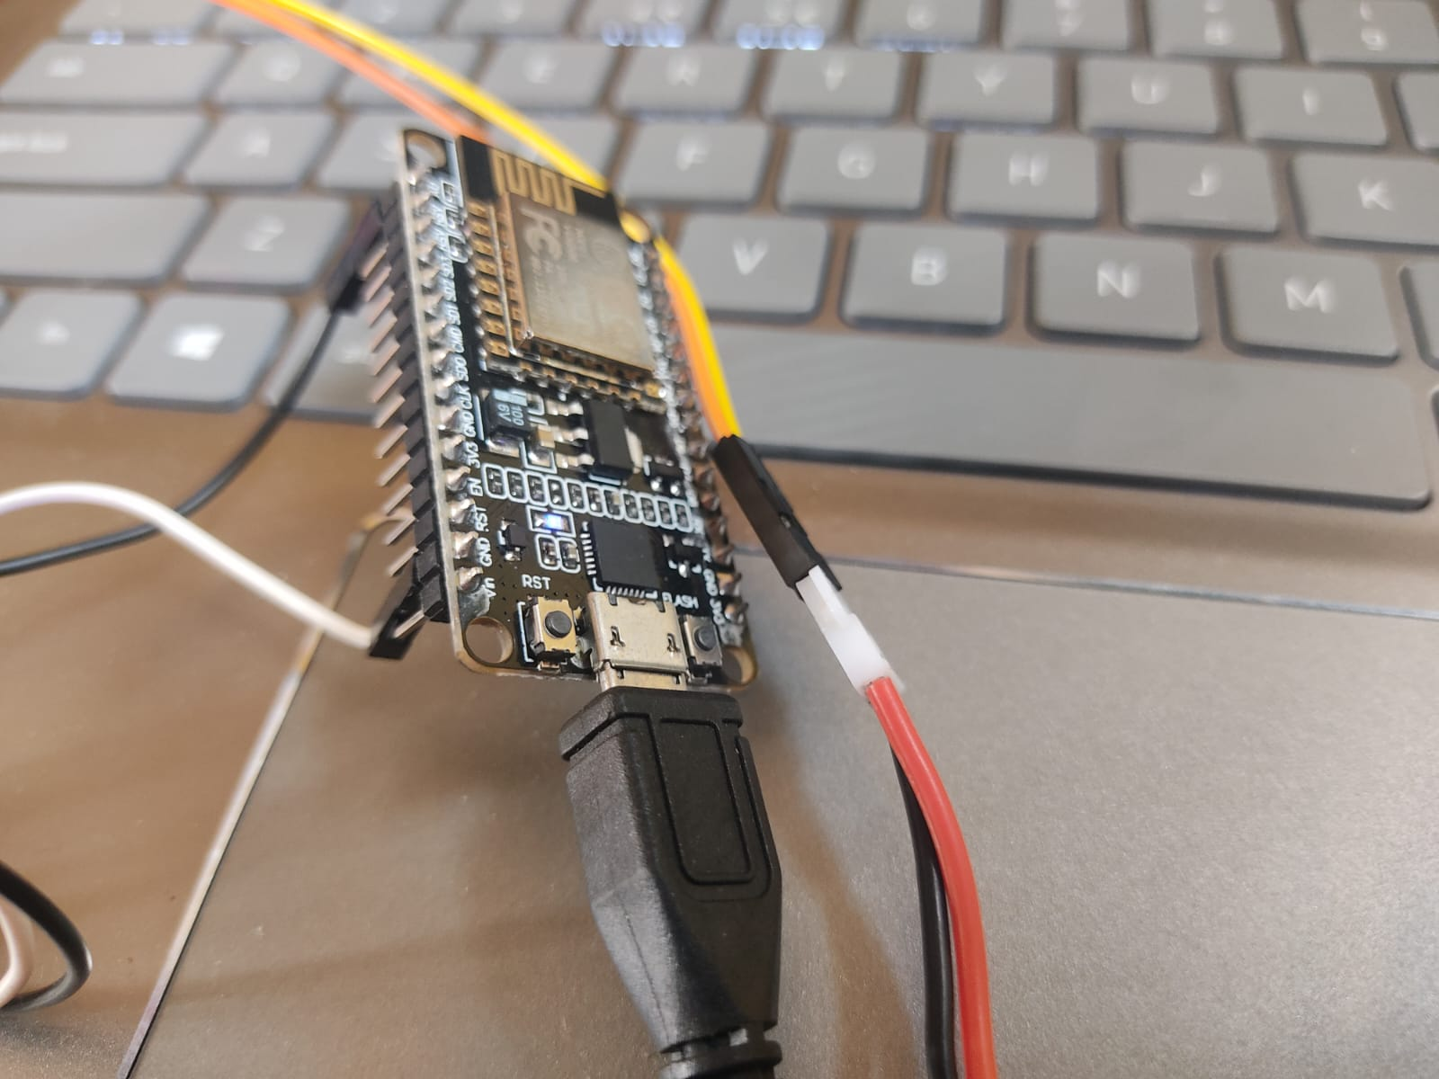Small Sized module to fit smartly inside your IoT projects

Fig 6.3 Node-MCU ESP-8266

23

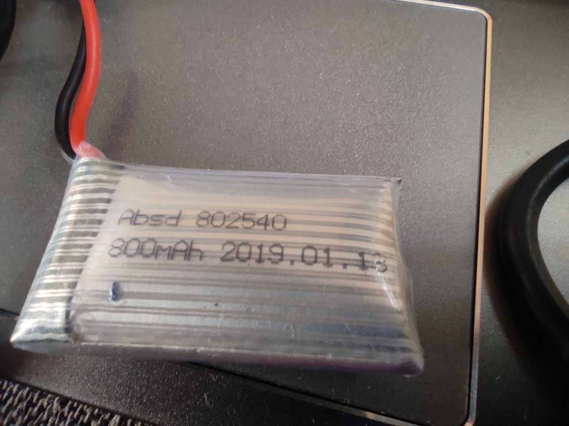**LiPo Battery** The 802540 is a 3.7V 800mAh rechargeable polymer battery that can quickly be integrated into a wide range of smart electronic devices. The battery comprises a single prismatic cell in a 1-series, 1-parallel configuration. An integrated battery protection circuit board (PCB) provides protection against over-charge, over-discharge, over-current, and short-circuit.

Fig 6.4 LiPo Battery

**Battery Specification**

|  |  |
| --- | --- |
| Product Type | 3.7V lipo battery |
| Model number | 802540 |
| Voltage (Nominal) | 3.7V |
| Capacity (Nominal) | 800mAh |
| Dimensions | Cell 8.0±0.2*25±0.5*40±0.5mm |
| Constant Discharge Current | 0.2C(Standard), 1C(Max ) |
| Working Temperature | charge: 0-45℃; discharge: -20-60℃ |

24

**CHAPETR 6**

**RESULTS AND OBSERVATION**

**RESULT AND OBSERVATIONS**

Lithium-ion batteries exhibit nonlinear behavior due to their electrochemical nature. However, conventional battery models often fail to accurately capture this behavior, especially at high current levels and low state of charge (SoC) levels. This limitation is due to the fact that many models are designed to simulate the average operating mode of the battery, where Fig. 3. TP 4056 Charging Module Fig. 4. Node-MCU ESP 8266 the current-voltage relationship is roughly proportional. Such models use equivalent circuit design with fixed parameters, ignoring the battery’s nonlinear behavior. While some models with variable parameters have been developed to provide better accuracy, they often neglect accuracy at low SoC levels. This limitation restricts the practical use of lithium-ion batteries to a narrow SoC window of around 10 % to 90 % in EV manufacturer practice. Electrochemical models such as the pseudo-two-dimensional model (P2D), the single particle model (SPM), and the single particle model of the electrolyte (SPMe) have been proposed to increase model accuracy. These models, however, need a large number of parameters and sophisticated partial differential equations, making them computationally demanding and unsuitable for various applications. It is critical to understand the origins Fig. 5. Setup Fig. 6. Serial Monitor Output Fig. 7. Voltage vs SoC of battery nonlinearities and their impacts on the model in order to obtain high accuracy across a wide variety of SoCs while retaining model simplicity. The problem is to create models that effectively describe nonlinear battery behaviour while being computationally efficient. By solving this issue, we may increase battery model accuracy and make better use of battery capacity, especially at low SoC levels. The dynamic behaviour of batteries is influenced by electrochemical processes such as charge transfer kinetics, mass transport, and thermodynamics. The Butler-Volmer equation is commonly used to explain charge transfer kinetics at the electrode-electrolyte interface, whereas Fick’s diffusion rule is commonly used to describe mass transfer processes. However, because the battery system is nonlinear due to the coupling of many processes, pure model analysis with assumptions may not fully capture the system’s response. Temperatures allowed for Lithium-ion batteries (LIBs) generally vary from -20°C to 60°C.

25

Therefore, other methods such as cooling plates, phase change materials, and heat pipes are commonly used to regulate the temperature of the battery. In addition, improving the thermal conductivity of the electrode and electrolyte materials can also enhance the heat dissipation of the battery, which can help prevent thermal runaway and improve safety. Overall, understanding the effects of temperature on LIBs is important for designing and implementing effective temperature control strategies to ensure battery performance, safety, and longevity.

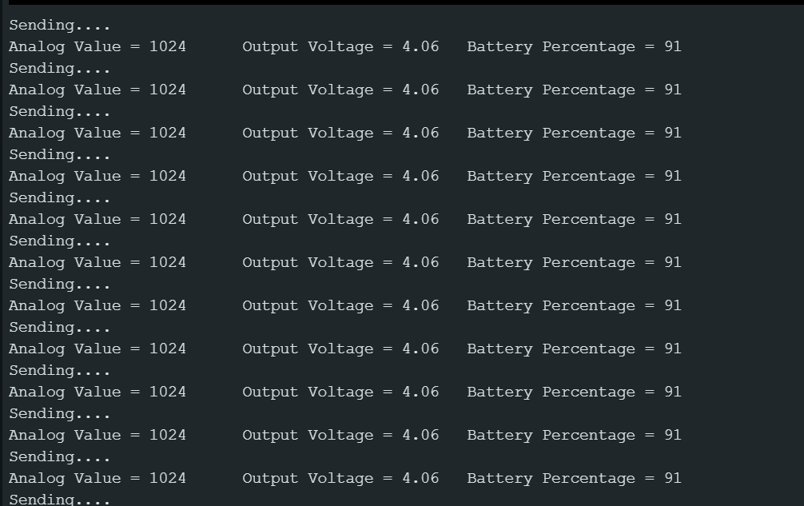

Fig 5.1 Serial Monitor Output

26

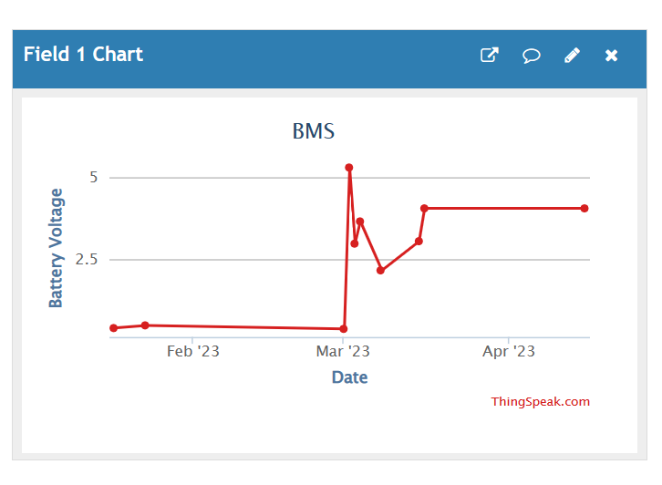

Fig 5.2 Battery Voltage Visualisation

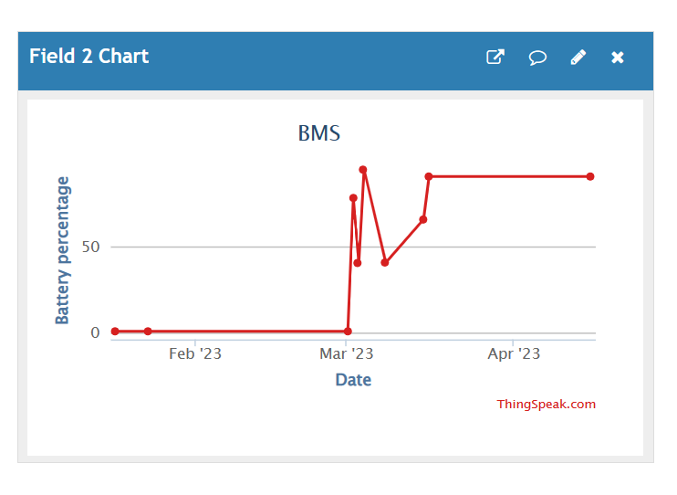

Fig 5.3 Battery SOC Visualisation

27

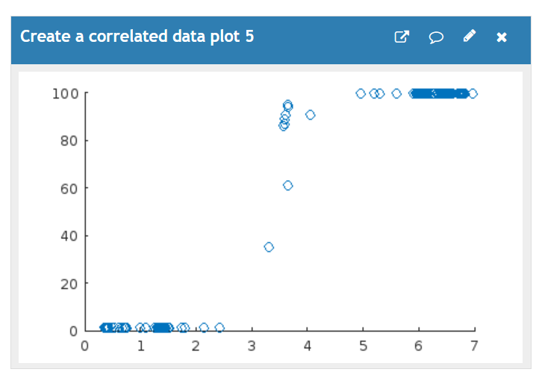

Fig 5.4 V-SOC Correlation

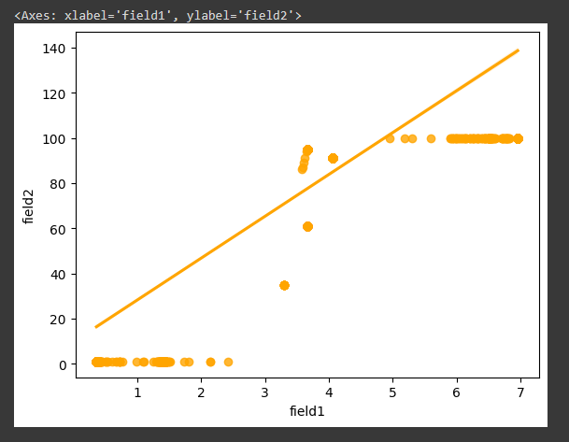

Fig 5.5 Battery SOC Estimation

28

**CHAPTER 7**

**CONCLUSION**

**CONCLUSION**

Lithium-ion batteries have become an essential part of our daily lives, powering everything from portable electronics to electric vehicles. However, their performance and lifespan are affected by various factors, including their state of charge, current levels, temperature, and other environmental conditions. The nonlinearity of the battery system poses a challenge to accurately model and predict their behavior, particularly at low state of charge levels and high current levels. Improving the accuracy of battery models is crucial for optimizing their performance and lifespan. Furthermore, temperature control is critical for reliable battery operation and performance, as exposure to high or low temperatures can cause significant degradation in capacity and power, as well as safety risks. Therefore, understanding the sources of battery nonlinearities and the effects of temperature on battery behavior is essential for developing improved battery technologies and optimizing their use in various applications.

Future Scope:

1. Advancements in IoT Integration:

The future of battery management systems lies in further advancements in IoT integration. As IoT technologies continue to evolve, we can expect more sophisticated sensors, improved connectivity, and enhanced data analytics capabilities. This will enable even more precise monitoring, analysis, and control of battery performance, leading to optimized battery usage and extended lifespan.

2. Artificial Intelligence and Machine Learning:

The integration of artificial intelligence (AI) and machine learning (ML) algorithms holds immense potential for battery management systems. AI and ML can process vast amounts of battery data to identify patterns, predict battery behavior, and optimize charging and discharging cycles. This will contribute to more accurate battery health monitoring, proactive maintenance, and enhanced energy efficiency.

29

3. Development of Advanced Battery Chemistries:

The evolution of battery chemistries will drive the future scope of battery management systems. As new battery technologies, such as solid-state batteries and lithium-sulfur batteries, become more commercially viable, battery management systems will need to adapt to effectively manage and optimize their unique characteristics. Future battery management systems will be designed to accommodate the specific requirements of these advanced chemistries.

4. Integration with Smart Grids and Energy Storage Systems:

Battery management systems will play a vital role in the integration of battery systems with smart grids and energy storage systems. As renewable energy generation and storage become increasingly prevalent, battery management systems will facilitate the efficient utilization and management of energy storage assets. This integration will enable grid stabilization, load balancing, and the seamless integration of renewable energy sources.

5. Enhanced Safety Features:

The future of battery management systems will prioritize safety features. With the increasing use of high-capacity batteries in various applications, ensuring the safety of battery systems is crucial. Future battery management systems will incorporate advanced safety mechanisms, such as fault detection, thermal management, and rapid shutdown capabilities, to minimize the risk of accidents or malfunctions.

6. Standardization and Interoperability:

As the adoption of battery management systems expands, standardization and interoperability will become essential. Future battery management systems will need to adhere to industry standards to ensure compatibility with different battery chemistries, devices, and communication protocols. This will enable seamless integration, facilitate data exchange, and promote the interoperability of battery management systems across various applications.

30

7. Sustainability and Circular Economy:

The future scope of battery management systems will also focus on sustainability and the circular economy. As battery technology advances, the need for effective battery recycling and second-life applications will become more critical. Future battery management systems will incorporate features to track battery life cycles, facilitate efficient recycling processes, and enable the repurposing of batteries for secondary applications.

In conclusion, the future of battery management systems holds tremendous potential for advancements in IoT integration, the incorporation of AI and ML algorithms, the development of advanced battery chemistries, integration with smart grids and energy storage systems, enhanced safety features, standardization and interoperability, and a focus on sustainability. These advancements will pave the way for more efficient battery usage, extended lifespan, and a sustainable energy ecosystem.

31

**CHAPTER 8**

**REFERENCES**

**REFERENCES**

[1] FirouzY. et al. Block-oriented system identification for nonlinear modeling of all-solid-state Li-ion battery technology J. Energy Storage (2020)

[2] R. Cecchini, G. Pelosi IEEE Antennas Propag. Mag., 34 (1992), pp. 30-37

[3] Justus Simiyu, Sebastian Waita and Denis Wekesa, ”Automobile Battery Monitoring sytem using Arduino UNO R3 Microcontroller Board”, The International Journal of science Technology, vol. 5, no. 6, pp. 24-36, 2017.

[4] Aniket Rameshwar Gade, The New Battery Management System in Electric Vehicle, International Journal of Engineering Research Technology, vol. 10, no. 7, pp. 402-405, 2021.

[5] Siddhesh Adavade, Rohit Shirudkar, Abhishek Jamnare, Nikhil Shirsath and Nikhil Abraham, ”Lithium -ion Battery Chemistries Battery cooling system”, International Research Journal of Engineering and Technology, vol. 8, no. 2, pp. 402-406, 2021.

[6] Qing Xie, Siyu Yue and Massoud pedram, ”Adaptive Thermal Management for portable system Batteries by Forced Convection Cooling”, Design Automation Test in Europe Conference Exhibition, pp. 978- 981, 2013.

[7] IoT based Lithium-Ion Battery Monitoring System in Electric Vehicle V. G, Aruna N, Janadharani S, Varshini N D Engineering 2023 Third International Conference on Artificial Intelligence and Smart Energy (ICAIS) 2023

[8] Sushrut Deshmukh, S.W. Khubalkar, Designing of Control Strategy for High Voltage Battery Isolation in an Electric Vehicles, IEEE International Conference on Convergence in Technology, I2CT, Pune, 29-31 March 2019.

[9] Ramtekkar, Pankaj, Harikumar Naidu, and Suraj Dudhe. ”An Innovative Safe Electrical Vehicle using Fuzzy Logic based Voice Control Device.” In 2022 10th International Conference on Emerging Trends in Engineering and Technology-Signal and Information Processing (ICETET-SIP22), pp. 01-04. IEEE, 2022.

[10] Baghmare, Kundan, and P. M. Daigavane. ”Supercapacitor based Controller for electric vehicle to Grid Power.” In 2021 Second International Conference on Electronics and Sustainable Communication Systems (ICESC), pp. 1-8. IEEE, 2021. [11] Raut, Sonu, Prema Daigavane, and M. B. Shaikh. ”Test Bench of Automotive Component of an Electric Vehicle for Electrical Parameter Measurement.”

32

In Innovations in Electrical and Electronic Engineering: Proceedings of ICEEE 2020, pp. 479-488. Springer Singapore, 2021.

[12] Khandait, Rohit, Vasant Kumar, Vivek Bhurse, Vivek Tiwari, and Swapnil Khubalkar. ”Quadcopter Control using Different Controllers.” In 2022 International Conference on Intelligent Controller and Computing for Smart Power (ICICCSP), pp. 1-6. IEEE, 2022.

[13] Lanjewar, S.W. Khubalkar, and A.S. Junghare, “Comparative Analysis of Two Loop Integerand Fractional Order PID Controller for Inverted Pendulum,” ICSEDPS 2018, GHRCE, Nagpur, June 2018.

[14] M.Patil, K. Vadirajacharya, and S.W. Khubalkar,”Design and tuning of digital fractional-order PID controller for permanent magnet DC motor.” IETE Journal of Research (2021): 1-11.

[15] M.Patil, K.Vadirajacharya, S.W. Khubalkar, Design of fractional order controllers using constrained optimization and reference tracking method, International Journal of Power Electronics and Drive Systems, Vol11, No1, March 2020.

[16] Padwad, Dipali, and Hari Kumar Naidu. ”A Review of Electrical Boat Vehicle Solar Generation for Energy Sustainability and Development.” In 2022 10th International Conference on Emerging Trends in Engineering and Technology-Signal and Information Processing (ICETET-SIP-22), pp. 1-6. IEEE, 2022.

[17] J.Mane, M.V.Aware, S.W.Khubalkar, MulticarrierMulti-Modulation Techniques in Multilevel Neutral Point Clamped Inverter Setup for Advanced Power Electronics and Drives Lab, The International Journal of Electrical Engineering & Education, April 2020.

[18] Mohit Chaudhari, S.W. Khubalkar, Off-grid Hybrid Online Solar Power Conditioning Unit For Domestic Purposes, IEEE International Conference On Computing, Power And Communication Technologies GUCON 2019.

[19] Betala, Rachna, and Hari Kumar Naidu. ”A Review to Innovative a Green Electric Vehicle for Future.” In 2022 10th International Conference on Emerging Trends in Engineering and Technology-Signal and Information Processing (ICETET-SIP-22), pp. 01-06. IEEE, 2022

33

**PICTURE WITH INDUSTRY GUIDE**

