

INTERNATIONAL UNIVERSITY - VNU HCMC

Object-Oriented Programming – Project Report

TOPIC: **Pac Man**

|  |  |
| --- | --- |
| **NAME** | **STUDENT’S ID** |
| 1. PHẠM ĐÔNG QUÂN | ITDSIU19015 |
| 1. NGUYỄN HUỲNH THUỶ TIÊN | ITDSIU19056 |
| 1. VŨ XUÂN LINH | ITDSIU19008 |

INSTRUCTOR: LE THANH SON

GROUP NUMBER 10

Table of contents

1. Class diagram 3

2. Instruction 4

2.1. Game rules 4

2.2. Levels 6

1. **Class diagram**

Class diagram:

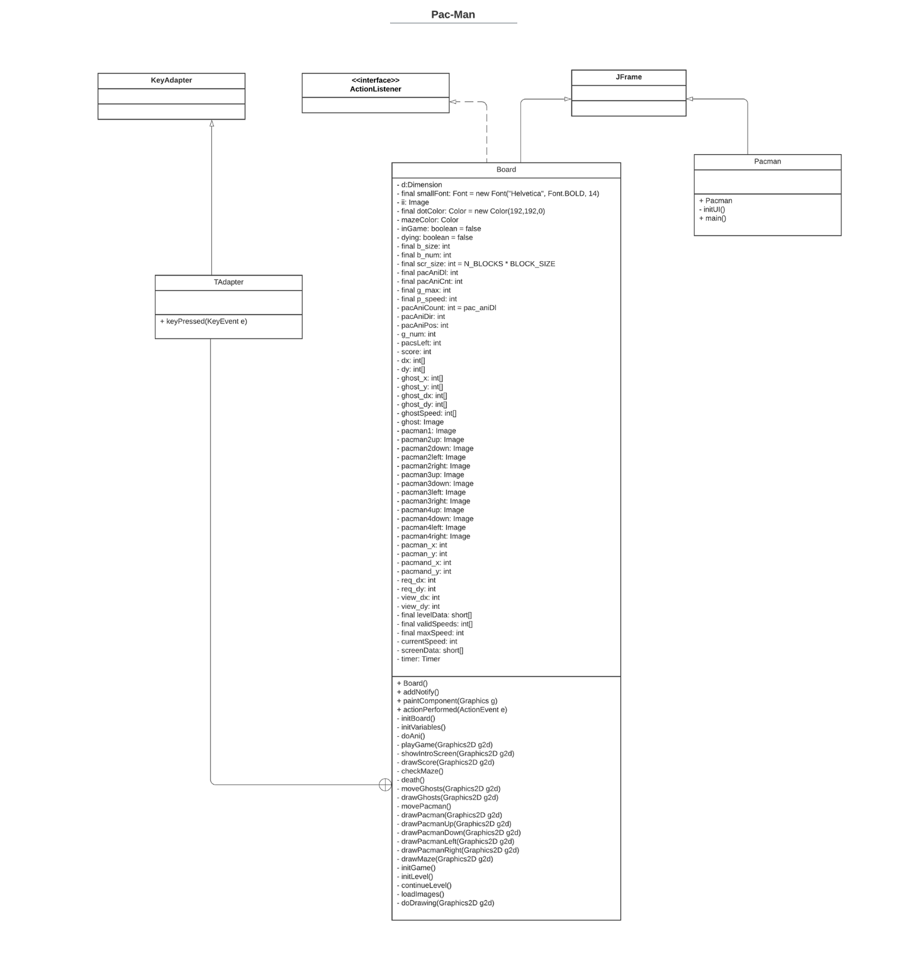

1. **Instruction**

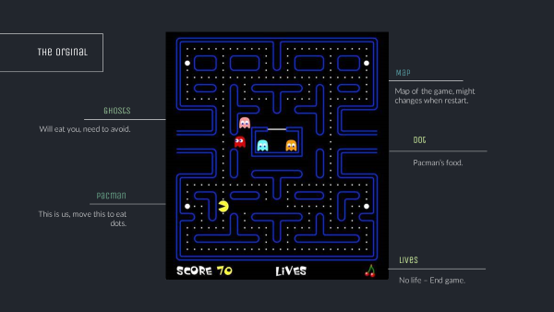

## 2.1. Game rule

***Original game:***

* The goal of the game is to each all the points on the map while avoiding our colored ghosts - Blinky (red), Pinky (pink), Inky (cyan), and Clyde (orange) - that pursue him. Each of the four ghosts have their own unique “personality”, which includes that Blinky gives direct chase to Pac-Man, Pinky and Inky try to position themselves in front of Pac-Man, usually by cornering him, and Clyde will switch between chasing Pac-Man and fleeing from him.
* Pac Man has 3 lives at start and loses one live if it makes contact with a ghost, and the game ends when Pac Man has no lives left. There are special points that gains Pac Man the ability to kill the ghosts for a period of time. Eating a certain number of dots in a level will cause a bonus item, usually in the form of a fruit, to appear underneath the center box, which can be eaten for bonus points.
* To the sides of the maze are two "warp tunnels", which allow Pac-Man and the ghosts to travel to the opposite side of the screen. Ghosts become slower when entering and exiting these tunnels.  Levels are indicated by the fruit icon at the bottom of the screen.

***Our custom game:***

* Pac Man have 3 lives at start, and the lives replenish after passing 1 level. The goal is to eat all the points while avoiding a certain number of ghosts, which is different for each level.
* Limitation:
  + - No original soundtrack included in the game.
    - The original’s ghosts’ “personality” is not in our game, instead, ghost have random movements.
    - No special points included

## 2.2. Levels

Level 1:

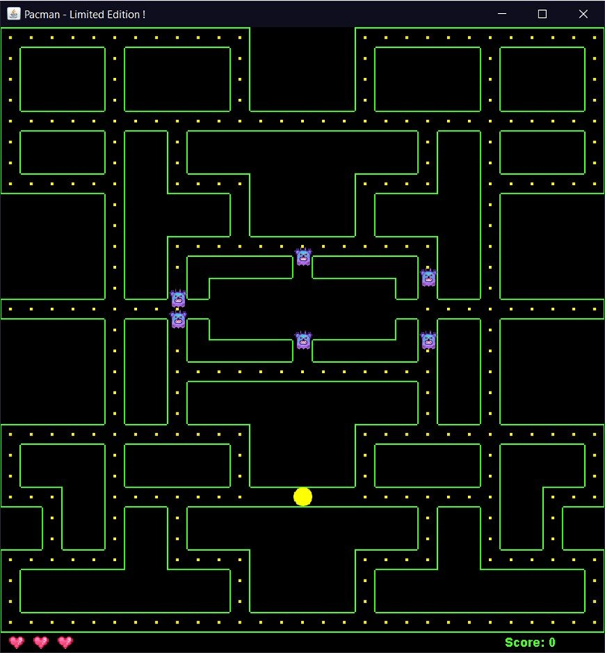

* Death penalty: None
* Passing bonus: 50p

Level 2:

* Death penalty: Ghosts have an increase in speed and in number by 1.
* Passing bonus: 130p

Level 3:

* Death penalty: Ghosts have an increase in speed and in number by 1.
* Passing bonus: 150p for each live left

Bonus level:

* Pac Man only has 1 live.
* Passing bonus: 1000p