**ASSIGNMENT 1 FRONT SHEET**

|  |  |  |  |
| --- | --- | --- | --- |
| **Qualification** | **TEC Level 5 HND Diploma in Computing** | | |
| **Unit number and title** | **Unit 43: Internet of Things** | | |
| **Submission date** | 24/6/2021 | **Date Received 1st submission** |  |
| **Re-submission Date** |  | **Date Received 2nd submission** |  |
| **Student Name** | Nguyen Vu Thai | **Student ID** | GCH190530 |
| **Class** | GCH0803 | **Assessor name** | Le Anh Ngoc |
| **Student declaration**  I certify that the assignment submission is entirely my own work and I fully understand the consequences of plagiarism. I understand that making a false declaration is a form of malpractice. | | | |
|  |  | **Student’s signature** | Thai |

**Grading grid**

|  |  |  |  |  |  |  |  |  |  |
| --- | --- | --- | --- | --- | --- | --- | --- | --- | --- |
| P1 | P2 | P3 | P4 | M1 | M2 | M3 | M4 | D1 | D2 |
|  |  |  |  |  |  |  |  |  |  |

|  |  |  |
| --- | --- | --- |
| **❒ Summative Feedback: ❒ Resubmission Feedback:** | | |
| **Grade:** | **Assessor Signature:** | **Date:** |
| **Internal Verifier’s Comments:** | | |
| **Signature & Date:** | | |

Contents

I. Introduction 4

1. Task 1- Review and evaluate about IoT aspects. 4

1.1 Review IoT functionality, standard architecture frameworks, tools, hardware and APIs 4

2. Plan an appropriate IoT application 14

2.1 Determine a problem and IoT solution 14

II. Conclusion 20

III. References 21

Figure 1: IoT 4

Figure 2: IoT works 5

Figure 3: Smart City 6

Figure 4: Smart Home 7

Figure 5: Smart Car 8

Figure 6: IoT Architecture 10

Figure 7: Frame Work 12

Figure 8 15

Figure 9 15

Figure 10 16

Figure 11 16

Figure 12 17

Figure 13 18

Figure 14 18

Figure 15 19

# Introduction

This report will This report will cover the main component structure of an IoT system, how does IoT works and some real application in our life. The next, I will show problems and solution for using IoT.

## Task 1- Review and evaluate about IoT aspects.

### Review IoT functionality, standard architecture frameworks, tools, hardware and APIs

#### Concepts about IoT

##### Definition

IoT (Internet of Things) is known as a wide network of things around the globe connected to the Internet. In simpler terms, IoT is all the devices that people use that have the ability to connect and interact with each other through the Internet. From there, people easily collect, process and transmit information data.

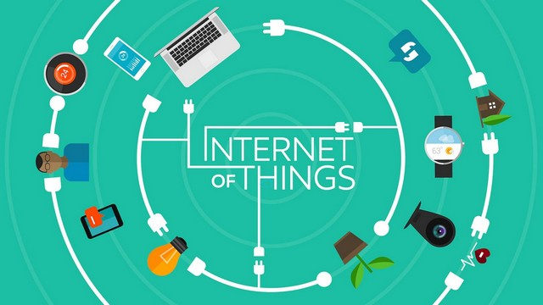

Figure 1: IoT

##### How does IoT work?

IoT is the collection of all devices that can connect to websites, allowing them to collect, send, and process information in their surroundings. These devices are integrated with sensors, a computer's processor, and software that can interact with each other. Scientists call them “connected” or “smart” devices. Data from “smart devices” is transferred to other devices forming a process known as M2M (machine-to-machine).

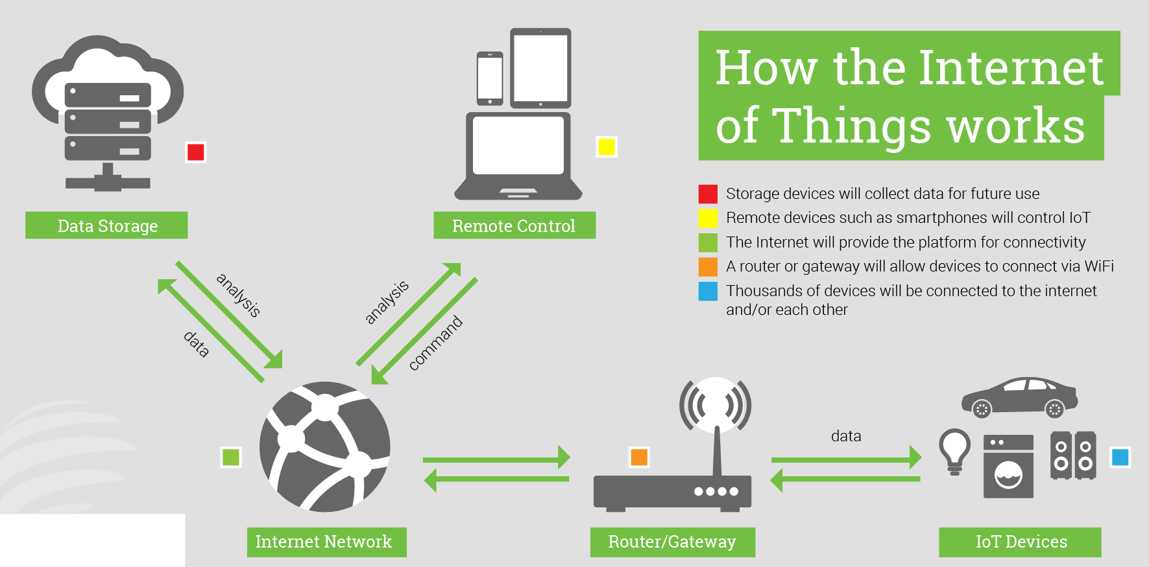

Figure 2: IoT works

##### Application of IoT

Nowadays, IoT is applied a lot in people's life. However, here are the most valuable applications that IoT brings:

1. Smart City

The smart city gives people a great comfort. The fact that everything in the city is connected helps people get information quickly. Everything is built-in on smart devices that people own. For example, send a signal of empty parking lots, easily find the supermarket, restaurant you want, ...

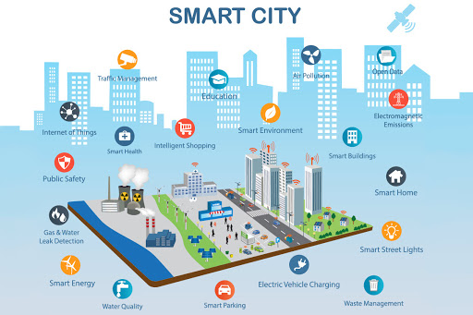

Figure : Smart City

1. Smart House

Designed to provide you with ultimate safety and convenience, smart homes ensure you're back in a paradise. Smart home is a system that allows monitoring and control via phone or tablet, helping to automate home appliances such as lights, switches, doors, air conditioners, sprinklers, water pumps, etc. curtains, as well as other devices anytime, anywhere.

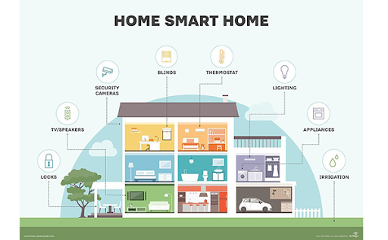

Figure : Smart Home

1. Smart Car

Equipped with tons of devices like sensors, gyroscopes, internet and more, these cars sense huge chunks of data about traffic, pedestrians, road conditions such as deceleration, potholes, corners, quick turns and instant handling with fast speed. This information is passed to the controller with the corresponding driving decisions.

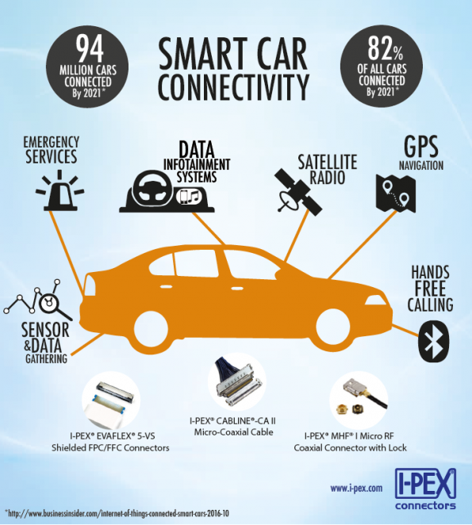

Figure : Smart Car

##### IoT Characteristics

*Dynamic and self-adapting:* The IoT devices can dynamically adapt with sensed environment, their operating conditions, and user’s context and take actions accordingly. For ex: Surveillance System.

*Self-configuring:* IoT devices can be able to upgrade the software with minimal intervention of user, whenever they are connected to the internet. They can also setup the network, a new device can be easily added to the existing network.

*Interoperable Communication:* IoT allows different devices (different in architecture) to communicate with each other as well as with different network.

*Unique identities:* The devices which are connected to the internet have unique identities IP address through which they can be identified throughout the network. The IoT devices have intelligent interfaces which allow communicating with users. It adapts to the environmental contexts. It also allows the user to query the devices, monitor their status, and control them remotely, in association with the control, configuration and management infrastructure.

*Integrated into information network:* The IoT devices are connected to the network to share some information with other connected devices. The devices can be discovered dynamically in the network by other devices. For ex. If a device has wifi which connectivity then that will be shown to other nearby devices having wifi connectivity. The IoT devices become smarter due to the collective intelligence of the individual devices in collaboration with the information network. For Ex: weather monitoring system. Here the information collected from different monitoring nodes (sensors, arduino devices) can be aggregated and analysed to predict the weather.

##### Some examples for real world application of IoT

1. DASH

How it’s using IoT: Dash’s free app for iOS and Android receives data from a variety of sensors to keep you informed your car’s current status and immediate or future maintenance needs.

Industry impact: The company's app has a parental control function that allows parents or caretakers to get email alerts if a young driver exceeds set thresholds or tries to circumvent them.

You can watch in: https://www.youtube.com/watch?v=EPAl9qdz9XA&t=20s

1. JOSH.AI

How it's using IoT: JOSH.AI provides voice-controlled home automation using a variety of devices.

Industry impact: Got your amp cranked to 11 when an important call comes in and can't find the remote? No problem. You can turn down the volume using your watch, phone, tablet or computer.

You can view in: <https://www.josh.ai/>

#### Review about standard architectures, frameworks, tools, hardware and APIs available using in IoT development

##### Architecture

In spite of each IoT system is different, the foundation for the IoT architecture as well as their general data processing flow is almost the same. The first layer of architecture including many stuffs that connected to Internet, embedded sensors can sense their surrounding and collect information then transmitted to IoT gateway. The second layer is IoT data collection systems and gateways that collect large of unprocessed data then convert them into a digital stream, filter and process them to make it ready for analysis. The third layer is the devices that responsible for advanced data processing and analysis. This layer is also where visualization and machine learning technologies can be found. After that the data is moved to cloud data centers or local installations that where data is stored, managed and analyzed for using them.

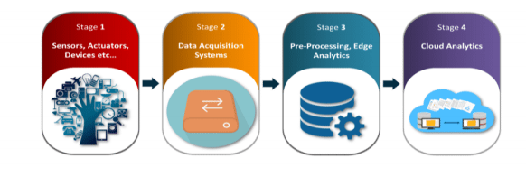

Figure 6: IoT Architecture

1. Sensors/ Actuators

As the foundation for any IoT system, connected devices are responsible for delivering data. To receive physical parameters outside or inside, the devices need sensors. Sensors can be embedded in devices or stand alone for remote data collection. An integral element of this class is the actuator. Working closely with sensors, actuators can transform data generated by smart objects into physical actions.

1. Gateway and Data Acquisition Systems

As intermediaries between things connected to the cloud, gateways and data collection systems are the connection points that link the rest of the layers together. Gateways support communication between sensors and the rest of the system by converting sensor data into formats that are easy to convert and use by other components in the system. Furthermore, the gateway can control, filter, and select data to minimize the amount of information that needs to be moved to the cloud.

1. Pre-Processing, Edge Analytics

Given the limited accessibility and data transfer speeds of IoT cloud platforms, analytics systems can provide faster response times and greater flexibility in handling and analyzing IoT data

1. Cloud Analytics

The data center or cloud stores, processes, and analyzes massive volumes of data for deeper insights using powerful data analytics tools and machine learning mechanisms. The cloud will help people interact with the system, control and monitor, and make informed decisions on the basis of reports and data viewed in real time.

##### Frameworks

The IoT framework is what makes it possible for the connected devices to have smooth communication over the Internet. It is no wonder, then, that it is referred to as the ‘Internet of Things’ framework, or in other words, the framework that facilitates the interaction of ‘Things’ (devices) over the Internet.

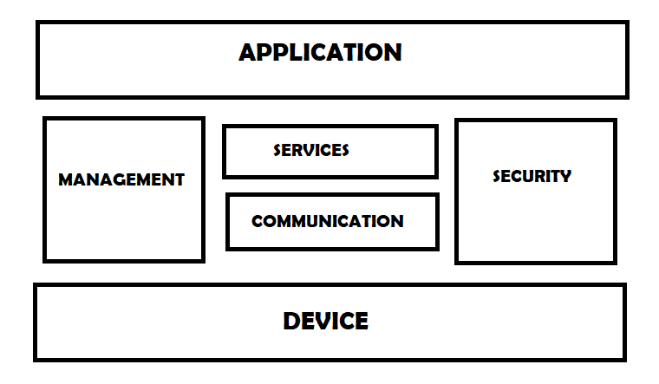

Figure : Frame Work

The fundamental components of IoT frameworks include:

*Device:* The IoT devices can share information with as well as collect information from other connected devices and applications (directly and indirectly). They can process the data locally or in the cloud to find greater insights and put them into action based on temporal and space constraints. For ex: wearable sensors, smart watches, LED lights…

*Communications:* It refers to various communication protocols which allows different devices to communicate with each other by sharing some information. It also allows interoperability among different devices.

*Services:* IoT system provides various services such as device monitoring, device control services, data publishing services, device discovery services.

*Management:* Various management functions to govern the IoT system.

*Security:* It secures the IoT system by providing authentication, authorization, message and content integrity and data security.

*Application:* IoT applications provide an interface that the users can use to control and monitor various aspects of the IoT system. It also allows viewing the system status and view or analysing the processed data.

##### Tools

IoT development tools are software development solutions specifically targeted to developers building IoT applications. These tools may include integrated development environments (IDEs), command line interface (CLIs), software development kits (SDKs), libraries and frameworks of code, or APIs that are tailored to IoT developers. IoT developers can use these tools when building web, mobile, and device applications. There are some best Tools for using in IoT development in 2020:

* Arduino IDE
* Eclipse IoT
* Blynk IoT Platform
* IBM Watson

##### Hardware

Connected hardware devices play an extremely important role in an IoT system. They perform monitoring and control of real-world devices such as industrial systems, manufacturing, smart homes or even people.

Sensor: Sensor is a device that detects, measures or indicates any specific physical quantity such as light, heat, motion, moisture, pressure, or similar entities, by converting them into any other form which is mostly, electrical pulses.

Actuators: Whereas sensors sense and send, actuators act and activate. The actuator gets a signal and sets in motion what it needs to set in motion in order to act upon/within an environment.

##### APIs

Application programming interface is a set of requirements that govern how one application can talk to another. API’s do all these things by exposing some of program’s internal functions to the outside world in a limited fashion.

Mainly two types of communication APIs are used in IoT. Those are as follows:

* REST based communication API
* WebSocket based communication API

REST based communication API

Representational State Transfer (REST) is a set of architectural principles by which you can design web services and web APIs that focus on a system’s resources and how resource states are addressed and transferred. REST APIs follow the request-response communication model. The REST architectural constraints apply to the components, connectors, and data elements, within a distributed hypermedia system.

WebSocket based communication API

Web Socket APIs allow bi-directional, full-duplex communication between clients and servers. It follows the exclusive pair communication model. This Communication API does not require a new connection to be set up for each message to be sent between clients and servers. Once the connection is set up the messages can be sent and received continuously without any interruption. WebSocket APIs are suitable for IoT Applications with low latency or high throughput requirements.

## Plan an appropriate IoT application

### Determine a problem and IoT solution

#### Investigate clearly a most common IoT platform (including frameworks, tools, hardware and API)

##### Framework

1. Zetta

Zetta is an open-source based IoT platform based on Node.js. It is considered as a complete toolkit to make HTTP APIs for devices. Zetta combines REST APIs, Web-Sockets to make data-intensive and real-time applications. The following are some notable features.

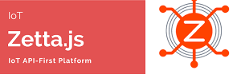

Figure

1. WSO2

WSO2 is an open-source IoT framework that allows its enterprises to control their mobile applications and devices. It provides a secure way of manufacturing the devices and manages them efficiently. The optimal design of the platform ensures the protection of both device and its data. Also, the capability of analyzing the gathered data helps in real-time visualizing. The identification of different types of patterns and data is possible.

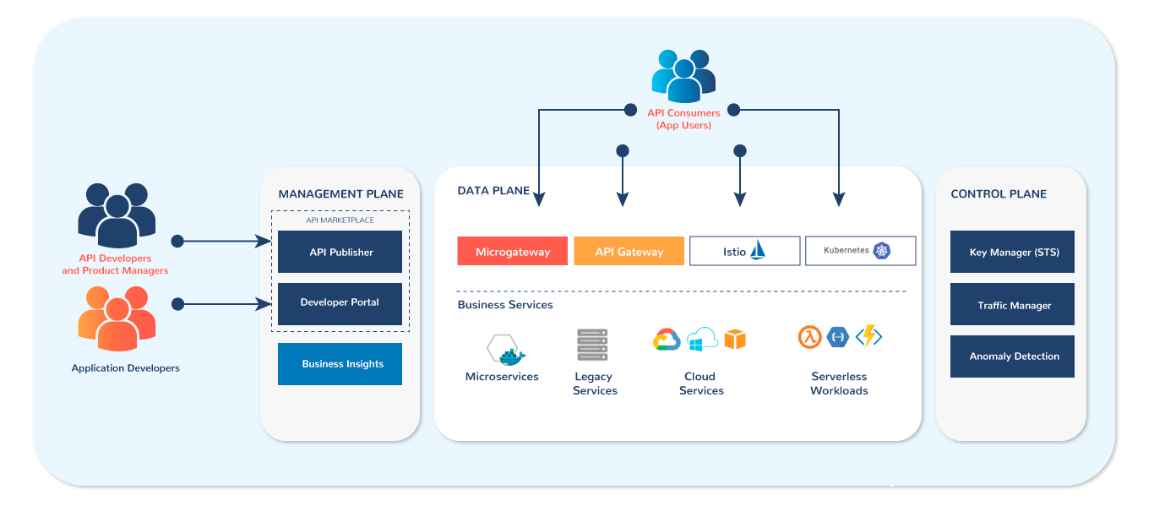

Figure

1. myDevices

myDevices is an open-source IoT framework which has front end IoT with application features. The data of sensors are very easily manageable and also the platform helps in fixing bugs. It is very easy to set up using plug and play getaways. This platform enables a user to set alerts according to the data received through the sensors. Steps are taken inside the app If there is an issue. Third-party apps and services can also receive data from the app. The old data can be retrieved from the app for future needs

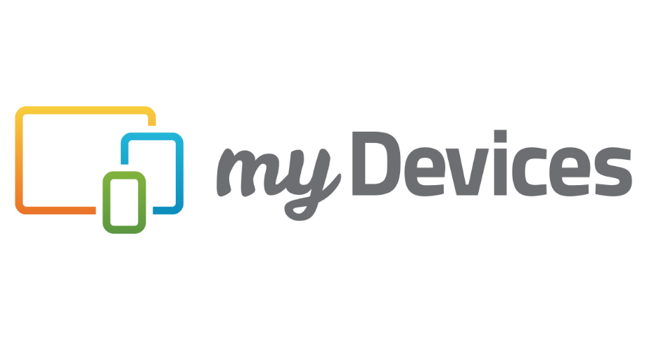

Figure

##### Tool

1. Arduino IDE

Arduino IDE (Arduino Integrated Development Environment) is a text editor that helps you write code to load into the Arduino board.



Figure

1. Eclipse IoT

Eclipse IoT is an ecosystem of entities working together to create a foundation for IoT based entirely on open-source technologies. Their focus remains on the open-source production areas that implement standard IoT technology; create open-source frameworks and services for use in IoT solutions; and develop tools for IoT developers.

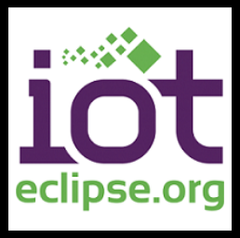

Figure

##### Hardware

1. Arduino

Arduino is the ubiquitous name in the electronic development space. The company offers a range of open-source development kits, microcontrollers, and software tools for building connected products.

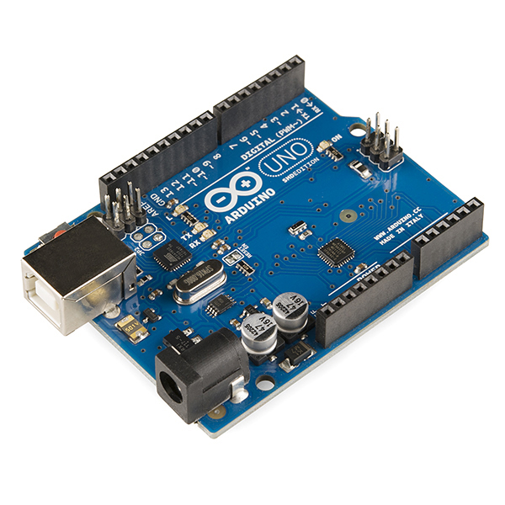

Figure

1. Raspberry Pi

A Raspberry Pi is a single-board-based computer that runs on Linux and is designed for prototyping small computing applications. Raspberry Pi products are perfect for people of all ages and are a good way to get into electronic development.

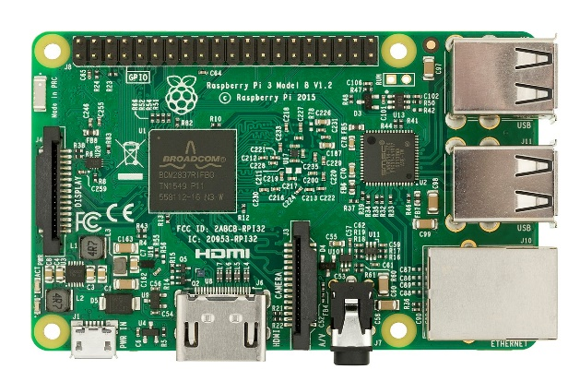

Figure

1. Particle

Particle offers a range of development kits designed to connect to the Internet over Wi-Fi, cellular, or BLE. Particle is the best platform to build a connected project from prototype to production.

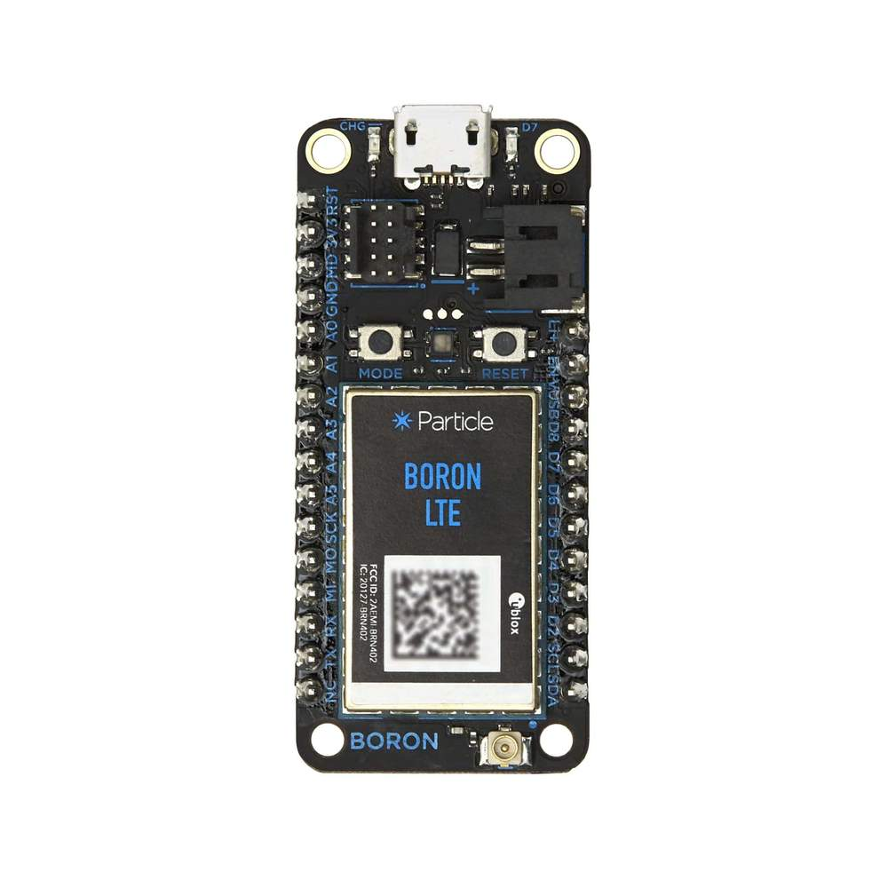

Figure

#### Problem to solve using IoT

##### Introduction problem

Nowadays, in our country, the number of cars and motorbikes is increasing rapidly while the number and area of ​​parking lots are not enough to meet the demand. You need to reduce the time it takes to find a parking spaces, you need to reduce the complexity of parking your car, all those problems will be solved if there is a parking guidance system. Not only does it work for car owners, but this system also brings many benefits to parking managers. The management of vehicles in and out has become easier than ever, the statistics are specific and highly accurate. Each position in the parking lot is effectively utilized, there will be no situation where the car enters the parking lot and still cannot find a parking space even though there are still many empty spaces.

##### Benefit of system

* Optimized Parking: Users can find the best available location, saving time, resources and effort.
* Reduced traffic: Instead of driving around for hours looking for a suitable parking space, car owners can fully access smart parking lots easily and quickly.
* Reduce pollution: The optimal parking solution reduces daily vehicle waste by reducing search time, reducing fuel burn.
* Safety: Parking security guards manage all the data so that parking violations or suspicious activities can be prevented. License recognition cameras can capture appropriate footage. In addition, reducing the traffic of vehicles looking for parking on the road can reduce accidents caused by distractions from searching for a parking space.

##### Design

Hardware

* The hardware to run the demo smart parking system are:
* USB cable and Micro-USB cable (connect to laptop to processing code)
* Circuit board jumper wire (power and connection port)
* LED light (Show available space)
* Light sensor (Determine if the car is parked or not)
* Resistance (protect equipment)
* Breadboard (plugging devices together)
* WEMOS D1

Software

I use the Arduino IDE to write the code and upload it to Wemos. I use Blynk app on my smartphone to show the interface on the client side.

# Conclusion

After the report, we have a better understanding of the main components of an IoT system. Frameworks and tools can help develop an IoT system. The next, it also mentions about my IoT solution to handle real life problem.

# References

GeeksforGeeks. 2021. *Characteristics of Internet of Things - GeeksforGeeks*. [online] Available at: <https://www.geeksforgeeks.org/characteristics-of-internet-of-things/> [Accessed 24 June 2021].

dzone.com. 2021. *Top 10 IoT Development Tools in 2020 - DZone IoT*. [online] Available at: <https://dzone.com/articles/top-10-iot-development-tools-in-2020> [Accessed 24 June 2021].

IoTbyHVM - Bits & Bytes of IoT. 2021. *Logical Design of IoT | IoT Communication Models & APIs*. [online] Available at: <https://iotbyhvm.ooo/logical-design-of-iot/> [Accessed 24 June 2021].

Carritech Telecommunications. 2021. *Internet of Things: Explained | News | Carritech Telecommunications*. [online] Available at: <https://www.carritech.com/news/internet-of-things/> [Accessed 24 June 2021].