**ASSIGNMENT 1 FRONT SHEET**

|  |  |  |  |
| --- | --- | --- | --- |
| **Qualification** | **BTEC Level 5 HND Diploma in Computing** | | |
| **Unit number and title** | **Unit 3: Professional Practice** | | |
| **Submission date** | 15/12/2020 | **Date Received 1st submission** | 15/12/2020 |
| **Re-submission Date** |  | **Date Received 2nd submission** |  |
| **Student Name** | Nguyen Vu Thai | **Student ID** | GCH190530 |
| **Class** | GCH0804 | **Assessor name** | Bui Le Thuy Trang |
| **Student declaration**  I certify that the assignment submission is entirely my own work and I fully understand the consequences of plagiarism. I understand that making a false declaration is a form of malpractice. | | | |
|  |  | **Student’s signature** | Thai |

**Grading grid**

|  |  |  |  |  |  |  |  |  |
| --- | --- | --- | --- | --- | --- | --- | --- | --- |
| P1 | P2 | P3 | P4 | M1 | M2 | M3 | D1 | D2 |
|  |  |  |  |  |  |  |  |  |

|  |  |  |
| --- | --- | --- |
| **❒ Summative Feedback: ❒ Resubmission Feedback:** | | |
| **Grade:** | **Assessor Signature:** | **Date:** |
| **Signature & Date:** | | |

Contents

A. INTRODUCTION 5

B. DEMONSTARE, USING DIFFERENT COMMUNICATION STYLES AND FORMAT, THAT YOU CAN EFFECTIVELY DESIGN AND DELIVER A TRAINING EVENT FOR A GIVEN TARGET AUDIENCE (P1) 5

I. Definition and the importance of communication skill 5

1. What is Communication? 5

2. The importance of communication skill 6

II. Verbal Communication 9

III. Non-verbal Communication 10

IV. Communication in my group 12

C. DEMONSTRATE THE USE OF DIFFERENT PROBLEM-SOLVING TECHNIQUES IN THE DESIGN AND DELIVERY OF AN EVENT (P3) 29

I. Definition and the importance of problem solving 29

II. Some techniques and tools for the problem solving: 30

III. Problems and solutions in the event and teamwork 31

D. DEMONSTRATE THAT CRITICAL REASONING HAS BEEN APPLIED TO GIVEN SOLUTION (P4) 32

I. Definition and the importance of critical reasoning 32

II. Apply to a given solution 33

E. PERFROMANCE EVALUTION 34

I. Team member’s roles 34

II. My contribution 34

F. CONCLUSION 35

G. References 35

Figure 1 6

Figure 2 7

Figure 3 9

Figure 4 14

Figure 5 15

Figure 6 15

Figure 7 16

Figure 8 16

Figure 9 17

Figure 10 17

Figure 11 18

Figure 12 18

Figure 13 19

Figure 14 19

Figure 15 20

Figure 16 20

Figure 17 21

Figure 18 21

Figure 19 22

Figure 20 22

Figure 21 23

Figure 22 24

Figure 23 25

Figure 24 26

Figure 25 27

Figure 26 27

# INTRODUCTION

Nowadays, communication, problem-solving skill and time management skill are the most importance skill in work, school, etc. This assignment will focus on all of those skill. Thereby will apply to my group activities.

# DEMONSTARE, USING DIFFERENT COMMUNICATION STYLES AND FORMAT, THAT YOU CAN EFFECTIVELY DESIGN AND DELIVER A TRAINING EVENT FOR A GIVEN TARGET AUDIENCE (P1)

## Definition and the importance of communication skill

### What is Communication?

Communication is the process of sending and receiving messages through verbal or nonverbal means, including speech, or oral communication; writing and graphical representations (such as infographics, maps, and charts); and signs, signals, and behavior. More simply, communication is said to be "the creation and exchange of meaning."

Media critic and theorist James Carey defined communication as "a symbolic process whereby reality is produced, maintained, repaired and transformed" in his 1992 book "Communication as Culture," positing that we define our reality via sharing our experience with others.

All creatures on earth have developed means in which to convey their emotions and thoughts to one another. However, it's the ability of humans to use words and language to transfer specific Greek that sets them apart from the animal kingdom.



Figure

### The importance of communication skill

Listening is an important part of communication

Being able to actively listen is an important communication skill. It’s easily overlooked, as people tend to focus more on what they want to say, rather than listening to what the other person is saying.

Knowing when to pause to allow the other person to talk is an important skill. It conveys respect and a willingness to hear the other person’s point of view.

[Active listening skills](https://virtualspeech.com/blog/active-listening-skills-examples-and-exercises) will help you and your colleagues have more open and useful exchanges, where each contributor’s point of view is expressed and heard. This should lead to a more positive working environment.

In demand by businesses

Oral and written communication proficiencies are consistently ranked in the top ten desirable skills by employer surveys year after year. Employees are often encouraged to take online courses and in-person training to improve their presentation and communication skills.

Skills potential employers seek:

* Communication (written and verbal)
* Organisation
* Teamwork
* Critical thinking
* Analytical skills

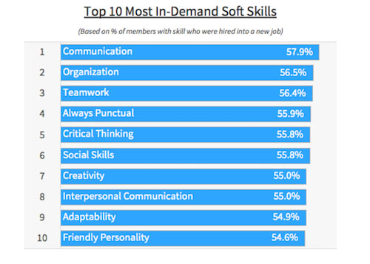

Figure

1. ***Valued in the workplace***

If you are applying for jobs or looking for a promotion with your current employer, you will almost certainly need to demonstrate good communication skills. Communication skills are needed to speak appropriately with a wide variety of people whilst maintaining good eye contact, demonstrate a varied vocabulary and tailor your language to your audience, listen effectively, present your ideas appropriately, write clearly and concisely, and work well in a group. Many of these are essential business skills that employers seek.

Having the ability to listen carefully, speak clearly and put others at ease is valuable in any organisation and can involve a wide range of skills:

* Listening to others and showing interest in what they say
* Dealing with telephone conversations appropriately
* Encouraging interest and interaction from others in your team
* Expressing an opinion or asking a question clearly
* Being able to persuade others

1. ***Helps your career progression***

You will need to request information, discuss problems, give instructions, work in teams, interact with colleagues and clients. If you are to achieve co-operation and effective teamwork, good human relations skills are essential. Also, as the workplace is also becoming more global, there are many factors to consider if you are to communicate well in such a diverse environment.

Being able to deliver messages clearly and understand other people means work can be completed more effectively and to the benefit of the company as a whole.

Employers want staff who can think for themselves, use initiative and solve problems, staff who are interested in the long-term success of the company. If you are to be seen as a valued member of the organization, it is important not just to be able to do your job well, but also to communicate your thoughts on how the processes and products or services can be improved.

1. ***Allows you to speak concisely***

It is natural to feel some nerves when speaking to superiors or to clients. Communication skills training will help you learn how best to communicate effectively in a wide range of situations, and how to be direct in order to get the most out of your dealings with others.

1. ***Builds better rapport with customers***

Customers desire nothing more than to be understood by a company and they wish to feel like they are being heard and listened to. This is a particularly important point if your business involves a large amount of contact with customers, either face-to-face or over the phone.

1. ***Influences how you learn***

Communication skills have played an important part of your existing knowledge and beliefs. You learn to speak in public by first having conversations, then by answering questions and then by expressing your opinions. You learn to write by first learning to read, then by writing and learning to think critically. Good communication skills help you absorb information and express your ideas in a clear, concise and meaningful way to other people.

1. ***Enhances your professional image***

You want to make a good first impression on your friends and family, instructors, and employer. They all want you to convey a positive image, as it reflects on them. In your career, you will represent your business or company in spoken and written form. Your professionalism and attention to detail will reflect positively on you and set you up for success.

1. ***Other benefits of effective communication***

The most successful organisations understand that if they are to be successful in today’s business world, good communication at all levels is essential. Here is a useful mnemonic to remember the benefits you and your organisations can achieve from effective communication:

* Stronger decision-making and problem-solving
* Upturn in productivity
* Convincing and compelling corporate materials
* Clearer, more streamlined workflow
* Sound business relationships
* Successful response ensured

***Methods of communication***

* Verbal communication is delivered and received face to face, by phone, radio, computer, television and other media.
* Non-verbal communication is delivered and received through body language, eye contact, gestures, and how we dress or behave.
* Visual communication is delivered and received via charts, maps, images and graphs.
* Written communication is delivered and received through printed or digital media such as letters, e-mails, books, magazines, and the internet.



Figure

## Verbal Communication

***Definition:*** The Verbal Communication is a type of oral communication wherein the message is transmitted through the spoken words. Here the sender gives words to his feelings, thoughts, ideas and opinions and expresses them in the form of speeches, discussions, presentations, and conversations.

The success of the verbal communication depends not only on the speaking ability of an individual but also on the listening skills. How effectively an individual listens to the subject matter decides the effectiveness of the communication. The verbal communication is applicable in both the formal and informal kind of situations.

**Examples of Verbal Communication Skills:**

Here are some examples of effective workplace verbal communication skills employed in different workplace contexts.

* ***Verbal Communications for Supervisors:*** The best supervisors don’t merely tell their subordinates what to do and expect them to listen. Instead, they employ active listening skills to understand employee needs and perspectives, engage in verbal negotiation to address and defuse issues, and capitalize upon opportunities to praise individual and team achievement.
* ***Verbal Communications for Team Members:*** Open and constant lines of communication are vital to team success, particularly when completing quality- and deadline-critical projects. One of the most important team-building skills, strong verbal communications help to ensure that issues will be spotted and resolved in formative stages, averting costly escalation.
* ***Verbal Communications with Clients:*** If a large part of your work involves one-on-one communications with customers, it’s helpful to have a “gift of gab” – particularly if you are a sales professional. Keep in mind, though, that your conversations need to be focused upon identifying and addressing your clients’ needs; using your verbal talents to encourage consultative dialogues will ensure positive client relations.
* ***Verbal Communications for Presenters:*** Public speaking is a talent that is honed both through practice and through formal training. Speaking articulately and persuasively to a live audience involves

## Non-verbal Communication

***Definition:*** Nonverbal communication, also called manual language, is the process of sending and receiving messages without using words, either spoken or written. Similar to the way that italicizing emphasizes written language, nonverbal behavior may emphasize parts of a verbal message.

Types of Nonverbal Communication:

1. ***Facial Expressions***

Facial expressions are responsible for a huge proportion of nonverbal communication.

Consider how much information can be conveyed with a smile or a frown. The look on a person's face is often the first thing we see, even before we hear what they have to say.

While nonverbal communication and behavior can vary dramatically between cultures, the facial expressions for happiness, sadness, anger, and fear are similar throughout the world.

1. ***Body Language and Posture***

Posture and movement can also convey a great deal of information.4﻿ Research on body language has grown significantly since the 1970s, but popular media have focused on the over-interpretation of defensive postures, arm-crossing, and leg-crossing, especially after publishing Julius Fast's book Body Language.

While these nonverbal behaviors can indicate feelings and attitudes, research suggests that body language is far more subtle and less definitive than previously believed.

1. ***Appearance***

Our choice of color, clothing, hairstyles, and other factors affecting appearance are also considered a means of nonverbal communication.8﻿ Research on color psychology has demonstrated that different colors can evoke different moods. Appearance can also alter physiological reactions, judgments, and interpretations.

Just think of all the subtle judgments you quickly make about someone based on his or her appearance. These first impressions are important, which is why experts suggest that job seekers dress appropriately for interviews with potential employers.

Researchers have found that appearance can play a role in how people are perceived and even how much they earn. One 1996 study found that attorneys who were rated as more attractive than their peers earned nearly 15 percent more than those ranked as less attractive.

Culture is an important influence on how appearances are judged. While thinness tends to be valued in Western cultures, some African cultures relate full-figured bodies to better health, wealth, and social status.

DEMONSTRATE THAT YOU HAVE USED EFFECTIVE TIME MANAGEMENT SKILLS IN PLANNING AN EVENT (P2)

Definition and the importance of time management skill

Definition:

Time management is the process of organizing and planning how to divide your time between specific activities. Good time management enables you to work smarter – not harder – so that you get more done in less time, even when time is tight and pressures are high.

Importance of time management skill:

* ***IMPROVE YOUR PERFORMANCE***

When you learn to block time out of your day for all your important tasks, you’ll have a better idea of everything you need to accomplish and how long each task should take. When you have a schedule to follow, you’ll likely find that you spend less time deciding what to work on or procrastinating and more time getting down to important work. Time management can help you focus on just the essential tasks ahead of you and avoid time-consuming distractions.

* ***PRODUCE BETTER WORK***

When you’re not constantly racing to meet a deadline, you can put more effort and thought into your work. Time management helps you prioritize your tasks so that you ensure you have enough time available to complete every project. The quality of your work increases when you’re not rushing to complete it ahead of a fast approaching deadline.

* ***REDUCE YOUR STRESS***

It’s easy to become anxious when you have a full list of tasks to accomplish both for work and in your personal life. Good time management can help you prioritize your to-do list and set aside the time needed for your most important tasks, so you know exactly what you need to do and how much time you have available to complete everything. Prioritizing your tasks and giving yourself enough time to accomplish them can help reduce your stress levels.

* ***IMPROVED CAREER OPPORTUNITIES***

Time management can help you become a more reliable employee who always submits high-quality work by your due dates. This in turn will make you more valuable as a worker and improve your professional reputation, which can help you find new opportunities to expand your career.

## Communication in my group

Communication is a mode of communication in an organization, between employers and employees, and employees in teams/groups. Group communication can further be looked from an marketing perspective as communicating to a group of people or target customers in order to market a product.

Verbal communication:

Language: It’s help group member to exchange information, discussion and solving problems

Non-verbal communication:

Body language: When presentation, it’s helps other people better understand the presentation

Eye contact: It’s help to show signature when something goes wrong or need pay attention. May help the member to present better.

DEMONSTRATE THAT YOU HAVE USED EFFECTIVE TIME MANAGEMENT SKILLS IN PLANNING AND EVENT (P2)

Definition and the importance of time management skill

Definition:

Time management” is the process of organizing and planning how to divide your time between specific activities. Good time management enables you to work smarter – not harder – so that you get more done in less time, even when time is tight and pressures are high.

The importance of time management skill:

**Time is limited.**No matter how you slice it, there are only 24 hours in a day. That applies to you, and to your coworker who only seems able to do half the amount of work you do. But it also applies to the former coworker who consistently accomplishes more than you, and was promoted as a result. If you want to rise through the ranks, you have to acknowledge the importance of finding a way to manage this limited resource.

**You can accomplish more with less effort.**When you learn to take control of your time, you improve your ability to focus. And with increased focus comes enhanced efficiency, because you don’t lose momentum. You’ll start to breeze through tasks more quickly (the workday will also seem to fly by).

**Become more successful in your career.** Time management is the key to success. It allows you to take control of your life rather than following the flow of others. As you accomplish more each day, make more sound decisions, and feel more in control, people notice. Leaders in your business will come to you when they need to get things done. And that increased exposure helps put you in line for advancement opportunities.

**Learning opportunities are everywhere.** Obviously, the more you learn, the more valuable you are to your employer. And great learning opportunities are around you, if you’ve got time to stop and take advantage them. When you work more efficiently, you have that time. You can help out with that new product launch your development team’s been working on.

Planning a training event (group work)

Name of the program: Orientation for IT student

Main goals:

* Provide general explanation and introduction of IT industry
* Provide opportunity for student to experience new learning and

working environment

* Provide student more knowledge about AI

Location: FPT software headquarter and Detech tower University of Greenwich

Participants: Student manager company, and guest

Date: From 1/1/2021 to 4/1/2021, 4 days total

Agenda:

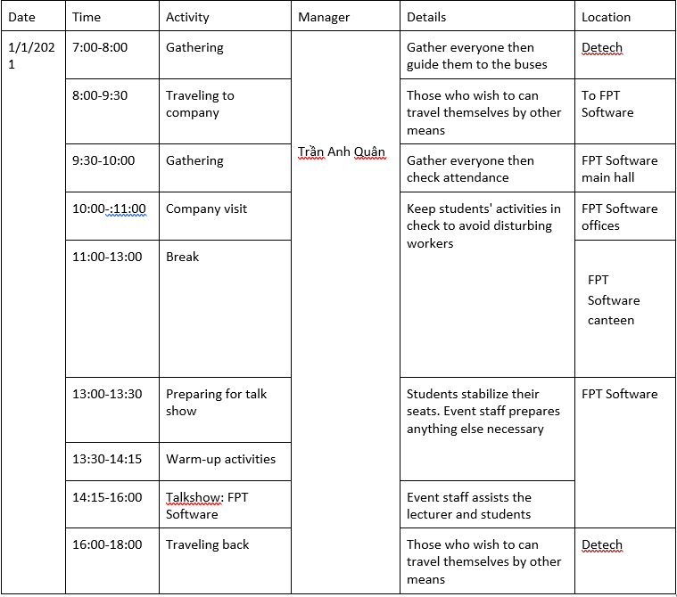

Figure

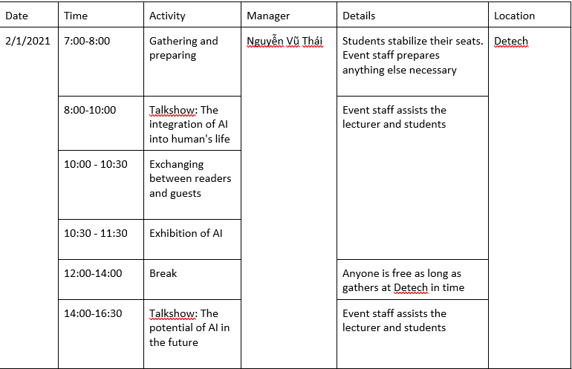

Figure

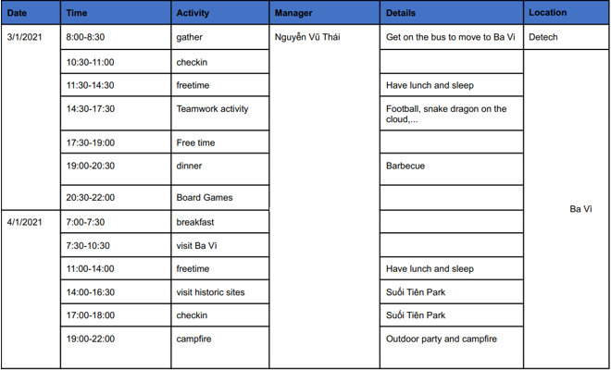

Figure

Estimated Budget:

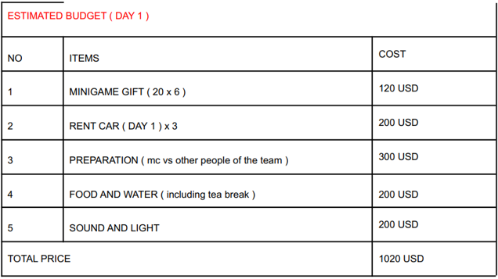

Figure

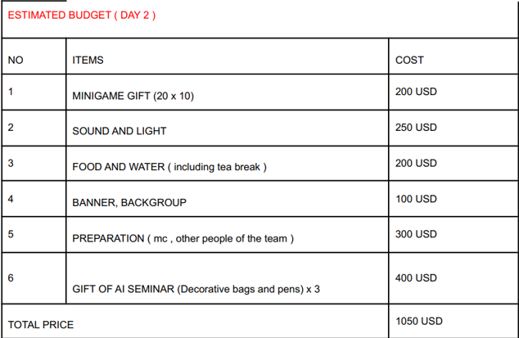

Figure

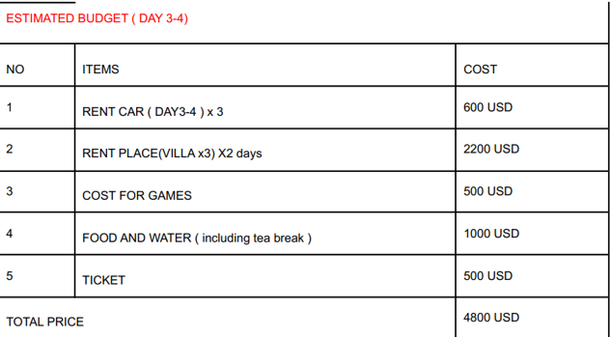

Figure

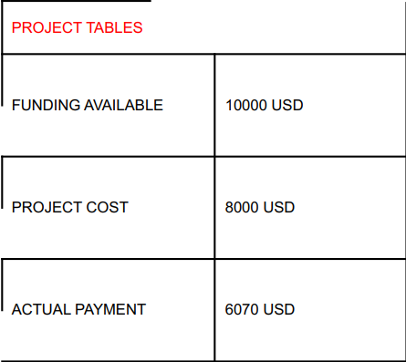

Figure

GANTT chart:

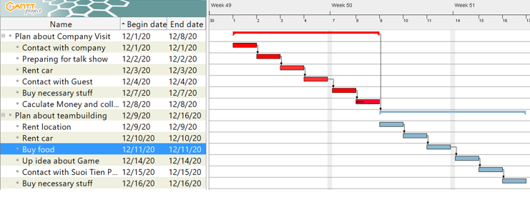

Figure

Slide for “Team Dynamic”

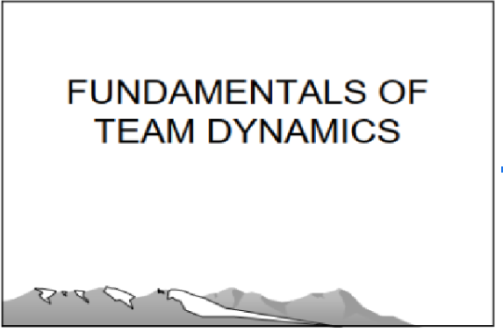

Figure

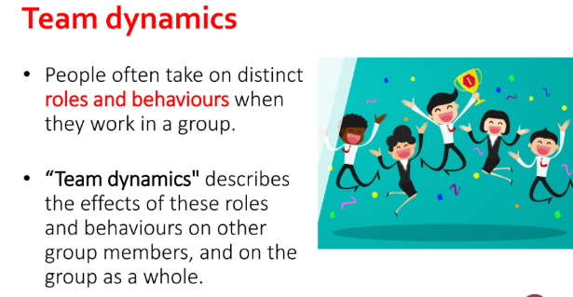

Figure

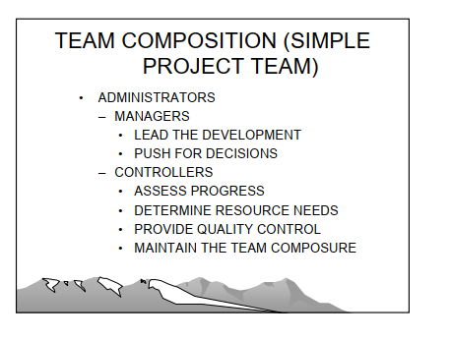

Figure

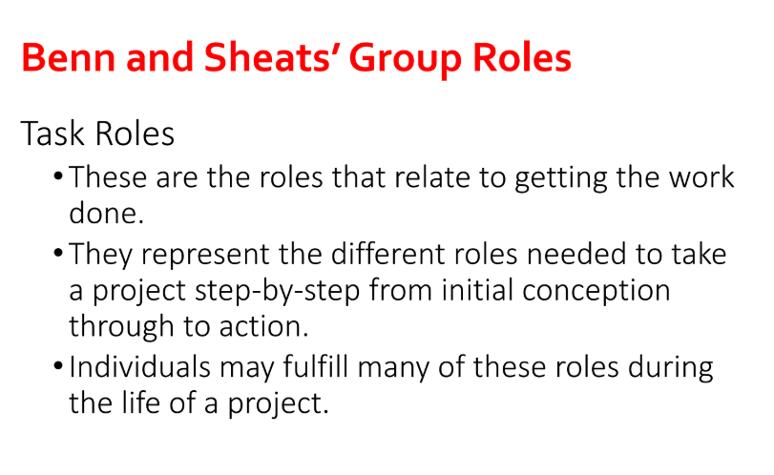

Figure

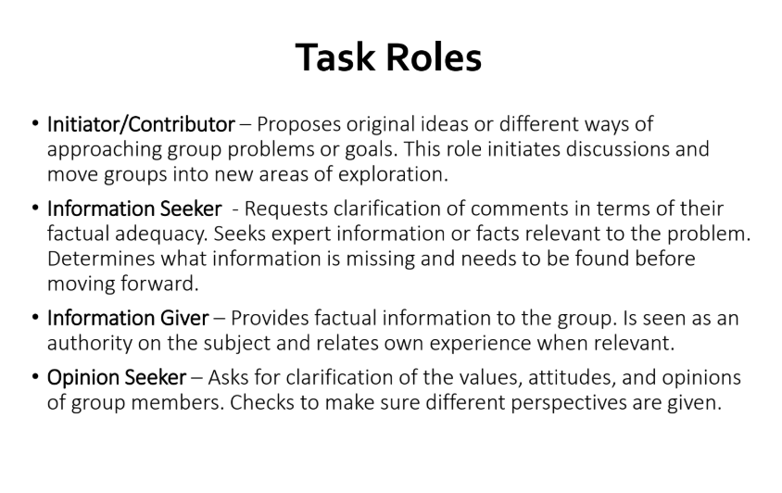

Figure

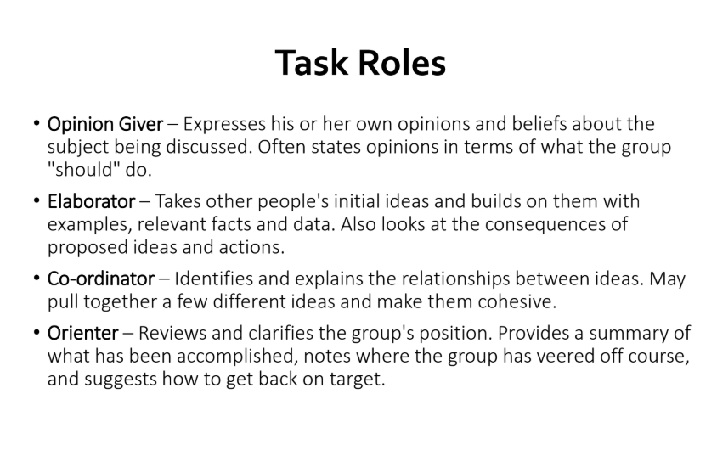

Figure

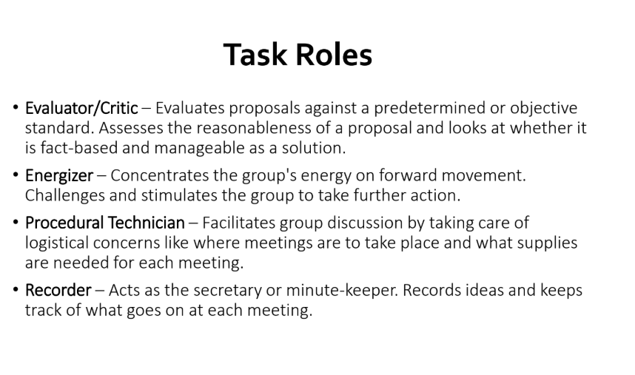

Figure

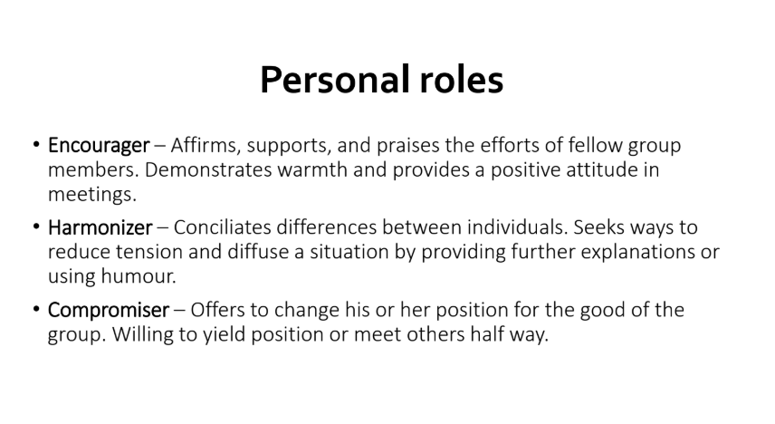

Figure

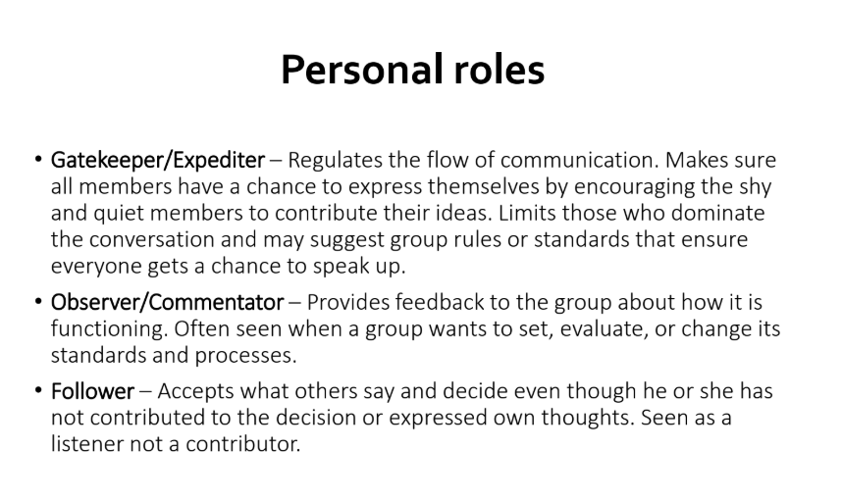

Figure

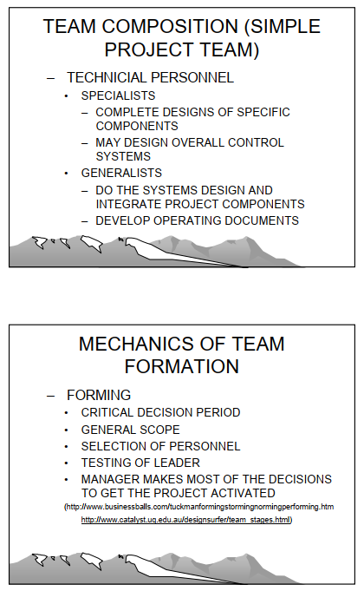

Figure

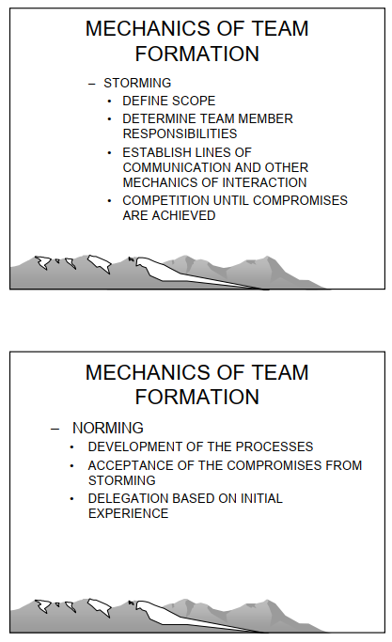

Figure

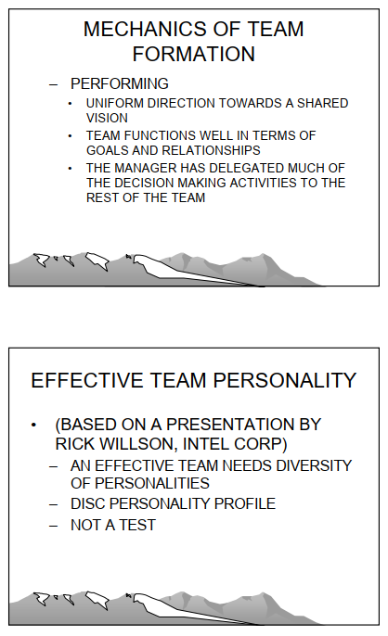

Figure

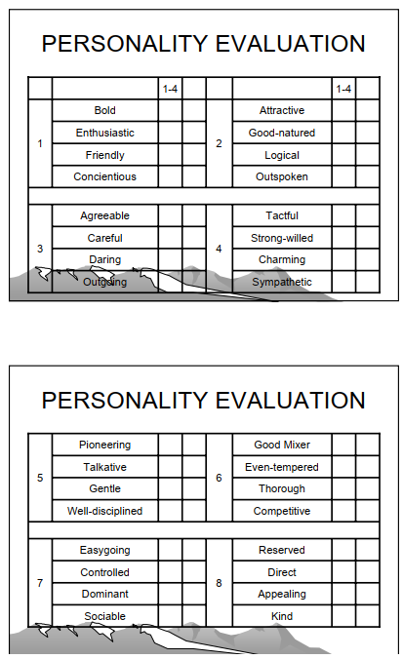

Figure

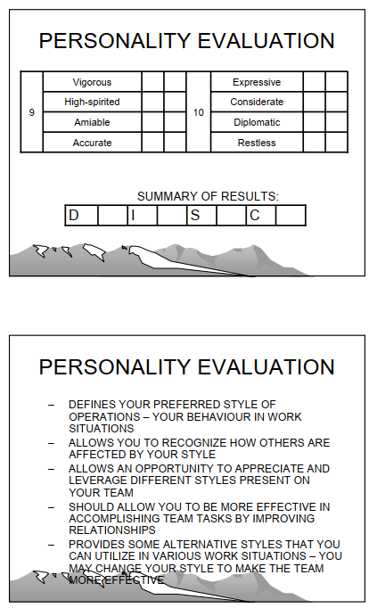

Figure



Figure

Speaker Notes:

Hello everyone, we are 3 group and Today We are here to present about Fundamental Team Dynamic

Team Dynamics: People often take on distinct roles and behaviours when they work in a group Describes the effects of these roles and behaviours on other group members Benn and Sheat's Group Roles Task Roles

We have at least 2 compostion in each team: administartors and technique personel

Next we go to Mechanics of team formation We should follow this team formation:

* Forming: Critical descision period, General scope, selection of personnel, testing of leader, Manager maes most of the descisions to get the project activated.
* Storming: Define scope, determine team member responsibilities,..
* Norming: Development of the preocesses, acceptance of the compromises from stroming Performing: uniform direction towards a shared vision, team functions,.

Next we go to Effective team personality: am effective tea, needdiversity of personalities, disc personality profile, not a test

1. Task Roles

* These are the roles that relate to getting the work done.
* They represent the different roles needed to take a project step-by-step from initial conception through to action.
* Individuals may fulfill many of these roles during the life of a project. Benn and Sheats’ Group Roles
* Initiator/Contributor – Proposes original ideas or different ways of approaching group problems or goals. This role initiates discussions and move groups into new areas of exploration.
* Information Seeker - Requests clarification of comments in terms of their factual adequacy. Seeks expert information or facts relevant to the problem. Determines what information is missing and needs to be found before moving forward.
* Information Giver – Provides factual information to the group. Is seen as an authority on the subject and relates own experience when relevant.
* Opinion Seeker – Asks for clarification of the values, attitudes, and opinions of group members. Checks to make sure different perspectives are given.
* Opinion Giver – Expresses his or her own opinions and beliefs about the subject being discussed. Often states opinions in terms of what the group "should" do.
* Elaborator – Takes other people's initial ideas and builds on them with examples, relevant facts and data. Also looks at the consequences of proposed ideas and actions.
* Co-ordinator – Identifies and explains the relationships between ideas. May pull together a few different ideas and make them cohesive.
* Orienter – Reviews and clarifies the group's position. Provides a summary of what has been accomplished, notes where the group has veered off course, and suggests how to get back on target.
* Evaluator/Critic – Evaluates proposals against a predetermined or objective standard. Assesses the reasonableness of a proposal and looks at whether it is fact-based and manageable as a solution.
* Energizer – Concentrates the group's energy on forward movement. Challenges and stimulates the group to take further action.
* Procedural Technician – Facilitates group discussion by taking care of logistical concerns like where meetings are to take place and what supplies are needed for each meeting.
* Recorder – Acts as the secretary or minute-keeper. Records ideas and keeps track of what goes on at each meeting.

1. Personal roles

* Encourager – Affirms, supports, and praises the efforts of fellow group members. Demonstrates warmth and provides a positive attitude in meetings.
* Harmonizer – Conciliates differences between individuals. Seeks ways to reduce tension and diffuse a situation by providing further explanations or using humour.
* Compromiser – Offers to change his or her position for the good of the group. Willing to yield position or meet others half way.
* Gatekeeper/Expediter – Regulates the flow of communication. Makes sure all members have a chance to express themselves by encouraging the shy and quiet members to contribute their ideas. Limits those who dominate the conversation and may suggest group rules or standards that ensure everyone gets a chance to speak up.
* Observer/Commentator – Provides feedback to the group about how it is functioning. Often seen when a group wants to set, evaluate, or change its standards and processes.
* Follower – Accepts what others say and decide even though he or she has not contributed to the decision or expressed own thoughts. Seen as a listener not a contributor.

Personality evalution:

Defines your preferred style of operations- your behaviour in work situations, allow you to recognize how others are affected by your style, allows an opportunity to appreciate and leverage different styles present on your team…

Thank for you attendance.

# DEMONSTRATE THE USE OF DIFFERENT PROBLEM-SOLVING TECHNIQUES IN THE DESIGN AND DELIVERY OF AN EVENT (P3)

## Definition and the importance of problem solving

Definition:

There are many definitions of problem-solving – but at a basic level, it focuses on the ability to accurately assess a situation and arrive at a positive solution.

Importance of problem solving:

* ***Make the inconceivable conceivable:*** Information alone isn't the key to understanding issues but or maybe, complimenting it with orderly problem-solving approaches makes the contrast. This makes a difference people and organizations overcome risky challenges.
* ***Makes you a stand out:*** Individuals are prepared to do the regular. They have procured abilities and information in what they do. Be that as it may, individuals can barely unravel issues when they are unforeseen or uncommon ones. On the off chance that you ended up a customary issue solver at your work environment, you're effectively taken note, recognized, and appreciated.
* ***Increased certainty:*** No matter where you work or what your calling is, having the capacity to fathom issues will boost your certainty level. Since you're beyond any doubt of your capacity to solve problems, you don’t spend time stressing approximately what you may do on the off chance that a issue ought to arise.

## Some techniques and tools for the problem solving:

5 Whys

The 5 Whys is a method that uses a series of questions to drill down into successive layers of a problem. The basic idea is that each time you ask why, the answer becomes the basis of the next why.

One application of this technique is to more deeply analyze the results of a Pareto analysis. Here’s an example of how to use the 5 Whys:

* Why is downtime in final assembly higher than our goal? According to the Pareto chart, the biggest factor is operators needing to constantly adjust Machine A
* Why do operators need to constantly adjust Machine A? Because it keeps having alignment problems
* Why does Machine A keep having alignment problems? Because the seals are worn
* Why are Machine A’s seals worn? Because they aren’t being replaced as part of our preventive maintenance program
* Why aren’t they being replaced as part of our preventive maintenance program?

Fishbone Diagram

A fishbone diagram sorts possible causes into various categories that branch off from the original problem. Also called a cause-and-effect or Ishakawa diagram, a fishbone diagram may have multiple sub-causes branching off of each identified category.

Pareto Chart

A Pareto chart is a histogram or bar chart combined with a line graph that groups the frequency or cost of different problems to show their relative significance.

The Pareto chart example above is a report from layered process audit software that groups together the top seven categories of failed audit questions for a given facility. Layered process audits (LPAs) allow you to check high-risk processes daily to verify conformance to standards. LPAs identify process variations that cause defects, making Pareto charts a powerful reporting tool for analyzing LPA findings.

5W1H

The 5W1H is an abbreviation of 5 What - When - Where - Why - Who - How English words. This is a very famous technical phrase not only because of their simplicity and ease of understanding, but also because of their very high applicability in many jobs, especially in business. They help businesses and business managers understand customer behaviors with their products / services, identify the exact problems they are facing, and make sound decisions.

## Problems and solutions in the event and teamwork

I choose 5W1H technique to solve problem in this event and teamwork

|  |  |  |  |  |  |  |
| --- | --- | --- | --- | --- | --- | --- |
| Problems | What | When | Where | Who | Why | How |
| Mic broken | Mic of speaker was broken | Speaker talking | Talk show | Set up teams | Forgot to charge the mic and no back up mic | Check carefully all equipment before talk show |
| Not enough money | Spending not appropriate then not enough money for other | Buy something next | Company | Accounting  Department | There is no clear consensus between member | Must have a clear discussion, grasp the market, detailed price |
| Bad Weather | Event is canceled due to bad weather | While teambuilding | Ba Vi | Set up teams | Not having a backup plan for bad weather | Always have a second venue in mind.  Create event plans B, C, D, and E. |
| Event mistake | Leaving little to no time for event set up or take down | Before next event in day | Ba Vi and Detech | Event teams | Why it is absolutely paramount that you as the event planner give your partners plenty of time – or as much time as the venue will allow – to get everything taken care of | Thinking ahead and communicating with everyone from the venue relationship manager to your team and your signage team will really help make sure the event begins and ends on a high note. |
| Teamwork Conflict | Conflicts between members while participating in teambuilding | While teambuilding | Ba Vi | Team members | The team's performance was not so good which led to some people not keeping their cool | Listen carefully the reason for the conflict and resolve it appropriately for both sides. |

# DEMONSTRATE THAT CRITICAL REASONING HAS BEEN APPLIED TO GIVEN SOLUTION (P4)

## Definition and the importance of critical reasoning

Definition:

You’ve surely heard of critical thinking, but you might not be entirely sure what it really means, and that's because there are many definitions. For the most part, however, we think of critical thinking as the process of analyzing facts in order to form a judgment. Basically, thinking about thinking.

Importance of Critical Thinking:

1. Critical Thinking Is Universal

Critical thinking is a domain-general thinking skill. What does this mean? It means that no matter what path or profession you pursue, these skills will always be relevant and will always be beneficial to your success. They are not specific to any field.

1. Crucial for The Economy

Our future depends on technology, information, and innovation. Critical thinking is needed for our fast-growing economies, to solve problems as quickly and as effectively as possible.

1. Improves Language & Presentation Skills

In order to best express ourselves, we need to know how to think clearly and systematically — meaning practice critical thinking! Critical thinking also means knowing how to break down texts, and in turn, improve our ability to comprehend.

1. Promotes Creativity

By practicing critical thinking, we are allowing ourselves not only to solve problems, but also come up with new and creative ideas to do so. Critical thinking allows us to analyze these ideas and adjust them accordingly.

1. Important for Self-Reflection

Without critical thinking, how can we really live a meaningful life? We need this skill to self-reflect and justify our ways of life and opinions. Critical thinking provides us with the tools to evaluate ourselves in the way that we need to.

## Apply to a given solution

In the Teamwork Conflict problem, I think above solution just a temporary solution. This solution just helps the conflict does not significantly interfere with team performance but not logic. For the best solution, I decide to:

First, you need to collect the views and opinions of both sides to avoid the conflict being "overblown" and putting all mistakes for a certain party. You can more effectively solve the problem if you have identified its source. Demonstrating their strengths and the inappropriate ones will help the parties see the problem from a different angle. You will need to set up a few meetings with stakeholders and ask them to give feedback on how they feel and about the current situation.

# PERFROMANCE EVALUTION

## Team member’s roles

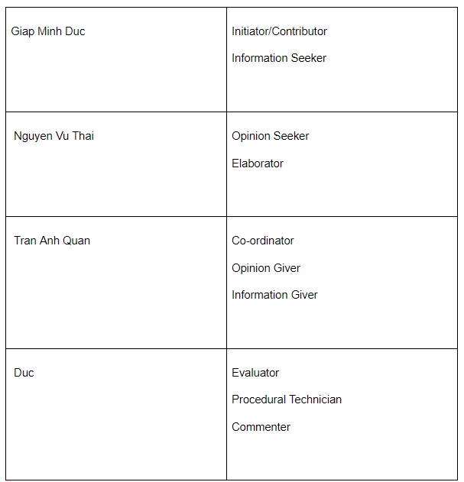

## My contribution

* During this group work, I tried to bring the new opinion to team member
* Work actively
* And connect member’s ideas to conclusion that help team growing and succeed in activities

# CONCLUSION

At the end of this assignment, I have explained the above skills in detail as well as how to resolve issues related to my group's operation.

# References

Virtualspeech.com. 2020. *Importance Of Communication Skills In Business*. [online] Available at: <https://virtualspeech.com/blog/importance-of-communication-skills> [Accessed 17 November 2020].

The Balance Careers. 2020. *List Of Verbal Communication Skills Employers Seek*. [online] Available at: <https://www.thebalancecareers.com/verbal-communication-skills-list-2059698> [Accessed 17 November 2020].

Verywell Mind. 2020. *What Are The 9 Types Of Nonverbal Communication You Might Be Missing?*. [online] Available at: <https://www.verywellmind.com/types-of-nonverbal-communication-2795397> [Accessed 17 November 2020].

Team, M., 2020. *Group Communication Definition | Marketing Dictionary | MBA Skool-Study.Learn.Share.*. [online] MBA Skool-Study.Learn.Share. Available at: <https://www.mbaskool.com/business-concepts/marketing-and-strategy-terms/7049-group-communication.html> [Accessed 15 December 2020].

Mindtools.com. 2020. *What Is Time Management?: Working Smarter To Enhance Productivity*. [online] Available at: <https://www.mindtools.com/pages/article/newHTE_00.htm> [Accessed 15 December 2020].

FreshBooks. 2020. *The Importance Of Time Management: Tips For Boosting Your Productivity*. [online] Available at: <https://www.freshbooks.com/hub/productivity/importance-of-time-management#:~:text=Time%20management%20is%20important%20for,business%20in%20a%20sustainable%20manner.> [Accessed 15 December 2020].

University of the People. 2020. *The Importance Of Critical Thinking*. [online] Available at: <https://www.uopeople.edu/blog/why-is-critical-thinking-important/> [Accessed 15 December 2020].