**ASSIGNMENT 1 FRONT SHEET**

|  |  |  |  |
| --- | --- | --- | --- |
| **Qualification** | **BTEC Level 5 HND Diploma in Computing** | | |
| **Unit number and title** | Unit 13:Computing Research Project | | |
| **Submission date** | 5/1/2022 | **Date Received 1st submission** |  |
| **Re-submission Date** |  | **Date Received 2nd submission** |  |
| **Student Name** | Ngo Tuan Anh | **Student ID** | GCH190543 |
| **Class** | GCH0803 | **Assessor name** |  |
| **Student declaration**  I certify that the assignment submission is entirely my own work and I fully understand the consequences of plagiarism. I understand that making a false declaration is a form of malpractice. | | | |
|  |  | **Student’s signature** |  |

**Grading grid**

|  |  |  |  |  |  |  |  |  |  |
| --- | --- | --- | --- | --- | --- | --- | --- | --- | --- |
| P1 | P2 | P3 | P4 | P5 | M1 | M2 | M3 | D1 | D2 |
|  |  |  |  |  |  |  |  |  |  |

|  |  |  |
| --- | --- | --- |
| **❒ Summative Feedback: ❒ Resubmission Feedback:** | | |
| **Grade:** | **Assessor Signature:** | **Date:** |
| **Internal Verifier’s Comments:** | | |
| **Signature & Date:** | | |

Table of Content

I. Introduction the purpose of the research 4

1. Choose particular topic of Remote working 4

2. Create a reseach question for your topic 4

3. Scope and purpose 4

II. Literature Review 4

1. Review Remote Working in general 4

2. Review the impact of Remote working on human being in the past and current now 4

3. Pros of working remotely 5

4. Cons of Remote Work 7

5. Identify your topic (research question) in the wider context 8

III. Primary research 11

1. Definition 11

2. Conclusion 12

3.Create question of Interview and survey 12

Interview 12

Servey 13

Observations: 13

4. Result of Interview and survey 14

Interview 14

SURVEY 15

OBSERVATION 19

IV.Analyse research findings 23

V. Conclusion 29

Recommend 29

Limited 30

VI. Research Ethics Approval Form 31

VII. Resference 35

# Introduction the purpose of the research

## Choose particular topic of Remote working

I chose the topic of Monitoring and Productivity Tools, their uses and implications.

This topic will mention the benefits and effects of distance learning tools for students. During the current covid 19 period, it is very difficult for students to go to school, all students and teachers have to limit their travel to prevent the epidemic, so the use of teaching tools is very difficult. Distance teaching is a must for all students and teachers so in this article I will research and learn about distance teaching tools.

## Create a reseach question for your topic

**How do online learning tools improve efficiency in universities during covid 19?**

I will explain to you why I chose this topic. Distance teaching tools are making learning more convenient, overcoming the limitations of online learning, besides, it helps students improve efficiency and create more motivation in learning. volume. However, there have not been many research papers on this issue or these reports have not been explored in detail yet. So in this report, I will conduct research on the utility and impact of distance teaching tools to help students improve their learning.

## Scope and purpose

In this report, I will take the scope of students from universities in Vietnam. They are the ones who have had a great impact on learning from covid, so the study of distance teaching tools will be well known to the students, so that it can easily serve my research. With the aim of understanding the utility and improving learning for students, this study will help students understand the positive effects of distance teaching tools and thereby improve the quality of learning. practice.

# Literature Review

## Review Remote Working in general

According to (remoteyear,2021): Remote working is a style of work allows people to work outside the traditional environment, work will be deployed and done anywhere. Beside, According to (vmware, 2021): working remotely is that workers can do their work but not in the office, that location can be their own home or anywhere outside of space traditional work.

In short, working remotely is working not in a traditional workspace, can work anywhere. People need to connect to working devices remotely to be able to work.Working remotely supports people during the Covid-19 pandemic instead of going to the office, school ... Every day to work from a designated place, everyone remotely can take their projects and pass their goals wherever they want. People have the flexibility to design their days so that their personal and professional lives can be experienced to the best of their ability.

## Review the impact of Remote working on human being in the past and current now

Previously in the past, working remotely was not as popular as it is now, people did not focus on working remotely because they thought it was quite inadequate and would not be as effective as working directly due to the unstable internet connection. communication restrictions, it is difficult to exchange information through a working remotely environment. The remote working jobs that are often chosen by people are part-time jobs, work from home to earn extra income or senior employees or learn through the web. However, nowadays due to the influence of covid 19, everyone can't come to work because they have to comply with the epidemic prevention order, so almost everyone is deploying working remotely. That has changed everyone's living time, at first everything was too confusing, but increasingly, working remotely shows more and more effectiveness when working or studying at home. People have the initiative in terms of time and space, work more efficiently, be more productive to help increase efficiency and work success quickly.

Here are some reports talking about the impact of working remotely on everyone today:

According to (White Papers, 2021): Remote working has increased by 159% since 2009. Although covid has made working remotely more common, it is not something new. In fact, working remotely has been popular for a long time because it helps employees to balance their lives.

According to (Buffer, 2021): 99% of people can enjoy working remotely for life. People tend to love the flexibility, freedom, and work-life balance over the years. Besides, most remote workers are in the top 3 industries: 15% from healthcare, 10% from technology and 9% from financial services (Owl Labs, 2021). 65% of workers in the US are willing to take a 5% pay cut to fully work remotely (Breeze, 2021). According to a survey of 1,000 American workers conducted by Breeze, the majority of participants agree to a pay cut in exchange for a fully remote position for a long time. 77% of telecommuting employees claim increased productivity while working from home (CoSo Cloud, 2021) . Author Survey of remote collaborators. This result suggests less stress, better health, and higher levels of motivation. Those are some of the effects of working remotely on people's lives, it gives us something new at work, improves parks, life balance and countless other benefits. But instead, their personal time will be reduced and can cause many other harms.

## Pros of working remotely

1. **Better work-life balance**

According to Kissflow( 2021): Working remotely will help employees have more free time to relax or do a hobby of theirs. That helps them feel more comfortable at work. beside , according to (ProofHub, 2021): working remotely helps employees balance work-life. Help them save a considerable amount of time to be able to spend time with family and children. That will help them feel happier in their family, thereby improving work productivity.

Therefore, working remotely helps to balance the lives of employees when they can balance their working time and their life time. According to a number of reports by Apollotechnical.com and Upwork, it is found that: 68% of hiring managers say that working remotely is more effective for them and 77% of employees who work remotely confirm increased work productivity. up while working from home.

1. **More freedom**

According to (Kissflow, 2021): when traditional employees work, they cannot work separately during their working hours, all of which must be done after working hours are over . However , teleworkers have the right to create their own schedule , they can do whatever time they feel comfortable or enjoy if they feel like it Most productive.Beside, according to (Fortune, 2021): they are free to run errands, send the kids to school or participate in sports activities, as long as they can. complete their tasks ahead of time, instead of the traditional work of having to wait until the allotted time to finish the job before they can do their own work.

In general, both reports show that the benefit of working remotely is more freedom, allowing them to be proactive in terms of time, working at any time they think is most effective. Helping them to be more productive, feel more comfortable and freer at work.

1. **Reduce cost**

According to (Kissflow, 2021): According to some studies, organizations can save $2,000 per employee when learning to work remotely by saving office space. and their infrastructure, beside , according to Staffingindustry : several studies indicate that US companies can save more than $500 billion a year with remote work. Not only reducing costs for the organization, working remotely also reduces costs for employees: because they do not have to move to the company or office, employees can save on travel costs. Employees can save more on clothing costs because they do not need to dress well to attend company parties (Fortune, 2021)

In general, working remotely helps to reduce costs for both the organization and its employees, which makes it possible for the organization to save a large amount of money on infrastructure rental and employee allowances or living expenses for the company. In addition, employees will also be able to reduce travel costs because they do not need to travel to the company, employees can save money on lunch or breakfast when at the company, reduce the cost of extra pages when not traveling to the company. have to go to company parties.

1. **Productivity increase**

According to (Kissflow, 2021): Employees working remotely will feel more comfortable than traditional office workers. Working remotely helps employees to focus more because there is not too much interruption in their work due to breaks or meals… The report shows that 77% feel more productive at home, 75 % feel uninterrupted while working from home. Beside, according to (Fortune, 2021): Employees feel more productive when they save on commuting time and are more focused when at home, working without distractions at the office.

Thereby, working remotely is a reasonable solution in today's epidemic period. It helps to increase employee efficiency as they work from home more focused.

In addition to the advantages reported by (Direct Recruiters Inc., (2021) indicated that it also shows that working remotely also helps to improve health. Some points of view indicate that working remotely helps them have more time to exercise, avoid contact with sick colleagues, if they are sick, it will make it easier to take care of themselves.

In terms of learning, working remotely also helps teachers and students adjust the progress according to the students' level. Easy schedule change and convenience for both teachers and students. They can study at home. Besides, online learning also helps the lesson not to be boring when the lesson is combined with entertaining games, helping students to reduce stress and fatigue after each study session. Each lecture will be recorded, so that students can review it at any time to review the ending. In addition, working remotely is also an ideal place for students to study effectively in groups.

All in all, working remotely from the network brings a lot of benefits to us, in all respects it appears, it makes everything easier and more convenient.

### Cons of Remote Work

1. **No face-to-face interaction**

According to (Kissflow, 2021): this is a significant disadvantage to working remotely, as it will not have direct interaction between team meetings, some worry afraid that working remotely will not work effectively when they are not able to interact directly with each other when doing traditional work. In many cases, employees feel lonely when they are not interacted with, and they can be Beside, according to (Fortune, 2021), many managers are concerned ,that not interacting directly with employees will make their employees unmotivated to work, making work less productive.

In general, both reports point to the negative side of working remotely, working remotely will reduce direct interaction between team members or within the company, which is a problem that needs to be solved for all projects business owners. So, the way to mitigate this: Managers can carefully plan weekly 1:1 meetings with each team member.

1. **Lack of information access**

According to (Kissflow, 2021): When working from home, employees will take longer to find information. When doing traditional work, they will need 30% of the time to be able to find information. While working remotely, this number can double as work done from home will not be guided by detailed management, which makes employees feel confused and depressed when working from home. It takes a lot of time to get a job done. Beside, according to (Direct Recruiters Inc., 2021), when employees working from home encounter some errors that they cannot fix, they will also have difficulty finding someone to solve the problem with them, it may take them a long time for them to solve the problem on their own, or they can't solve the problem on their own, which makes them feel bored and reduced their ability to work.

How to stay away from it: Integrate a unified digital workplace platform to make accessing all work-related data and applications easier for employees.

1. **Decreased collaboration**

According to: employees working remotely will have less opportunity to talk to each other, although this may not be necessary, it will help them feel more comfortable in work and life. they won't have intimate conversations like traditional work. Besides, according to (Direct Recruiters Inc., 2021), employees can easily interact with colleagues and clients through technology but it It won't be like a face-to-face meeting, there won't be a luncheon or informal conversation.

In general, both reports show that working remotely will make employees less collaborative when it comes to limiting working remotely when employees cannot meet to exchange or talk directly, which affects the environment. their work productivity to mitigate this: Organize informal team meetings to allow everyone to connect and catch up on a personal level.In addition to the negative aspects that Kissflow's report mentions, according to (Direct Recruiters Inc., 2021) there are also some disadvantages of working. remotely for example:

Need a high degree of discipline and self-discipline: working remotely will easily lose motivation and concentration, so it is important that they have purpose and determination. Besides, the author also points out that the opinion is completely contrary to the interests of Kissflow when pointing out that: working remotely will not give us the feeling of enjoying work-life balance. In life, we can't clearly separate the space between work and family, they will blend together, they can't stop working at work and find themselves constantly checking their phones and emails .

## Identify your topic (research question) in the wider context

During the covid 19 period, online teaching has solved many of the limitations brought by the covid 19 epidemic.So, in this report, I refer to the issue of How do online learning tools improve efficiency in universities during covid 19? And here are some of the reports that I have participated in. All of them researched on students' online learning during the covid period.

During the complicated period of covid 19 making all activities difficult, even students going to school are prevented, so using online teaching tools is a good solution to overcome difficulties. restore this situation. With online learning has opened up a different way of learning compared to traditional learning with the multitude of benefits that it brings, it is like a new wind that changes the way students learn, helping students feel more comfortable and easier to understand the lesson.

**The first problem that we mention is the effectiveness of learning tools for learning, make learning and teaching more convenient .**

According to (Khadijah Mukhtar, 2020): this report has outlined the advantages of online learning during the closure of facilities due to the covid 19 epidemic, the study explains the views of students and lecturers, showing that online learning methods make learning more efficient and flexible as most people agree that this makes distance learning easier, easier to manage and accessible at the same time with the use of less resources and time. Any student can easily access the material to study.Online learning will have very useful features such as whiteboards, chat rooms, polls, quizzes, discussion forums and surveys, allowing students and teachers to communicate with each other and share the content of the lesson.The survey has collected some opinions from students about the benefits of online learning such as convenience in the covid 19 situation when not having to go to school to implement epidemic prevention. Easier management: teachers can have permission to turn on and off microphones, share students' screens, and check if students are really listening to lectures, shy students in the classroom can easily easy to speak. Besides, the combination of learning and playing makes students feel excited.

After referencing this report, the author gives opinions and data to talk about the effectiveness of using online teaching tools. All opinions are directly surveyed by the author after using the online teaching application. They all align with the advantages of online learning that traditional learning does not have and make it easier for students to learn. However, the report does not specify the effectiveness of using online teaching tools in any way, besides, the report has very little data and limited scope, so the survey cannot be conducted. demonstrate all the advantages and disadvantages of online learning.

In addition, Ghada Refaat El Said (2021) surveyed 435 students and interviewed a sample of professors about their learning and teaching experiences using the tools for online teaching. The results have shown that almost all students are interested in and satisfied when using online teaching tools 74% agree that using online teaching tools is very easy to use and simple. portal simplicity and document accessibility. 62% of students agree that online learning can be accessed anywhere, anytime. On the other hand, the highest majority of students (89%) agree that the material available on the portal is adequate and that the lectures are presented in an organized and understandable manner. In general, the research paper has been surveyed by the author on a large number of students, the strength of this report is that it clearly shows the research data with a large scope. Most of the evaluations are positive when almost all students find it convenient to use online teaching tools, the positive indicators that the author surveyed are greater than 50%, It shows that most of the students are adapting well to online teaching tools and have a positive impact on learning.

In addition, according to (RabailTahir, 2020) : the report has extracted from 93 articles published in the past few years on kahoot, as revealed, most studies (88%) have shown how students and perceptions use kahoot. All research results show that learning outcomes have been improved for teaching methods using kahoot - a distance teaching tool. When using online teaching tools, the author showed that students were more active in learning, less late to class, more course materials, and higher overall scores (61% for gamification). learning compared to 53% for traditional). In addition, and the more efficiency supported by the technology performed significantly better in the latter test (scoring 90%) than the paper-based group (75% score).

In general, after reviewing this report, we can see that the author has made a comparison between traditional learning and online learning when using a specific application called Kahoot, all students' learning Students have improved after using online learning tools. However, these studies have not clearly shown how kahoot contributes to improving academic performance. That is an omission in the author's report and that will be my fill-up in my report.

In my opinion, All 3 reports show the convenience of online teaching tools. With the first report pointed out the advantages of working remotely in unniversity. The report has listed the advantages of online learning to make learning easier. Almost all students expressed satisfaction with online learning. However, the report also has some limitations and shortcomings that is the scope of the survey not large, the report only is 1 medical college with 12 students and 12 teachers after using it . with the second report , the main objective of the report is to talk about the benefits and effectiveness of kahoot for students and faculty , it creates a fun class , contributes to useful motivation to participate in the classroom , motivating students to actively interact with the classroom . With the third report, this report evaluated the use of online learning tool kahoot based on 93 reports. The goal of the report is to talk about the effectiveness that kahoot brings to students. Concluding, kahoot can have a positive impact on students compared to traditional learning.

**Besides the convenience that online teaching tools bring, online teaching tools also help students be more motivated to learn.**

According to (Fuster-Guilló, et al., 2019) , almost 88% of students feel more joyful when participating in using online teaching tools. Most students have a positive perception and positive attitude towards learning (56% believe it reinforces what has been learned and 48% believe it greatly promotes learning). that makes the lesson more interesting and easier for students to understand. In general, this report has shown the adaptability of the students when using online teaching tools. The figures show that students have improved their learning thanks to online teaching tools that keep them motivated to learn.This is a clear positive sign of motivation. Besides, Wang, Alf Inge; Tahir, Rabail (2020): also shows that: the results show that students use teaching tools Distance learning has had a positive impact on students, including improved class attendance, less lateness to class, more downloads of course materials, more active students in the classroom and, most importantly, higher overall score (61% for using online learning tools with 53% for traditional). Students' scores also increased significantly when supported by technology that performed significantly better on the latter test (scoring 90%) than the paper-based group (75% score). 70% of studies with tests of statistical significance on academic performance show that using online teaching tools significantly improves final grade or test results compared to other teaching methods is different. Most of the students were more motivated to learn when using distance learning tools, which resulted in improved student learning outcomes. With the data that the author has listed, we can see that the use of online teaching tools has helped students to be more competitive, more focused on the lesson.

However ,in another report (Ram Gopal, 2018), the factors that helped students to be motivated to learn to improve their learning were attention and concentration , interaction and participation , learning and knowledge retention . With a survey report on students participating in an online teaching application, the author has shown that online teaching tools attract and maintain their attention. Besides, it also makes it easier for students to interact with teachers, which has motivated them in the learning environment. Moreover , it is highly competitive , which is seen as a powerful motivator . Moreover, it is very convenient to study and review on teaching tools from the beginning, it has contributed significantly to promoting the learning motivation of students.

When I finished reviewing this report, I feel that the author has pointed out all the aspects that have helped students improve their learning when using online learning applications. All the factors that the author mentioned are completely convincing when it shows the limitations that traditional students face, causing students to lose motivation, but that has been resolved. When using distance learning tools. However, a small shortcoming that the author mentioned in their report is not clear that is the effectiveness of online teaching tools and the proven data. However, this is a very suitable report for me to refer to and based on this report to improve and develop, besides adding more data to my article to prove the effectiveness of the article. online teaching tools.

According to the two reports above, the authors have listed the factors and statistics to show that online teaching tools have improved students' learning. These factors have made students have a lot of motivation in learning. These reports will be good materials that can help me with my report on distance teaching tools.

The studies that I found above all show the benefits of distance learning and make distance education so popular today. However, there are some important things that the above reports have not pointed out or only outlined, which is the effectiveness of distance training tools. The reports all show the benefits of using distance learning tools, but it is still unclear how distance learning tools contribute to improving efficiency, besides there are no data yet. effectiveness specifically. Therefore, this report will study the effectiveness of online learning applications in universities during the current covid-19 epidemic.

# III. Primary research

## 1. Definition

Primary research is a research method that collects data that does not depend on data from previous studies. This is a study that needs to be done to address a specific problem that requires a thorough examination. “Target” is the most important advantage of this study, it focuses on a specific problem to find a solution.(QuestionPro.2021). Beside, another study shows that primary research is the kind of research you can do yourself. Include survey , interview , observation ... to collect data instead of depending on existing data . The researcher has full control over the data(Blog, 2021).

In general, the two reports show the definition of primary research. The difference between the two articles is that the author .(QuestionPro.2021) has pointed out the strength that primary research is "Target" - focusing on a problem and finding a solution.

- Interview: this is a method that has existed for a long time. These conversations will be conducted by the researcher either face-to-face or over the phone. This method will attract positive responses from the respondents because these questions are more personal, it helps the researcher to explore deeply in the mind of the respondents (QuestionPro. 2021). Besides, (Blog, 2021)indicates that, interview is a Type of qualitative data collection method that includes questioners and respondents through live conversation and Indirect. The interviews will have open-ended questions that allow respondents to share their thoughts. Besides, the researcher can use other tools to collect data including recorders, camcorders and cameras. In general, both articles state the definition of interview which is a qualitative data collection method including questioner and respondent. However, Blog( 2021) article mentioned interview support tools, but QuestionPro(2021)'s article did not mention this issue.

- Online surveys: this is a very convenient survey because it can be sent via email or can be completed online. Most devices with internet connection such as phones, computers, ipads ... can access them. Surveys will be launched by the researcher and sent to everyone to complete the survey and return the results to the researcher. (QuestionPro. 2021) . Besides, (Blog, 2021)has shown that this is a survey that can be considered as a means of opinion sampling because it collects diverse answers to research questions to help respondents understand in-depth about the research object.

- Obvervations: researchers will draw conclusions after considering the subject's reactions and takes notes. Such responses will be recorded using a webcam or observer. (QuestionPro. 2021). Besides, author Blog (2021) pointed out that this is a qualitative study, the researcher will closely examine the research subjects as they interact with the environment over a period of time. A certain time allows researchers to collect their behavior.

The reason I chose these 3 methods is because it helps me to better understand people's thoughts, easy to analyze information and easy to implement. With interview, this is a method that will help me gather specific opinions, go into many aspects of the issue. Besides, the tools for interviewing are very simple, just need to build conversation skills, but the positive response rate is very high. For Online servey, this is a quick method because the survey time is only 2/3 of other methods. With low cost because there is no cost to allocate time and resources. Besides, it can automatically analyze the collected data, which is extremely convenient for the researcher. Moreover, during the covid epidemic, limiting going out and using online survey tools is essential to prevent the epidemic. With the Obvervations method, this is a very reliable collection method, it can help me collect people's behaviors, with the above 2 methods having to rely on the question to collect data, this method helps I don't depend on their answers but still get good information.

## 2. Conclusion

After doing this research, we can understand what remote working is and how it affects teaching. With this report, I have outlined 2 main themes so that I can clearly explain my research question. With the first topic being the effectiveness of learning tools for learning, making learning and teaching more convenient while making it easier to find materials, increasing competition with others students, have functions that traditional learners do not. Learning becomes fun when learning and playing are combined, help students pay more attention to the lecture when combined with sounds and images. From this topic, it is possible to further analyze the usefulness and effectiveness of online teaching tools through interviews and surveys services or observations that I will make below to clarify my point of view.

In addition to the convenience that online teaching tools bring, online teaching tools also help students to be more motivated to learn, such as creating competition with students, motivating students to participate. Engage in more discussions with teachers, thereby helping to improve learning. Below, I will analyze this aspect in depth through a survey with university students to understand more about their change in motivation after using online teaching tools. online and from which conclusions can be drawn for my research paper.

## 3.Create question of Interview and survey

### Interview

1.How has the covid 19 pandemic affected your studies?

2.What did the school and you do to remedy the situation?

3.What tools does your school use to teach online?

4.How do you feel when using online teaching tools?

5.What are the advantages of online teaching tools that traditional teaching does not have?

6.With those advantages, how did it help your study?

7.For the above benefits, how have online teaching tools helped you improve your learning?

8.To make online learning more effective, what do you think needs to be done?

9.How have these improvements impacted your academic performance?

10.With the benefits it brings, Do you want to use online teaching tools to replace traditional learning? Why ?

### Servey

1.What is your name?

2. Are you using online teaching tools?(Yes, No, Maybe)

3. What teaching tools does it include?(Google Meets , Zoom , Classroom, Ms Team )

4. How do you feel about using distance learning tools?(Very satisfied, satisfied , Normal , Unsatisfied , Dissatisfaction)

5. What are the advantages you feel when using online teaching tools that traditional teaching does not have?( Teachers can allow students to share screens ; Online teaching tools have the function of turning off the mic and camera ; Teachers can add images, audio, and video to the lesson ; Learning is mixed with play, helping students not to be bored; use entertaining teaching tools for subjects such as Quizziz, Quizlet, Kahoot! ...)

6. What are the most important benefits of online teaching tools?( find documents faster; easier to cheat ; Easier to learn ; study every time and everywhere ; learning combined with play)

7. Do the benefits of distance learning tools help improve your learning?( completely improve learning ; a little improve ; unimproved; learning decline ; )

8. What are the main factors that help your learning improve when using distance learning tools?( Distance learning tools create high competition; Distance learning tools make it easy to find learning materials ; Motivate students to be active in learning, increase self-discipline. ; easily focus on the teacher's lecture ; Study every time and everywhere)

9. Do you want to use online teaching tools instead of traditional learning?( Should switch from traditional learning to online learning; Should learn both online and traditional learning methods ; Shouldn't study online but only traditional learning)

### Observations:

I start observing on December 18, 2021 on youtube and record interviews with the interviewees.

Date: 12/18/2021-12/24/2021

- 3 days on the impact of online learning tools on student learning

- 3 days for the challenge of online learning tools

## 4. Result of Interview and survey

### Interview

**1.How has the covid 19 pandemic affected your studies?**

I feel that the Covid-19 pandemic has greatly affected my studies. At the beginning of the epidemic, when the school did not have a way to implement remote learning methods, covid caused my learning to be stopped completely because I could not go to school. With that time, studying became very difficult for me.

**2.What did the school and you do to remedy the situation?**

With the current complicated epidemic situation, the school has allowed all students to stay at home to implement social distancing, prevent the spread of covid, and the school has implemented online learning. I feel this method is really effective and reasonable in this time period.

**3.What tools does your school use to teach online?**

Currently, our school has applied online teaching methods on the Microsoft Teams teaching application. Besides, as far as I know, the school also uses other teaching applications to improve learning for students such as quizizz, quilet or Kahoot.

**4.How do you feel when using online teaching tools?**

It's great that I was born during this time to be able to use those online teaching tools. Without it, I probably wouldn't be able to learn the knowledge that the teachers still teach. It is a very useful tool. Since using it, I feel that I am more interested in learning, listening more attentively.

**5.What are the advantages of online teaching tools that traditional teaching does not have?**

As far as I can see, with online teaching tools, it helps teachers' lectures become more vivid when combined with images, audio or video. Besides , the lectures will be archived into videos so that students can review the lectures or find documents more easily . Limiting travel when just staying at home can also attend classes. Therefore, it can help me be more active in terms of time. Those online teaching tools can also turn off the mic or turn off the camera, which is something I feel very interested in. Besides, it also helps me to discuss better with my teacher and my classmates without being shy. Furthermore , learning will often be accompanied by games , for example using quizizz , kahoot , quilet , which can accommodate both learning and playing without fear of the subject being boring. Those are the advantages that I feel traditional teaching methods do not have.

**6.With those advantages, how did it help your study?**

With those advantages, learning for me becomes really easy, it makes me feel more interested in learning. Has a lot of motivation to learn, Easy to absorb knowledge.

**7.For the above benefits, how have online teaching tools helped you improve your learning?**

After 1 year of using online teaching tools, I noticed that my learning has improved significantly, when I used to feel very lazy when looking for materials to learn, now, when using online teaching tool, my learning has become very easy, even the teachers' lectures are recorded, so there are places that I don't understand, I can replay the video to see . So, my subject scores have improved, before that my score was around 5-6. But now it has increased to 8-9 points per subject, I feel very happy about it.

**8.To make online learning more effective, what do you think needs to be done?**

For me, making online learning more effective is

First: we must choose a quiet place to listen to the lecture and not be disturbed.

Second: listen attentively to the teacher's lecture and review the recorded lectures to understand the lesson better.

Third: actively participate in group activities and give feedback to teachers.

**9.With the benefits it brings, Do you want to use online teaching tools to replace traditional learning? Why ?**

In my opinion, this is a temporary solution to prevent the spread of the disease, but with the benefits that it brings, perhaps I will also consider online learning and traditional learning. But now, I really like learning online because of the benefits it brings.

**Link audio:**

<https://drive.google.com/file/d/1vPm6P_zAupOj9V5chDT1CXsUtTyjmhqO/view?usp=sharing>

### SURVEY

**1.What is your name ?**

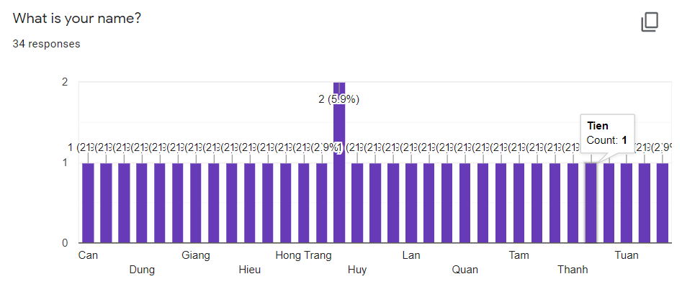

The subjects that I surveyed are all students of universities in Vietnam.

**2.Are you using online teaching tools?**

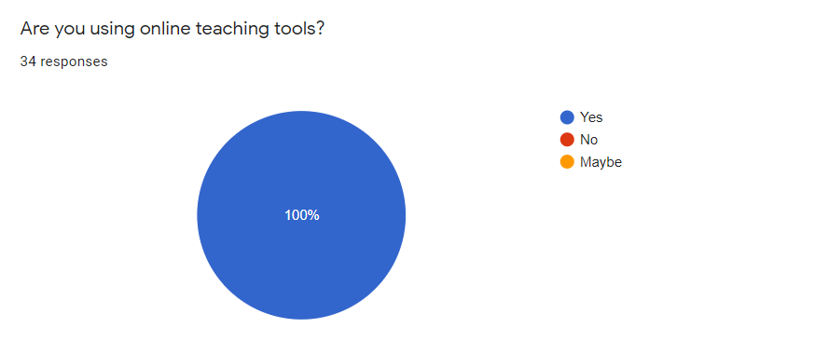

Most, 100% of students are using online teaching tools to implement their learning during the covid 19 pandemic.

**3.What teaching tools does it include?**

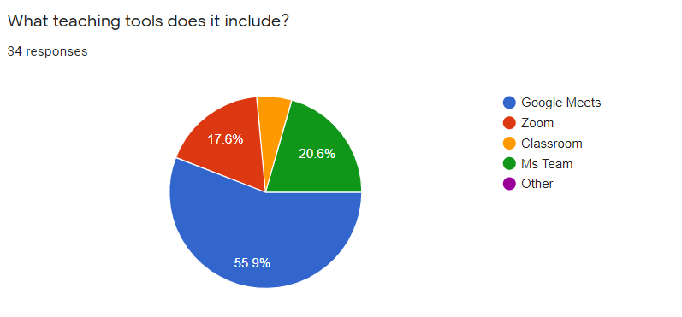

Most students use the teaching tool google meets to conduct online learning, accounting for 55.9%, followed by Microsoft's Ms team learning application accounting for 20.6%. Teaching tools like Zoom account for 17.6% and the remaining 5.9%, students use classroom tools to learn online.

**4.How do you feel about using distance learning tools?**

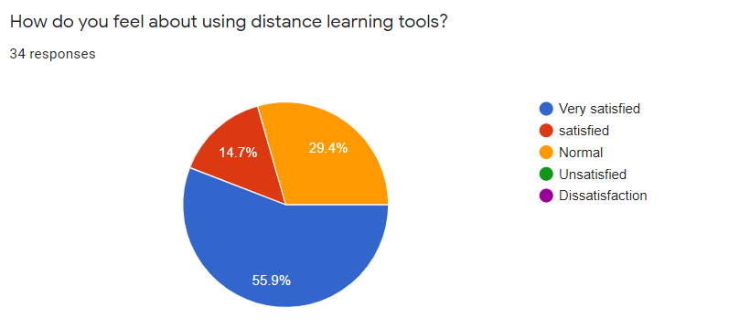

Almost all students feel satisfied when using online teaching tools, when 55.9% of students feel very satisfied, 14.7% of students feel satisfied and 29.4% feel satisfied. feel normal when using online teaching tools.

**5.What are the advantages you feel when using online teaching tools that traditional teaching does not have?**

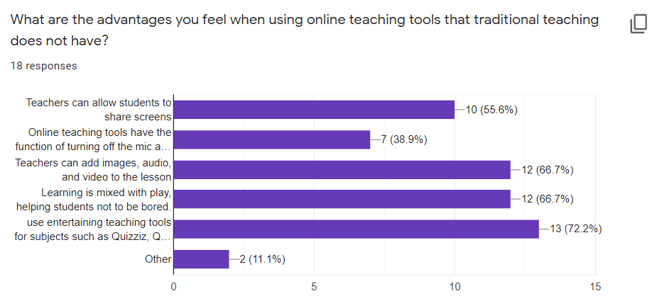

Most students feel that online teaching tools that allow students to turn on and off the mic and camera are the convenient for learning, accounting for 44.1%. Followed by online teaching applications that allow teachers and students to share screens accounted for 29.4%. 11.8% of students indicated that learning is mixed with play , helping students not to be bored.8.8% of students show that the strength of online teaching tools is that it can be used entertaining teaching tools for sub... 5.9% is the smallest number of students who think that online learning makes lessons more enjoyable should be more vivid when combined with audio, images, and video.

**6.What are the most important benefits of online teaching tools?**

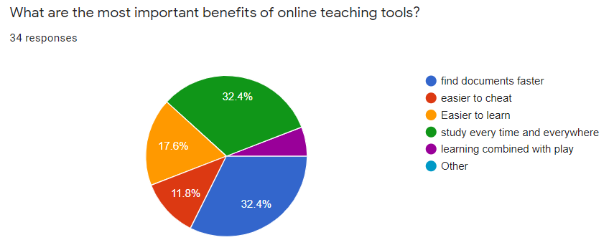

students said that the most important benefit of using online teaching tools is finding materials faster and being able to learn anytime, anywhere, both 32.4%. The next is easier to learn. accounting for 17.6% of the number of students. 11.8% is the number of students who choose easy to cheat. 5.9% is the smallest number of students who think learning combined with play.

**7.Do the benefits of distance learning tools help improve your learning?**

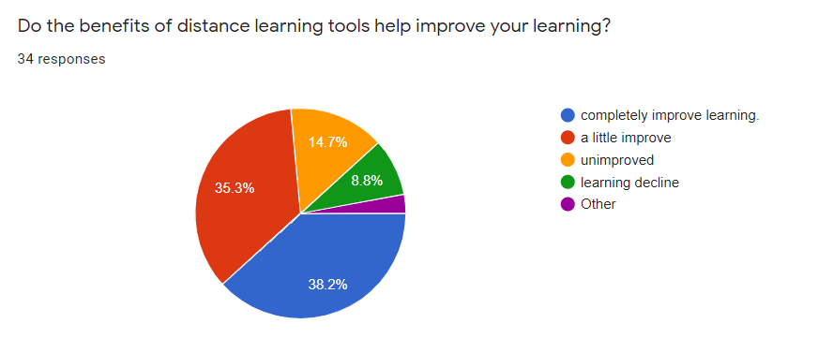

Most of the students feel that their learning has been improved when using online teaching tools when 38.2% of students think that online teaching tools help to completely improve learning. 35.3% of students said that their learning has improved slightly. 14.7% showed that their learning remained unchanged when using online teaching tools and only a small number of 8.8% of students said that their learning was reduced when learning online teaching tools. .

**8.What are the main factors that help your learning improve when using distance learning tools?**

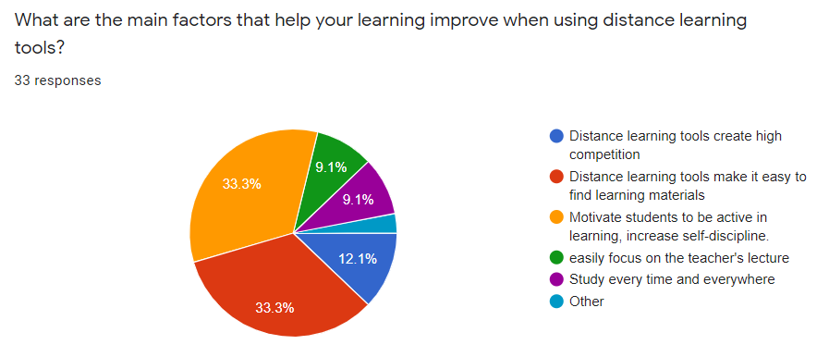

Students all said that the main factors that help students improve their learning when using online teaching tools are distance learning tools make it easy to find learning materials and motivate student to ve active in learning, increase self-discipline , both make up 33.3% of the student population. 12.1% of students think that Distance learning tools create high competition. Besides, easily focus on the teacher's lecture and study every time and everywhere . both accounted for 9.1% of the student population.

**9.Do you want to use online teaching tools instead of traditional learning?**

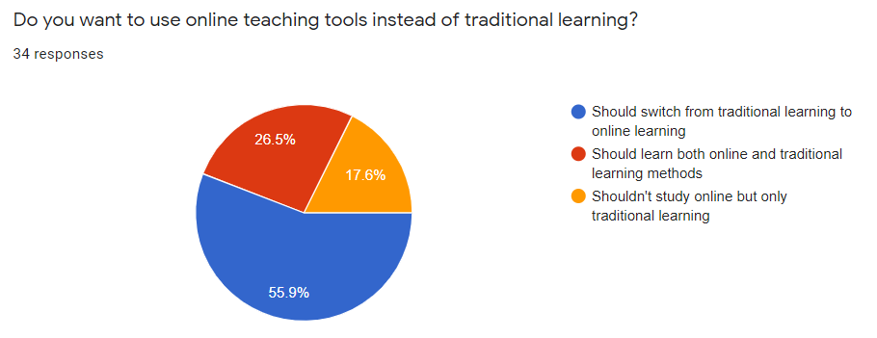

According to the survey, 55.9% of students want to switch from traditional learning to online learning because of the benefits it brings that traditional learning does not have. 26.5% of students think that both methods should be studied because both methods have useful aspects. 17.6% of students think that traditional learning should not be changed to online learning.

### OBSERVATION

**Opportunities and challenges of online learning in critical times of COVID-19**

Link: <https://www.youtube.com/watch?v=cpVuGN7iiNI>

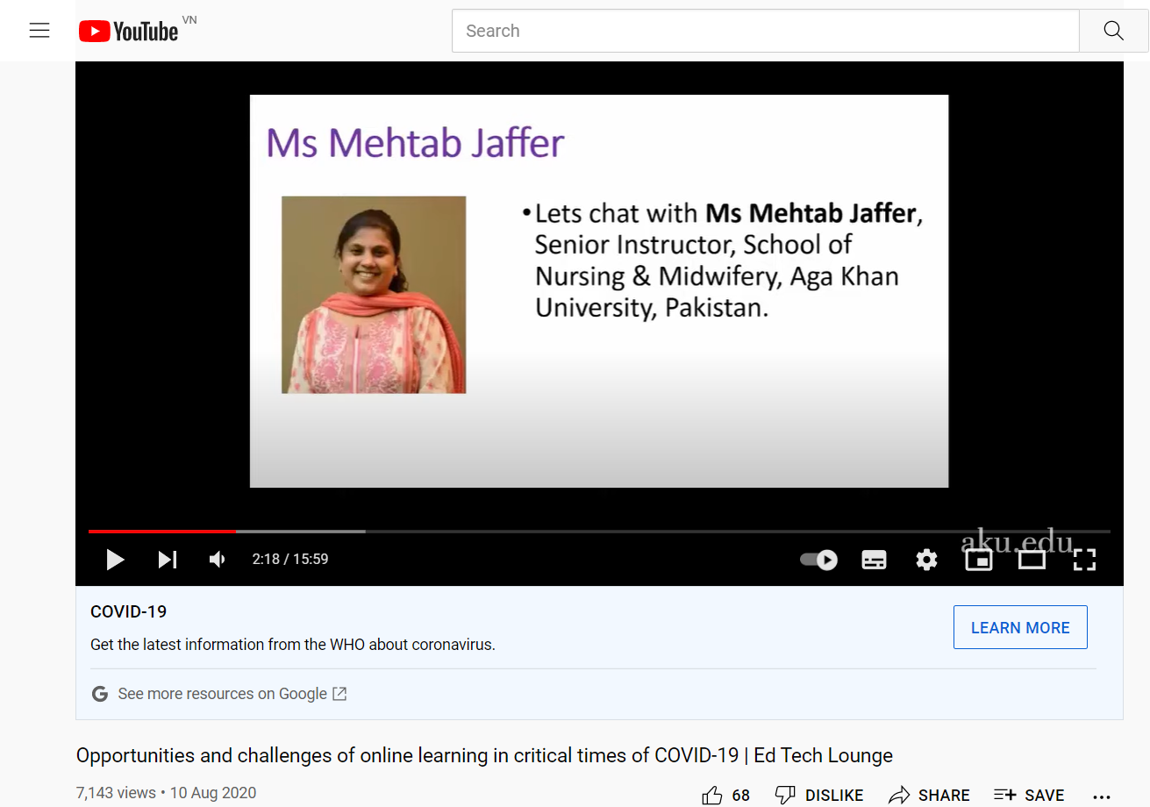

The video has talked about the impact of covid 19 on education, so this is an opportunity for online teaching tools to maximize their effects. Due to the covid 19 pandemic, all students have to study online. Online teaching tools help students access materials more easily. The students can discover questions and answers using google. Besides, the video says that online teaching tools can be used at any time. Online teaching tools make it easy for students to discuss with each other. Besides, it helps to motivate students as online teaching tools make students competitive, helping students to pay attention to the lecture.

**Lessons Learned During the COVID-19 Pandemic: Transitioning to Online Learning**

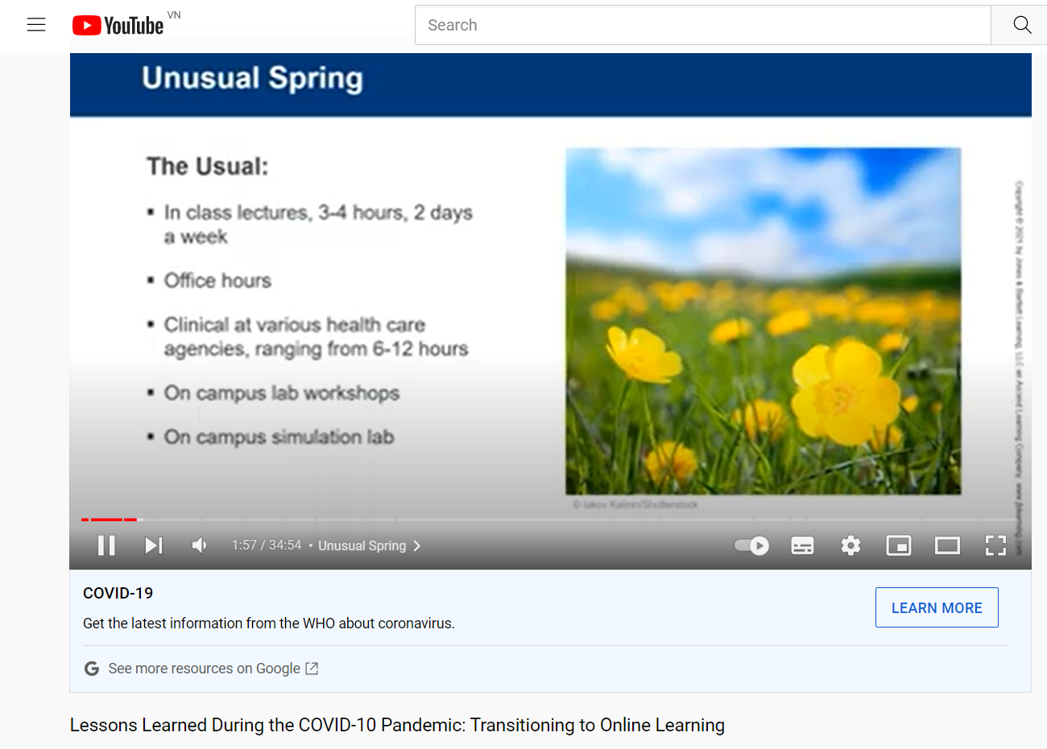

Link: <https://www.youtube.com/watch?v=16nBVi3xgds>

Due to the impact of the covid 19 pandemic, education has shifted to online learning. At first, teachers feel overwhelmed with online teaching tools because it has too many functions. However, after using it for a period of time, teachers are all interested in online teaching tools because it is very convenient. Besides, the students feel very interested when the lectures can be recorded, helping students who do not understand the lesson can review the lecture without delay. In addition, students easily interact with group members, helping each other in learning. Students can use games for learning like Kahoot… that helps students not get bored while studying. Besides, online teaching tools allow students and teachers to learn. can share the screen, allowing students and teachers to share documents with each other.

**Enhance your Online Learning Experience | 7 Tips to Improve Online Classes**

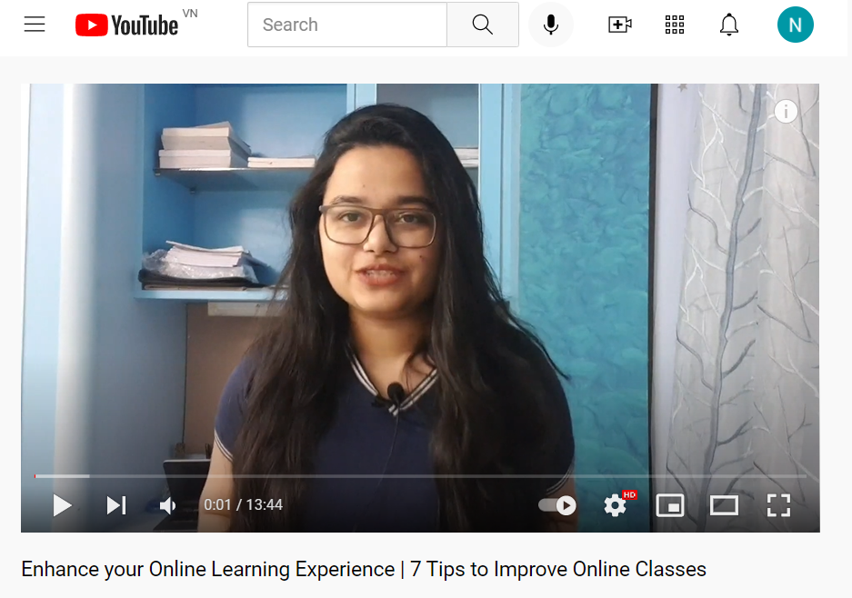

Link :<https://www.youtube.com/watch?v=dB2rMnBpTVk>

The video talks about ways to make online learning more effective. First, students need to be proactive in finding documents when the library of materials is endless. Second, the students should study in a quiet place and not be disturbed by anyone. Students need to know how to manage their timetable so that they can be active in their studies. In addition, students need to review recorded lectures to supplement their knowledge. In addition, students need to actively participate in group activities, actively interact with friends and teachers in the classroom to improve their learning.

**How is online learning changing higher education?**

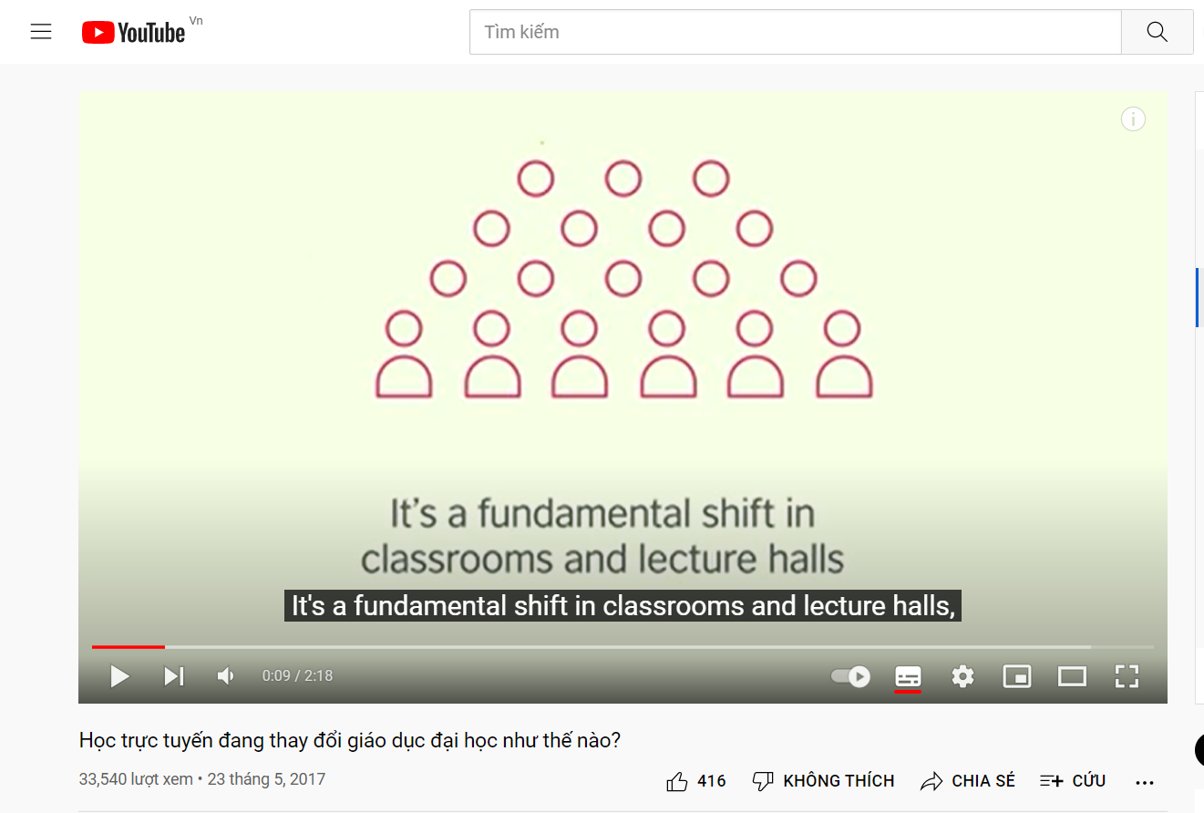

Link :[**https://www.youtube.com/watch?v=eDp-PzVY3og**](https://www.youtube.com/watch?v=eDp-PzVY3og)

The video talked about the change of education when using online teaching tools. When the whole world is going digital. online teaching tools can be accessed from any device such as phones, computers, laptops. Online learning helps students take the initiative in finding documents, making it easier for students to find documents. Besides, lectures become more diverse and richer when combined with video, audio, and images.

# IV.Analyse research findings

**Learning tools for learning, make learning and teaching more convenient .**

Online teaching tools increasingly popular, giving students a completely new way of learning. Online teaching tools have opened up a new learning method with many useful features that traditional teaching does not have, thereby helping students feel more interested in learning. According to Khadijah Mukhtar (2020) surveyed students and all obtained their satisfaction when using distance teaching tools when students pointed out the benefits of distance teaching tools that helped greatly benefit their learning.. For example: distance learning tools can use games to support learning to make students feel more comfortable…. In addition, according to CareerStep (2022): the author believes that when using online teaching tools, students can save time going to school and can study anywhere, allowing students to be comfortable with their studies time. Beside, Moore, B.(2022) Indicated that teaching tools are very suitable for busy people to help students take initiative in terms of time. Prove this point, the interviewees were asked How do you feel when using online teaching tools?. According to Nguyen Hong Trang, “It is a very useful tool. Since using it, I feel that I am more interested in learning, listening more attentively.” . She enjoys using distance learning tools as they are packed with features that make her learning easier. In addition, we also surveyed students to check their satisfaction with online teaching tools, giving the following results:



With 34 responses from students, we can see that the number of students feeling satisfied is up to 85.3%, in which the number of students feeling very satisfied is up to 55.9%. It shows that distance teaching tools have helped students feel more interested in learning. The special thing is that no student feels dissatisfied with online teaching tools. That shows that online teaching tools have done better than traditional teaching methods when it has full of utilities that even traditional teaching methods do not have. With the above conclusions, we can see that the students are all interested in using distance teaching tools when the students change their learning methods, it is like a new breeze that has changed. Change the learning methods of students during the current epidemic period.

Distance learning tools also have advantages that traditional learning does not have. To prove this point, according to the author (Khadijah Mukhtar, 2020): he surveyed the students and obtained the following results: Teachers and students can share screens, students can Turn camera and microphone off or on, use game tools to aid learning. In addition, we obtained the results of an interview with a student, who was asked the question What are the advantages of online teaching tools that traditional teaching does not have? Beside, according to Hospitalityinsights.ehl.edu (2022), distance teaching tools will help students feel more flexible when working, easily communicate with teachers and class members, easily document search... Those are the benefits that the author listed in their report. Furthermore, Online.illinois.edu (2022) indicated that students use distance learning tools to help students reduce travel costs, learning is combined with play tools to support for the class to help students feel not boring…According to Nguyen Hong Trang, online learning has many benefits that traditional learning methods do not have, such as: lectures are taught more abundantly when they are attached with videos, images, and audio. Camera and mic can be turned off and on, learn anytime, anywhere and limit travel, there are games to support learning such as Quizziz, Kahoot, Quilet... Those are the advantages that traditional teaching methods do not have. With traditional learning now making the students gradually feel bored when the lectures are not taught in a rich way, the students just sit and listen to the teacher for 2-3 hours without any fun. play and there is no innovation in djay teaching, now distance teaching tools have solved those problems of students, making the class more fun and effective. In addition, I surveyed students when asking about the features of online teaching tools that traditional teaching methods do not have and obtained the following results:



Most of these advantages are chosen by more than 50% of the surveyed students. Of which the most are (Use entertaining teaching tools for subjects such as Quizziz, Quizlet, Kahoot! ...) accounting for 72.2% of the surveyed students, which proves that traditional learning is very boring for 72.2% of the students surveyed, which is quite a high number to reflect the situation where traditional learning is not attracting students as lectures have gradually become more popular. boring and without games to help students have more energy to study and online teaching tools have done a great job when combined with entertainment tools to support learning like Kahoot , Quizziz , Quilet ... to help students enjoy learning more. Besides, there are advantages such as Teachers can add images, audio, and video to the lesson, accounting for 66.7% of the number of students participating in the survey. When the traditional teaching methods, the students only listen to the teacher for 2-3 hours with a book, it makes students feel extremely boring when going to school. However, online teaching tools have overcome that situation when lectures can easily add video, audio, and images, making the subject more diverse and interesting, helping students pay attention. more lectures. At least 38.9% are Online teaching tools have the function of turning off the mic and camera and 11.1% are other utilities. We can see that most of the surveyed students admit that these features have helped their learning which is proven when more than most methods are chosen over 50% of the students. pellets.

In addition, I also surveyed students about the most important advantages of online learning:



According to my survey, most of the students feel that the important benefits of using online teaching tools are finding materials faster and learning anytime, anywhere, both of which account for 32 percent of the total. .4% of students surveyed. With traditional learning, students have to find resources in books or in the library, which takes a lot of time and effort and is not really effective because the resources are not diversified and abundant. However, when students use remote teaching tools, they are used and searched on a huge library with a global reach like google, students can easily find documents more easily. with rich and diverse contents ... Besides , when studying traditionally , students have to default to school with the specified time period . That makes distant students feel tired when they have to go a long way to school and can't take the initiative in terms of time. However, when students use distance learning tools, as long as students use their phones or computers, they can join the class anywhere, which helps students take the initiative in space. and time .

Through the above studies, surveys and interviews, the advantages of distance teaching tools have greatly helped students' learning, which I have proven above.

**Online teaching tools also help students be more motivated to learn.**

Besides the benefits that distance learning tools bring, it also helps to improve student learning. To prove the point above, according to the author Wang, Alf Inge; Tahir, Rabail (2020) have shown that remote teaching tools make students download more materials, actively participate in discussions with groups and teachers, creating a competitive environment for students. , the students participate in the class more fully. These are the author's conclusions when surveying the students. The author has pointed out the aspects that help students improve their learning when using distance teaching tools, all of the factors that the author mentioned are completely convincing when pointing out the problems that students learn. Traditionally, students feel unmotivated to learn, but distance learning tools have solved that problem. Furthermore, Pearson - Always ESL Blog(2022) indicated that distance teaching tools help students improve group learning, making it easier for students to communicate with group members and teachers, besides there, it creates a more competitive environment, more active participation in the class...Besides, I interviewed a student with the question How have online teaching tools helped you improve your learning?. According to Nguyen Hong Trang, she has studied harder than before, learning has become easier, her subject scores have increased from 5-6 points to 8-9 points per subject. With the above-proven advantages, we can see the factors that have helped students to be more motivated in learning, which are easy to find documents, discuss and communicate with groups and students. more teachers , rich and varied lectures… that makes students enjoy learning and has improved their learning. In addition, I have conducted a survey with students at different universities. university with the question Do the benefits of distance learning tools help improve your learning? and get the result:



According to the survey, we can see that the number of students who feel they have improved their learning is up to 73.5% (both of completely improe learning and a litlte improve). In which, the number of students who feel completely accounted for 38.2% is higher than all other options, which shows that online learning has really improved students' learning a lot. Part of the reason is that distance learning tools have helped students have more motivation to learn when students have improved teamwork, better interact with friends and teachers, attentive to lectures more and many other factors that traditional teaching methods cannot meet . However, there are still some students who feel that online learning has not really improved their learning and is somewhat decreasing, but it only accounts for a small percentage of students surveyed.

With such improvement in learning , to clarify the above point , I asked the students what were the main factors that helped their learning improve and got the following results :



According to the survey, Motivate students to be active in learning materials and distance learning tools make it easy to find learning materials, both accounted for 33.3% of the number of students participating in the survey. When using distance learning tools, finding materials is really easy. Instead of traditional learning, students have to find documents in books and school libraries, which makes students spend a lot of time searching and the materials are not rich and diverse. However, when using distance learning tools, students can search for documents on google, this is an extremely large library, containing all the knowledge of mankind, which makes students exposed to the world, more knowledge and more convenient than traditional learning. Besides, distance teaching tools help students have higher self-discipline. When online learning can be learned anytime, anywhere, it helps students to be more proactive in terms of time and space, helping students to be more active when participating in classes when the number of students increases. Student absenteeism has tended to decrease when studying online. Moreover, when using distance learning tools, students must complete assignments on time as assigned by teachers, which helps students to be more active in doing assignments. Furthermore, distance learning tools create high competition accounted for 12.1%. When students use distance learning tools, they can participate in games to earn points, which helps students to speak up and actively contribute to the lecture. In addition, distance learning tools will make it difficult for students to cheat, when there are many anti-cheat tools for schools to apply in exams, it will help students actively study. old to check but can't cheat. This is followed by Study every time and every where and easily focus on teacher's material, both of which account for 9.1%.

With these views in mind, I interviewed a student: Do you want to use online teaching tools to replace traditional learning? Why ? According to Nguyen Hong Trang – “I feel this is a temporary relief, but given the benefits of distance learning tools, she will choose distance learning tools.” We can see that distance learning tools have brought a new learning method, overcoming the disadvantages that traditional learning is facing when distance learning tools have many conveniences and improvements. improve student learning. In addition, I surveyed a group of students whether they wanted to use distance learning tools instead of traditional learning and got the following results:



According to the survey, the number of students who want to switch from traditional learning to using distance learning tools accounted for 55.9% of the surveyed students, which showed the influence of the companies. distance learning tools for students' learning when distance learning tools have solved traditional learning problems such as difficulty in finding materials, fear of communicating with friends and teachers, members, not actively participating in group activities or bored when knowledge is not rich and diverse. Besides, the number of students who want to learn both traditional and online learning methods is 26.5% and 17.6% of students are not ready to switch to using distance learning tools.

# V. Conclusion

## Recommend

After analyzing the data I collected, we can see that all agree with my point of view.

Online learning makes it easier for students to find documents when they have access to an online library (more diverse and richer). when using distance learning tools, students can search for documents on google, this is an extremely large library, containing all the knowledge of mankind, which makes students exposed to the world, more knowledge and more convenient than traditional learning(Nguyen Hong Trang , 2021)

Online learning helps students focus more on lectures when lectures are combined with audio, images, and videos. That helps students feel more interested in learning.

Online learning makes learning easier and more convenient for students. Distance learning tools have many utilities that overcome the problems of traditional learning. For example : teachers and students can share screens , and turn mic and camera on and off . Any student can easily access the material to study.Online learning will have very useful features such as whiteboards, chat rooms, polls, quizzes, discussion forums and surveys, allowing students and teachers to communicate with each other and share the content of the lesson (Khadijah Mukhtar, 2020)

Online learning makes student learning more enjoyable and enjoyable. Distance teaching tools come with play , teachers can use games on remote teaching tools to help students feel not bored while learning . According to Khadijah Mukhtar (2020) surveyed students and all obtained their satisfaction when using distance teaching tools when students pointed out the benefits of distance teaching tools that helped greatly benefit their learning.. For example: distance learning tools can use games to support learning to make students feel more comfortable…

Distance learning tools help improve student learning. Students are competitive in a healthy environment, actively participate in group activities and actively respond to teachers and other students. Wang, Alf Inge; Tahir, Rabail (2020) indicated that remote teaching tools make students download more materials, actively participate in discussions with groups and teachers, creating a competitive environment for students. , the students participate in the class more fully.

## Limited

With the complicated epidemic situation, making the interview difficult when everyone restricts going out to protect themselves from the epidemic. That allowed me to do very few interviewers. In addition , the responses of the interview did not go into depth . About the report , I have not yet rated other researchers' reports well, I will try to improve these issues in the future.

# Plan of Research

|  |  |  |  |
| --- | --- | --- | --- |
|  | **Name** | **Begin date** | **End date** |
| **Research Question** | Create research question | 23/11/21 | 31/11/21 |
| Create Research proposal form | 23/11/21 | 26/11/21 |
| **Writing literature review** | Check project progress: Literature review | 29/11/21 | 30/11/21 |
| Preparation | 1/12/21 | 3/12/21 |
| Take feedback from the Totor | 6/12/21 | 9/12/21 |
| Get feedback from the Totor | 10/12/21 | 16/12/21 |
| Represent the findings | 17/12/21 | 21/12/21 |
| **Assignment 1** | Writing assignment 1 | 23/12/21 | 28/12/21 |
| Submit assignment 1 – Draft | 29/12/21 | 31/12/21 |
| Submit assignment 1 - Final | 3/1/21 | 4/1/12 |
| **Assignment 2** | Writing Assignment 2 | 5/1/21 | 5/1/21 |
| Submit assignment 2 – Draft | 6/1/21 | 6/1/21 |
| Presentation | 7/1/21 | 7/1/21 |
| Submit assignment 2 - Final | 10/1/21 | 10/1/21 |

# VI. Research Ethics Approval Form

**Section One: Basic details**

Project title: Monitoring and Productivity Tools, their uses and implications.

Student name: Ngo Tuan Anh

Student number: anhntgch190543

Programme: ..................................................................................................................................................................................................................................................................

School: Greenwich University

Intended research start date: 5/10/2021

Intended research end date: 4/1/2022

**Section Two: Project summary**

Please select all research methods that you plan to use as part of your project:

• Interviews x

• Questionnaires

• Observations x

• Use of personal records x

• Data analysis x

• Action research

• Focus groups

• Other (please specify): ..................................................................................................................................................................................................................................

**Section Three: Participants**

Please answer the following questions, giving full details where necessary.

Will your research involve human participants?

-Yes , I will.

Who are the participants? Tick all that apply:

Children aged 12–16:   Young people aged 17–18: **x**  Adults: **x**

How will participants be recruited (identified and approached)?

-All participants are university students

Describe the processes you will use to inform participants about what you are doing:

- I will go directly to them or can contact them through the media, or can send a google form to them for survey.

How will you obtain consent from participants? Will this be written? How will it be made clear to participants that they may withdraw consent to participate at any time?

- For face-to-face meetings, I will receive their participation answers. If working remotely, they can email or text me if they want to participate or withdraw their consent to participate at any time.

Studies involving questionnaires:

Will participants be given the option of omitting questions they do not wish to answer?

Yes: **x** No: 

If No please explain why below and ensure that you cover any ethical issues arising from this:

Studies involving observation: Research on the utility and effectiveness of distance teaching tools.

Confirm whether participants will be asked for their informed consent to be observed.

Yes: **x**   No: 

Will you debrief participants at the end of their participation (i.e. give them a brief explanation of the study)?

Yes: **x**  No: 

Will participants be given information about the findings of your study? (This could be a brief summary of your findings in general.)

Yes: **x**   No: 

**Section Four: Data storage and security**

Confirm that all personal data will be stored and processed in compliance with the Data Protection Act (1998):

Yes: **x**  No: □

Who will have access to the data and personal information?

- Only the person being studied has access to personal data and information.

**During the research:**

Where will the data be stored? The data is stored by me on word or excel, or google drive

Will mobile devices (such as USB storage and laptops) be used?

Yes: **x**  No: □

If yes, please provide further details: The data can also be accessed from other devices.

**After the research:**

Where will the data be stored?

- Data is saved in word format

How long will the data and records be kept for and in what format?

- Data will be stored and secured for other research.

Will data be kept for use by other researchers? Yes.

Yes: **x**  No: □

**Section Five: Ethical issues**

Are there any particular features of your proposed work which may raise ethical concerns?

-No

If so, please outline how you will deal with these:

It is important that you demonstrate your awareness of potential risks that may arise as a result of your research. Please consider/address all issues that may apply. Ethical concerns may include, but are not limited to the following:

**Section Six: Declaration**

I have read, understood and will abide by *[insert centre name]* Research Ethics Policy:

Yes: **x**  No: □

I have discussed the ethical issues relating to my research with my Unit Tutor:

Yes: **x**  No: □

**I confirm that to the best of my knowledge:**

The above information is correct and that this is a full description of the ethics issues that may arise in the course of my research.

Name: Ngo Tuan Anh

Date: 4/1/2022

**Please submit your completed form to:** CMS Greenwich University......................................................................................................................................................................

# VII. Resference

1. Remote Year. 2021. What is Remote Work?. [online] Available at: <https://www.remoteyear.com/blog/what-is-remote-work> [Accessed 3 December 2021].
2. VMware. 2021. Remote Work. [online] Available at: <https://www.vmware.com/topics/glossary/content/remote-work> [Accessed 3 December 2021].
3. Global Workplace Analytics. 2021. White P.apers. [online] Available at: <https://globalworkplaceanalytics.com/whitepapers> [Accessed 3 December 2021].
4. Lp.buffer.com. 2021. State of Remote Work 2020. [online] Available at: <https://lp.buffer.com/state-of-remote-work-2020> [Accessed 3 December 2021].
5. Owllabs.com. 2021. 2019 State of Remote Work Report. [online] Available at: <https://www.owllabs.com/state-of-remote-work/2019> [Accessed 3 December 2021].
6. Meetbreeze.com. 2021. [online] Available at: <https://www.meetbreeze.com/blog/employees-give-up-benefits-salary-remain-remote> [Accessed 3 December 2021].
7. CoSo Cloud | Secure Virtual Training & Collaboration. 2021. Press Release | CoSo Survey Shows Working Remotely Benefits. [online] Available at: <https://www.cosocloud.com/press-releases/coso-survey-shows-working-remotely-benefits-employers-and-employees> [Accessed 3 December 2021].
8. Kissflow. 2021. Working Remotely Pros & Cons You Must Know Before Going Remote. [online] Available at: <https://kissflow.com/digital-workplace/remote-work/pros-and-cons-of-working-remotely/> [Accessed 3 December 2021].
9. ProofHub. 2021. Pros and Cons of Working Remotely That You Should Know. [online] Available at: <https://www.proofhub.com/articles/pros-and-cons-of-working-remotely> [Accessed 3 December 2021].
10. Fortune. 2021. Commentary: The pros and cons of working remotely. [online] Available at: <https://fortune.com/2021/04/17/remote-work-home-hybrid-model-future/> [Accessed 3 December 2021].
11. Direct Recruiters Inc. 2021. Working Remotely Has Advantages & Disadvantages...Is it Right for You? - Direct Recruiters Inc.. [online] Available at: <https://www.directrecruiters.com/dri-candidate-advice/working-remotely-advantages-disadvantages-right/> [Accessed 3 December 2021].
12. Fuster-Guilló, Andrés; Pertegal-Felices, María Luisa; Jimeno-Morenilla, Antonio; Azorín-López, Jorge; Rico-Soliveres, María Luisa; Restrepo-Calle, Felipe (2019). *Evaluating Impact on Motivation and Academic Performance of a Game-Based Learning Experience Using Kahoot.*
13. Wang, Alf Inge; Tahir, Rabail (2020). The effect of using kahoot!
14. Ghada Refaat El Said, "How Did the COVID-19 Pandemic Affect Higher Education Learning Experience? An Empirical Investigation of Learners’ Academic Performance at a University in a Developing Country"
15. QuestionPro. 2021. Primary Research: Definition, Examples, Methods and Purpose | QuestionPro. [online] Available at: <https://www.questionpro.com/blog/primary-research/> [Accessed 09 December 2021].
16. QuestionPro. 2021. Secondary Research- Definition, Methods and Examples. | QuestionPro. [online] Available at: <https://www.questionpro.com/blog/secondary-research/> [Accessed 09 December 2021].
17. Blog, F., 2021. What is Primary Research? + [Methods & Examples]. [online] Formpl.us. Available at: <https://www.formpl.us/blog/primary-research> [Accessed 9 December 2021].
18. Licorish, Sherlock A.; Owen, Helen E.; Daniel, Ben; George, Jade Li (2018). *Students’ perception of Kahoot!’s influence on teaching and learning. Research and Practice in Technology Enhanced Learning*

19. Butnaru, G. I., Niță, V., Anichiti, A., & Brînză, G. (2021). The Effectiveness of Online Education during Covid 19 Pandemic—A Comparative Analysis between the Perceptions of Academic Students and High School Students from Romania.

2022. [online] Available at: <https://research.com/research/primary-research-vs-secondary-research> [Accessed 4 January 2022].

20. Voxco. 2022. Secondary Research Guide: Uncover secondary research with Voxco - Voxco. [online] Available at: <https://www.voxco.com/blog/secondary-research/> [Accessed 4 January 2022].

21. CareerStep. 2022. *Flexibility & Convenience: Benefits of Online Education | CareerStep*. [online] Available at: <https://www.careerstep.com/blog/referrals/flexibility-convenience-benefits-of-online-education/> [Accessed 5 January 2022].

22. Moore, B., 2022. *The convenience of online learning | moore.1925's Blog*. [online] U.osu.edu. Available at: <https://u.osu.edu/moore.1925/2014/02/23/the-convenience-of-online-learning/> [Accessed 5 January 2022].

23. Hospitalityinsights.ehl.edu. 2022. *11 advantages of online learning*. [online] Available at: <https://hospitalityinsights.ehl.edu/advantages-of-online-learning> [Accessed 5 January 2022].

24. 2Online.illinois.edu. 2022. *5 Benefits of Studying Online (vs. Face-to-Face Classroom)*. [online] Available at: <https://online.illinois.edu/articles/online-learning/item/2017/06/05/5-benefits-of-studying-online-(vs.-face-to-face-classroom)> [Accessed 5 January 2022].

25. Pearson - Always ESL Blog. 2022. *Motivating Students for Online Learning*. [online] Available at: <https://longmanhomeusa.com/blog/motivating-students-for-online-learning/> [Accessed 5 January 2022].