e

Configuration des équipements
(Document à compléter)

- Plan d’adressage IP :
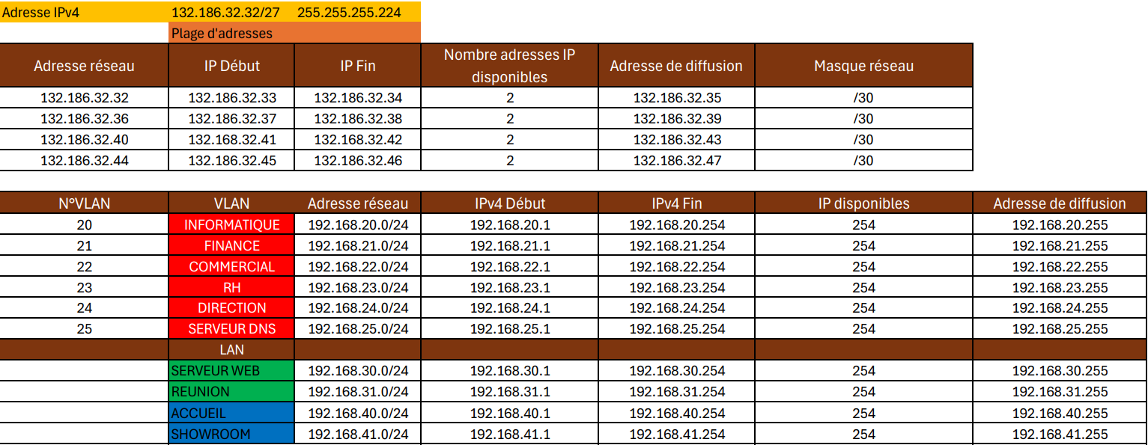
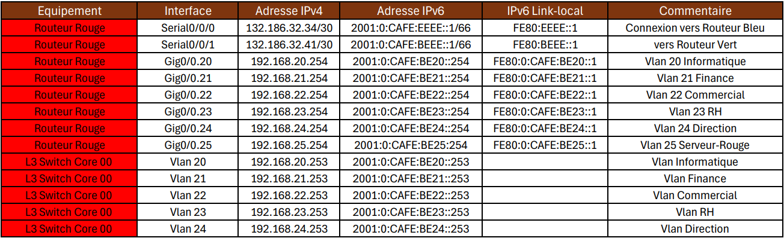
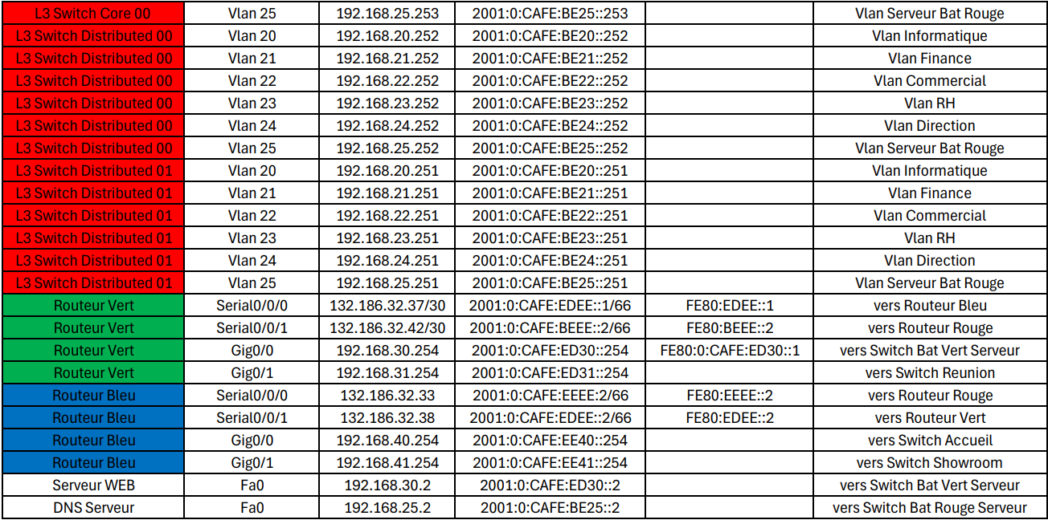

- Configuration DNS :
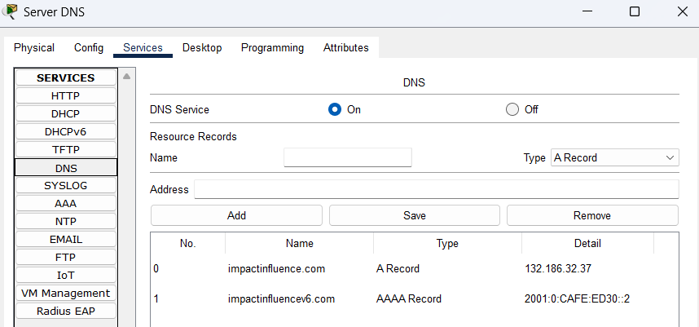
- Configuration des routeurs (comprenant les tables de routage, les sous-interfaces et les NAT) :
Bâtiment Bleu :
- hostname Router-bat-bleu
- ip dhcp pool ACCUEIL
network 192.168.40.0 255.255.255.0
default-router 192.168.40.254
dns-server 192.168.25.2
- ip dhcp pool SHOWROOM
network 192.168.41.0 255.255.255.0
default-router 192.168.41.254
dns-server 192.168.25.2

- ipv6 unicast-routing

- interface GigabitEthernet0/0
description "vers Switch Accueil"
ip address 192.168.40.254 255.255.255.0
ip nat inside
duplex auto
speed auto
ipv6 address 2001:0:CAFE:EE40::254/64
ipv6 eigrp 1

- interface GigabitEthernet0/1
description "vers Switch Showroom"
ip address 192.168.41.254 255.255.255.0
ip nat inside
duplex auto
speed auto
ipv6 address 2001:0:CAFE:EE41::254/64
ipv6 eigrp 1

- interface Serial0/0/0
description "vers Routeur Bat Rouge"
ip address 132.186.32.33 255.255.255.252
ip nat outside
ipv6 address FE80:EEEE::2 link-local
ipv6 address 2001:0:CAFE:EEEE::2/66
ipv6 eigrp 1
clock rate 2000000

- interface Serial0/0/1
description "vers Routeur Bat Vert"
ip address 132.186.32.38 255.255.255.252
ip nat outside
ipv6 address FE80:EDEE::2 link-local
ipv6 address 2001:0:CAFE:EDEE::2/66
ipv6 eigrp 1
clock rate 2000000

- router eigrp 1
network 132.186.32.36 0.0.0.3
network 132.186.32.32 0.0.0.3

- ipv6 router eigrp 1
eigrp router-id 3.3.3.3
no shutdown
passive-interface GigabitEthernet0/0
passive-interface GigabitEthernet0/1

- ip nat inside source list 40 interface Serial0/0/1 overload
- ip nat inside source list 41 interface Serial0/0/1 overload

- access-list 40 permit 192.168.40.0 0.0.0.255
- access-list 41 permit 192.168.41.0 0.0.0.255

- show ip route :
Gateway of last resort is not set
132.186.0.0/16 is variably subnetted, 5 subnets, 2 masks
C 132.186.32.32/30 is directly connected, Serial0/0/0
L 132.186.32.33/32 is directly connected, Serial0/0/0
C 132.186.32.36/30 is directly connected, Serial0/0/1
L 132.186.32.38/32 is directly connected, Serial0/0/1
D 132.186.32.40/30 [90/2681856] via 132.186.32.37, 00:12:47, Serial0/0/1
[90/2681856] via 132.186.32.34, 00:12:46, Serial0/0/0
192.168.40.0/24 is variably subnetted, 2 subnets, 2 masks
C 192.168.40.0/24 is directly connected, GigabitEthernet0/0
L 192.168.40.254/32 is directly connected, GigabitEthernet0/0
192.168.41.0/24 is variably subnetted, 2 subnets, 2 masks
C 192.168.41.0/24 is directly connected, GigabitEthernet0/1
L 192.168.41.254/32 is directly connected, GigabitEthernet0/1

- show ipv6 route :
D 2001:0:CAFE:BEEE::/66 [90/2681856]
via FE80:EDEE::1, Serial0/0/1
via FE80:EEEE::1, Serial0/0/0
D 2001:0:CAFE:ED30::/64 [90/2170112]
via FE80:EDEE::1, Serial0/0/1
D 2001:0:CAFE:ED31::/64 [90/2170112]
via FE80:EDEE::1, Serial0/0/1
C 2001:0:CAFE:EDEE::/66 [0/0]
via Serial0/0/1, directly connected
L 2001:0:CAFE:EDEE::2/128 [0/0]
via Serial0/0/1, receive
C 2001:0:CAFE:EE40::/64 [0/0]
via GigabitEthernet0/0, directly connected
L 2001:0:CAFE:EE40::254/128 [0/0]
via GigabitEthernet0/0, receive
C 2001:0:CAFE:EE41::/64 [0/0]
via GigabitEthernet0/1, directly connected
L 2001:0:CAFE:EE41::254/128 [0/0]
via GigabitEthernet0/1, receive
C 2001:0:CAFE:EEEE::/66 [0/0]
via Serial0/0/0, directly connected
L 2001:0:CAFE:EEEE::2/128 [0/0]
via Serial0/0/0, receive
L FF00::/8 [0/0]
via Null0, receive

Bâtiment Rouge :
- hostname Router-bat-rouge
- ipv6 unicast-routing

- ipv6 dhcp pool VLAN20
dns-server 2001:0:CAFE:BE25::2

- ipv6 dhcp pool VLAN21
dns-server 2001:0:CAFE:BE25::2

- ipv6 dhcp pool VLAN22
dns-server 2001:0:CAFE:BE25::2

- ipv6 dhcp pool VLAN23
dns-server 2001:0:CAFE:BE25::2

- ipv6 dhcp pool VLAN24
dns-server 2001:0:CAFE:BE25::2

- interface GigabitEthernet0/0.20
description "vlan 20 Informatique"
encapsulation dot1Q 20
ip address 192.168.20.254 255.255.255.0
ip access-group VlanIT in
ip nat inside
ipv6 address FE80:0:CAFE:BE20::1 link-local
ipv6 address 2001:0:CAFE:BE20::254/64
ipv6 nd other-config-flag
ipv6 dhcp server VLAN20

- interface GigabitEthernet0/0.21
description "vlan 21 Finance"
encapsulation dot1Q 21
ip address 192.168.21.254 255.255.255.0
ip access-group VlanFinance in
ip nat inside
ipv6 address FE80:0:CAFE:BE21::1 link-local
ipv6 address 2001:0:CAFE:BE21::254/64
ipv6 nd other-config-flag
ipv6 dhcp server VLAN21

- interface GigabitEthernet0/0.22
description "vlan 22 Commercial"
encapsulation dot1Q 22
ip address 192.168.22.254 255.255.255.0
ip access-group VlanCommercial in
ip nat inside
ipv6 address FE80:0:CAFE:BE22::1 link-local
ipv6 address 2001:0:CAFE:BE22::254/64
ipv6 nd other-config-flag
ipv6 dhcp server VLAN22

- interface GigabitEthernet0/0.23
description "vlan 23 RH"
encapsulation dot1Q 23
ip address 192.168.23.254 255.255.255.0
ip access-group VlanRH in
ip nat inside
ipv6 address FE80:0:CAFE:BE23::1 link-local
ipv6 address 2001:0:CAFE:BE23::254/64
ipv6 nd other-config-flag
ipv6 dhcp server VLAN23

- interface GigabitEthernet0/0.24
description "vlan 24 Direction"
encapsulation dot1Q 24
ip address 192.168.24.254 255.255.255.0
ip access-group VlanDirection in
ip nat inside
ipv6 address FE80:0:CAFE:BE24::1 link-local
ipv6 address 2001:0:CAFE:BE24::254/64
ipv6 nd other-config-flag
ipv6 dhcp server VLAN24

- interface GigabitEthernet0/0.25
description "vlan 25 Serveur Bat Rouge"
encapsulation dot1Q 25
ip address 192.168.25.254 255.255.255.0
ip access-group VlanDNS in
ipv6 address FE80:0:CAFE:BE25::1 link-local
ipv6 address 2001:0:CAFE:BE25::254/64

- interface Serial0/0/0
description "vers Routeur Bat Bleu"
ip address 132.186.32.34 255.255.255.252
ip nat outside
ipv6 address FE80:EEEE::1 link-local
ipv6 address 2001:0:CAFE:EEEE::1/66
ipv6 eigrp 1

- interface Serial0/0/1
description "vers Routeur Bat Vert"
ip address 132.186.32.41 255.255.255.252
ip nat outside
ipv6 address FE80:BEEE::1 link-local
ipv6 address 2001:0:CAFE:BEEE::1/66
ipv6 eigrp 1

- router eigrp 1
network 132.186.32.40 0.0.0.3
network 132.186.32.32 0.0.0.3

- ipv6 router eigrp 1
eigrp router-id 1.1.1.1
no shutdown
passive-interface GigabitEthernet0/0

- ip nat inside source list VLAN20 interface Serial0/0/1 overload
- ip nat inside source list VLAN21 interface Serial0/0/1 overload
- ip nat inside source list VLAN22 interface Serial0/0/1 overload
- ip nat inside source list VLAN23 interface Serial0/0/1 overload
- ip nat inside source list VLAN24 interface Serial0/0/1 overload
- ip nat inside source list VLAN25 interface Serial0/0/1 overload

- ip access-list standard VLAN20
permit 192.168.20.0 0.0.0.255
- ip access-list standard VLAN21
permit 192.168.21.0 0.0.0.255
- ip access-list standard VLAN22
permit 192.168.22.0 0.0.0.255
- ip access-list standard VLAN23
permit 192.168.23.0 0.0.0.255
- ip access-list standard VLAN24
permit 192.168.24.0 0.0.0.255
- ip access-list standard VLAN25
permit 192.168.25.0 0.0.0.255

- ip access-list extended VlanIT
permit udp 192.168.20.0 0.0.0.255 host 192.168.25.2 eq domain
permit tcp 192.168.20.0 0.0.0.255 host 132.186.32.37 eq www
permit icmp 192.168.20.0 0.0.0.255 192.168.21.0 0.0.0.255 echo
permit icmp 192.168.20.0 0.0.0.255 192.168.22.0 0.0.0.255 echo
permit icmp 192.168.20.0 0.0.0.255 192.168.23.0 0.0.0.255 echo
permit icmp 192.168.20.0 0.0.0.255 192.168.24.0 0.0.0.255 echo
permit icmp 192.168.20.0 0.0.0.255 192.168.25.0 0.0.0.255 echo
permit icmp 192.168.20.0 0.0.0.255 host 132.186.32.37
permit icmp 192.168.20.0 0.0.0.255 host 132.186.32.38
permit icmp 192.168.20.0 0.0.0.255 host 132.186.32.41
- ip access-list extended VlanFinance
permit udp 192.168.21.0 0.0.0.255 host 192.168.25.2 eq domain
permit tcp 192.168.21.0 0.0.0.255 host 192.168.30.2 eq www
permit tcp 192.168.21.0 0.0.0.255 host 132.186.32.37 eq www
permit icmp 192.168.21.0 0.0.0.255 192.168.20.0 0.0.0.255 echo-reply
permit icmp 192.168.21.0 0.0.0.255 192.168.22.0 0.0.0.255
permit icmp 192.168.21.0 0.0.0.255 192.168.23.0 0.0.0.255
permit icmp 192.168.21.0 0.0.0.255 192.168.24.0 0.0.0.255
permit icmp 192.168.21.0 0.0.0.255 host 132.186.32.37
permit icmp 192.168.21.0 0.0.0.255 host 132.186.32.38
permit icmp 192.168.21.0 0.0.0.255 host 132.186.32.41
- ip access-list extended VlanCommercial
permit udp 192.168.22.0 0.0.0.255 host 192.168.25.2 eq domain
permit tcp 192.168.22.0 0.0.0.255 host 192.168.30.2 eq www
permit tcp 192.168.22.0 0.0.0.255 host 132.186.32.37 eq www
permit icmp 192.168.22.0 0.0.0.255 192.168.20.0 0.0.0.255 echo-reply
permit icmp 192.168.22.0 0.0.0.255 192.168.21.0 0.0.0.255
permit icmp 192.168.22.0 0.0.0.255 192.168.23.0 0.0.0.255
permit icmp 192.168.22.0 0.0.0.255 192.168.24.0 0.0.0.255
permit icmp 192.168.22.0 0.0.0.255 host 132.186.32.37
permit icmp 192.168.22.0 0.0.0.255 host 132.186.32.38
permit icmp 192.168.22.0 0.0.0.255 host 132.186.32.41
- ip access-list extended VlanRH
permit udp 192.168.23.0 0.0.0.255 host 192.168.25.2 eq domain
permit tcp 192.168.23.0 0.0.0.255 host 192.168.30.2 eq www
permit tcp 192.168.23.0 0.0.0.255 host 132.186.32.37 eq www
permit icmp 192.168.23.0 0.0.0.255 192.168.20.0 0.0.0.255 echo-reply
permit icmp 192.168.23.0 0.0.0.255 192.168.21.0 0.0.0.255
permit icmp 192.168.23.0 0.0.0.255 192.168.22.0 0.0.0.255
permit icmp 192.168.23.0 0.0.0.255 192.168.24.0 0.0.0.255
permit icmp 192.168.23.0 0.0.0.255 host 132.186.32.37
permit icmp 192.168.23.0 0.0.0.255 host 132.186.32.38
permit icmp 192.168.23.0 0.0.0.255 host 132.186.32.41
- ip access-list extended VlanDirection
permit udp 192.168.24.0 0.0.0.255 host 192.168.25.2 eq domain
permit tcp 192.168.24.0 0.0.0.255 host 192.168.30.2 eq www
permit tcp 192.168.24.0 0.0.0.255 host 132.186.32.37 eq www
permit icmp 192.168.24.0 0.0.0.255 192.168.20.0 0.0.0.255 echo-reply
permit icmp 192.168.24.0 0.0.0.255 192.168.21.0 0.0.0.255
permit icmp 192.168.24.0 0.0.0.255 192.168.22.0 0.0.0.255
permit icmp 192.168.24.0 0.0.0.255 192.168.23.0 0.0.0.255
permit icmp 192.168.24.0 0.0.0.255 host 132.186.32.37
permit icmp 192.168.24.0 0.0.0.255 host 132.186.32.38
permit icmp 192.168.24.0 0.0.0.255 host 132.186.32.41
- ip access-list extended VlanDNS
permit icmp 192.168.25.0 0.0.0.255 192.168.20.0 0.0.0.255 echo-reply
permit udp host 192.168.25.2 eq domain 192.168.20.0 0.0.0.255
permit udp host 192.168.25.2 eq domain 192.168.21.0 0.0.0.255
permit udp host 192.168.25.2 eq domain 192.168.22.0 0.0.0.255
permit udp host 192.168.25.2 eq domain 192.168.23.0 0.0.0.255
permit udp host 192.168.25.2 eq domain 192.168.24.0 0.0.0.255

- sh ip route :
Gateway of last resort is not set
132.186.0.0/16 is variably subnetted, 5 subnets, 2 masks
C 132.186.32.32/30 is directly connected, Serial0/0/0
L 132.186.32.34/32 is directly connected, Serial0/0/0
D 132.186.32.36/30 [90/2681856] via 132.186.32.42, 00:01:55, Serial0/0/1
[90/2681856] via 132.186.32.33, 00:01:55, Serial0/0/0
C 132.186.32.40/30 is directly connected, Serial0/0/1
L 132.186.32.41/32 is directly connected, Serial0/0/1
192.168.20.0/24 is variably subnetted, 2 subnets, 2 masks
C 192.168.20.0/24 is directly connected, GigabitEthernet0/0.20
L 192.168.20.254/32 is directly connected, GigabitEthernet0/0.20
192.168.21.0/24 is variably subnetted, 2 subnets, 2 masks
C 192.168.21.0/24 is directly connected, GigabitEthernet0/0.21
L 192.168.21.254/32 is directly connected, GigabitEthernet0/0.21
192.168.22.0/24 is variably subnetted, 2 subnets, 2 masks
C 192.168.22.0/24 is directly connected, GigabitEthernet0/0.22
L 192.168.22.254/32 is directly connected, GigabitEthernet0/0.22
192.168.23.0/24 is variably subnetted, 2 subnets, 2 masks
C 192.168.23.0/24 is directly connected, GigabitEthernet0/0.23
L 192.168.23.254/32 is directly connected, GigabitEthernet0/0.23
192.168.24.0/24 is variably subnetted, 2 subnets, 2 masks
C 192.168.24.0/24 is directly connected, GigabitEthernet0/0.24
L 192.168.24.254/32 is directly connected, GigabitEthernet0/0.24
192.168.25.0/24 is variably subnetted, 2 subnets, 2 masks
C 192.168.25.0/24 is directly connected, GigabitEthernet0/0.25
L 192.168.25.254/32 is directly connected, GigabitEthernet0/0.25

- sh ipv6 route :
C 2001:0:CAFE:BE20::/64 [0/0]
via GigabitEthernet0/0.20, directly connected
L 2001:0:CAFE:BE20::254/128 [0/0]
via GigabitEthernet0/0.20, receive
C 2001:0:CAFE:BE21::/64 [0/0]
via GigabitEthernet0/0.21, directly connected
L 2001:0:CAFE:BE21::254/128 [0/0]
via GigabitEthernet0/0.21, receive
C 2001:0:CAFE:BE22::/64 [0/0]
via GigabitEthernet0/0.22, directly connected
L 2001:0:CAFE:BE22::254/128 [0/0]
via GigabitEthernet0/0.22, receive
C 2001:0:CAFE:BE23::/64 [0/0]
via GigabitEthernet0/0.23, directly connected
L 2001:0:CAFE:BE23::254/128 [0/0]
via GigabitEthernet0/0.23, receive
C 2001:0:CAFE:BE24::/64 [0/0]
via GigabitEthernet0/0.24, directly connected
L 2001:0:CAFE:BE24::254/128 [0/0]
via GigabitEthernet0/0.24, receive
C 2001:0:CAFE:BE25::/64 [0/0]
via GigabitEthernet0/0.25, directly connected
L 2001:0:CAFE:BE25::254/128 [0/0]
via GigabitEthernet0/0.25, receive
C 2001:0:CAFE:BEEE::/66 [0/0]
via Serial0/0/1, directly connected
L 2001:0:CAFE:BEEE::1/128 [0/0]
via Serial0/0/1, receive
D 2001:0:CAFE:ED30::/64 [90/2170112]
via FE80:BEEE::2, Serial0/0/1
D 2001:0:CAFE:ED31::/64 [90/2170112]
via FE80:BEEE::2, Serial0/0/1
D 2001:0:CAFE:EDEE::/66 [90/2681856]
via FE80:EEEE::2, Serial0/0/0
via FE80:BEEE::2, Serial0/0/1
D 2001:0:CAFE:EE40::/64 [90/2170112]
via FE80:EEEE::2, Serial0/0/0
D 2001:0:CAFE:EE41::/64 [90/2170112]
via FE80:EEEE::2, Serial0/0/0
C 2001:0:CAFE:EEEE::/66 [0/0]
via Serial0/0/0, directly connected
L 2001:0:CAFE:EEEE::1/128 [0/0]
via Serial0/0/0, receive
L FF00::/8 [0/0]
via Null0, receive

Bâtiment Vert :
- hostname Router-bat-vert
- ip dhcp pool REUNION
network 192.168.31.0 255.255.255.0
default-router 192.168.31.254
dns-server 192.168.25.2

- ipv6 unicast-routing

- interface GigabitEthernet0/0
description "vers Switch Serveur Bat Rouge"
ip address 192.168.30.254 255.255.255.0
ip nat inside
duplex auto
speed auto
ipv6 address FE80:0:CAFE:ED30::1 link-local
ipv6 address 2001:0:CAFE:ED30::254/64
ipv6 eigrp 1

- interface GigabitEthernet0/1
description "vers Switch Reunion"
ip address 192.168.31.254 255.255.255.0
duplex auto
speed auto
ipv6 address 2001:0:CAFE:ED31::254/64
ipv6 eigrp 1

- interface Serial0/0/0
description "vers Routeur Batiment Bleu"
ip address 132.186.32.37 255.255.255.252
ip nat outside
ipv6 address FE80:EDEE::1 link-local
ipv6 address 2001:0:CAFE:EDEE::1/66
ipv6 eigrp 1

- interface Serial0/0/1
description "vers Routeur Batiment Rouge"
ip address 132.186.32.42 255.255.255.252
ip nat outside
ipv6 address FE80:BEEE::2 link-local
ipv6 address 2001:0:CAFE:BEEE::2/66
ipv6 eigrp 1
clock rate 2000000

- router eigrp 1
network 132.186.32.36 0.0.0.3
network 132.186.32.40 0.0.0.3

- ipv6 router eigrp 1
eigrp router-id 2.2.2.2
no shutdown
passive-interface GigabitEthernet0/0
passive-interface GigabitEthernet0/1

- ip nat inside source list WEB interface Serial0/0/0 overload
- ip nat inside source static tcp 192.168.30.2 80 132.186.32.37 80
- ip nat inside source static 192.168.30.2 132.186.32.37

- ip access-list standard WEB
permit 192.168.30.0 0.0.0.255

- show ip route :
Gateway of last resort is not set
132.186.0.0/16 is variably subnetted, 5 subnets, 2 masks
D 132.186.32.32/30 [90/2681856] via 132.186.32.41, 00:03:09, Serial0/0/1
[90/2681856] via 132.186.32.38, 00:03:08, Serial0/0/0
C 132.186.32.36/30 is directly connected, Serial0/0/0
L 132.186.32.37/32 is directly connected, Serial0/0/0
C 132.186.32.40/30 is directly connected, Serial0/0/1
L 132.186.32.42/32 is directly connected, Serial0/0/1
192.168.30.0/24 is variably subnetted, 2 subnets, 2 masks
C 192.168.30.0/24 is directly connected, GigabitEthernet0/0
L 192.168.30.254/32 is directly connected, GigabitEthernet0/0
192.168.31.0/24 is variably subnetted, 2 subnets, 2 masks
C 192.168.31.0/24 is directly connected, GigabitEthernet0/1
L 192.168.31.254/32 is directly connected, GigabitEthernet0/1

- show ipv6 route :
C 2001:0:CAFE:BEEE::/66 [0/0]
via Serial0/0/1, directly connected
L 2001:0:CAFE:BEEE::2/128 [0/0]
via Serial0/0/1, receive
C 2001:0:CAFE:ED30::/64 [0/0]
via GigabitEthernet0/0, directly connected
L 2001:0:CAFE:ED30::254/128 [0/0]
via GigabitEthernet0/0, receive
C 2001:0:CAFE:ED31::/64 [0/0]
via GigabitEthernet0/1, directly connected
L 2001:0:CAFE:ED31::254/128 [0/0]
via GigabitEthernet0/1, receive
C 2001:0:CAFE:EDEE::/66 [0/0]
via Serial0/0/0, directly connected
L 2001:0:CAFE:EDEE::1/128 [0/0]
via Serial0/0/0, receive
D 2001:0:CAFE:EE40::/64 [90/2170112]
via FE80:EDEE::2, Serial0/0/0
D 2001:0:CAFE:EE41::/64 [90/2170112]
via FE80:EDEE::2, Serial0/0/0
D 2001:0:CAFE:EEEE::/66 [90/2681856]
via FE80:BEEE::1, Serial0/0/1
via FE80:EDEE::2, Serial0/0/0
L FF00::/8 [0/0]
via Null0, receive

- Configuration des switchs (comprenant les paramètres DHCP, les VLAN, le LACP et les ACL) :

  - Configuration des switchs de type layer 3 :
Switch Core :
- hostname sw-core-00
- ip routing

- ipv6 unicast-routing

- interface GigabitEthernet1/0/1
description "vers Routeur Bat Rouge"
switchport trunk allowed vlan 20-25
switchport mode trunk

- interface GigabitEthernet1/0/2
description "vers Switch Distributed 00"
switchport trunk allowed vlan 20-25
switchport mode trunk

- interface GigabitEthernet1/0/3
description "vers Switch Distributed 01"
switchport trunk allowed vlan 20-25
switchport mode trunk

- interface Vlan20
description "vlan Informatique"
mac-address 0090.2b42.4801
ip address 192.168.20.253 255.255.255.0
ipv6 address 2001:0:CAFE:BE20::253/64

- interface Vlan21
description "vlan Finance"
mac-address 0090.2b42.4802
ip address 192.168.21.253 255.255.255.0
ipv6 address 2001:0:CAFE:BE21::253/64

- interface Vlan22
description "vlan Commercial"
mac-address 0090.2b42.4803
ip address 192.168.22.253 255.255.255.0
ipv6 address 2001:0:CAFE:BE22::253/64

- interface Vlan23
description "vlan RH"
mac-address 0090.2b42.4804
ip address 192.168.23.253 255.255.255.0
ipv6 address 2001:0:CAFE:BE23::253/64

- interface Vlan24
description "vlan Direction"
mac-address 0090.2b42.4805
ip address 192.168.24.253 255.255.255.0
ipv6 address 2001:0:CAFE:BE24::253/64

- interface Vlan25
description "vlan Serveur Bat Rouge"
mac-address 0090.2b42.4806
ip address 192.168.25.253 255.255.255.0
ipv6 address 2001:0:CAFE:BE25::253/64

Switch Distributed 1 :
- hostname sw-distri-00
- ip dhcp pool VLAN20
network 192.168.20.0 255.255.255.0
default-router 192.168.20.254
dns-server 192.168.25.2
- ip dhcp pool VLAN21
network 192.168.21.0 255.255.255.0
default-router 192.168.21.254
dns-server 192.168.25.2
- ip dhcp pool VLAN22
network 192.168.22.0 255.255.255.0
default-router 192.168.22.254
dns-server 192.168.25.2
- ip dhcp pool VLAN23
network 192.168.23.0 255.255.255.0
default-router 192.168.23.254
dns-server 192.168.25.2
- ip dhcp pool VLAN24
network 192.168.24.0 255.255.255.0
default-router 192.168.24.254
dns-server 192.168.25.2

- ip routing

- ipv6 unicast-routing

- interface Port-channel1
description "range Gigabit Ethernet1/0/2-5"
switchport trunk allowed vlan 20-25
switchport mode trunk

- interface GigabitEthernet1/0/1
description "vers Switch Core 00"
switchport trunk allowed vlan 20-25
switchport mode trunk

- interface GigabitEthernet1/0/2
description "Load-Balancing Protocole LACP"
switchport trunk allowed vlan 20-25
switchport mode trunk
channel-protocol lacp
channel-group 1 mode active

- interface GigabitEthernet1/0/3
description "Load-Balancing Protocole LACP"
switchport trunk allowed vlan 20-25
switchport mode trunk
channel-protocol lacp
channel-group 1 mode active

- interface GigabitEthernet1/0/4
description "Load-Balancing Protocole LACP"
switchport trunk allowed vlan 20-25
switchport mode trunk
channel-protocol lacp
channel-group 1 mode active

- interface GigabitEthernet1/0/5
description "Load-Balancing Protocole LACP"
switchport trunk allowed vlan 20-25
switchport mode trunk
channel-protocol lacp
channel-group 1 mode active

- interface GigabitEthernet1/0/6
description "vers Switch Serveur Bat Rouge"
switchport access vlan 25
switchport mode access

- interface GigabitEthernet1/0/7
description "vers Switch Informatique"
switchport access vlan 20
switchport mode access

- interface GigabitEthernet1/0/8
description "vers Switch Finance"
switchport access vlan 21
switchport mode access

- interface GigabitEthernet1/0/9
description "vers Switch Commercial"
switchport access vlan 22
switchport mode access

- interface GigabitEthernet1/0/10
description "vers Switch RH"
switchport access vlan 23
switchport mode access

- interface GigabitEthernet1/0/11
description "vers Switch Direction"
switchport access vlan 24
switchport mode access

- interface Vlan20
description "vlan Informatique"
mac-address 0002.16b6.4701
ip address 192.168.20.252 255.255.255.0
ipv6 address 2001:0:CAFE:BE20::252/64

- interface Vlan21
description "vlan Finance"
mac-address 0002.16b6.4702
ip address 192.168.21.252 255.255.255.0
ipv6 address 2001:0:CAFE:BE21::252/64

- interface Vlan22
description "vlan Commercial"
mac-address 0002.16b6.4703
ip address 192.168.22.252 255.255.255.0
ipv6 address 2001:0:CAFE:BE22::252/64

- interface Vlan23
description "vlan RH"
mac-address 0002.16b6.4704
ip address 192.168.23.252 255.255.255.0
ipv6 address 2001:0:CAFE:BE23::252/64

- interface Vlan24
description "vlan Direction"
mac-address 0002.16b6.4705
ip address 192.168.24.252 255.255.255.0
ipv6 address 2001:0:CAFE:BE24::252/64

- interface Vlan25
description "vlan Serveur Bat Rouge"
mac-address 0002.16b6.4706
ip address 192.168.25.252 255.255.255.0
ipv6 address 2001:0:CAFE:BE25::252/64

Switch Distributed 2 :
- hostname sw-distri-01
- ip dhcp pool VLAN20
network 192.168.20.0 255.255.255.0
default-router 192.168.20.254
dns-server 192.168.25.2
- ip dhcp pool VLAN21
network 192.168.21.0 255.255.255.0
default-router 192.168.21.254
dns-server 192.168.25.2
- ip dhcp pool VLAN22
network 192.168.22.0 255.255.255.0
default-router 192.168.22.254
dns-server 192.168.25.2
- ip dhcp pool VLAN23
network 192.168.23.0 255.255.255.0
default-router 192.168.23.254
dns-server 192.168.25.2
- ip dhcp pool VLAN24
network 192.168.24.0 255.255.255.0
default-router 192.168.24.254
dns-server 192.168.25.2

- ip routing

- ipv6 unicast-routing

- interface Port-channel1
description "range GigabitEthernet1/0/2-5"
switchport trunk allowed vlan 20-25
switchport mode trunk

- interface GigabitEthernet1/0/1
description "vers Switch Core 00"
switchport trunk allowed vlan 20-25
switchport mode trunk

- interface GigabitEthernet1/0/2
description "Load-balancing Protocole LACP"
switchport trunk allowed vlan 20-25
switchport mode trunk
channel-protocol lacp
channel-group 1 mode active

- interface GigabitEthernet1/0/3
description "Load-balancing Protocole LACP"
switchport trunk allowed vlan 20-25
switchport mode trunk
channel-protocol lacp
channel-group 1 mode active

- interface GigabitEthernet1/0/4
description "Load-balancing Protocole LACP"
switchport trunk allowed vlan 20-25
switchport mode trunk
channel-protocol lacp
channel-group 1 mode active

- interface GigabitEthernet1/0/5
description "Load-balancing Protocole LACP"
switchport trunk allowed vlan 20-25
switchport mode trunk
channel-protocol lacp
channel-group 1 mode active

- interface GigabitEthernet1/0/6
description "vers Switch Serveur Bat Rouge"
switchport access vlan 25
switchport mode access

- interface GigabitEthernet1/0/7
description "vers Switch Informatique"
switchport access vlan 20
switchport mode access

- interface GigabitEthernet1/0/8
description "vers Switch Finance"
switchport access vlan 21
switchport mode access

- interface GigabitEthernet1/0/9
description "vers Switch Commercial"
switchport access vlan 22
switchport mode access

- interface GigabitEthernet1/0/10
description "vers Switch RH"
switchport access vlan 23
switchport mode access

- interface GigabitEthernet1/0/11
description "vers Switch Direction"
switchport access vlan 24
switchport mode access

- interface Vlan20
description "vlan Informatique"
mac-address 00e0.8f82.c601
ip address 192.168.20.251 255.255.255.0
ipv6 address 2001:0:CAFE:BE20::251/64

- interface Vlan21
description "vlan Finance"
mac-address 00e0.8f82.c602
ip address 192.168.21.251 255.255.255.0
ipv6 address 2001:0:CAFE:BE21::251/64

- interface Vlan22
description "vlan Commercial"
mac-address 00e0.8f82.c603
ip address 192.168.22.251 255.255.255.0
ipv6 address 2001:0:CAFE:BE22::251/64

- interface Vlan23
description "vlan RH"
mac-address 00e0.8f82.c604
ip address 192.168.23.251 255.255.255.0
ipv6 address 2001:0:CAFE:BE23::251/64

- interface Vlan24
description "vlan Direction"
mac-address 00e0.8f82.c605
ip address 192.168.24.251 255.255.255.0
ipv6 address 2001:0:CAFE:BE24::251/64

- interface Vlan25
description "vlan Serveur Bat Rouge"
mac-address 00e0.8f82.c606
ip address 192.168.25.251 255.255.255.0
ipv6 address 2001:0:CAFE:BE25::251/64

  - Configuration des switchs de type layer 2 :
Switch Serveur WEB :
- hostname sw-serveur-bat-vert
- interface FastEthernet0/1
description "vers Serveur WEB"
switchport mode access

- interface GigabitEthernet0/1
description "vers Routeur Bat Vert"
switchport mode access

Switch Réunion:
- hostname sw-reunion
- interface FastEthernet0/1
description "vers Reunion"
switchport mode access

- interface GigabitEthernet0/1
description "vers Routeur Bat Vert"
switchport mode access

Switch Accueil:
- hostname sw-accueil
- interface FastEthernet0/1
description "vers Accueil"
switchport mode access

- interface GigabitEthernet0/1
description "vers Routeur Bat Bleu"
switchport mode access

Switch Showroom:
- hostname sw-showroom
- interface FastEthernet0/1
description "vers Showroom"
switchport mode access

- interface GigabitEthernet0/1
description "vers Routeur Bat Bleu"
switchport mode access

Switch Direction:
- hostname sw-direction
- interface FastEthernet0/1
description "vers Direction"
switchport access vlan 24
switchport mode access

- interface GigabitEthernet0/1
description "vers Switch Distributed 00"
switchport access vlan 24
switchport mode access

- interface GigabitEthernet0/2
description "vers Switch Distributed 01"
switchport access vlan 24
switchport mode access

Switch RH:
- hostname sw-rh
- interface FastEthernet0/1
description "vers RH"
switchport access vlan 23
switchport mode access

- interface GigabitEthernet0/1
description "vers Switch Distributed 00"
switchport access vlan 23
switchport mode access

- interface GigabitEthernet0/2
description "vers Switch Distributed 01"
switchport access vlan 23
switchport mode access

Switch Commerciaux/Chargés de clientèle:
- hostname sw-commercial
- interface FastEthernet0/1
description "vers Commercial"
switchport access vlan 22
switchport mode access

- interface GigabitEthernet0/1
description "vers Switch Distributed 00"
switchport access vlan 22
switchport mode access

- interface GigabitEthernet0/2
description "vers Switch Distributed 01"
switchport access vlan 22
switchport mode access

Switch Finance :
- hostname sw-finance
- interface FastEthernet0/1
description "vers Finance"
switchport access vlan 21
switchport mode access

- interface GigabitEthernet0/1
description "vers Switch Distributed 00"
switchport access vlan 21
switchport mode access

- interface GigabitEthernet0/2
description "vers Switch Distributed 01"
switchport access vlan 21
switchport mode access

Switch Service Informatique :
- hostname sw-informatique
- interface FastEthernet0/1
description "vers Informatique"
switchport access vlan 20
switchport mode access

- interface GigabitEthernet0/1
description "vers Switch Distributed 00"
switchport access vlan 20
switchport mode access

- interface GigabitEthernet0/2
description "vers Switch Distributed 01"
switchport access vlan 20
switchport mode access

Switch du serveur DNS :
hostname sw-serveur-bat-rouge

- interface FastEthernet0/1
description "vers Serveur DNS"
switchport access vlan 25
switchport mode access

- interface GigabitEthernet0/1
description "vers Switch Distributed 00"
switchport access vlan 25
switchport mode access

- interface GigabitEthernet0/2
description "vers Switch Distributed 01"
switchport access vlan 25
switchport mode access

