Planning Report

Graded Unit 2

James Park | Software Development | 21/03/2023

Contents

Introduction 2

High level requirements 2

Investigation 3

Fact finding Techniques 3

Introduction 3

Reading 3

Questionnaires 3

Interviews 3

Observation 4

Conclusion 4

interview questions & responses 4

Functional & non-functional requirements 8

Functional 8

Non-Functional 8

initial top level use case model 10

initial top level class diagram 10

Resources and Materials Required 11

Comparison of Development Platforms 11

ASP.Net & C# 11

Django & Python 12

Spring & Java 14

Justification of choice 16

ASP.Net Framework & C# 16

Bibliography 17

# Introduction

I have been hired by Birdston Kennels, which is a bog boarding kennels located between Kirkintilloch and Milton of Campsie, just seven miles from Glasgow center. They house a dog grooming service on top of purpose-built kennels for housing pets from as little time as one day. This facility is situated in 122 acres of beautiful, wooded countryside.

The problem I have been hired to solve is to develop a booking system for the kennel side of the business to allow customers to book one or multiple dogs in for a stay. This will allow a good alternative for bookings to the current method of using social media pages and phone calls to gather booking requests from interested customers. To evaluate and fulfill the list of requirements gathered from the Kennels I will carry out a full investigation into the business. Through talking to the staff, researching to business through their socials, and get a full accounting of the facilities available.

## High level requirements

1. Process bookings for stays of one or multiple pets to be housed in the facility.
2. Process bookings for daycare of one or multiple pets.
3. Allow cancellations of bookings.
4. View active bookings.
5. View previous bookings.
6. Allow returning customers to create accounts.
7. Secure logins
8. Allow registered users to store information about their pets on their account.
9. Allow deposits to be paid at the time of booking.
10. Allow card details to be attached to the registered users account.
11. Allow staff to have a login portal to change any details relating to pricing and availability.
12. Reminders should be able to be sent to customers with upcoming bookings.
13. Staff should be able to view data relating to members, staff, and bookings from the database.

# Investigation

## Fact finding Techniques

### Introduction

The first step of my project development of this project is to identify all business rules and the systems requirements. I achieved this by carrying out some effective fact-finding techniques designed to determine the requirements of the system (these requirements are both functional and non-functional. The techniques I considered are detailed below.

### Reading

Reading information on the company is another option for information gathering this is a good method for gaining background information on the business. I did use the project brief as good source of written information to influence other aspects of my information gathering process.

Downsides to this method is that you cannot rely on all the written information to be up to date and finding and reading all information is a very time-consuming task to be carried out. I decided to not focus too hard on this method of information gathering. I did however investigate their social media page on Facebook as currently this is the main point of contact online for their customer base. As well as checking their current website to give me an idea of the type of branding of the business, and services on offer.

### Questionnaires

I created a questionnaire that was delivered to the client to gather as much Knowledge behind the business’s operational need for the requested system. This should allow me to better understand each individual need that the project needs to fulfill to achieve the overall goal.

The information gathered from the questionnaire clearly outlines the customers wants and needs for the project. I can now use this information to complete a full list of functional and non-functional requirements to guide me through my project.

### Interviews

By interviewing the manager of the kennels, I can gain valuable information and maybe clear up some of the questions from the questionnaire and elaborate on the answers (if needed). This format of information gathering also allows for more substantial discussion about a question which can gleam more useful points than simple yes or no answers. When deciding questions for this form of interview

From initial interview conversation with the client, I have managed to clear up some how some of the functions should be implemented.

### Observation

Observation of the businesses is valid tactic of information gathering to gather information on the booking process from an operational standpoint. This method has the issue of me potentially becoming a disturbance to daily operations. It can also become a very time-consuming method. The main information I need in relation to the booking process is how bookings are tracked and the relative information required to store the booking. This information can be gathered through documentation and interviewing the client.

### Conclusion

After considering all steps available for gathering the required information to start the planning of my system, a questionnaire is my main point of initial communication from a fact-finding standpoint. Interviews are also possible as the project planning progresses and further into development. Using a combination of all methods I feel that the amount of information I will be able to ascertain will be more than enough to fulfill the requirements of the project.

## interview questions & responses

1. What is the Budget of the project?
2. What is the Timescale of the project?

Please find below an extract of our contract for your consideration.

1. The Developer shall complete the development of the Software according to the milestones described on the form below:

1. In accordance with such milestones, the final product shall be delivered to the Client by 9/06/2023 (the “**Delivery Date**”).
2. For a period of 6 months after delivery of the final product, the Developer shall provide the Client attention to answer any questions or assist solving any problems about the operation of the Software up to 40 hours free of charge and billed to the Client at a rate of £100 per hour for any assistance thereafter. The Developer agrees to respond to any reasonable request for assistance made by the Client regarding the Software within 10 days of the request.
3. The Developer shall provide to the Client after the Delivery Date, a cumulative 8 hours of training with respect to the operation of the Software if requested by the Client.
4. If the Software as delivered does not conform to the Specifications, the Client shall within 6 months of the Delivery Date notify the Developer in writing of the ways in which it does not conform with the Specifications. The Developer agrees that upon receiving such notice, it shall make reasonable efforts to correct any non-conformity.
5. In consideration for the Service, the Client shall pay the Company at the rate of £100 per hour (the “Hourly Rate”), with a maximum total fee for all work under this Software Development Agreement of £10,000. Fees billed under the Hourly Rate shall be due and payable upon the Developer providing the Client with an invoice. Invoices will be provided for work completed by the developer once every 4 weeks.
6. The Parties acknowledge and agree that the Client will hold all intellectual property rights in the Software including, but not limited to, copyright and trademark rights. The Developer agrees not to claim any such ownership in the Software’s intellectual property at any time prior to or after the completion and delivery of the Software to the Client. The Software will not violate the intellectual property rights of any other party.
7. Is there any current branding to be incorporated into the design?
8. If not, are you open to the creation of a logo and colour scheme?

We require that you follow a responsive design approach to developing interfaces suitable for a range of touchscreen phones, tablets, and traditional pointer-driven desktop computers. We hope that the new design will reflect our company values and mission.

1. Are there any special accessibility requirements?

We rely on your experience and expertise to enhance the user experience for all your visitors — including those with disabilities or limitations who land on your site. This includes those with disabilities and limitations such as: Blindness, Low vision, Learning disabilities, Cognitive disabilities, Deafness, Hearing loss, Speech disabilities.

1. what if any are your social media accounts you wish to be linked to your page?

Instagram, Twitter, Facebook

1. can users’ book without an account?

No

1. Do you want third party account verification like logging in with a Facebook account?

Yes.

1. Do you want two factor authentication to be implemented?

Yes.

1. are there distinct levels of employee access i.e., basic employee, admin?

We require you as the IT expert to develop an IT system that is secure.

* Admin- will have the responsibility to register new members of staff and provide them with a username (consists of first name, second name and company name for the domain name) and password.
* Front desk clerk – access Booking, Customer Records and Payment processing
* Manager – access to all data, pricing.
* Dog Porters – access the kennel keeping list.
* Stock Manager – access to Dog supplies Records.
* Dog Groomers– access to daily customers list for breakfast and dinner.
* All users require a User Id and Password.

Staff should generate the following reports (daily, weekly, yearly):

•Daily List of Bookings Arriving/Leaving

•Weekly list of bookings showing arrival and departure times

•List of dogs with special requirements, e.g., medication, dietary needs

•Monthly report of revenues received

the reports should be able to be exported in different formats (Word, excel, PDF, etc.)

1. Do you require the implementation of both grooming appointments and stays in the first iteration?

No. Booking kennels/stays is a priority. Grooming can be offered as an extra service to the customer at the point of booking.

1. Are there any dates that are not available for booking?

We operate 7/24.

1. Are deposits at the time of booking needed to secure the booking?

Payments should be made in full at the point of sale. Acceptable payment methods are –credit/debit cards, PayPal & invoices for corporate customers.

Cancelations made more than 3 days before booking are refunded automatically on to the card registered to the customer.

1. Do you want reminders of the booking sent via email close to the booking date?

Yes. Email and SMS confirmation required for confirmation of bookings, amendments, cancelations, payments.

1. is there a maximum stay period?

We don’t have a maximum or minimum stay.

1. Do you want a contact form implemented?

Yes.

1. if so, what are the contact details for the business?

Birdston Kennels, Loch Lomond Drive, Renfrew, PA75 6QB

info@birdstonkennels.com

0141-302811

## Functional & non-functional requirements

### Functional

1. The website will have links to the business’s social medias.
2. Users will require an account to create a booking.
3. The website will have third party logging in via Facebook or Gmail
4. Users should have the option for two factor authentication.
5. The system must be secure.
6. There should be an admin role.
7. Admins should be able to register new staff members.
8. Staff should be able to generate reports.
9. Daily lists of bookings arrivals and departures should be generated.
10. Weekly list of bookings showing arrivals and departures should be generated.
11. Dog list with any special requirements should be generated.
12. Monthly report of revenue should be generated.
13. all reports should be exportable in different formats (word, excel, pdf)
14. Customers should be able to book a stay with the kennel.
15. Customers should be able to add optional grooming onto their booking.
16. Cancellations made for bookings more than 3 days before the booking date should be automatically refunded on the customers registered payment method.
17. Email and SMS confirmation of bookings should be sent.
18. The website should have a contact form implemented.

### Non-Functional

1. The final product should be delivered to the client on or by 09/06/2023.
2. The developer should provide support to the client for 6 months after the delivery date with the first 40 hours free of charge and then an hourly rate of £100.
3. there should be a period of training after the delivery date of 8 hours for the developer to teach the client on the products use.
4. There will be a 6-month period after the delivery date for the client to bring forward anyways in which the product does not conform to the desired specifications.
5. The projects will be billed at £100 per hour to a max of £10,000.
6. Invoices for work complete will be provided every 4 weeks.
7. The website will have a responsive design with a suitable range of support for touchscreen and desktop.
8. The design will reflect the company’s values and current branding.
9. The website will follow appropriate accessibility to enhance user experience for all.
10. There is no maximum or minimum stay period.
11. Bookings should be always possible with exception to holidays such as Christmas / new year (however boarding over these days is available just no pickups or drop offs)
12. Payments should be made in full at the time of booking.
13. In the case of cancelations or amendments there should also be confirmation sent.
14. Payment methods should be credit/debit card or PayPal.
15. Employee usernames should follow the format (first name, last name, @ company name)
16. There should be a front desk clerk role with access to the bookings, customer records and payment processing.
17. There should be a manager role with access to all data and pricing.
18. There should be a dog porter role with access to the kennel keeping list.
19. There should be a stock manager role with access to the dog supplies records.
20. There should be a dog groomers role with access to the daily list of grooming.

## initial top level use case model

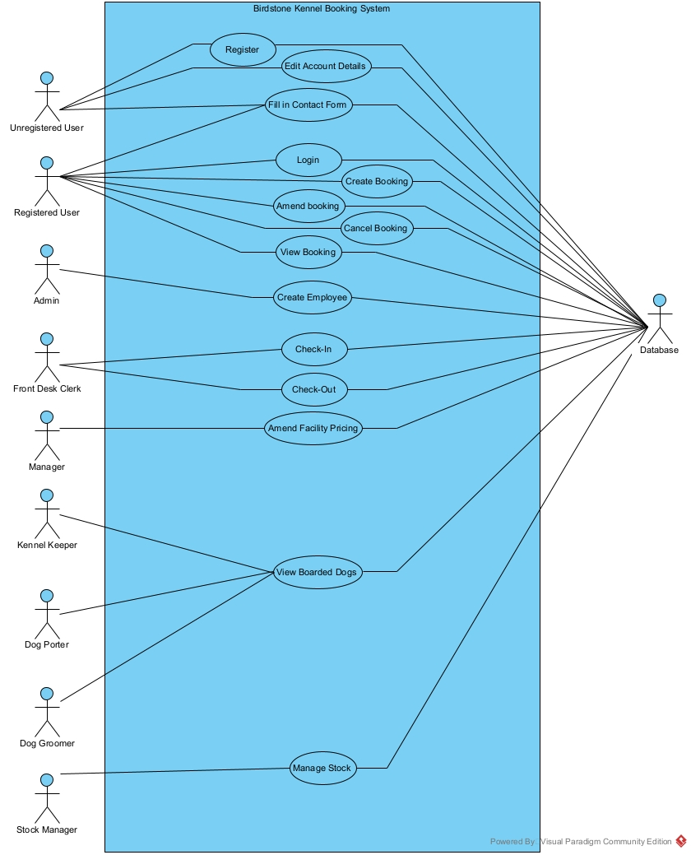

## initial top level class diagram

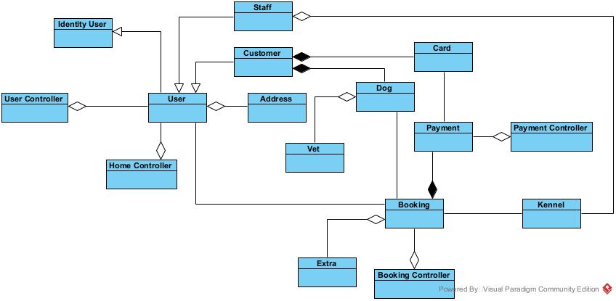

# Resources and Materials Required

## Comparison of Development Platforms

### ASP.Net & C#

#### ASP.Net

.Net is one of if not the most powerful framework when it comes to software development. It offers a great range of features and support being used to develop systems in the C#, F# and Visual Basics programming language.

under .NET there are two technologies in the forms of .Net Framework and .Net Core, with .Net core being the more advances technology.

Although it is known as a revolutionary framework for developers Microsoft .Net is in no means perfect.

##### Pros

* Object oriented Software Development Model.
* Visual Studio IDE is a robust and powerful application.
* Simple Caching System - allows improved performance and scalability.
* Language Independence of .NET Core - cross platform across Windows, Linux, and macOS.
* Easy to Deploy.
* Multiple App Support - developing possible in many applications i.e., gaming, mobile, IoT, AI, & ML.

##### Cons

* Limited object Relational Support - may not align with emerging database designs due to flexibility issues.
* Vendor Lock-in - being a part of the Microsoft family means that any changes the company impose will impact projects done in this framework.
* Licensing Cost - .NET family can come with a cost in the terms of licensing fees.
* Stability Issues for New Releases - new releases can lack proper documentation and support and can be prone to drastic changes.
* Difficulty in Transitioning to .NET Core - if you were transferring an existing application to .Net Core the process can be long and tedious.
* Memory Leaks.

#### C#

C# is a preferred backend language for backend development and is one of the .NET languages. The syntax of C# is popular with developers of C-style languages like Java and C++. Being such a popular language does mean it comes with several pros.

##### Pros

* Integrates well with windows.
* Applications in this language are easily deployed on the network - as long as the workstation or server support .NET.
* Popular language among developers means finding someone to work in it is easier.
* close similarities to languages like Java meaning resources and help can cross over to an extent.
* Visual Studios has tools to allow teams to work together efficiently.
* C# is a compiled language meaning the code is stored in binary form on the public facing server meaning the source code is not easily visible to any hacking attempts.

##### Cons

* The fact that C# is a compiled language it also has its disadvantages - it must be recompiled even after the smallest of changes.
* Due to it being part of the .Net framework, the server must be running windows.
* Windows servers are more costly.
* Older .NET frameworks become unsupported by Microsoft - which means older systems need to run older versions of Windows OS.

### Django & Python

#### Django

Django is a framework developed for fast web development. It is also a very powerful tool and allows web development alongside the Python language. Being supported by a vast community Django provides constant development and new features and functionalities, this also means that the framework is well tested and documented.

Django comes with many advantages some major ones are listed below, It also has its disadvantages even though it contains all the functionality one may need. These disadvantages come from a design standpoint rather than a performance one.

##### Pros

* Implemented in Python - making it very easy to read and using the same language between the front end and the back end.
* Better CDN (Content Delivery Networks) Connectivity & Content Management - Django provides libraries and tools so it can be used as a Content Management System (CMS).
* Batteries Included Framework - Made by web developers for web developers.
* Fast Processing - Django is designed to make the process of transmitting resources over the internet faster and easier.
* Rapid-Development - Django is the best framework in the industry for rapid development since it uses the MTV architecture.
* Scalable - this framework is used by some of the biggest and busiest websites since it can handle nearly any kind of hardware.
* Secured - Due to it being made by the world’s best web developers it is a trusted framework. and with great built-in encryption for passwords and information you can be confident that the data is secure.

##### Cons

* Monolithic - Django has a particular way that developers must learn and follow to create a project using the Django framework.
* Not for Smaller Projects - Django’s functionality comes with a lot of code and for this reason requires a lot of processing and time on the server end.
* Regular Expression for URLs.

#### Python

Over time the demand for Python development has only grow, which is to be expected with one of the world’s most popular programing language. Even though it is widely used and plays a major role in web development there are cons on top of the obvious pros.

##### Pros

* Less code – Due to its lightweight syntax python can be very powerful with less code written compared to languages like C# or Java.
* Wide Community Support – Because of its vast adoption and popularity across the globe there is a large community which means there is a lot of documentation and help to be found.
* Syntax – the simplicity and easy to read nature of the Python syntax, code is easily managed, written, and read.
* Library Support – Python has a large collection of libraries to help the developer build all kinds of applications from web apps to game apps and even machine learning apps.
* Frameworks – these allow easy construction of web apps, and they are fast to implement.

##### Cons

* Speed - Because Python uses an interpreter in place of a compiler there is some issues with the speed of the language compared to compiled languages.
* Memory Consumption - Python consumes a large volume of memory when running heavy web applications.
* Not Great for Mobile Use - Python has been reported to not run optimally when running over mobile devices.
* Design Restrictions - Due to Python being a dynamically typed language there are restrictions on design because of tasks being performed during runtime which in other languages can be run statically.

### Spring & Java

#### Spring

The Spring framework is used for making programming in the java language faster, safer, and easier. It has become one of the world’s most popular frameworks due to its productivity, speed, and simplicity.

##### Pros

* Light weight - there is no need to inherited classes or implement interfaces due to POJO (Plain Old Java Object) implementation.
* Flexible - Spring has a variety of trusted libraries and allows developers to choose between XML or java-based annotation.
* Secure - Due to Spring monitoring third party dependencies closely, as well as regular updates Spring is a secure framework to work with.
* Supportive - Spring has a great community which is responsible for providing support and resources.

##### Cons

* Complexity - Developing in the Spring framework is a complex process, which requires a good amount of expertise in it or time to learn.
* No Specific Guidelines - Due to Spring not having cross-site scripting, the developer must work on securing the application against infiltration and malicious attacks.
* High Learning Curve - Difficult and time consuming to learn.
* Lots of XML - developing in Spring requires a lot of XML.

#### Java

Java is one of the top languages in the world which is said to have the capability to "Write Once, Run Anywhere". It is an Object-Oriented Programming language. With such a popularity Java comes with its pros, however it comes with its cons as well.

##### Pros

* Simple - Java is an easy to learn, easy to understand language making it a language that is easy to debug and maintain.
* OOP - Java is an object-oriented programming language which is defined by its structure and data types as well as its defined functions.
* High-Level Language - Java is easy to learn be it coming from no programming background or from another language. begin a high-level language it resembles human language compared to some other lower-level languages that look like machine code.
* APIs for Application Development - java offers various APIs (Application Programming Interfaces) to aid in things like database connection, networking, utilities, and more.

##### Cons

* - Memory Requirements - due to each line of code needing interpreting and being a nonnative language Java is memory consuming which can make it down.
* - Verbose - A downside to being a high-level language Java is that the code is made up of longer more complex sentences making it a little over complex.
* - Lack of Native Look and Feel - When used for desktop application Java can be weaker when creating GUI (Graphical User Interface). This means more research would be required when developing applications for windows.

## Justification of choice

### ASP.Net Framework & C#

For this project I have decided to go with the combination of ASP.Net Framework and the C# Programming language. Due to my familiarity with these technologies, I can better put my time to learning new functions such as adding payment gateways, third party logins, and two factor authentication. This framework has everything in place I need to create an application that will meet all the functional requirements that I require it to.

From my research into .Net Framework I feel that the structure of the development environment to be very intuitive and easy to get used to once the time has been taken to get used to it. And due to its popularity, there is a great source of knowledge to take from to progress my understanding of different concepts and functions that will form the foundation and structure of my project. C# as a language for the backend development is a perfect choice because in my experience it has been easy to understand, write and debug with the knowledge I have of it.

# Bibliography

Successive (2023)*”* *Pros and Cons of .NET Framework”* Available at: <https://successive.tech/blog/pros-and-cons-of-net-framework/> (Accessed: 29/03/2023)

C-sharp Corner(03/12/2023)*”* *Difference between .NET and .NET Core”* Available at: <https://www.c-sharpcorner.com/article/difference-between-net-framework-and-net-core/> (Accessed: 29/03/2023)

Agilites (2023) *“Pros and Cons of Using C# as Your Backend Programming Language” Available at:* [*https://www.agilites.com/pros-and-cons-of-using-c-as-your-backend-programming-language.html*](https://www.agilites.com/pros-and-cons-of-using-c-as-your-backend-programming-language.html)(Accessed: 29/03/2023)

Data-Flair (2023) *“Django Advantages and Disadvantages – Why You Should Choose Django?”* Available at: <https://data-flair.training/blogs/django-advantages-and-disadvantages/#:~:text=Django's%20first%20side%20reveals%20rapid,of%20Django%20advantages%20and%20disadvantages> (Accessed: 29/03/2023)

Analytics-Insight(May 29, 2022) *“Top 5 Pros and 5 Cons of Using Python in Web Development Projects”* Available at: <https://www.analyticsinsight.net/top-5-pros-and-5-cons-of-using-python-in-web-development-projects/> (Accessed: 29/03/2023)

Java-T-Point (2021) *“Java Spring Pros and Cons”* Available at: <https://www.javatpoint.com/java-spring-pros-and-cons> (Accessed: 29/03/2023)

Baires-Dev (2023) *“The Pros and Cons of Java Development”* Available at: <https://www.bairesdev.com/java/pros-cons/> (Accessed: 29/03/2023)