Software Requirements Specification Template
CptS 322—Software Engineering
9 February 2005

The following annotated template shall be used to complete the Software Requirements Specification (SRS) assignment of WSU-TC CptS 322. The instructor must approve any modifications to the overall structure of this document.

Template Usage:
Text contained within angle brackets (‘<’, ‘>’) shall be replaced by your project-specific information and/or details. For example, <Project Name> will be replaced with either ‘Smart Home’ or ‘Sensor Network’.

Italicized text is included to briefly annotate the purpose of each section within this template. This text should not appear in the final version of your submitted SRS.

This cover page is not a part of the final template and should be removed before your SRS is submitted.

Acknowledgements:
Sections of this document are based upon the IEEE Guide to Software Requirements Specification (ANSI/IEEE Std. 830-1984). The SRS templates of Dr. Orest Pilskalns (WSU, Vancover) and Jack Hagemeister (WSU, Pullman) have also be used as guides in developing this template for the WSU-TC Spring 2005 CptS 322 course.

Project
Reminder

Software Requirements Specification

Version 1.0
April 18, 2016

Document created by:

Team Spyro

Revision History

Date | Description | Author | Comments
<date> | <Version 1> | <Your Name> | <First Revision>

Document Approval

The following Software Requirements Specification has been accepted and approved by the following:
Signature | Printed Name | Title | Date
 | <Your Name> | Lead Software Eng.
 | A. David McKinnon | Instructor, CptS 322

Table of Contents

Revision History ii
Document Approval ii
1. Introduction 1
1.1 Purpose 1
1.2 Scope 1
1.3 Definitions, Acronyms, and Abbreviations 2
1.4 References 2
1.5 Overview 2
2. Overall Description 2
2.1 Product Perspective 2
To be written 2
2.2 Product Functions 2
2.4 General Constraints 2
3. Specific Requirements 3
3.2 Functional Requirements 3
3.2.1 <Functional Requirement or Feature #1> 3
3.2.2 <Functional Requirement or Feature #2> 3
3.3 Use Cases 3
3.3.1 Use Case #1 3
3.3.2 Use Case #2 3
3.4 Classes / Objects 3
3.4.1 <Class / Object #1> 3
3.4.2 <Class / Object #2> 3
3.5 Non-Functional Requirements 3
3.5.1 Performance 4
3.5.2 Reliability 4
3.5.3 Availability 4
3.5.4 Security 4
3.5.5 Maintainability 4
3.5.6 Portability 4
3.6 Inverse Requirements 4
3.7 Design Constraints 4
3.8 Logical Database Requirements 4
3.9 Other Requirements 4
4. Analysis Models 4
4.1 Sequence Diagrams 4
4.3 Data Flow Diagrams (DFD) 4
4.2 State-Transition Diagrams (STD) 4
5. Change Management Process 4
A. Appendices 5
A.1 Appendix 1 5
A.2 Appendix 2 5

Introduction
One of our new Clients have requested from “Spyro” to create a new web application. The main goal of the application is to be used by customers as a to-do list. For the purpose of this project the application will be called “Reminder”.

Purpose
The purpose of the document is define the application, its requirements, how this product will be used. The futures that will be developed and document the concept of the project. In short, the purpose of this SRS document is to provide a detailed overview of our software product, its parameters and goals. This document describes the application’s functionalities and software specifications. It defines how our client, team and audience see the product and its functionality.
A detailed description of the new Web Application “Reminder”. It will explain the purpose and features of the system, the interfaces of the system, what the system will do, the constraints under which it must operate and how the system will react to external stimuli. This document is intended for both the stakeholders and the developers of the system and will be send to the Client for its approval before “Spyro” starts with actual development.

Scope

This SRS is aimed at specifying requirements of software to be developed. The application will be developed to maximize the user’s productivity by providing tools to assist him by giving the chance to keep all his tasks in one place excluding the need of manually taking notes and looking in more than one application to synchronize all tasks and make schedule . By maximizing the user’s work efficiency and production the application will meet the user’s needs while remaining easy to understand and use.
More specifically, this application is designed to allow user to manage and keep record of his future meeting, remaining tasks and overall acting plan. The application will send reminders via email and will notify for close events set by him.

1.3 Definitions, Acronyms, and Abbreviations

1.4 References
This subsection should:
(1) Provide a complete list of all documents referenced elsewhere in the SRS, or in a separate, specified document.
(2) Identify each document by title, report number - if applicable - date, and publishing organization.
(3) Specify the sources from which the references can be obtained.
This information may be provided by reference to an appendix or to another document.

1.5 Overview
The remaining sections of this document provide an overall description including functional and data requirements of the product. We are going to focus on describing the system in terms of product perspective, product functions, user characteristics and dependencies on the following sections of this document. Next, we will address specific requirements of the system, performance requirements, and other requirements.

2. Overall Description

2.1 Product Perspective

To be written

2.2 Product Functions
To be written

2.4 General Constraints
To be written

2.5 Flow Chart

UML Use case Diagram log in application(the other functionalities to be added):

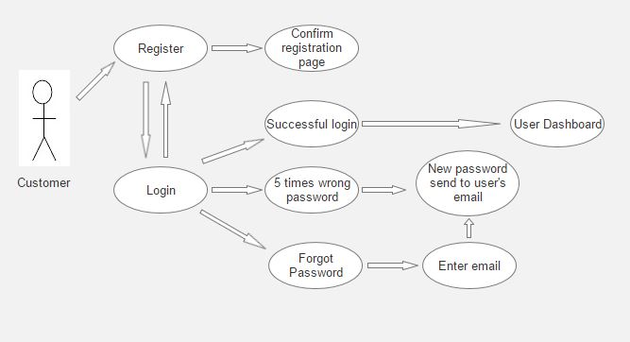

3. Specific Requirements

3.1Functional Requirements
Reminder application should support the following use cases:

CLASS OF USE CASES | № | USE CASES | DESCRIPTION OF USE CASES
Related to System Authentication | 1 | Register | Register in the Reminder
Related to System Authentication | 2 | Log in | Login in the Reminder
 | 3 | Forgot Password | User enters email he used for registration and receives new password on that email
 | 4 | Change Password | Changes the login password

Use cases related to System Authentication:
Use Case №1: Register
Primary Actor: User/Registered User
Pre Condition: Installed browser and active internet connection. User hits Reminter ulr in the address bar. User is redirected to Reminder main page. From there user hits “Register” (Refer to prototype)

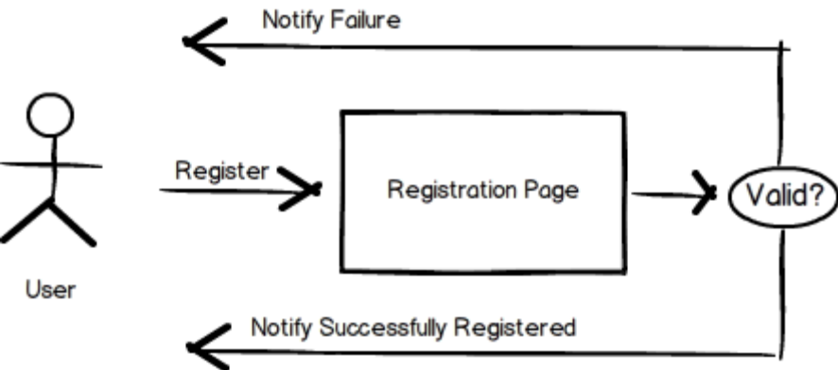

Valid Format for different Fields:
“Username” field:
- Username is a sequence of letters and digits, where '.', '-' and '_' can appear between them
- Small and capital letters from Latin alphabet
- Special symbols “_ . -”
- Digits 0-9
- Each username must start with small or capital letter
- Two symbols can’t be used one after the other
“Email address” field:
Emails are considered to be in format <user>@<host>, where:
- <user> is a sequence of letters and digits, where '.', '-' and '_' can appear between them.
- <host> is a sequence of at least two words, separated by dots '.'. Each word is sequence of letters and can have hyphens '-' between the letters
“Password” field:
- A minimum of 6 characters is required.
- Small and capital letters from Latin alphabet
- Punctuation marks
- Digits 0-9
- Password must be mix of uppercase and lowercase characters, numbers and punctuation.
- If you change an existing password, the new one must be different from the last password
“Confirm password” field:
- Exact match with “Password” field

Main scenario:
- User types his desired username in “Username” filed
- User types his email address in “Email address” filed
- User types his desired password in “Password” filed
- User confirms his desired password in “Confirm password” filed
- System does authentication
- User is redirected to new page with message: ”To complete the registration, please confirm you details send on your email address.”
- Once he click on the link from the message send to email address upon registration he will be redirected to his Dashboard. In this email will be described the T&C that he accept upon hit.
Alternate scenario:
- Authorization fails – User hits the “Register now” button with blank:
- “Username” field
- “Email address” field
- “Password” field
- “Confirm password” field
  - System does Authentication
  - Prompt the user error messages
- “Enter username”
- “Enter email address”
- “Enter password”
- “Confirm password”
  - User is allowed to enter all details

- Authorization fails – User hits the “Register now” button with one or more blank fields
  - System does Authentication
  - Prompt error message to enter the data where fields are left blank
  - Information in “Username” and “Email address” fields if there is such provided is been saved
  - Information in “Enter password” and “Confirm password” fields if there is such provided in been deleted
  - User is allowed to enter the details

- Authorization fails – User hits the “Register now” button with details in all fields.
  - System does Authentication
    - If one or more fields are not in the right format
      - Prompt error messages for incorrect credentials
      - Information in all field where data is not in the right format is deleted including the “Enter password” and “Confirm password” fields no matter if they are in the right format
      - User is allowed to enter new details

    - If there is a registration with both the username typed in “Username” and the email typed in “Email address”
      - Prompt error messages “Username is already taken” and “Email address is already used for registration”
      - Information in “Username” is deleted.
      - Information in “Email address” field is deleted
      - Information in “Enter password” and “Confirm password” fields is deleted
      - User is allowed to enter new details

    - If there is a registration with the username typed in “Username” and all other fields are completed correctly
      - Prompt error messages “Username is already taken”
      - Information in “Username” is deleted.
      - Information in “Email address” field is deleted
      - Information in “Enter password” and “Confirm password” fields is deleted
      - User is allowed to enter new details

    - If there is a registration with the email typed in “Email address” field and all other fields are completed correctly
      - Prompt error messages “Email address is already used for registration”
      - Information in “Username” is kept.
      - Information in “Email address” field is deleted
      - Information in “Enter password” and “Confirm password” fields is deleted
      - User is allowed to enter new details
  - Authorization fails – User hits the “Register now” button with different passwords in “Password” and “Confirm password” fields
    - If information in “Username”, “Email address” and “Password” fields is valid
      - Prompt error message “Password not match”
      - Information in “Username” is kept.
      - Information in “Email address” is kept
      - Information in “ “Confirm password” field is deleted
      - User is allowed to enter new details
    - If information in one or more of “Username”, “Email address” and “Password” fields is not valid
      - Prompt error messages for incorrect fields
      - Information in “Username” is deleted if not valid.
      - Information in “Email address” is deleted if not valid
      - Information in “ “Confirm password” field is deleted
      - User is allowed to enter new details

- User select the “Log in” button
  - User is redirected to “Log in” page from where he can enter the system

Use Case №2: Login
Primary Actor: User/Registered User
Pre Condition: Installed browser and active internet connection. User hits Reminter ulr in the address bar. User is redirected to Reminder main page. User select the “Log in” button and is redirected to “Log in” page (Refer to prototype).

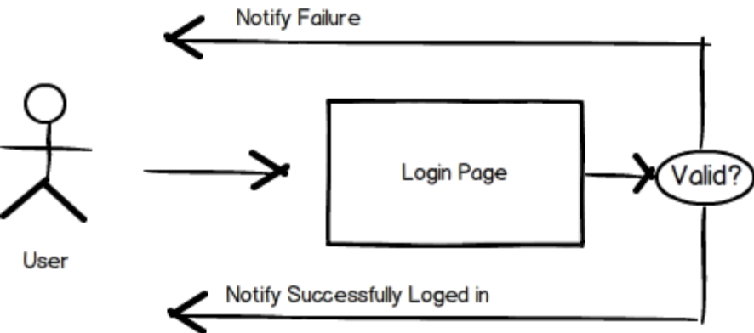
Main scenario:
- User types valid username or email address in “Username or email address” field and valid password in “Password” field
- User hits the “Log in” button
- System does authentication
- Reminder Dashboard is displayed
Alternate scenario:
- Authorization fails – User hits the “Log in” button with blank “Username or email address” field and blank “Password” field.
  - System does authentication
  - Prompt the user error messages “Enter username” and “Enter password”
  - User is allowed to enter username or email address and password

- Authorization fails – User hits the “Log in” button with blank “Username or email address” field and any password typed in “Password” field.
  - System does authentication
  - Prompt the user error message “Enter username”
  - Typed in the “Password” field is deleted and field is returned to its initial state - blank
  - User is allowed to enter username or email address and password

- Authorization fails – User hits the “Log in” button with typed registered/not registered username or email address in “Username or email address” field and blank “Password” field.
  - System does authentication
  - Prompt the user error message “Enter password”
  - User is allowed to enter password. “Username or email address” field keeps the information

- Authorization fails – User hits the “Log in” button with typed not registered username or email address in “Username or email address” field and any password typed in “Password” field.
  - System does authentication
  - Prompt the user error message “Incorrect username”
  - Typed in the “Password” and in “Username or email address” fields is deleted and fields are returned to their initial state - blank
  - User is allowed to enter password. “Username or email address” field keeps the information

- Authorization fails – User hits the “Log in” button with typed registered username or email address in “Username or email address” field and incorrect password typed in “Password” field.
  - System does authentication
  - Prompt the user error messages “Incorrect password”
  - User is allowed to re-enter password. “Username or email address” field keeps the information
  - If user tried 5 times with wrong passwords, the account will be closed for log in and email will be send to users email address. He will be redirected to different page with information about that.

- Authorization fails – User hits the “Log in” button with typed correct password for some registered user or for the user entered in “Password” field in “Username or email address” field and valid registered username or email address typed in “Password” field.
  - System does authentication
  - If typed in “Username or email address” doesn’t match any registered username or email address
    - Prompt the user error messages “Incorrect User”
    - Typed in the “Password” and in “Username or email address” fields is deleted and fields are returned to their initial state - blank
    - User is allowed to re-enter username.
  - If typed in “Username or email address” matches registered username or email address
    - Prompt the user error messages “Incorrect Password”
    - Typed in the “Password” field is deleted and field is returned to its initial state - blank
    - User is allowed to re-enter username.

- User select the “Back to Register” button
  - User is redirected to “Register” page from where he can register
- User select the “Forgot password” button
  - User is redirected to “Forgotten password” page from where he can fill in his email address in order to receive new password

Use Case №3: Forgot password
Primary Actor: User/Registered User
Pre Condition: Installed browser and active internet connection. User hits Reminter ulr in the address bar. User is redirected to Reminder main page. User selects the “Log in” button and is redirected to “Log in” page. User selects “Forgot password” label and is redirected to “Forgotten password” page (Refer to prototype).
Main scenario:
- User types valid email address in “Email address” field
- User hits the “Send new password” button
- System does authentication
- User is redirected to different page that confirms a new password is sent to his email.
Alternate scenario:
- Authorization fails – User hits the “Send new password” button with blank “Email address” field
  - System does authentication
  - Prompt the user error message “Enter email”
  - User is allowed to enter email address

- Authorization fails – User hits the “Send new password” button with email in invalid format written in “Email address” field
  - System does authentication
  - Prompt the user error message “Invalid email format”
  - User is allowed to enter email address

- Authorization fails – User hits the “Send new password” button with not registered email written in “Email address” field
  - System does authentication
  - Prompt the user error message “Not registered email”
  - User is allowed to enter email address

Use Case №4: Change password
Primary Actor: Registered User
Pre Condition: User is logged in in the Reminder. User selects “Account” menu. User selects “Change Password” option. A pop-up window displays the “Change password” panel (Refer to prototype).
Main scenario:
- User types his current password in “Current password” field
- User types his desired new password in valid format in “New password” field
- User confirms his new password in “Confirm new password” field
- User hits the “Change password” button
- System does authentication
- A password conformation message is shown on the same pop-up window
Alternate scenario:
- Authorization fails – User hits the ““Change password” button with blank one or more of the fields “Current password”, “New password”, “Confirm new password”
  - System does authentication
  - Prompt the user error message where field/s is/are blank
  - Information in all fields is deleted
  - User is allowed to enter email address

- Authorization fails – User hits the ““Change password” button with password in invalid format in or more of the fields “Current password”, “New password”, “Confirm new password”
  - System does authentication
  - Prompt the user error message where field/s is/are not in the right format
  - Information in all fields is deleted
  - User is allowed to enter email address

- Authorization fails – User hits the ““Change password” button with password that doesn’t match his current password in “Current password” field, and any or bland information in or more of the fields “New password”, “Confirm new password”
  - System does authentication
  - Prompt the user error message “Invalid password” for “Current password” field
  - Information in all fields is deleted
  - User is allowed to enter email address

- Authorization fails – User hits the ““Change password” button with password that matches his current password in “Current password” field, and password in invalid format in “New password” and “Confirm new password” fields
  - System does authentication
  - Prompt the user error message “Invalid password format” for “New password” field and/or “Confirm new password” field
  - Information in all fields is deleted
  - User is allowed to enter email address

- Authorization fails – User hits the ““Change password” button with password that matches his current password in “Current password” field, and different passwords in valid format in “New password” and “Confirm new password” fields
  - System does authentication
  - Prompt the user error message “Password not match” for “Confirm new password” field
  - Information in all fields is deleted
  - User is allowed to enter email address

- User hits the ““Change password” button with password that matches his current password in “Current password” field, and same password for “New password” and “Confirm new password” fields
  - System does authentication
  - Prompt the user error message “Incorrect password”
  - Information in all fields is deleted
  - User is allowed to enter email address

More cases to be tested. To be added in test cases:

- User hits the ““Change password” button with password that doesn’t match his current password in “Current password” field, his current password in “New password” and “Confirm new password” fields
  - System does authentication
  - Prompt the user error message “Invalid password”
  - Information in all fields is deleted
  - User is allowed to enter email address

______________________________________________________________________________

This section describes specific features of the software project. If desired, some requirements may be specified in the use-case format and listed in the Use Cases Section.

3.2.1 <Functional Requirement or Feature #1>
3.2.1.1 Introduction
3.2.1.2 Inputs
3.2.1.3 Processing
3.2.1.4 Outputs
3.2.1.5 Error Handling

3.2.2 <Functional Requirement or Feature #2>
…

3.3 Use Cases

3.3.1 Use Case #1

3.3.2 Use Case #2
…

3.4 Classes / Objects

3.4.1 <Class / Object #1>

3.4.1.1 Attributes
3.4.1.2 Functions
<Reference to functional requirements and/or use cases>

3.4.2 <Class / Object #2>
…

3.5 Non-Functional Requirements
Non-functional requirements may exist for the following attributes. Often these requirements must be achieved at a system-wide level rather than at a unit level. State the requirements in the following sections in measurable terms (e.g., 95% of transaction shall be processed in less than a second, system downtime may not exceed 1 minute per day, > 30 day MTBF value, etc).

3.5.1 Performance

3.5.2 Reliability

3.5.3 Availability

3.5.4 Security

3.5.5 Maintainability

3.5.6 Portability

3.6 Inverse Requirements
State any *useful* inverse requirements.

3.7 Design Constraints
Specify design constrains imposed by other standards, company policies, hardware limitation, etc. that will impact this software project.

3.8 Logical Database Requirements
Will a database be used? If so, what logical requirements exist for data formats, storage capabilities, data retention, data integrity, etc.

3.9 Other Requirements
Catchall section for any additional requirements.

4. Analysis Models
List all analysis models used in developing specific requirements previously given in this SRS. Each model should include an introduction and a narrative description. Furthermore, each model should be traceable the SRS’s requirements.

4.1 Sequence Diagrams

4.3 Data Flow Diagrams (DFD)

4.2 State-Transition Diagrams (STD)

5. Change Management Process
Identify and describe the process that will be used to update the SRS, as needed, when project scope or requirements change. Who can submit changes and by what means, and how will these changes be approved.

A. Appendices
Appendices may be used to provide additional (and hopefully helpful) information. If present, the SRS should explicitly state whether the information contained within an appendix is to be considered as a part of the SRS’s overall set of requirements.

Example Appendices could include (initial) conceptual documents for the software project, marketing materials, minutes of meetings with the customer(s), etc.

A.1 Appendix 1

A.2 Appendix 2

