Irakoze Peace Arlaine

23753

AssignmenII

-- Connect to the Oracle database as SYSDBA

sqlplus sys as SYSDBA

-- Display the current user to verify the connection

show user

-- Retrieve the name of the current database instance

SELECT instance_name from v$instance;

-- List all pluggable databases (PDBs) available in the container database (CDB)

show pdbs;

-- Retrieve data files associated with a specific container ID (CON_ID = 3)

SELECT CON_ID, TABLESPACE_NAME, FILE_NAME

FROM CDB_DATA_FILES

WHERE CON_ID = 3;

-- Create a new pluggable database named 'plsql_class2024db'

CREATE PLUGGABLE DATABASE plsql_class2024db

ADMIN USER pdbadmin IDENTIFIED BY YourPassword -- Create an admin user with a password

FILE_NAME_CONVERT = (

'D:\SEMESTER_7\PLSQL\ORADATA\ORCL\PDBSEED\', -- Source path of PDB$SEED

'D:\SEMESTER_7\PLSQL\ORADATA\ORCL\plsql_CLASS2024db\' -- Destination path for new PDB files

);

-- Open the newly created pluggable database to make it available for use

ALTER PLUGGABLE DATABASE plsql_class2024db OPEN;

-- Change the session context to the newly created PDB

ALTER SESSION SET CONTAINER = plsql_class2024db;

-- Create a new user 'ar_plsqlauca' in the PDB with a specified password

CREATE USER ar_plsqlauca IDENTIFIED BY 123;

-- Grant all privileges to the new user, allowing full access to the database objects

GRANT ALL PRIVILEGES TO ar_plsqlauca;

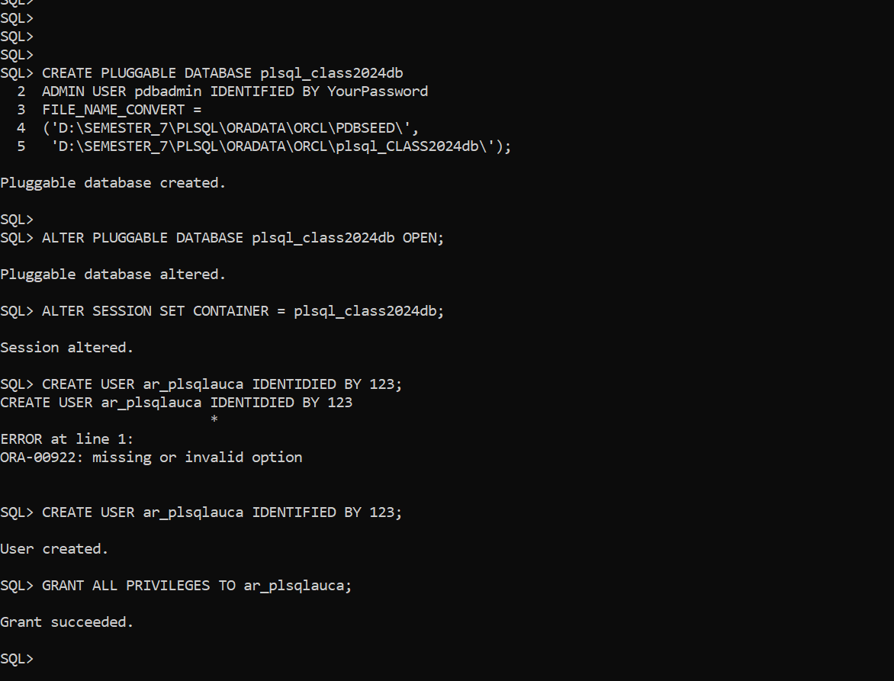

**TASK2**

-- Attempt to create a pluggable database named 'ar_to_delete_pdb' from within a PDB

CREATE PLUGGABLE DATABASE ar_to_delete_pdb

ADMIN USER pdbadmin IDENTIFIED BY 123 -- Create an admin user with the specified password

FILE_NAME_CONVERT = (

'D:\SEMESTER_7\PLSQL\ORADATA\ORCL\PDBSEED\', -- Source path of PDB$SEED

'D:\SEMESTER_7\PLSQL\ORADATA\ORCL\ar_to_delete_pdb\' -- Destination path for new PDB files

);

-- Error occurs because the operation is not allowed from within a pluggable database

ERROR at line 1:

ORA-65040: operation not allowed from within a pluggable database

-- Switch to the root container (CDB$ROOT) to perform the database creation

ALTER SESSION SET CONTAINER = CDB$ROOT;

-- Create the pluggable database again, now in the root container

CREATE PLUGGABLE DATABASE ar_to_delete_pdb

ADMIN USER pdbadmin IDENTIFIED BY 123 -- Create an admin user with the specified password

FILE_NAME_CONVERT = (

'D:\SEMESTER_7\PLSQL\ORADATA\ORCL\PDBSEED\', -- Source path of PDB$SEED

'D:\SEMESTER_7\PLSQL\ORADATA\ORCL\ar_to_delete_pdb\' -- Destination path for new PDB files

);

-- Switch back to the root container (CDB$ROOT) for further operations

ALTER SESSION SET CONTAINER = CDB$ROOT;

-- Attempt to close the pluggable database; however, there is a typo in the command

ALTER PLUGGABLE DATABSE ar_to_delete_pdb CLOSE; -- This will cause an error due to a typo

-- Correct command to close the pluggable database

ALTER PLUGGABLE DATABASE ar_to_delete_pdb CLOSE;

-- Attempt to close the pluggable database, but it is already closed

ERROR at line 1:

ORA-65020: pluggable database AR_TO_DELETE_PDB already closed

-- Drop the pluggable database including its data files

DROP PLUGGABLE DATABASE ar_to_delete_pdb INCLUDING DATAFILES; -- This permanently removes the PDB and its associated files

-- Confirmation that the pluggable database has been dropped

Pluggable database dropped.

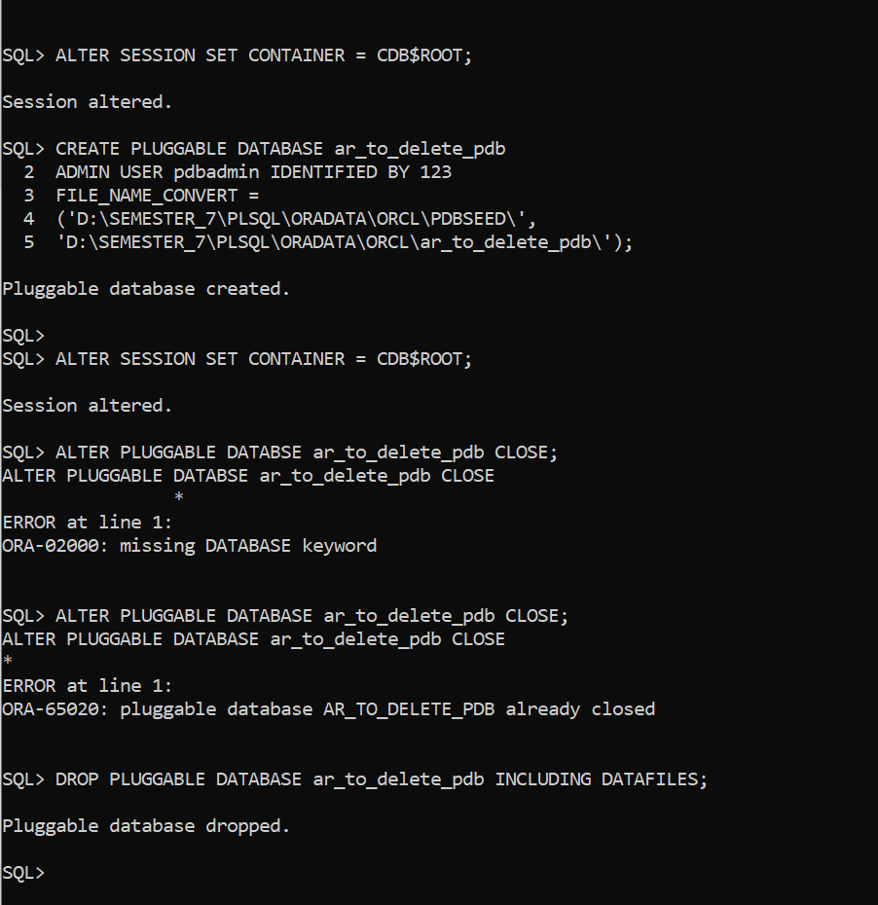

**TASK 3**

Here is the configured Oracle Enterprise Manager and a screenshot of the dashboard

