**Documentation**

**PeaceTrack Android - Peace Corps**

**GSoC - 2015**

**By:**

**Bhagya Hettige -** [**Systers Profile**](http://systers.org/systers-dev/doku.php/bhagya_gayathri_hettige)

**Last Edited: August, 2015**

**Table of Contents**

Introduction

Setting up the Development Environment

Main entities associated with the application

System Design

Back-end Design

Data models

Database Design

Front-end Design

Screenshots of the Application

# Introduction

PeaceTrack is a mobile application designed for the volunteers in Peace Corps to track their day-to-day volunteering tasks. The mobile application is developed in two versions, Android and iOS. Volunteers serve the world by giving hand to the people in rural communities to improve their knowledge, literacy and skills. Activities are performed on a specific community to achieve the expected positive outcomes. Then the volunteers performs tests necessary to measure the outcomes in the community. Peace Corps uses these measured outcome data to derive useful statistical information about the communities and activities. Data has to be recorded even in offline state, and synchronized with the central database when connected to a network.

The manual recording system of the volunteering tasks is a long, error-prone process. Currently the volunteers have to spend a tremendous amount of time filling the forms by hand and submitting. Then there should be a data entry operator to enter all the collected data in digital format in order to store in the central database.

This document intends present the system architecture, system design and system implementation details on PeaceTrack Android application. It further provides insights into the application by giving an overview on the technologies used. Basic guidelines on setting up the development environment for PeaceTrack Android application is also presented.

# Setting up the Development Environment

1. Download Android Studio IDE from [this link](https://developer.android.com/sdk/index.html).
2. Download and install the Android SDK bundle for Android Studio from [this link](https://developer.android.com/sdk/installing/index.html).
3. Clone the latest github repository of PeaceTrack – Android. In this repository, the PeaceTrack folder contains the Android Studio project. PeaceTrack-Eclipse folder contains the last year’s Eclipse project.

git clone https://github.com/systers/peacetrack-android.git

1. Open the project from Android Studio.

Note: An external jar library has been used in the application called aCharEngine which is included in the project:

~/pecetrack-android/PeaceTrack/app/src/main/libs/achartengine-1.0.0.jar (available [here](http://code.google.com/p/achartengine/)).

# Main entities associated with the application

1. **Cohort**

A cohort is a group of people on which an activity is targeted at. (e.g.-: Study group of 50 students, football team, senior citizens)

1. **Activity**

An activity is a task carried out by a volunteer for a cohort. Activities are associated with a number of outputs. (e.g.-: Football game organized to discuss and improve awareness of Malaria, workshop organized to teach English)

1. **Measurement**

A measurement is positive or negative effect of an activity on a cohort.

1. **Impact**

An impact is a graphical view of multiple measurements with a common outcome.

# System Design

The system design details of PeaceTrack Android application is presented in this section. Back-end of the application is explained with the data models and the relationships among them. Front-end design of the application is presented with the User Interface design and their functionalities.

## Back-end Design

### Data models

1. **Cohort**

The central database should hold the cohort information globally to track cohort performances, to compare with other cohorts and to make decisions on improving future activities. Following are the data to be recorded in the central database about a particular cohort.

* Cohort identification number (unique across ALL the cohorts)
* Cohort name
* Post
* Sector
* Description
* Activities

In the mobile application we have to track these data. When a volunteer creates a new cohort, the following data have to be tracked and stored locally in the phone.

* Cohort name (unique across the cohorts reported by the volunteer)
* Description
* Activities

1. **Activity**

With activities, Peace Corps can track the volunteer performance and activeness of cohorts. The data which have to be recorded in the central database are as follows.

* Activity identification number
* Activity title
* Description
* Cohort participated
* Date
* Time
* Outputs and data

The phone local storage should hold the following data. When the volunteer creates an activity, these data should be provided.

* Activity title
* Description
* Cohort
* Date
* Time
* Outputs and data

1. **Measurement**

In a measurement, the important data to be stored in the central database are as follows.

* Measurement identification number
* Measurement title
* Date
* Time
* Cohort
* Outcome and data

When a volunteer tracks a measurement, the data to be recorded in the local phone storage are as follows.

* Measurement title
* Cohort
* Outcome and data

### **Database Design**

The data recorded by the volunteers should be sent to the central database via Internet. But due to the network connection issues in the rural communities where the volunteers work, they cannot connect to the Internet very often. As a solution to this problem, we expect to have the data entered in the local database and synchronize the data with the central server whenever the mobile device is connected to a network. Therefore we identified 2 main states of the application where data storage can be handled.

|  |  |
| --- | --- |
| **Offline state** | The data recorded are stored in the local database with a flag “isSynched” set to FALSE. |
| **Online state** | Manual synchronization or automatic synchronization can be enabled from the settings.  Send the data saved with the flag “isSynched” set to FALSE in the local database to the central database. |

**Database Schema for Mobile Application**

The database in the mobile application is implemented with SQLite database.

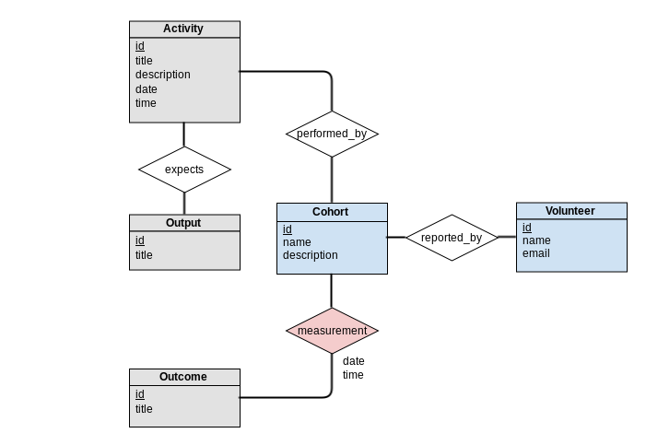

**Database Schema for Mobile Application Control Center**

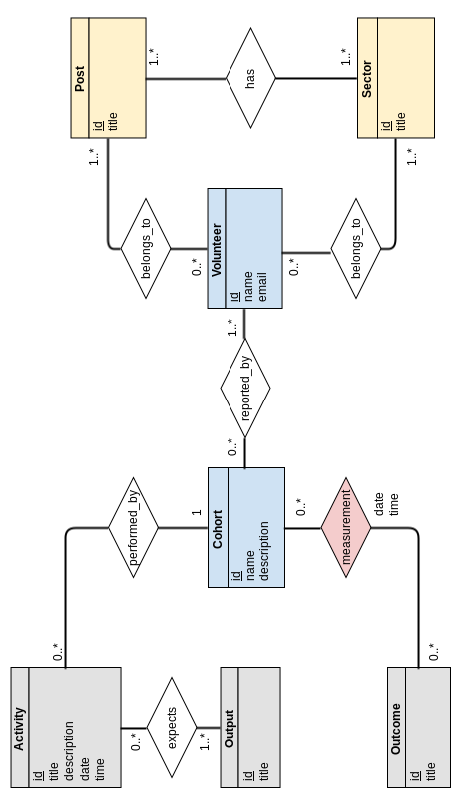

# Front-end Design

Front-end design of an application heavily affects the usability of the application. We should consider several factors when designing the user interfaces for the users to interact with computing device – learnability, efficiency of use, error handling and acceptability.

We should decide on the user interface changes with the Peace Corps and finalize the design. UI wireframes should be designed as the next step to start implementation.

This section provides the main work-flow associated with the main operations in PeaceTrack mobile application.

**Login Flow**

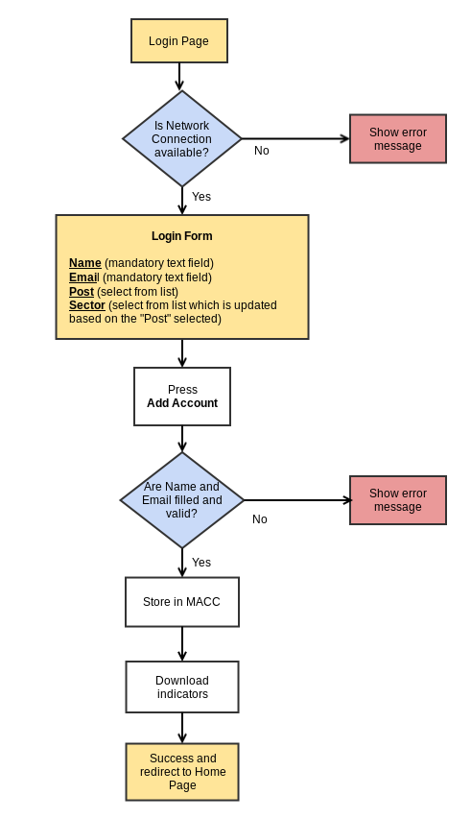

**Cohort Management**

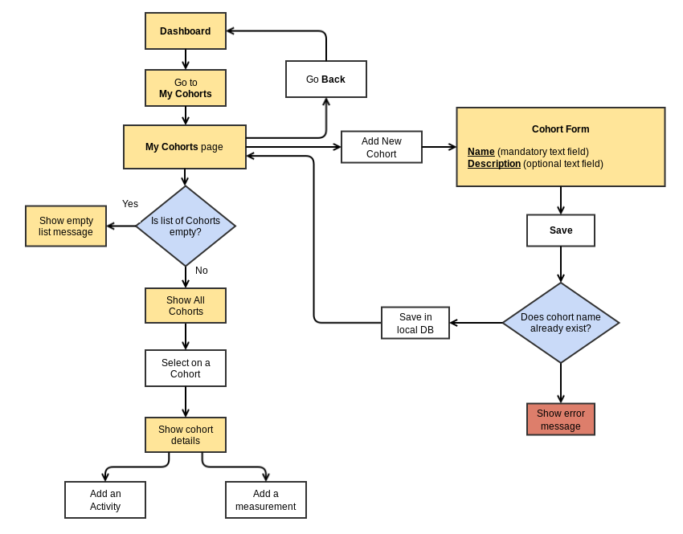

## **Screenshots of the Application**

**Login Screen**

When PeaceTrack is downloaded, and opened for the first time, the user has to login to the application by giving the name and email address. The user should select his/her post and sector in advance. For this login process the mobile device should be connected to network.

NOTE: We have to validate the user to check if this user is a valid Peace Corps volunteer. For this we can use the Peace Corps Identification Number. When the user successfully login to the application, we have to download the relevant output and outcome indicators by communicating with the MACC.

|  |  |
| --- | --- |
| When user opens the application for the first time and the device is not connected to a network. |  |
| When user opens the application for the first time and the device is connected to a network. |  |
| When name and email are not entered properly error messages are displayed and the user cannot proceed. |  |

**Welcome Screen**

Once the user has successfully login to the application, he/she gets the welcome screen with the dashboard. In this screen 4 main buttons are placed.

* Manage cohorts
* Add an activity
* Add a measurement

|  |  |
| --- | --- |
| The user sees the welcome screen. |  |

**Cohort Management**

Cohort management includes adding a new cohort, editing an existing cohort, deleting a cohort, displaying the details of the cohorts, listing all the cohorts and searching for a cohort etc.

|  |  |
| --- | --- |
| The user get a list of cohorts available. |  |
| When a cohort is searched a filtered list of cohorts is given. |  |
| When a cohort is selected from the list details of the cohort is given.  User can directly add an activity or a measurement for the selected cohort via this screen. |  |
| The cohort can be deleted from the list. (NOTE: Once a cohort is deleted, all the activities and measurements associated with the cohort are also deleted.) |  |
| A new cohort can be added. |  |
| When the cohort details are not entered or the name is a duplicate then an error message is displayed. |  |

**Activity Management**

Activity management includes adding a new activity, editing an existing activity, deleting an activity, displaying the details of the activities, listing all the activities and searching for an activity etc.

|  |  |
| --- | --- |
| The user get a list of activities available. |  |
| When an activity is searched a filtered list of activities is given. |  |
| When an activity is selected from the list details of the activity is given. |  |
| The activity can be deleted from the list. |  |
| When adding a new activity, it checks whether there are cohorts added to the application, if not the this message is displayed. |  |
| If there are existing cohorts, a new activity can be added. In the first screen the activity details are entered. |  |
| Date and time fields in Add Activity pop up the shown dialogs to select the relevant date and time of the activity. |  |
| The second page of Add Activity is Add Indicators in which the outputs are entered. |  |
| The outputs are selected to be entered. |  |
| When there are any violations in adding the activity, error messages are shown accordingly. |  |

**Measurements Management**

In the current version of the application, only the adding measurement feature and listing all the available measurement feature are implemented.

|  |  |
| --- | --- |
| If there are no cohorts in the application, a message is displayed. |  |
| Adding a measurement would give the form if there are existing cohorts in the application. |  |
| The user can get a list of all measurements available. |  |
| When there are any violations in adding the measurement, error messages are shown accordingly. |  |

# References

* [Android Code](https://github.com/systers/peacetrack-android)
* [PeaceTrack Requirements Doc](https://github.com/PeaceCorps/peacetrack-readme)