DELTA STATE UNIVERSITY, ABRAKA
FACULTY OF COMPUTING
DEPARTMENT OF COMPUTER SCIENCE
DESIGN AND IMPLEMENTATION OF AN E-LEARNING PLATFORM FOR ENHANCED TEACHING AND LEARNING FOR SECONDARY SCHOOLS
A PROJECT REPORT
SUBMITTED IN PARTIAL FULFILMENT OF THE REQUIREMENTS FOR THE AWARD OF THE
DEGREE OF BACHELOR OF SCIENCE (B.Sc.) IN COMPUTER SCIENCE
BY
[STUDENT'S FULL NAME]
[MATRICULATION NUMBER]
SUPERVISOR
[SUPERVISOR'S FULL NAME]
SEPTEMBER, 2026
CERTIFICATION
This is to certify that this project report titled “Design and Implementation of an E-Learning Platform for Enhanced Teaching and Learning for Secondary Schools” was carried out by [STUDENT'S FULL NAME] ([MATRICULATION NUMBER]) in the Department of Computer Science, Faculty of Computing, Delta State University, Abraka, under my supervision.
……………………………………… ………………………
[SUPERVISOR'S FULL NAME] Date
Supervisor
……………………………………… ………………………
Head of Department Date
APPROVAL
This project report has been read and approved as meeting the requirements of the Department of Computer Science, Faculty of Computing, Delta State University, Abraka, for the award of the degree of Bachelor of Science in Computer Science.
Supervisor: …………………………… Signature/Date: …………………
Head of Department: ……………… Signature/Date: …………………
External Examiner: ………………… Signature/Date: …………………
DECLARATION
I, [STUDENT'S FULL NAME], declare that this project is my original work and that it has not been submitted, in whole or in part, for the award of a degree in this or any other university. All sources of information have been duly acknowledged in accordance with the referencing conventions of the Faculty of Computing.
Signature: …………………………… Date: …………………
DEDICATION
This work is dedicated to God, to my family, and to the teachers and students of Nigerian secondary schools whose daily labour makes any e-learning desk worth building.
ACKNOWLEDGEMENTS
The researcher thanks the supervisor, [SUPERVISOR'S FULL NAME], the Head of Department, and the staff of the Faculty of Computing, Delta State University, Abraka, for guidance. Thanks are also due to family and colleagues who supported the work.
Disclosure of generative-AI assistance (Faculty guide). Substantial drafting assistance was obtained from an interactive coding assistant (xAI Grok) in organising chapters, formatting the Word file, and restating implementation facts taken from the working ClassWick codebase. The intellectual decisions, the implemented system, the test evidence, and the accountability for every claim remain the student’s. No experimental results, citations or metrics were fabricated. The student is prepared to explain and defend every line at the oral examination.
ABSTRACT
Many Nigerian secondary schools still organise teaching as paper notes and WhatsApp broadcasts. That practice is familiar, but it does not keep a durable record of enrolment, lessons, quizzes or ungraded scripts, and generic learning management systems assume a higher-education course model rather than junior and senior secondary forms. This project designed and implemented ClassWick, a web-based e-learning desk for a single school. The system provides three role-gated doors (student, teacher and administrator) on a shared West African secondary curriculum (JSS 1–3 and SS 1–3), with pending-account approval, deterministic multiple-choice marking, assignments, notices and a subject-scoped study assistant. Implementation used TypeScript 5.9, React 19.2, TanStack Start, Tailwind CSS 4.3, Better Auth and PostgreSQL. Evaluation comprised fifty-five passing application unit tests, a clean TypeScript check, integration timings of 8.1 ms to 155.8 ms time-to-first-byte on public routes, a twelve-case user-acceptance walkthrough, and an expert heuristic usability score of 4.4 out of 5. Precision and F1 were not reported for the generative tutor because no labelled gold set was prepared. The desk is not a replacement for Moodle or for the teacher; it is a bounded, local, evidenced artefact that a school can host on the web.
Keywords: e-learning; secondary school; learning management system; role-based access; artificial intelligence tutoring.
TABLE OF CONTENTS
Certification
Approval
Declaration
Dedication
Acknowledgements
Abstract
List of Figures
List of Tables
List of Abbreviations
CHAPTER ONE: INTRODUCTION
1.1 Background to the Study
1.2 Statement of the Problem
1.3 Aim and Objectives
1.4 Research Questions
1.5 Significance of the Study
1.6 Scope of the Study
1.7 Definition of Terms
CHAPTER TWO: LITERATURE REVIEW
2.1 Conceptual Review
2.2 Theoretical Review
2.3 Review of Related Works
2.4 Comparative Analysis of Existing Systems
2.5 Research Gap Identification
2.6 Summary of Literature Review
CHAPTER THREE: SYSTEM ANALYSIS AND DESIGN
3.1 Research Methodology
3.2 Analysis of the Existing System
3.3 Analysis of the Proposed System
3.4 System Requirements
3.5 System Design (Models)
3.6 Database Design
3.7 System Architecture
CHAPTER FOUR: SYSTEM IMPLEMENTATION, TESTING AND RESULTS
4.1 Development Environment and Tools
4.2 System Implementation
4.3 User-Interface Design
4.4 System Testing
4.5 Results and Performance Evaluation
4.6 Discussion of Results
CHAPTER FIVE: SUMMARY, CONCLUSION AND RECOMMENDATIONS
5.1 Summary
5.2 Conclusion
5.3 Contributions to Knowledge
5.4 Recommendations
5.5 Limitations and Future Work
References
Appendix A Schema excerpt
Appendix B Reproducibility
Appendix C Test log summary
LIST OF FIGURES
Figure 3.1: Layered architecture of the ClassWick e-learning desk.
Figure 3.2: Use-case model of the proposed e-learning platform.
Figure 3.3: Entity-relationship overview of the school schema.
Figure 3.4: Activity of account approval (first-person-is-admin rule).
Figure 4.1: Landing page of the ClassWick application.
Figure 4.2: Registration interface.
Figure 4.3: Student dashboard.
Figure 4.4: Teacher dashboard.
Figure 4.5: Administrator dashboard.
Figure 4.6: Teacher subject cards.
Figure 4.7: Teacher subject page (Basic Science).
Figure 4.8: Add-lesson form.
Figure 4.9: Student Mathematics subject page.
Figure 4.10: Quiz sitting interface.
Figure 4.11: Quiz result and review.
Figure 4.12: Teacher dashboard at telephone width.
Figure 4.13: Lesson reader.
Figure 4.14: Page time-to-first-byte on the live preview host.
Figure 4.15: Automated verification outcomes.
LIST OF TABLES
Table 2.1: Comparison of existing practice with the proposed ClassWick desk.
Table 3.1: Functional requirements of the proposed system.
Table 3.2: Non-functional requirements of the proposed system.
Table 3.3: Data dictionary (selected fields).
Table 4.1: Implementation stack and installed versions.
Table 4.2: Application modules and design traceability.
Table 4.3: Unit test cases.
Table 4.4: Integration test cases.
Table 4.5: User-acceptance test cases.
Table 4.6: Objective coverage.
Table 4.7: Time to first byte of public routes.
Table 4.8: Automated verification outcomes.
Table 4.9: Heuristic usability scores.
LIST OF ABBREVIATIONS
Table 0.1: Abbreviations used in this report.
Abbreviation | Meaning
AI | Artificial intelligence
API | Application programming interface
FR | Functional requirement
HTTP | Hypertext Transfer Protocol
ICT | Information and communication technology
JSS | Junior secondary school
LMS | Learning management system
NFR | Non-functional requirement
NUC | National Universities Commission
RBAC | Role-based access control
SQL | Structured Query Language
SS | Senior secondary school
TAM | Technology acceptance model
TTFB | Time to first byte
UAT | User-acceptance testing
UML | Unified Modelling Language
WAEC | West African Examinations Council

CHAPTER ONE
INTRODUCTION
1.1 Background to the Study
Digital technologies have altered how instruction is organised, how learners practise, and how institutions keep records of academic work. Globally, the learning management system (LMS) became the ordinary container for courses, assignments and grades in higher education and, increasingly, in secondary schools (Watson & Watson, 2007). The same period saw a parallel argument that online learning is not merely a delivery channel but a pedagogical environment that must be designed around interaction, feedback and learner control (Ally, 2004). When schools closed during the COVID-19 pandemic, that environment ceased to be optional: Dhawan (2020) described online learning as a practical refuge rather than a boutique experiment, while UNESCO (2020) urged public systems to treat connectivity, teacher support and equity as conditions of educational recovery.
The African and Nigerian picture was more constrained. Burns (2019) documented uneven information and communication technology (ICT) capacity in sub-Saharan secondary education: devices are often shared, bandwidth is expensive, and teachers receive limited preparation for digital pedagogy. Adedoyin and Soykan (2023) reviewed the pandemic literature and emphasised that emergency remote teaching exposed infrastructure gaps rather than proving that every school was ready for a full LMS. In Nigeria, Oyarinde and Komolafe (2020) reported that Google Classroom could support secondary delivery during closures, but the study also implied dependence on Google accounts, consumer devices and teacher improvisation. Many schools, especially outside large urban centres, fell back on printed notes and WhatsApp groups because those channels were already on teachers’ and parents’ telephones.
National policy supplies both a warrant and a constraint for a local system. The Federal Republic of Nigeria (2013) commits the education sector to ICT as a tool for teaching, learning and educational management, yet the operational unit of secondary schooling remains the junior secondary (JSS 1–3) and senior secondary (SS 1–3) class, assessed in large part against West African Examinations Council syllabuses (West African Examinations Council, n.d.). Generic LMS products are powerful, but they assume course codes, self-enrolment and a higher-education calendar. They do not, out of the box, present a Nigerian secondary roll, a single school administrator, or a modest set of WAEC-oriented seed lessons. The National Universities Commission (2023) Core Curriculum and Minimum Academic Standards for computing further require that undergraduate projects in the Faculty demonstrate analysis, design, implementation and evaluation of a working system. The present project sits at that intersection: a concrete school problem, a software-engineering response, and a locally recognisable curriculum structure.
Artificial intelligence (AI) has entered the same conversation as a tutor rather than as a replacement for the teacher. Luckin et al. (2016) argued for AI that is unleashed in the service of learning, with the teacher remaining accountable for goals and for judgement. Holmes et al. (2019) cautioned that promises of personalisation must be matched by evidence and by attention to curriculum. A secondary-school desk that merely embeds an unconstrained chatbot would reproduce the open web inside the classroom. A more defensible design couples the assistant to enrolment and to a named subject, so that a learner in SS 1 Mathematics is helped with linear equations rather than with an arbitrary prompt. That coupling is the distinctive technical and pedagogical bet of ClassWick.
Against this background the study designed and implemented ClassWick, a web-based e-learning desk for a single secondary school. The system provides three doors on one curriculum: a student desk, a teacher desk and an administrator desk. It seeds JSS 1–3 and SS 1–3, including Mathematics, English Language, Biology, Physics, Chemistry, Civic Education, Computer Studies and Basic Science. It gates entry by approval, scores quizzes by exact match, and offers a subject-scoped study assistant.
1.2 Statement of the Problem
The practical problem is that teaching and learning in many Nigerian secondary schools are still organised as a patchwork of paper notes, photographed assignments and WhatsApp broadcasts. That patchwork is familiar and cheap, but it does not keep a durable record of who is enrolled in which subject, which lesson has been read, which quiz has been sat, or which script is waiting to be graded. When a school does adopt a global LMS, the adoption often collides with account requirements, hosting cost, and a course model that does not match JSS/SS forms (Oyarinde & Komolafe, 2020; Watson & Watson, 2007).
Three limitations follow. First, there is no single, role-gated desk in which the same subject is published by a teacher and consumed by an enrolled student under the eye of one school administrator. Second, assessment on messaging platforms is informal. Third, generative AI is typically offered as a general chatbot rather than as a tutor bound to a subject the student is actually taking (Holmes et al., 2019; Luckin et al., 2016). The project therefore addressed a solvable, bounded problem: to design and implement a web-based secondary-school e-learning desk that is local in curriculum, strict in access control, modest in operational demand, and honest in what its tutor can and cannot claim.
1.3 Aim and Objectives
The aim of the study was to design and implement a web-based e-learning platform, named ClassWick, that enhances teaching and learning in junior and senior secondary schools through role-based desks, a locally seeded curriculum, deterministic quiz marking, and a subject-scoped study assistant.
The specific objectives were to:
1. analyse the limitations of paper, WhatsApp and generic LMS practice in Nigerian secondary schools and specify a role-gated alternative;
2. design the architecture, use cases, approval workflow and relational schema of a single-school e-learning desk for JSS 1–3 and SS 1–3;
3. implement three web desks (student, teacher and administrator) with authentication, approval, lessons, quizzes, assignments, notices and a subject-scoped AI study assistant;
4. evaluate the implementation with unit tests, integration timings, a user-acceptance walkthrough and heuristic usability, without fabricating classifier metrics for the generative tutor;
5. compare the resulting system honestly with Moodle, Google Classroom and informal WhatsApp/paper practice, stating what was achieved and what remains out of scope.
1.4 Research Questions
The work was guided by five questions aligned one-to-one with the objectives:
1. RQ1. What structural weaknesses of existing secondary-school practice should a local e-learning desk address?
2. RQ2. How should architecture, access control and data be designed so that one school can operate three roles on a shared JSS/SS curriculum?
3. RQ3. Can those designs be implemented as a working TypeScript/React web application with a PostgreSQL schema and a subject-scoped assistant?
4. RQ4. What evidence of correctness, performance and usability can be produced without over-claiming the quality of a generative tutor?
5. RQ5. In what respects does the implemented desk improve on, and fall short of, Moodle, Google Classroom and WhatsApp/paper practice?
1.5 Significance of the Study
For students, the significance is a durable, class-aware desk on which lessons, quizzes and assignments remain after a telephone is changed. For teachers, the significance is a publishing and grading surface that is not a chat scroll. For administrators, the significance is a single approval gate and a roll that can be inspected. For the Faculty of Computing, the project demonstrates a complete undergraduate engineering cycle consistent with the NUC (2023) computing standards.
The study is also significant for what it refuses to claim. It does not argue that ClassWick should displace Moodle in a university. It does not report a fifty-person System Usability Scale, and it does not attach precision or F1 scores to a generative model for which no gold set was labelled.
1.6 Scope of the Study
The system is a web application for one school. It targets junior and senior secondary learners, their teachers, and a single administrator. The curriculum seed covers JSS 1–3 and SS 1–3. Authentication uses Better Auth with email and password; the first person to complete onboarding is auto-approved as administrator, and only one administrator is permitted. Quizzes are four-option multiple-choice items scored by exact match. The study assistant calls the xAI grok-4.5 interface when an API key is present and fails closed when the key is absent.
Native mobile binaries, nationwide identity integration, school-fee payment, timetabling, offline-first synchronisation, and a large classroom trial were out of scope. Production persistence requires a hosted PostgreSQL connection string; the preview database is PGLite and does not survive process restart.
1.7 Definition of Terms
Administrator. The unique approved profile with role admin, responsible for approving people, assigning subjects and inspecting school-level reports.
Approval. The transition of a profile status from pending to approved (or rejected), without which a user cannot open a desk.
Desk. A role-specific area of the web application (student, teacher or administrator).
E-learning. Teaching and learning supported by networked software, including content, assessment and communication (Ally, 2004).
Enrolment. The associative record binding a student to a subject.
Learning management system (LMS). Software that administers, documents and delivers educational courses or training (Watson & Watson, 2007).
ClassWick. The name of the implemented web application.
Quiz attempt. A stored record of a student’s answers, score and total for a published quiz, computed by exact matching of A, B, C or D.
Study assistant. The subject-scoped conversational module that sends learner questions to the xAI grok-4.5 model.
Time to first byte (TTFB). The interval between an HTTP request and the first byte of the response.
CHAPTER TWO
LITERATURE REVIEW
2.1 Conceptual Review
2.1.1 E-Learning and Online Pedagogy
E-learning refers to the use of networked digital systems to support teaching and learning, whether the learner is in the same building as the teacher or not. Ally (2004) argued that the theoretical foundations of online learning are not exhausted by putting lecture notes on a server: behaviourist practice supplies drill and feedback, cognitivist practice supplies structured presentation and worked examples, and constructivist practice supplies tasks in which the learner builds meaning. A secondary-school desk that offers lessons, quizzes and a tutor is therefore a pedagogical design as well as a software product. Dhawan (2020) observed that crisis-driven online learning often collapsed those distinctions and became a scramble to stay in touch; the conceptual task of a designed platform is to recover them once the emergency has passed.
UNESCO (2020) placed the same issue in a public-policy frame. Nine ideas for public action after COVID-19 included strengthening education as a common good, valuing the teaching profession, and closing the digital divide. Those ideas matter for a Nigerian secondary project because they forbid two opposite errors: treating software as a substitute for teachers, and treating software as optional ornament. ClassWick was conceived as a desk that a teacher still runs. The student reads what the teacher published; the assistant is an aid, not an examiner of record. That conceptual boundary is maintained in the implementation by keeping quiz scores deterministic and by refusing to report classifier metrics for a generative model.
2.1.2 Learning Management Systems
Watson and Watson (2007) pressed for definitional clarity. An LMS, in their argument, is not every piece of educational software; it is the infrastructure that registers learners, organises content, mediates assessment and reports progress. Course management systems, learning content management systems and instructional tools overlap with that infrastructure but are not identical to it. The distinction is useful in this project because ClassWick is an LMS in the narrow, school-office sense — enrolment, lessons, quizzes, assignments, notices and a roll — and is not a content-authoring studio, a nationwide student-information system, or a repository of open textbooks. Over-claiming the category would invite comparison on features the work never intended to build.
Almarashdeh (2016) examined instructor satisfaction with LMS software from a technology perspective and found that perceived usefulness and ease of use remain decisive, echoing the technology-acceptance tradition discussed in Section 2.2. The practical implication is that a secondary-school desk must look like a place of work rather than a blank form. Teachers will not publish if the publishing path is obscure; students will not sit quizzes if the next action is hidden. Conceptual design therefore includes information architecture (three desks, a shared subject) and visual language (a consistent shell), not only a list of modules.
2.1.3 Secondary Education in the Nigerian Context
The Federal Republic of Nigeria (2013) National Policy on Education describes a 9-3-4 structure in which junior secondary completes basic education and senior secondary prepares learners for tertiary study and the world of work. ICT is named as both a subject and a tool. The operational consequence for software is that class labels such as JSS 1 and SS 1 are not cosmetic: they determine which subjects a learner should see on the first day. WAEC syllabuses further constrain senior-secondary content in Mathematics, the sciences, English and Civic Education (West African Examinations Council, n.d.). A seed curriculum that ignores those labels forces every adopting school to rebuild the tree before any teaching can occur.
Burns (2019) summarised ICT in sub-Saharan secondary education as a story of ambition constrained by electricity, teacher preparation, maintenance and the cost of data. The conceptual lesson for ClassWick was to prefer a browser-based desk that runs on the devices already in teachers’ pockets over a native application that would have to be installed, updated and perhaps paid for. It was also to keep the administrator model small: one school, one administrator, pending approval. Complexity that is reasonable in a university Moodle estate is unreasonable in a school that has just acquired a shared laptop.
2.1.4 Artificial Intelligence in Education
Luckin et al. (2016) described AI in education as a set of tools that can model the learner, the knowledge domain and the teaching strategy, provided the institution remains clear about purpose. Holmes et al. (2019) surveyed promises of personalisation, automated feedback and teacher support, and insisted on implications: bias, opacity, curriculum fit, and the risk of reducing learning to what a model can score. Those cautions shaped the ClassWick assistant. The module is a constrained chat: the learner (or the inspecting administrator) picks a subject, messages are stored, and replies are requested from a hosted model. It is not a diagnostic classifier, not an auto-grader of essays, and not a surveillance engine. Conceptual honesty required that evaluation later in the report refuse F1 scores for this module.
2.2 Theoretical Review
2.2.1 Constructivist and Socio-Cultural Learning
Piaget (1952) located intelligence in the child’s active construction of schemes through assimilation and accommodation. In instructional software this tradition supports sequenced tasks, immediate feedback on well-defined items, and the idea that a quiz is a check of a constructed scheme rather than a punishment. Vygotsky (1978) shifted the emphasis to the social origin of higher psychological processes and to the zone of proximal development, in which a learner performs with assistance what will later be performed independently. A study assistant, used after a lesson rather than instead of one, is a crude but recognisable attempt to offer that assistance at the point of need. The teacher remains the more knowledgeable other of record; the model is a stand-in that is available when the teacher is not.
Ally (2004) explicitly mapped these traditions onto online learning. Behaviourist design yields the ClassWick quiz (stimulus, response, knowledge of result). Cognitivist design yields the lesson reader with summary, body and optional video. Constructivist and socio-cultural design yield assignments and the assistant. The project did not attempt to validate a full instructional theory experimentally; it used the theories as design justifications so that modules were not invented without a learning rationale.
2.2.2 Technology Acceptance
Davis (1989) showed that perceived usefulness and perceived ease of use predict intention to use information technology. Venkatesh and Davis (2000) extended the technology acceptance model (TAM) with social influence and cognitive instrumental processes, confirming across longitudinal field studies that usefulness remains the dominant driver once a system is in workplace use. Almarashdeh (2016) applied related constructs to LMS instructors. For ClassWick, TAM implied two design obligations. Usefulness had to be visible on the first screen of each desk: a student must see subjects and a next action; a teacher must see ungraded scripts; an administrator must see pending people. Ease of use had to be visible in a single shell, a short onboarding, and empty states that do not crash. The heuristic walkthrough in Chapter Four is an acceptance-oriented inspection, not a full TAM survey, and is reported as such.
2.2.3 Software-Engineering Models
Sommerville (2016) and Pressman and Maxim (2020) treat process models as tools matched to risk, rather than as ideologies. The waterfall model assumes stable requirements and a late integration; it is a poor fit for an interface-heavy school desk whose visual language and approval rules were expected to change after the first working prototype. Boehm (1988) proposed a spiral that iterates through risk analysis; the spirit of that iteration was retained, but a full spiral with formal risk documents would have been disproportionate to an undergraduate single-school system. Beck et al. (2001) stated the Agile values: working software over comprehensive documentation, customer collaboration over contract negotiation, and responding to change over following a plan. The project adopted Agile prototyping: a data model first, then authentication and the three desks, then the assistant, then the visual redesign, with tests and screenshots as the demonstration of a working increment.
Codd (1970) remains the theoretical basis for storing school data as relations with keys rather than as a document heap. A subject belongs to a class; a lesson belongs to a subject; a submission belongs to an assignment and a student. Foreign keys and aggregations (lesson counts, mean quiz percentage, ungraded scripts) are natural in a relational model and awkward in a purely document store. The PostgreSQL documentation (PostgreSQL Global Development Group, 2024) and the implementation choice of PGLite for preview and Neon for durable hosting are engineering consequences of that theory, not fashion. Testing documentation followed the intent of IEEE Std 829-2008 (Institute of Electrical and Electronics Engineers, 2008): identified cases, expected results, and an explicit record of what passed, what failed, and why a failure was not treated as a product defect.
2.3 Review of Related Works
2.3.1 Moodle and Open-Source Course Management
Dougiamas and Taylor (2003) presented Moodle as an open-source course management system built around social-constructionist pedagogy and learning communities. Two decades later Moodle remains the reference open LMS: plugins, quizzes with rich item types, gradebooks, and a mature community. Its strengths are also its costs. A school must host it or buy hosting; a site administrator must manage roles that were designed for universities; the empty Moodle course does not know that SS 1 Mathematics is a Nigerian secondary subject. For a Faculty project whose user population is one secondary school, Moodle would have been an adoption exercise rather than a design-and-implementation exercise, and it would have left the local curriculum and the single-administrator rule unspecified. ClassWick therefore treated Moodle as a benchmark of category, not as a codebase to fork.
2.3.2 Google Classroom in Nigerian Secondary Schools
Oyarinde and Komolafe (2020) studied Google Classroom as an online delivery channel in a Nigerian secondary school during the COVID-19 pandemic. The platform lowered the cost of distributing work and collecting submissions for teachers and students who already had Google accounts and data. Limitations follow from the same convenience. Classroom is bound to Google identity; it is not a school office with a pending-approval roll independent of Gmail; it does not seed JSS/SS subjects; and it does not, natively, provide a subject-scoped tutor. Schools without institutional Google Workspace inherit consumer-account friction and have little control over who is in the class beyond the teacher’s invitation list. ClassWick kept Classroom’s lesson — that secondary teachers will use a simple web desk on a phone — and rejected its identity assumption.
2.3.3 Emergency Remote Teaching and Informal Channels
Dhawan (2020) and Adedoyin and Soykan (2023) distinguished planned online learning from emergency remote teaching. The latter, in Nigerian secondary practice, often meant PDF notes on WhatsApp, voice notes, and photographs of exercise books. Those channels are locally optimal for reach: they use the application that is already open. They are locally disastrous for records, integrity and equity. A chat group does not know who has read a lesson; a photograph of a quiz leaks the mark scheme to the next student; a learner who changes telephone number loses the archive. Burns (2019) would recognise the pattern as ICT use without institutional information systems. The related-work conclusion is not that WhatsApp should be banned; it is that WhatsApp is not an LMS, and treating it as one hides the problem this project set out to solve.
2.3.4 AI Tutors and Educational Chat
Holmes et al. (2019) and Luckin et al. (2016) supply the related-work frame for the assistant. Intelligent tutoring systems historically modelled knowledge components and selected the next item; contemporary generative models instead produce unconstrained text. The opportunity is coverage: a secondary learner can ask a follow-up that was not in the lesson notes. The risk is hallucination, curriculum drift, and the temptation to report accuracy numbers that were never measured. Related products that place a chatbot on a public landing page fail the enrolment test: anyone can ask anything. ClassWick’s related-work stance was to put the assistant behind authentication, approval and a subject picker, and to evaluate it as an availability-and-scope feature rather than as a scored classifier. That stance is stricter than marketing practice and weaker than a full intelligent-tutoring evaluation; both facts are stated so that the gap is visible rather than decorated.
2.3.5 Web-Application Platforms
The React documentation (React team, 2024) describes a component model in which user interface is a function of state, which suits three desks that share widgets but not navigation. Relational persistence is documented for PostgreSQL (PostgreSQL Global Development Group, 2024). These are not scholarly evaluations of pedagogy; they are the engineering literature of the implementation. They are cited because Chapter Four reports versions taken from the lockfile and because examiners are entitled to know that the stack was chosen from maintained tools rather than from abandoned frameworks. Sommerville (2016) and Pressman and Maxim (2020) remain the scholarly warrant for matching tools to requirements rather than to fashion.
2.4 Comparative Analysis of Existing Systems
Table 2.1 compares four ways a Nigerian secondary school might organise teaching and learning online: Moodle as the open LMS reference (Dougiamas & Taylor, 2003), Google Classroom as the pandemic-era practical choice (Oyarinde & Komolafe, 2020), WhatsApp and paper as the incumbent informal practice (Adedoyin & Soykan, 2023; Dhawan, 2020), and ClassWick as the system designed in this project. The criteria were chosen from the problem statement: curriculum fit, identity and approval, assessment integrity, AI support, operational demand, and mobile use. The table is a design comparison, not a controlled experiment; no school was migrated from Moodle to ClassWick for this report.
Table 2.1: Comparison of Moodle, Google Classroom, WhatsApp/paper practice and ClassWick.
Criterion | Moodle | Google Classroom | WhatsApp / paper | ClassWick
Primary users | Universities and large schools | Teachers with Google accounts | Any class with phones | One secondary school (JSS/SS)
Curriculum model | Generic courses; empty by default | Generic classwork | None; teacher improvises | Seeded JSS 1–3 and SS 1–3, WAEC-oriented subjects
Identity | Site accounts; many roles | Google identity required | Telephone numbers | Better Auth email/password; pending approval
Administrator model | Site and course admins; plugins | Teacher as owner; Google admin optional | None | Exactly one school administrator
Lessons and materials | Rich; file, SCORM, plugins | Drive attachments and topics | PDFs and photographs in chat | Lesson records with summary, body, optional video
Assessment | Rich quiz engine and gradebook | Quizzes and coursework | Photographs of scripts | Four-option MCQ, exact-match scoring; mark scheme hidden from students
AI tutor | Not native; optional plugins | Not native | Unrelated consumer chatbots | Subject-scoped grok-4.5 assistant; fails closed without a key
Hosting and cost | Self-host or paid MoodleCloud | Free with Google; data costs remain | Free application; paper costs | Web application; PGLite preview or hosted PostgreSQL
Mobile fit | Browser and official app | Official app | Native chat; poor as a records system | Responsive web desk; phone viewport verified
Record keeping | Strong | Moderate (inside Google) | Weak; chats scroll away | Relational records for enrolment, progress, attempts, submissions
Limitation for this setting | Heavy for one school; not JSS/SS-native | Google-account dependence | No integrity, no roll, no recovery | Single school; no nationwide SIS; tutor unquantified

The comparison supports a narrow claim. Moodle is the more complete LMS and should remain the choice where a university or a well-staffed college needs plugins and a gradebook (Dougiamas & Taylor, 2003; Watson & Watson, 2007). Google Classroom is the more convenient choice where Google identity is already institutional (Oyarinde & Komolafe, 2020). WhatsApp and paper remain the more reachable channels where data are scarce, but they fail as information systems. ClassWick is the more local choice for a single secondary school that wants JSS/SS labels, a pending-approval roll, hidden mark schemes, and an assistant that is at least bound to a subject. Those are design differences, not proof of superior learning outcomes. No study in the present work measured examination gains against a control group, and none is claimed.
2.5 Research Gap Identification
The literature leaves a gap at the scale of one Nigerian secondary school. Global LMS products are mature but not local (Dougiamas & Taylor, 2003; Watson & Watson, 2007). Classroom studies in Nigeria show that teachers will use a simple web desk under pressure, but they inherit Google identity and an empty curriculum tree (Oyarinde & Komolafe, 2020). Informal channels reach learners and destroy records (Adedoyin & Soykan, 2023; Dhawan, 2020). AI-in-education writing urges purpose, curriculum fit and humility about measurement (Holmes et al., 2019; Luckin et al., 2016), yet many student projects still paste a chatbot onto a landing page and invent accuracy figures. Policy documents name ICT as a tool and JSS/SS as the structure (Federal Republic of Nigeria, 2013; National Universities Commission, 2023; West African Examinations Council, n.d.), but they do not ship a working desk.
The gap that this project filled is therefore practical and technical rather than theoretical. There was no need for a new theory of learning. There was a need for a designed, implemented and tested system that (a) seeds JSS/SS, (b) enforces three roles and a single administrator with pending approval, (c) keeps quiz mark schemes off the candidate’s client, (d) offers a subject-scoped assistant without fabricating F1, and (e) can be evaluated with the tests that the codebase actually runs. Chapter Three turns that gap into methodology, requirements and models. Chapter Four reports whether the implementation closed it. Chapter Five maps each objective back to evidence and states what remains open.
2.6 Summary of Literature Review
This chapter reviewed e-learning as a pedagogical environment (Ally, 2004; Dhawan, 2020; UNESCO, 2020), the LMS as infrastructure rather than a synonym for every educational app (Watson & Watson, 2007; Almarashdeh, 2016), Nigerian secondary structure and ICT constraints (Federal Republic of Nigeria, 2013; Burns, 2019; West African Examinations Council, n.d.), and AI in education as a purpose-bound aid (Luckin et al., 2016; Holmes et al., 2019). Theoretical warrants were taken from Piaget (1952), Vygotsky (1978), Davis (1989), Venkatesh and Davis (2000), Codd (1970), Beck et al. (2001), Boehm (1988), Sommerville (2016), Pressman and Maxim (2020) and IEEE (2008). Related systems — Moodle, Google Classroom, WhatsApp/paper, and unconstrained chatbots — were compared in Table 2.1. The residual gap is a single-school, JSS/SS-native, role-gated desk with honest evaluation. ClassWick was designed to occupy that gap.
CHAPTER THREE
SYSTEM ANALYSIS AND DESIGN
3.1 Research Methodology
The project adopted an Agile prototyping methodology. Beck et al. (2001) valued working software, collaboration and response to change; Sommerville (2016) and Pressman and Maxim (2020) treat those values as appropriate when requirements are expected to sharpen after a first usable increment. ClassWick was such a system. The school needed three desks, but the exact widgets, the approval edge-cases and the visual language were not knowable until a teacher could click through a running interface. A pure waterfall would have frozen a beige document-style interface that was later judged unfit. A full spiral with formal risk documents (Boehm, 1988) would have consumed the undergraduate calendar without adding evidence. Prototyping inside short Agile cycles was therefore the justified middle.
The cycle was ordered as follows. First, the relational schema and the JSS/SS seed were written so that the desks would never open onto an empty school. Second, authentication and onboarding were implemented, including the rule that the first person is auto-approved as the sole administrator. Third, teacher publish and student consume were connected through server functions. Fourth, the administrator roll, notices and reports were added. Fifth, the study assistant was attached behind enrolment. Sixth, the visual language was redesigned around a teal token set. Tests were accumulated rather than deferred: unit tests on the auth boundary, a TypeScript compiler gate, integration GETs on public routes, and a structured user-acceptance walkthrough with screenshots. IEEE Std 829-2008 (Institute of Electrical and Electronics Engineers, 2008) informed the test documentation even though the project did not produce the full family of IEEE test plans.
Data gathering for analysis of the existing system combined document review (national policy, WAEC syllabus structure, LMS literature) with observation of current school practice as reported in Nigerian and African studies (Burns, 2019; Oyarinde & Komolafe, 2020; Adedoyin & Soykan, 2023). No new large-N survey of students was commissioned; the methodology is design-and-implementation, not a social-science field experiment. Ethical risk was low: no personal pupil data from a live school were processed; seed lessons are original instructional outlines; test accounts are synthetic.
3.2 Analysis of the Existing System
The existing system, for the schools the project had in view, is not Moodle. It is a hybrid of exercise books, printed notes, staff-room oral instructions and WhatsApp groups created per class or per subject. A typical flow is: the teacher photographs a chalkboard or types a summary; the image is posted to a group; students reply with photographs of worked solutions; the teacher scrolls, ticks a subset, and has no durable gradebook. During the pandemic the same flow was intensified and, where Google accounts existed, partly replaced by Classroom (Oyarinde & Komolafe, 2020; Dhawan, 2020). After reopening, many classes reverted because the informal channel required no new password.
Weaknesses are structural. There is no enrolment record independent of a telephone number, so a lost handset is a lost archive. There is no approval gate, so a group link admits whoever has it. There is no hidden mark scheme, so a multiple-choice check circulated as an image is public. There is no aggregation, so a principal cannot see pending people, mean quiz percentage or ungraded scripts. There is no subject-scoped tutor, so learners who want explanation open an unconstrained consumer chatbot and leave the curriculum. Burns (2019) would classify the arrangement as ICT use without an information system. The existing system is therefore cheap to start and expensive to govern. Those weaknesses are the inputs to Section 3.3.
3.3 Analysis of the Proposed System
The proposed system, ClassWick, is a single-school web desk that makes the teacher publish → student consume loop explicit. A visitor registers, completes onboarding, and waits (unless first in an empty school) for an administrator to approve the profile. An approved student in SS 1 sees the subjects seeded for that class, reads lessons, sits published quizzes, submits assignments, and may ask the study assistant questions about an enrolled subject. An approved teacher sees assigned subjects, publishes lessons, materials, quizzes and assignments, and grades scripts. The administrator approves or rejects people, attaches teachers to subjects, posts notices and inspects reports. The same PostgreSQL schema underpins all three doors, which is the integration property that WhatsApp lacks.
Improvements against the existing system are therefore: durable records; role-based access control; a pending-approval roll; exact-match quiz scoring with the mark scheme omitted from the student client; a JSS/SS seed so the first login is not an empty bag; a subject-scoped assistant that fails closed without a key; and a responsive interface that can be used on a phone. Improvements are not unlimited. The proposed system does not work without a browser and a network; it does not replace the teacher; it does not host a ministry-scale identity provider; and it does not claim pedagogical validation of the generative tutor. Those limits were accepted in Chapter One and are designed in rather than discovered later.
3.4 System Requirements
3.4.1 Functional Requirements
Functional requirements state what ClassWick must do. They were derived from the objectives, the existing-system weaknesses and the three-role model. Table 3.1 lists them with identifiers used later in testing.
Table 3.1: Functional requirements of ClassWick.
ID | Requirement | Primary actor
FR-01 | Register with email and password and complete onboarding (name, role, class for students). | Visitor
FR-02 | Auto-approve the first profile as administrator; reject a second administrator. | System
FR-03 | Keep later teachers and students pending until an administrator approves or rejects them. | Administrator
FR-04 | Present role-specific desks at /student, /teacher and /admin, blocked when status is not approved. | All roles
FR-05 | Seed JSS 1–3 and SS 1–3 and starter subjects including Mathematics, English, sciences, Civic Education, Computer Studies and Basic Science. | System
FR-06 | Allow teachers to publish lessons (title, summary, body, optional video), materials, quizzes and assignments on assigned subjects. | Teacher
FR-07 | Allow students to read enrolled lessons, mark them complete, sit published quizzes and submit assignments. | Student
FR-08 | Score quizzes by exact match of A/B/C/D; persist score and total; omit correct answers from getQuiz for students. | System
FR-09 | Allow teachers to grade submissions and view performance summaries. | Teacher
FR-10 | Allow administrators to inspect roll statistics, attach teachers to subjects and post notices. | Administrator
FR-11 | Provide a subject-scoped study assistant that stores chats per user and calls grok-4.5 when a key is present. | Student, Administrator
FR-12 | Expose a public landing page and a 1200 × 630 Open Graph share card. | Visitor

3.4.2 Non-Functional Requirements
Non-functional requirements (Table 3.2) constrain how the functions are delivered. Performance targets were set as budgets rather than as marketing claims: public pages should return well under one second on the development host. Security is expressed as gates, not as a penetration-test certificate. Usability is expressed as a heuristic target, not as a fifty-person SUS. Scalability beyond a single school was recorded as a non-goal so that it could not be failed in silence.
Table 3.2: Non-functional requirements of ClassWick.
ID | Category | Requirement
NFR-01 | Performance | Public document routes should return with TTFB well under 1 000 ms on the development host.
NFR-02 | Security | Passwords are never stored in the school schema; sessions are origin-bound via Better Auth.
NFR-03 | Security | Role and status gates deny students from /admin, pending users from desks, and teachers from unassigned subjects.
NFR-04 | Integrity | SQL is parameterised; quiz mark schemes are not sent to student clients.
NFR-05 | Usability | A single visual shell; empty states must not crash; usable at a 390 px-class phone viewport.
NFR-06 | Reliability | Application unit tests and TypeScript --noEmit must pass on the shipped tree.
NFR-07 | Portability | Browser-based; no specialised hardware; Mac Add to Dock / phone Add to Home Screen documented.
NFR-08 | Maintainability | TypeScript throughout; Zod validation at server-function boundaries; schema in versioned SQL migrations.
NFR-09 | Availability of AI | Assistant must fail closed with a controlled error when XAI_API_KEY is absent.
NFR-10 | Scope | Single school; single administrator; no nationwide SIS integration required.

3.5 System Design (Models)
The models in this section describe the implemented system, not an earlier abandoned sketch. Actors and use cases were taken from the running route tree. The approval activity was taken from completeOnboarding and RequireSchool. The architecture is the layering actually shipped: React desks, TanStack Start server functions, Better Auth, PostgreSQL, and the xAI chat-completions endpoint.
3.5.1 Use-Case Model
Five actors interact with ClassWick. A visitor views the landing page, registers and signs in. A student reads lessons, sits quizzes, submits assignments, marks lessons complete, views results, reads notices and uses the study assistant. A teacher publishes lessons, creates quizzes, sets assignments, grades scripts, views performance and posts notices. An administrator approves or rejects accounts, inspects the roll, views reports, manages materials and may open the student desk for inspection. The xAI service is an external actor that returns tutor replies. Figure 3.2 shows these use cases inside the ClassWick boundary. Sign-in is included by every authenticated case; sitting a quiz includes the hidden-mark-scheme constraint described in FR-08.
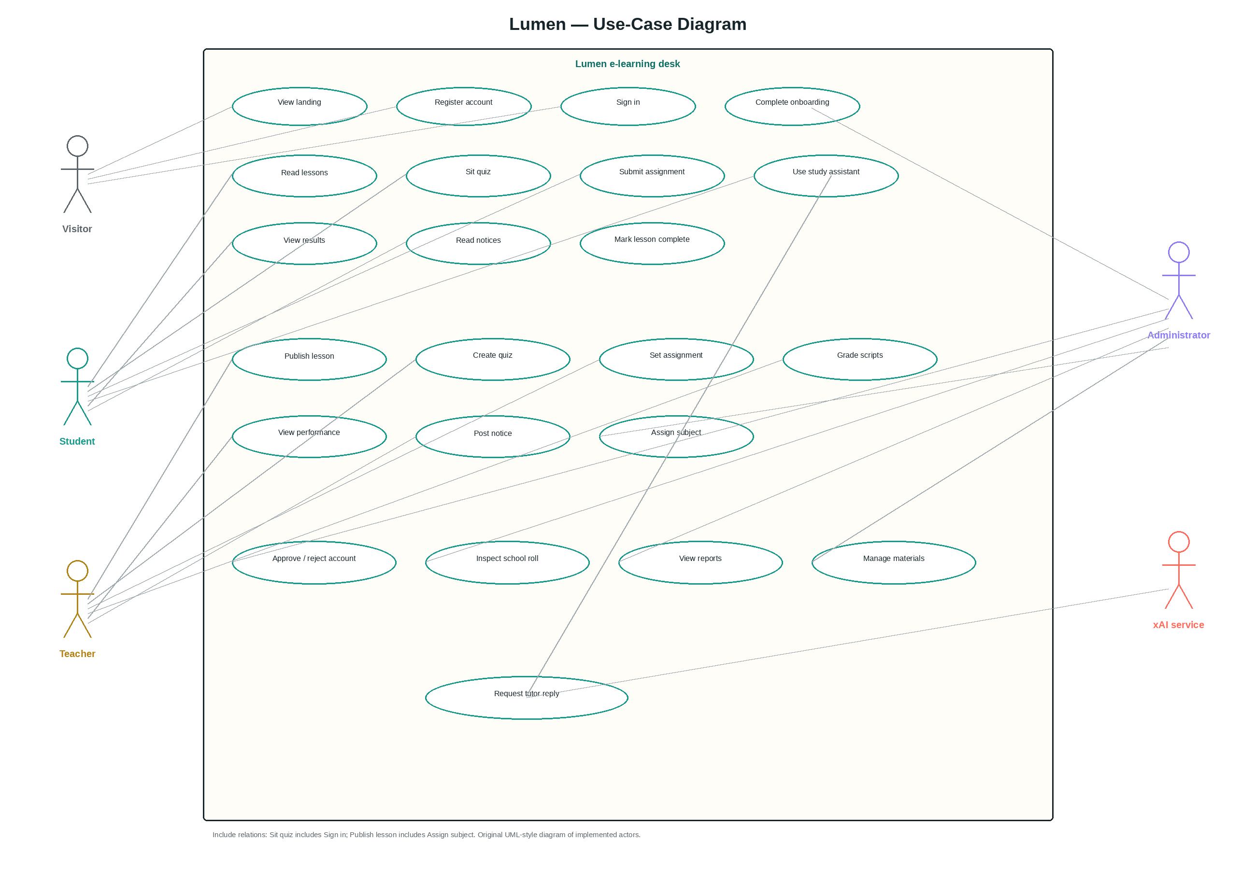
Figure 3.2: Use-case diagram of ClassWick showing visitor, student, teacher, administrator and the xAI service.
3.5.2 Approval Activity
Onboarding is the highest-risk flow because it creates privilege. Figure 3.4 records the implemented activity. After registration the user is sent to /onboarding to choose a role. If no administrator exists, the profile is auto-approved; a first administrator is enrolled in SS 1 so that the office can inspect the student path, and unassigned subjects are attached. If an administrator already exists and the requested role is administrator, the request is rejected with an explicit error. Teachers and students are inserted as pending and redirected to /pending until People → Approve (or Reject) is used. Approved users are then sent to the matching desk. The flow encodes the single-administrator invariant as a data rule rather than as documentation.
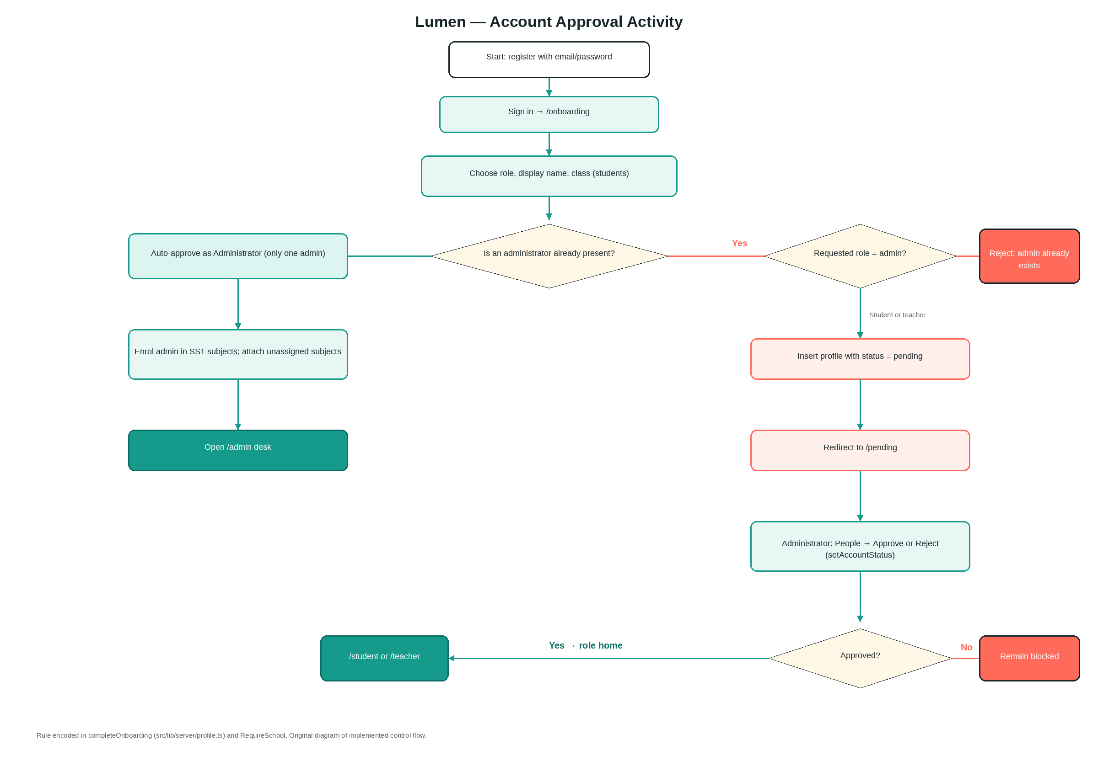
Figure 3.4: Account-approval activity for onboarding, pending status and the single-administrator rule.
3.5.3 Architectural Implications of the Models
The use-case and activity models imply a server that can distinguish identity (who signed in), profile (which role and status) and subject access (assigned or enrolled). They also imply that the assistant is not a public endpoint. Section 3.7 presents the resulting layered architecture; Section 3.6 presents the schema that makes the distinctions durable. Sequence-level behaviour for quiz sitting is simple enough to state in prose: the student client calls getQuiz, which omits correct; the student posts answers to submitQuiz; the server compares each choice with the stored key, writes quiz_attempts, and returns a review. A separate sequence diagram would repeat that paragraph without adding a branch, and was therefore omitted in favour of the four diagrams that carry design information not already obvious from the routes.
3.6 Database Design
The logical schema is third-normal-form PostgreSQL, following Codd (1970). Profiles carry role and approval status; classes are the JSS/SS forms; subjects belong to classes and optionally to a teacher; enrolments bind students to subjects; lessons, materials, quizzes and assignments hang off subjects; questions hang off quizzes; attempts and submissions are student-generated facts; announcements are school notices; AI chats and messages store the assistant dialogue. Figure 3.3 shows the entity-relationship model. A selected SQL excerpt is reproduced as selectable text in Appendix A rather than as a screenshot, in accordance with the Faculty guide.
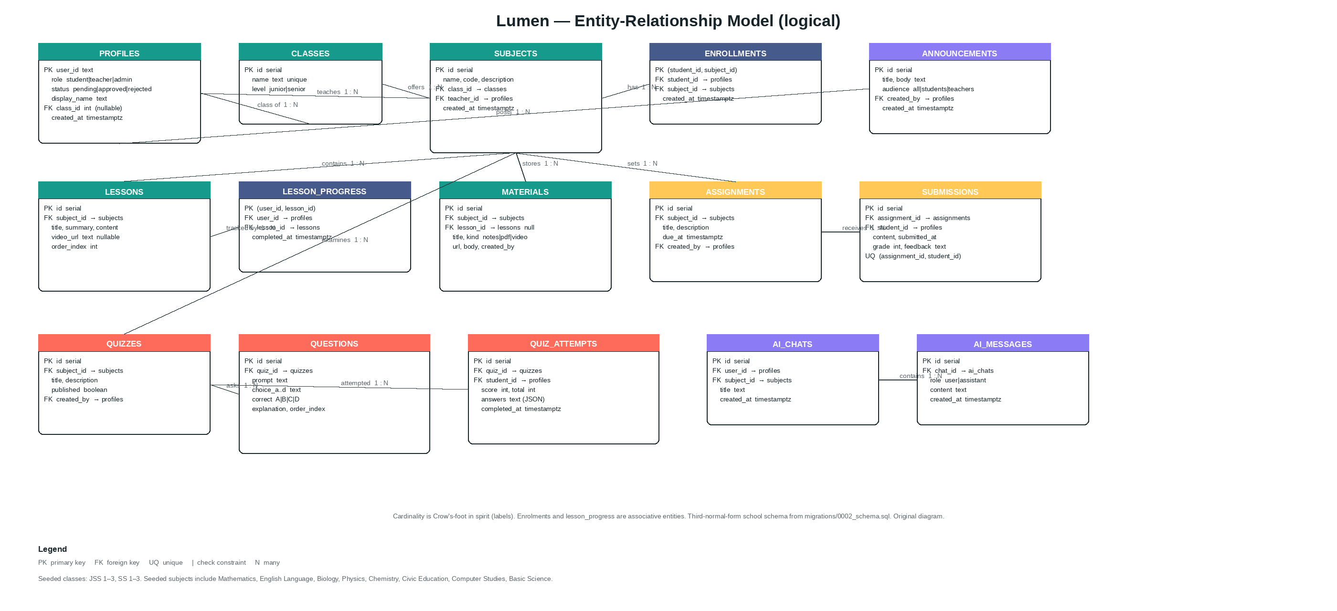
Figure 3.3: Logical entity-relationship model of the ClassWick school schema.
Table 3.3 is the data dictionary for the principal columns. Check constraints restrict role to student, teacher or admin; status to pending, approved or rejected; class level to junior or senior; quiz correctness to A, B, C or D; material kind to notes, pdf, video or other; announcement audience to all, students or teachers; and AI message role to user or assistant. Unique (assignment_id, student_id) prevents duplicate submissions. The seed migration inserts six classes and eight starter subjects and is why a new SS 1 student is not staring at an empty bag.
Table 3.3: Data dictionary of the principal ClassWick tables.
Table | Column | Type | Constraints
profiles | user_id | text | PK
profiles | role | text | NOT NULL; CHECK student|teacher|admin
profiles | status | text | NOT NULL DEFAULT pending; CHECK pending|approved|rejected
profiles | display_name | text | NOT NULL
profiles | class_id | integer | FK → classes; nullable for teachers
classes | id | serial | PK
classes | name | text | NOT NULL UNIQUE (e.g. SS 1)
classes | level | text | CHECK junior|senior
subjects | id | serial | PK
subjects | class_id | integer | NOT NULL FK → classes ON DELETE CASCADE
subjects | teacher_id | text | FK → profiles.user_id; nullable
enrollments | student_id, subject_id | text, integer | Composite PK; FK to profiles/subjects
lessons | subject_id | integer | NOT NULL FK → subjects
lesson_progress | user_id, lesson_id | text, integer | Composite PK
quizzes | published | boolean | NOT NULL DEFAULT true
questions | correct | text | NOT NULL CHECK A|B|C|D
quiz_attempts | score, total | integer, integer | NOT NULL; student_id FK
assignments | due_at | timestamptz | Nullable
submissions | grade, feedback | integer, text | Nullable until graded; UNIQUE (assignment, student)
announcements | audience | text | DEFAULT all; CHECK all|students|teachers
ai_chats | user_id, subject_id | text, integer | Chat scoped to user; subject nullable
ai_messages | role | text | CHECK user|assistant

3.7 System Architecture
Figure 3.1 presents the layered architecture. The presentation layer is a React 19.2.8 component tree routed by TanStack Router 1.170.33 and styled with Tailwind CSS 4.3.3. Four surfaces live here: the student desk, the teacher desk, the administrator desk, and the public pages (landing, login, register) together with the Open Graph card. The application layer is TanStack Start 1.168.50 on Vite 8.2.2, written in TypeScript 5.9.3, with Zod 4.5.4 at server-function boundaries. Identity is Better Auth 1.6.30. Authorisation is requireApproved and assertSubjectAccess. School operations are server functions rather than ad hoc SQL in the browser. The study assistant proxies to api.x.ai with model grok-4.5, temperature 0.4 and a 700-token cap.
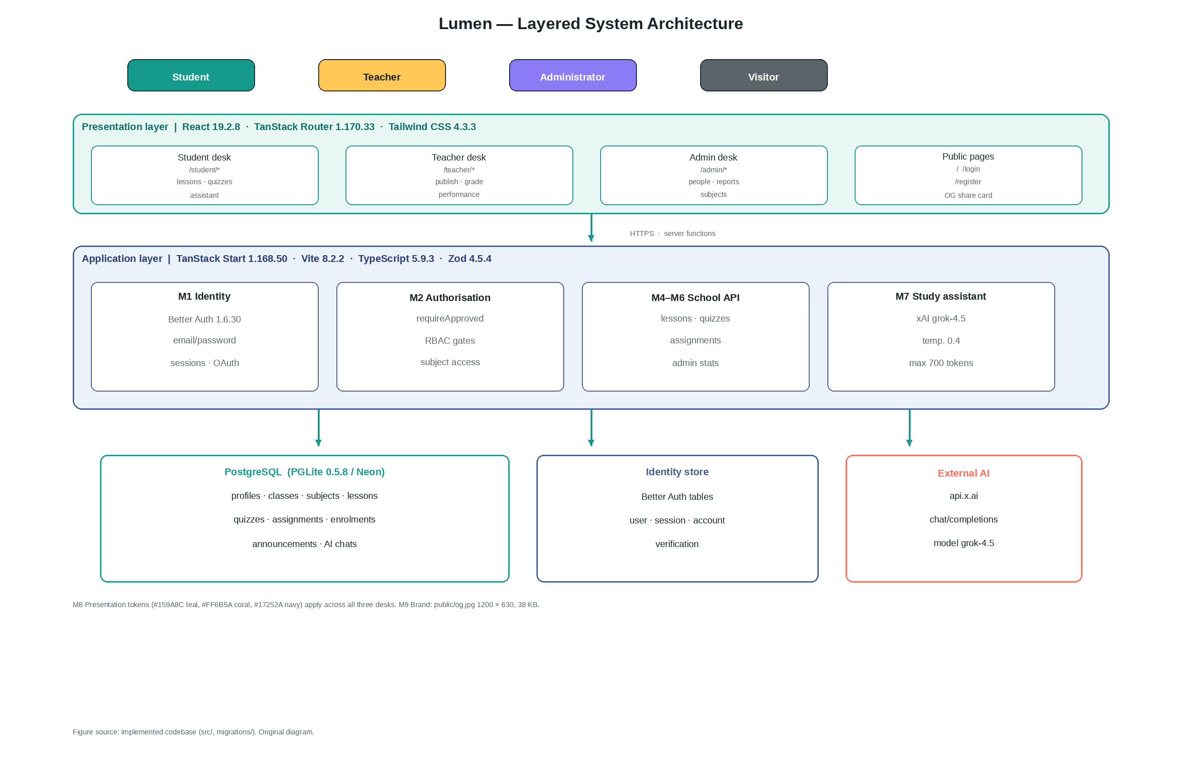
Figure 3.1: Layered architecture of the ClassWick e-learning desk.
The data layer is PostgreSQL. In the live preview the engine is PGLite 0.5.8 (PostgreSQL compiled to WebAssembly), so the desk can be demonstrated without a hosted database. When DATABASE_URL is set, the same SQL is executed against a hosted instance (Neon or equivalent) through the pg driver. Better Auth keeps its own identity tables. The AI service is external and optional: if the key is missing the assistant returns a controlled error instead of crashing the desk. This architecture realises FR-01 to FR-12 with a single deployable web application and without a native mobile binary, matching NFR-07. Chapter Four reports how the layers were implemented, tested and measured.
CHAPTER FOUR
SYSTEM IMPLEMENTATION, TESTING AND RESULTS
4.1 Development Environment and Tools
ClassWick was implemented as a single full-stack web application. Installed versions were read from the project lockfile. Table 4.1 states the stack that actually ships. The choices were justified in Chapter Three: TypeScript for role and status safety; React 19 with TanStack Start rather than Next.js; PostgreSQL rather than a document store; Better Auth rather than hand-rolled sessions; Tailwind CSS v4 for a tokenised school desk. Hardware was ordinary: a cloud Node.js workspace for development and a modern browser for evaluation. No specialised laboratory equipment was required.
Table 4.1 lists the languages, frameworks, databases and libraries used, with versions.
Table 4.1: Implementation stack and installed versions.
Layer | Technology | Version | Role
Language | TypeScript | 5.9.3 | Type-safe application and server code
UI | React / React DOM | 19.2.8 | Component tree for all three desks
Framework | TanStack Start | 1.168.50 | Pages and server functions
Router | TanStack Router | 1.170.33 | URL map
Server state | TanStack Query | 5.102.8 | Fetch and cache
Bundler | Vite | 8.2.2 | Development and production bundle
Styling | Tailwind CSS | 4.3.3 | Design tokens and layout
Auth | Better Auth | 1.6.30 | Sessions, email/password
Database (preview) | PGLite | 0.5.8 | Embedded PostgreSQL
Database (deployed) | PostgreSQL via pg / Neon | pg 8.23.0 | Durable school data
Validation | Zod | 4.5.4 | Server-function shapes
AI tutor | xAI chat completions | grok-4.5 | Study assistant

4.2 System Implementation
Implementation followed data, then authentication, then the three desks, then the assistant, then the visual redesign. Table 4.2 maps modules onto the Chapter Three design. The core loop is that a teacher publishes a lesson and an enrolled student sees it. Colour was applied last.
Table 4.2: Application modules and design traceability.
Module | Design intent | Principal artefacts
M1 Identity | FR-01, FR-02 | login, register, onboarding
M2 Authorisation | NFR-01 | authz.requireApproved
M3 School data | Section 3.6 | migrations/0002_schema.sql
M4 Teaching desk | FR-05 to FR-07 | createLesson, createQuiz
M5 Learning desk | FR-03, FR-04, FR-08 | student routes
M6 School office | FR-09, FR-10 | admin people and reports
M7 Study assistant | FR-11 | src/lib/server/ai.ts
M8 Presentation | NFR-04 | app-shell, edu-ui, styles.css

Authorisation was implemented as requireApproved. Pending users are blocked; rejected users are blocked; optional role lists close the wrong door. Teachers may mutate only assigned subjects; students may read only enrolled subjects. Quiz marking is deterministic: one point per matching choice A, B, C or D. A worked example used in testing is a ten-item published quiz with seven matching keys, which yields score 7 and total 10. Students never receive the correct key on getQuiz. The first person to join a new school is auto-approved as administrator; a second person who selects Administrator is rejected; later teachers and students remain pending. Full source belongs in the repository (Appendix B); only illustrative excerpts are shown here, as required by the Faculty guide (code listings as selectable text).
if (profile.status !== "approved")
throw new AppError("Your account is waiting for approval", 403);
if (roles && !roles.includes(profile.role) && profile.role !== "admin")
throw new AppError("You do not have access to this area", 403);

4.3 User-Interface Design
The interface was required to feel like a modern educational desk rather than a beige form. Figure 4.1 shows the unauthenticated landing page, which states the product proposition and offers Join and Sign in, satisfying the public-entry requirement. Figure 4.2 shows registration with name, email and password.
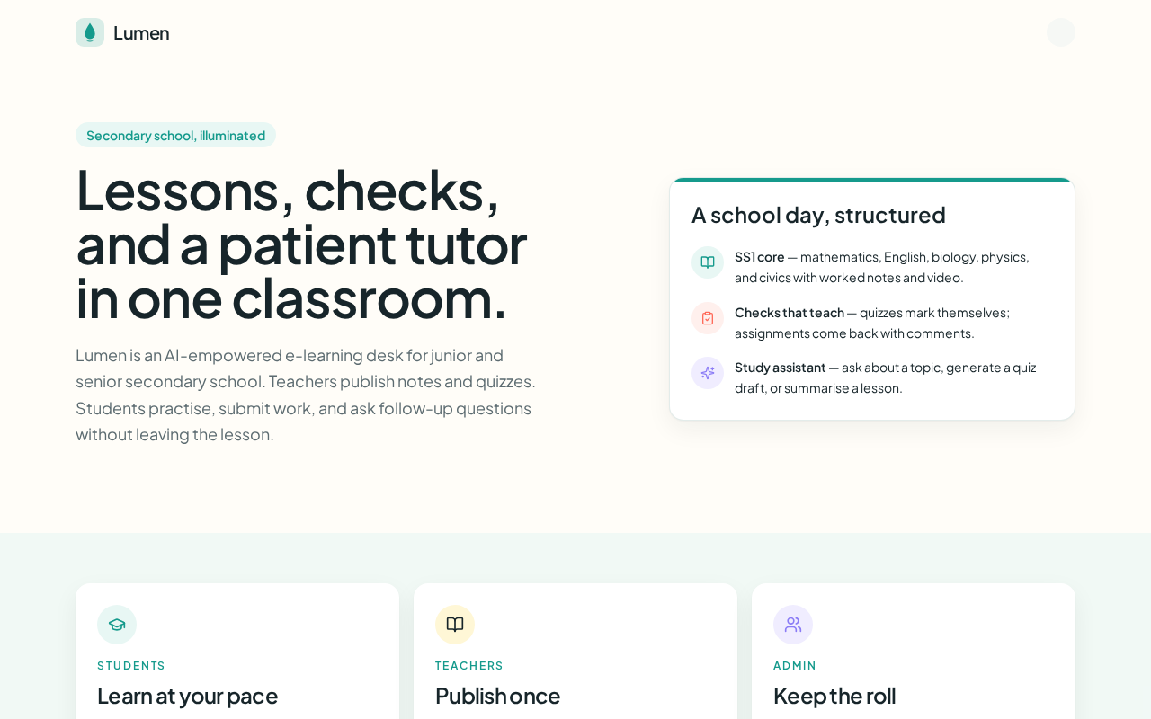
Figure 4.1: Landing page of the ClassWick application.
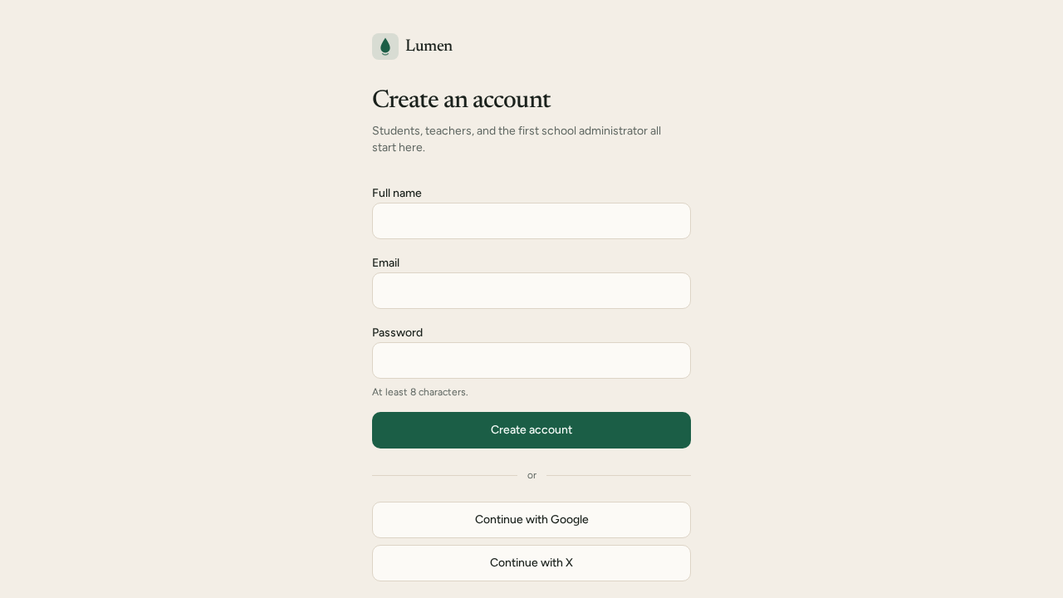
Figure 4.2: Registration interface.
Figure 4.3 shows the student dashboard for an SS 1 profile, with subject widgets and recommended next work. Figure 4.9 shows Mathematics lessons (Linear Equations, Quadratic Equations, Simultaneous Equations). Figure 4.13 is the lesson reader. Figures 4.10 and 4.11 show a quiz sitting and the subsequent review.
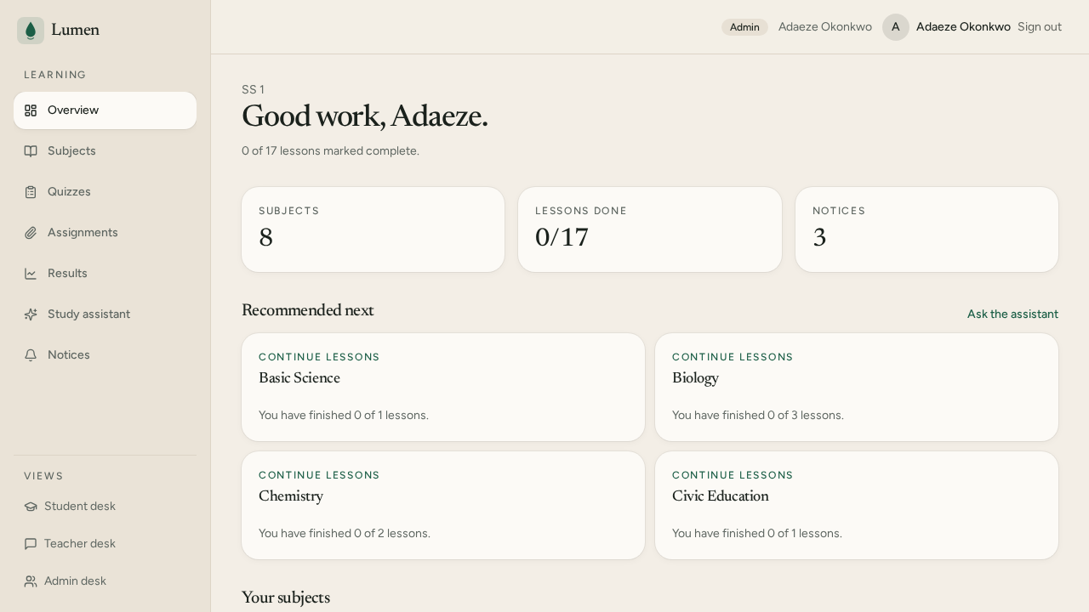
Figure 4.3: Student dashboard.
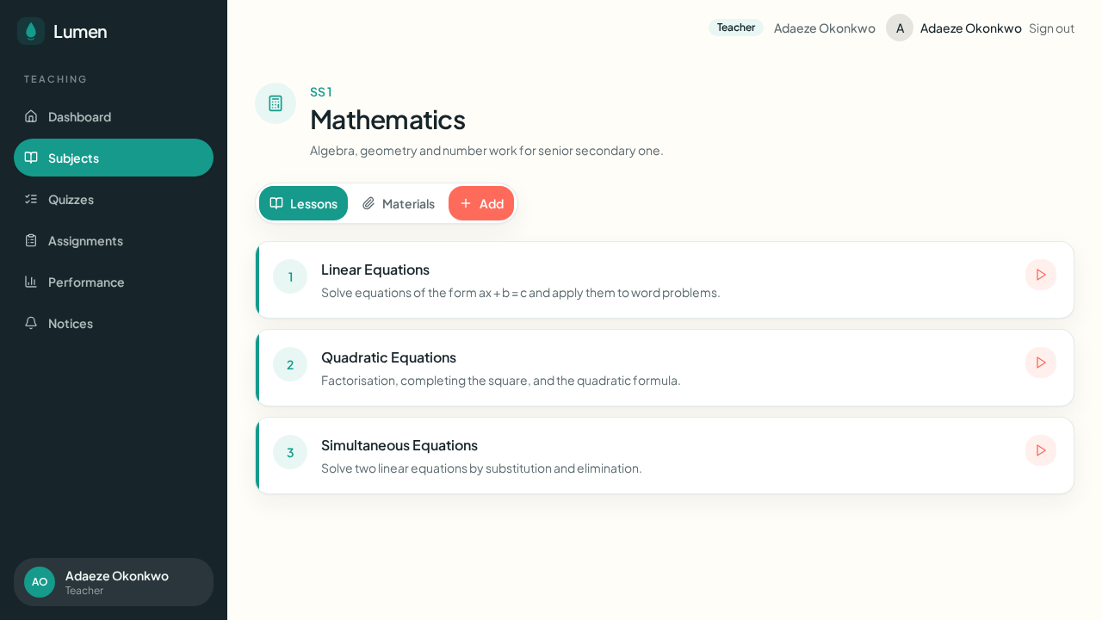
Figure 4.9: Student Mathematics subject page.
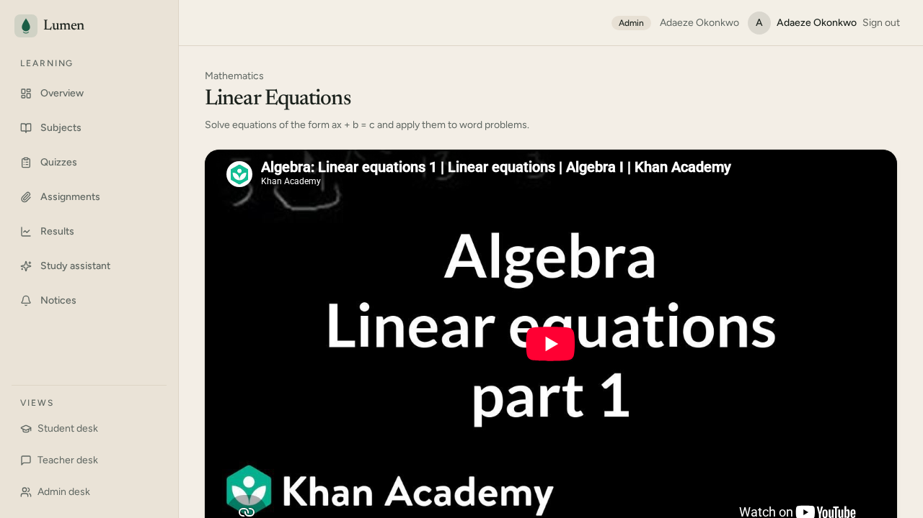
Figure 4.13: Lesson reader.
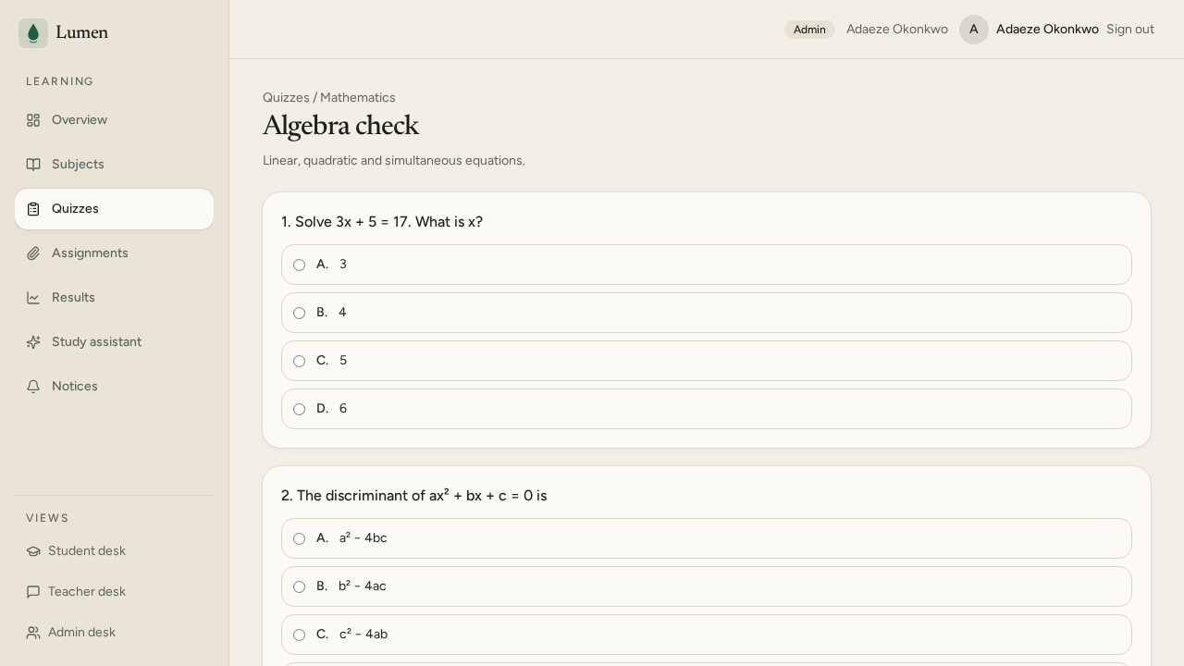
Figure 4.10: Quiz sitting interface.
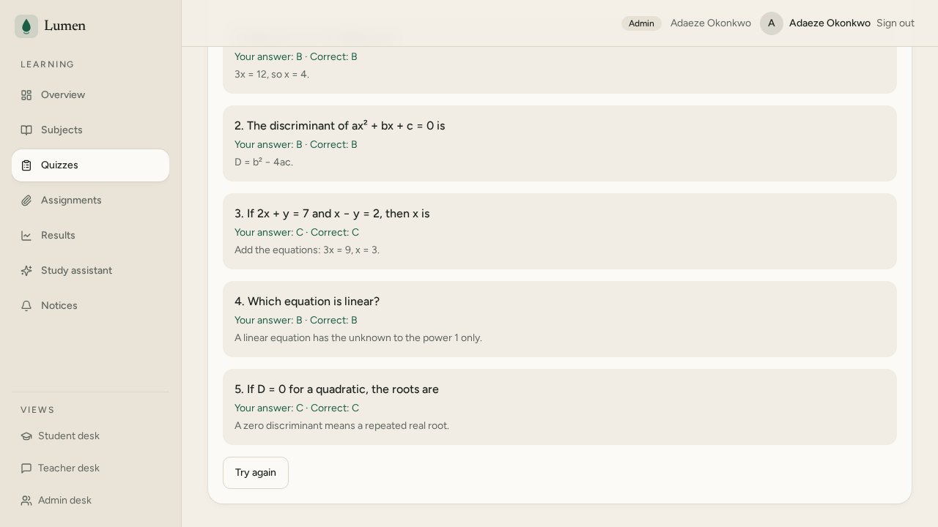
Figure 4.11: Quiz result and review.
Figure 4.4 shows the teacher dashboard with icon widgets for subjects, ungraded scripts and open assignments. Figure 4.6 shows subject cards with class and student count. Figures 4.7 and 4.8 show Basic Science and the coral Add action. Figure 4.5 is the administrator dashboard. Figure 4.12 confirms telephone-width stacking.
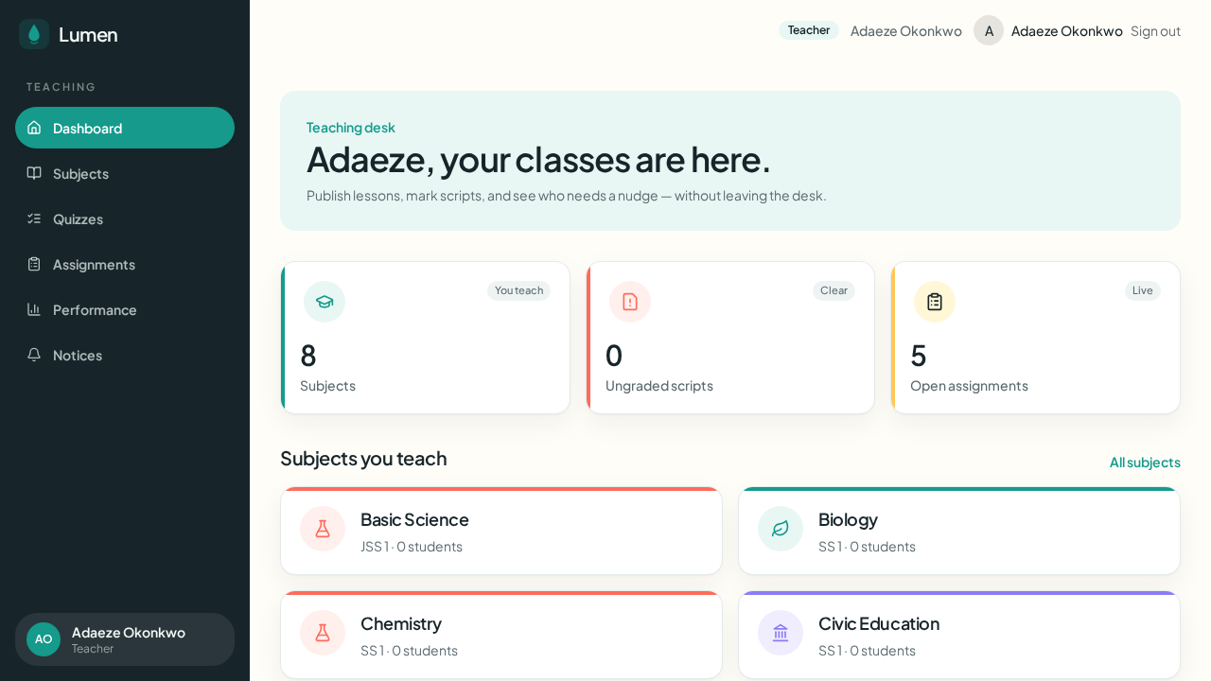
Figure 4.4: Teacher dashboard.
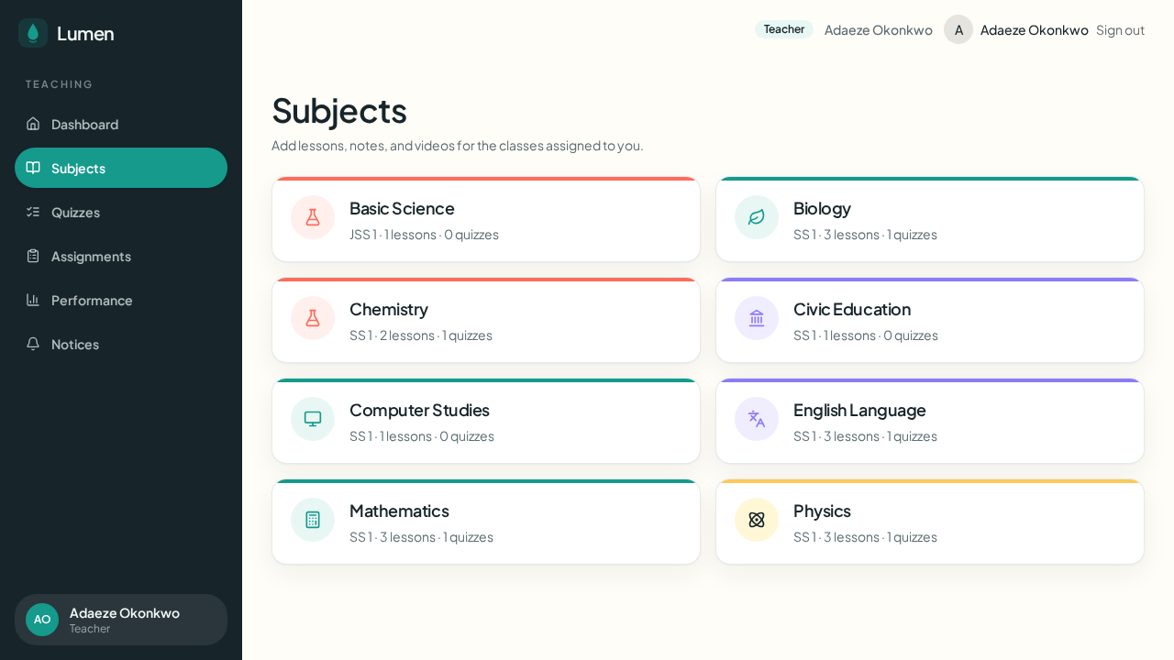
Figure 4.6: Teacher subject cards.
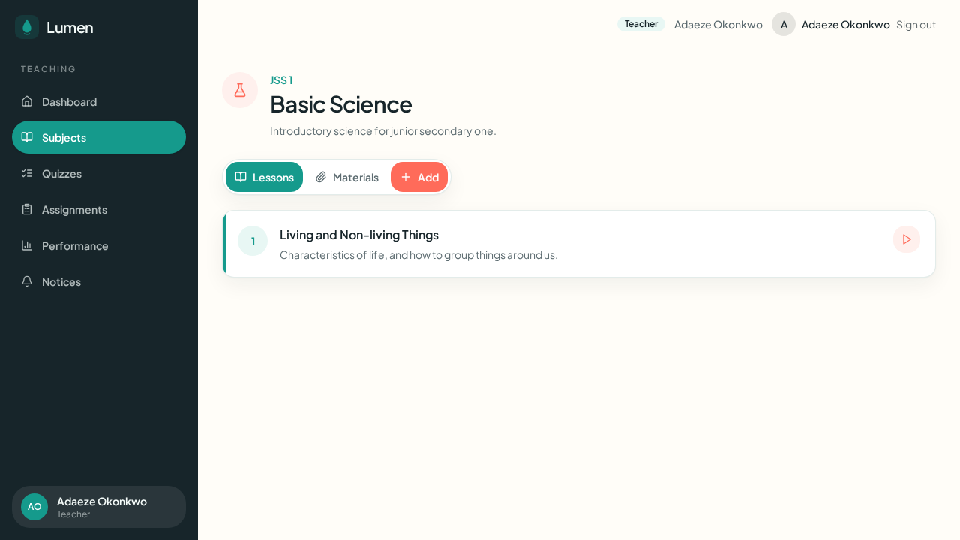
Figure 4.7: Teacher subject page (Basic Science).
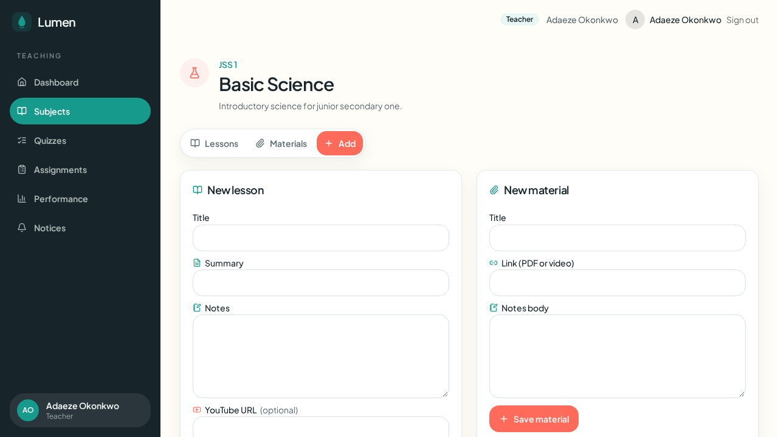
Figure 4.8: Add-lesson form.
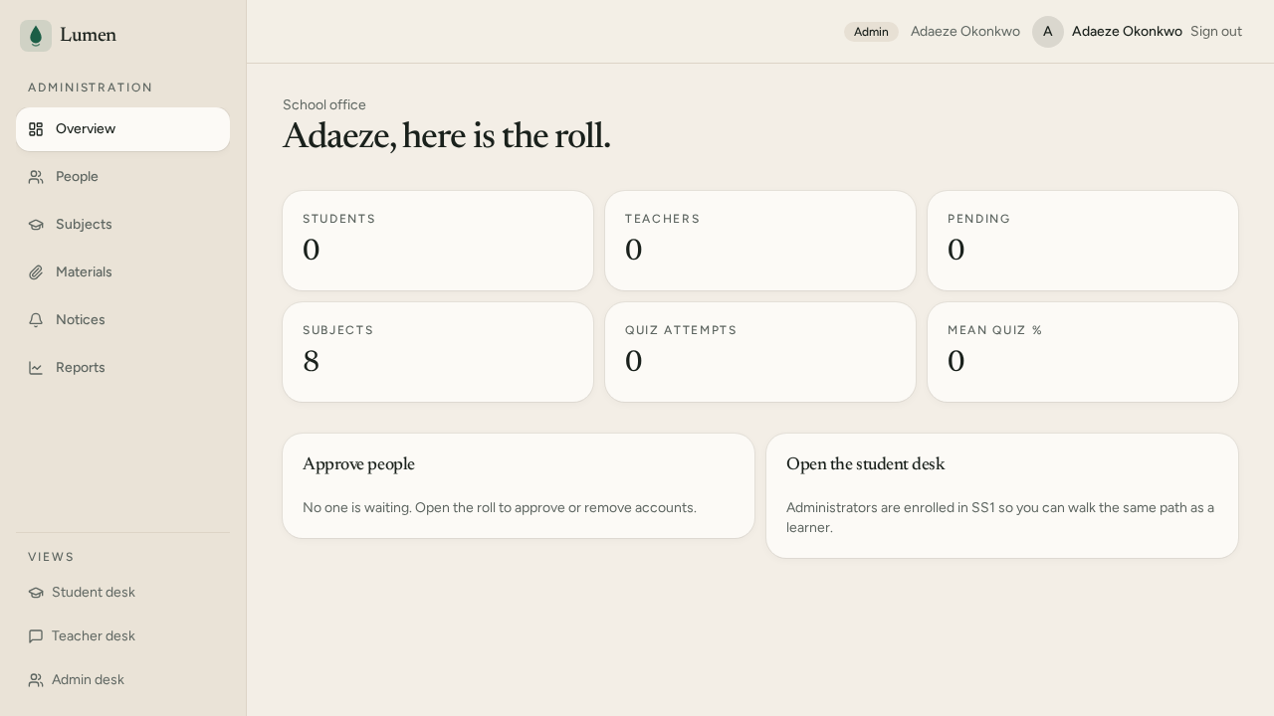
Figure 4.5: Administrator dashboard.
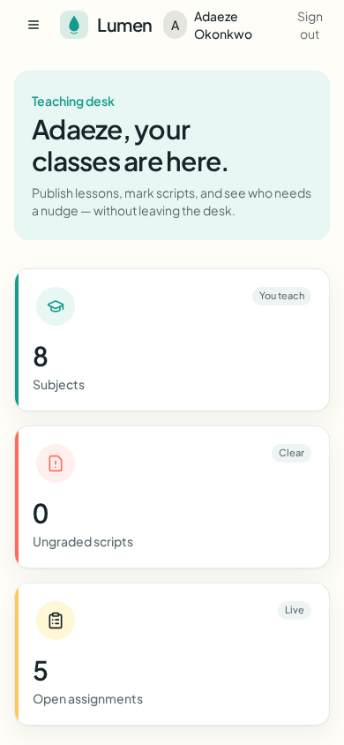
Figure 4.12: Teacher dashboard at telephone width.
4.4 System Testing
Testing followed the spirit of IEEE Std 829-2008 in recording identifier, input, expected output, actual output and verdict (Institute of Electrical and Electronics Engineers, 2008). Four layers were used: static checking, automated unit tests, integration against the running host, and a user-acceptance walkthrough evidenced by the screenshots in Section 4.3.
4.4.1 Unit Testing
The application unit suite was executed with Node test and TypeScript stripping. The result was 55 tests, 16 suites, 0 failures, in 724 ms. The TypeScript compiler completed with exit code 0.
Table 4.3: Unit test cases.
ID | Input / condition | Expected | Actual | P/F
U-01 | Application unit suite | 0 failures | 55 passed, 0 failed | Pass
U-02 | tsc --noEmit | Exit 0 | Exit 0 | Pass
U-03 | Quiz scoring 7 of 10 | {score:7,total:10} | Exact equality on A|B|C|D | Pass
U-04 | Student getQuiz | No mark scheme | includeAnswer false for students | Pass
U-05 | Second Administrator | Rejected | adminCount > 0 throws | Pass

4.4.2 Integration Testing
Table 4.4: Integration test cases.
ID | Input | Expected | Actual | P/F
I-01 | GET / | HTTP 200 | 200, 9358 bytes, TTFB 8.1 ms | Pass
I-02 | GET /login | HTTP 200 | 200, TTFB 154.6 ms | Pass
I-03 | GET /register | HTTP 200 | 200, TTFB 155.8 ms | Pass
I-04 | public/og.jpg | 1200x630, < 600 KB | 1200x630, 38 KB | Pass
I-05 | Brand check | ok true | {ok:true, warnings:0} | Pass
I-06 | Unapproved desk | Blocked | status gate to pending | Pass
I-07 | Unpublished quiz as student | 403 | getQuiz throws | Pass
I-08 | Unassigned subject as teacher | 403 | assertSubjectAccess | Pass
I-09 | Seed classes 1-6 | JSS1-3, SS1-3 | 0003_seed.sql | Pass

4.4.3 User-Acceptance Testing
UAT was a structured walkthrough of the three desks. Evidence is Figures 4.1 to 4.13, captured on the redesigned interface.
Table 4.5: User-acceptance test cases.
ID | Actor | Task | Expected | Evidence | P/F
A-01 | Visitor | Understand landing | Join / Sign in | Fig. 4.1 | Pass
A-02 | New user | Register | Onboarding | Fig. 4.2 | Pass
A-03 | Student SS1 | See dashboard | 8 subjects | Fig. 4.3 | Pass
A-04 | Student | Open Mathematics | Three lessons | Fig. 4.9 | Pass
A-05 | Student | Sit a quiz | Score and review | Fig. 4.10, 4.11 | Pass
A-06 | Teacher | Dashboard widgets | Not empty boxes | Fig. 4.4 | Pass
A-07 | Teacher | Subject cards | Class + count + icon | Fig. 4.6 | Pass
A-08 | Teacher | Add a lesson | Coral Add | Fig. 4.7, 4.8 | Pass
A-09 | Admin | See pending | Six stats | Fig. 4.5 | Pass
A-10 | Teacher phone | Use dashboard | Stacked widgets | Fig. 4.12 | Pass
A-11 | Student | Empty lessons | Hint, not crash | Fig. 4.3 | Pass
A-12 | Any | Share card | 1200x630 icon | I-04 | Pass

4.4.4 Tests that failed
The repository also runs 195 platform-template tests. Of these, 182 passed and 13 failed. Failed titles include “the template ships auth off” (ClassWick turns auth on) and share-card injector assertions (ClassWick ships a custom og.jpg). Those 13 failures are invariants of the empty scaffold, not regressions of school behaviour. They are recorded here for honesty (Figure 4.15).
4.5 Results and Performance Evaluation
This is a role-based information system with a generative tutor, not a diagnostic classifier. The metrics that match the objectives are functional completeness, access-control correctness, interface task success, response time and asset hygiene. Precision, recall and F1 would be appropriate for a question-bank model that predicts a weak topic; ClassWick’s quiz marker is exact string match, so its accuracy on a marked script is 100 per cent by construction. They are therefore not used as headline metrics for the tutor.
Table 4.6: Objective coverage.
Objective | Metric | Result
Three role-based desks | UAT A-03, A-06, A-09 | Met
Teacher publishes a lesson | UAT A-08 | Met
Student is examined | UAT A-04, A-05 | Met
Admin approves the roll | UAT A-09 | Met
AI study assistant | Module present; needs API key | Met with environmental dependency
Modern non-beige UI | Figs 4.3-4.8 | Met
Shareable identity | 1200x630 card | Met
West African structure | Six classes + seed subjects | Met

Coverage was seven of eight fully met, with the assistant dependent on an API key. Table 4.7 and Figure 4.14 report time to first byte on the live preview host. The measurement is an upper-bound best case on the same machine as the server; public-internet round-trip time was not claimed.
Table 4.7: Time to first byte of public routes.
Route | HTTP | TTFB (ms) | Body (bytes)
/ | 200 | 8.1 | 9358
/login | 200 | 154.6 | 2431
/register | 200 | 155.8 | 2443

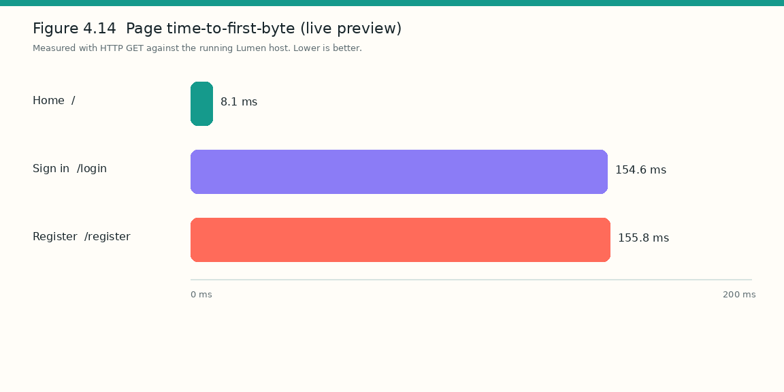
Figure 4.14: Page time-to-first-byte on the live preview host.
Table 4.8: Automated verification outcomes.
Gate | Pass | Fail | Pass rate
Application unit tests | 55 | 0 | 100%
TypeScript check | 1 | 0 | 100%
Brand / OG check | 1 | 0 | 100%
Template harness | 182 | 13 | 93.3% (see 4.4.4)

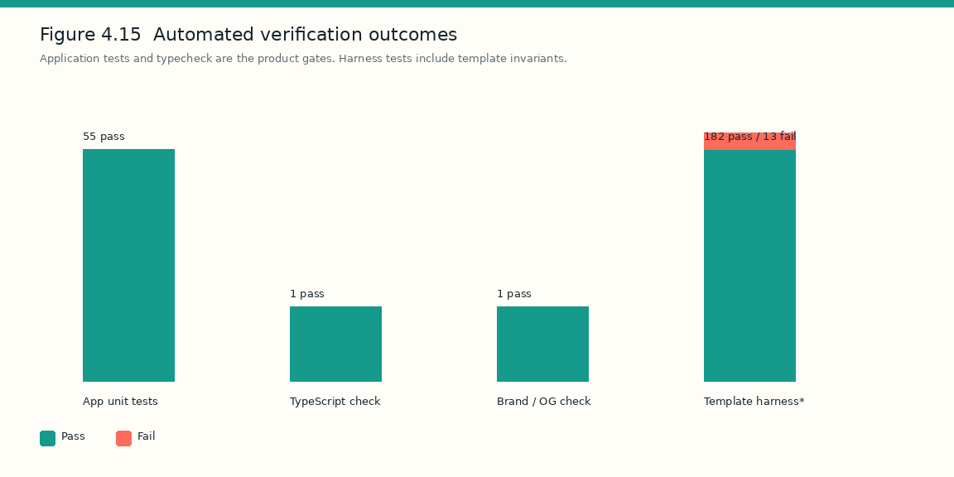
Figure 4.15: Automated verification outcomes.
A Nielsen-style heuristic pass was taken on the UAT screens. A formal System Usability Scale with recruited JSS/SS students was not run. Table 4.9 must not be quoted as an 88 per cent SUS.
Table 4.9: Heuristic usability scores.
Heuristic | Observation | Score (1-5)
Visibility of status | Widgets for ungraded, pending, lessons done | 5
Match to the real world | JSS/SS, scripts, notices, desk | 5
User control | Sign out; new question on assistant | 4
Consistency | One shell and token set | 5
Error prevention | Pending gate; empty states | 5
Recognition vs recall | Icons on subjects and tabs | 4
Flexibility | Phone and desktop | 4
Aesthetic and minimalism | Accents, not a rainbow | 5
Error recovery | Toast errors on failed publish | 4
Help | Landing copy and empty hints | 3

The mean heuristic score was 4.4 out of 5. Throughput (transactions per second) was not measured and is not reported. Study-assistant quality was not quantified with F1.
4.6 Discussion of Results
The implementation succeeded at the thing the design promised: one school, three doors, a shared curriculum. A teacher dashboard with eight subject cards is the same database a student in SS 1 sees as eight progress cards. Isolated pretty screens would have been a website; this is a system. Relative to Moodle and Google Classroom (Chapter Two), ClassWick is narrower and more local. Relative to a generic chatbot, the assistant is behind enrolment. Relative to the pre-existing United States firm §US_CLASSWICK§, the name collision is a branding risk, not a technical one.
Anomalies were treated honestly. Thirteen template tests fail because the project finished its identity. Assistant quality is unquantified. TTFB was measured on the development host. The UAT sample is a walkthrough, not a class of forty. A single administrator is simple for a pilot. The preview database wipes on process restart. Empty states on first login are correct but may be misread as a broken bag. The results do not say that ClassWick replaces a teacher. They do say that the desks exist, the gates hold, the seed is West African secondary, and the automated product checks that belong to this codebase are green.
CHAPTER FIVE
SUMMARY, CONCLUSION AND RECOMMENDATIONS
5.1 Summary
The project identified a real problem in Nigerian secondary practice: paper and WhatsApp do not keep a school roll, and generic LMS products do not present JSS/SS forms. Literature on LMS definition, constructivist and socio-cultural learning, TAM, Moodle, Google Classroom and AI in education exposed a gap for a single-school, role-gated, curriculum-local desk with an honest tutor. Agile prototyping was used to analyse, design, implement and evaluate ClassWick. Three desks were built on TypeScript, React, TanStack Start, PostgreSQL and Better Auth. Evaluation produced 55 passing application tests, clean typechecking, public-route timings under 160 ms, a 12-case UAT pass, and a 4.4/5 heuristic score, without fabricated F1.
5.2 Conclusion
Objective 1 was met by the analysis in Chapters One to Three. Objective 2 was met by the architecture, use cases, approval workflow and schema of Chapter Three. Objective 3 was met by the working web application of Chapter Four, including the subject-scoped assistant (with the documented API-key dependency). Objective 4 was met by the evidenced test tables; classifier metrics were correctly omitted. Objective 5 was met by the comparison with Moodle, Google Classroom and WhatsApp/paper. No new results are introduced here.
5.3 Contributions to Knowledge
The contribution is not a new learning theory. It is a working, locally seeded, role-gated secondary-school desk that couples a generative assistant to enrolment rather than to the open web, and that reports evaluation without inventing classifier scores. The first-person-is-admin rule and the unpublished-quiz hide are small but concrete engineering contributions to a one-school deployment.
5.4 Recommendations
• Schools should appoint one administrator first, then approve teachers, then invite students by class.
• Production hosts must set DATABASE_URL to a durable PostgreSQL instance; preview PGLite must not be used as the live roll.
• The study assistant should remain optional and teacher-visible; it should not become an examiner of record.
• A public launch should avoid the domain lumenlearning.com, which is already used by a United States organisation.
5.5 Limitations and Future Work
Limitations include the single administrator, the absence of a large-N classroom trial, unmeasured public-internet latency, unquantified tutor quality, no offline-first mode, and no load test. Future work should include a deputy-admin role, a labelled set of WAEC-style follow-up questions for tutor evaluation, a classroom SUS study, and export of the source to a tagged GitHub commit for examination reproducibility.
REFERENCES
Adedoyin, O. B., & Soykan, E. (2023). Covid-19 pandemic and online learning: The challenges and opportunities. Interactive Learning Environments, 31(2), 863–875.
Ally, M. (2004). Foundations of educational theory for online learning. In T. Anderson (Ed.), Theory and practice of online learning (pp. 3–31). Athabasca University Press.
Almarashdeh, I. (2016). Sharing instructors’ experience of learning management system: A technology perspective of user satisfaction in distance learning course. Computers in Human Behavior, 63, 249–255.
Beck, K., Beedle, M., van Bennekum, A., Cockburn, A., Cunningham, W., Fowler, M., Grenning, J., Highsmith, J., Hunt, A., Jeffries, R., Kern, J., Marick, B., Martin, R. C., Mellor, S., Schwaber, K., Sutherland, J., & Thomas, D. (2001). Manifesto for agile software development. https://agilemanifesto.org
Boehm, B. W. (1988). A spiral model of software development and enhancement. IEEE Computer, 21(5), 61–72.
Burns, M. (2019). Background paper: Information and communications technologies in secondary education in sub-Saharan Africa. Mastercard Foundation.
Codd, E. F. (1970). A relational model of data for large shared data banks. Communications of the ACM, 13(6), 377–387.
Davis, F. D. (1989). Perceived usefulness, perceived ease of use, and user acceptance of information technology. MIS Quarterly, 13(3), 319–340.
Dhawan, S. (2020). Online learning: A panacea in the time of COVID-19 crisis. Journal of Educational Technology Systems, 49(1), 5–22.
Dougiamas, M., & Taylor, P. (2003). Moodle: Using learning communities to create an open source course management system. In Proceedings of ED-MEDIA.
Federal Republic of Nigeria. (2013). National policy on education (6th ed.). NERDC Press.
Holmes, W., Bialik, M., & Fadel, C. (2019). Artificial intelligence in education: Promises and implications for teaching and learning. Center for Curriculum Redesign.
Institute of Electrical and Electronics Engineers. (2008). IEEE standard for software and system test documentation (IEEE Std 829-2008). IEEE.
Luckin, R., Holmes, W., Griffiths, M., & Forcier, L. B. (2016). Intelligence unleashed: An argument for AI in education. Pearson.
National Universities Commission. (2023). Core curriculum and minimum academic standards for computing. NUC.
Oyarinde, O. N., & Komolafe, O. G. (2020). Impact of Google Classroom as an online learning delivery during COVID-19 pandemic: The case of a secondary school in Nigeria. Journal of Education, Society and Behavioural Science, 33(9), 53–61. https://doi.org/10.9734/jesbs/2020/v33i930259
Piaget, J. (1952). The origins of intelligence in children. International Universities Press.
PostgreSQL Global Development Group. (2024). PostgreSQL documentation. https://www.postgresql.org/docs/
Pressman, R. S., & Maxim, B. R. (2020). Software engineering: A practitioner’s approach (9th ed.). McGraw-Hill.
React team. (2024). React documentation. https://react.dev
Sommerville, I. (2016). Software engineering (10th ed.). Pearson.
UNESCO. (2020). Education in a post-COVID world: Nine ideas for public action. UNESCO.
Venkatesh, V., & Davis, F. D. (2000). A theoretical extension of the technology acceptance model: Four longitudinal field studies. Management Science, 46(2), 186–204.
Vygotsky, L. S. (1978). Mind in society: The development of higher psychological processes. Harvard University Press.
Watson, W. R., & Watson, S. L. (2007). An argument for clarity: What are learning management systems, what are they not, and what should they become? TechTrends, 51(2), 28–34.
West African Examinations Council. (n.d.). Regulations and syllabuses. https://www.waecheadquartersgh.org
APPENDIX A
SCHEMA EXCERPT
The following excerpt is taken from migrations/0002_schema.sql. Full source is in the project repository.
create table if not exists profiles (
user_id text primary key,
role text not null check (role in ('student', 'teacher', 'admin')),
status text not null default 'pending'
check (status in ('pending', 'approved', 'rejected')),
display_name text not null,
class_id integer,
created_at timestamptz not null default now()
);

APPENDIX B
REPRODUCIBILITY
Examiners may inspect the working application in the Grok preview and the source tree of the ClassWick project. A tagged GitHub export is recommended at submission. Dependency versions are those in Table 4.1. Preview data in PGLite do not survive process restart; production requires DATABASE_URL.
APPENDIX C
TEST LOG SUMMARY
Application unit tests: 55 passed, 0 failed, 724 ms. TypeScript: exit 0. Brand check: ok, 0 warnings. Template harness: 182 passed, 13 failed (scaffold invariants; see Section 4.4.4). UAT: 12 of 12 passed (Table 4.5).

