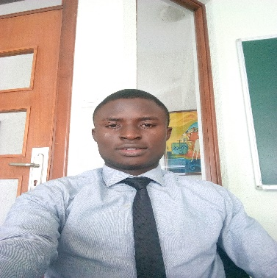

**PEACE BAKARE**

**Web Developer**

Phone: 08108015546, 08050421247.

Email: peaceultimatum4@gmail.com

*LinkedIn:*

<https://www.linkedin.com/in/bakare-peace-828b79b4/>

*Twitter:*

<https://twitter.com/BakarePeace2>

*GitHub:*

<https://github.com/PeaceOfGod>  
Facebook:

<https://www.facebook.com/bakare.peace.5>

**EDUCATION**

|  |  |
| --- | --- |
| SCHOOL | University of Lagos |
| Faculty | Sciences |
| Department | Computer sciences |
| Level | 400 |
| Best Course so far | Algorithms and Discrete Structures |