

**Philosophische** Fakultät III

Sprach-, Literatur- und Kulturwissenschaften

Institut für Information und Medien, Sprache und Kultur (I:IMSK)  
Lehrstuhl für Medieninformatik

Interaktionstechniken und –technologien (ITT)

Modul: MEI-M 32.1 + 2 (M.Sc.)

SS 2017

Leitung: Dr. Raphael Wimmer

IPlanPy – The New Charting Tool

Sebastian Peiser, Julia Sageder

1691711, 11694688

Medieninformatik

1. Semester M.Sc., 8. Semester B.A.

Email:

[Sebastian.Peiser@stud.uni-regensburg.de](mailto:Sebastian.Peiser@stud.uni-regensburg.de)

[Julia.Sageder@stud.uni-regensburg.de](mailto:Julia.Sageder@stud.uni-regensburg.de)

Abgegeben am 06.08.2017

**List of figures**

Figure 1 – User Interface 6

Figure 2 – Connection Menu 7

Figure 3 – Save/Load Menu 7

Figure 4 – Card Connection 7

Figure 5 – Card Connections 7

Figure 6 – Standard Card Type 8

Figure 7 – Header Card Type 8

Figure 8 – Card Colors 8

Figure 10 – Focused Card 9

Figure 9 – Unfocused Card 9

Contents

1 Concept and Usage 4

2 System 4

3 Implementation 5

3.1 iplanpy.py 5

3.2 iplanpy.ui 6

3.3 connectionmanager.py 7

3.4 card.py 8

3.5 gestureclassifier.py 9

3.6 vectortransform.py 9

3.7 wiimote.py 10

3.8 demo.chart 10

4 IPlanPy-Team Collaboration 10

5 Cheat Sheet 11

# Concept and Usage

In everyday life, organizing is an important part to be prolific and efficient. Not only in private, also in professional life it’s necessary to have structures. Especially at work there are many cases where building a structure is a big advantage for planning e.g. a work process/tasks etc. This is where our system steps in: IPlanPy is the perfect solution for creating diagrams. It is easy to handle and a great way of presenting, for example, abstract processes, hierarchies or complex systems. IPlanPy is designed for cooperation work in a team, especially with the Wiimote, but can also be used from a single person simply with the mouse instead of the Wii-controller. The support of collaboration is an important feature of the system. Sketching with IPlanPy will prove the capacity for teamwork in that team, because the best way of usage is in splitting the input roles at two different people. Certainly, our system can also be used as a single user, just with a mouse and a keyboard. The application areas are not limited at all. In every use case where a chart is needed, IPlanPy is your system to use.

# System

To use our system IPlanPy you need a laptop or computer with Linux, a keyboard and a mouse (for single usage) or a Wiimote and therefore also IR-Sensors (for team usage). To get the best performance your system may have the following requirements: Intel i5, 4GB RAM

With IPlanPy it is possible to build diagrams. The system supports the following features:

* Create a new card
* Switch the card type between:
  + Standard (Title and Field)
  + Header (Title)
* Delete a card
* Change the card color between prescribed colors
* Build a connection between two cards presented as a line from card middle to card middle
* Delete a connection between two cards (Undo)
* Delete all connections from one card
* Save your chart
* Load your saved charts
* Connect your Wiimote (Stores connected Wiimotes automatically)
* New chart (Rejects all unsaved data and clears the screen)
* Feedback to the user through message boxes in sensitive situations (e.g. Overwrite existing files, Chart saved, Warnings with error informations)

# Implementation

## iplanpy.py

This is the main python script, where all the corresponding threads run together. The script imports many other scripts with their classes, like **wiimote**, **vectortransform, gestureclassifier**, **connectionsmanager** and **card**. It also contains the class *IPlanPy*, which includes all relevant handling processes. The user interface of IPlanPy is loaded from the **iplanpy.ui** script, which contains all start-widgets (see **3.2 iplanpy.ui**). The buttons are connected in the *init_ui* to their specific definitions:

The “New Chart” button deletes all cards and connections in the *on_btn_new_chart*. The *toggle_* definitions handle the visibility of the two menus (“Connection Settings”, “Save/Load”). Charts can be loaded trough the *load_chart* definition, which opens and loads the selected **.chart** file from a list (*load_available_charts*). The loading is managed from the *create_* definitions, which interpret the data of the **.chart** file and display the saved *Card*s (with *card_info*) and *connections*. Charts can be saved through the *save_chart* definition, which encodes the current chart to a **.chart** file (see **3.10 demo.chart**). Is the “Save” button clicked, there is also checked if an existing file may be overwritten. This procedure ensures good usability (see **2 System**: Feedback). The user is able to scan for new Wiimotes (*scan_for_wiimotes*), if he wants to register a new one. The known Wiimotes are persistent saved in the **wii.motes** file, which is managed, loaded and displayed through the iplanpy.py file. Through the selection of the right address of the Wiimote which should be connected, the user is able to connect the Wiimote with a following click on the “Connect” Button (*connect_wiimote*). After this he is able to call the *disconnect_wiimote* by clicking the “Disconnect” Button (Text-changed “Connect” Button) to disconnect the Wiimote.

The *on_wiimote_button*, *on_wiimote_ir* and *on_wiimote_accelerometer* detect events of the Wiimote. To circumvent the problems of the different thread of the Wiimote events, the button events of the Wiimote are interpreted as mouse-click and mouse-press events. Key-press events are also registered and handled to ensure a single user usage. The different (simulated) mouse events manage the interaction of the user (see **5 Cheat Sheet** for detailed information). The *mouseReleaseEvent* is handling the checking if a card should be deleted (over “Delete” button) or connected (over another card) or just moved to this point.

If a new *Card* should be created, the *Card* class is invoked and a default *Card* is created, only the *id* is set individually from the beginning (see **3.4 card.py**).

The *paintEvent* is called by the *update()* method manually. It draws the *connections* between the *Card*s by iterating over the *connections.connections* list.

## iplanpy.ui

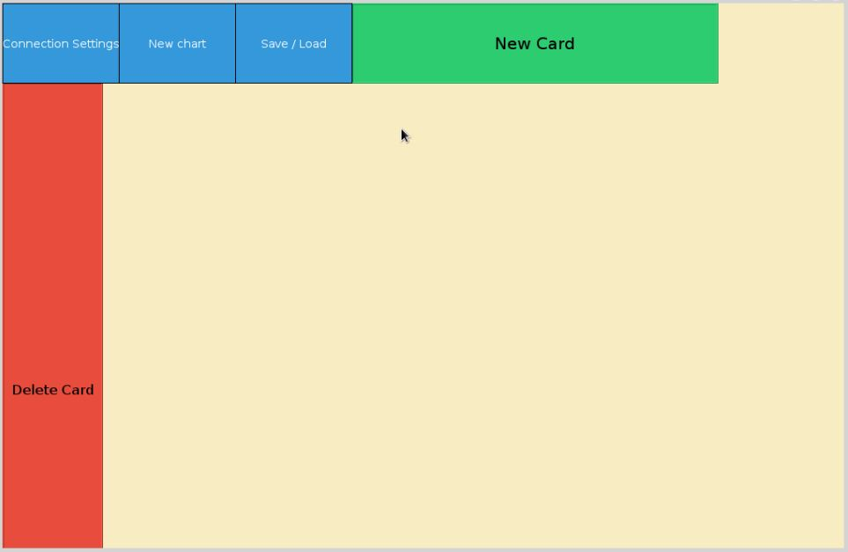The user interface was built in the *Qt Creator (Community)* and contains all start-widgets. This are the following buttons and labels: “New Card”, “Delete Card”, “Connection Settings”, “New Chart” and “Save/Load”. It is loaded in the *iplanpy.py* script.

Figure 1 – User Interface

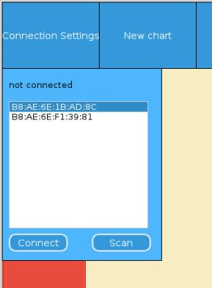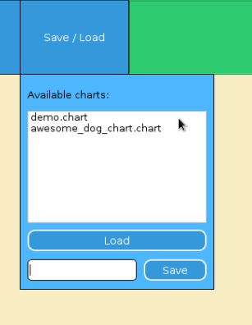The “Connection Settings” and the “Save/Load” contain in addition menus.

Figure – Connection Menu

Figure – Save/Load Menu

## connectionmanager.py

The **connectionmanager.py** script contains the *ConnectionManager* class, which handles the connections between the cards. The definitions contained are:

*connect*: This one saves a new connection and proves first if it isn’t already existing.

*delete_all_card_connections*: deletes all connections where the handed over card is involved. In addition the deleted connections are saved in the restorable_connections list to make them flexible for undo and redo.

*remove_last_connection*: deletes the last connection of the *connections* list and restores it in the *restorable_connections* list to make it flexible for undo and redo.

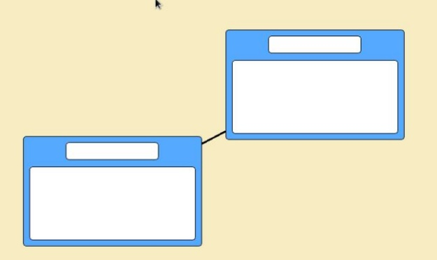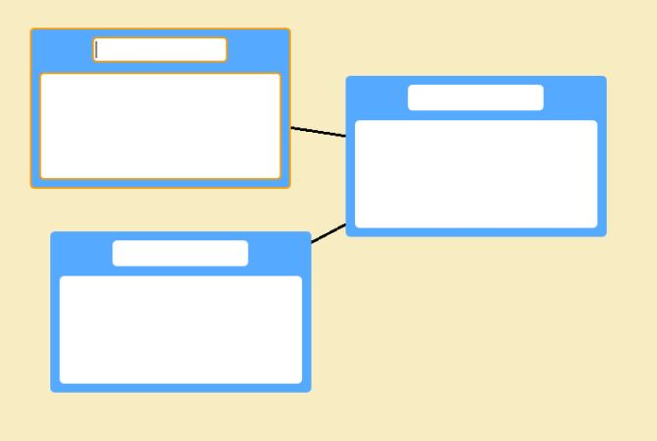*restore_connection*: restores the last deleted connection (if one exists) and adds it to the connections list for redo.

Figure – Card Connection

Figure – Card Connections

*get_centers*: determines the centers of the two cards where a connection should be build.

## card.py

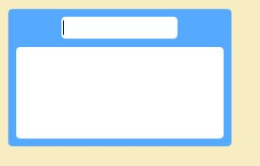The **card.py** script contains the card class, which is a *QFrame*, representing the cards of the system. The *__init__* function establishes the main properties of the *Card*s, such as *DEFAULT_COLOR* or *available_colors* list. The *setup_ui function* creates the user interface of the created *Card*, which contains a *QLineEdit* *title_field* and a *QTextEdit* *content_field*. There is also a type of *Card* where the *has_text_field* is *False*, and so there is only a *title_field*. The card type is switched in the *toggle_type* and the particular *setup_* definitions.

Figure – Standard Card Type

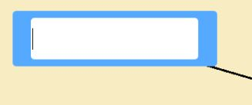

Figure – Header Card Type

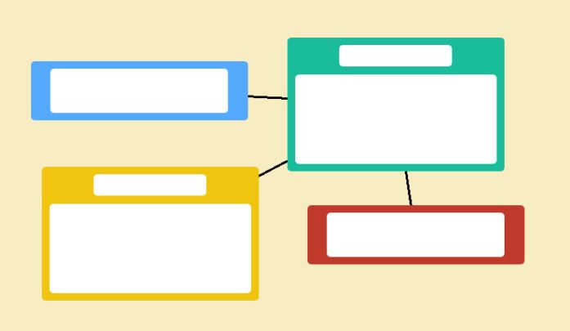The colors of the *Card*s can be switched by the *next_color* and *previous_color* definitions, which handle this by iterating over the *available_colors* list. Different looks of the *Card*s are handled over the *stylesheet*, manipulating *color*, *border* and *border*-*radius*.

Figure – Card Colors

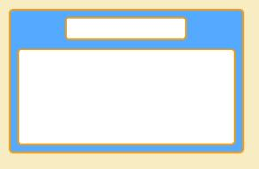Important actions of the *Card*s like *delete*, *focus*, *unfocus*, *move_to*, *collides*_*with*, *collides* and *hits*_*window*_*frame* are defined here. The *(un)focus* definitions are important for the interaction of the user (see **5 Cheat Sheet**). The *collision*, *hit* and *move* definitions are defining the movement and behavior of the *Card*s.

Figure 10 – Focused Card

## gestureclassifier.py

Figure 9 – Unfocused Card

The code of the *GestureClassifier* is adapted and adjusted from results achieved in Assignment 8 and from the provided files in the course. The result is from the Team F2 – Ariane Demleitner and Sebastian Peiser, who is also a Team Member of the IPlanPy project.

The *GestureClassifier* contains the *CATEGORIES* *steady* and *shake*, which train the support vector machine with the two defined .csv files. The accelerometer data from the Wiimote is compared to the trained data and detects a possible *shake gesture*.

This shake.csv file contains the values for classifying the *shake gesture* with the **gestureclassifier.py** script. The **steady.csv** file contains data when the Wiimote is moved as its standard movement is expected.

## vectortransform.py

Contains the class *VectorTransform* which is used in the **iplanpy.py** file. The calculations in this file are adapted and adjusted from the provided *Jupyter Notebook* files in the course.

The *VectorTransform* class handles the interpretation of the IR-sensor data of the Wiimote. The incoming data is proofed (there must be at least four signals), filtered and sorted, ascending by their size (strongest signal first). This should proof that the system uses the LEDs from all incoming signals, not e.g. the sun (which has infrared radiation, too). Next, the signals are sorted by their y value, so the first and the second values are from the both bottom LEDs, the third and the fourth from the both upper.

## wiimote.py

This python script was provided of the university lecturer of the course, Dr. Raphael Wimmer. It is a Wiimote wrapper in in Python 3.[1]

Based on this script it is able to handle the Wiimote callbacks in the **iplanpy.py** main script.

## demo.chart

The **.chart** files represent the saved charts of the user. They encode the card and connection data of the saved chart in a csv-like format and can be loaded to continue the work on previous (saved) charts.

# IPlanPy-Team Collaboration

The IPlanPy-Team contains two People: Sebastian and Julia. I (Julia) did the implementation of the features and logic, which Sebastian revised. Sebastian also was responsible for implementing the *VectorTransform* class, the gesture recognition and the interaction with the user interface which he built. He made the video of the system, while I wrote the documentation. In general, it was a very good cooperation with big discussions, which helped on the whole project. We got a result we are proud of, because we think IPlanPy is an easy-to-use but useful product for everyone.

# Cheat Sheet

The list of all possible interactions with IPlanPy:

|  |  |
| --- | --- |
| Create a new card | Mouse: Click Button “New Card”  Wii: Cursor over “New Card” + Button B |
| Focus card | Mouse: Click card  Wii: Cursor over card + Button B |
| Switch the card type | Mouse: Cursor over card + Alt + Left/Right  Wii: Cursor over card + Left/Right |
| Delete a card | Mouse: Drag and Drop card to “Delete”  Wii: Drag and Drop with Button B to “Delete” |
| Change the card color | Mouse: Cursor over card + Alt + Up/Down  Wii: Cursor over card + Up/Down |
| Build a connection between two cards | Mouse: Drag and Drop card to card  Wii: Drag and Drop with Button B to card  OR (Redo case)  Mouse: Alt + Plus  Wii: Plus |
| Delete a connection between two cards  (Undo) | Mouse: Strg + Minus  Wii: Minus |
| Delete all connections from one card | Mouse: Not possible! Wii exclusive!  Wii: Focus card + shake gesture |
| Save your chart | Mouse: Click “Save/Load” + new chart name + Click “Save”  Wii: Cursor over “Save/Load” + Button B + new chart name + Cursor over “Save” + Button B |
| Load a saved chart | Mouse: Click “Save/Load” + select chart + click “Load”  Wii: Cursor over “Save/Load” + Button B + select chart with Button B + Cursor over “Save” + Button B |
| New chart | Mouse: Click “New Chart”  Wii: Cursor over “New Chart” + Button B |
| Connect your Wiimote | Mouse: (Click Scan +) select your Wiimote + Click “Connect”  Wii: Not possible! Just for changing performing Wiimote! |

1. Copyright © 2014 Raphael Wimmer <Raphael.wimmer@ur.de>