DIT 5407

Data Visualization and Interface Design Information Visualization Report

Student Name: CHAN ROY NAI YIN

Student ID: 170523811

Introduction of your project

For financial analysis, it is so important that to use economic data to make a big picture for analysts to predict the trend of the world economy, so they could make a good investment decision in their business.

In this project, I would like to use React and D3.js to visualize world economic data, such as population, GDP.

Describe what data you choose

All data are placed in the data file.

**World Map**:

I use topojson to draw a world map to visualize the population data. As the file size of topojson is much smaller than the geojson, so I choose the topojson.

I download the geojson from ‘https://geojson-maps.ash.ms/’.

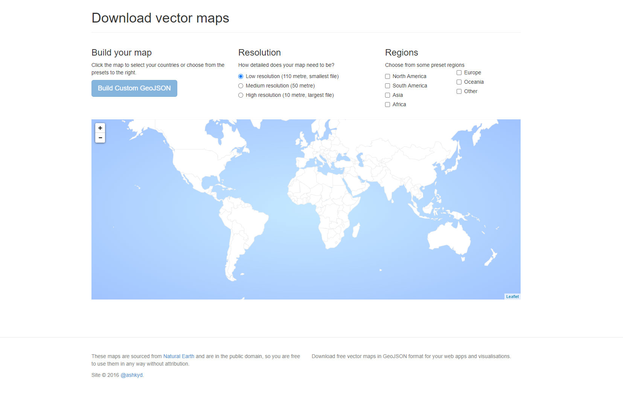

Then, I use the “topojson-server” to convert the geojson to topojson in command prompt.

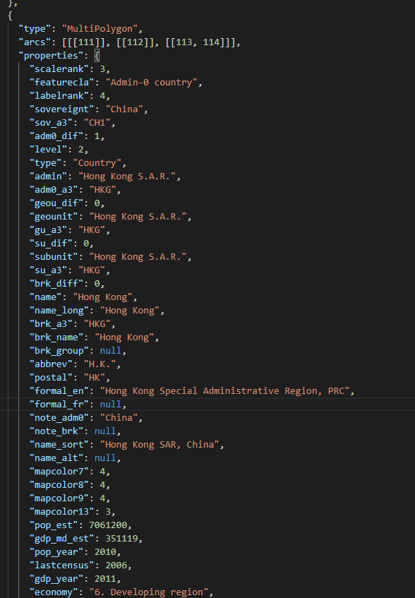

The topojson has all the data I needed including name and country code, so that I could easily match other data from world bank.

**Country Population**:

To seized the world population data, I choose to use the world bank data from <https://data.worldbank.org/indicator/SP.POP.TOTL>

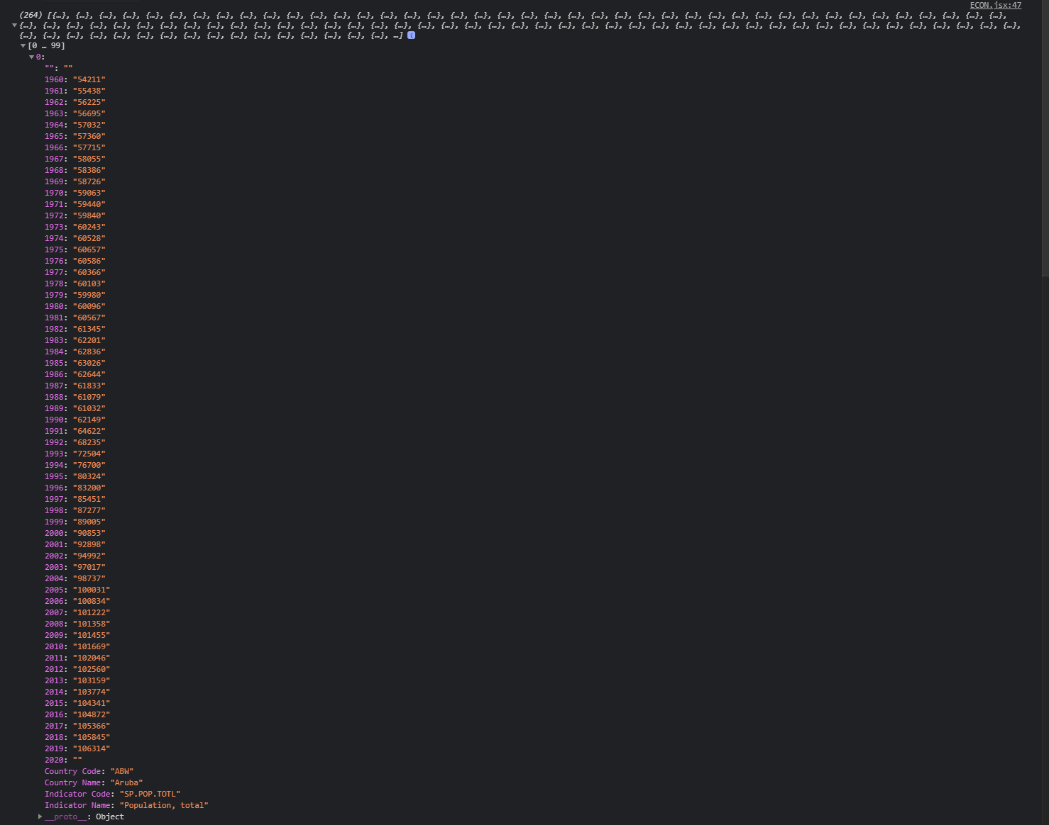

The above image shows the population of Aruba from 1960 to 2019. The country name and country code are matched the name and code from the topojson, so I can use them to make a world map and fill the countries in color according to the population in a specific year.

Population is so important in economy analysis. As population is a key in economic growth, country with higher population usually has better economic growth. Therefore, the visualization in

GDP pre Capita:

To seized the GDP (per capita) data, I choose to use the world bank data from <https://data.worldbank.org/indicator/NY.GDP.PCAP.CD>

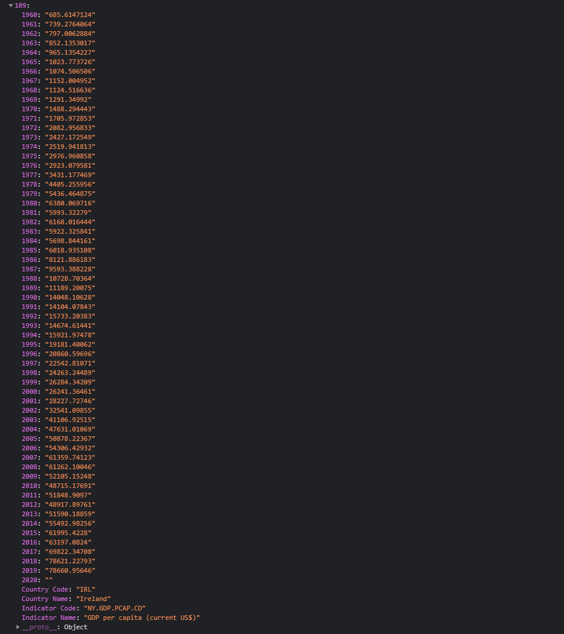

The above image shows the GDP (per capita) of Ireland from 1960 to 2019. With GDP only which cannot reflect the actually prosperity of a country or city, because higher population should have higher GDP. So the GDP divided by the population (GDP per capita) may provide a better picture of citizens’ income in a country or city.

Type of the chart

To visualize the population, geo map would be a good choice for visualization.

The black color means the population are undefined from the world bank.

The population will be visualized by the colors, from white to brown. Deeper color means higher population.

Therefore, the below image shows the population in 2019, China and India have the highest population.

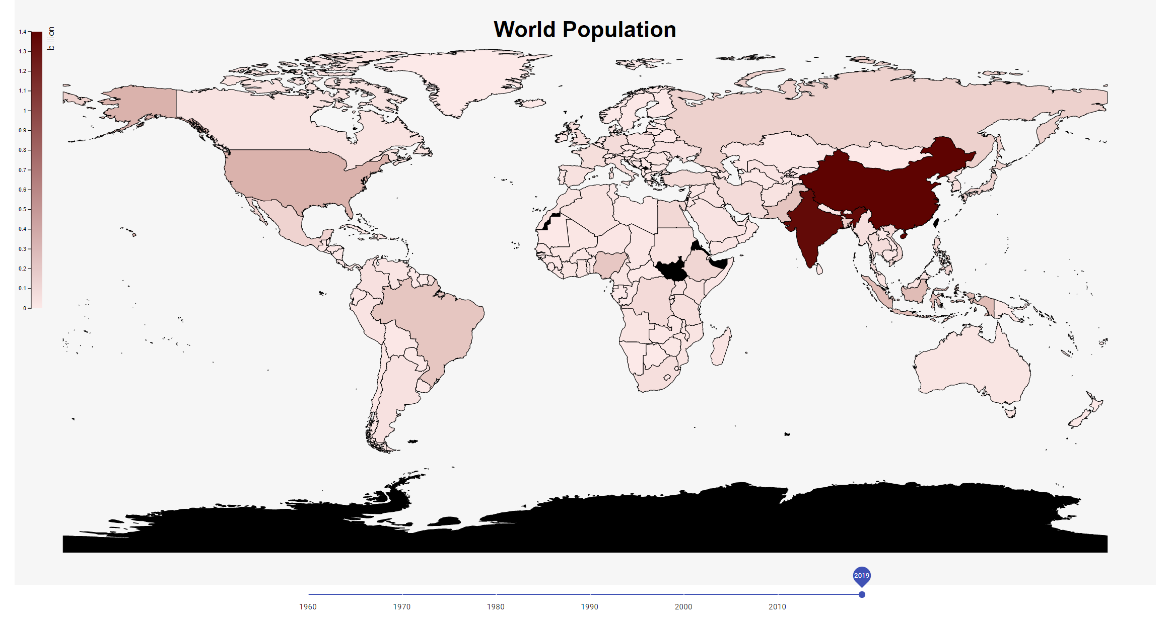

You may use the bottom slider to choose the year you want to visualize.

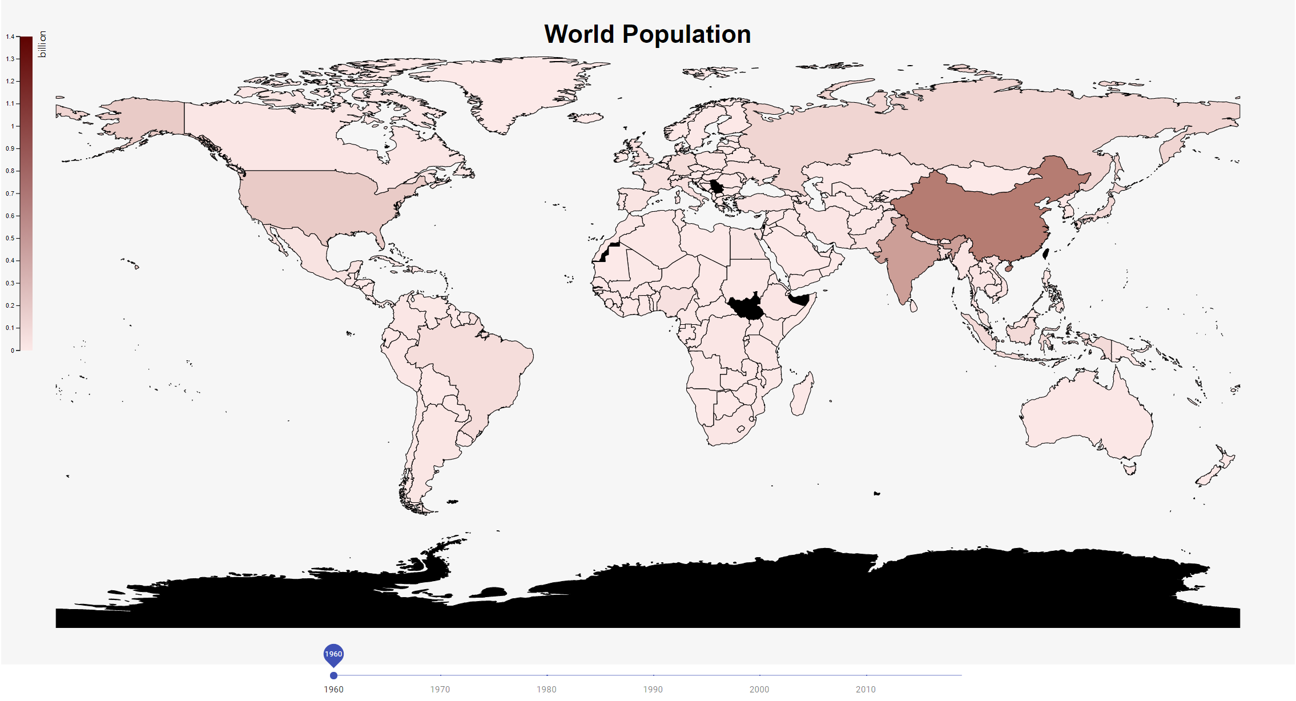

The above image shows the world population in 1960, you could see the colors are lighter than the population in 2019.

As for the GDP per capita, I use line chart to compare two selected countries in linear-timeline way.

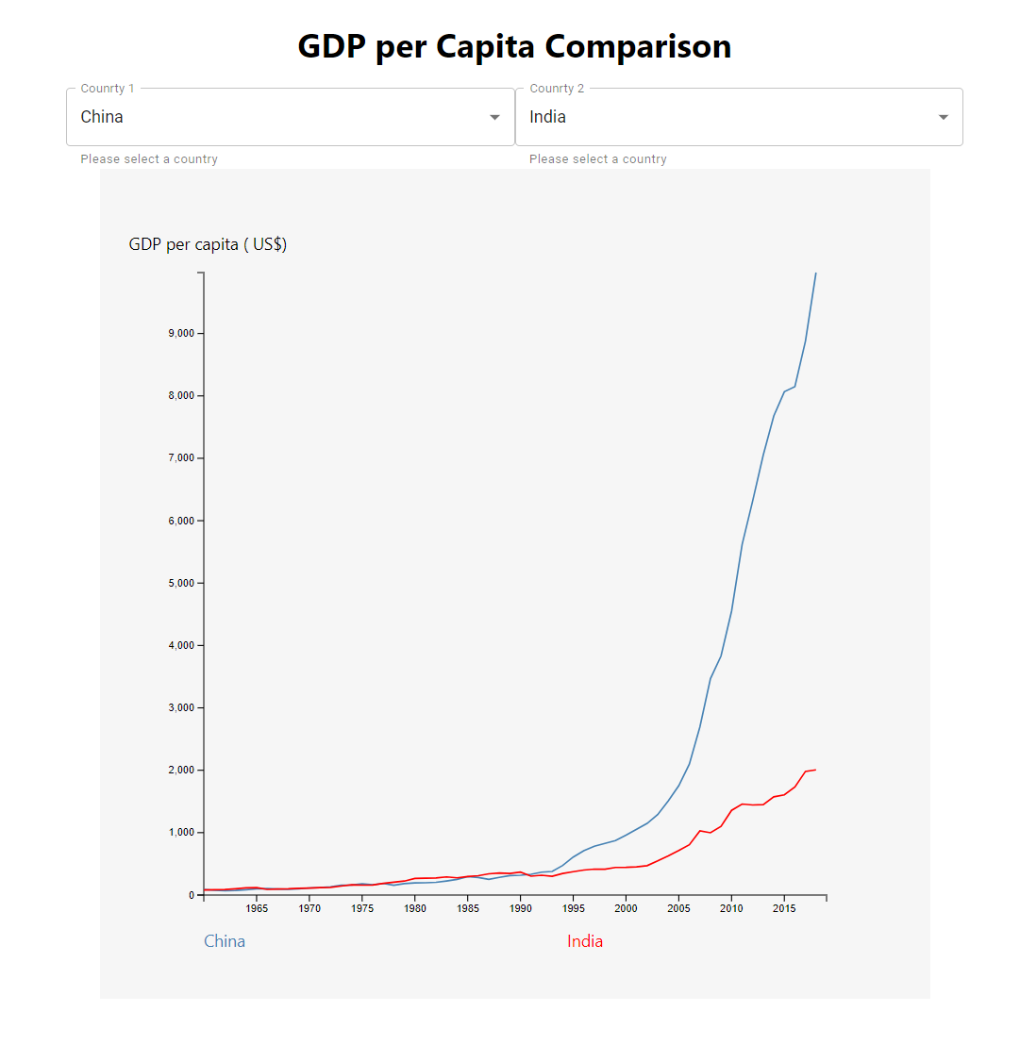

From the above image, you can see there are two selection boxes for user to choose the specific countries they want to compare. The above shows the GDP per capita in China and India, the blue line refers to China, the red line refers to India. In this comparison, although the population between China and India are closed, you can see from the 90’s the economy of the China boost, the average income of individual in China is much better than Indian 2019.

However, if I change India to Japan, shows below. The GDP per capita in Japan is about 4 times higher than the China, which means the price that the people make averagely is higher in Japan. 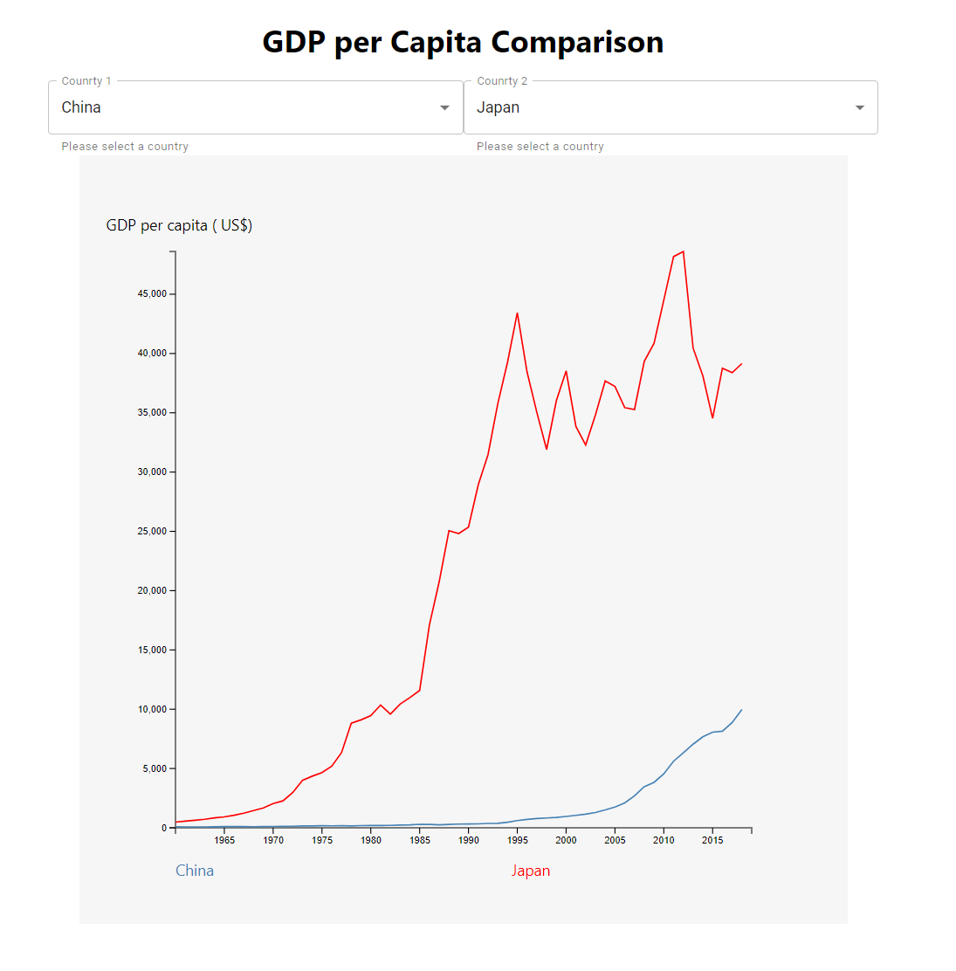

Self-reflection

Through this project I found out data visualization is interesting, which help us easier to analyze and do prediction. However, the chain method in D3.js is quite difficult for me to pick, I had a hard time to figure out how to place D3 in React, making legends and hover tooltip on map.

In future, I will keep studying better skills in D3.js, and I would like to analyze the economic data, and stock data, which are so useful and important for me to do investment decision.