Homework 3 – Written Portion

Daniel Miller

# Question 1

With , the background contains a bit of noise left from the gradient magnitude process, as the derivatives of an image amplify it’s noise. When sigma is increased to 8, a much larger second derivative Gaussian filter is used. This smooths more of the noise out, reducing noise in the final image.

# Question 2

After applying the Laplacian filter with , pixels around image edges are highlighted. On top of the cow’s head, the edge is shown as a transition from white to black pixels as we move down the image. This is because the image gradient steps “up” from the grey background to the higher intensity white fur.

The edge above the cow’s ears, however, appears as a transition from black to white pixels, opposite of those described above. This is because the gradient steps “down”, from the grey background to the low intensity black ears.

# Question 3

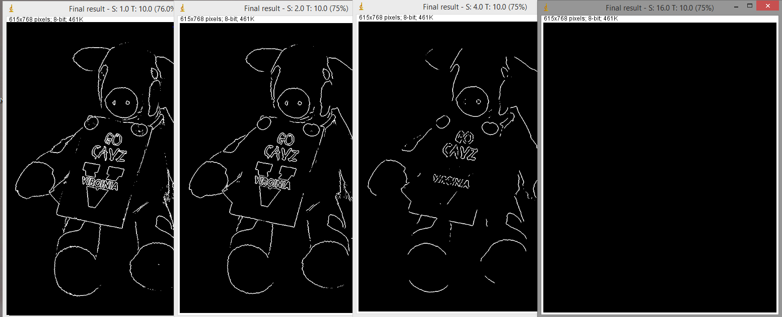

As shown in the picture above, as sigma increases, many of the weaker edges fall off. By the final trial, no edges can be seen, as they are all smoothed away.

To combat the negative effects shown above, the threshold must be decreased as sigma increases. As shown below, fine edge details are lost with increased sigma:

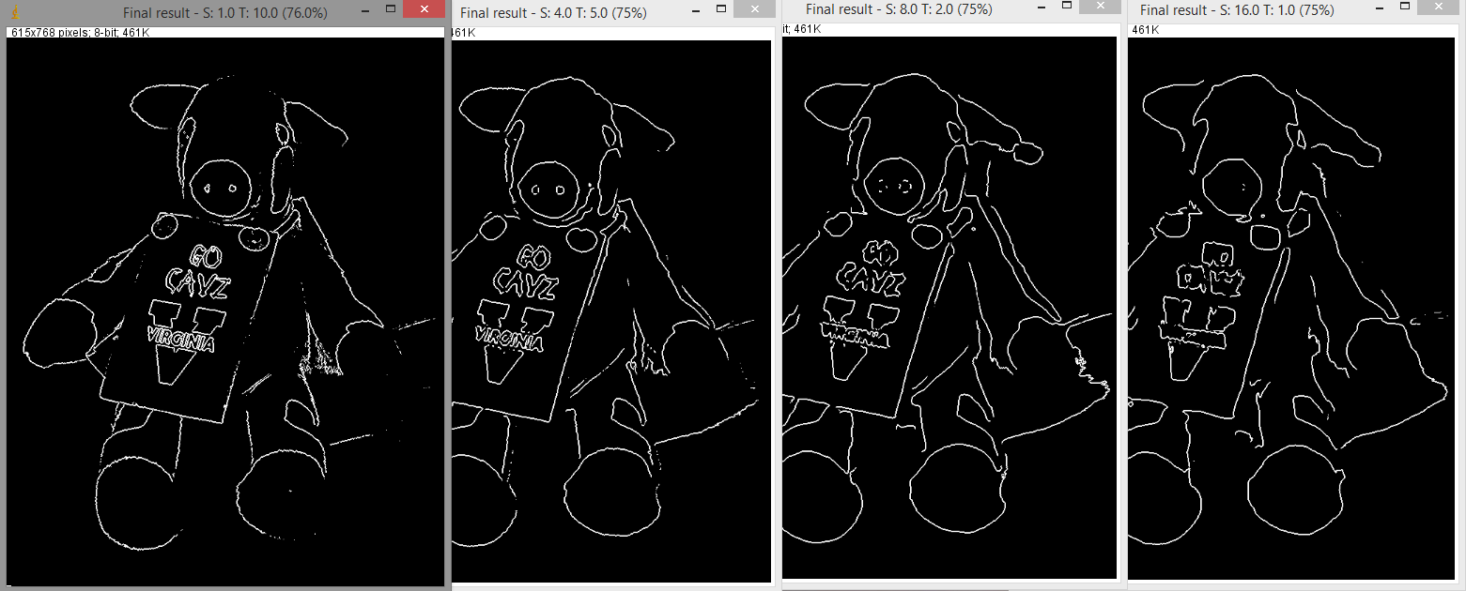

# Question 4

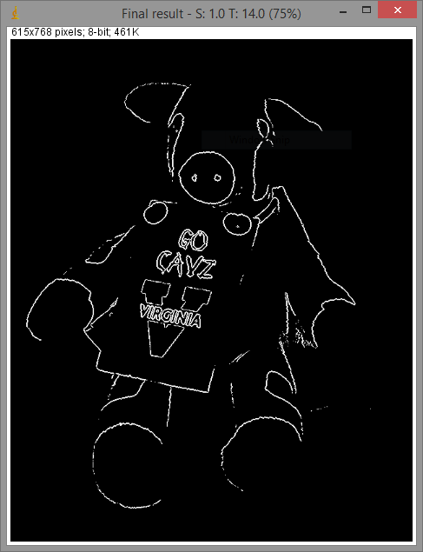

This image was taken with sigma at 1.0, and a threshold of 14. At this high threshold, only the strongest edges are preserved (such as around the letters on the sign), while reducing smoothing effects. With less smoothing, the letter boundaries remain crisp and accurate.

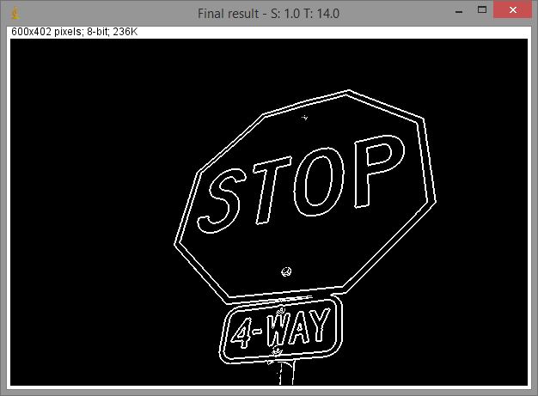Sign1 responded well to the same values of sigma and threshold.

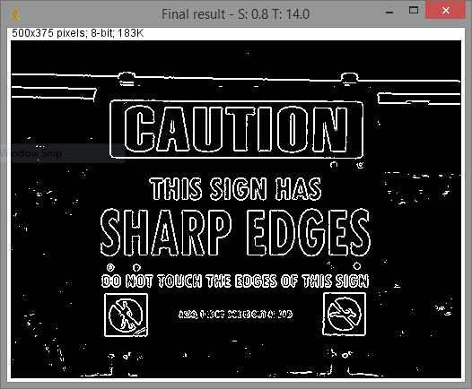However, sign2 is much smaller resolution, and required sigma of 0.8 in order to keep most of the text legible. Despite my best efforts, the small lettering at the bottom was almost always illegible