# Programming

## Question 1

The Circular_Hough plugin detects circles within a given image. The result of this detection is shown below, with the detected circles displayed on the right. This PlugInFilter utilizes an ImageStack to maintain a 3 dimensional accumulator array. This stack is displayed both before and after thresholding, for debugging purposes. The detected circles are then drawn over the original image. In order to filter the candidate circles appropriately, this filter makes use of both non-maximum suppression, and thresholding. The threshold is calculated proportionally to the radius of the circle at that level of the accumulator array, as larger circles create higher peaks within an image.

This PlugInFilter also makes use of the Bresenham Circle drawing algorithm found at the following address: <http://onyx.boisestate.edu/~tcole/cs498/spr04/ammeraal/Bresenham.java>

The Bresenham Circle algorithm is used to draw circles very quickly in the accumulator array. The final accumulator array may be examined by dragging the slider at the bottom, and is shown below reference.

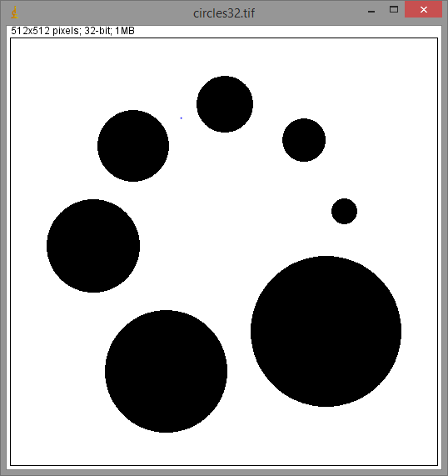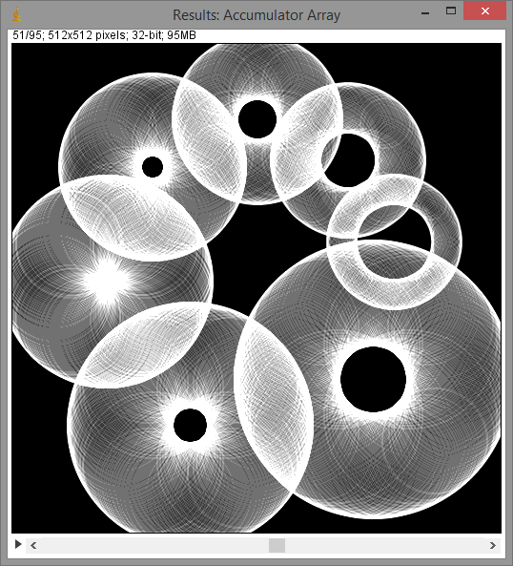

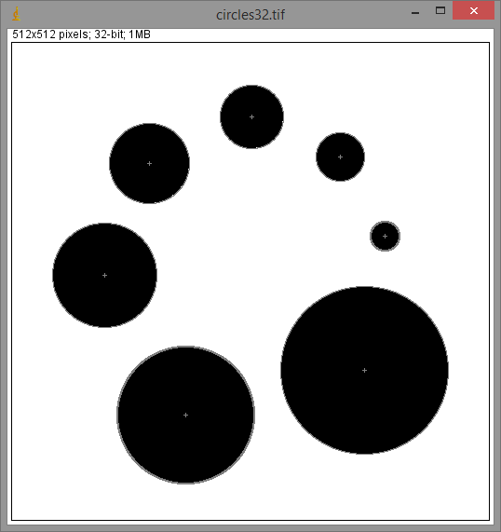

# Experimentation

## Question 2

As shown in the following two images, the white dots in the background of the image are easily removed using morphological filtering of the black and white image. The image on the right is the result of applying an “Open” with a circular structure element of radius 3.

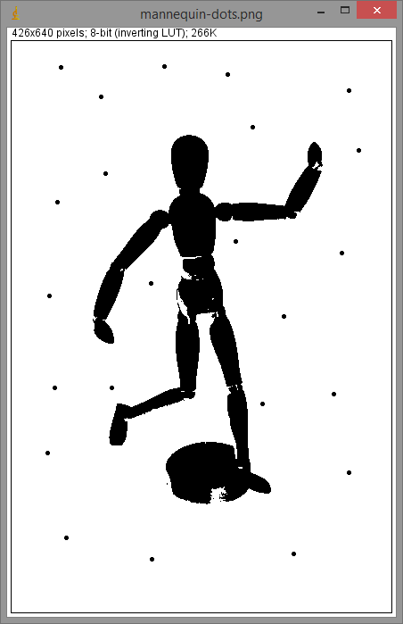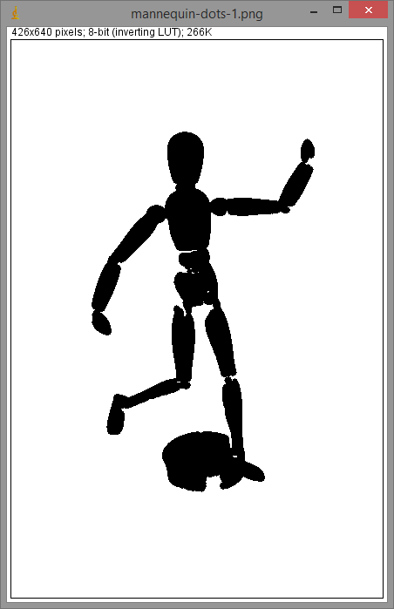

# Written

## Question 3:

Write the following line equation in polar form:

## Question 4:

## 

Accumulator Array

|  |  |  |  |  |  |  |  |  |  |  |  |  |  |  |  |
| --- | --- | --- | --- | --- | --- | --- | --- | --- | --- | --- | --- | --- | --- | --- | --- |
|  | -3 | -2.8 | -2.1 | -2 | -1.4 | -1 | -0.7 | 0 | 0.7 | 1 | 1.4 | 2 | 2.1 | 2.8 | 3 |
| -45° |  | 0 | 1 |  | 0 |  | 2 | 1 | 1 |  | 0 |  | 1 | 0 |  |
| 0° | 1 |  |  | 1 |  | 1 |  | 1 |  | 0 |  | 3 |  |  | 0 |
| 45° |  | 0 | 0 |  | 0 |  | 4 | 0 | 1 |  | 0 |  | 0 | 1 |  |
| 90° | 0 |  |  | 2 |  | 0 |  | 1 |  | 3 |  | 0 |  |  | 1 |

## Question 5:

|  |  |  |  |  |  |  |  |
| --- | --- | --- | --- | --- | --- | --- | --- |
| 0 | 0 | 0 | 0 | 0 | 0 | 0 | 0 |
| 0 | 0 | 0 | 1 | 1 | 1 | 1 | 0 |
| 0 | 0 | 0 | 1 | 1 | 1 | 1 | 0 |
| 0 | 1 | 1 | 1 | 1 | 1 | 1 | 0 |
| 0 | 1 | 1 | 1 | 1 | 1 | 1 | 0 |
| 0 | 1 | 1 | 1 | 1 | 0 | 0 | 0 |
| 0 | 1 | 1 | 1 | 1 | 0 | 0 | 0 |
| 0 | 0 | 0 | 0 | 0 | 0 | 0 | 0 |

|  |  |  |
| --- | --- | --- |
| 1 | 0 | 0 |
| 0 | 0 | 0 |
| 0 | 0 | 1 |

A = B =

|  |  |  |  |  |  |  |  |
| --- | --- | --- | --- | --- | --- | --- | --- |
| 0 | 0 | 0 | 0 | 0 | 0 | 0 | 0 |
| 0 | 0 | 0 | 0 | 0 | 0 | 0 | 0 |
| 0 | 0 | 0 | 0 | 1 | 1 | 0 | 0 |
| 0 | 0 | 0 | 0 | 1 | 1 | 0 | 0 |
| 0 | 0 | 1 | 1 | 0 | 0 | 0 | 0 |
| 0 | 0 | 1 | 1 | 0 | 0 | 0 | 0 |
| 0 | 0 | 0 | 0 | 0 | 0 | 0 | 0 |
| 0 | 0 | 0 | 0 | 0 | 0 | 0 | 0 |

|  |  |  |  |  |  |  |  |
| --- | --- | --- | --- | --- | --- | --- | --- |
| 0 | 0 | 1 | 1 | 1 | 1 | 0 | 0 |
| 0 | 0 | 1 | 1 | 1 | 1 | 0 | 0 |
| 1 | 1 | 1 | 1 | 1 | 1 | 1 | 1 |
| 1 | 1 | 1 | 1 | 1 | 1 | 1 | 1 |
| 1 | 1 | 1 | 1 | 1 | 1 | 1 | 1 |
| 1 | 1 | 1 | 1 | 1 | 1 | 1 | 1 |
| 0 | 0 | 1 | 1 | 1 | 1 | 0 | 0 |
| 0 | 0 | 1 | 1 | 1 | 1 | 0 | 0 |

(Erosion) (Dilation)

|  |  |  |  |  |  |  |  |
| --- | --- | --- | --- | --- | --- | --- | --- |
| 0 | 0 | 0 | 0 | 0 | 0 | 0 | 0 |
| 0 | 0 | 0 | 1 | 1 | 0 | 0 | 0 |
| 0 | 0 | 0 | 1 | 1 | 1 | 0 | 0 |
| 0 | 1 | 1 | 0 | 1 | 1 | 1 | 0 |
| 0 | 1 | 1 | 1 | 0 | 1 | 1 | 0 |
| 0 | 0 | 1 | 1 | 1 | 0 | 0 | 0 |
| 0 | 0 | 0 | 1 | 1 | 0 | 0 | 0 |
| 0 | 0 | 0 | 0 | 0 | 0 | 0 | 0 |

|  |  |  |  |  |  |  |  |
| --- | --- | --- | --- | --- | --- | --- | --- |
| 0 | 0 | 0 | 0 | 0 | 0 | 0 | 0 |
| 0 | 0 | 0 | 1 | 1 | 1 | 1 | 0 |
| 0 | 0 | 0 | 1 | 1 | 1 | 1 | 0 |
| 0 | 1 | 1 | 1 | 1 | 1 | 1 | 0 |
| 0 | 1 | 1 | 1 | 1 | 1 | 1 | 0 |
| 0 | 1 | 1 | 1 | 1 | 0 | 0 | 0 |
| 0 | 1 | 1 | 1 | 1 | 0 | 0 | 0 |
| 0 | 0 | 0 | 0 | 0 | 0 | 0 | 0 |

(Opening) (Closing)