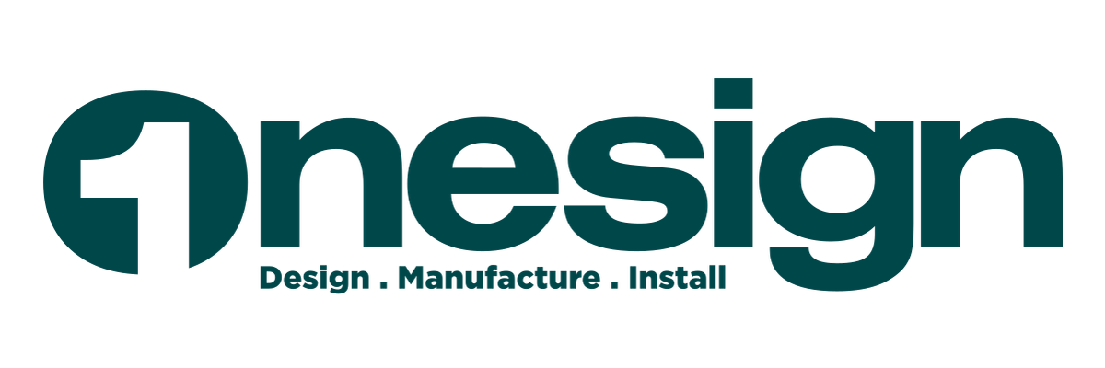
CASE STUDY
Persimmon Homes

Digital Procurement
for Branded Signage
How a single platform replaced spreadsheets, emails and manual coordination

Onesign and Digital
D86 Princesway, Gateshead NE11 0TU
onesignanddigital.com | 0191 487 6767

The Challenge

For large housebuilders managing branded signage across hundreds of active sites, procurement is often more complex than it needs to be. Requirements arrive via spreadsheets, brand guidelines live in separate documents, and procurement teams spend hours reconciling requests.

- Limited visibility of what is ordered across sites
- Inconsistent brand application without visual references
- Version control issues with shared spreadsheets
- Manual administration for every order
- Extended lead times from clarification cycles

The Solution

Working with Persimmon Homes, we built a branded digital procurement portal. Site managers browse approved signage with images, select variants, and submit orders directly. Procurement teams get structured data, full visibility, and a single source of truth.
One platform. Visual product selection. Structured ordering. Complete visibility from site to sign.

The Platform
The Persimmon Signage Portal replaces fragmented workflows with a single digital ordering experience. Here's how it works.

Secure Access & Category Browsing
Site managers log in through a branded entry point. On login, they see all available signage categories — Site Setup Packs, Environmental Signs, Health & Safety, and more.
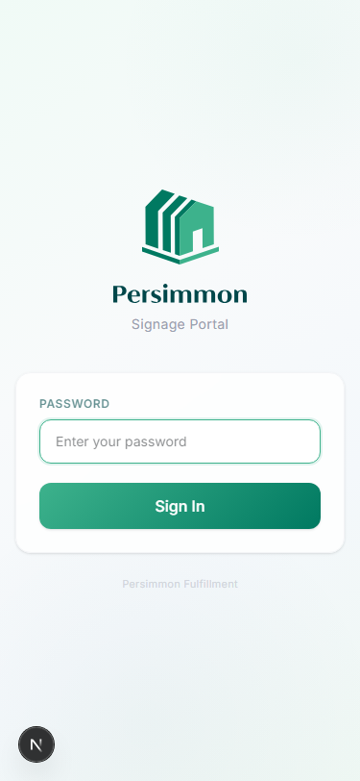 | 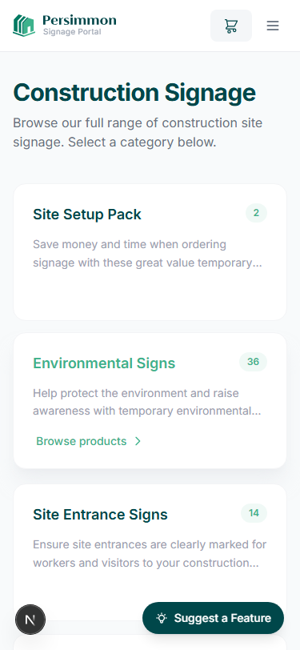
Branded login screen | Category overview

Visual Product Catalog
Products are displayed with images, codes, names, and pricing. Each product page shows all available size and material variants with clear pricing.
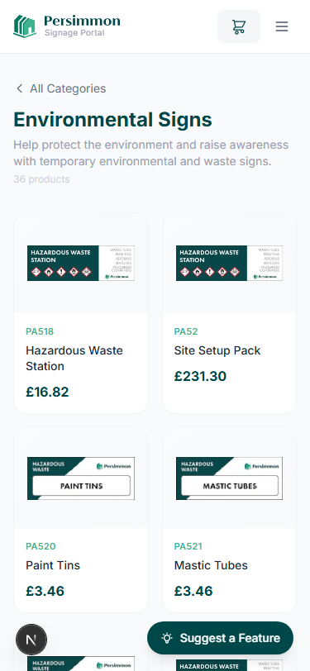 | 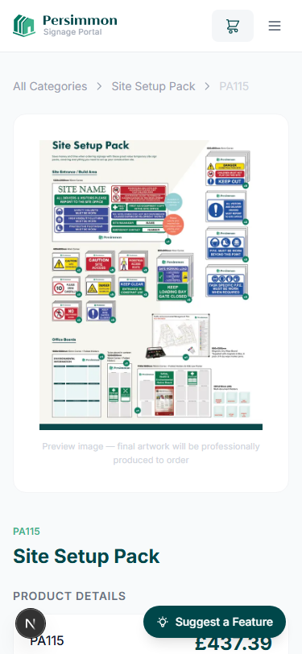
Product grid with images and pricing | Variant selection with preview

The Ordering Experience
Basket & Checkout  Selected items are summarised in a basket with images, quantities, and a full pricing breakdown including VAT.  At checkout, users select a contact, delivery site, and optional purchaser from saved records. A PO number and special instructions can be attached.  Previously saved contacts and sites make repeat ordering fast.  Structured Data  Every order captures:  - Contact and site details  - Product codes and quantities  - PO reference  - Special instructions  Clean, actionable data replaces ambiguous email requests. | 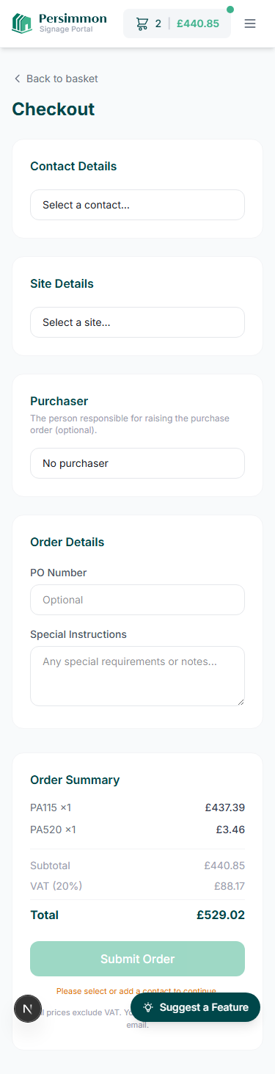  Complete checkout flow

Custom Sign Builder
For bespoke requirements, users specify sign type, shape, size, material, and text. A live preview renders the sign in real time. Custom signs are submitted as quote requests — the team reviews and confirms pricing before manufacture.
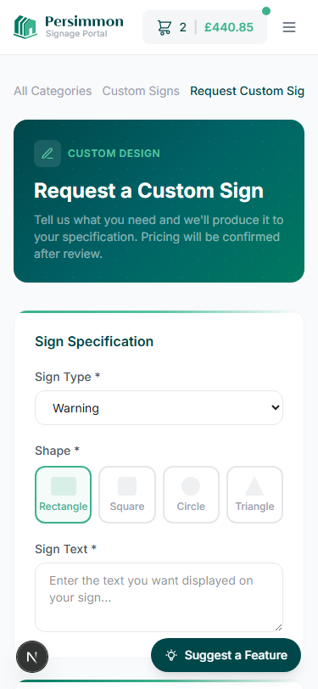 | 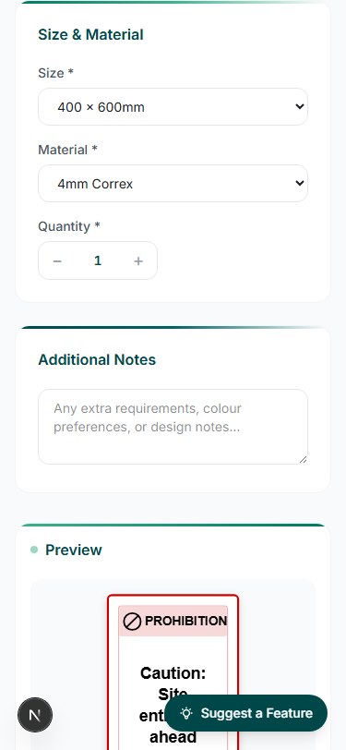
Sign specification form | Live preview with size and material options

Visibility & Control
Both site managers and the production team get complete order visibility. Users track progress without chasing updates. The admin dashboard gives the production team a single view of all orders across the estate.
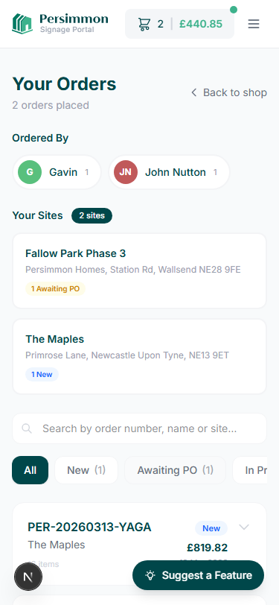 | 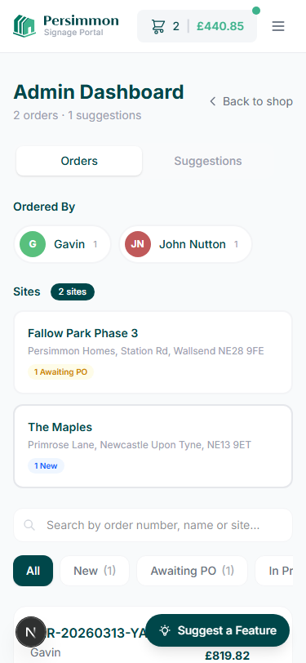
Order tracking with filters and status | Admin dashboard for order management

The Results

By replacing manual processes with a structured digital workflow, the portal delivers measurable improvements across procurement, operations, and brand management.

Faster Ordering | Site managers browse and order in minutes, not days
Brand Consistency | Every order uses approved, visually referenced products
Complete Visibility | Full oversight of every order across every site
Structured Data | Clean order data replaces ambiguous email requests
Reduced Admin | No more manual reconciliation of spreadsheets
Scalable | The same platform serves five sites or five hundred

From site manager to delivered signage: one digital workflow replacing spreadsheets, emails, and manual coordination.

Get in Touch
If you'd like to explore how a digital procurement portal could simplify signage ordering across your estate, we'd be happy to show you how it works.
mike@onesignanddigital.com
0191 487 6767
onesignanddigital.com
Onesign and Digital
D86 Princesway, Gateshead NE11 0TU

