# 4.Model Ⅰ（~~problem1~~）

An artist is influenced by influencers, and as an influencer he influences other artists. If an artist is followed by many artists, his musical influence may be great. If an artist is not followed by many artists, his musical influence may be great. If an artist is followed by one artist with great influence, his musical influence may be great. We also consider that an artist's musical influence is influenced by time. In different periods of time, an artist is followed by different numbers of artists with different influences, and that artist's musical influence will change accordingly. At the same time, if a genre is popular, the musical influence of its artists increases. To sum up, we evaluate the influence of music by considering the influence size of followers, the time interval between the influencer and followers, the popularity of the genre in the period of followers, and the attention of followers. In this section, we propose an improved VPR model to measure the musical influence of artists.

1、Musical influence evaluation index

Musical influence is used to measure the influence of a musician on the music industry, which is divided into two dimensions: the influence on artists of the same genre and the influence on artists of different genres. The influence on artists in the same genre is that it causes more artists to enter the genre and start their musical careers. The influence on artists in different genres means that artists in another genre are involved in the creation of works in the field.

The essence of an artist following another artist is the process of the spread of the artist's musical influence. The concept of time heterogeneity is involved here, and factors such as the different prevalence of different schools in different time spans should also be considered to reduce the impact of time heterogeneity on the evaluation results. Therefore, in order to minimize the impact of the temporal heterogeneity of the evaluation index of music influence on the analysis results, different weights should be set for the communication index of music influence composed by artists of different genres in different years.

**The degree of preference**

An artist may have many influencers, and the degree of preference for different influencers is different, so we define the degree of preference as

prei=A*1/(追随总人数)

If the influencer belongs to the same genre as the artist, then the artist prefers the influencer, and the weight A = a. If the influencer is not in the same genre as the artist, then the weight A= 1-a .a属于（0.5，1）

**Musical Influence**

If he is followed by many artists who have great influence in recent years, his musical influence will also be high. Therefore, for each artist, his MI(i) depends on the musical influence of all artists who follow him and the popularity of his genre in recent years.

The formula is as follows:

 其中,w(i,j) is the probability function of jumping from j to i【MI(j)前面加上prei】

Since most artists will follow the influencers of influencers, that is, artists may choose the influencer as another influencer from among the influencers, the weighting factor among artists is:

w(i,j)=α×LS(t)+(1-α)×f(i,j)

其中，LS(t) refers to the popularity of the genre of the artist, and f(I,j) refers to the time interval between the decade that the artists began their music career.

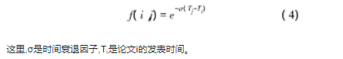 符号 is a decline factor , 符号is the decade that the artist i began his music career.（括号改成绝对值）

We believe that there is a linear relationship between the influence of a genre and the proportion of the genre to the total number of artists in a given year.So:

LS(t)=求和/求和

**Model implementation and result analysis**

We implement our proposed model with the data given. The modified VPR model has four parameters in total: a,σ, α和d。d is set to 0.85， learned from the research of Professor Zhang [1].σ is set as 0.137. Parameter αis used to adjust the time factor.So α属于[0.1, 1]。We set it as 0.3

Here, we only select artists beginning their music careers in 2000 and 2010 as data for model implementation. The relationship between Influencers and followers is shown in Figure X. Set the follower as “target” and the Influencer as “sourse”.

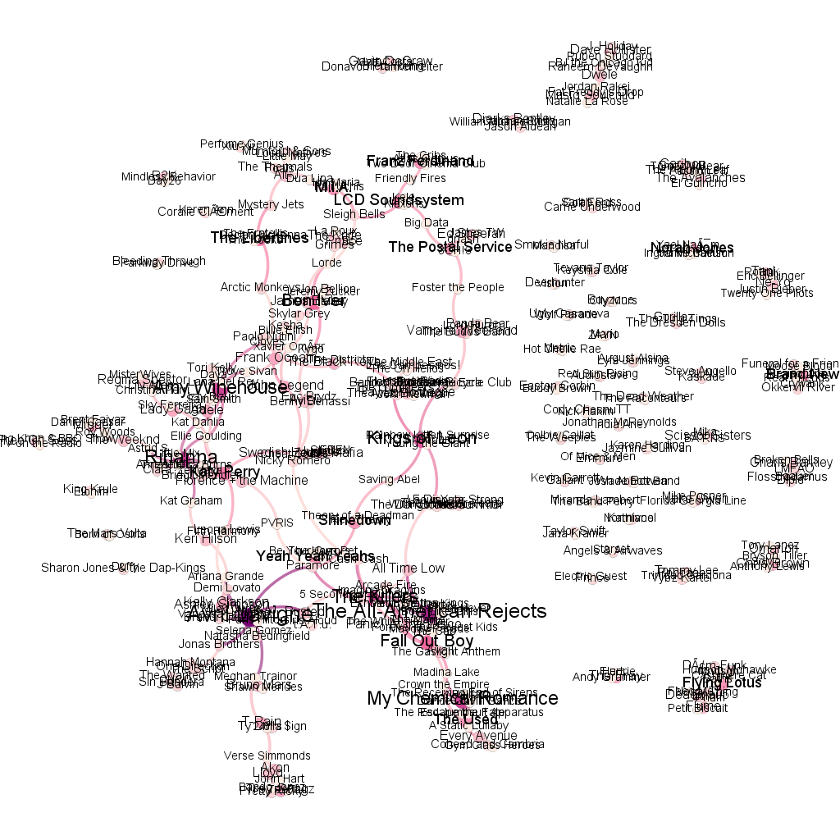

As shown in Figure X, Kings of Leon's different musical influences on Saving Abel, Sheppard, Young the Giant, The Lumineers, George Ezra, Rainbow Kittens Surprise and Rainbow Kittens Surprise are shown. The size of the circle indicates the amount of influence.

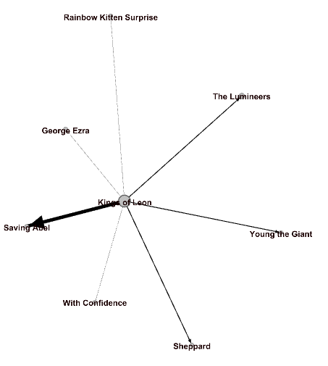

We can find that this model can well represent the musical influence. Combined with the data_influence file, it can be seen that Kings of Leon influences Saving Abel, Sheppard, Young the Giant, The Lumineers, George Ezra, Rainbow Kittens Surprise, Rainbow Kittens Surprise, all of which are pop/rock genre, Saving Abel, Sheppard, Young the Giant started their musical career in 2000, but by 2010 no one had followed them. The Lumineers started Pop/Rock in 2000 and had a following The Oh Hellos, who started in 2010. As we can see from the percentage of genre’s new additions, Pop/Rock was more popular in 2000, so MI (Kings of Leon) was the biggest of the bunch.