# 2.

1. We then substitute 15 variables for each genre into the formula to get 4 principal component scores for each genre.【这里编号是2】

Through the above steps, we reduced the dimension of 15 variables of each genre to 4 variables, and the results are shown in the figure below:

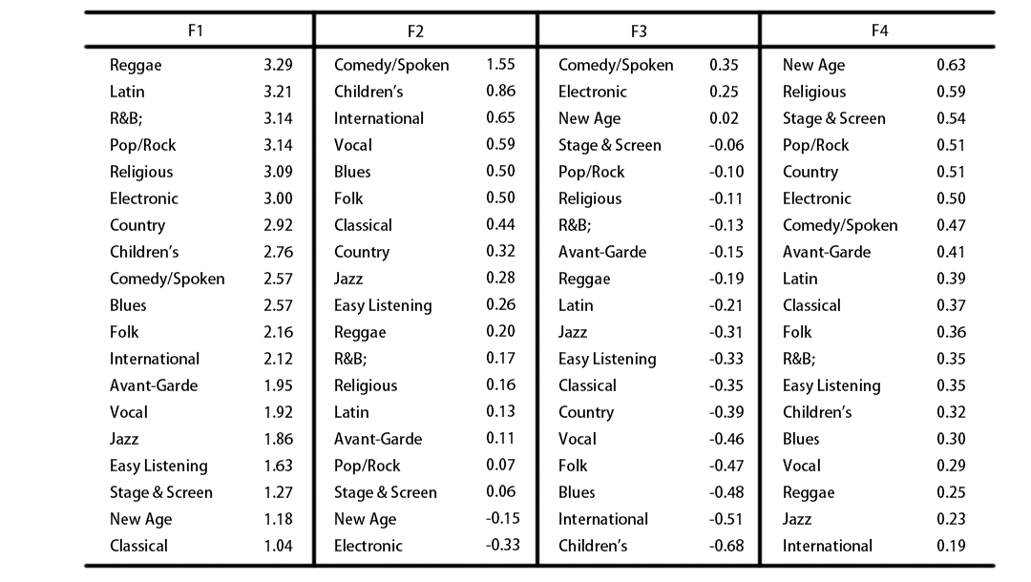

1. 对于F1，流派的值越极端，则该流派可能在valence,danceability,loudness,tempo,energy，instrumentaness的一个或多个特质上有显著特点。(1) for F1, genre’s value the more extreme, the genre may in valence and danceability, loudness, tempo, energy, instrumentaness has distinctive features in one or more characteristics.

We can see from the picture F1 larger Reggae, Latin, R&B, Pop/Rock, Religious, Electronic, these genres have a strong sense of rhythm, high strength, high loudness etc, thus has the high valence, danceability, loudness, tempo, energy value, in line with the actual situation. Genres with less F1 are Classical,New Age,Stage & Screen, all of which have the characteristics of serenity, ease and leisure, and are mainly composed of pure music with few vocals, so these genres have high instrumentaness value.

1. 对于F2，流派的值越极端，则该流派可能在year,populrity,acousticness的一个或多个特质上有显著特点。(2) for F2, genres value the more extreme, this genre may in the year, populrity, acousticness has distinctive features in one or more characteristics.

Analyzing the above figure, Comedy/Spoken usually directly adopts by the artist's original sound, so it has a high acousticness value. However, with the development of time in recent years, Electronic has become more and more popular among people, especially young people, and thus has a higher popularity. In addition, Electronic music is created by Electronic instruments, and most of them have technology or enhancements and electrical amplification by computers and other devices, so they have low acousticness.

1. for the F3, it reflects the main speechiness, explicit, liveness values.

Referring to the Figure above,we have an insight of Comedy/Spoken. Among them, Comedy/Spoken is mainly made up of dialogue (high speechiness), most of which include lyrics (high explicit value), and some songs include audience reactions. In most comedies, audience laughter (high liveness) is added to enhance the appealingness (which is in line with the calculated results).

1. For F4, duration_ms, Key, Mode values are reflected. These three values are not related to the style of music, so there is little difference in F4 values between different genres.

Through the Through analysis above, we can draw a general way to distinguish genres, that is, to distinguish them through some characteristics. However, since the KMO test value calculated in the previous principal component analysis method is 0.535, the result may be poor. Therefore, there may be some deviation in the result for the music genres with no obvious relevant characteristics, that is, the genres in the middle position in the above table.