CST2540– Digital System Design
Coursework 2
Group Project Meeting and Progress Form

Group Members:

3

Names and IDs:

Amal Ali Anwar M00734729
Mirza Mohamed Faiq Baig M00696479
Hamad Mohamed Asif M00695912

Individual Task Division: Please identify your individual task number below.
Member Name | Task Number
Amal Ali Anwar | Task 1
Faiq Baig | Task 2
Hamad Mohamed Asif | Task 3

Planned Meetings for Group Coursework Component (extend this section as needed):
(Copy paste emails, WhatsApp Group conversations or any other evidence of planned meetings – you can include screenshots)
For each meeting provide the Agenda, the input (if any) of each member, and the output/conclusions of the meeting. Provide information also if the meeting was scheduled and some members did not show up or postponed the meeting.

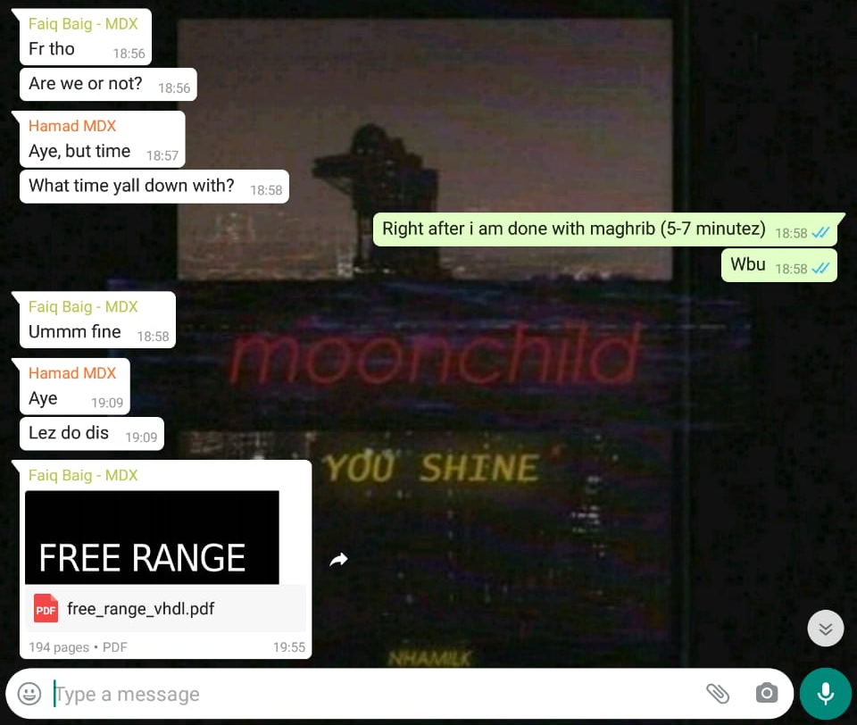
Meeting 1 Agenda: Introduction to coursework/Distribution of tasks (WhatsApp screenshot) – 26 April
Output of meeting – every member took up an individual task to work on and was supposed to read the VHDL reference book to have a better understanding of the group tasks.

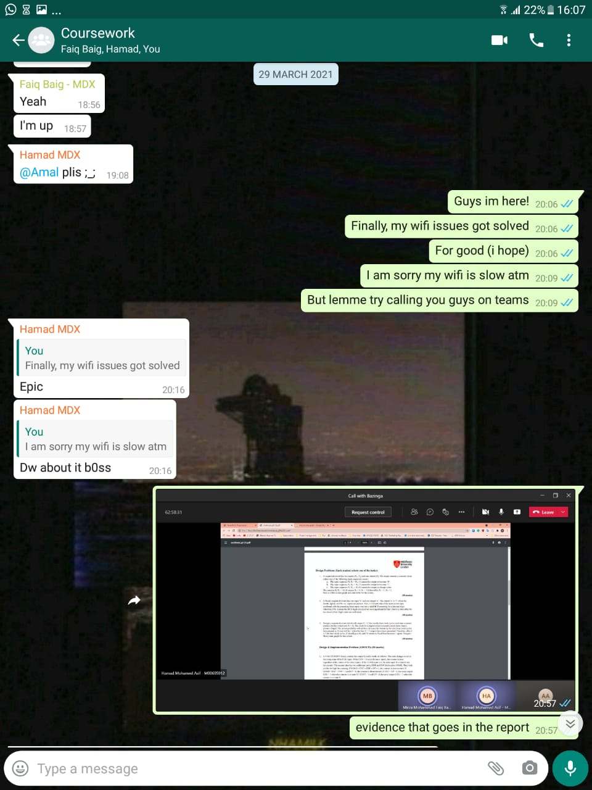

Meeting 2 Agenda: Explanation of tasks – (WhatsApp screenshot) 29 March
Output of meeting: We came to the conclusion that the tasks will take less time to understand and solve if we were to meet in person. We scheduled an in-person meeting for 8th April.
Meeting 3: In person Meeting – 8 April
Output of meeting: We were able to make a draft of our individual tasks and finish off the 2nd task of the group questions
Meeting 4: In person Meeting – 12 April
Output of meeting: Finalised individual tasks and came up with the VHDL code for the group questions.
Meeting 5: Final Meeting – (WhatsApp screenshot) 15 April
Output of meeting: Got the testbench to work and compiled every answer into a report to submit. The report was submitted by Hamad.

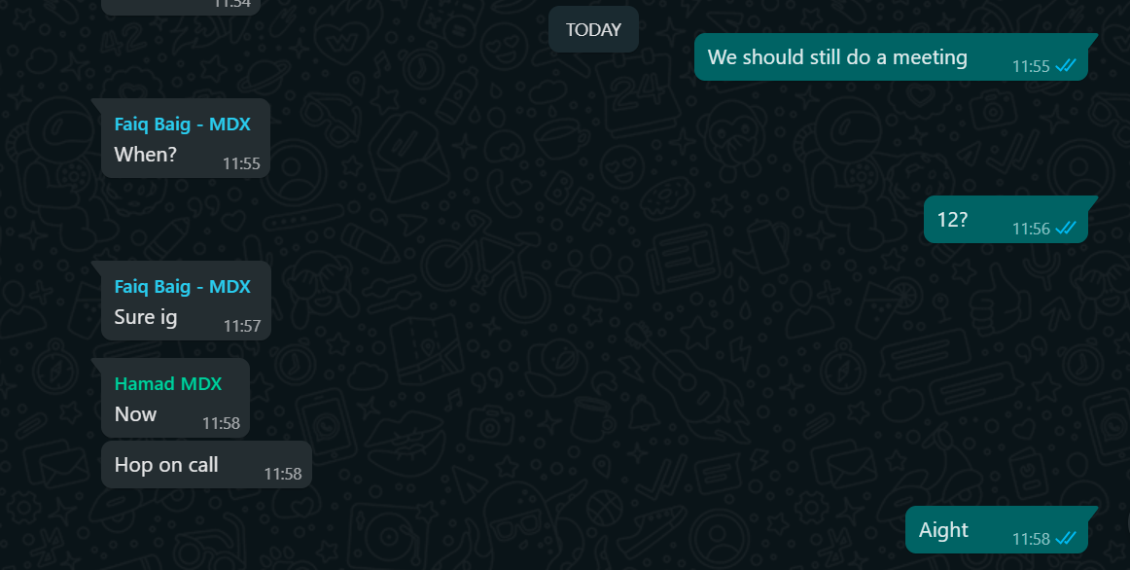

Final Tasks (who did the actual work)

Member Name | Task Done | Signature
Amal Ali Anwar | 1 | 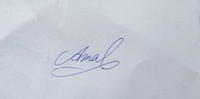
Mirza Mohamed Faiq Baig | 2 | 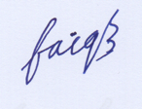
Hamad Mohamed Asif | 3 | 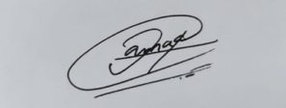

Date: 14th April 2021

