CST2560 COURSEWORK 5

1. **Title**

Applications of Virtual Reality Technology in Psychotherapy

**Key words**

Virtual Reality Therapy, VRET, Psychotherapy, VR, psychology, Virtual Reality Exposure Therapy

**Introduction and context description**

This project proposal is a research-centric piece, focusing on how Virtual Reality (VR) technology can impact or aid the treatment of psychological conditions. It will go into detail about various pieces of research that explore such technology, construct a more nuanced image of the problems and dependencies of such applications for this technology, and finally plan a method of conducting similar research that takes the problems of existing research and knowledge into account.

As technology advances, more and more ideas that were previously assumed to only be fiction are made possible. Such technological advances are often accompanied by societal progression, where more and more social issues are able to be examined in greater detail. One prevalent aspect of societal progression is recognition of mental health as a larger priority than previously assumed. As some of the most prevalent mental health conditions such as anxiety or PTSD are often triggered by exposure to certain environmental conditions, it makes sense to use the technology available to create controlled environments in which better examination of these conditions can be conducted. Advancements in hardware such as graphics processing units, as well as greater availability of software that aids constructing virtual environments such as game engines like Unity and the Unreal Engine, make the construction of such environments much easier than before. Along with existing ventures into such environment realisation and testing, potential pitfalls and previously unknown concerns about conducting such research have been unearthed, which serve to pave the way for future higher-quality research that can aid understanding and treatment of these conditions.

**Evidence of requirements**

Ritchie and Roser (2017) cited the Institute for Health Metrics and Evaluation, who reported in their 2017 flagship study *Global Burden of Disease* that 792 million people worldwide suffered from some manner of mental health disorder, which is approximately 10% of the global population. Given the widespread nature of mental health disorders in this day and age coupled with the fact that psychological distress has jumped 71% in people aged 18 to 25 between 2008 and 2017 (Twenge et al, 2019), what is seen is a genuine and widespread need for methods with which to treat mental health conditions and ease psychological distress.

**Problem definition**

The problem this project aims to solve is mental health disorders. Specifically, it accomplishes this by engineering a new method of treatment of these disorders through virtually exposing patients to triggers of their disorders, such that they become less sensitive to these triggers and so experience less distress when exposed to such triggers in the future. This use of VR technology to perform therapy through stimulus exposure is known as Virtual Reality Exposure Therapy, or VRET as defined by Zhang et al (2020).

**Aims**

This project aims to gain further insight into the effects of VR on selected mental health conditions. It seeks to immerse participants in a controlled environment related to the condition they face, exposing them to triggers of their condition in varying degrees of intensity. Condensed, the aims are as follows:

* Review all existing literature on the subject.
* Conduct an experiment that has been refined based on previous experiments.

**Objectives**

The objectives of this project would be as follows:

* Research past VR experiments that deal with psychotherapy, and compile a list of issues faced and risks unmitigated across all these past experiments.
* Clear ethical concerns that may arise through conducting the experiment.
* Evaluate various VR systems to conduct the experiment with, such as the Valve Index, Oculus Rift or the HTC Vive.
* Acquire the necessary hardware and software.
* Find willing participants to engage with the system and be examined for the experiment.
* Conduct the experiment and record and process any and all findings.

**Methods chosen for project implementation**

First, what existing methods and trials have already been conducted must be researched in order to understand what previous works have found and what difficulties and oversights were seen in those experiments. To this end, a detailed literature review will be conducted.

Next, evaluation of what technology to use for this project’s experiment must be conducted. Different devices and VR systems will be examined from several aspects, including hardware and software, ease of setup and what proprietary software or devices are needed to run then, as well as compatibility with common game engines like Unreal and Unity.

After this, participants for the experiment will be acquired with all necessary clearance acquired as well. Once this is accomplished, the experiment can commence.

The experiment will immerse participants into a virtual environment, noting several physical and subjective metrics which will later be evaluated to understand the outcome of the experiment.

**Brief product description**

The experiment aims to examine anywhere from 30 to 50 participants, half of which will be healthy patients exposed to the virtual environment as a control group. Before the experiment itself, participants will be interviewed and categorised based on their condition and its severity. Causes, triggers and general health information will be noted, and the participants shall be briefed on what the experiment entails.

Virtual environments will be constructed with relevant conditions and features that trigger each particular participant’s condition, to the extent that they specify. Trained psychological professionals and technicians will be assisting in conducting the experiment.

Immediately before, during and after the experiment, blood pressure levels and heart rate will be monitored, and subjective levels of distress will be reported before and after each round of testing. Trials will be repeated over the course of several weeks to understand whether the VR exposure therapy experiment is effective in reducing participants’ distress.

Graphs will be made of the aforementioned quantitative values measured, namely blood pressure and heart rate, as well as analyses of the participants’ reports to observe a general trend and confirm how effectively the virtual environments recreate the conditions in which patients experience their symptoms. Repeat trials will be conducted to examine the effect of exposure on symptoms, and detailed interviews will be conducted with participants following the experiment to understand the effects it had on them. Based on all the data that will be collected and processed, a report will be put together detailing all aspects of the experiment including methods, hurdles and results.

**Deliverables**

The end result of this experiment will be a detailed report on the conditions the experiments were conducted in, along with in-depth review of the methods used and representations of the data collected along with relevant details regarding the nature of the participants’ conditions.

**Outcome/product evaluation/testing approach**

The nature of each participant’s condition will be recorded as mentioned before, and virtual environments will be constructed with stimuli that the participants will be exposed to. One example would be in the case of acrophobia, a fear of heights. The virtual environment would be composed of a high location that an acrophobic participant could interact with; the height of the location would be the stimulus that the participant would be exposed to. While they are exposed to the stimulus, heart rate and blood pressure will be monitored, and the participant will be interviewed afterwards. This exposure/post-exposure interview combination would consist of one trial. Each participant would undergo several trials over the course of several weeks, with the anticipated outcome of the participant reporting less distress by the final trial compared to the first trial.

**Resources**

To conduct the experiment and obtain results, several tools will be used.

The virtual environment in which the participants will be immersed will be constructed using a game engine which is to be chosen during the technology evaluation phase, e.g., Unreal Engine, Unity, Godot etc. In addition to this, a virtual reality system will be used to implement the experiment with, again chosen during the technology evaluation phase, e.g., HTC Vive, Oculus Rift etc.

Data will be recorded by means of a heart rate monitor and blood pressure monitor, along with detailed surveys of each participant upon completion of each trial.

Microsoft Excel will be used to process the quantitative data, along with the production of several visual representations of the data.

**Bibliography**

Ritchie, H. and Roser, M. (2018) - "Mental Health". Available at: https://ourworldindata.org/mental-health (Accessed: 15 April 20S21)

Twenge, J.M., Cooper, A.B., Joiner, T.E., Duffy, M.E. and Binau, S.G. (2019) “Age, period, and cohort trends in mood disorder indicators and suicide-related outcomes in a nationally representative dataset, 2005–2017.” Journal of abnormal psychology, 128(3), pp.185.

Zhang, W., Paudel, D, Shi, R., Liang, J., Liu, J., Zeng, X., Zhou, Y. and Zhang, B. (2020) “Virtual Reality Exposure Therapy (VRET) for Anxiety Due to Fear of COVID-19 Infection: A Case Series.” *Neuropsychiatric Disease and Treatment.* 16, pp. 2669-2675 Available at: <https://doi.org/10.2147/NDT.S276203> (Accessed 16 April 2020)

**Project Plan including Work Breakdown Structure & Gantt chart**

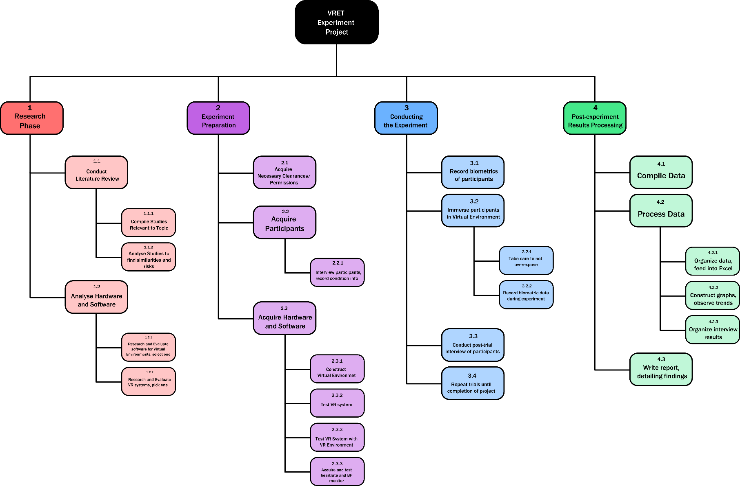

WBS:

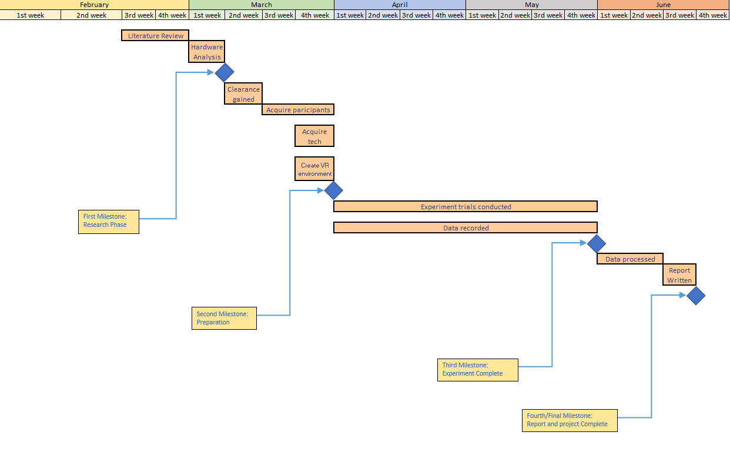GANTT CHART for project, Year 2022: