
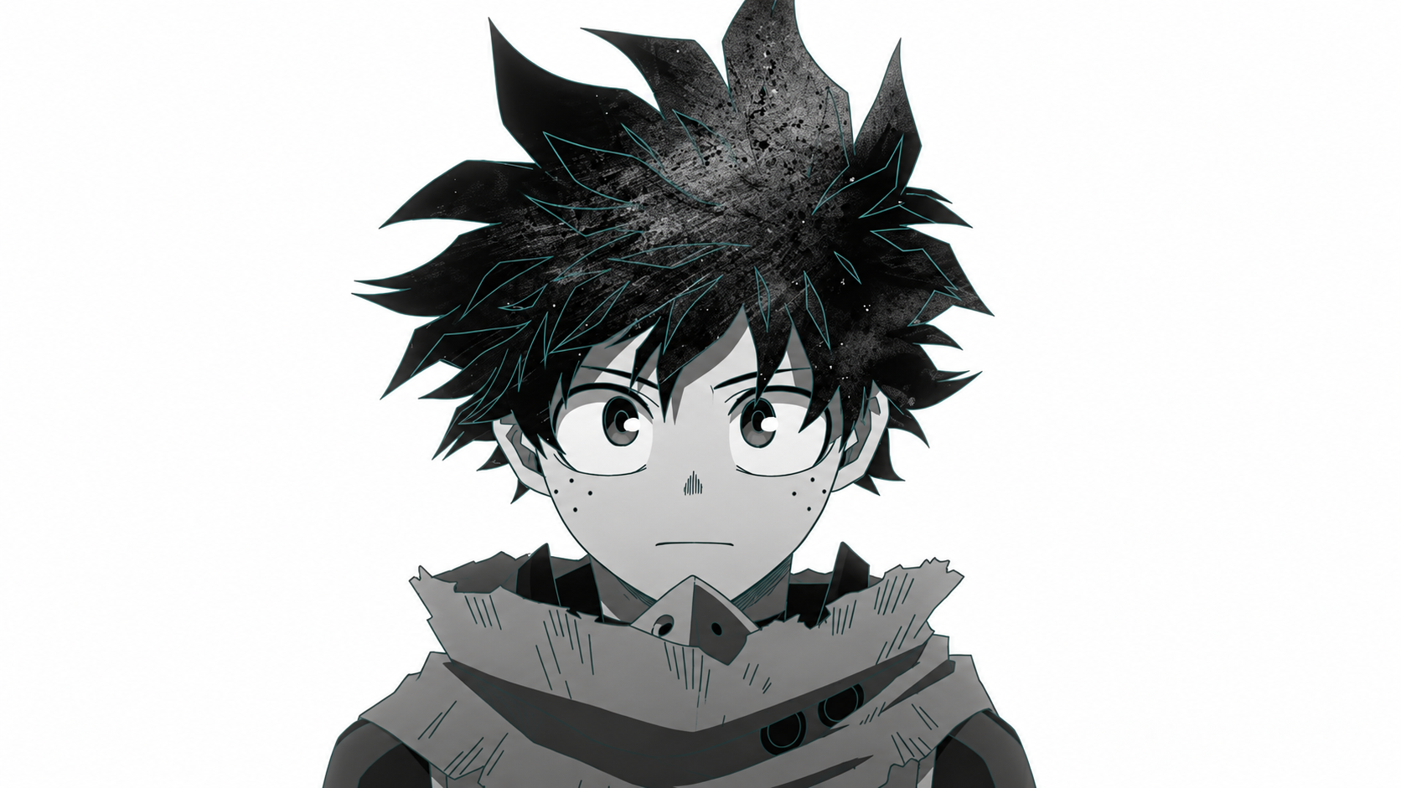
To,
The Head of Department
Sardar Vallabhbhai Institute of Technology
Department of Artificial Intelligence

Date: 6 October 2026

Subject: Request for Leave Permission to Attend College Fest

Respected Sir/Madam,

I am Aarav Mehta, a student of B.Tech, 3rd Semester in the Department of Ar
Artificial Intelligence, bearing Roll Number AI23B047. I am writing to requ
request permission to remain absent from academic activities from 15 Octobe
October 2026 to 17 October 2026 as I will be participating in TechNova 2026
2026, organized by National Institute of Technology Surat.

I will be representing/participating in AI Innovation Challenge as a Partic
Participant. I kindly request you to grant me leave for the aforementioned
period. I assure you that I will complete any academic work, assignments, o
or other responsibilities missed during my absence.

I would be grateful for your consideration and approval of my leave request
request.

Thank you.

Yours sincerely,
Aarav Mehta
AI23B047
B.Tech, 3rd Semester
Department of Artificial Intelligence
98765 43210

