Geometry and Quantum-Chemical Corrections in Predicting Fluoride Ion Affinity
Simin Huang*, Shenqi Zong, and Han Chen
Tanwei College, Tsinghua University, Beijing 100086, China
*Correspondence: hsm24@mails.tsinghua.edu.cn

Abstract
Fluoride ion affinity (FIA) prediction depends on molecular representation, chemical coverage and the computational reference level. We compare fixed-geometry message-passing models, descriptor controls and quantum-assisted refinement on all 48,986 FIA49k molecules, using preserved identities, validation-only selection and a separate ligand-scaffold holdout. The lowest mean test MAE among the geometry-only models is 11.21 kJ mol−1, compared with 12.11 kJ mol−1 from released FIA-GNN predictions, whereas learning the DSD-BLYP–PBEh-3c FIA correction achieves 3.29 kJ mol−1 and 3.35 kJ mol−1 under the scaffold holdout. Matched-ligand corrections and frozen-model geometry-source tests delimit these gains: the refinement requires fluoride-adduct calculations, and increased agreement with computed labels does not establish absolute or base-independent Lewis-acidity accuracy.
Keywords: fluoride ion affinity; Lewis acidity; geometric learning; quantum-chemical correction; chemical generalization; model validation

Introduction
Fluoride ion affinity (FIA), the negative enthalpy change for fluoride binding to a Lewis acid, provides a well-defined target for predicting Lewis acidity toward a hard base. It is useful for comparing potential fluoride acceptors, but does not alone determine catalytic activity, the rate of adduct formation or affinity toward another base. Broad p-block FIA datasets now permit learning across many central elements and coordination environments. [1,2] The practical question is which information a prediction workflow must obtain, and whether its added preparation cost is justified by better accuracy on chemically distinct molecules.
FIA-GNN established connectivity-based prediction on FIA49k. [1] More recent interpretable models for boron acids obtained strong accuracy by restricting the scaffold space and using chemically informed descriptors. [3] Their results motivate targeted chemical analysis, rather than a general inference that a higher-dimensional representation must be superior. Equivariant feature messages, directional message passing and continuous distance filters offer different inductive biases. [4–6] These architectures can be compared empirically, but their rankings do not identify the physical origin of Lewis acidity. In particular, a network built from interatomic distances can encode angular relationships through its multi-atom geometry; a distance-based model is not a distance-only chemical theory.
A second source of information is a less expensive quantum-chemical estimate of the target. Δ-learning treats the discrepancy between approximate and higher-level calculations as the supervised quantity. [7] For FIA, this changes the task substantially: a lower-level FIA already contains information about the free acid and the fluoride adduct. A successful correction model is therefore a refinement tool for an existing quantum workflow, whereas a connectivity model can be used before these calculations are available. These input regimes should be evaluated with separate controls.
Here we examine representation and reference-level effects under an identity-preserving protocol. The study combines repeated geometric-model training, classical controls, a ligand-scaffold holdout, matched-ligand method corrections and a frozen-model test of geometry-source sensitivity. The contribution is this controlled account of when additional inputs help on FIA49k; it is not a new family of graph networks or a new Δ-learning algorithm. We use one optimized structure per molecule. Explicit learning over conformer ensembles is a separate problem with established benchmarks, [8] and is not claimed here.

Computational methods

Endpoint, geometry and partitions
The primary endpoint is fia_gas-DSDBLYP, in kJ mol−1, from FIA49k: RI-DSD-BLYP-D3(BJ)/def2-QZVPP single-point calculations on PBEh-3c geometries with the dataset’s thermochemical and reference conventions. [1,11] Solution-phase FIA is a separate endpoint. Versioned target, geometry and released-prediction archives were obtained from Figshare and their published MD5 checksums verified. [11–13] The coordinate converter accepts only the explicitly requested unbound-acid geometry; it never substitutes an optimized fluoride-adduct structure. It retains all 48,986 molecules, all 22 atomic species and the largest 118-atom molecule. The 13 elements serving as accepting centers are a different count from the atom-type vocabulary.
The primary benchmark retains 32,333 training and 7,001 validation molecules and six published test groups: FIA44k (6,732), CSD (1,200), bimacrocycles (763), four-membered-ring compounds (911), phase-transfer catalysts (15) and additional catalysts (31). No test compound is removed for descriptor failure, atom count or vocabulary mismatch. Exact identifiers, geometries and target arrays are checked before comparing exports. The CSD source also contributes training and validation examples; the CSD test is therefore not a wholly unseen source. The two catalyst groups are case studies with limited sample sizes.
For a separate structural-generalization experiment, the original train, validation and main-test pool of 46,066 molecules is regrouped by ligand structure, excluding the central element from the key. Each cyclic ligand is represented by its generic Bemis–Murcko scaffold; an acyclic ligand uses its generic full graph. The sorted multiset of these ligand representations is hashed with a fixed seed, assigning whole groups to train/validation/test with nominal probabilities 0.70/0.15/0.15. The resulting sizes are 33,460/6,379/6,227 across 12,448 groups. Individual ligands and scaffold components may recur in different combinations; the split holds out complete generic ligand-scaffold multisets, not every individual ligand. Published FIA-GNN predictions are not used as a baseline for this new partition, because their training membership would be incompatible. An exact-ligand-set holdout is also provided in the SI.

Models and input regimes
The released FIA-GNN predictions are rescored by Compound identifier without retraining. [13] New histogram-based gradient-boosting (HGB) controls use central-element identity, oxidation number, period, group, ligand count and denticity. Additional inputs are either RDKit 2D descriptors or six unbound-acid PBEh-3c quantities: Mulliken and Löwdin center charges, dipole magnitude, global electrophilicity, and HOMO/LUMO energies. [14,15] Training-only filtering retains 190 varying RDKit descriptors; all molecular SMILES parse in the recorded environment. Nonfinite descriptors remain missing values handled natively by HGB. All HGB comparisons use 1,000 fitted stages, learning rate 0.05, at most 31 leaves, L2 regularization 1 and no internal validation split; stages 100, 400 and 1,000 are compared using the designated validation set only.
Geometric models use trainable atomic-number embeddings and a 5.0 Å radius graph containing bonded and nonbonded neighbors. Ragged batches contain no padded atoms or artificial padding edges. The reconstructed EGNN feature-message baseline has seven width-128 residual layers using pair features and squared distances; coordinates remain fixed, following the upstream QM9 implementation. [4] A radial-filter model has four width-128 interaction layers, 32 Gaussian radial functions and a cosine cutoff envelope, drawing on continuous-filter constructions. [6] Its sum readout is compared with concatenated accepting-center, mean and sum representations. The accepting center follows the archive’s first-atom convention, with its elemental identity checked for every molecule. This check does not independently resolve equivalent atoms of the same element.
A fresh PyTorch Geometric DimeNet++ reference uses four interaction blocks, width 128, interaction width 64, basis width 8, output width 256, seven spherical and six radial functions. [5] The neighbor cap is raised to 118, avoiding the library’s default 32-neighbor truncation for this dataset. This reimplementation does not reproduce the legacy TensorFlow training schedule or reuse QM9 weights. All neural models use AdamW, normalized L1 loss, initial learning rate 0.001, weight decay 10−6, validation-plateau learning-rate reduction and a maximum of 100 epochs with patience 25. Batch sizes are 64, or 32 for DimeNet++. Seeds 1, 2 and 3 are reported separately. The checkpoint with lowest validation MAE is frozen before test export; its training IDs, normalizer, configuration and dataset fingerprint are saved.
Two additional controls examine information rather than model names. A composition control uses the same radial model on a complete graph with distances set to zero, removing geometry from both edges and messages. An acid-QM fusion model appends a learned encoding of the six acid electronic descriptors and four numerical metadata fields to the geometric readout; median imputation and standardization are fitted on training records alone. A composition-plus-QM control receives identical global descriptors without coordinates. The latter experiments are identified as an exploratory extension. Acquiring PBEh-3c geometries already entails an acid calculation, so the acid-QM fusion is operationally relevant when those calculations are available; it is not a SMILES-only model.

Quantum refinement and analysis
In the separate refinement regime the prediction is FIA_hat(DSD) = FIA(PBEh-3c) + f(x), where f is fitted to FIA(DSD) − FIA(PBEh-3c). The HGB correction receives the lower-level FIA, metadata, RDKit descriptors and the six acid electronic quantities. Controls are raw PBEh-3c FIA, a training-set global mean correction, a training-set center-class mean correction and a metadata-based HGB correction. All models are refitted for the scaffold partition. No DSD-BLYP electronic feature or adduct descriptor is provided to the correction learner; nevertheless, its lower-level FIA requires acid and adduct calculations and carries a higher input cost than the other prediction regimes.
MAE, RMSE, signed error and pooled R2 = 1 − SSE/SST are computed from identical target vectors. For neural models we report mean and standard deviation across three seeds and, separately, the unweighted prediction ensemble. Paired central-class-stratified bootstrap intervals use 2,000 resamples of fixed test predictions. They describe sensitivity to test composition, not prospective coverage or full training uncertainty. Training wall times are recorded on a shared GPU host and do not establish an isolated architecture-speed ranking. All model, partition and feature variants are retained in the machine-readable reports, including unfavorable results.
To probe deployment sensitivity, the frozen radial-center ensemble is also evaluated with la-GFN2xTB structures, preserving molecule identities, atom ordering, targets and partition labels. Radius graphs are recomputed from the alternate geometry, but weights and normalization remain fixed. This is a geometry-source shift, not a conformer-ensemble calculation or an evaluation of an xTB-trained model. Separate paired acid/adduct diagnostics quantify heavy-atom pair-distance changes after checking atom-count and element-order correspondence. These distances are not deformation energies. Matched-ligand comparisons of reference-method corrections use training examples only, averaging repeated records within each ligand-set/center-class cell before pairing.

Results and discussion

Representation effects under independent evaluation
Table 1. Main-test MAE (kJ mol−1; identical 6,732 molecules). Neural values are seed mean ± sample SD; ensembles are listed separately. Input regimes are explicit. FIA-GNN is a released reference, not a matched-budget retraining; HGB controls are fixed-budget comparisons.
Model | Inputs | MAE | Ensemble MAE
Released FIA-GNN | Connectivity | 12.11 | —
HGB metadata | Metadata | 37.57 | —
HGB RDKit | Metadata + 2D | 18.73 | —
HGB acid QM | Metadata + acid QM | 23.02 | —
HGB 2D + acid QM | Metadata + 2D + acid QM | 17.35 | —
composition control | Composition | 28.70 | 28.70
EGNN feature-message baseline | Acid geometry | 12.08 ± 0.16 | 11.04
DimeNet++ | Acid geometry | 11.21 ± 0.27 | 10.29
radial filters with sum readout | Acid geometry | 12.39 ± 0.11 | 11.22
radial filters with center readout | Acid geometry | 12.22 ± 0.17 | 11.15
composition + acid QM | Acid QM + composition | 20.16 | 20.16
geometry + acid QM | Acid geometry + QM | 12.18 ± 0.04 | 11.12
The best geometry-only seed mean in this comparison is 11.21 ± 0.27 kJ mol−1 for DimeNet++. The reconstructed EGNN feature-message baseline gives 12.08 ± 0.16, and DimeNet++ gives 11.21 ± 0.27. These results should be compared with the released FIA-GNN MAE of 12.11 as a reference point, rather than attributed solely to architecture: the published model has its own optimization history. All new models were initialized from scratch under the stated common selection protocol. The older sampled-cohort accuracy figures are excluded; the SI documents their identity and metric audit.
Removing geometric information gives a composition-control MAE of 28.70 kJ mol−1. The center-conditioned and sum radial readouts give 12.22 and 12.39, respectively. Adding acid electronic quantities gives 12.18 ± 0.04, compared with 20.16 for its geometry-free control. These comparisons quantify the utility of complete input pipelines. They do not isolate a unique orbital or steric mechanism, and the composition control is deliberately weaker than a connectivity model. Its failure cannot establish that a modern 2D GNN requires 3D coordinates.
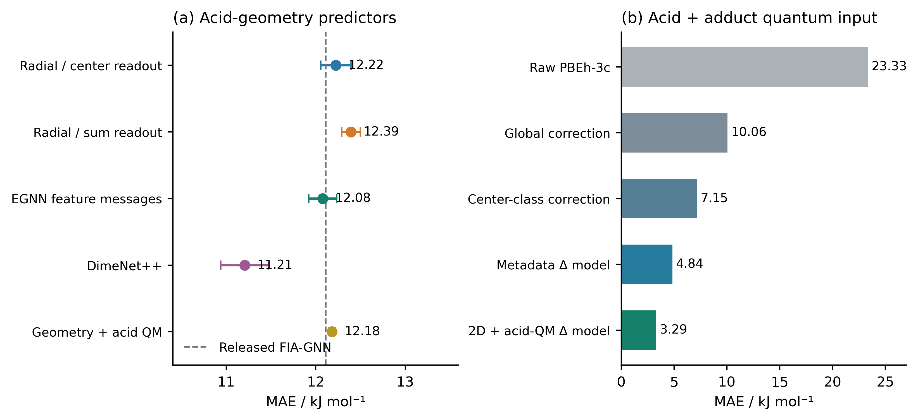
Figure 1. Main-test error by input regime. Left: representation controls with neural seed mean ± SD; the dashed line marks the released FIA-GNN reference. Right: adduct-dependent quantum refinement and its raw and bias-correction controls. Separate panels prevent an equal-cost interpretation of the two regimes.
The external groups expose limits obscured by an aggregate score. The published FIA-GNN MAE rises to 24.08 kJ mol−1 for bimacrocycles and 17.93 for four-membered rings. Figure 2 reports the corresponding new model results without pooling these groups into a single favorable total. Central-class results include sample counts and target variance, because an R2 decrease within a narrow target range need not imply an equally large increase in absolute error. In particular, phosphorus-class discrepancies remain descriptive; neither error rankings nor fixed-geometry feature messages demonstrate a failure to represent lone-pair anisotropy.
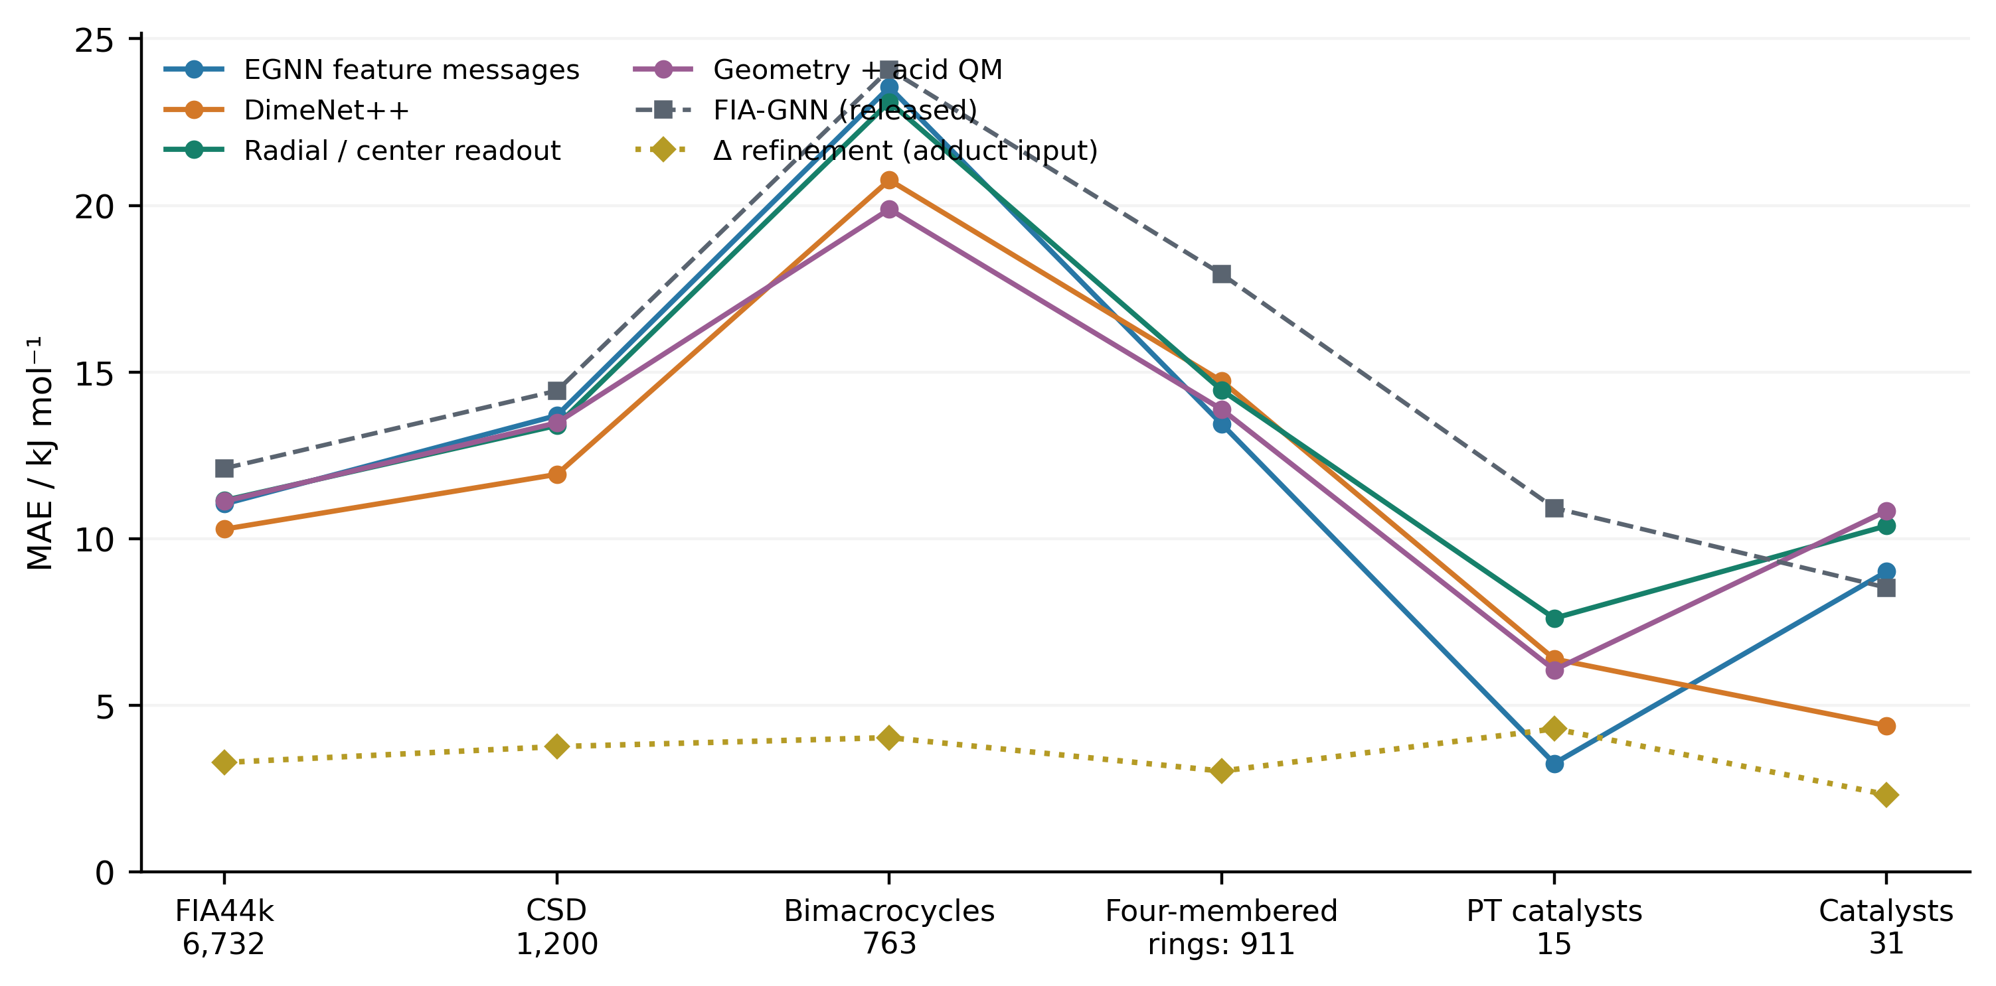
Figure 2. Error across the six published test groups. Geometric and acid-QM curves use unweighted three-seed ensembles; FIA-GNN uses released predictions. The adduct-dependent correction is identified separately. Catalyst groups with 15 and 31 molecules support case studies, not precise population rankings; complete seed and paired-bootstrap results are supplied in the SI.

Learning reference-method corrections
Raw PBEh-3c FIA has main-test MAE 23.33 kJ mol−1 and signed error -23.04, indicating a substantial offset relative to the dataset’s DSD-BLYP target. A training-only global bias correction reduces MAE to 10.06, and class-specific mean corrections reduce it to 7.15. The metadata correction gives 4.84, while the full descriptor correction gives 3.29 with RMSE 4.49 and R2 0.9965. Thus a large part of the apparent difficulty depends on what lower-level information is already available. These gains are measured against appropriate quantum controls; they are not evidence that the refinement is a faster substitute for a connectivity-only screening model.
Table 2. Quantum-refinement MAE (kJ mol−1) across the six official test groups. Every row uses lower-level FIA or corrects it; all correction parameters are fitted on training data.
Control/model | Main | CSD | Bimacro | Ring-4 | PT (15) | Cat. (31)
PBEh3c_raw | 23.33 | 26.73 | 29.76 | 26.64 | 14.19 | 14.63
PBEh3c_global_bias | 10.06 | 10.67 | 11.31 | 10.00 | 9.78 | 9.74
PBEh3c_class_bias | 7.15 | 8.41 | 8.33 | 6.82 | 3.23 | 6.82
delta_metadata | 4.84 | 6.94 | 5.00 | 3.79 | 5.37 | 3.21
delta_RDKit_LA_QM | 3.29 | 3.77 | 4.03 | 3.03 | 4.30 | 2.32
Class dependence is not solely an artifact of comparing unrelated ligand populations. In 34 training ligand sets shared by P(III) and As(III), the mean DSD-BLYP–PBEh-3c correction is 2.66 kJ mol−1 larger for As(III), with a paired ligand-set bootstrap interval of 0.84–4.62. Corresponding differences for 98 Ge(II)/Sn(II) pairs and 103 Sn(II)/Pb(II) pairs are 6.40 and 6.35 kJ mol−1, respectively. These are changes in computational-method discrepancy at matched ligand identity, not isolated measurements of orbital effects or absolute acid strength. The full declared neighboring-center comparison set, including intervals spanning zero, is retained in Figure 3 and the SI.
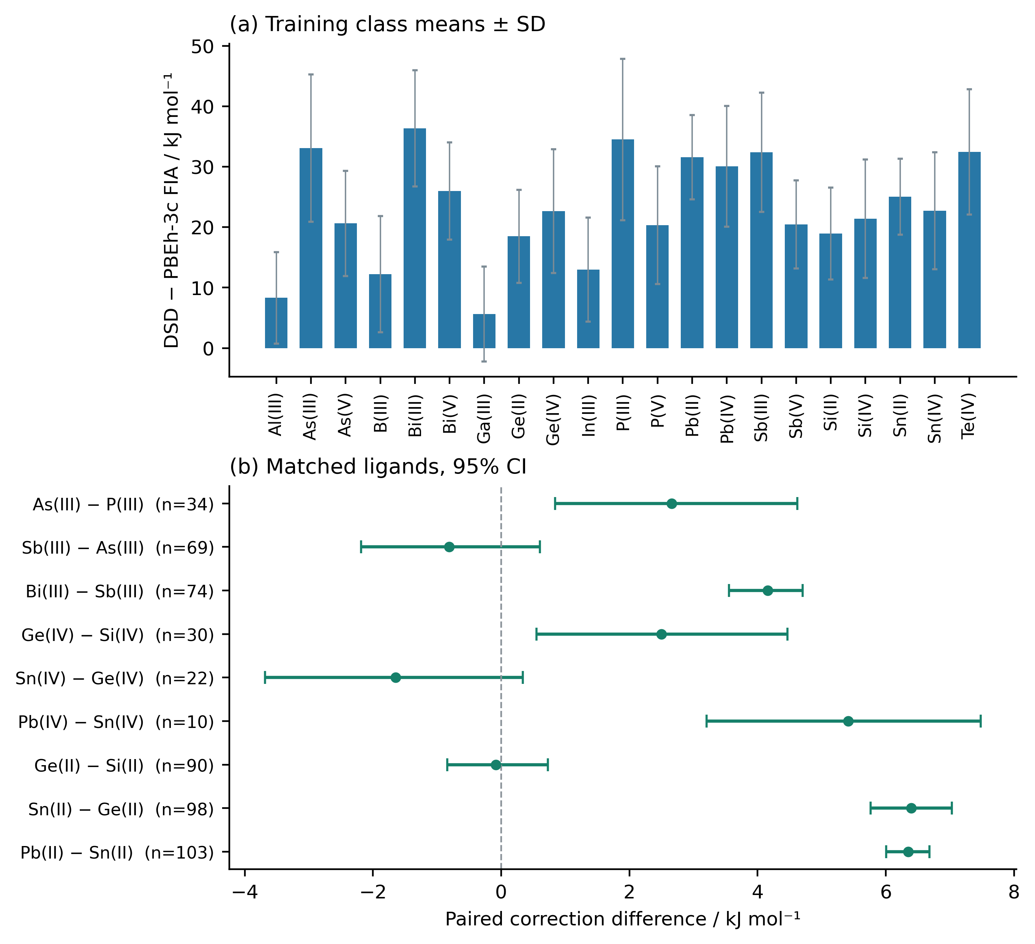
Figure 3. Reference-method corrections in training data. Upper: class means of FIA(DSD-BLYP) − FIA(PBEh-3c), with within-class SD. Lower: mean paired differences between neighboring central elements at identical canonical ligand sets; bars are 95% ligand-set bootstrap intervals. Sample sizes are shown, and all declared comparisons are included.

Structural and geometry-source generalization
On the generic ligand-scaffold multiset holdout, the radial-center model has MAE 12.77 ± 0.13 kJ mol−1; acid-QM fusion gives 12.75 ± 0.03. The independently refitted RDKit control gives 19.10. In the separate quantum-refinement regime, the full correction gives 3.35, versus 7.25 for the class-bias control. This secondary experiment tests transfer across whole generic ligand-scaffold combinations, while maintaining shared individual components and central classes. It does not establish generalization to entirely new elements, every unseen ligand or a new electronic-structure method. Near-neighbor and tautomer relationships are also not eliminated by exact canonical-identity checks alone.
The frozen radial-center ensemble has main-test MAE 11.15 on PBEh-3c structures and 13.02 after substituting xTB structures (Figure 4). The reference labels are unchanged, so this experiment measures sensitivity of a deployed predictor to its input-generation procedure. It does not evaluate equilibrium conformer populations, and the xTB results must not be presented as the achievable accuracy of a separately trained xTB model. Recording and controlling the geometry source is therefore part of model specification, alongside the split and feature normalizer.
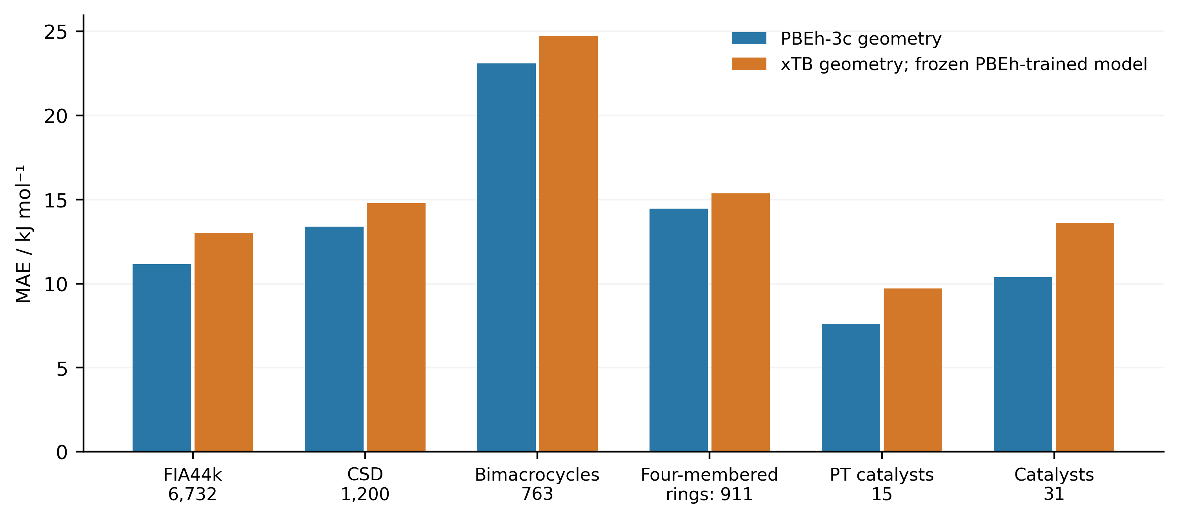
Figure 4. Frozen-model response to a change in geometry source. Blue: radial-center ensemble evaluated on its PBEh-3c input domain. Orange: the same weights evaluated on corresponding GFN2-xTB acid geometries. Molecule IDs, elements, targets and partitions are unchanged. No retraining or conformer pooling is performed.

Chemical scope and limitations
A distorted free acid may bind fluoride differently because of changes in both its internal energy and its interaction with the incoming base. An electronic decomposition would require ΔE_def = E_LA(R_LA in adduct) − E_LA(R_LA free) and ΔE_int = E_adduct(R_adduct) − E_LA(R_LA in adduct) − E_F− at a consistent computational level, plus thermal and reference corrections for an enthalpy. Pair-distance changes or a blocked approach direction cannot substitute for those energies. We therefore describe the original constrained-structure cases as hypotheses and provide their identities, depictions and geometry diagnostics without assigning an uncomputed deformation penalty. Gradient-based coordinate sensitivity, when reported, is a local response of the learned function rather than an additive atomic contribution or causal explanation.
All precision values in this study concern the chosen computational target. A separate FIA benchmark has shown that basis-set diffuseness and anchor-point conventions materially affect calculated FIA accuracy. [9] A surrogate can reproduce systematic reference errors, even when its prediction residual is small. Similarly, recent borane calculations show that relative acid rankings can depend on the probe base. [10] Neither a lower FIA error nor a visually plausible saliency map establishes general catalytic utility. Additional independent reference calculations, explicit conformer sampling and prospective chemical validation would address different limitations from those tested here.

Conclusions
FIA prediction should be assessed with preserved molecular identities, independent selection partitions and explicit input costs. Across the tested geometric models, complete seed and subgroup results provide a more defensible basis for comparison than sampled-cohort accuracy or a universal architecture ranking. The strongest refinement performance comes from learning a reference-level correction when lower-level acid and adduct calculations are available, and remains strong under the declared ligand-scaffold holdout. Matched-ligand discrepancies and geometry-source sensitivity identify actionable limits for deploying these predictors. They support a choice of workflow appropriate to the information already available, while leaving absolute FIA accuracy and broader Lewis-base or catalytic behavior to independent validation.

Supporting Information
Dataset and geometry provenance; split definitions and identity checks; model configurations and seed-level errors; subgroup and paired-bootstrap comparisons; geometry-source robustness; original-cohort audit and chemical-case depictions (PDF). Machine-readable manifests, predictions and frozen checkpoints accompany the reproducibility archive.

Data and software availability
FIA49k targets, geometries and released FIA-GNN predictions are available under CC BY 4.0 at https://doi.org/10.6084/m9.figshare.24635136.v1, https://doi.org/10.6084/m9.figshare.24635157.v1 and https://doi.org/10.6084/m9.figshare.24635187.v1. Preparation, training and analysis code, configurations and machine-readable result tables are available at https://github.com/PeanutUp/Lewis-Acidity-Prediction, revision branch codex/reliable-fia-benchmark. The prepared data can be regenerated from versioned sources with checksum validation. The final publication archive requires an immutable code/data DOI; no DOI for the new revision is asserted here.

Conflicts of interest
The authors will provide their conflict-of-interest declaration before submission.

Acknowledgements
OpenAI Codex assisted with manuscript drafting, source-code inspection, implementation, execution of computational experiments and preparation of analysis scripts during revision. Author review of the scientific interpretation and all generated material is required before submission.

References
[1] L. M. Sigmund, S. Sowndarya S. V., A. Albers, P. Erdmann, R. S. Paton and L. Greb. Predicting Lewis Acidity: Machine Learning the Fluoride Ion Affinity of p-Block-Atom-Based Molecules. Angew. Chem. Int. Ed. 2024, 63, e202401084. https://doi.org/10.1002/anie.202401084.
[2] P. Erdmann, J. Leitner, J. Schwarz and L. Greb. An Extensive Set of Accurate Fluoride Ion Affinities for p-Block Element Lewis Acids and Basic Design Principles for Strong Fluoride Ion Acceptors. ChemPhysChem 2020, 21, 987–994. https://doi.org/10.1002/cphc.202000244.
[3] J. Fenogli, L. Grimaud and R. Vuilleumier. Constructing and explaining machine learning models for the exploration and design of boron-based Lewis acids. Digital Discovery 2025, 4, 3623–3634. https://doi.org/10.1039/D5DD00212E.
[4] V. Garcia Satorras, E. Hoogeboom and M. Welling. E(n) Equivariant Graph Neural Networks. Proceedings of ICML, PMLR 2021, 139, 9323–9332. https://proceedings.mlr.press/v139/satorras21a.html.
[5] J. Gasteiger, S. Giri, J. T. Margraf and S. Günnemann. Fast and Uncertainty-Aware Directional Message Passing for Non-Equilibrium Molecules. arXiv 2020, 2011.14115. https://doi.org/10.48550/arXiv.2011.14115.
[6] K. T. Schütt, P.-J. Kindermans, H. E. Sauceda, S. Chmiela, A. Tkatchenko and K.-R. Müller. SchNet: A continuous-filter convolutional neural network for modeling quantum interactions. Advances in Neural Information Processing Systems 2017, 30. https://papers.nips.cc/paper_files/paper/2017/hash/303ed4c69846ab36c2904d3ba8573050-Abstract.html.
[7] R. Ramakrishnan, P. O. Dral, M. Rupp and O. A. von Lilienfeld. Big Data Meets Quantum Chemistry Approximations: The Δ-Machine Learning Approach. J. Chem. Theory Comput. 2015, 11, 2087–2096. https://doi.org/10.1021/acs.jctc.5b00099.
[8] Y. Zhu, J. Hwang, K. Adams, Z. Liu, B. Nan, B. Stenfors, Y. Du, J. Chauhan, O. Wiest, O. Isayev, C. W. Coley, Y. Sun and W. Wang. Learning Over Molecular Conformer Ensembles: Datasets and Benchmarks. ICLR 2024. https://proceedings.iclr.cc/paper_files/paper/2024/hash/7eb6233e02f7d9efbb84acd839a996fb-Abstract-Conference.html.
[9] M. Lehmann, S. N. Balogun, M. Reimann and M. Kaupp. The Fluoride Ion Affinity Revisited: Do We Need the Anchor-Point Approach? Chem. Eur. J. 2025, 31, e202404662. https://doi.org/10.1002/chem.202404662.
[10] A. Mahdian, K. Laasonen and K. Farshadfar. Quantifying Base-Dependent Lewis Acidity in Substituted Boranes through DFT and Machine Learning. Inorg. Chem. 2026, 65, 25557–25566. https://doi.org/10.1021/acs.inorgchem.6c04676.
[11] L. M. Sigmund. FIA49k.csv.gz. Figshare, version 1, 2024. https://doi.org/10.6084/m9.figshare.24635136.v1.
[12] L. M. Sigmund. FIA49k.zip. Figshare, version 1, 2024. https://doi.org/10.6084/m9.figshare.24635157.v1.
[13] L. M. Sigmund. FIA49k_predictions.csv.gz. Figshare, version 1, 2024. https://doi.org/10.6084/m9.figshare.24635187.v1.
[14] RDKit: Open-source cheminformatics, version 2026.09.2. https://www.rdkit.org/.
[15] F. Pedregosa et al. Scikit-learn: Machine Learning in Python. J. Mach. Learn. Res. 2011, 12, 2825–2830. https://jmlr.org/papers/v12/pedregosa11a.html.

Table of contents graphic
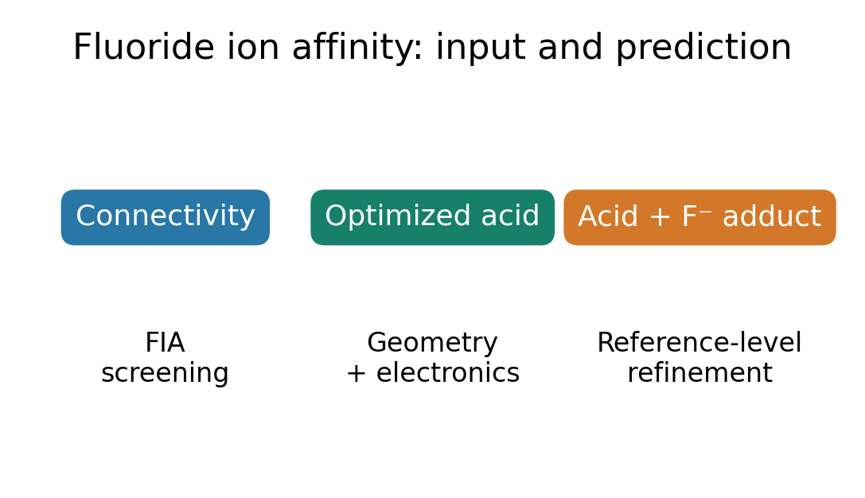
Input availability determines the appropriate FIA prediction workflow.

