Supporting Information
Geometry and Quantum-Chemical Corrections in Predicting Fluoride Ion Affinity
Simin Huang, Shenqi Zong, and Han Chen

S1. Versioned data and complete geometry preparation
File | Figshare file ID | Verified MD5
FIA49k.csv.gz | 43289211 | 76b9018afda2f8b9c776d1555f55180f
FIA49k_predictions.csv.gz | 43289322 | 7f0f55c3e876d34452abd7bbb0c0e657
FIA49k.zip | 43289292 | 60e9ffd7280bdfd6baeb37d6a641f81b
All 48,986 molecules and 1,617,147 atoms are retained; maximum atom count 118. Atomic numbers: 1, 5, 6, 7, 8, 9, 13, 14, 15, 16, 17, 31, 32, 33, 35, 49, 50, 51, 52, 53, 82, 83. SHA256 fingerprints for the source archives and prepared NPZ are in reports/geometry_provenance.json.
Assignment | n
train | 32333
validate | 7001
test | 6732
test_2 | 1200
test_4 | 911
test_3 | 763
test_6 | 31
test_5 | 15
All atom and target arrays are finite, coordinate row counts are exact, unknown atomic symbols raise an error, and Compound identifiers are unique. No fallback from acid to fluoride-adduct geometry is allowed. The first-atom accepting-center convention is checked against central-element identity for every record. Element-sequence agreement cannot alone exclude permutations of chemically equivalent atoms. The original full processed DimeNet NPZ agrees exactly with the new public-data target, coordinate, atom-count and atomic-number arrays; converter defects identified elsewhere in the legacy code are therefore not assumed to have affected that verified NPZ.

S2. Partition definitions and regression checks
Generic ligand-scaffold multiset: {"n_molecules": 46066, "counts": {"train": 33460, "validate": 6379, "test": 6227}, "individual_ligand_overlap": {"validate": 0.8081203950462454, "test": 0.8458326642042717}}
Exact complete ligand set: {"n_molecules": 46066, "counts": {"train": 32184, "test": 6983, "validate": 6899}, "individual_ligand_overlap": {"validate": 0.8109870995796492, "test": 0.8025204067019905}}
Canonical acid identity auditing found zero records crossing partitions under the defined RDKit canonicalization. This does not prove the absence of related ligand families, tautomeric relationships, protonation variants or near-duplicate geometry. The full canonical grouping keys and original/reassigned molecule identities are included in the machine-readable manifests. Generic scaffold keys retain the multiset of ligand scaffolds; an individual scaffold may recur in a different multiset.
The regression suite checks disjoint and reproducible legacy splits; strict prediction identity and target matching; malformed geometries and unknown elements; rotation, translation and permutation invariance; independent batching; exact checkpoint restoration; train-only target normalization; train-only electronic-feature standardization and source fingerprint validation; and deterministic ligand grouping. The validation record accompanies the code. Tests of geometric invariance cover the new invariant models; they are not a proof of physical causality.

S3. Neural configurations and all seed-level main-test results
Run | Parameters | Epochs | Selected | Val MAE | Test MAE | Test RMSE
radial-site-s1 | 378,757 | 86 | 61 | 11.918 | 12.417 | 18.670
radial-site-s2 | 378,757 | 85 | 60 | 11.919 | 12.095 | 18.111
radial-site-s3 | 378,757 | 100 | 97 | 11.844 | 12.161 | 18.491
radial-sum-s1 | 345,989 | 99 | 74 | 11.971 | 12.299 | 18.291
radial-sum-s2 | 345,989 | 87 | 62 | 11.846 | 12.507 | 18.598
radial-sum-s3 | 345,989 | 83 | 58 | 11.873 | 12.373 | 18.716
egnn-sum-s1 | 758,408 | 100 | 83 | 11.944 | 12.255 | 18.883
egnn-sum-s2 | 758,408 | 100 | 99 | 11.699 | 12.013 | 18.285
egnn-sum-s3 | 758,408 | 87 | 62 | 11.720 | 11.965 | 18.524
dimenet-s1 | 1,885,830 | 100 | 94 | 10.496 | 10.993 | 17.010
dimenet-s2 | 1,885,830 | 100 | 83 | 10.834 | 11.506 | 17.732
dimenet-s3 | 1,885,830 | 100 | 99 | 10.583 | 11.119 | 17.276
acid-qm-s1 | 413,061 | 100 | 94 | 11.549 | 12.152 | 18.554
acid-qm-s2 | 413,061 | 93 | 68 | 11.769 | 12.168 | 18.437
acid-qm-s3 | 413,061 | 72 | 47 | 11.759 | 12.222 | 18.804
scaffold-site-s1 | 378,757 | 92 | 67 | 12.558 | 12.630 | 17.886
scaffold-site-s2 | 378,757 | 100 | 98 | 12.407 | 12.790 | 18.182
scaffold-site-s3 | 378,757 | 97 | 72 | 12.520 | 12.893 | 18.380
scaffold-qm-s1 | 413,061 | 53 | 28 | 12.322 | 12.762 | 18.155
scaffold-qm-s2 | 413,061 | 69 | 44 | 12.086 | 12.780 | 18.391
scaffold-qm-s3 | 413,061 | 72 | 47 | 12.213 | 12.713 | 18.180
composition-s1 | 378,757 | 56 | 31 | 28.397 | 28.695 | 39.451
composition-qm-s1 | 413,061 | 64 | 39 | 19.732 | 20.155 | 29.017
Scaffold runs use their separate scaffold test, not the official main test. All errors are kJ/mol. An unweighted ensemble and a seed-average MAE are different estimands and are reported separately. Runtime is observed shared-host epoch wall time, not an isolated speed comparison. CUDA index_add may produce nondeterministic rounding even with fixed RNG seeds. Full configurations, data fingerprints and history logs accompany each checkpoint.

S4. Neural ensemble errors across partitions
Model | Split | n | MAE | RMSE | R2
radial-site | test | 6732 | 11.152 | 17.225 | 0.9481
radial-site | test_2 | 1200 | 13.398 | 18.432 | 0.9215
radial-site | test_3 | 763 | 23.104 | 30.382 | 0.8720
radial-site | test_4 | 911 | 14.454 | 18.618 | 0.9224
radial-site | test_5 | 15 | 7.615 | 9.583 | 0.8962
radial-site | test_6 | 31 | 10.389 | 14.811 | 0.9322
radial-sum | test | 6732 | 11.222 | 17.222 | 0.9481
radial-sum | test_2 | 1200 | 13.942 | 19.534 | 0.9118
radial-sum | test_3 | 763 | 22.876 | 30.245 | 0.8732
radial-sum | test_4 | 911 | 14.143 | 17.939 | 0.9279
radial-sum | test_5 | 15 | 9.017 | 11.378 | 0.8537
radial-sum | test_6 | 31 | 9.364 | 13.233 | 0.9459
egnn-sum | test | 6732 | 11.044 | 17.298 | 0.9477
egnn-sum | test_2 | 1200 | 13.697 | 19.445 | 0.9126
egnn-sum | test_3 | 763 | 23.544 | 31.357 | 0.8637
egnn-sum | test_4 | 911 | 13.438 | 17.616 | 0.9305
egnn-sum | test_5 | 15 | 3.260 | 5.018 | 0.9715
egnn-sum | test_6 | 31 | 9.018 | 12.131 | 0.9545
dimenet | test | 6732 | 10.288 | 16.394 | 0.9530
dimenet | test_2 | 1200 | 11.931 | 16.809 | 0.9347
dimenet | test_3 | 763 | 20.760 | 27.895 | 0.8921
dimenet | test_4 | 911 | 14.726 | 19.261 | 0.9169
dimenet | test_5 | 15 | 6.392 | 7.609 | 0.9346
dimenet | test_6 | 31 | 4.394 | 6.008 | 0.9888
acid-qm | test | 6732 | 11.125 | 17.423 | 0.9469
acid-qm | test_2 | 1200 | 13.478 | 18.347 | 0.9222
acid-qm | test_3 | 763 | 19.887 | 26.055 | 0.9059
acid-qm | test_4 | 911 | 13.877 | 18.294 | 0.9250
acid-qm | test_5 | 15 | 6.067 | 8.828 | 0.9119
acid-qm | test_6 | 31 | 10.836 | 16.921 | 0.9116
scaffold-site | test | 6227 | 11.660 | 16.828 | 0.9446
scaffold-qm | test | 6227 | 11.705 | 17.009 | 0.9434
composition | test | 6732 | 28.695 | 39.451 | 0.7277
composition | test_2 | 1200 | 37.944 | 48.967 | 0.4457
composition | test_3 | 763 | 33.981 | 43.911 | 0.7326
composition | test_4 | 911 | 25.621 | 33.465 | 0.7492
composition | test_5 | 15 | 36.785 | 40.195 | -0.8258
composition | test_6 | 31 | 25.230 | 33.265 | 0.6582
composition-qm | test | 6732 | 20.155 | 29.017 | 0.8527
composition-qm | test_2 | 1200 | 25.481 | 34.479 | 0.7252
composition-qm | test_3 | 763 | 22.842 | 30.332 | 0.8724
composition-qm | test_4 | 911 | 21.049 | 29.001 | 0.8116
composition-qm | test_5 | 15 | 18.522 | 20.596 | 0.5206
composition-qm | test_6 | 31 | 21.827 | 33.458 | 0.6542

S5. Classical baselines and quantum-refinement controls
qm_baseline
Model | Split | n | MAE | RMSE
metadata | test | 6732 | 37.569 | 49.465
metadata | test_2 | 1200 | 51.748 | 62.948
metadata | test_3 | 763 | 54.034 | 63.876
metadata | test_4 | 911 | 39.702 | 48.455
metadata | test_5 | 15 | 42.694 | 47.346
metadata | test_6 | 31 | 81.991 | 92.345
metadata_plus_LA_QM | test | 6732 | 23.020 | 31.939
metadata_plus_LA_QM | test_2 | 1200 | 29.262 | 38.617
metadata_plus_LA_QM | test_3 | 763 | 25.799 | 33.267
metadata_plus_LA_QM | test_4 | 911 | 21.361 | 28.366
metadata_plus_LA_QM | test_5 | 15 | 39.281 | 40.008
metadata_plus_LA_QM | test_6 | 31 | 39.802 | 59.367
rdkit_baseline
Model | Split | n | MAE | RMSE
RDKit2D | test | 6732 | 18.729 | 25.821
RDKit2D | test_2 | 1200 | 23.198 | 30.162
RDKit2D | test_3 | 763 | 24.989 | 33.197
RDKit2D | test_4 | 911 | 21.162 | 28.056
RDKit2D | test_5 | 15 | 27.060 | 31.027
RDKit2D | test_6 | 31 | 9.288 | 12.577
RDKit2D_plus_LA_QM | test | 6732 | 17.347 | 24.176
RDKit2D_plus_LA_QM | test_2 | 1200 | 22.978 | 29.944
RDKit2D_plus_LA_QM | test_3 | 763 | 21.848 | 29.331
RDKit2D_plus_LA_QM | test_4 | 911 | 18.034 | 24.415
RDKit2D_plus_LA_QM | test_5 | 15 | 25.807 | 28.398
RDKit2D_plus_LA_QM | test_6 | 31 | 21.501 | 30.282
refinement
Model | Split | n | MAE | RMSE
PBEh3c_raw | test | 6732 | 23.332 | 26.268
PBEh3c_raw | test_2 | 1200 | 26.732 | 29.532
PBEh3c_raw | test_3 | 763 | 29.759 | 32.182
PBEh3c_raw | test_4 | 911 | 26.639 | 29.333
PBEh3c_raw | test_5 | 15 | 14.195 | 15.127
PBEh3c_raw | test_6 | 31 | 14.635 | 16.728
PBEh3c_global_bias | test | 6732 | 10.062 | 12.616
PBEh3c_global_bias | test_2 | 1200 | 10.674 | 13.322
PBEh3c_global_bias | test_3 | 763 | 11.307 | 14.129
PBEh3c_global_bias | test_4 | 911 | 9.999 | 12.945
PBEh3c_global_bias | test_5 | 15 | 9.783 | 10.195
PBEh3c_global_bias | test_6 | 31 | 9.739 | 11.753
PBEh3c_class_bias | test | 6732 | 7.149 | 9.218
PBEh3c_class_bias | test_2 | 1200 | 8.407 | 10.854
PBEh3c_class_bias | test_3 | 763 | 8.332 | 10.328
PBEh3c_class_bias | test_4 | 911 | 6.821 | 8.748
PBEh3c_class_bias | test_5 | 15 | 3.231 | 5.589
PBEh3c_class_bias | test_6 | 31 | 6.818 | 8.613
delta_metadata | test | 6732 | 4.845 | 6.314
delta_metadata | test_2 | 1200 | 6.938 | 8.734
delta_metadata | test_3 | 763 | 5.000 | 6.492
delta_metadata | test_4 | 911 | 3.789 | 5.026
delta_metadata | test_5 | 15 | 5.371 | 6.428
delta_metadata | test_6 | 31 | 3.208 | 4.080
delta_RDKit_LA_QM | test | 6732 | 3.289 | 4.485
delta_RDKit_LA_QM | test_2 | 1200 | 3.765 | 4.897
delta_RDKit_LA_QM | test_3 | 763 | 4.034 | 5.193
delta_RDKit_LA_QM | test_4 | 911 | 3.030 | 4.092
delta_RDKit_LA_QM | test_5 | 15 | 4.298 | 4.773
delta_RDKit_LA_QM | test_6 | 31 | 2.323 | 2.832
grouped_scaffold
Model | Split | n | MAE | RMSE
RDKit2D | test | 6227 | 19.095 | 26.180
delta_RDKit_LA_QM | test | 6227 | 3.348 | 4.453
The final HGB stage budget is matched across primary, grouped and refinement experiments: stages 100/400/1000 are selected on validation only. Earlier 400-stage pilot controls were superseded and are not mixed into final tables. Every fitted feature list and selection score is saved in the corresponding config.json. The lower-level FIA in refinement is an explicit adduct-dependent input; it is not included in the acid-QM fusion models.

S6. Paired uncertainty and subgroup interpretation
Model | Split | Δ MAE | 95% lower | 95% upper
radial-site | test | -0.960 | -1.194 | -0.729
radial-site | test_2 | -1.041 | -1.731 | -0.365
radial-site | test_3 | -0.977 | -2.054 | 0.116
radial-site | test_4 | -3.480 | -4.289 | -2.663
radial-site | test_5 | -3.308 | -7.129 | 1.392
radial-site | test_6 | 1.858 | 0.886 | 2.855
radial-sum | test | -0.890 | -1.121 | -0.658
radial-sum | test_2 | -0.498 | -1.204 | 0.238
radial-sum | test_3 | -1.204 | -2.321 | -0.087
radial-sum | test_4 | -3.791 | -4.625 | -2.988
radial-sum | test_5 | -1.905 | -5.902 | 3.183
radial-sum | test_6 | 0.834 | -0.379 | 2.031
egnn-sum | test | -1.068 | -1.313 | -0.837
egnn-sum | test_2 | -0.742 | -1.422 | -0.043
egnn-sum | test_3 | -0.537 | -1.718 | 0.590
egnn-sum | test_4 | -4.496 | -5.174 | -3.811
egnn-sum | test_5 | -7.662 | -10.714 | -4.395
egnn-sum | test_6 | 0.487 | -0.808 | 1.733
dimenet | test | -1.824 | -2.060 | -1.592
dimenet | test_2 | -2.509 | -3.196 | -1.808
dimenet | test_3 | -3.321 | -4.509 | -2.179
dimenet | test_4 | -3.208 | -4.241 | -2.252
dimenet | test_5 | -4.531 | -7.537 | -1.209
dimenet | test_6 | -4.136 | -4.971 | -3.299
acid-qm | test | -0.987 | -1.227 | -0.749
acid-qm | test_2 | -0.962 | -1.661 | -0.258
acid-qm | test_3 | -4.193 | -5.474 | -2.938
acid-qm | test_4 | -4.057 | -4.981 | -3.163
acid-qm | test_5 | -4.856 | -8.492 | -0.166
acid-qm | test_6 | 2.305 | 0.978 | 3.573
scaffold-site | test | -7.435 | -7.809 | -7.049
scaffold-qm | test | -7.390 | -7.770 | -7.000
composition | test | 16.583 | 15.952 | 17.190
composition | test_2 | 23.504 | 21.795 | 25.210
composition | test_3 | 9.900 | 8.089 | 11.715
composition | test_4 | 7.687 | 6.420 | 8.983
composition | test_5 | 25.862 | 17.058 | 34.221
composition | test_6 | 16.699 | 14.655 | 18.698
composition-qm | test | 8.043 | 7.611 | 8.483
composition-qm | test_2 | 11.041 | 9.794 | 12.399
composition-qm | test_3 | -1.239 | -2.840 | 0.355
composition-qm | test_4 | 3.115 | 2.087 | 4.131
composition-qm | test_5 | 7.599 | 3.193 | 12.941
composition-qm | test_6 | 13.297 | 11.173 | 15.557
Δ MAE is new-model ensemble error minus reference error; negative values favor the new model. Official-partition reference: released FIA-GNN. Scaffold reference: the independently refitted RDKit HGB baseline. Each bootstrap resample preserves central-class counts and pairs predictions on the same molecules. These intervals condition on the fitted weights. The complete by_class.csv contains per-class n, target variance, MAE, RMSE and R2; small classes and low-variance targets require caution.

S7. Geometry-source and paired-structure diagnostics
Seed | Split | xTB MAE | PBEh MAE | Δ MAE | Mean |Δ prediction|
1 | test | 14.385 | 12.417 | 1.969 | 7.117
1 | test_2 | 16.621 | 14.913 | 1.709 | 6.848
1 | test_3 | 26.005 | 24.738 | 1.267 | 7.876
1 | test_4 | 16.647 | 15.921 | 0.726 | 5.127
1 | test_5 | 11.279 | 8.116 | 3.162 | 3.903
1 | test_6 | 16.706 | 13.330 | 3.376 | 5.282
2 | test | 13.919 | 12.095 | 1.824 | 7.196
2 | test_2 | 16.117 | 14.717 | 1.401 | 6.504
2 | test_3 | 25.641 | 23.918 | 1.724 | 7.571
2 | test_4 | 16.239 | 15.527 | 0.712 | 4.959
2 | test_5 | 10.860 | 8.484 | 2.376 | 3.298
2 | test_6 | 10.419 | 7.835 | 2.583 | 5.942
3 | test | 14.022 | 12.161 | 1.860 | 6.992
3 | test_2 | 16.354 | 14.961 | 1.393 | 6.513
3 | test_3 | 26.121 | 24.795 | 1.326 | 7.639
3 | test_4 | 16.070 | 14.907 | 1.163 | 5.560
3 | test_5 | 8.843 | 8.227 | 0.616 | 2.832
3 | test_6 | 17.693 | 12.877 | 4.816 | 7.212
Paired acid/adduct structure check: N_adduct=N_acid+1; all preceding Z equal; final Z=9; xTB Z equal. Element-sequence equality checks the archive order convention; identical-element atom permutations cannot be excluded by Z alone.
The heavy-atom pair-distance RMS change is sqrt(mean[(d_ij,adduct − d_ij,acid)^2]) over unordered heavy-atom pairs. The 2.7 Å center-shell cutoff is geometric and does not assign covalent bonds. Distances are in Å. The added fluoride is the final atom in the checked archive convention. No new single-point energies, deformation energies or DFT calculations were performed during revision. The full 48,986-row geometry diagnostic export is included in the archive.

S8. Original-run and metric audit
Original export | n | MAE | RMSE | Pooled R2
dimenet_sampled_predictions.xlsx | 2000 | 10.02886 | 15.98951 | 0.95876
egnn_sampled_predictions.xlsx | 2000 | 7.63508 | 15.16637 | 0.96290
Both spreadsheets contain the same 2,000 identities and reproduce the original rounded RMSE values, but their pooled MAE and R2 do not reproduce all printed values. Label differences relative to the full target archive are at most approximately 3.1×10−5 kJ/mol, consistent with float32 export. Under the saved DimeNet configuration (45,000 train, 2,000 validation, seed 42) and verified processed-data ordering, 1,813 of these identities reconstruct as training, 105 as validation and 82 as test. This reconstruction assumes that the saved configuration describes the historical run. The original EGNN training manifest remains unavailable; its membership must not be inferred from the DimeNet reconstruction.
A separate legacy dataset constructor independently sampled train, validation and test partitions. That code path can overlap, but its presence alone does not prove the precise history of a missing checkpoint. Other legacy defects include padding edges, incomplete element conversion and geometry fallback. The corrected runs avoid all these paths and save their identities and normalizers. The upstream QM9 EGNN implementation fixes coordinates, so a physical-relaxation or pseudo-repulsion interpretation is unsupported.

S9. Chemical cases and interpretation limits
Compound | fia_gas-DSDBLYP | fia_solv-DSDBLYP | set_assignment | mol_type | ca_class
B_3_ZT009074 | 68.761 | -123.385 | train | fia44k | B(III)
P_3_ZT017132 | 140.553 | -27.655 | train | fia44k | P(III)
As_3_ZT018788 | 106.538 | -56.124 | train | fia44k | As(III)
As_3_ZT018778 | 406.095 | 164.664 | test | fia44k | As(III)
P_3_B014413 | 252.053 | 65.652 | test | fia44k | P(III)
P_3_B014420 | 243.055 | 72.385 | train | fia44k | P(III)
P_3_B014554 | 210.578 | 10.365 | train | fia44k | P(III)
P_3_ZB016799 | 116.495 | -45.439 | validate | fia44k | P(III)
P_3_ZT026756 | 406.055 | 210.17 | train | fia44k | P(III)
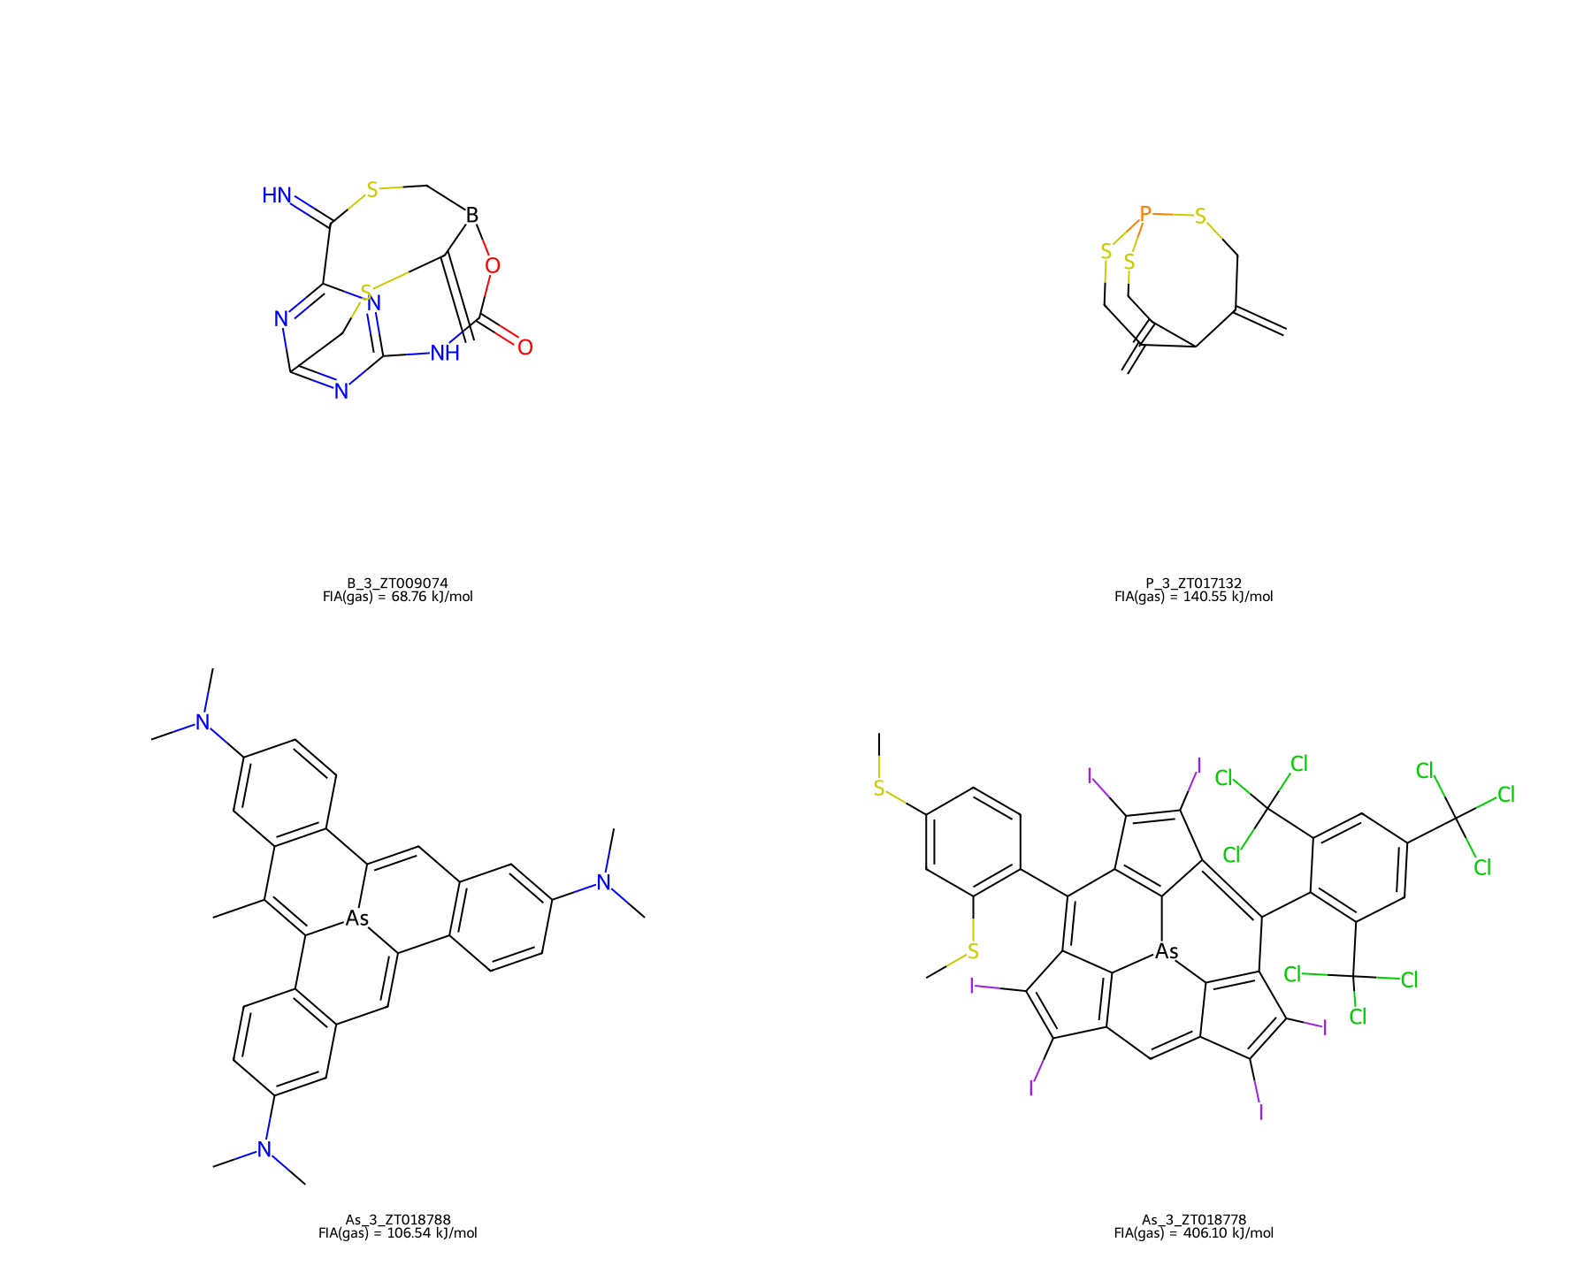
Figure S1. Four original case-study connectivities redrawn from public SMILES on a white background. Dataset membership is given above; these depictions alone do not validate a steric or energetic mechanism.
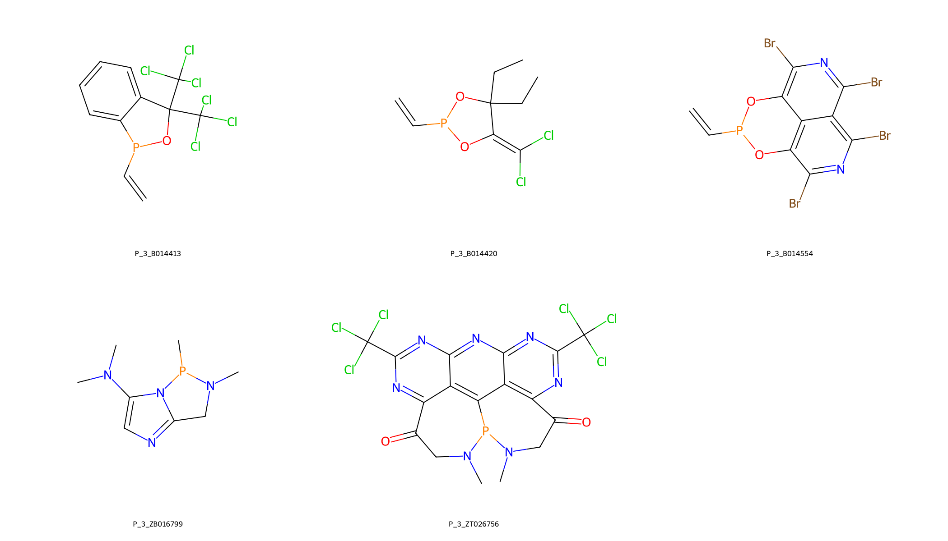
Figure S2. Five original phosphorus-centered cases, redrawn from their released SMILES. The panel illustrates connectivity, not the distribution of a lone pair or a measured deformation energy.
As_3_ZT018778 was underpredicted by 147.46 kJ/mol in the old EGNN case table; describing this as overprediction is incorrect. The old DimeNet entry is missing and must remain missing. As_3_ZT018788 has approximately 15.00/13.81 kJ/mol errors in the old table, not errors above 100. Some original cases belong to official training or validation, so they cannot be presented as independent official-test failures. Local coordinate gradients are derivatives of the learned predictor, in kJ mol−1 Å−1, and are not causal atomic contributions.

S10. Reproduction and provenance
README.md gives the preparation, training, evaluation and analysis commands. reports/experiment_plan.json distinguishes the initial fixed comparisons from exploratory acid-QM and geometry-source extensions. requirements-benchmark.txt and run configurations record the software environment; THIRD_PARTY.md records upstream code commits and licenses. A frozen archive contains split identities, all prediction exports, histories and checkpoints, together with a checksum manifest. The authors must deposit that archive persistently and cite its immutable DOI before publication; no new archive DOI is invented in this draft.

