**IN3046: CLOUD COMPUTING**

**COURSEWORK – SPECIFICATION OF APPLICATION**

Authors:

Saffan Ahmed – 170009150

Yordon Kitov – 170022161

Xiuping Su –

City University London

DR. MARIA KROTSIANI

# Requirements of the Application

The application we are proposing to build, as part of the Cloud Computing module, is a web based notes application. For the cloud aspect we will focus on using Amazon Web Services and more specifically – Simple Storage Service (S3). User will be able to log in, create notes, save them to the cloud, retrieve them, edit and delete them.

# Typical Users

The application is aimed at users who prefer to have constant access to their reminders no matter of which local machine they are using. Thus universal accessibility of the app on multiple computers will be unbounded. This guarantees in the events of data loss through local systems malfunctioning, the user will be able to retrieve their notes from an online database which not only safeguards the data using encryption but also preventing data loss. It is important for the users to have a stable internet connection as well as a machine compatible with hosting the application. This way, users will always be able to access notes and reminders that they have saved. This eliminates the risk of machine failure and losing everything that has been saved locally.

# Implementation

The application will be coded using Amazon Web Services IaaS solution S3, this emphasises focus on using platform as a service (PaaS) cloud infrastructure. The main application will be written in Python that will utilise data storage capabilities from Amazon S3. The Cloud Dataspace service from S3 offers to store and retrieve any amounts of data from anywhere but also supports the universal accessibility of the app mentioned earlier. Users will be able to register, and their details will be saved on the cloud. That way multiple users will be able to use the same application on the same machine without looking at what others are saving.

To access the Amazon servers, we will use *boto3* API that has been provided by Amazon itself. It will allow us to access and manage the S3 buckets based on the logged in user.

Users will be stored in a MySQL database. For this, we will use Amazon RDS (Relational Database Service) which will host our user’s database. And again, using the *boto3* API, we will be able to access and edit the database from the app.

## Graphical Representation of Components

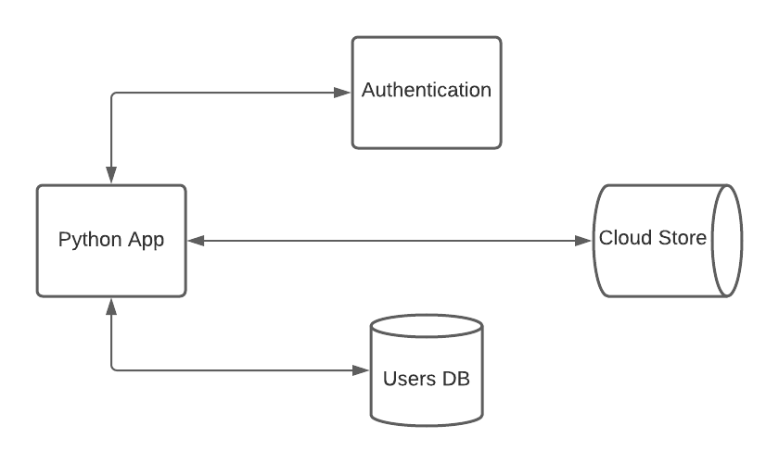

# Distribution of Work

Ensuring each team member has equal contribution towards this project we have divided the workload amongst each team member as follows:

|  |  |
| --- | --- |
| **Team Member** | **Objectives** |
| Ahmed, Saffan | ***Backend Configuration:***   * Cloud Configuration / Database Configuration AWS |
| Kitov, Yordan | ***Backend Configuration:***   * Connection & Interaction with Cloud Store. |
| Su, Xuiping | ***Graphic User Interface (GUI):***   * Visual Interface Design and User Interactions for the program. |