Meshcentral.com

WebRTC
Microstack
Building WebRTC enabled
native applications

Version 0.0.1
Saturday, December 13, 2014
Ylian Saint-Hilaire

Table of Contents
1. Abstract 1
2. Introduction 1
3. Running the C# Sample 2
3.1 Basic Sample Design 2
3.2 Limitations of the Sample 3
4. License 4
5. Conclusion 4

Document Changes

December 13, 2014 – 0.0.1
First version.
- Abstract
This document is a quick overview of the WebRTC Microstack, a data-only (no audio/video) WebRTC stack that is compatible with browsers and can be used by native applications. We review the justification, what is part of this package and based design of the sample application. This is the same WebRTC data stack that is use in the Mesh Agent of Meshcentral. For information on Meshcentral to http://info.meshcentral.com.

The reader should be familiar with the basics of WebRTC to fully appreciate this sample and stack, but running the sample may also help understand how the technology works.

- Introduction
When designing and building Meshcentral.com, we wanted to make use of WebRTC for remote monitoring and control of computers and other devices. WebRTC provides a way to have web application communicate directly with other entities on the network, it has excellent firewall traversal capability and allows our server to scale by reducing the amount of traffic going thru it.

Generally, WebRTC is seen as a browser-to-browser technology, but it does not have to be this way. We can take the data communication part of WebRTC and implement it in native applications. This is exactly what we did with the Mesh agent, we added WebRTC and allowed browsers to communicate directly with background agents running on computers. You could then do remote desktop, remote terminal and file transfers.

In general, making WebRTC available to native application allows pretty much everyone to join in and we can now use WebRTC as a common communication framework for everything on the internet. Servers, computers, IoT devices and web applications.

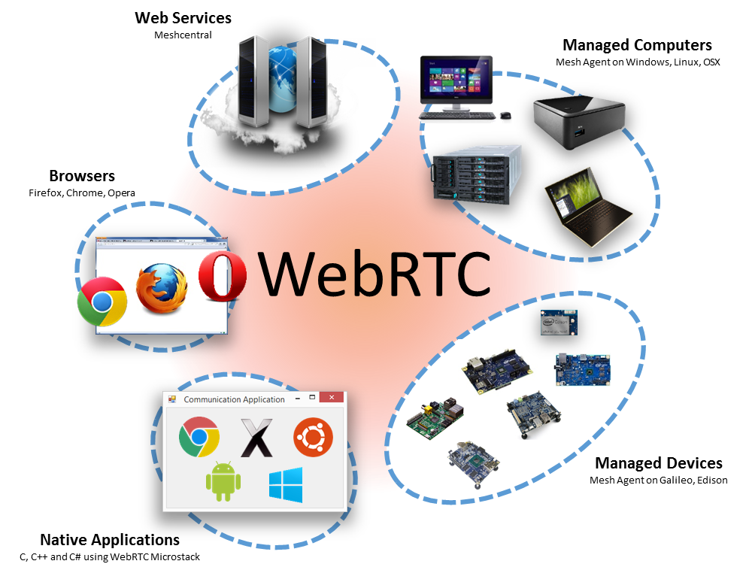

We opted to create a WebRTC stack that is data-only. The audio and video part of WebRTC are very valuable for web applications, but is you’re going to do command and control to other native applications, it’s not needed.

In this package we present a lightweight WebRTC data-only stack with C# bindings and a full C# sample. It should take only a few minutes to run the sample and get a WebRTC session going between a browser and the C# application. After that, you can look at the code and take the parts you need to build your own application and usages.

- Running the C# Sample
In this package, go to “WebRTC Sample/bin/debug” and run “WebRTC Sample.exe”. This is a C# application with a small user interface. The sample has a simple button you can hit “Launch Browser”. This will open a browser and cause a sample WebRTC page to load and get the WebRTC communication started between the web page and the C# application. Here are the steps to running the sample:
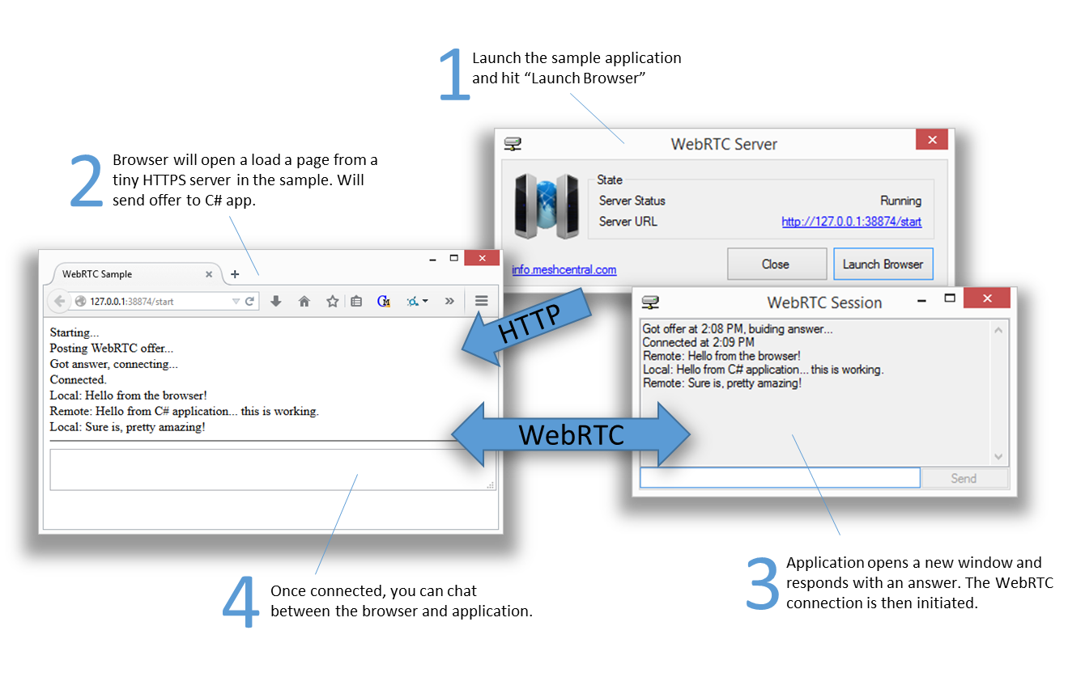
The C# application has a very small HTTP server built-in. This server is not intended to be used by any developers, rather it’s just a minimalize server used to make the sample work. The C# application loads the “webrtcsample.html” page and serves it to the browser. The JavaScript code in the web page will then start running and will make an AJAX query to the tiny web server to send the WebRTC offer and get the answer back. The session will then be established.

Basic Sample Design
In short, the WebRTC stack is built in pure portable C code and compiles on just about any platform (Windows, OSX, Linux…). To make the WebRTC stack work in C#, we wrapped the stack into a DLL and statically linked OpenSSL which is required to provide the security algorithms needed along with dTLS (datagram TLS). The “WebRTC.dll” is pretty big, but it’s mostly all OpenSSL.

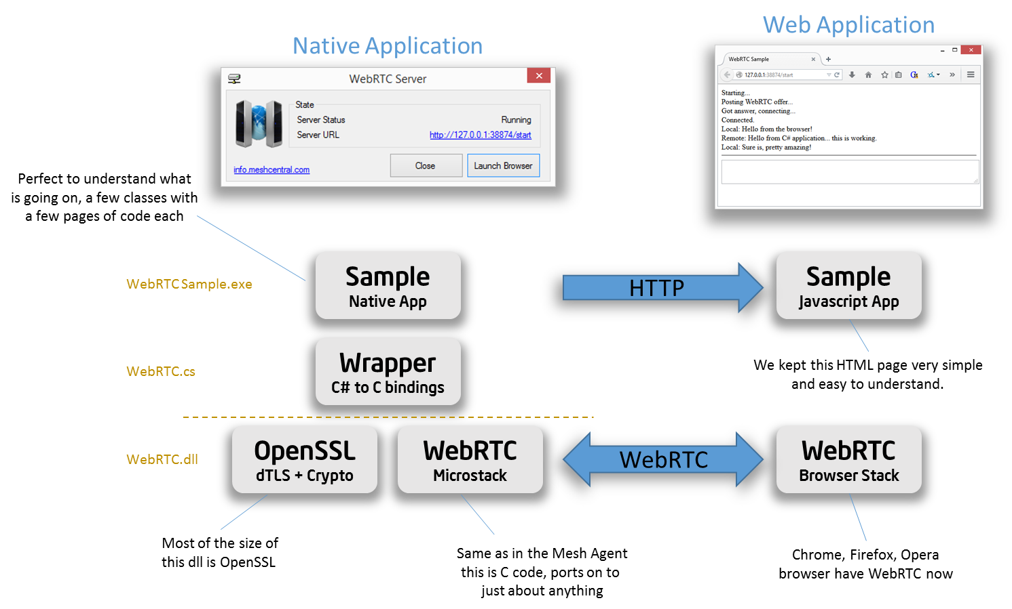

On top of the stack’s DLL, we have WebRTC.cs, the file that does all of the C#-to-C binding. This makes it possible for C# applications to invoke the native C code. Then we have a basic sample that includes a tiny HTTP server and the HTML sample web page we use on the browser side.

To use WebRTC in your own applications, all you need to do is include the WebRTC.cs file in your project, add the line "using OpenSource.WebRTC;" to your code and start using WebRTC C# classes.

Limitations of the Sample
While this sample works, there are a few things that you really should not do in a real product. Probably the first issue is that WebRTC required that the offer and answer be exchanged securely and to the correct authenticated parties. So, using HTTP that is completely unsecured to exchange the offer/answer is really not something you should ever do. The way the exchange of the offer and answer are done is out of scope of WebRTC, but you have to do it in a secure way. So, even if the WebRTC protocol always uses encryption, it’s not going to be of any use of the offer/answer is exchanged insecurely.

Also, WebRTC works by exchanging the offer/answer but also be appending more network interface candidates on both sides as they became available. This sample just makes one exchange of the offer and answer using an HTTP POST and does not send any follow-up additional candidates. In a real product, you really want to do this correctly. For example, you have the browser connect to the server using WebSockets and then exchange the offer and answer, continuing to add candidate on both sides as they are made available. The WebRTC stack we provide supports this, we just kept the sample very simple and did not add this in the C# and JavaScript code.

- License
The entire stack provided in this package and samples are open source under Apache 2.0 license with the exception of OpenSSL that is released under a different license. For details go to http://openssl.org.
- Conclusion
WebRTC is an amazing technology for secure and scalable communication over the Internet. Probably the best thing about it is that it’s built into many browsers and so, makes it possible for web application to have direct two-way text and binary communication with other entities. By making WebRTC data channel also available to native applications, WebRTC truly because a communication framework for anything and everything.

