VEREC
AI-Powered Real-Time Video Recognition
& Security Intelligence Platform

PROJECT BRIEFING
Prepared for Official Review
Pearl Labs · 14 July 2026

Table of Contents
Right-click and choose “Update Field” to build the table of contents.

Executive Summary

VEREC is a real-time video recognition and reasoning platform that turns any camera feed — a local camera, an IP/CCTV stream, or a live URL — into structured, searchable intelligence. It detects and counts objects, recognizes human posture and action, and uses an on-device AI vision model to describe what is happening in plain language, continuously and without a human operator watching every frame.
Beyond live monitoring, VEREC automatically compresses everything it observes into a tagged, timestamped “memory” that can be searched by keyword or asked a direct question — for example, “was a delivery van seen at the gate in the last hour?” — without ever re-processing raw footage. All perception and reasoning models run on self-hosted, local infrastructure, so video and its derived intelligence never have to leave the operator’s own network.
This briefing summarizes the system’s architecture, how it processes video end to end, its core capabilities, the technology it is built on, and how it is deployed — in terms intended for non-technical review.

1. Introduction & Background

Conventional CCTV and camera systems record video but leave the work of watching, understanding, and recalling events entirely to human operators. As the number of cameras grows, so does the amount of footage no one has time to review — and incidents are often noticed only after the fact, if at all.
VEREC was built to close that gap: to give any existing camera the ability to understand what it is seeing, describe it in plain language, and remember it in a form that can be searched or questioned later — turning passive recording into an active, queryable record.

2. Project Objectives

- of live video without requiring an operator to watch every feed at all times.Provide continuous, automated monitoring
- , not just raw pixels — detecting objects, recognizing actions, and captioning scenes as they happen.Make footage understandable in plain language
- that can be searched or questioned after the fact, without re-reviewing hours of recorded video.Build an institutional memory of events
- , running on self-hosted models rather than sending video to third-party cloud services.Keep data and intelligence on-premises
- , from a single low-cost machine to GPU-accelerated, multi-camera installations.Support both light and high-performance deployments

3. Key Capabilities

VEREC combines five capabilities into a single live dashboard:
Capability | What it does
Object Detection | Locates and counts people, vehicles, and other objects in the frame in real time.
Pose & Action Recognition | Tracks human posture and classifies what a person is doing (e.g. walking, loitering, falling).
AI Scene Captioning | An on-device vision-language model writes a plain-language description of the scene as it changes.
Conversational Chat & Reports | An operator can ask questions about the current view, or request an instant written summary.
Intelligent Memory & Search | Events are compressed into a searchable record; operators can search by keyword or ask a direct question about past activity.

4. System Architecture

The system is organized into three layers: video sources feed a central AI engine, which in turn drives a single command dashboard used by operators.
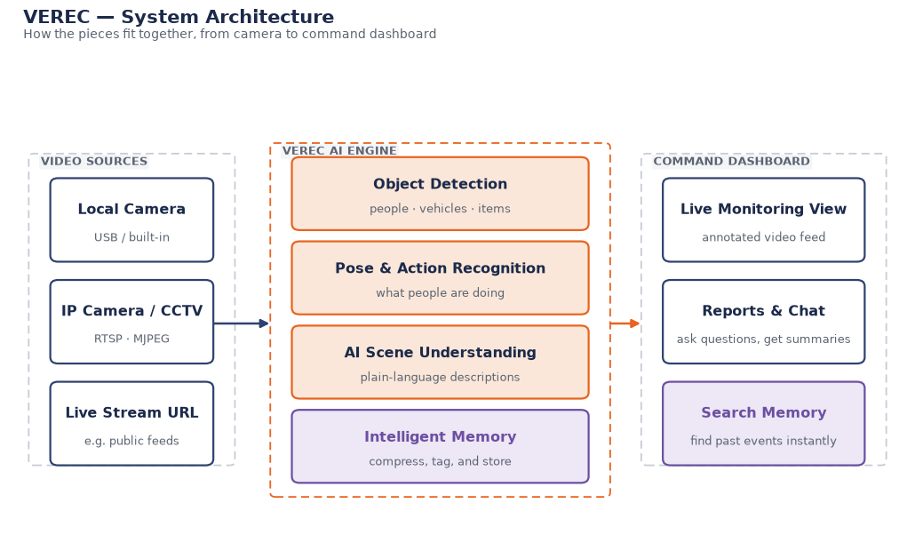
Figure 1. VEREC system architecture, from camera to command dashboard.
Video sources can be a local camera, an IP/CCTV stream (RTSP or MJPEG), or a live stream URL. The VEREC AI engine runs detection, pose and action recognition, scene understanding, and memory compression on every relevant frame. Results are pushed live to the command dashboard, where an operator monitors the feed, reads reports, chats with the system about what it sees, and searches past events.

5. How It Works — Process Flow

Each frame of video moves through the same six-step pipeline, fully automatically:
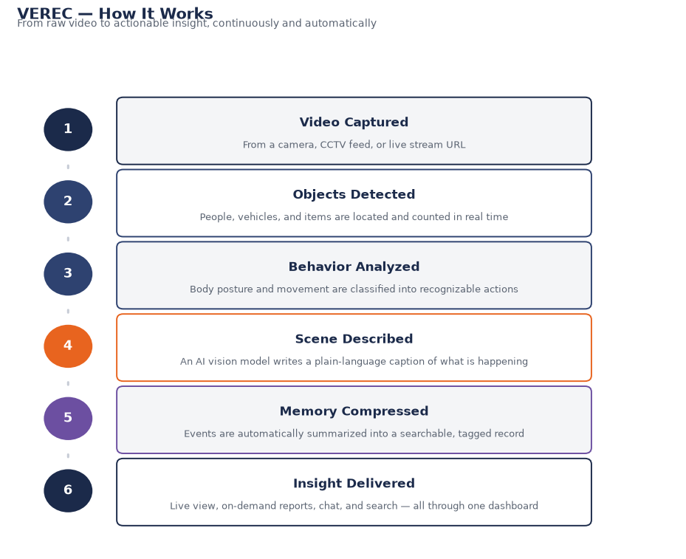
Figure 2. The VEREC processing pipeline, from raw video to actionable insight.
Detection and action recognition run on every frame; scene description runs only when the scene changes meaningfully, keeping the system responsive without wasting computation on a static view. Memory compression happens continuously in the background, so insight is always current.

6. Intelligent Memory & Search

Rather than requiring anyone to re-watch footage to answer a question, VEREC continuously turns what it observes into a compact, searchable record.
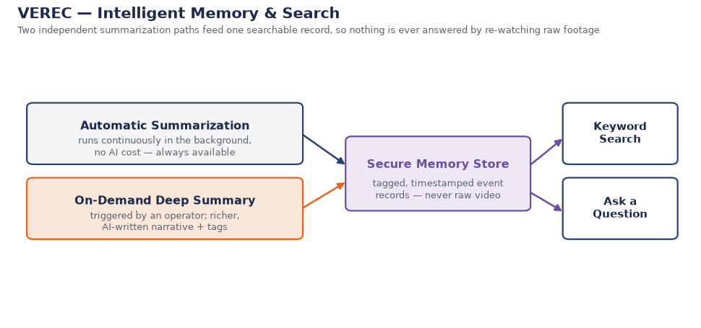
Figure 3. Two summarization paths feed one searchable memory store.
A lightweight automatic summarizer runs at all times, requiring no AI processing and never going offline. For a richer, narrative summary, an operator can trigger an AI-written deep summary on demand. Both feed the same secure memory store — tagged, timestamped event records, never raw video — which can then be searched by keyword or questioned directly in natural language. Answers are grounded strictly in these stored records, so the system reports when it does not have enough information rather than guessing.

7. Technology Stack

Layer | Technology
Dashboard | Web-based interface (Next.js / React) — works in any modern browser, no installation required.
Application Server | Python-based service (FastAPI) coordinating video, models, and storage.
Object Detection | YOLO11 — industry-standard real-time object detector.
Pose & Action Recognition | YOLO Pose + ST-GCN action classifier.
Vision-Language Understanding | Qwen2.5-VL, a multimodal AI model that describes scenes in natural language.
Reasoning & Reporting | Llama 3.2, used for report writing, memory summarization, and question answering.
Model Hosting | Ollama — runs all AI models locally, with no external API calls.

Every model in the stack runs on infrastructure the operator controls. No video frame or derived description is sent to a third-party cloud service at any point in the pipeline.

8. Deployment & Operating Modes

VEREC is packaged as two containerized services — a dashboard and an application server — that can be deployed on a single machine or across a small server cluster, and scaled to the available hardware.
Mode | Best for
Standard (CPU) | Low-cost, single-machine deployments — no specialized hardware required.
Accelerated (GPU) | Higher frame rates and multiple simultaneous camera feeds.
Development | Rapid iteration and on-site configuration during rollout.

9. Benefits & Use Cases

- — continuous, automated situational awareness across sites without a dedicated operator watching every screen.Public safety & security monitoring
- — ask what happened at a given place and time and get a grounded answer in seconds, instead of scrubbing through hours of recording.Incident review & accountability
- — automatic counting and behavior recognition for planning and safety.Traffic & crowd monitoring
- — flag unusual activity (loitering, unexpected presence, new objects) as it happens.Facility & asset protection
- — because every model is self-hosted, footage and derived intelligence remain within the operator’s own infrastructure at all times.Data sovereignty

10. Current Status & Roadmap

VEREC is under active development. The core pipeline — detection, pose and action recognition, scene captioning, conversational chat, reporting, and hierarchical memory search — is implemented and running end to end on live and streamed video.

Planned Next Steps
- with a unified dashboard across sites.Multi-camera support
- for higher throughput at scale.GPU-accelerated deployment profiles
- for multi-user, institutional deployments.Role-based access and audit logging
- for specific event types (e.g. after-hours activity, restricted-area entry).Configurable alerting

11. Conclusion

VEREC turns ordinary camera footage into a continuously updated, understandable, and searchable record — without relying on external cloud services or requiring a human to watch every frame. It is designed to scale from a single-camera pilot to a multi-site deployment, and the architecture described in this briefing is running and demonstrable today.
We welcome the opportunity to present a live demonstration and answer any questions.

