Artificial Intelligence Lab (23CP307P)
Experiment 1

Implementing BFS and DFS

Name: Pearl Kalariya Semester: VI
Roll No.: 23BCP248 Faculty: Davinder Singh
Division: 4 Lab: 1
Branch: Computer Engineering

Aim: WAP to implement DFS and BFS for traversing a graph from source node
(S) to goal node (G), where source node and goal node are given by the user as an input.

DFS:
Code:
def dfs(graph, start, goal):
visited = set()
stack = [(start, [start])]

while stack:
node, path = stack.pop()

if node == goal:
return path

if node not in visited:
visited.add(node)
for neighbor in reversed(graph.get(node, [])):
if neighbor not in visited:
stack.append((neighbor, path + [neighbor]))

return None

graph = {
'A': ['B', 'C'],
'B': ['D', 'E'],
'C': ['F'],
'D': [],
'E': ['F'],
'F': []
}

source = input("Enter source node: ").strip()
goal = input("Enter goal node: ").strip()

path = dfs(graph, source, goal)

if path:
print(f"Path found: {' -> '.join(path)}")
else:
print("No path found")

Output:
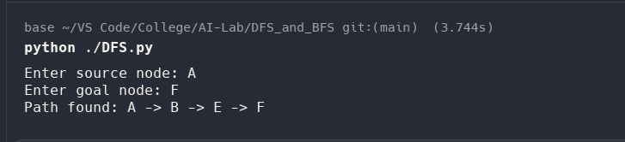

BFS:
Code:
from collections import deque

def bfs(graph, start, goal):
visited = set([start])
queue = deque([(start, [start])])

while queue:
node, path = queue.popleft()

if node == goal:
return path

for neighbor in graph.get(node, []):
if neighbor not in visited:
visited.add(neighbor)
queue.append((neighbor, path + [neighbor]))

return None

graph = {
'A': ['B', 'C'],
'B': ['D', 'E'],
'C': ['F'],
'D': [],
'E': ['F'],
'F': []
}

source = input("Enter source node: ").strip()
goal = input("Enter goal node: ").strip()

path = bfs(graph, source, goal)

if path:
print(f"Path found: {' -> '.join(path)}")
else:
print("No path found")

Output:
