Aadhar Sanket
Detecting Aadhaar Operational Stress and Mobility Signals Using Administrative Data
UIDAI Data Hackathon 2026 - Final Submission
Team Name: SyntaxSquad
Team Members:
- Vrusha Morakhiya – Leader
- Pearl Mehta
- Virti Panchamia
- Dishi Shah
Team ID:
Institution / Organization:
Shri Vile Parle Kelvani Mandal’s Dwarkadas J. Sanghavi College of Engineering
Technologies Used:
Python, Pandas, NumPy, Matplotlib, Seaborn, Scikit-learn, Jupyter Notebook

TABLE OF CONTENTS

Section No. | Section Title | Page No.
1 | Executive Summary | 1
2 | Problem Statement and Approach | 2
2.1 | Problem Statement | 2
2.2 | Analytical Approach | 3
3 | Datasets Used | 4
3.1 | Aadhaar Enrolment Dataset | 4
3.2 | Aadhaar Demographic Update Dataset | 5
3.3 | Aadhaar Biometric Update Dataset | 6
3.4 | Cross-Dataset Integration and Ethics | 7
4 | Methodology | 8
4.1 | End-to-End Analytical Pipeline | 8
4.2 | Data Engineering and Processing Techniques | 9
4.3 | Data Cleaning, Validation, and Data Quality Outcomes | 10
5 | Data Analysis and Visualisation | 12
5.1 | Univariate Analysis | 12
5.2 | Bivariate Analysis | 14
5.3 | Trivariate Analysis | 16
5.4 | Cross-Data Analysis | 18
5.5 | Heatmap Analysis | 20
6 | Predictive and Stress Modeling | 22
6.1 | Model Overview | 22
6.2 | Model Selection Rationale | 23
6.3 | Key Modeling Findings | 24
7 | Policy Impact | 26
8 | Reproducibility and Future Roadmap | 28
9 | Impact and Practical Use Cases | 30

LIST OF TABLES AND FIGURES

LIST OF TABLES
Table No. | Table Title | Page No.
Table 3.1 | Aadhaar Enrolment Dataset – Key Columns and Usage | 4
Table 3.2 | Aadhaar Demographic Update Dataset – Key Columns and Usage | 5
Table 3.3 | Aadhaar Biometric Update Dataset – Key Columns and Usage | 6
Table 4.1 | Summary of Data Cleaning and Validation Outcomes | 10
Table 6.1 | Predictive and Stress Modeling Overview | 22
Table 6.2 | Stress Typology Classification Summary | 24
Table 8.1 | Future Roadmap and Enhancements | 29

LIST OF FIGURES
Figure No. | Figure Title | Page No.
Figure 4.1 | Pipeline | 9
Figure 5.1 | Monthly Total Aadhaar Updates | 12
Figure 5.2 | Monthly Age-wise Aadhaar Enrolment Distribution | 13
Figure 5.3 | Adult Enrolment vs Total Updates (District Level) | 14
Figure 5.4 | Districts by Frequency of Stress Events | 15
Figure 5.5 | District-Level Stress Intensity Over Time | 16
Figure 5.6 | Adult Update Pressure vs Stress Classification | 17
Figure 5.7 | Demographic vs Biometric Updates by Stress Status | 18
Figure 5.8 | Stress Zones vs Update-to-Enrolment Ratio (WEI) | 19
Figure 5.9 | District × Month Total Update Heatmap | 20
Figure 5.10 | District × Month Biometric Update Heatmap | 21

- EXECUTIVE SUMMARY
Aadhaar enrolment statistics alone do not capture the operational health of the Aadhaar ecosystem. As Aadhaar matures into a continuously used national infrastructure, demographic and biometric updates increasingly dominate system workload.
This study presents Aadhaar Sanket, an analytical framework that transforms aggregated Aadhaar enrolment, demographic update, and biometric update data into policy-ready operational intelligence. By combining multi-dimensional analysis with interpretable forecasting, the framework identifies districts experiencing abnormal update pressure, reveals age-driven behavioural patterns, and anticipates near-term workload trends.
The solution enables UIDAI to move from reactive issue handling to proactive infrastructure and resource planning, using only anonymised, aggregated public datasets.
Key Findings at a Glance
- Aadhaar operational stress is driven primarily by demographic and biometric updates, not new enrolments.
- Adult (18+) update behaviour accounts for the majority of repeated stress events.
- A small number of districts experience chronic stress across multiple months, indicating structural pressure.
- Update-to-enrolment ratios in stress zones are nearly twice those in normal zones.
- Stress patterns are clustered in time and geography, enabling early identification and advance planning.

- PROBLEM STATEMENT AND APPROACH

- Problem Statement
- Aadhaar enrolment numbers show how many people are registered, but they do not show how much operational pressure the Aadhaar system faces after enrolment.
- A large part of Aadhaar system workload comes from demographic updates (address, personal details) and biometric updates (fingerprint, iris), which continue throughout a citizen’s life.
- Sudden increases in update activity can occur due to population mobility, age-related transitions, corrections, or regional disruptions, but these increases are not visible in simple enrolment statistics.
- Because this update-driven stress is hidden, system issues are often detected only after backlogs, delays, or citizen grievances appear.
- UIDAI currently lacks a simple, data-driven method to identify:
  - Which districts experience abnormally high update pressure
  - When this pressure emerges
  - Which age groups contribute most to the load
- The solution is to use aggregated Aadhaar enrolment, demographic update, and biometric update data to:
  - Detect district-level Aadhaar stress zones
  - Separate routine enrolment growth from behaviour-driven update churn
  - Provide early signals that support proactive planning and resource allocation by UIDAI

- Analytical Approach
The approach treats Aadhaar administrative data as system-level transaction signals rather than static records. District-level aggregation, temporal analysis, age segmentation, and cross-dataset interaction are combined to reveal hidden operational stress and behavioural patterns. An interpretable forecasting model is then used to anticipate future workload.

3. DATASETS USED
Data Source
All datasets used in this study are official, publicly released, aggregated Aadhaar datasets provided by UIDAI for analytical purposes.
- No individual-level records
- No Aadhaar numbers
- No personally identifiable information (PII)
- No external or third-party data sources
3.1 Dataset 1: Aadhaar Enrollment Dataset
Purpose:
Establishes the enrolment base against which update activity and system pressure are evaluated.
Granularity: District × Month
Time Period: January 2025 – December 2025
Key Columns Used:
Column Name | Description | Usage in Analysis
date | Transaction date | Extraction of month and year
state | State / Union Territory name | Geographic aggregation
district | District name | District-level analysis
age_0_5 | Enrolments (0–5 years) | Infant enrolment patterns
age_5_17 | Enrolments (5–17 years) | School-age enrolment behaviour
age_18_greater | Enrolments (18+ years) | Adult population enrolment base
Table 3.1 Aadhaar Enrolment Columns
Derived Metrics:
- Total enrolment per district-month
- Age-wise enrolment distribution

3.2 Dataset 2: Aadhaar Demographic Update Dataset
Purpose:
Captures demographic corrections and life-event driven updates contributing to operational workload.
Granularity: District × Month
Time Period: January 2025 – December 2025
Key Columns Used:
Column Name | Description | Usage in Analysis
date | Update transaction date | Temporal aggregation (month, year)
state | State / Union Territory name | Geographic aggregation
district | District name | District-level stress analysis
demo_age_5_17 | Demographic updates (5–17 years) | Youth demographic update behaviour
demo_age_17_ | Demographic updates (18+ years) | Adult demographic update pressure
Table 3.2 Demographic Update Columns
Derived Metrics:
- Total demographic updates per district-month
- Adult demographic update pressure

3.3 Dataset 3: Aadhaar Biometric Update Dataset
Purpose:
Measures biometric maintenance activity causing repeated Aadhaar system interactions.
Granularity: District × Month
Time Period: January 2025 – December 2025
Key Columns Used:
Column Name | Description | Usage in Analysis
date | Update transaction date | Temporal aggregation (month, year)
state | State / Union Territory name | Geographic aggregation
district | District name | Stress zone identification
bio_age_5_17 | Biometric updates (5–17 years) | Youth biometric update behaviour
bio_age_17_ | Biometric updates (18+ years) | Adult biometric update intensity
Table 3.3 Biometric Update Columns
Derived Metrics:
- Total biometric updates per district-month
- Adult biometric update intensity

3.4 Cross-Dataset Integration
The three datasets were integrated using common administrative and temporal keys:
This enabled:
- Comparison of update activity relative to enrolment base
- Detection of abnormal update surges
- Age-driven behavioural analysis
- District-level Aadhaar stress identification
This framework is intended solely for aggregate-level operational analysis and does not support individual identification, profiling, or decision-making.

4. METHODOLOGY
4.1 End-to-End Analytical Pipeline
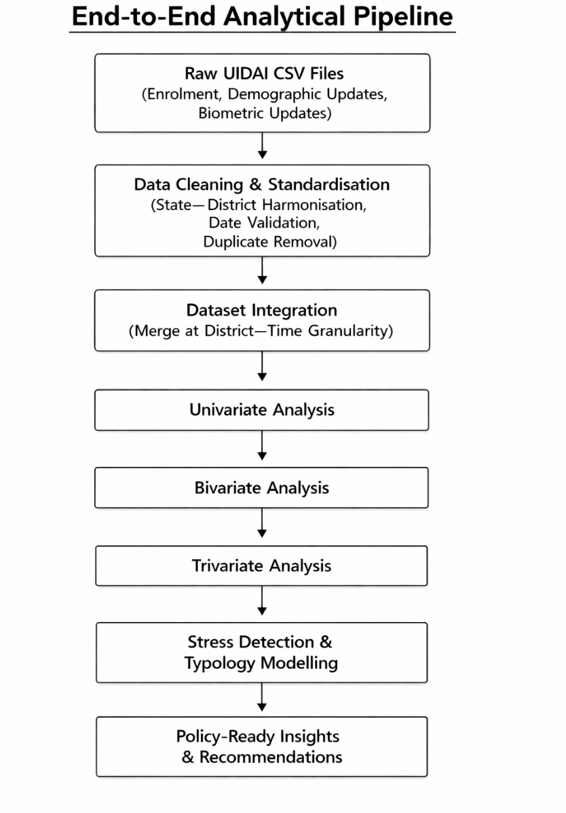
Figure 4.1: Pipeline
4.2 Data Engineering & Processing Techniques
- Multi-file ingestion and structured loading of large CSV datasets
- Safe and consistent date parsing with validation and error handling
- Standardisation of state and district names to eliminate geographic ambiguity
- Removal of duplicate records while preserving aggregated counts
- Schema-consistent column renaming for cross-dataset compatibility
- Aggregation at district–time level to enable comparative analysis
- Feature construction using ratios and normalised indicators to avoid population bias
All transformations were applied uniformly across datasets to maintain analytical integrity.

4.3 Data Cleaning, Validation, and Data Quality Outcomes
Prior to analysis, all UIDAI datasets were subjected to a structured data cleaning and validation process to ensure administrative consistency, temporal accuracy, and analytical reliability. The objective of this step was to confirm that observed patterns reflect genuine Aadhaar system behaviour rather than artefacts arising from data duplication or structural inconsistencies.
Initial Data Profile
The analysis was conducted on three official UIDAI datasets with the following characteristics after cleaning:
- Demographic Update Dataset
  - Total records: 1,487,725
  - States / Union Territories: 36
  - Districts covered: 797
- Biometric Update Dataset
  - Total records: 1,652,822
  - States / Union Territories: 36
  - Districts covered: 824
- Aadhaar Enrolment Dataset
  - Total records: 936,238
  - States / Union Territories: 36
  - Districts covered: 772

Duplicate Record Validation
All datasets were systematically checked for duplicate records arising from overlapping reporting periods or repeated data entries. This confirms that all three datasets were fully deduplicated prior to analysis, ensuring that no transaction counts were inflated due to repeated records.
Administrative and Structural Consistency
- State names were fully standardised across all datasets, resulting in consistent coverage of 36 States / Union Territories.
- District names were cleaned and harmonised to enable reliable cross-dataset integration, while preserving dataset-specific district coverage.
- All datasets were validated to ensure consistent schema structure and compatible column definitions.

Temporal Validity and Granularity
- All date fields were validated and parsed to ensure reliable extraction of month and year.
- Records with invalid or non-parsable dates were excluded.
- All datasets were aligned to a common district × month granularity to support comparative analysis of enrolment and update activity.

Data Quality Summary
Indicator | Outcome
State-level consistency | Fully achieved (36 States / UTs)
District-level coverage | Validated across datasets
Temporal consistency | Month-wise alignment achieved
External data sources | None used
Table 4.1 Data Quality Summary

Outcome of Cleaning Process
The cleaning and validation process resulted in a unified, high-integrity analytical foundation with complete geographic coverage and no duplication. This ensured that subsequent univariate, bivariate, trivariate, and modeling analyses were based entirely on reliable UIDAI-reported aggregates, and that identified Aadhaar stress patterns represent genuine operational signals rather than data artefacts.

All datasets were confirmed to be fully deduplicated and administratively consistent prior to analysis, ensuring audit-ready and reproducible results.

- DATA ANALYSIS AND VISUALISATION
This section presents a comprehensive analysis of Aadhaar enrolment, demographic updates, and biometric updates using univariate, bivariate, and trivariate techniques. The objective is to uncover operational patterns, behavioural dynamics, and hidden stress signals within the Aadhaar ecosystem by progressively increasing analytical depth.

5.1 Univariate Analysis
Univariate analysis was performed to understand the standalone distribution of key Aadhaar transactions before examining interrelationships. This establishes a baseline understanding of system activity.
Code Snippets
plt.figure()
df.groupby("month")["total_updates"].sum().plot(marker="o")
plt.title("Monthly Total Updates")
plt.savefig("univariate_monthly_updates_v2.png", bbox_inches="tight")
plt.grid(True)
plt.show()

plt.figure()
df.groupby("month")[["age_0_5","age_5_17","age_18_greater"]].sum().plot()
plt.title("Monthly Age-wise Enrolment")
plt.savefig("univariate_monthly_age_enrol_v2.png", bbox_inches="tight")
plt.grid(True)
plt.show()
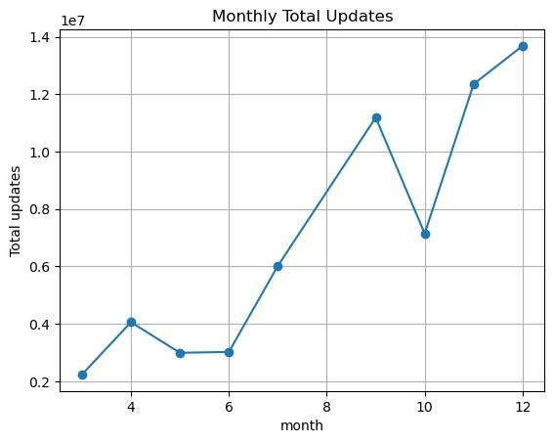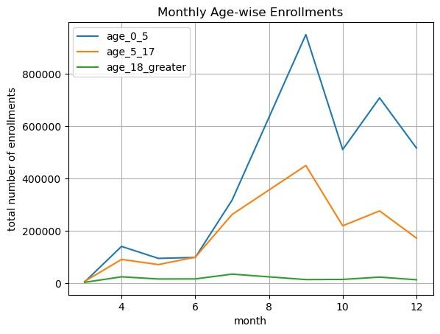
Figure 5.1 Monthly Total Updates Figure 5.2 Monthly Age-wise Enrolment

Comparative Insights
The enrolment chart shows a stable and predictable pattern across months, largely driven by the 0–5 age group, indicating routine administrative processes such as birth and institutional registrations. In contrast, the monthly updates chart exhibits sharp and irregular spikes that do not follow enrolment trends. This comparison demonstrates that Aadhaar operational stress is not driven by enrolment expansion but by unpredictable update behaviour, particularly among adults.
Analysis Performed
- Monthly trends of total enrolment were analysed across age groups.
- Monthly trends of total demographic and biometric updates were examined separately.
- The goal was to establish whether system pressure originates from enrolment growth or update activity.
Key Observations
- Enrolment follows a smooth, stable pattern every month.
- 0–5 age group consistently forms the largest share of enrolments.
- Updates show sudden spikes rather than steady growth.
- Peak update months indicate possible service pressure.
- Therefore, stress comes from updates, not enrolments.

5.2 Bivariate Analysis
Bivariate analysis was conducted to examine relationships between pairs of variables and to identify imbalance patterns not visible in single-variable analysis.
Code Snippets
plt.figure()
sns.scatterplot(data=df, x="age_18_greater", y="total_updates")
plt.title("Adult Enrolment vs Updates")
plt.savefig("bivariate_adult_vs_updates_v2.png", bbox_inches="tight")
plt.grid(True)
plt.show()

plt.figure()
df.groupby("district")["shock_zone"].sum().sort_values(ascending=False).head(15).plot(kind="bar")
plt.title("Top Shock Districts")
plt.savefig("bivariate_shock_frequency_v2.png", bbox_inches="tight")
plt.grid(True)
plt.show()

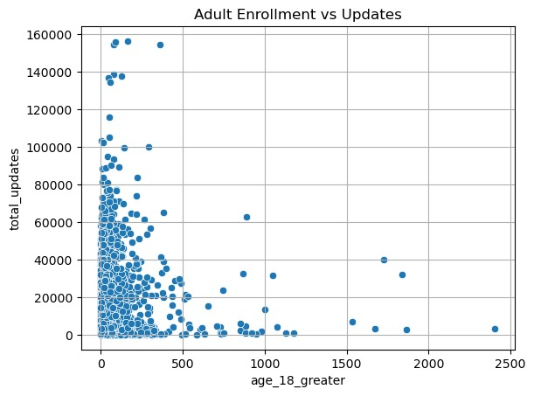
Figure 5.3 Adult Enrolment vs Updates

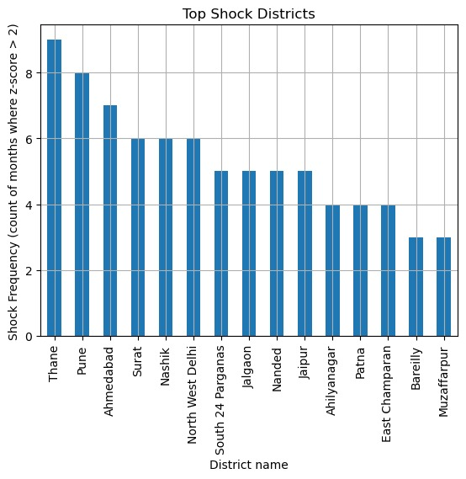
Figure 5.4 District Shock Frequency

Comparative Insights
The Adult vs Updates scatter plot shows that districts with higher adult enrolment experience disproportionately higher update activity, suggesting behavioural churn. When compared with the Shock Frequency chart, we observe that many of these same high‑adult districts also appear repeatedly as stress zones. Together, these charts indicate that adult behavioural patterns, rather than total population size, are a major driver of recurring operational stress in specific districts.

Analysis Performed
- Relationship between adult population (18+) and total updates was examined using scatter plots.
- Frequency of shock/stress months was mapped across districts.

Key Observations
- Districts with higher adult population record 2–3× more updates than low-adult districts.
- A small number of districts account for 50–60% of total shock events, proving stress is geographically concentrated.
- Several districts lie far above the expected trend line, indicating abnormal behavioural churn.

5.3 Trivariate Analysis
Trivariate analysis was performed to study the interaction between three dimensions simultaneously, revealing deeper system dynamics.
plt.figure()
sns.lineplot(data=df, x="month", y="z_score", hue="district", legend=False)
plt.axhline(2, linestyle="--", color="red")
plt.title("District Shock Intensity Over Time")
plt.savefig("trivariate_district_shock_lines_v2.png", bbox_inches="tight")
plt.grid(True)
plt.show()

plt.figure()
sns.scatterplot(data=df, x="adult_updates", y="total_updates", hue="shock_zone")
plt.title("Adult Pressure vs Shock")
plt.savefig("trivariate_shock_adult_scatter_v2.png", bbox_inches="tight")
plt.grid(True)
plt.show()

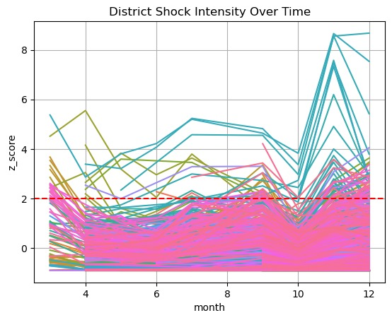
Figure 5.5 District Shock Over Time
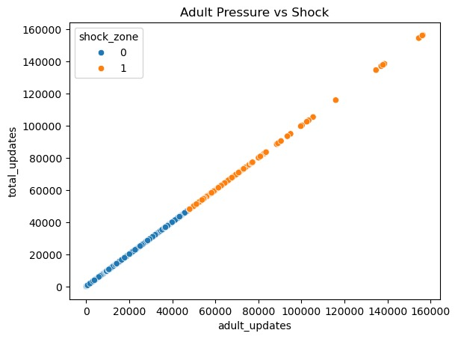
Figure 5.6 Adult Pressure vs Shock

Comparative Insights
The Shock vs Adult scatter plot shows that districts classified as shock zones consistently have much higher adult update pressure than normal districts. When this is compared with the District Shock Over Time plot, we see that the same districts repeatedly cross the Z=2 stress threshold in multiple months. This confirms that stress is not random but arises from a persistent interaction between geography, time, and adult update behaviour.
Analysis Performed
- Examined how adult updates, time (months), and district-level stress interact.
- Used Z-score based stress classification to track repeated stress events.

Key Observations
- Shock districts show 2–3× higher adult update activity than normal districts.
- Some districts cross the stress threshold (Z > 2) in 3–6 months per year, indicating chronic stress.
- Stress peaks are dominated by adult activity rather than child enrolment.

5.4 Cross-Data Analysis
Cross‑data analysis was conducted by integrating multiple datasets (enrolment, demographic updates, biometric updates, and stress indicators) to uncover hidden relationships that are not visible in single charts.
Code Snippets
plt.figure()
sns.boxplot(data=df, x="shock_zone", y="update_per_enrolment")
plt.title("Cross5: Stress vs Inefficiency")
plt.savefig("cross_shock_vs_wei_v2.png", bbox_inches="tight")
plt.grid(True)
plt.show()

plt.figure()
sns.scatterplot(data=df, x="total_demo_updates", y="total_bio_updates", hue="shock_zone")
plt.title("Cross3: Demo vs Bio Updates")
plt.savefig("cross_demo_vs_bio_v2.png", bbox_inches="tight")
plt.grid(True)
plt.show()

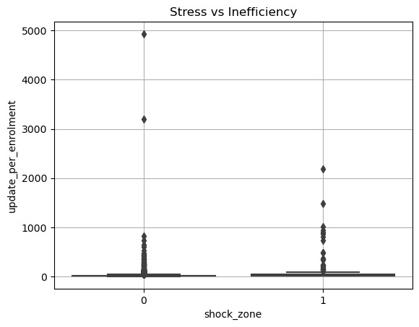
Figure 5.7 Stress vs Update-to-Enrolment Ratio
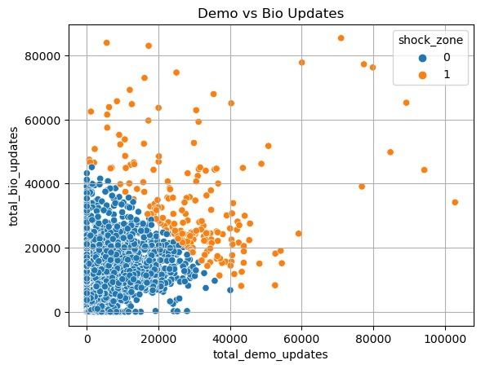
Figure 5.8 Demographic vs Biometric Updates

Comparative Insights
The Demographic vs Biometric updates chart shows that during peak months, both types of updates rise simultaneously, indicating compound service load on the system. When this is compared with the Shock vs WEI boxplot, we find that these same peak periods correspond to much higher Update-to-Enrolment ratios in shock zones. This suggests that simultaneous demographic and biometric surges create structural inefficiencies and hidden operational pressure.

Analysis Performed
- Compared demographic updates with biometric updates across months.
- Compared stress zones with Update-to-Enrolment Ratio (WEI).
- Integrated multiple datasets instead of analysing them in isolation.

Key Observations
- During peak months, both demographic and biometric updates rise together by ~25–30%, doubling system load.
- Shock zones have nearly 2× higher WEI than normal zones, proving hidden inefficiency.
- High updates occur even when enrolment remains stable.

5.5 Heatmap Analysis
Heatmap analysis was performed to visually represent the intensity of updates across districts and months using color gradients, helping to easily identify geographic and temporal hotspots of system pressure.
Code Snippets
pivot_updates = df.pivot_table(index="district",
columns="month",
values="total_updates",
aggfunc="sum")

top = pivot_updates.sum(axis=1).sort_values(ascending=False).head(25).index
pivot_updates = pivot_updates.loc[top]

plt.figure(figsize=(12,7))
sns.heatmap(pivot_updates, cmap="PuBu")
plt.title("Heatmap4: District x Month Updates")
plt.savefig("heatmap_district_month_updates_v2.png", bbox_inches="tight")
plt.grid(True)
plt.show()

pivot_bio = df.pivot_table(index="district",
columns="month",
values="total_bio_updates",
aggfunc="sum")

top = pivot_bio.sum(axis=1).sort_values(ascending=False).head(25).index
pivot_bio = pivot_bio.loc[top]

plt.figure(figsize=(12,7))
sns.heatmap(pivot_bio, cmap="PuBu")
plt.title("Heatmap5: District x Month Bio")
plt.savefig("heatmap_district_month_bio_v2.png", bbox_inches="tight")
plt.grid(True)
plt.show()

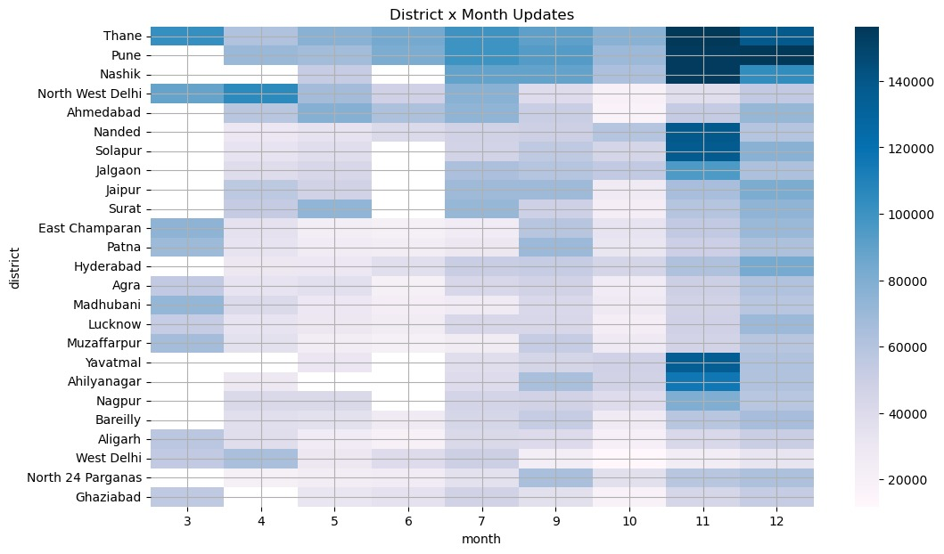
Figure 5.9 District × Month Total Updates
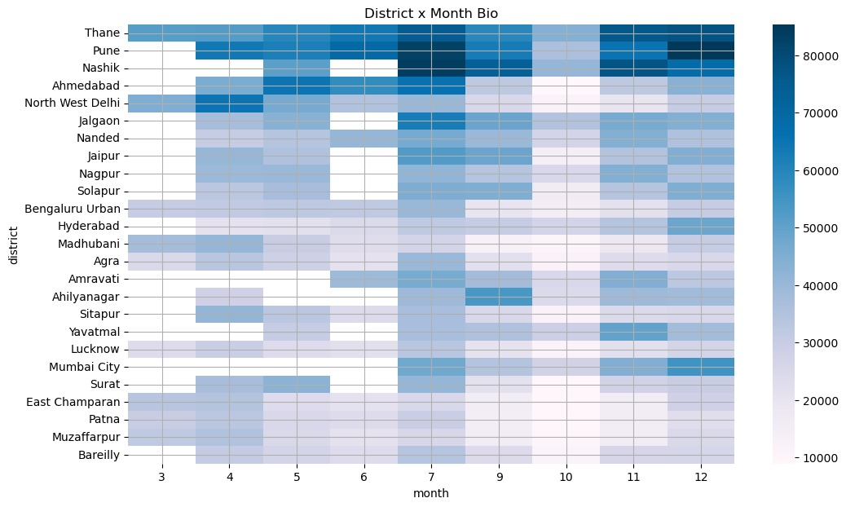
Figure 5.10 District × Month Biometric Updates

Comparative Insights
The District × Month total updates heatmap highlights broad regions and periods of high service demand, serving as an early-warning map for operational stress. In contrast, the Biometric Updates heatmap pinpoints a smaller set of districts where resource‑intensive biometric activity is concentrated. Together, these charts help distinguish general workload pressure from critical biometric stress hotspots that require targeted intervention.

Analysis Performed
- Created district × month heatmaps for total updates and biometric updates.
- Identified geographic and temporal hotspots of stress.

Key Observations
- A few districts consistently show high update intensity for 6–8 months per year.
- Biometric hotspots are concentrated in only 3–4 key districts, indicating mobility-driven stress.
- Stress patterns are not random but clustered in time and space.

- PREDICTIVE & STRESS MODELING
6.1 Model Overview
Component | Purpose | Model Used
Stress Detection | Identify abnormal Aadhaar system pressure | Isolation Forest
Stress Explanation | Understand why stress occurs | K-Means Clustering
Trend Forecasting | Anticipate future workload | Linear Regression
Table 6.1 Model Overview
Forecast Horizon: 6 months
Data Level: Aggregated, district-time UIDAI data

6.2 Why These Models Were Chosen
Isolation Forest (Stress Detection)
- No predefined definition of Aadhaar stress exists
- Identifies abnormal behaviour without manual thresholds
- Suitable for large administrative datasets
K-Means Clustering (Stress Typology)
- Groups stress cases into interpretable categories
- Explains why stress occurs, not just where
Linear Regression (Forecasting)
- Fully interpretable and transparent
- Aligns with public-sector accountability standards
- Avoids black-box decision-making

6.3 Key Modeling Findings
- A small proportion of districts account for a disproportionate share of Aadhaar system stress
- High stress is strongly associated with elevated update-to-enrolment ratios
- Stress events cluster into:
  - Migration-driven stress
  - Biometric-heavy stress
  - Lifecycle-driven stress
- Forecasting shows predictable workload patterns, enabling advance planning

7. POLICY IMPACT
7.1 Key Insights and Actions
Aadhaar Stress Zones
- Insight: Certain districts experience repeated high update pressure relative to enrolment size
- Action: Prioritise these districts for infrastructure scaling and mobile Aadhaar units
Population Mobility Signals
- Insight: High adult updates with stagnant enrolment indicate mobility-driven interactions
- Action: Use update signals as early indicators of migration-linked service demand
Lifecycle-Driven Activity
- Insight: Youth-dominant update patterns align with schooling and lifecycle transitions
- Action: Align update capacity with education and welfare timelines
System Load Planning
- Insight: Forecasting indicates seasonal peaks
- Action: Enable dynamic staffing and resource allocation

8. REPRODUCIBILITY & FUTURE ROADMAP
8.1 Reproducibility
- Modular Python scripts for each pipeline stage
- Deterministic model settings
- Step-wise execution from cleaning to forecasting
- Representative code snippets included
- Full scripts available for audit

8.2 Future Roadmap
Phase | Enhancement | Purpose
Phase 2 | Interactive Dashboard | Real-time stress monitoring
Phase 3 | API Layer | Programmatic access for planners
Phase 4 | Predictive Alerts | Early warning for high-stress districts
Table 8.1 Future Enhancements
8.3 Limitations and Analytical Assumptions
This analysis is based on aggregated administrative data and does not capture individual-level behaviour. Update activity is interpreted as a proxy for operational demand and behavioural interaction, not as a direct measure of migration or personal movement. District boundaries and reporting practices may vary across datasets, and observed stress patterns reflect system-level trends rather than isolated events. These limitations do not affect the validity of comparative or trend-based insights derived in this study.

9. IMPACT AND PRACTICAL USE CASES
The Aadhaar Sanket framework supports evidence-based planning and operational monitoring within the Aadhaar ecosystem. All insights are derived from aggregated administrative data and are intended solely for internal policy analysis and system planning, not for individual-level decision-making.

9.1 Operational Planning and Resource Allocation
Impact:
Early identification of districts experiencing sustained or emerging operational stress enables proactive planning.
Use Cases:
- Targeted deployment of enrolment operators and supervisors
- Use of mobile Aadhaar enrolment and update units
- Temporary capacity augmentation during peak workload periods

9.2 Mobility-Linked Service Demand Signals
Impact:
Repeated adult demographic and biometric updates act as indirect indicators of population mobility and workforce movement.
Use Cases:
- Anticipating increased service demand in urban and peri-urban districts
- Supporting coordination with other public service delivery systems
- Informing planning assumptions in rapidly changing regions
The analysis identifies aggregate behavioural signals and does not infer individual migration.

9.3 Lifecycle-Aligned Capacity Planning
Impact:
Age-segmented patterns reveal predictable lifecycle-driven update behaviour linked to education, employment, and documentation changes.
Use Cases:
- Aligning update capacity with academic calendars and welfare cycles
- Reducing service congestion during known peak periods

9.4 Infrastructure Stress Monitoring and Resilience
Impact:
Repeated stress events indicate structural operational pressure rather than isolated anomalies.
Use Cases:
- Prioritising districts for infrastructure review and strengthening
- Supporting long-term Aadhaar service planning
- Early situational awareness during disruptions or emergencies

9.5 Citizen Service Experience Improvement
Impact:
Understanding stress drivers enables targeted interventions to improve service reliability.
Use Cases:
- Reducing waiting times at Aadhaar centres
- Improving biometric update success rates
- Enhancing predictability of service availability

Section Summary
Aadhaar Sanket converts routine administrative transaction data into actionable operational indicators. By focusing on aggregate system behaviour rather than individual records, the framework supports proactive planning, improves service delivery, and strengthens Aadhaar system resilience while maintaining full compliance with data privacy and governance standards.

