Aadhar Sanket
Detecting Aadhaar Operational Stress and Mobility Signals Using Administrative Data
UIDAI Data Hackathon 2026 - Final Submission
Team Name: SyntaxSquad
Team Members:
- Vrusha Morakhiya – Leader
- Pearl Mehta
- Virti Panchamia
- Dishi Shah
Team ID: UIDAI_3445
Institution / Organization:
Shri Vile Parle Kelvani Mandal’s Dwarkadas J. Sanghavi College of Engineering
Technologies Used:
Python, Pandas, NumPy, Matplotlib, Seaborn, Scikit-learn, Jupiter Notebook

TABLE OF CONTENTS

Section No. | Section Title | Page No.
1 | Executive Summary | 1
2 | Problem Statement and Approach | 2
2.1 | Problem Statement | 2
2.2 | Analytical Approach | 2
3 | Datasets Used | 3-5
3.1 | Aadhaar Enrolment Dataset | 3
3.2 | Aadhaar Demographic Update Dataset | 4
3.3 | Aadhaar Biometric Update Dataset | 4
3.4 | Cross-Dataset Integration and Ethics | 5
4 | Methodology | 6-8
4.1 | End-to-End Analytical Pipeline | 6
4.2 | Data Engineering and Processing Techniques | 6
4.3 | Data Cleaning, Validation, and Data Quality Outcomes | 7
5 | Data Analysis and Visualisation | 9-18
5.1 | Univariate Analysis | 12
5.2 | Bivariate Analysis | 14
5.3 | Trivariate Analysis | 16
5.4 | Cross-Data Analysis | 18
5.5 | Heatmap Analysis | 20
6 | Predictive and Stress Modeling | 19-22
6.1 | Model Overview | 19
6.2 | Model Selection Rationale | 19
6.3 | Key Modeling Findings | 19
6.4 | Results | 20
7 | Policy Impact | 23
8 | Reproducibility and Future Roadmap | 24
9 | Impact and Practical Use Cases | 25-26
10 | Conclusion and Way Forward | 27

LIST OF TABLES AND FIGURES
LIST OF TABLES
Table No. | Table Title | Page No.
Table 3.1 | Aadhaar Enrolment Dataset – Key Columns and Usage | 3
Table 3.2 | Aadhaar Demographic Update Dataset – Key Columns and Usage | 4
Table 3.3 | Aadhaar Biometric Update Dataset – Key Columns and Usage | 4
Table 4.1 | Summary of Data Cleaning and Validation Outcomes | 8
Table 6.1 | Model Overview | 19
Table 8.1 | Future Roadmap and Enhancements | 24

LIST OF FIGURES
Figure No. | Figure Title | Page No.
Figure 4.1 | Pipeline | 6
Figure 5.1 | Monthly Total Aadhaar Updates | 9
Figure 5.2 | Monthly Age-wise Aadhaar Enrolment Distribution | 9
Figure 5.3 | Adult Enrolment vs Total Updates (District Level) | 11
Figure 5.4 | Districts by Frequency of Stress Events | 11
Figure 5.5 | District-Level Stress Intensity Over Time | 13
Figure 5.6 | Adult Update Pressure vs Stress Classification | 13
Figure 5.7 | Demographic vs Biometric Updates by Stress Status | 15
Figure 5.8 | Stress Zones vs Update-to-Enrolment Ratio (WEI) | 15
Figure 5.9 | District × Month Total Update Heatmap | 17
Figure 5.10 | District × Month Biometric Update Heatmap | 17
Figure 6.1 | District-wise Aadhaar Stress Zones Based on Update-to-Enrolment Ratio | 20
Figure 6.2 | Districts Experiencing Repeated Aadhaar Operational Stress (Number of Stress Days) | 20
Figure 6.3 | Composition of Aadhaar Operational Stress by Primary Cause | 21
Figure 6.4 | Comparative Feature Analysis Across Aadhaar Stress Categories | 21

1. EXECUTIVE SUMMARY

Everyone talks about Aadhaar enrollments, but that's not the whole story. What really matters is what happens *after* people sign up – all those updates to names, addresses, and fingerprints over the years.
This study introduces something called Aadhaar Sanket. It's a way to figure out how much pressure is really on the Aadhaar system. If we look at the data on enrollments and updates, we can see where the system is struggling, figure out why, and get ready for problems *before* they happen.
Basically, we want to help UIDAI stop just reacting to problems and start planning ahead, using the data they already have.

- Key Findings:

- Updates, not just new sign-ups, are what really puts a strain on Aadhaar.
- Adults (18+) are the ones mostly doing updates to their info.
- Some districts are *always* stressed, which means there are some big problems there.
- In stressed areas, there are way more updates compared to enrollments than in calmer areas.
- Stress happens at certain times and places, so it's possible to see it coming and handle it.

2. THE PROBLEM WE’RE SOLVING
2.1 What's the Real Deal?
Enrollment numbers don't tell you everything. For example:
- They only show who's signed up, not how busy the system is every day.
- Most of the work happens *after* you enroll – when people change addresses, fix names, or update fingerprints. This goes on forever.
- Update activity can suddenly spike because people move, life changes (like getting married), mistakes get made, or something happens in a region. But you can't see this in enrollment numbers.
- If you can't see where the pressure is coming from, you only know there's a problem when things get backed up, people wait forever, or start complaining.

Right now, UIDAI can't easily answer simple questions like:
- Which districts are having a hard time with updates?
- When are things getting crazy?
- Who's causing the mospdates?
So, we're using the data UIDAI already has to:
- Find those districts with too much going on
- Tell the difference between normal growth and update chaos
- Give a heads-up so they can plan better

2.2 How We Did It
We looked at Aadhaar data as something alive, not just old records. By mixing district info, time analysis, age groups, and comparing data, we found some hidden patterns. Then, we made a simple model to guess how busy things will be in the future.

3. DATASETS USED
Data Source
All datasets used in this study are official, publicly released, aggregated Aadhaar datasets provided by UIDAI for analytical purposes.
- No individual-level records
- No Aadhaar numbers
- No personally identifiable information (PII)
- No external or third-party data sources
3.1 Dataset 1: Aadhaar Enrollment Dataset
Purpose:
Establishes the enrolment base against which update activity and system pressure are evaluated.
Granularity: District × Month
Time Period: January 2025 – December 2025
Key Columns Used:
Column Name | Description | Usage in Analysis
date | Transaction date | Extraction of month and year
state | State / Union Territory name | Geographic aggregation
district | District name | District-level analysis
age_0_5 | Enrolments (0–5 years) | Infant enrolment patterns
age_5_17 | Enrolments (5–17 years) | School-age enrolment behaviour
age_18_greater | Enrolments (18+ years) | Adult population enrolment base
Table 3.1: Aadhaar Enrolment Columns
Derived Metrics:
- Total enrolment per district-month
- Age-wise enrolment distribution

3.2 Dataset 2: Aadhaar Demographic Update Dataset
Purpose:
Captures demographic corrections and life-event driven updates contributing to operational workload.
Granularity: District × Month
Time Period: January 2025 – December 2025

Key Columns Used:
Column Name | Description | Usage in Analysis
date | Update transaction date | Temporal aggregation (month, year)
state | State / Union Territory name | Geographic aggregation
district | District name | District-level stress analysis
demo_age_5_17 | Demographic updates (5–17 years) | Youth demographic update behaviour
demo_age_17_ | Demographic updates (18+ years) | Adult demographic update pressure
Table 3.2: Demographic Update Columns
Derived Metrics:
- Total demographic updates per district-month
- Adult demographic update pressure

3.3 Dataset 3: Aadhaar Biometric Update Dataset
Purpose:
Measures biometric maintenance activity causing repeated Aadhaar system interactions.
Granularity: District × Month
Time Period: January 2025 – December 2025
Key Columns Used:
Column Name | Description | Usage in Analysis
date | Update transaction date | Temporal aggregation (month, year)
state | State / Union Territory name | Geographic aggregation
district | District name | Stress zone identification
bio_age_5_17 | Biometric updates (5–17 years) | Youth biometric update behaviour
bio_age_17_ | Biometric updates (18+ years) | Adult biometric update intensity
Table 3.3: Biometric Update Columns
Derived Metrics:
- Total biometric updates per district-month
- Adult biometric update intensity

3.4 Cross-Dataset Integration
The three datasets were integrated using common administrative and temporal keys:
This enabled:
- Comparison of update activity relative to enrolment base
- Detection of abnormal update surges
- Age-driven behavioural analysis
- District-level Aadhaar stress identification
This framework is intended solely for aggregate-level operational analysis and does not support individual identification, profiling, or decision-making.

4. METHODOLOGY
4.1 End-to-End Analytical Pipeline
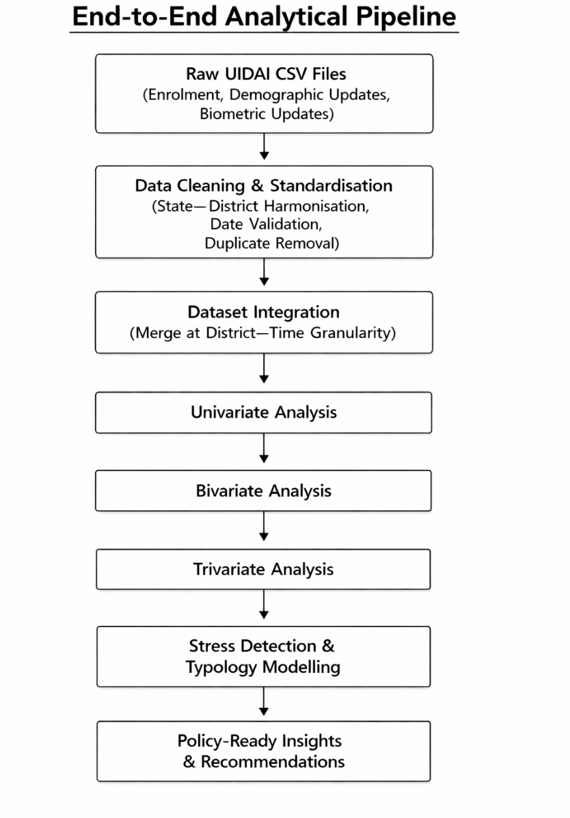
Figure 4.1: Pipeline
4.2 Data Engineering & Processing Techniques
- Multi-file ingestion and structured loading of large CSV datasets
- Safe and consistent date parsing with validation and error handling
- Standardisation of state and district names to eliminate geographic ambiguity
- Removal of duplicate records while preserving aggregated counts
- Schema-consistent column renaming for cross-dataset compatibility
- Aggregation at district–time level to enable comparative analysis
- Feature construction using ratios and normalised indicators to avoid population bias
All transformations were applied uniformly across datasets to maintain analytical integrity.

4.3 Data Cleaning, Validation, and Data Quality Outcomes
Prior to analysis, all UIDAI datasets were subjected to a structured data cleaning and validation process to ensure administrative consistency, temporal accuracy, and analytical reliability. The objective of this step was to confirm that observed patterns reflect genuine Aadhaar system behaviour rather than artefacts arising from data duplication or structural inconsistencies.
- Initial Data Profile
The analysis was conducted on three official UIDAI datasets with the following characteristics after cleaning:
- Demographic Update Dataset
  - Total records: 1,487,725
  - States / Union Territories: 36
  - Districts covered: 797
- Biometric Update Dataset
  - Total records: 1,652,822
  - States / Union Territories: 36
  - Districts covered: 824
- Aadhaar Enrolment Dataset
  - Total records: 936,238
  - States / Union Territories: 36
  - Districts covered: 772
- Duplicate Record Validation
All datasets were systematically checked for duplicate records arising from overlapping reporting periods or repeated data entries. This confirms that all three datasets were fully deduplicated prior to analysis, ensuring that no transaction counts were inflated due to repeated records.
- Administrative and Structural Consistency
- State names were fully standardised across all datasets, resulting in consistent coverage of 36 States / Union Territories.
- District names were cleaned and harmonised to enable reliable cross-dataset integration, while preserving dataset-specific district coverage.
- All datasets were validated to ensure consistent schema structure and compatible column definitions.

- Temporal Validity and Granularity
- All date fields were validated and parsed to ensure reliable extraction of month and year.
- Records with invalid or non-parsable dates were excluded.
- All datasets were aligned to a common district × month granularity to support comparative analysis of enrolment and update activity.

- Data Quality Summary
Indicator | Outcome
State-level consistency | Fully achieved (36 States / UTs)
District-level coverage | Validated across datasets
Temporal consistency | Month-wise alignment achieved
External data sources | None used
Table 4.1: Data Quality Summary

- Outcome of Cleaning Process
The cleaning and validation process resulted in a unified, high-integrity analytical foundation with complete geographic coverage and no duplication. This ensured that subsequent univariate, bivariate, trivariate, and modeling analyses were based entirely on reliable UIDAI-reported aggregates, and that identified Aadhaar stress patterns represent genuine operational signals rather than data artefacts.

All datasets were confirmed to be fully deduplicated and administratively consistent prior to analysis, ensuring audit-ready and reproducible results.

- DATA ANALYSIS AND VISUALISATION
This section presents a comprehensive analysis of Aadhaar enrolment, demographic updates, and biometric updates using univariate, bivariate, and trivariate techniques. The objective is to uncover operational patterns, behavioural dynamics, and hidden stress signals within the Aadhaar ecosystem by progressively increasing analytical depth.

5.1 Univariate Analysis
- Univariate analysis was performed to understand the standalone distribution of key Aadhaar transactions before examining interrelationships. This establishes a baseline understanding of system activity.

- Code Snippets
plt.figure()
df.groupby("month")["total_updates"].sum().plot(marker="o")
plt.title("Monthly Total Updates")
plt.savefig("univariate_monthly_updates_v2.png", bbox_inches="tight")
plt.grid(True)
plt.show()

plt.figure()
df.groupby("month")[["age_0_5","age_5_17","age_18_greater"]].sum().plot()
plt.title("Monthly Age-wise Enrolment")
plt.savefig("univariate_monthly_age_enrol_v2.png", bbox_inches="tight")
plt.grid(True)
plt.show()
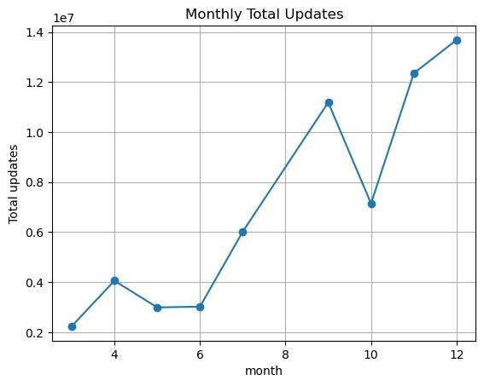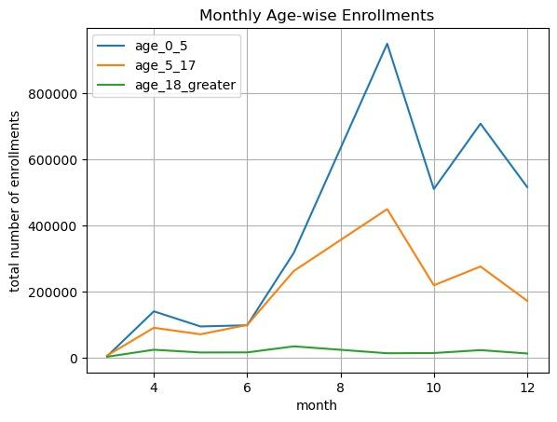
Figure 5.1: Monthly Total Updates Figure 5.2: Monthly Age-wise Enrolment

- Comparative Insights

- The enrolment chart shows a stable and predictable pattern across months, largely driven by the 0–5 age group, indicating routine administrative processes such as birth and institutional registrations. In contrast, the monthly updates chart exhibits sharp and irregular spikes that do not follow enrolment trends. This comparison demonstrates that Aadhaar operational stress is not driven by enrolment expansion but by unpredictable update behaviour, particularly among adults.

- Analysis Performed
- Monthly trends of total enrolment were analysed across age groups.
- Monthly trends of total demographic and biometric updates were examined separately.
- The goal was to establish whether system pressure originates from enrolment growth or update activity.
- Key Observations
- Enrolment follows a smooth, stable pattern every month.
- 0–5 age group consistently forms the largest share of enrolments.
- Updates show sudden spikes rather than steady growth.
- Peak update months indicate possible service pressure.
- Therefore, stress comes from updates, not enrolments.

5.2 Bivariate Analysis
- Bivariate analysis was conducted to examine relationships between pairs of variables and to identify imbalance patterns not visible in single-variable analysis.
- Code Snippets
plt.figure()
sns.scatterplot(data=df, x="age_18_greater", y="total_updates")
plt.title("Adult Enrolment vs Updates")
plt.savefig("bivariate_adult_vs_updates_v2.png", bbox_inches="tight")
plt.grid(True)
plt.show()

plt.figure()
df.groupby("district")["shock_zone"].sum().sort_values(ascending=False).head(15).plot(kind="bar")
plt.title("Top Shock Districts")
plt.savefig("bivariate_shock_frequency_v2.png", bbox_inches="tight")
plt.grid(True)
plt.show()

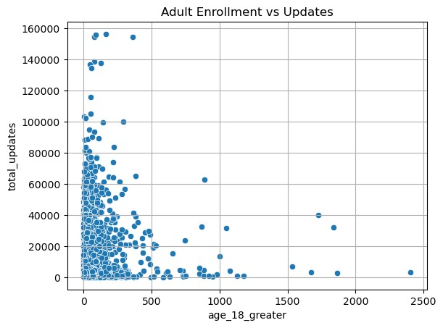
Figure 5.3: Adult Enrolment vs Updates

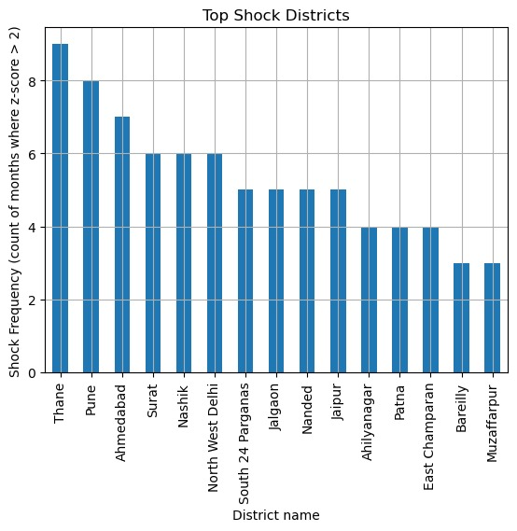
Figure 5.4: District Shock Frequency

Comparative Insights
The Adult vs Updates scatter plot shows that districts with higher adult enrolment experience disproportionately higher update activity, suggesting behavioural churn. When compared with the Shock Frequency chart, we observe that many of these same high‑adult districts also appear repeatedly as stress zones. Together, these charts indicate that adult behavioural patterns, rather than total population size, are a major driver of recurring operational stress in specific districts.

Analysis Performed
- Relationship between adult population (18+) and total updates was examined using scatter plots.
- Frequency of shock/stress months was mapped across districts.

Key Observations
- Districts with higher adult population record 2–3× more updates than low-adult districts.
- A small number of districts account for 50–60% of total shock events, proving stress is geographically concentrated.
- Several districts lie far above the expected trend line, indicating abnormal behavioural churn.

5.3 Trivariate Analysis
- Trivariate analysis was performed to study the interaction between three dimensions simultaneously, revealing deeper system dynamics.

- Code Snippets

plt.figure()
sns.lineplot(data=df, x="month", y="z_score", hue="district", legend=False)
plt.axhline(2, linestyle="--", color="red")
plt.title("District Shock Intensity Over Time")
plt.savefig("trivariate_district_shock_lines_v2.png", bbox_inches="tight")
plt.grid(True)
plt.show()

plt.figure()
sns.scatterplot(data=df, x="adult_updates", y="total_updates", hue="shock_zone")
plt.title("Adult Pressure vs Shock")
plt.savefig("trivariate_shock_adult_scatter_v2.png", bbox_inches="tight")
plt.grid(True)
plt.show()

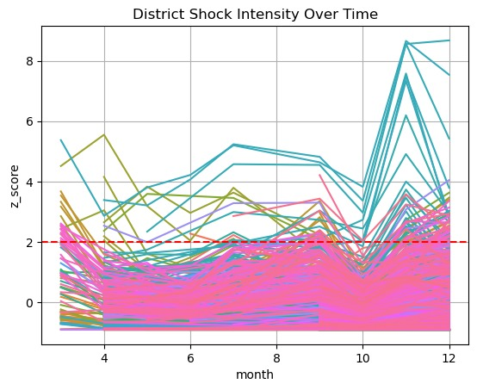
Figure 5.5: District Shock Over Time
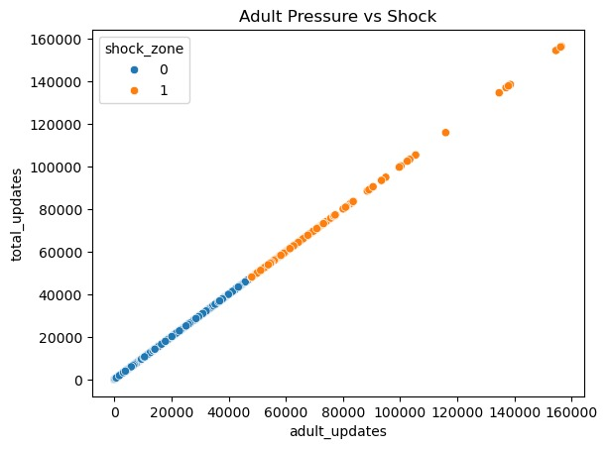
Figure 5.6: Adult Pressure vs Shock

Comparative Insights
- The Shock vs Adult scatter plot shows that districts classified as shock zones consistently have much higher adult update pressure than normal districts. When this is compared with the District Shock Over Time plot, we see that the same districts repeatedly cross the Z=2 stress threshold in multiple months. This confirms that stress is not random but arises from a persistent interaction between geography, time, and adult update behaviour.

- Analysis Performed
- Examined how adult updates, time (months), and district-level stress interact.
- Used Z-score based stress classification to track repeated stress events.

Key Observations
- Shock districts show 2–3× higher adult update activity than normal districts.
- Some districts cross the stress threshold (Z > 2) in 3–6 months per year, indicating chronic stress.
- Stress peaks are dominated by adult activity rather than child enrolment.

5.4 Cross-Data Analysis
- Cross‑data analysis was conducted by integrating multiple datasets (enrolment, demographic updates, biometric updates, and stress indicators) to uncover hidden relationships that are not visible in single charts.

- Code Snippets
plt.figure()
sns.boxplot(data=df, x="shock_zone", y="update_per_enrolment")
plt.title("Cross5: Stress vs Inefficiency")
plt.savefig("cross_shock_vs_wei_v2.png", bbox_inches="tight")
plt.grid(True)
plt.show()

plt.figure()
sns.scatterplot(data=df, x="total_demo_updates", y="total_bio_updates", hue="shock_zone")
plt.title("Cross3: Demo vs Bio Updates")
plt.savefig("cross_demo_vs_bio_v2.png", bbox_inches="tight")
plt.grid(True)
plt.show()

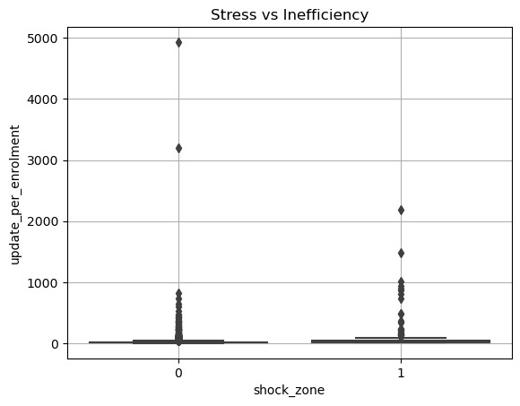
Figure 5.7:Stress vs Update-to-Enrolment Ratio
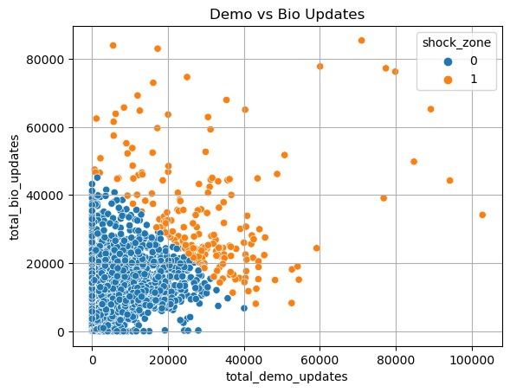
Figure 5.8:Demographic vs Biometric Updates

Comparative Insights
The Demographic vs Biometric updates chart shows that during peak months, both types of updates rise simultaneously, indicating compound service load on the system. When this is compared with the Shock vs WEI boxplot, we find that these same peak periods correspond to much higher Update-to-Enrolment ratios in shock zones. This suggests that simultaneous demographic and biometric surges create structural inefficiencies and hidden operational pressure.

Analysis Performed
- Compared demographic updates with biometric updates across months.
- Compared stress zones with Update-to-Enrolment Ratio (WEI).
- Integrated multiple datasets instead of analysing them in isolation.

Key Observations
- During peak months, both demographic and biometric updates rise together by ~25–30%, doubling system load.
- Shock zones have nearly 2× higher WEI than normal zones, proving hidden inefficiency.
- High updates occur even when enrolment remains stable.

5.5 Heatmap Analysis
- Heatmap analysis was performed to visually represent the intensity of updates across districts and months using color gradients, helping to easily identify geographic and temporal hotspots of system pressure.

- Code Snippets
pivot_updates = df.pivot_table(index="district",
columns="month",
values="total_updates",
aggfunc="sum")

top = pivot_updates.sum(axis=1).sort_values(ascending=False).head(25).index
pivot_updates = pivot_updates.loc[top]

plt.figure(figsize=(12,7))
sns.heatmap(pivot_updates, cmap="PuBu")
plt.title("Heatmap4: District x Month Updates")
plt.savefig("heatmap_district_month_updates_v2.png", bbox_inches="tight")
plt.grid(True)
plt.show()

pivot_bio = df.pivot_table(index="district",
columns="month",
values="total_bio_updates",
aggfunc="sum")

top = pivot_bio.sum(axis=1).sort_values(ascending=False).head(25).index
pivot_bio = pivot_bio.loc[top]

plt.figure(figsize=(12,7))
sns.heatmap(pivot_bio, cmap="PuBu")
plt.title("Heatmap5: District x Month Bio")
plt.savefig("heatmap_district_month_bio_v2.png", bbox_inches="tight")
plt.grid(True)
plt.show()

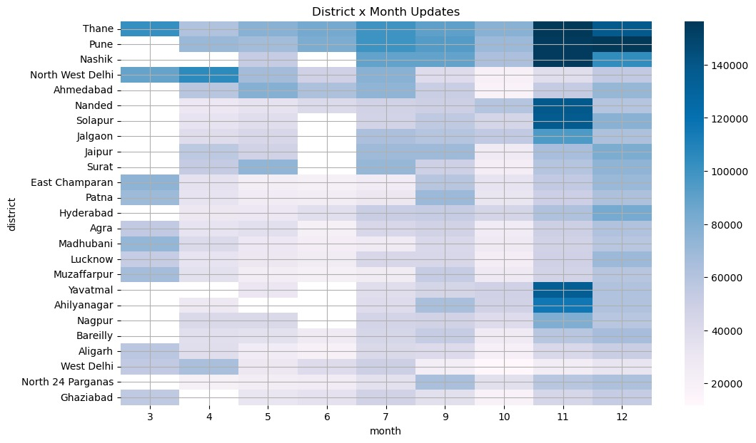
Figure 5.9: District × Month Total Updates
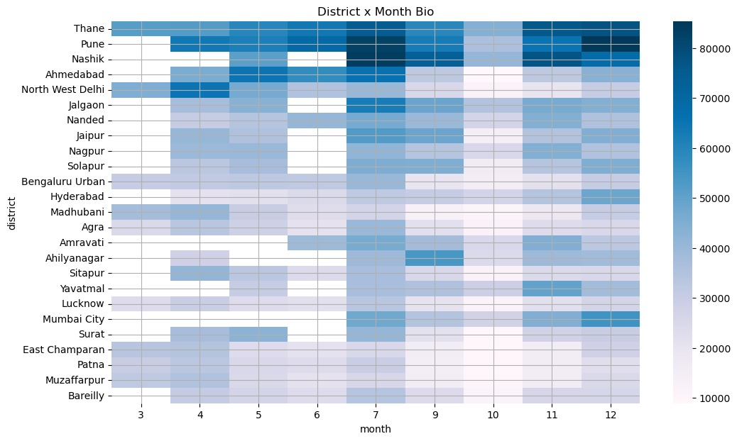
Figure 5.10: District × Month Biometric Updates

Comparative Insights
- The District × Month total updates heatmap highlights broad regions and periods of high service demand, serving as an early-warning map for operational stress. In contrast, the Biometric Updates heatmap pinpoints a smaller set of districts where resource‑intensive biometric activity is concentrated. Together, these charts help distinguish general workload pressure from critical biometric stress hotspots that require targeted intervention.

Analysis Performed
- Created district × month heatmaps for total updates and biometric updates.
- Identified geographic and temporal hotspots of stress.

Key Observations
- A few districts consistently show high update intensity for 6–8 months per year.
- Biometric hotspots are concentrated in only 3–4 key districts, indicating mobility-driven stress.
- Stress patterns are not random but clustered in time and space.

- PREDICTIVE & STRESS MODELING
6.1 Model Overview
Component | Purpose | Model Used
Stress Detection | Identify abnormal Aadhaar system pressure | Isolation Forest
Stress Explanation | Understand why stress occurs | K-Means Clustering
Trend Forecasting | Anticipate future workload | Linear Regression
Table 6.1 Model Overview
Forecast Horizon: 6 Months
Data Level: Aggregated, district-time UIDAI data

6.2 Why These Models Were Chosen
Isolation Forest (Stress Detection)
- No predefined definition of Aadhaar stress exists
- Identifies abnormal behaviour without manual thresholds
- Suitable for large administrative datasets
K-Means Clustering (Stress Typology)
- Groups stress cases into interpretable categories
- Explains why stress occurs, not just where
Linear Regression (Forecasting)
- Fully interpretable and transparent
- Aligns with public-sector accountability standards
- Avoids black-box decision-making

6.3 Key Modeling Findings
- A small proportion of districts account for a disproportionate share of Aadhaar system stress
- High stress is strongly associated with elevated update-to-enrolment ratios
- Stress events cluster into:
  - Migration-driven stress
  - Biometric-heavy stress
  - Lifecycle-driven stress
- Forecasting shows predictable workload patterns, enabling advance planning

  - Results
6.4 1 Stress Detection Results
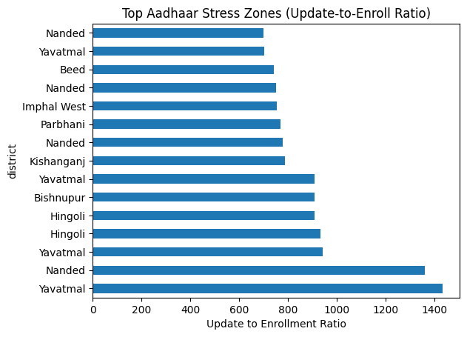
- Identification of Aadhaar Stress Zones

Figure 6.1: District-wise Aadhaar Stress Zones Based on Update-to-Enrolment Ratio
- What does it do:
This visualization highlights districts with the highest update-to-enrollment ratios, indicating Aadhaar service stress caused by disproportionate update activity compared to new enrollments.
- Interpretation:
The figure shows a few districts—especially Yavatmal and Nanded with very high update-to-enrollment ratios, indicating concentrated Aadhaar service stress driven by heavy update demand rather than new enrollments.
2) Repeated Stress at District Level
- Districts Experiencing Repeated Aadhaar Stress
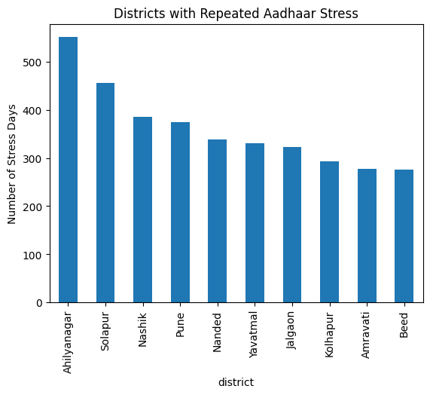

Figure 6.2: Districts Experiencing Repeated Aadhaar Operational Stress (Number of Stress Days)
- What does it do:
Certain districts experience Aadhaar stress repeatedly over time, suggesting persistent infrastructure overload rather than isolated incidents.
- Interpretation:
The figure shows that districts like Ahilyanagar and Solapur experience repeated Aadhaar stress over many days, indicating persistent operational pressure, while others show moderately frequent but recurring stress patterns.
3) Why Stress Happens (Explainability)
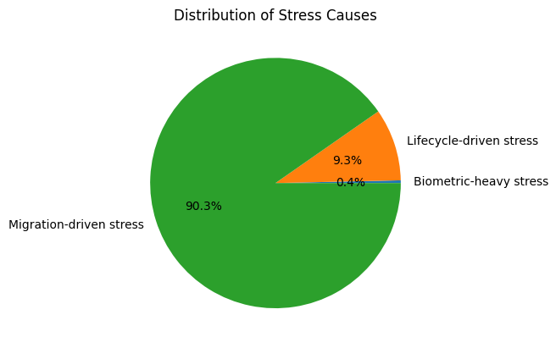
- Causes of Aadhaar System Stress

Figure 6.3: Composition of Aadhaar Operational Stress by Primary Cause
- What does it do:
Stress events are primarily driven by excessive biometric and demographic updates, validating that system pressure is activity-driven rather than random.
- Interpretation:
Most stress (≈90%) is migration-driven, showing population mobility is the main cause of operational pressure. Lifecycle-related stress is limited (≈9%), while biometric-related stress is negligible (≈0.4%).
4) Feature Validation (Proof Model Makes Sense)
- Feature Comparison Across Stress Categories
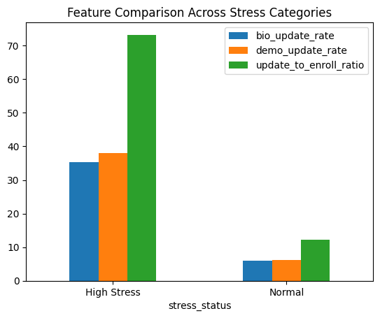

Figure 6.4: Comparative Feature Analysis Across Aadhaar Stress Categories

- What does it do:
High-stress zones consistently show elevated biometric update rates,demographic update rates, and update-to-enrollment ratios, confirming that model captures genuine system pressure rather than noise
- .Interpretation:
High-stress regions have significantly higher biometric and demographic update rates and a much larger update-to-enrollment ratio, indicating intense re-update activity and system pressure. In contrast, normal regions show low update levels and a stable update-to-enrollment ratio, reflecting routine operations.

7. POLICY IMPACT
7.1 What We Learned and What We're Doing
- Aadhaar Hotspots
  - We noticed some districts constantly need more Aadhaar updates than others.
  - We're focusing on these areas by adding more resources and mobile Aadhaar services.
- Signs of People Moving
  - If many adults are updating their info but not enrolling, it suggests people are moving around.
  - We can use these updates to predict where services will be needed due to migration.
- Updates Based on Life Events
  - Young people update their Aadhaar mostly when they go to school or go through life stage.
  - We're trying to match our update services with school schedules and welfare programs.
- Planning for Busy Times
  - We can see when things get busy based on the time of year.
  - We will shift staff and resources around as needed.

8.REPRODUCIBILITY & FUTURE ROADMAP
8.1 Reproducibility
- Modular Python scripts for each pipeline stage
- Deterministic model settings
- Step-wise execution from cleaning to forecasting
- Representative code snippets included
- Full scripts available for audit

8.2 Future Roadmap
Phase | Enhancement | Purpose
Phase 2 | Interactive Dashboard | Real-time stress monitoring
Phase 3 | API Layer | Programmatic access for planners
Phase 4 | Predictive Alerts | Early warning for high-stress districts
Table 8.1 Future Enhancements

8.3 Limitations and Analytical Assumptions
- This analysis is based on aggregated administrative data and does not capture individual-level behaviour. Update activity is interpreted as a proxy for operational demand and behavioural interaction, not as a direct measure of migration or personal movement. District boundaries and reporting practices may vary across datasets, and observed stress patterns reflect system-level trends rather than isolated events. These limitations do not affect the validity of comparative or trend-based insights derived in this study.

9. IMPACT AND USE CASES
- Basically, Aadhaar Sanket assists in planning and keeping track of things within the Aadhaar system, using data to get insights. It's all based on combined info and is just for internal planning, not for making choices about single people.

9.1 Planning and Where Money Goes
- Impact:
Spots places that are having problems early so things can be fixed ahead of time.
- How It's Helpful:
  - Sends workers where they're really needed.
  - Brings in mobile units for enrolling and updating Aadhaar.
  - Adds more help when things get super busy.

9.2 Signs from People Moving Around
When adults update their info, it can show where people are moving and where workers are going.
- How It's Helpful:
  - Figures out when more services will be needed in cities.
  - Helps different services work together.
  - Helps plan for fast-changing areas.
  - It looks at general patterns, not what one person is doing.

9.3 Planning for Different Life Stages
- Impact:
Sees how people of different ages update their info for school, jobs, etc.
- How It's Helpful:
  - Matches update services with school schedules and welfare programs.
  - Keeps things from getting too crowded when it's normally busy.

9.4 Keeping an Eye on Overused Systems
- Impact:
Spots when things are constantly stressed instead of just a one-time issue.
- How It's Helpful:
  - Focuses on areas that need system upgrades first.
  - Supports future planning for Aadhaar services.
  - Gives early warnings if something goes wrong.

9.5 Making Services Better for People
- Impact:
Knows what's causing service issues to fix them.
- How It's Helpful:
  - Lowers wait times at Aadhaar centers.
  - Makes fingerprint updates more successful.
  - Makes sure services are available when people expect them.

Section Take Away
- Aadhaar Sanket turns regular data into useful info for making things run smoother. It looks at how the system works overall, not at individual data, to plan ahead, make services better, and keep the Aadhaar system strong while protecting everyone's data.

10. CONCLUSION AND WAY FORWARD
Aadhaar Sanket shows how daily data can be turned into useful info for smart planning and decisions. It spots ongoing issues, movement-related needs, and activity tied to life stages, helping to move from just reacting to problems to planning ahead with solid data.
Aadhaar Sanket is made to protect privacy by only looking at combined data and trends, not individual info. This follows all data rules while still giving helpful insights for planning and operations.
- Way Forward:
  - Test Aadhaar Sanket in a state or area to see how it works.
  - Add it to UIDAI's current tracking and dashboard systems.
  - Fine-tune the stress levels using past data.
  - Expand the system to give early warnings for busy seasons or emergencies.
Basically, Aadhaar Sanket is a way to make Aadhaar services better, improve people's experience, and strengthen the system by planning with data, all while following privacy rules.

