**Study4U, Inc.**

Author: Hsing-Chen Chung, Yueh Tsao, Ying Wu, Peiyan Yu

Mission statement: Empowering you with comprehensive information to a fit master degree at your fingertips.

Mission objectives:

1. To learn about details of cities where targeted schools are located
2. To find master programs in a targeted city.
3. To perform search on program and school details including type, tuition, length, size, and expected salary.
4. To learn about program admission requirements.
5. To compare school and program rankings from different systems.
6. To learn the trends of school and program rankings.
7. To find master programs in targeted schools.
8. To know the school where certain programs belong to.
9. To find information efficiently.
10. To compare different programs easily through visualized graphs.

Finalized ER-Diagram

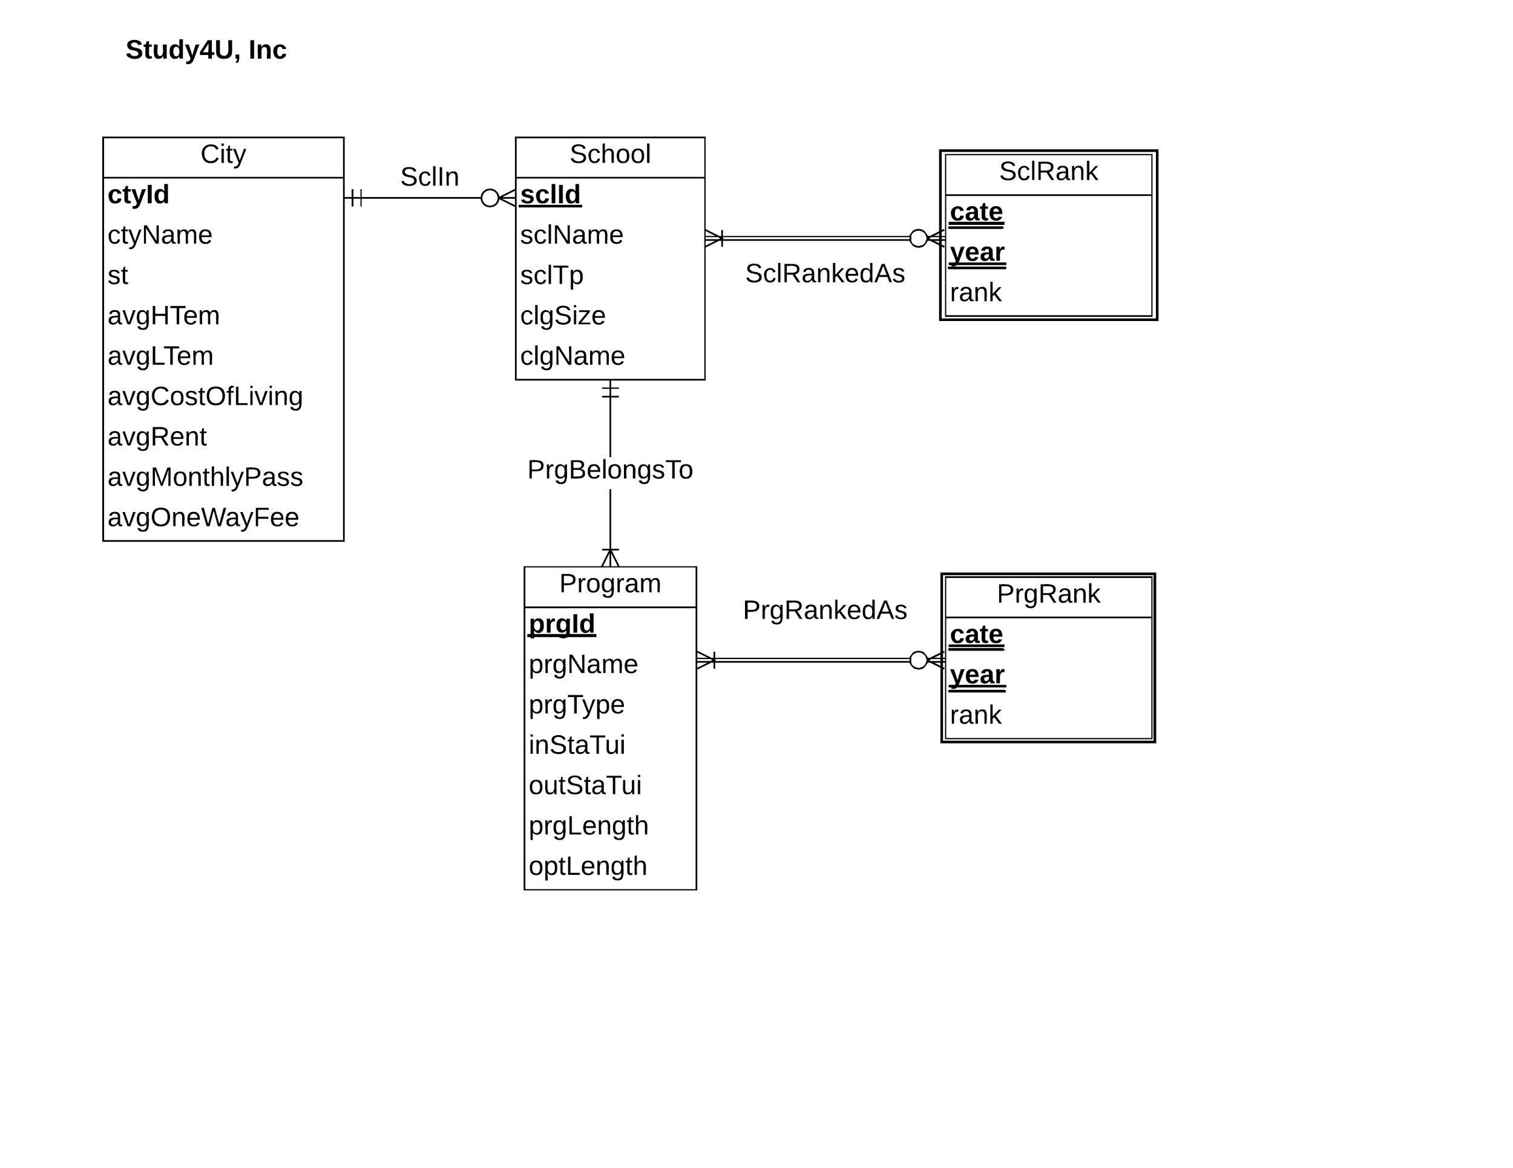

Relational Schema:

1. Relations:

Program (**prgId**, prgName, prgType, *sclId*, inStaTui, outStaTui, prgLength, optLength)

School (**sclId**, sclName, *ctyId*, sclTp, clgName, clgSize)

City (**ctyId**, ctyName, st, avgHTem, avgLTemp, avgRent, avgCostOfLiving, avgMonthlyPass, avgOneWayFee)

SclRank (**cate, year, *sclId,*** sclRank)

PrgRank (**cate, year, *prgId****,* prgRank)

1. Functional dependencies:

prgId → prgName, prgType, *sclId*, inStaTui, outStaTui, prgLength, optLength

sclId → sclName, *ctyId*, sclTp, clgName, clgSize

ctyId → ctyName, st, avgHTem, avgLTemp, avgRent, avgCostOfLiving, avgMonthlyPass, avgOneWayFee

cate, year, sclId → sclRank

cate, year, prgId → prgRank

1. Normalization to 3NF

Program (**prgId**, prgName, prgType, *sclId*, inStaTui, outStaTui, prgLength, optLength) **= 3NF**

School (**sclId**, sclName, *ctyId*, sclTp, clgName, clgSize) **= 3NF**

City (**ctyId**, ctyName, st, avgHTem, avgLTemp, avgRent, avgCostOfLiving, avgMonthlyPass, avgOneWayFee) **= 3NF**

SclRank (**cate, year, *sclId***, sclRank) **= 3NF**

PrgRank (**cate, year, *prgId***, prgRank) **= 3NF**

Business Rules:

1. When a school is deleted from the database, the program belongs to that school should be deleted as well.
2. When the information of a school has changed, the corresponding information of that program should be changed as well.
3. When a city is deleted from database, the school will temporarily have no city information.
4. When information of a city is changed, the corresponding school information should be changed accordingly.
5. A school cannot be deleted or changed from the database, if there is school rank record in the database.
6. A program cannot be deleted or changed from the database, if there is program rank record in the database.

Referential integrity:

|  |  |  |  |  |  |  |  |
| --- | --- | --- | --- | --- | --- | --- | --- |
| Relation | Foreign Key | Base Relation | Primary Key | Constraint:  ON DELETE | Business  Rule | Constraint:  ON UPDATE | Business  Rule |
| Program | sclId | School | sclId | CASCADE | R1 | CASCADE | R2 |
| School | cytId | City | cytId | SET NULL | R3 | CASCADE | R4 |
| SclRank | sclId | School | sclId | NO ACTION | R5 | NO ACTION | R5 |
| PrgRank | prgId | Program | prgId | NO ACTION | R6 | NO ACTION | R6 |

Sample data for each relation

1. Program (**prgId**, prgName, prgType, *sclId*, inStaTui, outStaTui, prgLength, optLength)

(**P100001**, Master in Business Administration, MBA, *100032*, 10000, 20000, 16, 2)

1. School (**sclId**, sclName, *ctyId*, sclTp, clgName, clgSize)

(**100132**, UMD, WA01, Public, 230, Robert H.Smith Business School, 100)

1. City (**ctyId**, ctyName, st, avgHTem, avgLTemp, avgRent, avgCostOfLiving, avgMonthlyPass, avgOneWayFee)

(**WA01**, Seattle, WA, 87.83°F, 43.29°F, $2,138, 76, $100, $2.3)

1. SclRank (**cate, year, *sclId***, sclRank)

(**USNews**, **2016**, ***100132***, 32)

1. PrgRank (**cate**, **year**, ***prgId***, prgRank)

(**USNews**, **2016**,***P100001***, 8)