1. Connect Tableau (Version 10.3) with SQL server.  
   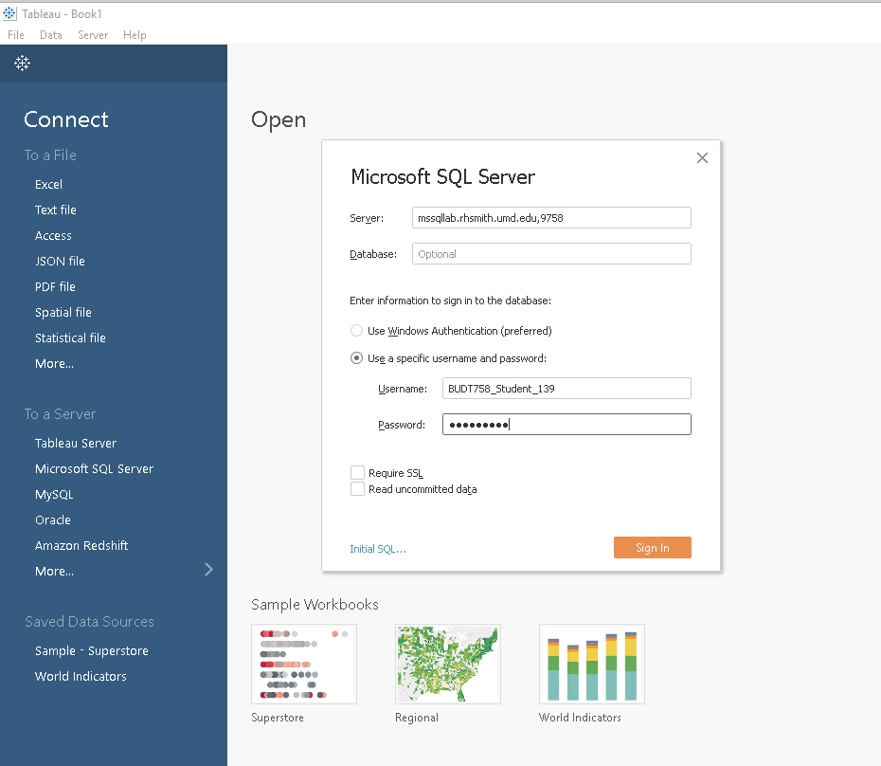
2. Drag 5 tables into Tableau database.  
   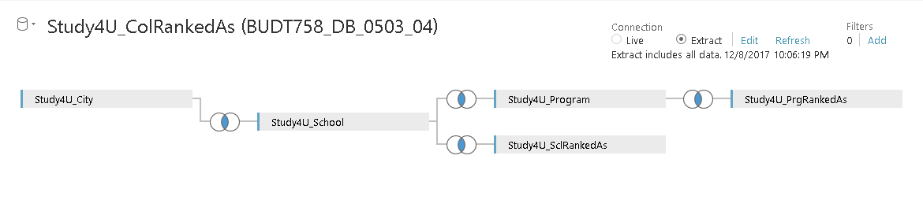
3. Create worksheet according to the data type and the way we want to present.  
   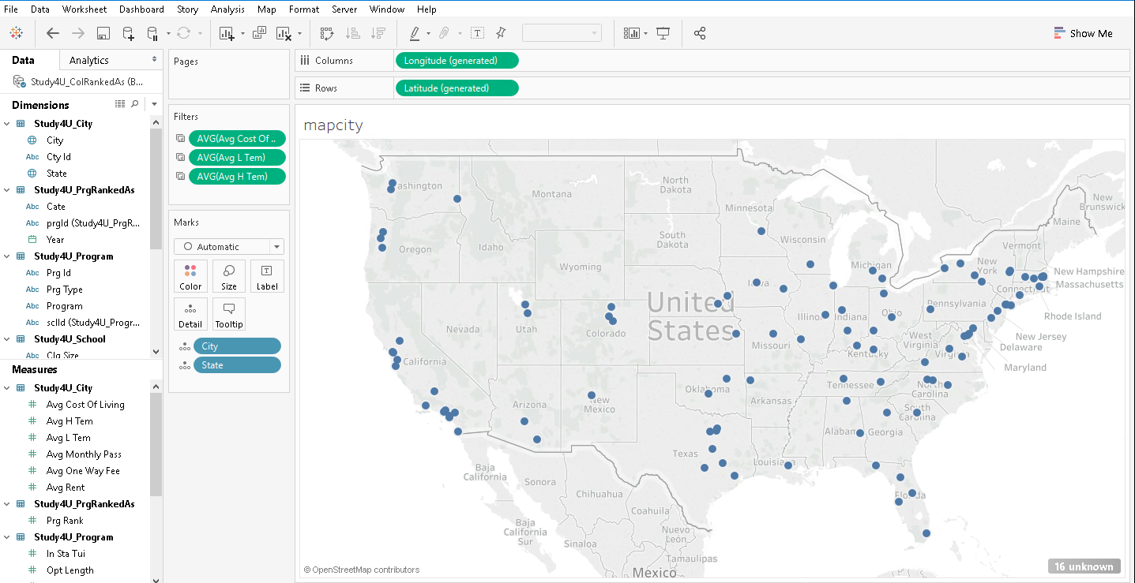
4. After creating all worksheets, create dashboards accodring to each web pages we designed.  
   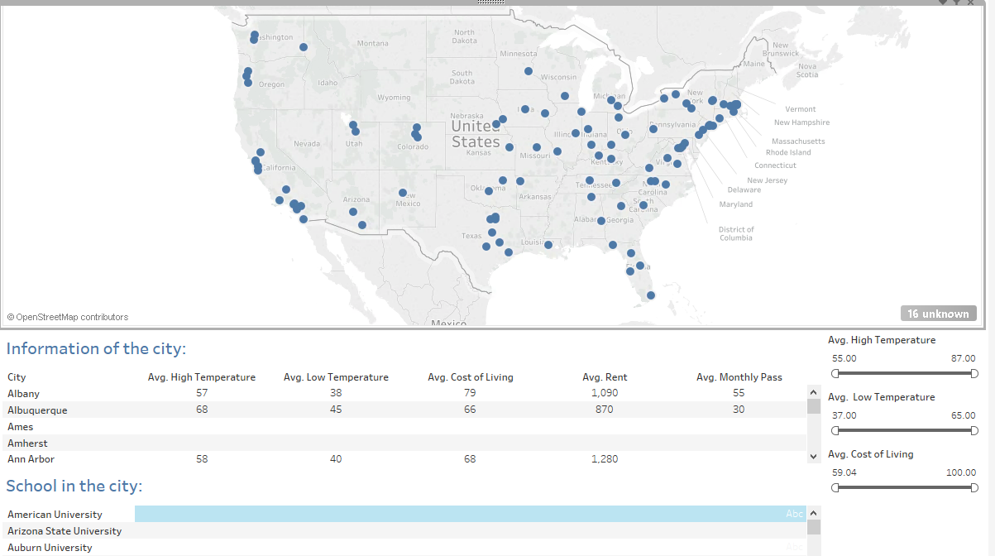
5. Apply filters to the corresponding worksheets.  
   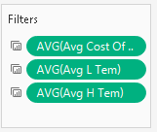
6. Public our Tableau to our online account.  
   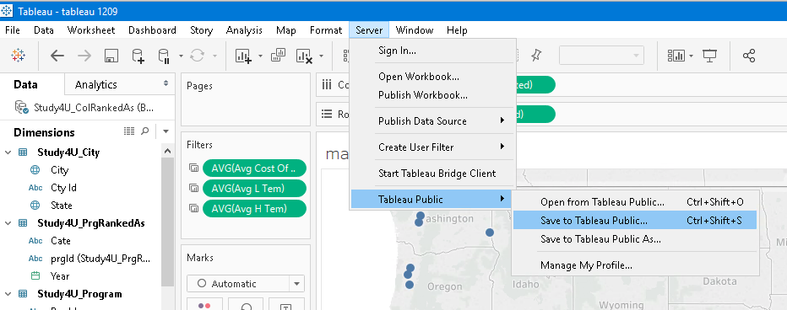
7. Please refer to file “tableau 1209.twb”.