Smarter Balanced Assessment Consortium

CAT Simulator User Guide

Published August 15, 2015

Prepared by the American Institutes for Research®



Contents

Introduction to this User Guide 1

Section I. Accessing CAT Simulator 2

Section II. CAT Simulator Layout 3

About the Banner 3

Selecting a Client 3

About the CAT Simulator Tabs 3

Section III. Loading Test Packages 5

Section IV. Running Simulations 6

Creating a New Simulation Session 6

Adding Tests to a Simulation Session 7

Running the Test Simulation 8

Section V. About Simulation Reports 10

Viewing Simulation Reports 10

Available Simulation Reports 10

Blueprint Summary Report 10

Blueprint Satisfaction Report 11

Overall Test Summary of Violations Report 11

Operational Item Distributions Report 11

Recycled Items Report 12

Field Test Distribution Report 12

Item Distribution Report 12

Opportunities Report 13

Items Report 13

Form Distributions Report 13

Test Package 13

Section VI. Simulation Session Maintenance 14

Editing Simulation Sessions 14

Managing Test Blueprints 15

Editing Blueprint Properties 16

Converting Blueprint Elements 16

Modifying Item Selection Parameters 17

Modifying Test Item Properties 18

Exporting Blueprints 19

Copying Simulation Sessions 20

Deleting Simulation Sessions 20

Appendix A. User Support 21

List of Figures

Figure 1. Login Page 2

Figure 2. Setup Simulation Sessions Tab (No Client Selected) 3

Figure 3. Load Test Packages Tab 5

Figure 4. Create New Simulation Session Window 6

Figure 5. Modify Simulation Session Page 7

Figure 6. Add Test(s) to Session Window 7

Figure 7. Manage Simulation Sessions Tab 8

Figure 8. Simulation Details Page 9

Figure 9. Blueprint Summary: Satisfactions Report 11

Figure 10. Blueprint Summary: Overall Test Summary of Violations 11

Figure 11. Blueprint Summary: Operational Item Distributions Report 11

Figure 12. Blueprint Summary: Recycled Items 12

Figure 13. Field Test Distribution Report 12

Figure 14. Item Distribution Report 12

Figure 15. Opportunities Report 13

Figure 16. Items Report 13

Figure 17. Forms Distributions Report 13

Figure 18. Modify Simulation Test Property Window 14

Figure 19. Manage Test Segment Blueprint Page 15

Figure 20. Item Selection Parameters 17

Figure 21. Item Properties 18

Figure 22. Item Group Properties 19

Figure 23. Copy from Existing Session ID Window 20

Introduction to this User Guide

This user guide provides information about using the Computer Adaptive Test (CAT) Simulator application. CAT Simulator allows you to import test packages created in the Test Authoring System (TAS) and run simulation sessions of those test packages. After running simulations, you can view reports to determine if the segments within a test package are functioning according to the blueprint.

This user guide includes the following sections:

* Section I, Accessing CAT Simulator, explains how to log in to CAT Simulator.
* Section II, CAT Simulator Layout, describes the tabs and features available in CAT Simulator.
* Section III, Loading Test Packages, provides instructions for importing test packages.
* Section IV, Running Simulations, provides instructions for running simulation sessions.
* Section V, About Simulation Reports, describes the reports available in CAT Simulator.
* Section VI, Simulation Session Maintenance, provides instructions for editing, copying, and deleting simulation sessions.

Table 1 describes icons and typographical elements that appear in this user guide.

Table . Key Icons and Elements

| Icon | Description |
| --- | --- |
|  | **Alert:** This symbol appears with text that contains important information regarding a task. |
|  | **Note:** This symbol appears next to text that contains helpful information or reminders. |
| **Text** | Text in bold indicates a clickable link or button. |
| Text | Text in bold italics indicates a page name. |
| Text | Text in italics indicates field names or labels. |
| “Text” | Text in quotation marks indicates the value specified for a field. |

# Accessing CAT Simulator

This section contains information about logging in to CAT Simulator. To access CAT Simulator, you must have an authorized username and password. Your system administrator sets up your user account and provides you with the login credentials.

To log in to CAT Simulator:

1. Open your web browser and navigate to CAT Simulator using the URL provided to you. You will be directed to the login page.

Figure . Login Page

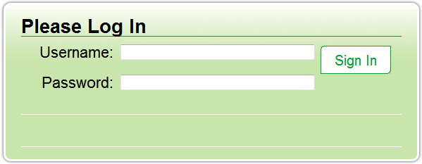

1. In the Username field, enter your username.
2. In the Password field, enter your password.
3. Click **Sign In**.

# CAT Simulator Layout

The CAT Simulator interface consists of a banner, a **Client** drop-down list, and three tabs related to simulation session tasks.

## About the Banner

A banner at the top of every page displays the following information and links:

* Your user name.
* **Logout**—Click to log out of CAT Simulator.
* **Help**—Click to view a help guide for editing test blueprints.

## Selecting a Client

When you log in to CAT Simulator, the tabs do not display any data until you select a client from the **Client** drop-down list on the left. Once you select a client, you will only be able to run and manage simulation sessions for that client.

Figure . Setup Simulation Sessions Tab (No Client Selected)

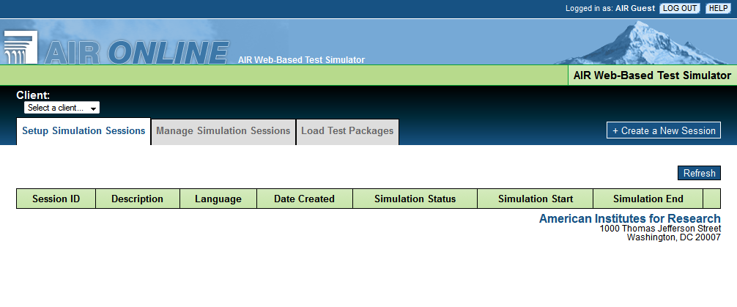

## About the CAT Simulator Tabs

The CAT Simulator interface consists of three tabs:

* **Setup Simulation Sessions**: Displays a table of existing simulation sessions and allows you to edit, copy, and delete each session. This tab appears automatically when you log in.
* **Manage Simulation Sessions**: Displays a table of existing simulation sessions and allows you to run each session and view the simulation results.
* **Load Test Packages**: Allows you to select test packages to import for use in simulation sessions.

The tables on the **Setup Simulation Sessions** and **Manage Simulation Sessions** tabs display identical data, but the action buttons available in each table are different. Table 2 provides an overview of the columns available in these tables.

Table . Simulation Session Table Descriptions

|  |  |
| --- | --- |
| Column Header | Description |
| Session ID | ID automatically generated for the simulation session upon creation. |
| Description | User-entered description for the simulation session. |
| Language | Language selected for the simulation session. |
| Date Created | Date simulation session was created. |
| Simulation Status | Displays whether the simulation session is in progress ("running"), finished ("completed"), or canceled ("aborted"). |
| Simulation Start | Latest time and date when the simulation session started running. |
| Simulation End | Latest time and date when the simulation session finished running. |
| [Action Buttons] | On the **Setup Simulation Sessions** tab, the following action buttons are available:   * **Copy**: Click to copy the details and test properties for an existing simulation session. * **Edit**: Click to modify the details and test properties for an existing simulation session. * **Delete**: Click to delete an existing simulation session.   On the **Manage Simulation Sessions** tab, the following action buttons are available:   * **Run Sim**: Click to run the simulation session. * **Cancel Sim**: Click to stop an in-progress simulation session. * **View Details**: Click to view the progress of a running simulation session or the reports for a completed simulation session. * **Clear Sim Data**: Click to erase the report data for a completed simulation session. * **Publish to ITS** and **Publish Test Packages**: These buttons only apply to simulation sessions in AIR's proprietary CAT Simulator application. |

# Loading Test Packages

In order to run simulation sessions in CAT Simulator, you must first upload the test packages to be used in the simulations. For information about creating test packages, see the Test Authoring System User Guide.

Figure . Load Test Packages Tab

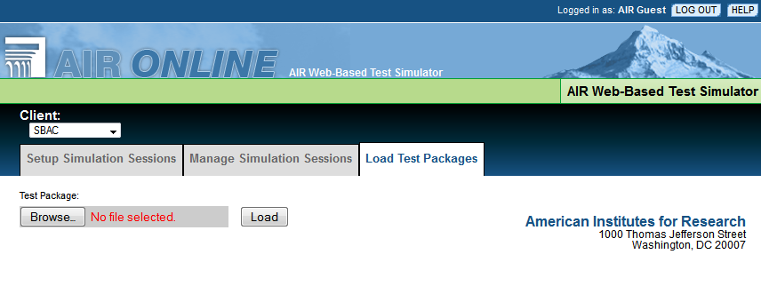

To upload test packages to CAT Simulator:

1. On the **Load Test** **Packages** tab, click **Browse**.
2. In the open file dialog box that pops up, select the required test package file. Test package files must be in valid XML format.
3. Click **Load**. When the upload completes, CAT Simulator displays a message indicating that the upload was successful.

|  |  |
| --- | --- |
|  | **Alert:** The test package upload process may take several minutes to complete, depending on the size of the file. Do not navigate away from the **Load Test Packages** tab while the upload is in progress. |

# Running Simulations

This section provides instructions for creating new simulation sessions, selecting tests, and running simulations. In order to run simulations, at least one test package must already be uploaded to CAT Simulator (for more information, see the section Loading Test Packages).

The basic workflow for running simulations in CAT Simulator is as follows:

1. User creates new simulation session.
2. User adds tests to the session.
3. User sets test properties for the simulation session.
4. User runs the simulation session.

## Creating a New Simulation Session

In order to run a simulation of a test package, you must first create a new simulation session.

To create a new session:

1. On the right side of the **Setup Simulation Sessions** tab (see Figure 2), click **Create a New Session**. The Create New Simulation Session window appears.

Figure . Create New Simulation Session Window

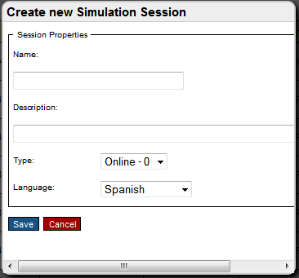

1. Enter a name and description for the simulation session. The name is stored in the database but does not appear anywhere in the CAT Simulator interface.
2. From the **Type** drop-down list, select either **Online - 0** or **Paper – 1**, as required.
3. From the **Language** drop-down list, select a language option for the simulation session.
4. Click **Save**. The Modify Simulation Session page appears (see Figure 5).

## Adding Tests to a Simulation Session

After you create a new simulation session, you must add test packages to the session and define properties for each test.

Figure . Modify Simulation Session Page

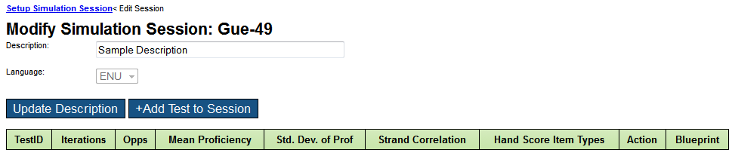

To add tests to a session:

1. On the Modify Simulation Session page (see Figure 5), click **Add Test to Session**. The Add Test(s) to Session window appears, displaying a list of tests available in the database (see Figure 6).

Figure . Add Test(s) to Session Window

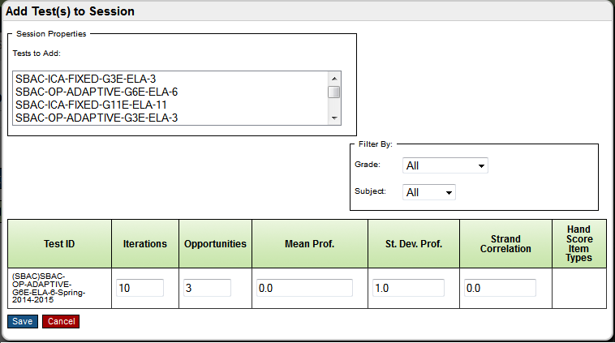

1. Optional: Select options from the **Grade** and **Subject** drop-down lists to filter the tests in the **Tests to Add** list.
2. Select a test from the **Tests to Add** list. The properties for the selected test appear in the table at the bottom of this window.

|  |  |
| --- | --- |
|  | **Notes:**   * The **Tests to Add** list displays test packages that have been imported via the **Load Test Package** tab. For more information, see the section Loading Test Packages. * If you selected **Online – 0** as the type when creating the session, the **Tests to Add** list only includes computer-adaptive tests. If you selected **Paper – 1** as the type, this list only includes fixed-form tests. For more information, see the section Creating a New Simulation Session. |

1. In the Iterations field, enter the number of iterations (testing students) to be included in the simulation session.
2. In the Opportunities field, enter the number of times each student will take the test in the simulation session.
3. In the Mean Prof. field, enter the mean proficiency (average student ability) for the test.
4. In the St. Dev. Prof. field, enter the standard deviation proficiency for the test.
5. In the Strand Correlation field, enter the strand correlation value for the test (usually this value is "1").
6. Click **Save**. The selected test appears in the table on the Modify Simulation Session page.
7. If the selected test contains hand-scored items, do the following:
   1. In the Action column of the test table, click **Edit**. The Modify Simulation Test Property window appears.
   2. In the **Hand Score Item Types** list, select the hand-scored item types included in the test. You can use the **Ctrl** or **Shift** key to select multiple item types.
   3. Click **Save**. The selected item types appear in the Hand Score Item Types column of the table. The simulation session will not score these item types.

|  |  |
| --- | --- |
|  | **Note:** There is no limit to the number of test packages, iterations, and opportunities you can include in a simulation session. However, the more you include of each, the longer the simulation takes to run. |

## Running the Test Simulation

After you add tests to a simulation session, you can run the test simulation.

Figure . Manage Simulation Sessions Tab

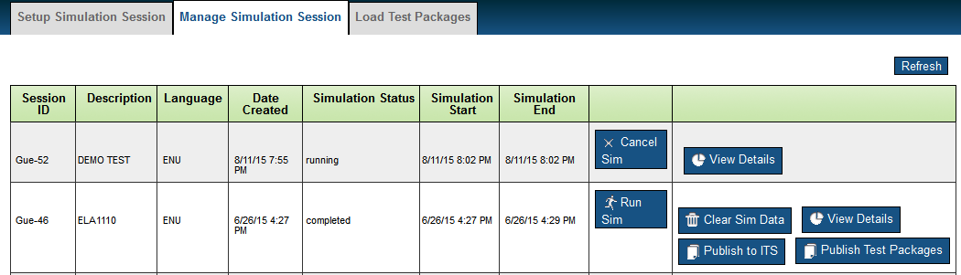

To run a test simulation:

1. On the **Manage Simulation Sessions** tab (see Figure 7), click **Run Sim** for the required simulation session. The Status column displays "running" until the simulation completes.
   * If you need to cancel the simulation, click **Cancel Sim**.
   * To update the information on this screen, click **Refresh** in the upper-right corner.
2. To view the simulation progress, click **View Details**. The Simulation Details page appears (see Figure 8).

Figure . Simulation Details Page

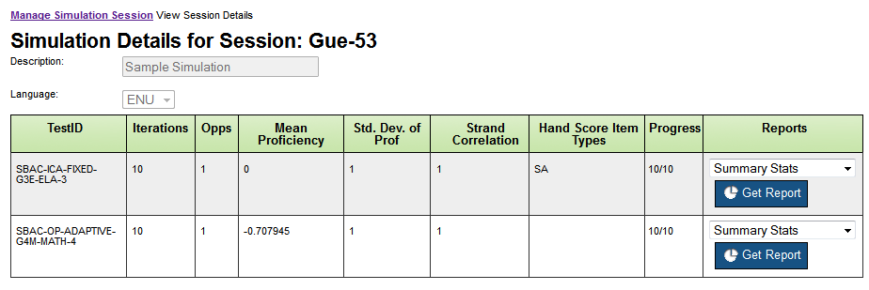

The table on the Simulation Details page displays the test properties entered on the Add Test(s) to Session window (see Figure 6) and also includes a column displaying the simulation progress and a drop-down list for viewing reports.

For more information about viewing simulation session reports, see the section About Simulation Reports.

# About Simulation Reports

When a simulation session finishes running, you can view simulation reports to determine if the test segments are functioning as expected. For more information about the types of reports available, see the section Available Simulation Reports.

## Viewing Simulation Reports

You can view reports for any completed simulation session.

To view a simulation report:

1. On the **Manage Simulation Sessions** tab, click **View Details** for a completed simulation session. The Simulation Details page appears (see Figure 8).
2. In the Reports column, select the required report from the drop-down list.
3. Click **Get Report**. The selected report appears in a new browser tab.
4. Optional: To download a CSV version of a report, click **Download CSV** above a report.

|  |  |
| --- | --- |
|  | **Note:** Some report types do not allow you to download a CSV version of the report, while other report types are only available in downloadable CSV format. For reports that are only available in CSV format, clicking **Get Report** opens a file download dialog box. You can view the downloaded file in Microsoft Excel or other CSV compatible programs. |

## Available Simulation Reports

This section provides an overview of the reports in CAT Simulator. The following reports are available:

* Blueprint Summary report
* Field Test Distribution report
* Item Distribution report
* Opportunities report
* Items report
* Form Distributions report
* Test Package

|  |  |
| --- | --- |
|  | **Note:** The Reports drop-down list on theSimulation Detailspage also lists "Summary Stats" and "Scores" as selectable options. However, these report types are not currently available due to the CAT Simulator scoring configuration. If you select these options, the corresponding reports will be blank or display incomplete data. |

### Blueprint Summary Report

The Blueprint Summary report indicates how closely the selection of items in the simulation session adheres to the blueprint. This report consists of a Blueprint Satisfactions report, an Overall Test Summary of Violations report, an Operational Items Distributions report, and a Recycled Items report.

#### Blueprint Satisfaction Report

The Blueprint Satisfactions report (see Figure 9) indicates whether the simulation included more or fewer items than the blueprint designated for each content level.

Figure . Blueprint Summary: Satisfactions Report

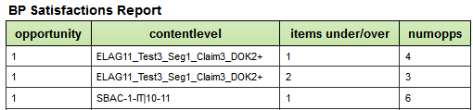

#### Overall Test Summary of Violations Report

The Overall Test Summary of Violations report (see Figure 10) displays the same information as the Blueprint Satisfactions report, but it also displays the segment in which each content level appeared.

Figure . Blueprint Summary: Overall Test Summary of Violations

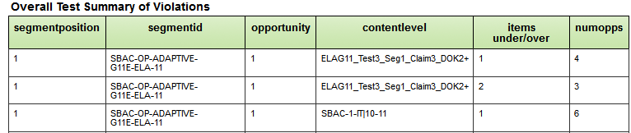

#### Operational Item Distributions Report

The Operational Items Distributions Report (see Figure 11) shows the distribution of unique operational items that appeared across the ranges of test iterations included in the simulation.

Figure . Blueprint Summary: Operational Item Distributions Report

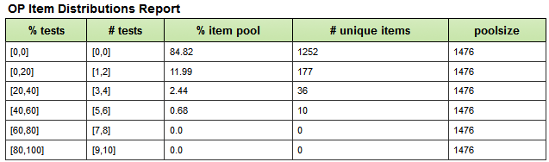

#### Recycled Items Report

The Recycled Items report displays any items that a single student encountered multiple times across all opportunities included in the simulation session. If no items appeared multiple times for any student, this report is blank (as is the case in Figure 12).

Figure . Blueprint Summary: Recycled Items

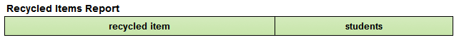

### Field Test Distribution Report

The Field Test Distribution report (see Figure 13) displays how many times each field test item appeared throughout the simulation session.

Figure . Field Test Distribution Report

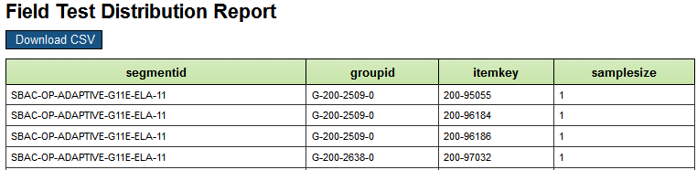

### Item Distribution Report

The Item Distribution report (see Figure 14) displays how many times each item appeared throughout the simulation session, including field test items, operational items, and unused items.

Figure . Item Distribution Report

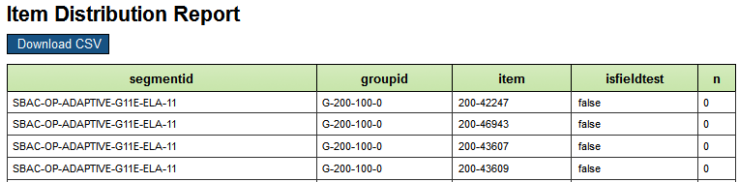

### Opportunities Report

The Opportunities report (see Figure 15) is only available in CSV format. This report provides a summary of each test opportunity included in the simulation session.

Figure . Opportunities Report

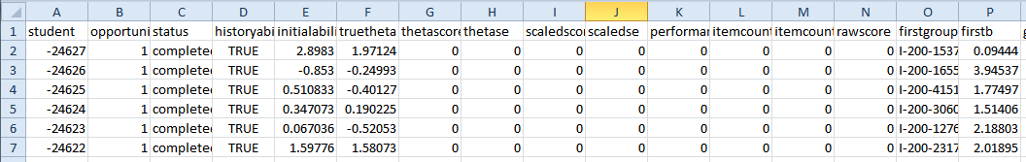

### Items Report

The Items report (see Figure 16) is only available in CSV format. This report provides a summary of the items that each student encountered in the simulation session, including each item's score and position in the test.

Figure . Items Report

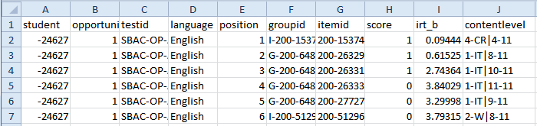

### Form Distributions Report

The Form Distributions report (see Figure 17) is only available in CSV format and is only used for simulation sessions consisting of fixed-form tests. This report shows how many students encountered each test form included in the simulation session.

Figure . Forms Distributions Report

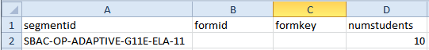

### Test Package

The Test Package option in the Reports drop-down list on the Simulation Detailspage is not a report. When you select this option and click **Get Report**, you can download a file of the test packages included in the simulation session.

# Simulation Session Maintenance

This section includes information about editing, copying, and deleting simulation sessions.

## Editing Simulation Sessions

If the simulation reports indicate that a test is not behaving as expected, you may need to edit the simulation session. When editing a simulation session, you can modify the session description, the associated tests, and the properties and blueprints for each test.

|  |  |
| --- | --- |
|  | **Alert:** If you edit a simulation session while the simulation is still in-progress, any changes you make will not apply to the running simulation. If you wish to modify a simulation session, you should stop the simulation, edit it, and then run it again. |

To edit a simulation session:

1. On the **Setup Simulation Sessions** tab, click **Edit** for the required session. The Modify Simulation Session page appears (see Figure 5).
2. Optional: To modify the description of the session, do the following:
   1. Enter a new value in the Description field.
   2. Click **Update Description**.
3. Optional: To add a test to the simulation session, click **Add Test to Session**. For more information, see the section Adding Tests to a Simulation Session.
4. Optional: To remove a test from the simulation session, click **Delete** in the Action column for the required test.
5. Optional: To modify the properties for a test, click **Edit** in the Action column for the required test. The Modify Simulation Test Property window appears (see Figure 18), allowing you to modify any properties you set when adding the test to the simulation session. For more information, see the section Adding Tests to a Simulation Session.

Figure . Modify Simulation Test Property Window

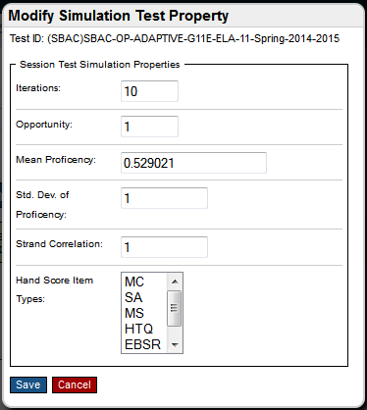

1. Optional: To modify the blueprint for a test, click **Manage Blueprint** in the Blueprint column for the required test. The Manage Test Segment Blueprint page appears (see
2. Figure 19). For more information about modifying test blueprints, see the section Managing Test Blueprints.

### Managing Test Blueprints

Test blueprints are created in TAS and are used to determine the quantity and types of items that appear in each segment of a test. You can also modify test blueprints directly from the Manage Test Segment Blueprint page in CAT Simulator (see

Figure 19).

The Manage Test Segment Blueprint page displays three tables for the selected test:

* **List of Segments**: Displays blueprint properties for each segment included in the test.
* **List of Segment Strands**: Displays blueprint properties for each strand included in each segment of the test. You can filter this table to only show properties for a selected strand.
* **List of Content Levels**: Displays blueprint properties for each content level or affinity group included in each segment of the test. You can filter this table to only show properties for a selected content level or affinity group.

|  |  |
| --- | --- |
|  | **Notes:**   * For information about the property columns in each of these tables, click **Help** in the CAT Simulator banner. * For more information about working with blueprints, see the Test Authoring System User Guide. |

Figure . Manage Test Segment Blueprint Page

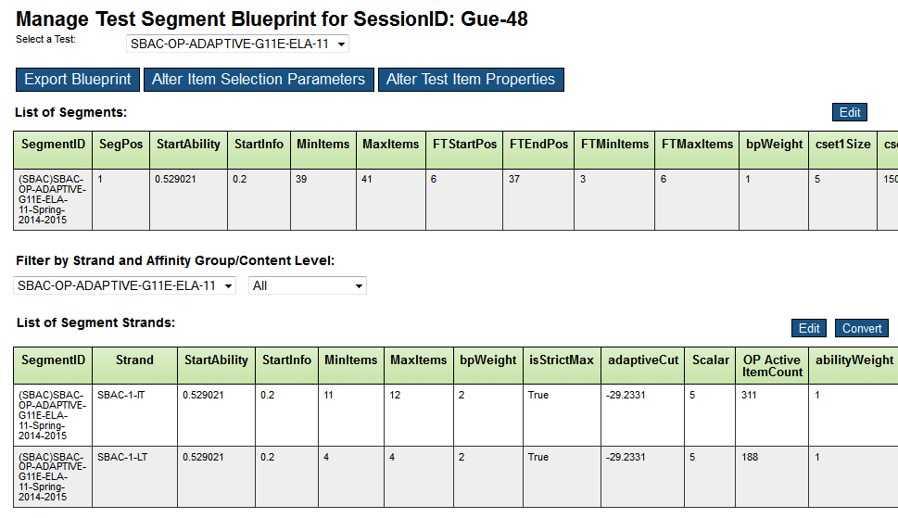

#### Editing Blueprint Properties

You can edit most of the properties in the Segments, Segment Strands, and Content Levels tables. However, certain properties cannot be modified in CAT Simulator.

To edit the blueprint properties for a table:

1. Click **Edit** in the upper-right corner of the required table. The table cells display editable fields, drop-down lists, or checkboxes, depending on the valid values for each column.
2. Modify the blueprint properties, as required.
3. Click **Save** in the upper-right corner of the table.
4. Click **OK** in the pop-up message that appears.

#### Converting Blueprint Elements

The strands in the List of Segment Strands table function as reporting categories, while the content levels and affinity groups in the List of Content Levels table do not. You can move elements from the List of Segment Strands table to appear in the List of Content Levels table (and vice versa) by converting the value of the isReportingCategory column in each table.

To convert blueprint elements:

1. Click **Convert** in the upper-right corner of the required table.
2. The cells of the isReportingCategory column display checkboxes.
   * In the List of Segment Strands table, the checkboxes are marked.
   * In the List of Content Levels table, the checkboxes are blank.
3. Do one of the following:
   1. If you are moving elements from the List of Segment Strands table to the List of Content Levels table, clear the required checkboxes.
   2. If you are moving elements from the List of Content Levels table to the List of Segment Strands table, mark the required checkboxes.
4. Click **Save** in the upper-right corner of the table.
5. Click **OK** in the pop-up message that appears.
   * If you marked the checkboxes, the converted rows now appear in the List of Segment Strands table.
   * If you cleared the checkboxes, the converted rows now appear in the List of Content Levels table.

#### Modifying Item Selection Parameters

You can modify a test blueprint's item selection parameters in CAT Simulator. For information about item selection parameters, click **Help** in the CAT Simulator banner.

To modify item selection parameters:

1. Click **Alter Item Selection Parameters** at the top of the Manage Test Segment Blueprint page. A window appears, displaying the item selection parameters for each segment in the test (see Figure 20).

Figure . Item Selection Parameters

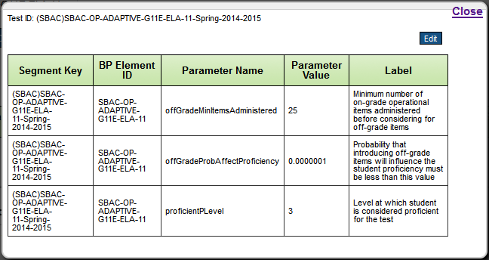

1. Click **Edit** in the upper-right corner of the window. The cells in the Parameter Value column display editable fields.
2. Edit the fields in the Parameter Value column, as required.
3. Click **Save** in the upper-right corner of the window.
4. Click **OK** in the pop-up message that appears.
5. Click **Close** in the upper-right corner of the window.

#### Modifying Test Item Properties

You can also modify a test blueprint's properties for individual items and for item groups. For information about item properties and item group properties, click **Help** in the CAT Simulator banner.

To modify item properties:

1. Click **Alter Test Item Properties** at the top of the Manage Test Segment Blueprint page. A window appears, displaying properties for the individual items in each item in the test (see Figure 21).
   1. Optional: To filter the list of items by segment, strand, or group, select options from the drop-down lists in this window.
   2. Optional: To search for a specific item, enter the item's key in the search field and click **Search**.

Figure . Item Properties

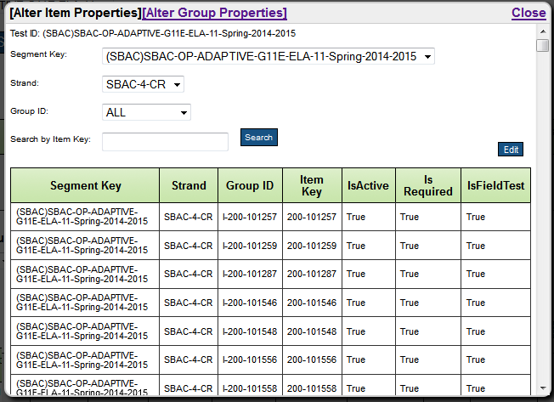

1. To edit properties for individual items, do the following:
   1. Click **Edit** in the upper-right corner of the window. The cells in the IsActive and Is Required columns display editable checkboxes.
   2. Mark or clear the checkboxes, as required.
   3. Click **Save** in the upper-right corner of the window.
   4. Click **OK** in the pop-up message that appears.
2. To edit properties for item groups, do the following:
   1. Click **Alter Group Properties** at the top of the window. The window displays a list of properties for each item group in the test (see Figure 22).

Figure . Item Group Properties

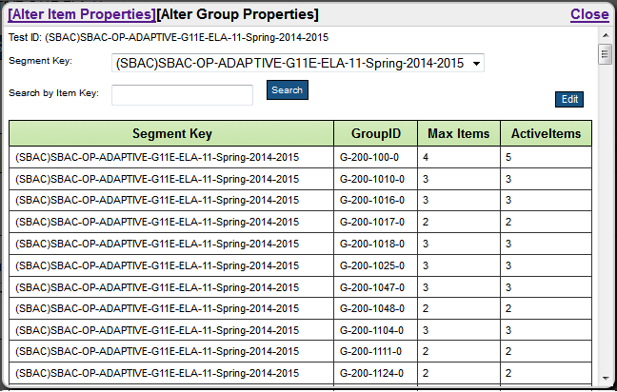

* 1. Optional: To filter the list of item groups by segment, select a segment from the drop-down list at the top of this window.
  2. Optional: To search for a specific item group, enter the group ID in the search field and click **Search**.
  3. Click **Edit** in the upper-right corner of the window. The cells in the Max Items column display editable fields.
  4. Modify the fields in the Max Items column, as necessary.
  5. Click **Save** in the upper-right corner of the window.
  6. Click **OK** in the pop-up message that appears.

1. Click **Close** in the upper-right corner of the window.

#### Exporting Blueprints

After editing a test blueprint, you can export the blueprint in CSV format.

To export a blueprint:

1. On the Manage Test Segment Blueprint page, click **Export Blueprint**. A file download dialog box appears.
2. Download the CSV file. You can open the blueprint in Microsoft Excel or other CSV compatible programs.

## Copying Simulation Sessions

You can make a copy of any existing simulation session in CAT Simulator.

To copy a simulation session:

1. On the **Setup Simulation Sessions** tab, click **Copy** for the required session. The Copy from Existing Session ID window appears.

Figure . Copy from Existing Session ID Window

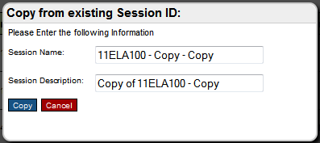

1. Enter a name and description for the copy of the session.
2. Click **Copy**.

## Deleting Simulation Sessions

You can delete any existing simulation session in CAT Simulator.

To delete a session:

1. On the **Setup Simulation Sessions** tab, click **Delete** for the required session.
2. Click **Yes** in the warning pop-up message that appears. The simulation session is no longer available on the **Setup Simulation Sessions** or **Manage Simulation Sessions** tab.

Appendix A. User Support

|  |  |
| --- | --- |
| Contact Information | |
| **Questions about state policies** | **Questions about technology and the overall administration procedures** |
| STATE  **Accommodations, Test Policy, Testing Irregularities**  {Blanks to fill in with your specific state information}   |  |  | | --- | --- | | Name: |  | | Phone: |  | | Email: |  |   **Your Smarter Balanced State Lead Contact (in the event of a security breach or irregularity)**  {Blanks to fill in with your specific state information}   |  |  | | --- | --- | | Name: |  | | Phone: |  | | Email: |  | | Assessment Program Name  Monday–Friday from 6:30 a.m. to 6:30 p.m. Eastern Time  800-555-5555  [demoHelpDesk@air.org](mailto:demoHelpDesk@air.org) |