**Loading the ITS configuration into the Simulator or TDS**

1. In the simulator interface, users with admin privilege can load configs. by specifying the config. ids to be loaded as below. This assumes that logical test ids for tests in the config. are already known (or the config. is previously loaded manually to establish logical ids)

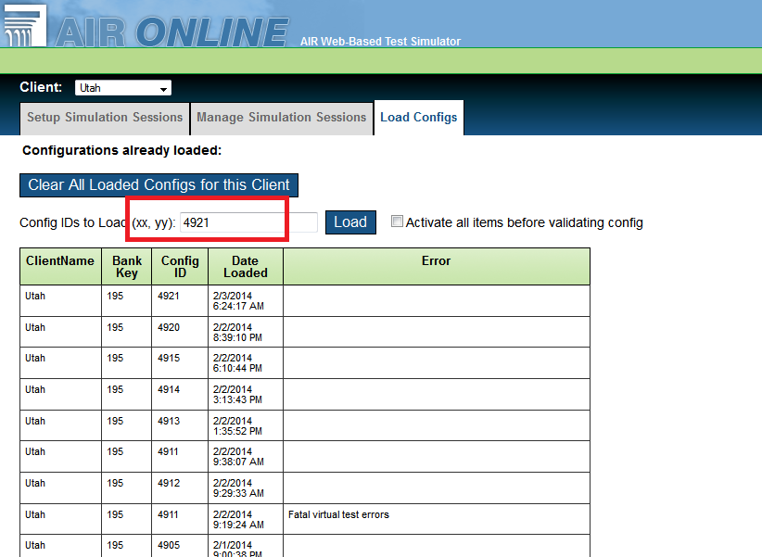

This process will invoke the following stored procedures in discrete steps – This allows to present errors to the user when occurs.

* Load_LoaderTablesFromDB – Loads the ITS configs into Loader staging tables
* Loader_Main – Loads the data from Loader staging table to TDS config
* UpdateTDSConfigs – Update the TDS configs.

1. The above process can also be done in the query window by performing the following steps:

Note: User should have r+w privilege to TDS Itembank and Config databases as well as to the TestScoringConfigs databases.

/* Load the CORRECT config into the loader tables */

exec load_loadertablesfromDB   **XXXX**

/* Verification Step: Confirm you just loaded the right config */

select * from loader_itembank where configid = **XXXX**

/* Verification Step: Check logicalIDs exist*/

select * from loader_logicaltests

/* Final commit into the DB */

exec Loader_Main

/* Update the TDS Configs */

updateTDSConfigs 0

1. When the tests contained in the config. are loaded for the first time from ITS Config to TDS Config the logical test should be established in the TDS Configs. Without this step the ‘Loader_Main’ will procedure will throw errors like

2678 FATAL ERROR (SBAC)Platform-ELA-11-Fall-2013-2014 Missing logical test ID

2678 FATAL ERROR (SBAC)Platform-ELA-3-Fall-2013-2014 Missing logical test ID

…

This is because LogicalID field in the Loader_LogicalTests table are NULL

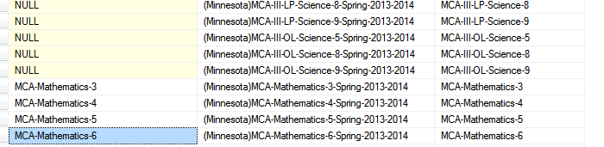

To fix this user need to establish logical test id for the tests. This is done by manually setting the LogicalID in the loader_logicalTests table conforming to client test id naming convention

UPDATE Loader_LogicalTests

SET LogicalID = 'SBAC-Platform-ELA-G5-ELA-5'

WHERE TestKey = '(SBAC)Platform-ELA-5-Fall-2013-2014'

….

Once the logical ids are set user should run

exec Loader_Main and then update the tds configs

EXEC UpdateTDSConfigs 0

For a first load you might get an error “Missing filepath for itembank content”. In that case add “@filepath='c:\dummy'” as a parameter to the Loader_Main call.

1. If for any reason, if the logical ids are set incorrectly and the user wanted to fix it then that can be done by deleting all the tests loaded for the config. (May be loadConfig=4862 also)

DELETE FROM TDSCONFIGS_Client_TestMode

WHERE testKey in (SELECT _Key FROM dbo.tblSetofAdminSubjects WHERE updateConfig = 4862)

DELETE FROM dbo.tblSetofAdminSubjects WHERE updateConfig = 4862

Note: This doesn’t delete records linked with old testids in tables listed below - But this seems to be okay.

TDSCONFIGS_Client_Test_Itemtypes,

TDSCONFIGS_Client_TestEligibility,

TDSCONFIGS_Client_TestWindow,

TDSCONFIGS_Client_TestformProperties, TDSCONFIGS_Client_TestProperties

Once the records for the incorrect testid are deleted, user can then reload the config. establishing the desired logical id mapping as specified in step 3.

**Populating the dropdown for “Select a Client…”.**

Make sure user has client specified in SIM_UserClients and there is an entry with environment SIMULATION in the _Externs table in the session DB for the client.

**Populating the dropdown for “add test to session”.**

When a new set of tests are loaded and you can’t save a newly created session: check that there is an entry in TDSCONFIGS_Client_Externs with the correct clientname and Environment = 'SIMULATION'. If not, add it by copying from another client and changing clientname. The other values don’t seem to matter for simulations.

When a new set of tests are loaded they sometimes do not show up in the drop down for adding tests to a session. Check that IsSelectable is set to 1 in TDSCONFIGS_Client_TestProperties. Also check that sessionType is set correctly in TDSCONFIGS_Client_TestMode 1 means PAPER and 0 means ONLINE (as selected in the simulator when the session is created). If this still fails look at the code in the ListClientTests stored function.

**Turning on (test) scoring for simulation runs.**

Run UpdateConfigs_Scorefeatures, e.g.:

select _Key from dbo.tblSetofAdminSubjects where TestID like 'MCA-Science-%'

exec dbo.UpdateConfigs_Scorefeatures @testkey = '(Minnesota)MCA-III-OL-Science-5-Spring-2013-2014'

exec dbo.UpdateConfigs_Scorefeatures @testkey = '(Minnesota)MCA-III-OL-Science-8-Spring-2013-2014'

exec dbo.UpdateConfigs_Scorefeatures @testkey = '(Minnesota)MCA-III-OL-Science-9-Spring-2013-2014'

This doesn’t seem to control what scores will be computed, just whether the TestScoringEngine will be called. It will then compute all measure with ComputationLocation = ‘SIM’. Note that if the TestScoringEngine throws an exception no scores will be recorded (and it might look like nothing is configured).

**Error logs.**

Errors logged by the simulator can be accessed from the SystemErrors synonym in the simulator Session DB. This only has the last days’ worth of errors. For older errors look in SystemErrorsArchive in the TDS_Archive DB (script the synonym to see which DB it is)

For config loader errors look in Loader_Errors in the SIM ItemBank.