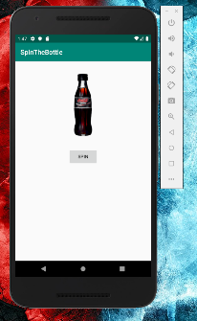**Section 1. Bottle App**

Start of app where nothing has been run

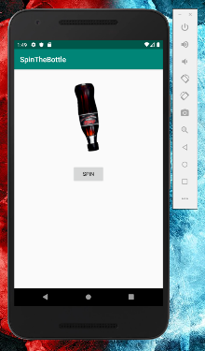

Bottle in motion when the spin button has been tapped

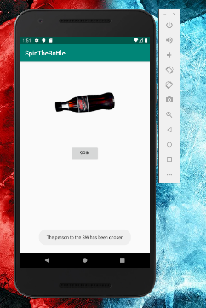

When the bottle lands at a location the toast message is sent to the screen telling the user where the bottle has landed. Either in the north east, south east, south west or north west quadrat.

**Section 2. LifeCycle of an Activity**

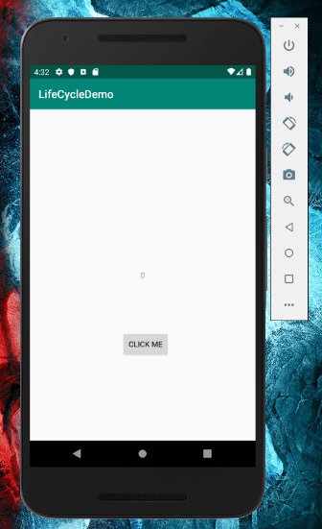

Start of the lifecycle app

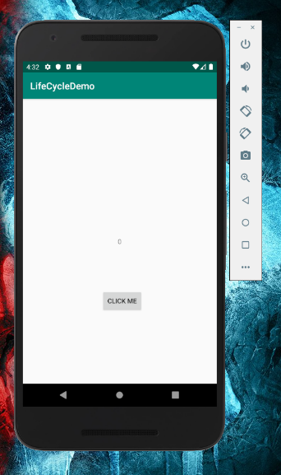

The lifecycle app being running by clicking the click me button

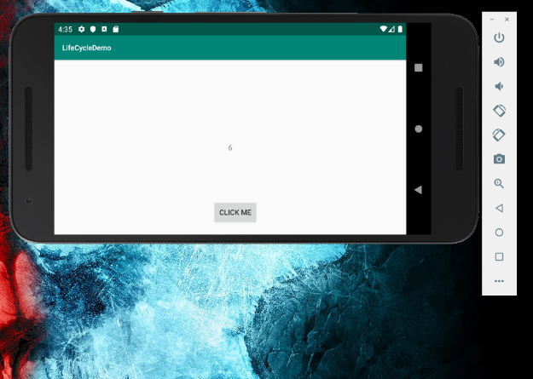

The app keeping the click number even after it is turned sideways

**Section 3. Simple List Adapter**

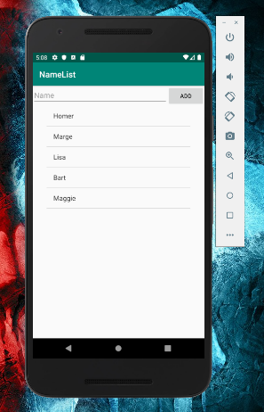

The simple list app shown at the start with a predefined list of users

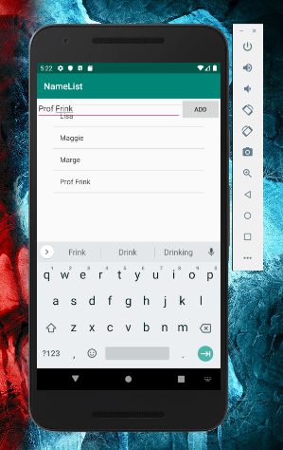

Inputting a name into the text field and adding it to the array list

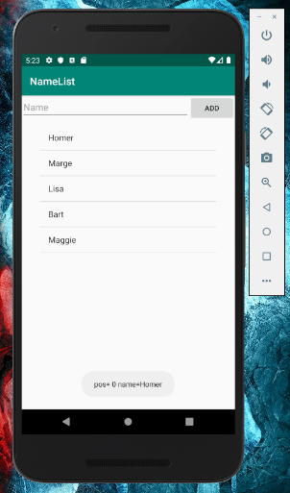

Clicking on the name gives a position of where it is and what the name is in a toast message.

**Section 4. Custom List Adapter**

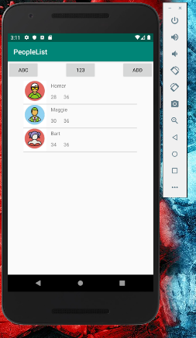

The app before it has been run

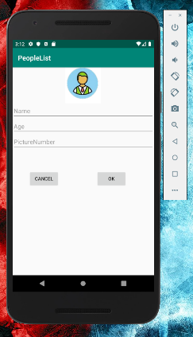

After clicking the add button on the top left of the screen before this brings up the add person

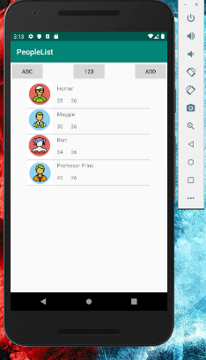

After clicking the add on the new person form it adds the new person to the list

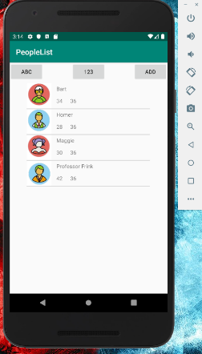

Hitting the ABC button on the top right will sort the app by the alphabet

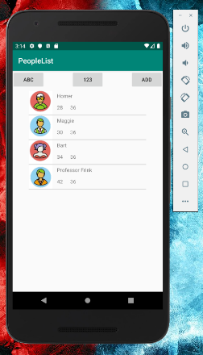

After hitting the middle button of the 123 it sorts the list by the age of the people

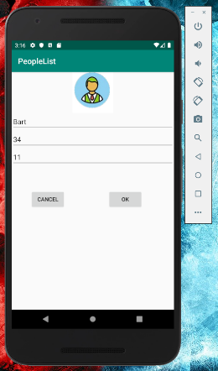

Clicking on a contact allows the ability to edit them

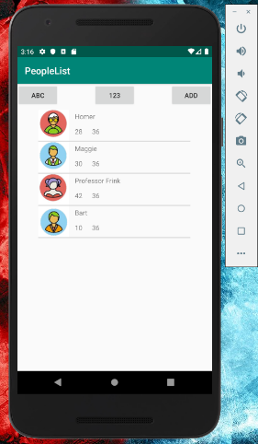

After changing the picture and the age of Bart and hitting okay it changes the information shown