Project: Todo Web Application
Course: CSD 380 – DevOps
Description: This test plan was created to verify that the Todo web application meets the business requirements. The tests focus on basic functionality such as loading the site, creating tasks, editing tasks, deleting tasks, and validating user input.
Date: 2/6/2026
To complete the test case plan, fill out the information for Project, Course, Description and Date in the header below.

TABLE OF CONTENTS
Test 1 Access Website via Standard URL 2
Test 2 Create a New Todo Task Item 2
Test 3 Prevent Blank Task Submission 3
Test 4 Edit an Existing Todo Item 3
Test 5 Delete a Todo Task Item 3

Test 1 | Access Website via Standard URL
 | Test Objective: Verify users can access the Todo application using the correct URL. | Developer: Daniel Graham  Date tested: 2/6/2026 | Peer tester: Paul Fralix  Date tested: 02/08/2026
Step | Action | Expected results: | Developer pass/fail | Tester pass/fail  + Screenshot
1 | Navigate to https://buwebdev.github.io/todo/ | Website loads successfully | Pass | 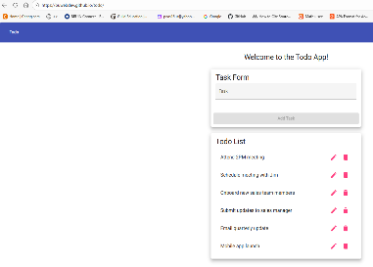  Pass
2 | Observe page content | Todo list interface is displayed | Pass | 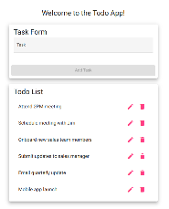  Pass
3 | Refresh the browser | Page reloads without errors | Pass | 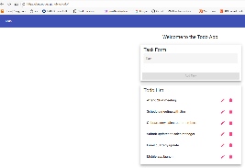  Pass
4 | Verify URL remains unchanged | URL stays correct | Pass | 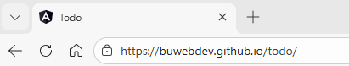  Pass
5 | Check for error messages | No error messages appear | Pass | Pass
Comments | The website loaded correctly using the required URL and displayed the Todo list as expected. Refreshing the page did not trigger any errors. The results of this test verify that users can access the page through the standard URL.

Test 2 | Create a New Todo Task Item
 | Test Objective: Verify users can create a new todo task. | Developer: Daniel Graham  Date tested: 2/6/2026 | Peer tester: Paul Fralix  Date tested: 02/08/2026
Step | Action | Expected results: | Developer pass/fail | Tester pass/fail
1 | Enter a task in the input field | Text appears in the field | Pass | 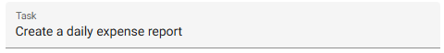  Pass
2 | Click the Add button | Task is added to the list | Pass | 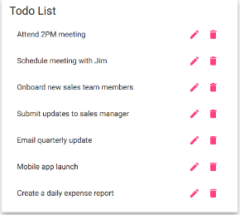  Pass
3 | Observe task list | New task appears in list | Pass | 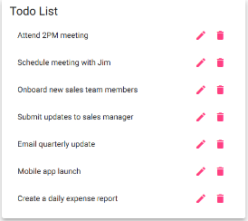  Pass
4 | Refresh browser | Task remains in list | Pass | 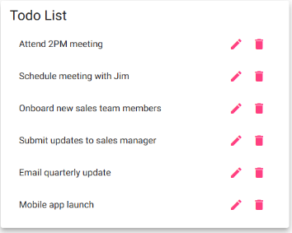  Fail
5 | Repeat with another task | Second task is added correctly | Pass | 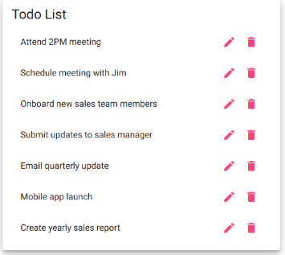  Pass
Comments | The system allows users to add new tasks without any problems. The task appears immediately after clicking the Add Task button. The task does not remain on the Todo list after refreshing the browser page. This prevents the user from closing and reopening the page while keeping the list intact.

Test 3 | Prevent Blank Task Submission
 | Test Objective: Verify users cannot submit a task without entering text. | Developer: Daniel Graham  Date tested: 2/6/2026 | Peer tester: Paul Fralix  Date tested: 02/08/2026
Step | Action | Expected results: | Developer pass/fail | Tester pass/fail
1 | Leave input field empty | Field remains blank | Pass | 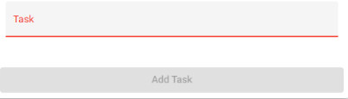  Pass
2 | Click Add button | Task is not added | Pass | 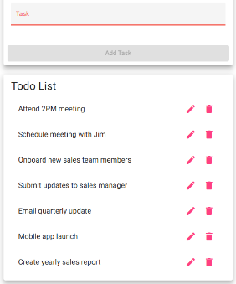  Pass
3 | Observe screen | No new task appears | Pass | Pass
4 | Enter valid task | Text appears in field | Pass | Pass
5 | Click Add button | Task is successfully added | Pass | 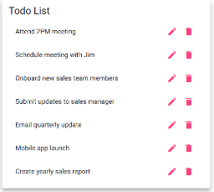  Pass
Comments | The application correctly blocks empty submissions and only allows valid tasks to be added. This helps prevent invalid data from being entered into the system.

Test 4 | Edit an Existing Todo Item
 | Test Objective: Verify users can edit an existing todo task. | Developer: Daniel Graham  Date tested: 2/6/2026 | Peer tester: Paul Fralix  Date tested: 02/08/2026
Step | Action | Expected results: | Developer pass/fail | Tester pass/fail
1 | Select an existing task | Task becomes editable | Pass | 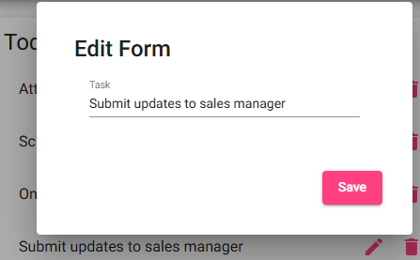  Pass
2 | Modify task text | Updated text appears | Pass | 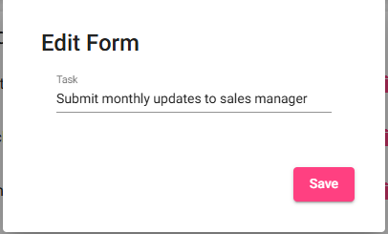  Pass
3 | Save the edited task | Changes are saved | Pass | 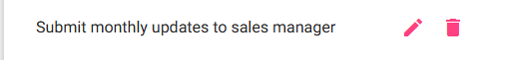  Pass
4 | Refresh the page | Edited task remains updated | Pass | 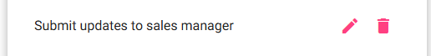  Fail
5 | Verify list display | Task shows updated text | Pass | Fail
Comments | The edit feature works as expected and allows tasks to be updated. The updated task is not retained in the list after the page is refreshed. This does not allow the user to update the task in the list and refresh the page.

Test 5 | Delete a Todo Task Item
 | Test Objective: Verify users can delete a todo task. | Developer: Daniel Graham  Date tested:2/6/2026 | Peer tester: Paul Fralix  Date tested: 02/08/2026
Step | Action | Expected results: | Developer pass/fail | Tester pass/fail
1 | Select an existing task | Task is highlighted or selected | Pass | 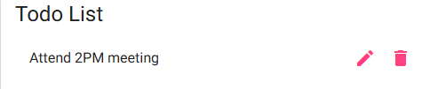  Pass
2 | Click delete/remove option | Task is removed from list | Pass | 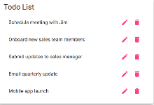  Pass
3 | Observe task list | Task no longer appears | Pass | Pass
4 | Refresh browser | Deleted task does not return | Pass | 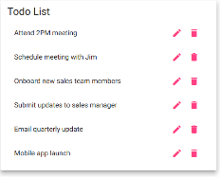  Fail
5 | Verify remaining tasks | Other tasks remain unchanged | Pass | Pass
Comments | The delete function removes tasks successfully. But they return to the list once the page is refreshed. This does not allow the user to maintain an updated todo list.

