Project: | Stephanie Ramos – M4.2 Assignment Test Plan
Course: | CSD 380 DevOps
Description: | Creating a test plan based on business requirements
Date: | 2026/02/03
To complete the test case plan, fill out the information for Project, Course, Description and Date in the header below.
.
TABLE OF CONTENTS
Create a New Todo Task Item 2
Edit a Todo Task Item 2
Delete a todo task item 3
Prevents a user from submitting a task without entering a todo item 4
Prevent users from submitting the edit form without entering a todo item 4

For each test, the developer should: provide a test description, a test objective, the developer name and date tested. For each step, fill out the actions to be taken and describe the expected results, and indicate yes or no for each step depending upon the result. The peer tester should provide their name, date tested, indicate yes or no for each step depending upon the result, and a screenshot (thumbnail) of the result.

Test 1 | Create a New Todo Task Item
 | Test Objective: Verifies that a user can create a new task and is displayed in todo list | Developer: Stephanie Ramos  Date tested: 2026/02/03 | Peer tester: Paul Fralix  Date tested: 2026/02/08
Step | Action | Expected results: | Developer pass/fail | Tester pass/fail  + Screenshot
1 | Visit https://buwebdev.github.io/todo/ | The webpage loads successfully | Yes | 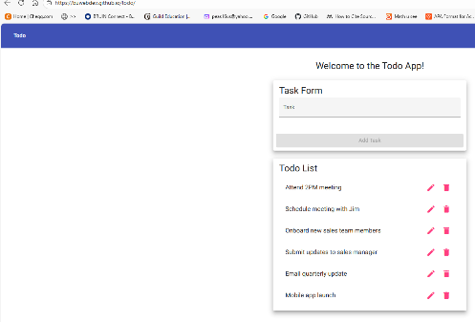  Pass
2 | Locate Task Form | The task input form is visible on the page | Yes | 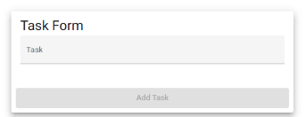  Pass
3 | Click on task input field | Input field is clickable and allows typing | Yes | 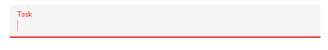  Pass
4 | Type a task in the input field | The user is able to type a task into the input field | Yes | 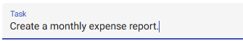  Pass
5 | Click “Add Task” | The new task is added and displayed in the list | Yes | 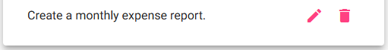  Pass
Comments | The page loads and displays correctly using the url. The todo list loads, and the Task Form displays correctly with a blank text input field. The form allows a new task to be entered by clicking the add button after entering text.

Test 2 | Edit a Todo Task Item
 | Test Objective: Verifies that a user can change/edit a task without creating a new task | Developer: Stephanie Ramos  Date tested: 2026/02/03 | Peer tester: Paul Fralix  Date tested: 2026/02/08
Step | Action | Expected results: | Developer pass/fail | Tester pass/fail
1 | Visit https://buwebdev.github.io/todo/ | The webpage loads successfully | Yes | Pass
2 | Locate existing task in the todo list | The task is visible in the todo list | Yes | 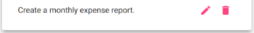  Pass
3 | Click on edit icon for the selected task | A pop-up window appears, displaying the existing task text in the input field | Yes | 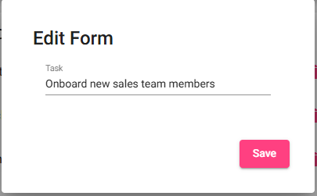  Pass
4 | Modify the task text in the input field | The user is able to edit the task text | Yes | 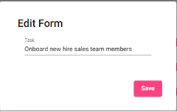  Pass
5 | Click the save button | The updated task replaces the original task and is displayed in the todo list | Yes | 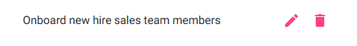  Pass
Comments | The page loads correctly without errors using the URL. The todo list displays correctly for the user. The edit icon opens a pop-up that displays the task to be edited and allows the user to edit the text before clicking the save button. The updated task shows in the todo list once the save button is clicked.

Test 3 | Delete a todo task item
 | Test Objective: Verifies that a user can remove a task from the todo list | Developer: Stephanie Ramos  Date tested: 2026/02/03 | Peer tester: Paul Fralix  Date tested: 2026/02/08
Step | Action | Expected results: | Developer pass/fail | Tester pass/fail
1 | Visit webpage | The webpage loads successfully | Yes | Pass
2 | Locate the existing task in the todo list | The task is visible in the todo list | Yes | Pass
3 | Click on the delete icon for the selected task | The selected task is removed from the todo list | Yes | 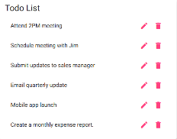  Pass
4 | Refresh the browser window | The page reloads successfully | Yes | 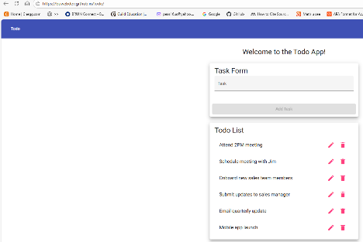  Pass
5 | Confirm the page reloaded without the deleted task | The deleted task does not appear in the todo list | Yes | 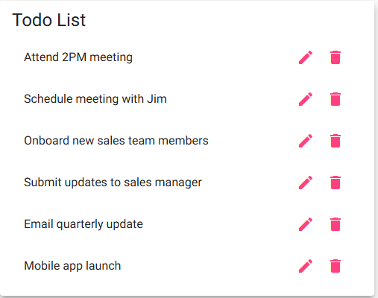  Fail
Comments | The page loads correctly without errors with the URL. The todo list displays with the task displayed correctly. The user can delete a selected task from the list. The task reappears in the list when the page is refreshed. This does not allow the user to refresh the page and receive an updated list with deleted tasks.

Test 4 | Prevents a user from submitting a task without entering a todo item
 | Test Objective: Verifies that the user cannot submit a todo task when the input field is empty | Developer: Stephanie Ramos  Date tested: 2026/02/03 | Peer tester: Paul Fralix  Date tested: 2026/02/08
Step | Action | Expected results: | Developer pass/fail | Tester pass/fail
1 | Visit https://buwebdev.github.io/todo/ | The webpage loads successfully | Yes | Pass
2 | Locate the task input field | The task input form and Add Task button are visible | Yes | 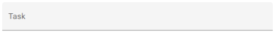  Pass
3 | Leave the task input field empty | Input field has no text | Yes | Pass
4 | Observe that the Add Task button is grey | The Add Task button is displayed and cannot be clicked | Yes | 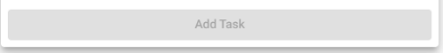  Pass
5 | Attempt to click on the Add Task button | The task is not added to the todo list | Yes | Pass
Comments | The page loads correctly without errors with the URL. The task input field displays correctly with the Add Task button displayed. The Add Task button remains disabled until text is entered in text field. This prevents user from entering blank text fields.

Test 5 | Prevent users from submitting the edit form without entering a todo item
 | Test Objective: Verifies that the user cannot save an edited todo task when the input field is empty | Developer: Stephanie Ramos  Date tested: 2026/02/03 | Peer tester: Paul Fralix  Date tested: 2026/02/08
Step | Action | Expected results: | Developer pass/fail | Tester pass/fail  + Screenshot
1 | Visit https://buwebdev.github.io/todo/ | The webpage loads successfully | Yes | Pass
2 | Locate an existing task in the todo list | The task is seen in the todo list | Yes | 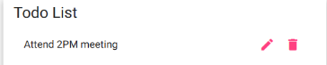  Pass
3 | Click the edit icon for the selected task | The edit pop-up opens with the existing text in the input field | Yes | 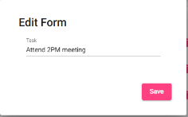  Pass
4 | Delete all text from the input field | The input field becomes blank | Yes | 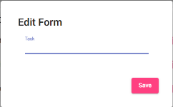  Pass
5 | Click the Save button | The application prevents saving an empty task. | No | 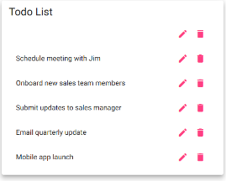  Fail
Comments | The page loads correctly without errors with the URL. The page displays the todo list, and a pop-up appears when the edit icon for the selected task is clicked. The user can clear the existing text from the text field. The application allows the user to click save with a blank text field. This allows the user to save a blank task in the todo list.

